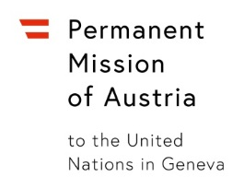
UNITED NATIONS HUMAN RIGHTS COUNCIL
48th session
Interactive Dialogue on Report of the Secretary-General on Cooperation with the United Nations, its representatives and mechanisms in the field of human rights
Wednesday, 29 September 2021
Thank you,

I have the honour to deliver this statement on behalf of Croatia, Slovenia and my own country, Austria.
We would like to thank Ms. Brands Kehris for the presentation of her report.
The contribution and information provided by individuals and groups seeking to cooperate with the United Nations, including NGOs, national human rights institutions, individual human rights defenders, journalists, lawyers and others, are crucial in order for our work to be based on current developments and responsive to the needs of victims of human rights violations.
We are deeply concerned that according to your report, a continuously high number of governments punish and retaliate against such cooperation with the UN. We strongly condemn any threats, attacks and reprisals against these individuals and groups, especially women, as well as against their families.
We are particularly concerned about cases of intimidation and reprisals committed by HRC Members, since they should uphold the highest standards in the promotion and protection of human rights.
We are also worried about the continued trend of using justifications of any kind for blocking access to the UN as well as measures adopted in response to the COVID-19 pandemic as a pretext to stifle civil society space.
Ms. Brands Kehris,
Let me also express our concern that under the current virtual working methods, we witness an increase in intimidation and reprisals online. How can we make sure to counter this trend?
I thank you.

