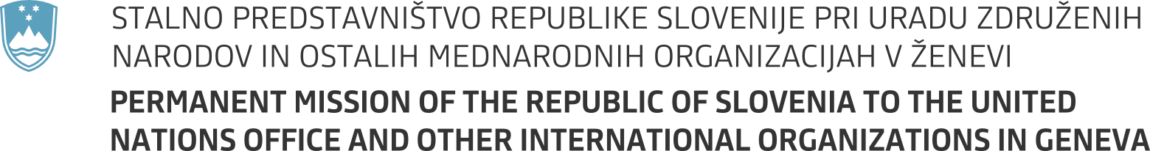

36th session of the United Nations Human Rights Council

Item 2 - Interactive Dialogue with the High Commissioner for Human Rights

13 September 2017

Statement by Slovenia

Mr President,

we align ourselves with the statement delivered on behalf of the EU.

Mr High Commissioner,

Slovenia welcomes your oral report from yesterday, as your views, after three years at this important position, give you a unique overview of the trends and challenges in the field of human rights. We would like to use this opportunity to also thank you for your visit in our country last week.

We are taking yesterday's comments you have made on the internal/external gap particularly seriously and hope we will be able to address some of our own shortcomings shortly. We strongly believe it is equally important to improve respect for human rights domestically, as it is internationally.

Mr High Commissioner,

We share also your view regarding the necessity of a human rights violations based approach, which could enable us to address human rights situations around the world in a more comprehensive way. In such a way we could move more swiftly and effectively as we raise the credibility of this body.

Meanwhile, Slovenia remains seriously concerned over the situation in Rakhine state in Myanmar. As one of the countries committed to demining and mine victim's assistance, we strongly deplore laying landmines that has been reported to take place along at the border with Bangladesh.

We remain dismayed also over reports of excessive use of force by security officers, and multiple other human rights violations, in the context of anti-Government protests in Venezuela. We'll address these and some other issues also during some of our upcoming interventions.

Mr High Commissioner,

Let me finish by expressing our continued support and gratitude for your work and the work of your office. I thank you!

