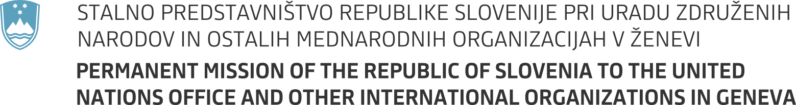

35th session of the United Nations Human Rights Council

Item 2 - Interactive Dialogue with the High Commissioner for Human Rights

7 June 2017

Statement by Slovenia

Mr President,

Slovenia aligns itself with the statement delivered on behalf of the EU.

Mr High Commissioner,

As you have eloquently put it yesterday the practice of naming does not necessarily entail shaming as the shaming lies in the acts and not in the naming itself. We welcome your overview of the trends, particularly concerning the question of effectiveness and cooperation with the human rights mechanisms.

We share your assessment that protection and respect for human rights as well as promotion of tolerance should be at the forefront of our efforts to counter terrorism and violent extremism. Divisiveness and hate speech must not guide our responses to these heinous acts we have been witnessing. Our message should be clear – we stand united in our values.

Mr High Commissioner,

We share your concern regarding the reprehensible behaviour towards and threats against Special Procedures mandate-holders and deeply deplore such acts. We firmly believe Special Procedures and other human rights mechanisms are key element in our efforts to promote and protect human rights. They should enjoy our full respect and cooperation. Slovenia has issued a standing invitation to all Special Procedures. We call upon all who haven't yet done so to follow such practice and to provide full and unhindered access for them to fulfil the tasks we have mandated them to do.

We share your assessment that Universal Periodic Review is not a mere courtesy conversation but a mechanism for improving situation on the ground. At this session Slovenia will present its voluntary mid-term report on the implementation of the recommendations we have supported during our second review.

Mr High Commissioner,

Let me finish by expressing our continued support and gratitude for your work and the work of your office.

Thank you!

