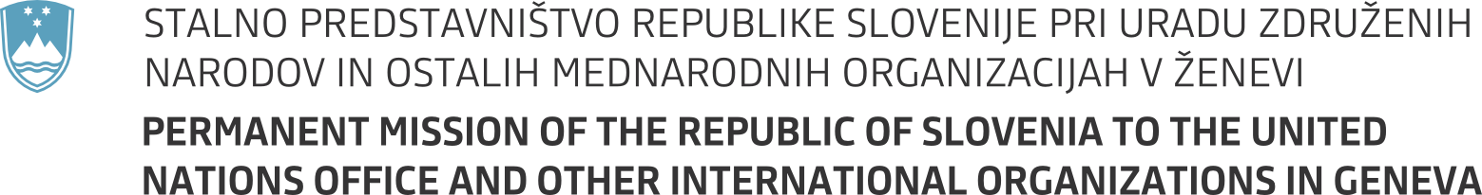

35th session of the UN Human Rights Council
Interactive dialogue with Working Group on the issue of discrimination against women in law and in practice
Geneva, 8 June 2017
Statement by Slovenia
Mr President,

we align ourselves with the statement delivered by the EU.

Slovenia is a strong supporter of promotion and protection of human rights of women and girls and opposes all forms of discrimination and violence against them. It is unacceptable that women, despite international legal and political obligations, in this time and age still face multiple and often intersecting forms of discrimination. We share concerns of the Working Group on negative trends in promotion and protection of women's human rights and on backlash on already achieved gains.

At the same time, it is encouraging to read the last report of the Working Group and see that there are positive steps around the globe with internationally recognised good practices. We thank the members of the Working Group for their work and we encourage them to continue their efforts.

I'm glad to report that Slovenia is already following the most recent recommendations of the Working group. Gender equality and empowerment of women has been and will remain high on our political agenda. As discrimination on the basis of sex is prohibited by our Constitution, our legislation follows suit, including the Equal Opportunities for Women and Men Act as well as Protection against Discrimination Act that was adopted last year.

Our national policies, including on fighting all forms of discrimination against women, are guided by strategic document of the government – National Programme for Equal Opportunities for Women and Men 2015–2020. Among its objectives are also anti-discrimination measures that affect women, in particular regarding violence, labour market, sexism in the media etc.

Slovenia is and will remain active in support to empowerment of women also on international level – through our bilateral relations, activities in international fora and through our international development cooperation.

We would welcome the views of the Working Group on how to best ensure sustainability of political will and activities for gender equality.

Thank you!

