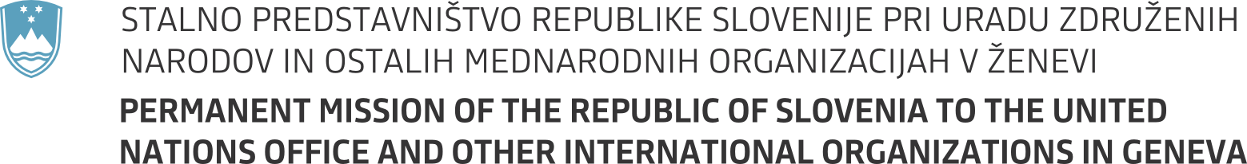

35th session of the United Nations Human Rights Council
Item 3 - Interactive dialogue with the Independent Expert on protection against violence and discrimination based on sexual orientation and gender identity
7 June 2017
Statement by Slovenia

Mr. President,

Slovenia aligns itself with the EU statement. We thank Professor Muntarbhorn for his report and presentation today. We believe your mandate will provide an important contribution in raising awareness on the issue of discrimination and violence faced by LGBTI-people.

It remains worrisome that gender identity and sexual orientation are often used as a pretext for human rights violations. This can be a sensitive issue for some countries, and continued dialogue with all relevant stakeholders is needed as we move forward in addressing these issues. Cooperation with Special Procedures and mandate holders as well as maintaining their independence is of particular importance in this regard. Special attention should be given to civil society and in particular human rights defenders in the area of LGBTI rights.

Often homophobic and transphobic violence remains unreported. In your report, you touch upon the issues of root causes of such acts against LGBTI persons. Can you provide more information on how can we best address the multi-layered nature of violence and discrimination, including the root causes?

Finally, it should be our common commitment to advance human rights that are equal for all. Cultural, traditional, and religious values should not be grounds to justify any form of discrimination, including discrimination based on sexual orientation or gender identity. Let me assure you Mr. Muntarbhorn that Slovenia remains a strong supporter of your mandate.

Thank you.

