Check against delivery

Statement by
Ambassador Boštjan Malovrh
Permanent Representative of the Republic of Slovenia
to the United Nations
at the
56th Commission on Population and Development
General Debate

New York, 11 April 2023

Mr. Chair,
Ladies and Gentlemen,

Slovenia aligns itself with the EU statement as well as cross-regional statement delivered by Argentina. I would like to share some additional remarks in our national capacity.

Slovenia remains committed to the ICPD Programme of Action and the outcomes of its reviews and welcomes this Session's priority theme focusing on education, which gives us the opportunity to address a wide spectrum of issues. Let me outline a few key areas.

First – the importance of equal opportunities

To reach inclusive and sustainable growth and development, we need to ensure equal opportunities for all. Women and girls represent over half of the current world population. Therefore, empowering women and providing them with choices through access to employment, education and ensuring sexual and reproductive health and rights is essential in this regard.

Slovenia will continue to advocate full access of women and girls to quality education, including digital literacy. Awareness-raising and education, including human rights education, women's full and equal participation in decision-making, the dismantling of gender stereotypes, as well as the role of men and boys are all important elements in our efforts to achieve full women and girls' equality.

As the largest catalysts for change young people are essential to advancing not just the ICPD Programme of Action but the implementation of all SDGs. With access to quality education, skills development, reliable information, including their sexual and reproductive health and rights, young people can truly become the positive force for sustainable development.

Second – education is key

Right to education is a human right. Inclusive and quality education and promoting lifelong learning opportunities for all is a key component for equipping current and future generations to rise to the challenges of today. Education is key to fostering social justice, solidarity, respect for diversity and human rights.

Slovenia recognises the central role of global education in eradicating of poverty and inequality, achieving sustainable development and educating active and responsible global citizens. Respect for and promotion of human rights, environmental responsibility and sustainable economies are at the heart of these efforts.

The COVID 19 pandemic has exposed the vulnerability of many societies in implementing the right to education. The pandemic also exposed inequalities in education systems. The lessons of pandemic however should also be seen as opportunities. In exposing these vulnerabilities it has also created new momentum for a more robust, inclusive and sustainable approach to education in line with the core of ICPD Programme of Action and SDGs.

Third – innovation and technology

This brings me to my last point. Innovation and technology have the potential to bridge different gaps, including the gender gap. Under right circumstances and with ethical application, innovation and technology can provide new and equal opportunities for all, irrespective of age or gender. The key cross-cutting principles again are inclusion and equity. Those principles must be applied across all areas of education systems, including the digital world.

In this respect let me mention the work of Slovenian based International Research Centre on Artificial Intelligence under the auspices of UNESCO (IRCAI). The center is particularly focusing on the interface between AI and development and has for this purpose developed a number of projects - one of them outlining the list of top 100 projects solving problems related to the 17 SDG's, which is becoming even more important in the post-pandemic era.

In conclusion

Today the ICPD Programme of Action and the outcomes of its reviews remain as valid as the day they were adopted – if not more.

As a first time member of ECOSOC Slovenia will continue to work towards the full implementation of the 2030 Agenda for Sustainable Development, addressing persistent inequalities and promote diversity, inclusion and the enhancement of resilience of societies.

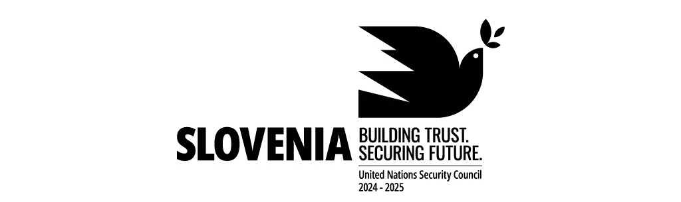
Thank you.

