 | 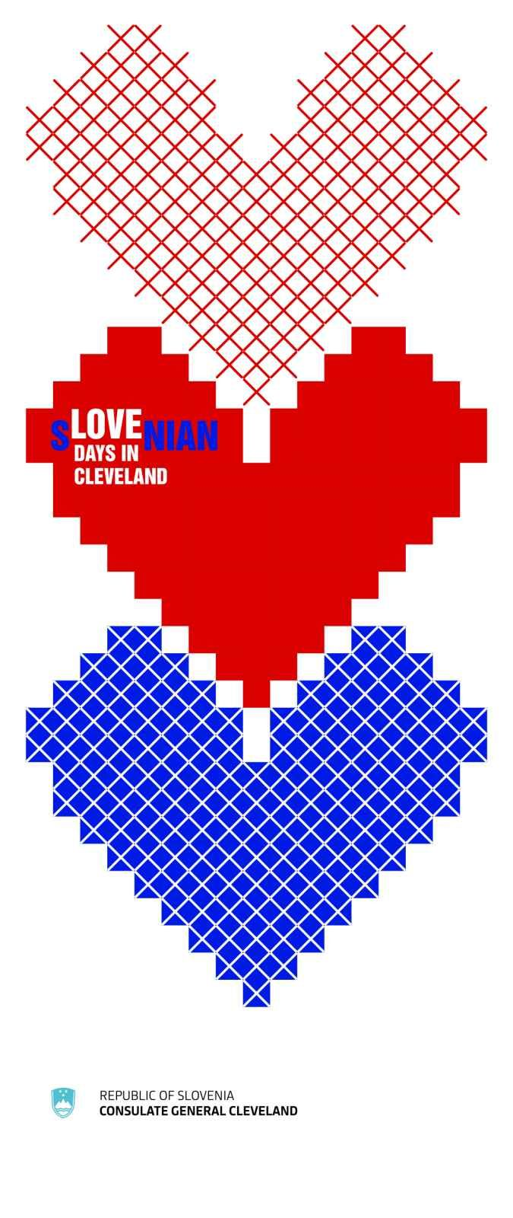 | Saturday - September 5  3:00 – 5:00 PM  Kres dance performance and picnic  Dancing by Slovenian folklore dance group Kres. Food, drinks, raffle and live music by the Aaron Dussing Band are waiting for you!  Admission: $5 for non-members at the gate  For more information go to:  https://slovenskapristava.org/Calendar  📍 Slovenska Pristava  1024 Brandt Road, Geneva, OH  _____________________________________  Saturday - September 12  4:00 – 10:00 PM  Vinska Trgatev/Wine Festival 2026  Gather for tasting of great Slovenian wines and bourbon. Great food and music by Patty C and the guys provided.  Admission: $5 for non-members at the gate  For more information go to:  https://slovenskapristava.org/Calendar  📍 Slovenska Pristava  1024 Brandt Road, Geneva, OH  ____________________________________  Sunday - September 20  3:00 – 7:00 PM  SNPJ Annual Grape Festival  Harvest parade starts at 2:45pm. Music by The Tony Fortuna Band. Admission: $8 pp, or free with costume or instrument.  https://www.snpjfarmkirtland.com/summer-schedule  📍 SNPJ Farm  10946 Heath Rd, Kirtland, OH  ________________________________  Friday - September 25  5:00 PM  Second Annual Beer Garden at SNH  Beer by Noble Beast Brewing, music by Fešta Band, and grilled Slovenian foods. Cheer on the Cleveland Bocce Club Tournament.  Admission: $5, free for SNH members  📍 Slovenian National Home  6417 Saint Clair Ave, Cleveland, OH | Sunday - September 6  1:00 – 6:00 PM  Slovenski festival at the Slovenian National Home Indy (NASH)  Enjoy Slovenian food, youthful dance troup Marela and polka band Max's Oberkrainer Express. Ride for Nash race starts at 11:00am.  For more information go to:  https://sloveniannationalhomeindy.com/  📍 Slovenian National Home Indy  2717 W. 10th Street, Indianapolis, IN 46222  ____________________________  Wednesday - September 16  5:30 PM  Culinary Class: Breskvice (peach cookies)  Learn to prepare delicious Slovenian dessert called "breskvice" during this culinary evening. Class is hands-on.  Admission: $20 pp  Registration required. More information at:  https://www.facebook.com/share/14oNT2HmNtv/  📍 Slovenian National Home, 6417 St. Clair Ave., Cleveland  ____________________________  Saturday - September 26  4:00 – 7:00 PM  St Clair Rifle & Hunting Club Annual Clambake  Clambake and Steak Dinner, along with Fešta Bend. Pre-sale tickets sold by club members only.  For more information go to: https://www.facebook.com/profile.php?id=100063654605947  📍 St.Clair Rifle & Hunting Club  6599 Ravenna Rd, Painsville, OH | Saturday - September 12  Noon – 8:00 PM  Annual Polka Hall of Fame Sausage Festival @ SNPJ Farm  Polka music, sausages, and dancing!  Vote for your favorite sausage.  Admission: $12 in advance, $15 at the gate  Information at:  https://www.snpjfarmkirtland.com/summer-schedule  📍 SNPJ Farm  10946 Heath Rd, Kirtland, OH  _________________________  Thursday - September 17  6:30 PM  Literary Evening Celebrating the 120th Anniversary of the Slovenian National Library in Cleveland  The Consulate General in Cleveland will host an evening celebrating and honoring the poetry and legacy of Srečko Kosovel for Slovenian literature and culture. Special guest Ms. Suzana Lep Šimenko, Minister for Slovenians Abroad of the Republic of Slovenia will join us.  Admission is free but registration is required.  👉 Email sloconsulate.cleveland@gov.si  📍 Slovenian National Home  6417 Saint Clair Ave, Cleveland, OH  ________________________________  Sunday – September 27  3:00 PM  The America 250 Celebration  Celebrate distinguished individuals from Slovenian community that left lasting legacy for future generations.  Free Admission. More information at: https://www.facebook.com/share/g/17tziBpFCd/  📍 Slovenian Cultural Garden  820 East Boulevard, Cleveland
______________________

For more details on these events, visit:
📘 Facebook: Slovenian Consulate General in Cleveland
📸 Instagram: Slovenian Consulate Cleveland
🌐 Website: www.cleveland.consulate.si

