Hitra analiza tveganja za glivo Choanephora cucurbitarum
(Express Pest Risk Analysis for Choanephora cucurbitarum)

Pripravila:
mag. Metka Žerjav in mag. Matej Knapič Kmetijski inštitut Slovenije
e-mail: metka.zerjav@kis.si

Predloge na Analizo tveganja so podali (24.4.2019): Strokovna skupina za analize tveganja na področju zdravja rastlin v sestavi: dr. Gregor Urek, dr. Sebastjan Radišek, dr. Barbara Piškur, dr. Irena Mavrič Pleško in dr. Tanja Dreo ter Anita Benko Beloglavec, mag. Erika Orešek, dr.
Alenka Zupančič (Uprava za varno hrano, veterinarstvo in varstvo rastlin).

Summary¹ of the Express Pest Risk Analysis for Choanephora cucurbitarum
PRA area: Slovenia
Describe the endangered area: The pathogen can establish and spread locally in all regions but South-east and central Slovenia are considered more endangered due to intensity of production of host plants (vegetables) and more suitable climate for disease spread
Main conclusions:
Likelihood of entry is high because many pathways are possible. There is a moderate uncertainty about pathways for entry because pathways cannot be ranged according to their importance. More research would be needed to find out if C. cucurbitarum is present on seeds of cucurbits and also which products imported from the countries where the disease is established could transfer this fungus.
Likelihood of establishment is high with moderate uncertainty because data about survival and reproduction of the organism at low temperatures were not included in the estimation.
The impact in the area of potential establishment was estimated as low due to characteristics of the climate in Slovenia. The periods during a growing season of susceptible crops when conditions for fungal development are favourable are usually short and only erratic appearance is expected. Variability of weather conditions and survival between seasons make impact uncertain. Phytosanitary measures to prevent entry or to limit the pathogen spread in the area are not feasible due to numerous pathways and saprophytic nature of C. cucurbitarum. In case that the pathogen would endanger the crops the fungicides use should be considered.

Phytosanitary Measures: No immediate action is needed
Phytosanitary risk for the endangered area (Individual ratings for likelihood of entry and establishment, and for magnitude of spread and impact are provided in the document) | High ☐ | Moderate ☐ | Low x
Level of uncertainty of assessment  (see Q 17 for the justification of the rating. Individual ratings of uncertainty of entry, establishment, spread and impact are provided in the document) | High ☐ | Moderate x | Low ☐
Other recommendations:
- A more detailed study of requirements which the fungus has to environmental conditions would improve the prediction of its further spread.
- There can be differences in pathogenicity in the populations of C. cucurbitarum. Investigation of pathogenicity to host plants cultivated in warmer areas of Europe and comparison of genetic structure of fungal isolates present in Europe with isolates from Asia and North America may give more precise information about the risk which this pathogen pose to plant production in Europe.
- Because the pathogen was already found in Slovenia a survey would give an answer about establishment and also about its impact. Better planning of control measures would be possible if such data would be available.

Express Pest Risk Analysis for (Fungi: Choanephoraceae)

Choanephora cucurbitarum

Prepared by: Metka Žerjav and Matej Knapič
Kmetijski Inštitut Slovenije (Agricultural Institute of Slovenia) metka.zerjav@kis.si, matej.knapic@kis.si

Date: August 2018

Stage 1. Initiation

Reason for performing the PRA: It was confirmed that blossom blight, abortion of young fruits and fruit rot of different varieties of squashes (Cucurbita pepo) in summer 2017 in Slovenia were caused by fungus Choanephora cucurbitarum. Choanephora fruit rot symptoms were observed in 2 fields and 4 gardens in August and September in 3 regions of Slovenia. Hosts affected were Cucurbita pepo var. cylindrica Paris, C. pepo L. subsp. pepo var. styriaca Greb. and C. moschata. This was the first detection of Choanephora cucurbitarum in Slovenia. The symptoms of disease appeared also in summer 2018.

The disease is more common in areas with warm and humid climates. It causes blight and rot of flowers and fruits of broad spectrum of cultivated plants, most often of those from Cucurbitacea family but hosts are also other economically important plants like pepper, eggplant, bean, okra etc.
The fungus is present in all continents with exception of New Zealand and according to Cabi (2018) Maine in U.S.A is the currently most northern collection place of C. cucurbitarum. There are no records of disease appearance for Europe in CABI database but a record was found that C. cucurbitarum appeared in Romania in 1979 where it caused damage on zucchini crop (Puşcaşu, 1984). Walker (1952) mentioned that necrosis of cotyledons of marrow seedlings (zucchini) had been reported in France. As no other records of C.cucurbitarum in Europe exist, it can be supposed that fungus is not yet widely spread in Europe or it appeared occasionally but did not cause damage on plants and therefore did not attract the attention of plant pathologists. Climate in most parts of Europe does not seem suitable for C cucurbitarum. The organism grows and multiplies the best at temperatures between 25 and 35˚C and high humidity as is typical for tropical areas. Changing climate with rising temperatures could enable the spread of the pathogen in shorter periods of a growing season at least in some regions of Europe, as was the case in Slovenia. In 2017 and 2018 yield losses appeared to be negligible but in special weather situations susceptible crops could be endangered.

PRA area: Slovenia

Stage 2. Pest risk assessment

Taxonomy:
Choanephora cucurbitarum (Berk. & Ravenel) Thaxt., Rhodora 5: 99 (1903) Choanephoraceae, Mucorales, Incertae sedis, Mucoromycetes, Zygomycota, Fungi Common name: Choanephora fruit rot
Synonymy:
Basionym: Rhopalomyces cucurbitarum Berk. & Ravenel, in Berkeley, Grevillea 3 (no. 27): 109 (1875)
Choanephora infundibulifera f. cucurbitarum (Berk. & Ravenel) Schipper
Other synonyms: Rhopalomyces elegans var. cucurbitarum (Berk. & Ravenel) Marchal, Revue mycol., Toulouse 15(no. 57): 11 (1893), Choanephorella cucurbitarum (Berk. & Ravenel) Vuill., Bull. Soc.

mycol. Fr. 20: 28 (1904), Mucor curtus Berk. & M.A. Curtis, in Berkeley, Grevillea 3(no. 28): 148 (1875), Mucor cucurbitarum Berk. & Ravenel, in Berkeley, N. Amer. Fung.: no. 701 (1875), Choanephora simsonii D.D. Cunn. [as 'simsoni'], Ann. R. bot. Gdn Calcutta 6: 169 (1895), Choanephora americana Möller, Bot. Mitt. Trop. 9: 18 (1901), Cunninghamella mandshurica Saito & H. Nagan., Bot. Mag., Tokyo 29: 285 (1915), Choanephora mandshurica (Saito & H. Nagan.) F.L. Tai, Sinensia, Shanghai 4: 219 (1934), Choanephoroidea cucurbitae I. Miyake & S. Ito, J. Tokyo Agric. Coll. 4: 31 (1935), Choanephora heterospora B.S. Mehrotra & M.D. Mehrotra, Mycologia 53(5): 467 (1962)
Position in classification:
Choanephoraceae, Mucorales, Incertae sedis, Mucoromycetes, Mucoromycotina, Zygomycota, Fungi

Pest overview
Fungus Choanephora cucurbitarum is saprophytic on plant tissues and a weak parasite of a broad range of plants. Most often senescing flower parts of susceptible plants are colonized by fungus. The germinating spores of the pathogen can penetrate directly into petals (McWhorter, 1978). Infected female flowers of Cucurbita pepo may remain attached to fruit and fungal mycelium grows into developing fruit and causes its abortion, wet or dry rot. Under humid conditions C. cucurbitarum can be recognized in the field by luxurious growth of sporangiophores which look like bristles with metallic luster and by black masses of spores (vesicles of sporangiola, sporangia). The fruits with wet rot decay rapidly in warm and humid weather but in drier and cooler environments they become brown and no fungal growth can be seen on the surface (Snowdon, 1991).

Only flowers and fruits can be infected in cucurbits but in pepper also immature tissues (buds, young leaves, very young fruits) are susceptible for direct infection and can become blighted (Blazques, 1986). Mechanical injuries of plants, often caused by insects, can be entry points for the fungus.

High relative humidity (80-100%), wet conditions of plant surfaces and high temperatures (25–35°C) favor fungal growth and sporulation. Time from infection to sporulation can be as short as 24 to 48 hours and many cycles with new infections are possible in a growing season which can cause built- up of inoculum and epidemic spread of disease. Spores are spread by wind, by splashing water, with help of insects or human. The fungus survives between growing seasons as a saprophyte on the decaying plant residues in the soil (McWhorter, 1978) or as zygospores. Zygospores are formed after pairing of compatible strains. They play an important role in the life cycle of Zygomycetes. They enable survival of fungus under adverse conditions and increase genetic variation of the population. Zygospores require a period of dormancy before they are able to sporulate. They have different modes of germination, either with sporangiophores which terminate with sporangia and release spores or with a branching germ tube (Yu & Ko, 1997).

Brief morphological description is summarized from A Monograph of the Choanephoraceae written by Kirk (1984), where more detailed morphological description can be found:
Colonies grow rapidly on potato-carrot agar at 25°C. They are at first white, later with areas of pale yellow. Aerial mycelium is abundant, non-septate. Sporangiophores arising from substrate mycelium or aerial hyphae bear two types of structures, sporangia or sporangiola.
The sporangia are solitary, variable in size, and may contain from one to many sporangiospores. Initially they are white but turning through yellow and pale brown to very dark brown at maturity. When mature they split along a single preformed meridional suture, usually into 2 segments. Sporangiospores are usually ellipsoid, more or less distinctly or indistinctly striate or sometimes apparently smooth. They usually possess a group of appendages at each pole, often up to twice the length of the spore.
Sporangiola are indehiscent, typically ellipsoid to broadly ellipsoid, containing one spore. They are aggregated in vesicles on a sporangiophore. Sporangial wall is normally not separable from the outer layer of the sporangiospore wall at maturity. Sporangiospores within sporangiola are broadly fusiform, ellipsoid (typically) to broadly ellipsoid, more or less distinctly longitudinally striate and hence giving the intact sporangiolum a striate appearance, remaining inside the wall of the sporangiolum at maturity.

Morphological characters of sporangia and sporangiola of C. cucurbitarum allow identification but their zygospores are indistinguishable from those of other members of Choanephoraceae (Kirk, 1984).

Is the pest a vector? Yes ☐ No ✓

- Is a vector needed for pest entry or spread? Yes ☐ No ✓

Regulatory status of the pest

Pest is not regulated in EU.
Based on data from New Zealand Fungi and Bacteria Database, C. cucurbitarum is not known to be present in New Zealand (NZFungi database, 2018). In Australia – New Zealand Bilateral Quarantine Arrangement Choanephora cucurbitarum was listed for pumpkins as a quarantine organism. Its presence on fruits was not permitted but treatments (where applicable) were allowed as corrective action (Department of Agriculture Biosecurity Plant Division, 2014).

Distribution
Table 1: Distribution and status of C. cucurbitarum

Continent | Distribution | Provide comments on the pest status in the different countries where it occurs | Reference
Africa | Benin, Nigeria | Widespread | CABI, 2018
 | Egypt, Ghana, Guinea, Kenya, Mauritius, Senegal, Seychelles, Sierra Leone, South Africa, Sudan, Zimbabwe | Present
 | Congo, Tanzania | Restricted distribution
North America | USA: Connecticut, Delaware, Georgia, Hawaii, Iowa, Present, Louisiana, Maine, Maryland, Massachusetts, Michigan, New Jersey, New York, Ohio, Oklahoma, Pennsylvania, Rhode Island, Texas, Virginia, West Virginia, Wisconsin | Present | CABI, 2018
 | USA: Florida, Mississippi, North Carolina, South Carolina | Widespread
Central America, Caribbean | Cuba, Jamaica, Panama, Puerto Rico, Trinidad and Tobago, United States Virgin Islands | Present | CABI, 2018
South America | Brazil, Colombia, Peru, Venezuela | Present | CABI, 2018
Asia | India | Present with restricted distribution in some states | CABI, 2018
 | Indonesia | Present, widespread on Java

Continent | Distribution | Provide comments on the pest status in the different countries where it occurs | Reference
 | Bangladesh, Brunei, Cambodia, China, Iraq, Republic of Korea, Malaysia, Oman, Thailand, Pakistan, Singapore, Sri Lanka, Taiwan, | Present
 | Japan | Present with restricted distribution on Hokkaido island
Europe | Romania |  | Puşcaşu, 1984
Oceania | Australia, Fiji, French Polynesia, New Caledonia, Papua New Guinea, Samoa, Solomon Islands, Tonga, Vanuatu | Present | CABI, 2018

Choanephora cucurbitarum is considered endemic in tropical and subtropical regions (McWhorter, 1978).

Host plants and their distribution in the PRA area

Table 2: Host plants of C. cucurbitarum in Slovenia

Host scientific name (common name) | Presence in PRA area (Yes/No) | Comments on importance in Slovenia* | Reference
Abelmoschus esculentus  (okra) | Yes | Minor crop, gardens | Plantwise Knowledge Bank, 2018
Amaranthus retroflexus  (redroot pigweed) | Yes | Widespread as a weed | Plantwise Knowledge Bank, 2018
Beta vulgaris var. saccharifera (sugarbeet) | Yes | Minor crop | Plantwise Knowledge Bank, 2018
Brassica oleracea var.  botrytis (cauliflower) | Yes | Minor crop | Plantwise Knowledge Bank, 2018
Brassica chinensis (Pak- Choi) | Yes | Minor crop | Pornsuriya et al.,2017
Capsicum (peppers) Capsicum annuum (bell pepper) and Capsicum frutescens (chilli) | Yes | Outdoor and greenhouse production | Plantwise Knowledge Bank, 2018
Citrullus lanatus  (watermelon) | Yes | Greenhouse and outdoor, minor crop | Plantwise Knowledge Bank, 2018
Cucumis sativus  (cucumber) | Yes | Greenhouse and outdoor | Plantwise Knowledge Bank, 2018
Cucurbitaceae (cucurbits)  Cucurbita pepo | Yes | - For oil production: outdoor, major crop, | Plantwise Knowledge Bank, 2018

Host scientific name (common name) | Presence in PRA area (Yes/No) | Comments on importance in Slovenia* | Reference
4.500 ha

- As vegetable (outdoor and indoor), minor crop
Glycine max (soyabean) | Yes | Major crop, 2.900 ha | Plantwise Knowledge  Bank, 2018
Ficus carica (fig) | Yes | Outdoor, locally, in the region with submediterranian climate | Plantwise Knowledge Bank, 2018
Ipomoea batatas (sweet potato) | Yes | Outdoor, minor crop | Plantwise Knowledge Bank, 2018
Phaseolus vulgaris  (common bean) | Yes | Outdoor, 600 ha | Plantwise Knowledge Bank, 2018
Pisum sativum (pea) | Yes | Outdoor , 700 ha | Plantwise Knowledge  Bank, 2018
Solanum melongena  (aubergine) | Yes | Greenhouse and outdoor, minor crop | Plantwise Knowledge Bank, 2018
Solanum tuberosum  (potato) | Yes | Outdoor, major crop,  3.200 ha | Plantwise Knowledge Bank, 2018
Sorghum bicolor  (sorghum) | Yes | Outdoor, minor crop | Plantwise Knowledge Bank, 2018
Spinacia oleracea  (spinach) | Yes | Outdoor, minor crop | Plantwise Knowledge Bank, 2018
Zea mays (maize) | Yes | Major crop, 66.300 ha | Plantwise Knowledge Bank, 2018
Vinca minor (common periwinkle) | Yes | Natural vegetation and ornamental | Plantwise Knowledge Bank, 2018
Ornamental plants
Dahlia pinnata (garden dahlia) | Yes | Minor crop |  | Plantwise Knowledge Bank,  2018
Euphorbia pulcherrima  (poinsettia) | Yes | Minor crop |  | Plantwise Knowledge Bank,  2018
Hosta plantaginea | Yes | Minor crop |  | Plantwise  Knowledge Bank, 2018
Phlox paniculata  (summer perennial phlox) | Yes | Minor crop |  | Plantwise  Knowledge Bank, 2018
Tagetes erecta (African marigold) | Yes | Minor crop |  | Plantwise Knowledge Bank,  2018
Zinnia | Yes | Minor crop |  | Plantwise

Host scientific name (common name) | Presence in PRA area (Yes/No) | Comments on importance in Slovenia* | Reference
Knowledge Bank,
2018
Petunia | Yes | Minor crop |  | Kwon et al, 2001;  Holcomb, 2003

* area of crop is from statistical data for 2016 or 2017

Other host species are not present in Slovenia, or very rarely and at minor areas:
Amaranthus cruentus (redshank), Amaranthus hybridus (smooth pigweed), Amaranthus viridis (slender amaranth), Cajanus cajan (pigeon pea), Gossypium (cotton), Crotalaria juncea (sunn hemp), Crotalaria spectabilis (showy rattlepod), Carica papaya (pawpaw), Catharanthus roseus (Madagascar periwinkle), Desmodium (tick clovers), Hibiscus rosa-sinensis (China-rose), Malvaviscus arboreus (wax mallow), Manihot esculenta (cassava), Piper nigrum (black pepper), Psidium guajava (guava), Oryza sativa (rice), Psophocarpus tetragonolobus (winged bean), Ricinus communis (castor bean), Sesamum indicum (sesame), Vigna (cowpea), Withania somnifera (poisonous gooseberry) (Plantwise Knowledge Bank, 2018) and Moringa oleifera (drumstick tree)(He et al, 2017)

Pathways for entry

Any host plants or their harvested crops, plant debris or soil originating from the area where the disease is endemic or present can harbour the pathogen. It is possible that C. cucurbitarum entered the PRA area already long time ago but remained undetected because climatic conditions did not support its multiplication.

No data about Choanephora as a seed-borne fungus of cucurbits were found but it is documented that seeds of okra can be infected or contaminated. Untreated okra seeds in a blotter test had 37% of seeds with Choanephora while in agar plate test, where seeds were surface disinfected with sodium hypochlorite, 17% were infected (Huang & Jamil, 1976). In similar study of seed-borne diseases of soybean in Malaysia
C. cucurbitarum was found at low percentage of seeds (0.5%) and only on seeds which were not surface disinfected. This indicates that seeds could be involved in disease spread. Similarly as Botrytis, which is often only a saprophyte or a weak pathogen but is frequently found on seeds, also Choanephora may be able to spread in this way without causing any visible symptoms of disease on germinating plants.
It is not known how C. cucurbitarum entered or enters Slovenia or when it happened. Table 3: Possible pathways of C. cucurbitarum entries
Possible pathways | Short description explaining why it is considered as a pathway | Pathway prohibited in the PRA area?  Yes/No | Pest already intercepted on the pathway?  Yes/No
Seeds of cucurbits and other host plants | Seeds for sowing of different crops, including genera Cucurbita and Capsicum for European market are multiplied in Asia (China, India) and possibility that they carry disease cannot be excluded. | No | No
Fruits or vegetables, pumpkin seeds for processing | Substantial quantities of Cucurbita pepo seeds for oil are imported to Europe from Asia, especially from China. Parts of pericarp attached to seeds may contain spores of the pathogen.  Disease symptoms on harvested fruits and vegetables develop fast after infection at favourable conditions. Infected fruits with symptoms would be discarded | Yes, for S. tuberosum, point 12, of Annex III of CD 2000/29/EC) | No

Possible pathways | Short description explaining why it is considered as a pathway | Pathway prohibited in the PRA area?  Yes/No | Pest already intercepted on the pathway?  Yes/No
 | before further distribution. Refrigerated commodity may be without visible symptoms.
Plants for planting with or without soil attached | C. cucurbitarum can be present on senescent parts of host plants. Zygospores can be present in soil and on plant debris mixed with soil | Yes, for some species or families (S. tuberosum, S. melongena, Capsicum – point 10, 13 of Annex III of CD 2000/29/EC) | No
Soil and growing medium |  | Yes, in point 14 of Annex III of CD 2000/29/EC

Rating of the likelihood of entry Low ☐ Moderate ☐ High ☑
Rating of uncertainty Low ☐ Moderate ☑ High ☐

- Likelihood of establishment outdoors in the PRA area

C. cucurbitarum was found and confirmed with laboratory analysis in Slovenia at six geographically separated locations in 2017. The symptoms were observed at even more places around the country in home gardens and commercial fields, on different hosts from Cucurbita. The disease reappeared on squashes also in the year 2018. Based on those facts it can be concluded that establishment of C. cucurbitarum on cucurbits outdoors most likely already happened. Taking in account its wide distribution it is less probable that it has been reintroduced every new season unless it is primarily distributed by seeds at high rate.

Host plants
Among host plants more susceptible to Choanephora different types of squash, cucumber, pepper, eggplant and beans are commercially grown in Slovenia. The area of pumpkin grown for oil production, belonging to C. pepo L. subsp. pepo var. styriaca Greb., has doubled in Slovenia in last 15 years and covered around 5000 ha in 2016. The majority of the fields are situated in north eastern region of Slovenia, partly at the edge of Pannonian basin. Production of squashes for oil is important in Austria and Hungary and known also in some other European countries. Commercial vegetable production (pepper, zucchini) is most intensive in South-eastern and central Slovenia.

Growing vegetables in home gardens and allotment gardens is a common practice in Slovenia in all of its regions. Many types of squash are grown as zucchini (Cucurbita pepo L. var. cylindrica Paris) which are most widespread. Beans can be found on almost every garden and in small fields for domestic consumption, while pepper and eggplant are not present in such extent in the gardens.

Maize, soybean and potato are also listed as hosts of C. cucurbitarum but no reliable reports about disease incidence or yield losses were found. More often soybean is mentioned as a host of a similar species Choanephora infundibulifera. Based on few records about the disease on these crops we concluded that Choanephora appeared as a pathogen only in extreme weather conditions which do not appear in our climate, therefore these crops are not considered as endangered in Slovenia.

Climate
Based on the biology of the fungus we estimated that establishment and spread of the pathogen in Slovenia would depend on climate and weather conditions in a particular year. It is also important that enough inoculum is available at the time of susceptible stage of plant growth that the disease can spread fast.

In many cases the conditions for. C. cucurbitarum growth and sporulation are described with general terms as high humidity, excessive rainfall, surface moisture, warm weather. Atmospheric conditions needed for the development and spread of C. cucurbitarum were described by Cunningham in 1878 as periods of high moisture in the air. He noticed that cloudless nights and heavy dew were the circumstances which stimulated spread of the disease while heavy rain or absence of dew slowed down its development (McWhorter, 1978).
Choudhary et al (2018) studied effect of temperature and humidity on mycelial growth in vitro. Maximum mycelial growth was observed at 100 and 90 % relative humidity with just slightly slower growth at 80 %. Growth was decreasing with lower humidity levels. Fungus grows at temperatures between 20°C and 40°C but maximum growth was observed between 25-35°C. It also sporulated efficiently at 80-100% relative humidity.
In a study of epidemiology of Choanephora twig blight of chili in India a temperature range between 28 to 30°C, 70-90% air humidity and 16 hours of surface moisture were the factors which enabled mycelial growth and spore germination (Das et al, 2017).

Blazquez (1986) had been observing disease symptoms on Capsicum annuum and Hibiscus coccineus in Florida for more years and found out that when the minimum daily temperatures were above 14.4 °C symptoms were widely distributed on both hosts but after the temperature dropped below 14.4 °C growth and sporulation stopped.

Wolf (1917) measured time needed for germination of spores on nutrient agar and in water. The germ tubes at temperatures close to optimal appeared within 2 hours and branching was visible on agar after 3 hours and a half. Sporagiophores with mature spores were observed after 24 to 48 hours.

Such optimal conditions never appear in our climate long enough but we saw that C. choanephora grew and sporulated on cucurbits in Slovenia anyway. We supposed that the development of a fungus on substratum (plants or senescent or dead plant parts) does not stop if temperature and moisture are not in the optimal range but only slow down. Also shorter periods of favorable conditions interrupted with less favorable, which are not lethal for the organism, can lead to multiplication and built up of fungal inoculum.

No precise data about the length of a period needed to complete reproduction cycle were found for suboptimal temperature and humidity. We used available data and selected minimum requirements for temperature and relative humidity which theoretically would enable growth and sporulation.

We checked how often we meet criteria of two scenarios in database of selected agrometeorological weather stations with following parameters:
- scenario 1 - days with at least 14 hours with temperature equal or higher than 14.5°C and at least 80 % relative humidity
- scenario 2 - days with at least 14 hours with temperature equal or higher than 16.5°C and at least 80 % relative humidity

We included the weather dataset of meteorological stations at 3 locations in 3 regions of Slovenia for the period of 6 years (2012-2017):
Jablje - Central Slovenia Šentjernej- South-east Slovenia Sebeborci – North east Slovenia

We calculated the number of days when these criteria were met. It is not known how much time would take from germination to sporulation at these minimal requirements. In this way we were not able to determine number of possible reproduction cycles in particular year and location but the obtained data indicate in which of selected regions the spread and establishment of the disease is more likely.

Table 4: Number of days in a year when at least 14 consecutive hours period has at least 80 % relative humidity (RH) and temperature not lower than 14.5°C or 16.5°C

 | Šentjernej |  | Jablje |  | Sebeborci
 | 14.5°C | 16.5°C | 14.5°C | 16.5°C | 14.5°C | 16.5°C
2017 | 10 | 3 | 22 | 7 | 4 | 2
2016 | 32 | 12 | 29 | 11 | 7 | 7
2015 | 27 | 10 | 28 | 12 | 7 | 3
2014 | 39 | 16 | 33 | 9 | 16 | 7
2013 | 12 | 2 | 15 | 0 | 4 | 0
2012 | 17 | 3 | 20 | 3 | 4 | 1

Table 5: Number of series of 2 or more consecutive days with temperature equal or higher than 14.5 °C and relative humidity of 80% or more

14.5°C | Šentjernej | Jablje | Sebeborci
2017 | 1 | 4 | 0
2016 | 7 | 7 | 1
2015 | 6 | 6 | 1
2014 | 8 | 7 | 3
2013 | 2 | 3 | 1
2012 | 3 | 5 | 1

The number of series was similar for Šentjernej and Jable location comparing 2014 and 2016.

Table 6: Number of 14 hours periods of scenario 2 and days with hours with maximal temperature of at least 25 °C

Year | Jablje | No. of days with Tmax above 25°C in the period of scenario 2
2017 | 7 | 5
2016 | 11 | 8
2015 | 13 | 4
2014 | 9 | 3
2013 | 0 | 0
2012 | 3 | 3

The periods of scenario 2 which have hours with the temperature above 25°C, which is optimal for the growth, did not appear every year or were really limited. However in the year 2016 the number of periods with hot temperatures was quite high.

In the summer months of 2014 to 2016 the number of the days (periods) with required values for disease development was high in Jablje and Šentjernej (table 4). We assume that such weather conditions which coincided with the time of cucurbits flowering caused an accumulation of fungal inoculum during these years and incidence of the disease has been increasing. As a consequence the C. cucurbitarum was already widespread in 2017 and therefore detected. This explanation is based on an assumption that fungus overwinters in Slovenia but there is no evidence yet to support it.
The number of the days with required values is similar for locations in Central Slovenia and South-east Slovenia but much smaller in the region North- east Slovenia where climate is dryer with app. 70% of precipitation comparing to other two regions.
In Slovenia short periods of weather conductive for development of fungus most likely enable its establishment but may not be sufficient to support epiphytotic spread of the disease.

Rating of the likelihood of establishment outdoors Low ☐ Moderate ☐ High ☑
Rating of uncertainty Low ☑ Moderate ☐ High ☐

Likelihood of establishment in protected conditions in the PRA area

Cucumber, pepper, aubergine and zucchini are vegetable crops commonly grown in greenhouses in Slovenia.
Kwon et al. (2001) found blossom blight of petunia caused by Choanephora cucurbitarum in greenhouse in Korea. Choanephora rot was observed also on Pak-Choi (Brassica chinensis) in greenhouse in Thailand
(Pornsuriya et al, 2017). Relative humidity and temperature values can be favourable for the fungus in greenhouses and it is possible that C.cucurbitarum can be established on crops grown in protected conditions. Leaf wetness is one of the factors which stimulate the spread of disease (Wolf, 1917) but formation of dew on plants in greenhouses is less intensive comparing to field grown plants and they are not exposed to rain, which could reduce the possibility of establishment of the pathogen in protected conditions.

Rating of the likelihood of establishment in protected conditions Low ☐ Moderate ☑ High ☐
Rating of uncertainty Low ☐ Moderate ☑ High ☐

Spread in the PRA area

Once introduced with plants, seeds, growing medium, soil or plant debris fungus can live as a saprophyte or in form of spores (zygospores). Because of different survival strategies the organism has ability to spread in many different ways. In the secondary cycles of disease development, where high quantities of monospored sporangiola are formed on plant tissues, wind is the principal agent in the dissemination of
C. cucurbitarum (Wolf, 1917; McWhorter, 1978). Similarly as pollen and spores of some other fungal species, spores of C. cucurbitarum are believed to be able to travel by air currents at long distances, but no report in literature was found confirming this hypothesis.

Pollinating insects and the insects feeding on plants can help dispersing spores. Bees, stripped and spotted cucumber beetles (Diabrotica vittata and D. punctata) were found to carry the spores (Wolf, 1917). Transfer with bees was later confirmed also by McWhorter (1978) by observing the sporangiola on their bodies and isolating the fungus. High proportion of bees was contaminated with spores. It is believed that also other pollinators can carry the spores. Diabrotica virgifera is a widespread pest of maize in Slovenia and is often found on cucurbits flowers in summer. It is very likely that this species can contribute to disease spread similarly as above mentioned beetles. The distance of spread caused by bees would be app. 4 to 5 km from the infection source and for other insects it depends on their mobility. The distances can be extended for few kilometres more in case of wind driven insects.

Humans can contribute to spread with transferring spores during field activities, either with machinery or by hands when weeding, harvesting etc.

As the host plants are present in most parts of PRA area the only limiting factor for a disease spread seem to be environmental conditions during flowering and fruit set stage. The pathogen can multiply in short cycles and rapid increase of inoculum is possible at optimal humidity and temperature. In case that inoculum from the previous year is high, there are more points with initial inoculum across PRA area at the beginning of growing season and a sensitive growth stage of a crop coincides with favourable weather conditions for sporulation, pest could spread widely within the area already in one growing season.

Rating of the magnitude of spread Low ☐ Moderate ☐ High ☑
Rating of uncertainty Low ☐ Moderate ☑ High ☐

Impact in the current area of distribution

Crop losses are highly variable between seasons and years. Many authors stressed that the appearance of symptoms, spread of disease and yield losses were connected with high temperature and humid conditions (Wolf, 1917; Blazques, 1986; Kwon & Jee, 2005; Kwon et al, 2001).
The symptoms on different hosts are similar: blossom blight, fruit rot, twig blight, leaf and stem blight of immature tissues.
Reports of Choanephora infected crops are numerous and there is no doubt about the impact it has on food production. In most cases only information about incidence of infected plants or their parts are given but data about yield losses or their estimations are rare. Economic impact varies across regions and depends primarily on climate of the region and crops grown. The disease is most often mentioned

on hosts from Cucurbitacea as fruit rot of squash, zucchini, watermelon, cucumber, etc., followed by
Capsicum crops. In Asia eggplant and okra are also frequently affected.

In susceptible crops, such as zucchini and squash one third of the flowers may be affected.
Losses of 50 % of zucchini fruits are said to be common in Samoa after wet weather. The disease is destructive but usually short-lived and from flowers which are formed later, when weather conditions changed to less favourable for the fungus, healthy fruits may develop (Cucurbit wet rot…, 2018).

Severe outbreaks of different varieties of green bean (Phaseolus vulgaris) and bell pepper (Capsicum annuum) were widespread in Florida, USA in 2002. Disease incidence on bean plants in four fields in Florida, USA was 40 to 100% and percentage of infected fruit ranged from less than 10 to 100% (Roberts & Urs, 2003).

In Korea a severe fruit soft rot on eggplant (Solanum melongena) was reported with infection rate of the diseased fruit about 2.6%. The fruits were infected through wounds and they rotted rapidly (Kwon & Jee, 2005).

Pod rot of cowpea (Vigna sinensis) caused by C. cucurbitarum appeared in the fields in Korea. The infected pods usually did not produced usable seeds. Infection rates of diseased pods were from 8,4% to
14.3 (Kwon et al, 2001).

Choanephora blight caused about 70% yield loss of quinoa (Chenopodium quinoa) in China. Disease symptoms initially appeared as water-soaked spots on the stem that turned into brown-to-dark brown lesions covering the whole stem. The infected tissues produced an abundance of sporangiophores bearing sporangiola (Sun et al., 2018).

Seed pod rot symptoms were observed recently on Moringa oleifera trees in Yunnan Province, China Infection resulted in rapid rotting of the whole pods, 10 to 50% of pods were infected(He et al, 2017).

When blossoms of pepper are infected by C. cucurbitarum they lose turgidity and drop prematurely. Excessive drop of flowers causes loss in early fruit set (Walker, 1952). The disease incidence estimated on pepper plants in three fields in Florida in 2001 was 35 to 40% with substantial fruit infection observed predominantly around the calyx (Roberts & Urs, 2003).

Observations of commercial pepper fields with Choanephora blight in southwest Florida in autumn showed that young plants were severely damaged and that the pathogen also caused seedling losses. During the three years of observations the highest estimated incidence of wet rot in individual fields ranged from 8% to 50%. At all seven locations under observation the disease appeared every year. The disease did not remain active for more than 15 days; with drop of temperature it stopped to spread (Blazques, 1986).

Crop losses in cowpea, potato and soybean in the Amazon basin in Peru varied with cultivar from moderate to total loss in most rainy part of season (Turkensteen, 1979, source Plantwise Knowledge Bank).

There are regions where economic impact can be high, as the case for example in some parts of India where eggplant and chilli are important commercial crops but often grown under conditions conductive for the disease. Symptoms of C. cucurbitarum infection on eggplant grown at foothills of Himalaya are present 7 months in a year, with 4 consecutive months with observed disease. In those 4 months average monthly relative humidity in the region is between 87 to 62%, minimal monthly temperatures between
25.7 to 12.1˚C and maximal between 33.4 to 27.3˚C (Pandey, 2010). India is the biggest producer of chilli in the world. Among five plant diseases considered as most important pathogens of chilli is also twig blight caused by C. cucurbitarum. Das et al (2017) described it as a devastating emerging pathogen in the region of West Bengal.

Hygiene measures and preventive agricultural practices cannot slow down disease epidemic in climate conductive to disease spread. In most cases producers use fungicides, including those based on

biological control agents. Preparations with compost and plant extracts were experimentally proven as partly efficient for disease control.

In regions where the disease is endemic ecological impacts can be of no concern but in regions where it was introduced and the climate was suitable for its invasive spread it could affect the native plant species. There were no documented evidences available about the damaging effect of the pathogen to ecosystems.

Rating of the magnitude of impact in the current area of distribution Low ☐ Moderate ☑ High ☐
Rating of uncertainty Low ☑ Moderate ☐ High ☐

Potential impact in the PRA area

Potential impact of C. cucurbitarum in Slovenia is expected to be smaller to that in tropical and subtropical climate where it is wide spread and active as a pathogen during longer periods of growing season. There an epidemic spread is possible due to continuously favourable conditions with high temperature and moisture.
Many host plants for which yield losses were reported in areas where disease is widespread are grown also in Slovenia. Most endangered species regarding susceptibility could be Cucurbita pepo (all varietas), Cucurbita moschata, Capsicum annuum, Solanum melongena. If also area under cultivation and economic importance of a crop is considered the impact may be higher for oil pumpkin, zucchini and pepper. Time of fruit set for oil pumpkin is not so long and when there are enough fruits on the plant they stop flowering or only few new flowers appear. Zucchini type squash and pepper are harvested continuously which stimulates formation of flower and young fruits. A control of disease with fungicide can be problematic for these crops because many applications would be needed to protect newly forming fruits and this would contribute to the impact.
The impact to yield loss in the field or after harvest is expected only in shorter warm and humid periods. In case that primary inoculum in spring is abundant and warm weather starts already in June the impact could increase. Variability of weather conditions and survival between seasons make impact uncertain.

Will impacts be largely the same as in the current area of distribution? No

Rating of the magnitude of impact in the area of potential establishment Low ☑ Moderate ☐ High ☐
Rating of uncertainty Low ☐ Moderate ☑ High ☐

Identification of the endangered area

Significant impact of pathogen establishment is expected in warmer and more humid parts of the country (South- eastern Slovenia, Central Slovenia) where it could affect vegetable production (pepper, zucchini). In the North-eastern region (Pomurje) fields sown with pumpkins for oil are concentrated and this area could be potentially most endangered but a study of weather data for last 6 years showed that conditions for disease development and spread are less favourable there due to less precipitations and lower humidity.

Overall assessment of risk

Likelihood of entry is high because many pathways are possible. There is a moderate uncertainty about pathways for entry because pathways cannot be ranged according to their importance. More research would be needed to find out if C. cucurbitarum is present on seeds of cucurbits and also which products, imported from the countries where the disease is established, could transfer this fungus.
Likelihood of establishment is high with moderate uncertainty because the data about survival and reproduction of the organism at low temperatures were not included in the estimation. The impact in the area of potential establishment was estimated as low due to characteristics of the climate in Slovenia.

The periods during a growing season of susceptible crops when conditions for fungal development are favourable are usually short and only erratic appearance is expected. Variability of weather conditions and survival between seasons make the impact estimation moderately uncertain. Phytosanitary measures to prevent entry or to limit the pathogen spread in the area are not feasible due to numerous pathways and saprophytic nature of C. cucurbitarum. In case that the pathogen would become damaging to crops use of fungicides should be considered.

Stage 3. Pest risk management

Phytosanitary measures

Because of the saprophytic nature of the fungus, its broad host range and possible presence on living plants, seeds, harvested crops and in soil, no measures to prevent entry seem feasible.
Eradication is not possible because when introduced the fungus can survive as a saprophyte or in form of spores in soil and has ability to spread in many different ways, including dispersal with wind.
At the place of production a spread of disease can be reduced with agricultural practices, especially those which reduce humidity as are low density of crops, avoidance of overhead irrigation, good drainage, weed control and ventilation in greenhouses. Fungicides may reduce spread of the disease. In Europe there are no fungicides yet registered to control C. cucurbitarum.

Uncertainty

It is uncertain whether disease will cause economically significant yield losses of cultivated plants and require strategies for its management. This could happen occasionally in years with extreme weather conditions but at long term it can locally even become a regular problem due to higher temperature and higher relative humidity as the result of climate changes. A detailed PRA is not needed but some more research, first of literature and then to obtain missing data about ecological adaptation of this species, especially regarding life cycle in cooler climate, its survival, pathways of entry with more attention to possibility of introducing new, more pathogenic strains. Because the pathogen was already found in the country a survey would give an answer if it became established and also about its impact. With these data planning of control measures would be possible in time.

Remarks

Due to the features of the pathogen (its polyphagous nature, survival as a saprophyte in soil and in plant debris, ability of natural distribution by air and insects), no phytosanitary measures to prevent the spread of the fungus are considered appropriate and potentially successful. In case of a yield loss of economically important crops in Slovenia (cucurbits, peppers, beans) use of fungicides should be considered as a control strategy. Some of the fungicides that are used to control other diseases of vegetables and oil pumpkins contain active ingredients which can slow down the spread of the pathogen. Testing the efficacy of fungicides already registered for use on pumpkins also against C. choanephora would give information needed to prepare strategy for disease control in case that it would become damaging. Resistant cultivars or plant hygiene measures are not considered as a solution for reducing the impact of the disease. C. cucurbitarum is an organism adapted to tropical and subtropical climate. No data were found about its reactions at low temperatures and it is not clear if it survives low winter temperatures in the open field in Slovenia or it has to be newly introduced in the areas with harsh winters. A more detailed study of requirements which the fungus has to environmental conditions would improve the prediction of its further spread in Slovenia and Europe. There can be differences in pathogenicity in the populations of C. cucurbitarum. Investigation of pathogenicity to host plants cultivated in warmer areas of Europe and comparison of genetic structure of fungal isolates present now in Europe with isolates in Asia and North America may give more information about the risk this pathogen pose to plant production in Europe.

REFERENCES

Blazquez CH (1986) Choanephora wet rot of pepper. Proc. Fla. State Hort. Soc. 99, 321-325.
Choudhary S, Ghasolia RP & Lakhran L (2018) Studies on physiological parameters of Choanephora cucurbitarum, the incitant of wet rot of cucumber. Journal of Pharmacognosy and Phytochemistry 7(3), 3227-3229.
Cucurbit wet rot: Pacific pests and pathogens fact sheets. http://www.pestnet.org/fact_sheets/cucurbit_wet_rot_144.htm (Accessed June 2018), (accessed May 2018).
Das S, Dutta S, Mondal B. (2017) Studies on variability,epidemiology and management of twig blight disease of chilli, caused by Choanephora cucurbitarum. Conference Paper: National symposium- Challenges and perspective in plant health management under climate change scenario, 23-24 November 2017, Kalyani, India, Indian Phytopathological Society (East Zone), Abstracts, 75-76.
He YY, Chen XQ, Huang MZ (2017) First report of seed pod rot of Moringa oleifera caused by Choanephora cucurbitarum in China, Plant Disease 101(10), 1824.
Holcomb GE (2003) First Report of Petunia Blight Caused by Choanephora cucurbitarum in the United States. Plant Disease 87(6), 751.
Huan TL & Jamil MM (1976) Seed-borne pathogens in okra fruit rot. MARDI Research Bulletin 3(2), 38-45. Kirk PM (1984) A Monograph of the Choanephoraceae. Mycol. Pap. 152, 61 p.
Kwon JH & Jee HJ (2005) Soft rot of eggplant (Solanum melongena) caused by Choanephora cucurbitarum in Korea. Mycobiology 33(3), 163-165.
Kwon JH, Kang SW, Kim JS & Park CS (2001) Occurrence of Blossom Blight of Petunia Caused by Choanephora cucurbitarum in Korea. Res. Plant Dis.7, 112-115.
Kwon JH, Shen SS & Park CS (2001) Pod rot of cowpea (Vigna sinensis) cCaused by Choanephora cucurbitarum. Plant Pathol. J. 17(6), 354-356.
McWhorter GA (1978) Studies on parasitism and ultrastructural development of Choanephora cucurbitarum. Disertation, University of Florida, 142 p.
Nik WZ (1980) Seed-borne fungi of soybean (Glycine max (L.) Merril) and their control. Pertanika 3(2), 125-132. NZFungi database (2018)
https://nzfungi2.landcareresearch.co.nz/default.aspx?NavControl=home (Accessed August 2018)
Pandey A (2010) Studies on fungal diseases of eggplant in relation to statistical analysis and making of a disease calendar. Recent Research in Science and Technology 2(9), 1-3
Pornsuriya C, Chairin T, Thaochan N & Sunpapao N (2017) Choanephora rot caused by Choanephora cucurbitarum on Brassica chinensis in Thailand. Australasian Plant Dis. Notes 12, 13.
Plantwise Knowledge Bank (2018) Technical Factsheet Choanephora fruit rot. https://www.plantwise.org/KnowledgeBank/Datasheet.aspx?dsid=13038
Puşcaşu A (1984) Producţia vegetală-Horticultura 33(7), 6-8.
Roberts PD & Urs RR (2003) Outbreak of Choanephora blight caused by Choanephora cucurbitarum on green bean and pepper in Florida. Plant Disease 87(9), 1149.
Sun SL, Zhu ZD, Zhang JL, Mei L (2018) Outbreak of Choanephora Stem Rot Caused by Choanephora cucurbitarum on Quinoa (Chenopodium quinoa) in China, Plant Disease.
https://doi.org/10.1094/PDIS-12-17-1922-PDN (accessed August 2018) Thaxter R (1903) A New England Choanephora. Rhodora, 5, 97-102.
Walker JC (1952) Diseases of Vegetable Crops, McGraw-Hill book Company, New York, 529p.
Wolf F (1917) A squash disease caused by Choanephora cucurbitarum. Journal of Agricultural research 3(9), 319- 327.
Yu MQ & Ko WH (2008) Factors Affecting Germination and the Mode of Germination of Zygospores of Choanephora cucurbitarum. Journal of Phytopathology 145, 357-361.
SI-Stat Database. http://www.stat.si/statweb (accessed August 2018).

Appendix 1. Relevant illustrative pictures (for information)

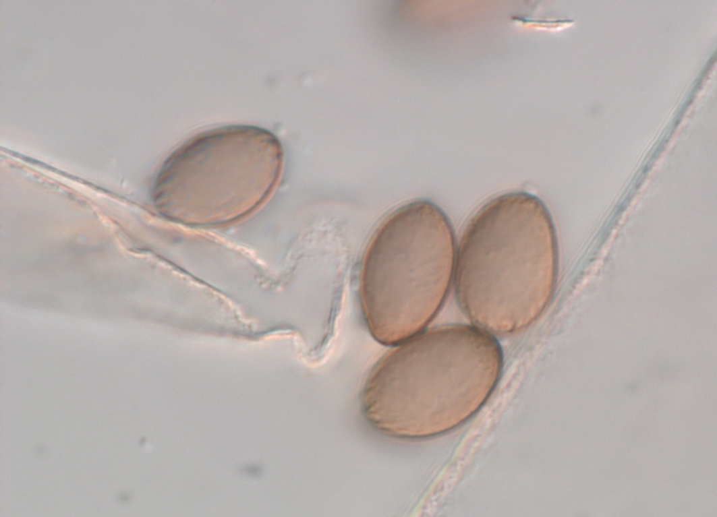
Photo 1: Striate spores in sporangiola
(Photo: Hans Josef Schroers)

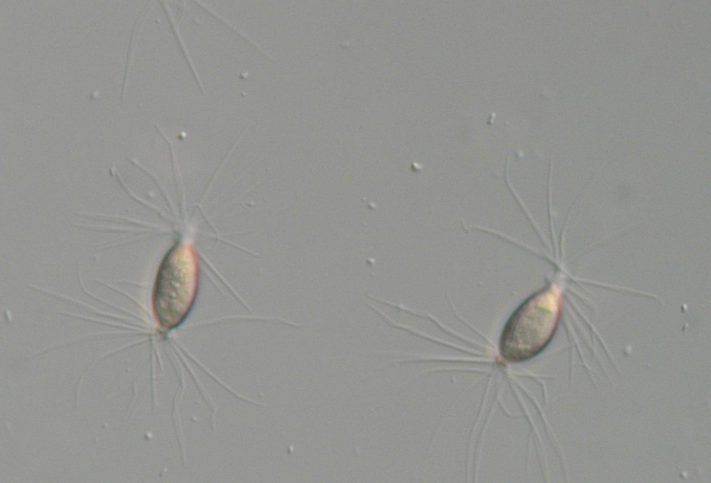
Photo 3: Microscopic images of spores from sporangia bearing groups of appendages at poles (Photo: Hans-Josef Schroers)

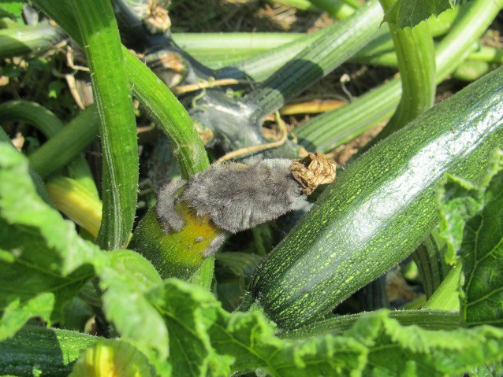
Photo 2: Symptoms caused by Choanephora cucurbitarum on young fruits of Cucurbita pepo var. cylindrica (Photo: Metka Žerjav)

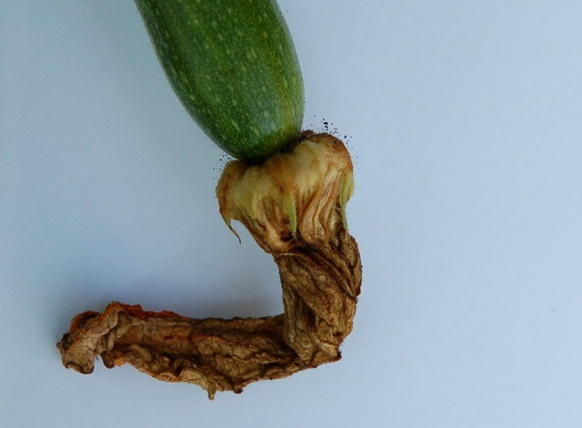
Photo 4: Sporulation of Choanephora cucurbitarum on flower of Cucurbita pepo var. cylindrica (Photo: Metka Žerjav)

