REPUBLIC OF SLOVENIA
MINISTRY OF AGRICULTURE, FORESTRY AND FOOD THE ADMINISTRATION OF THE REPUBLIC OF SLOVENIA FOR FOOD SAFETY, VETERINARY SECTOR
AND PLANT PROTECTION

PEST RISK ANALYSIS
for Citrus bark cracking viroid (CBCVd)

This PRA follows the EPPO Standard PM 5/5 Decision-Support Scheme for an Express Pest Risk Analysis. It was prepared on 24 April 2016 for PRA area Slovenia and extended on request of the EPPO Panel on Phytosanitary Measures (meeting in Paris, 2016-05-18/20) so that it is valid for the EPPO region with measures to prevent entry.

PRA area: EPPO region

Prepared by:
Dr. Sebastjan RADIŠEK Slovenian Institute of Hop Research and Brewing Plant Health Department, Diagnostic Laboratory Cesta Žalskega tabora 2,
SI-3310 Žalec, Slovenia

Date: 22 September 2016;

The PRA for Slovenia was upgraded to EPPO PRA area by Anita BENKO BELOGLAVEC, (Administration of the Republic of Slovenia for Food Safety, Veterinary Sector and Plant Protection, Dunajska 22, SI-1000 Ljubljana, Slovenia) and Dr. Sebastjan Radišek.

The review of and comments to PRA provided the following experts: Francois Petter, European and Mediterranean Plant Protection Organisation, Murriel Suffert, European and Mediterranean Plant Protection Organisation,
Expert Working Group for PRA in Slovenia (Dr. Gregor Urek, Dr. Ivan Žežlina, Dr. Irena Mavrič Pleško).

Cesta Žalskega tabora 2, SI-3310 Žalec, Slovenia
Phone: 03 71 21 600; Fax: 03 71 21 620; www.ihps.si; E-mail: tajnistvo@ihps.si
VAT ID No: (SI) 93987161, Registry No: 5051762000, Transaction Account No: 01100-6000006134

Summary of the Express Pest Risk Analysis for Citrus bark cracking viroid (CBCVd)

PRA area: EPPO

Describe the endangered area: CBCVd has the potential to establish throughout the EPPO region where host plants occur. On Citrus spp. and Poncirus trifoliata it causes only minor damage, usually in combination with other citrus viroids. On Humulus lupulus it causes severe disease symptoms and substantial economic loss. Endangered areas are hop growing areas in EPPO region.
Main conclusions:
Overall assessment of risk: The occurrence of CBCVd on hop presents an exemplary case of transmission of a less significant viroid on citruses to a new host, causing severe disease and high economic loss. The likelihood of entry is estimated as moderate because the import of citrus plants is prohibited in most EPPO countries. Fruits of citruses are a very suitable entry pathway, and there is trade.
Establishment is likely, where host plants are grown in the EPPO region, and CBCVd is already present in some citrus growing countries in the Mediterranean basin and in hop in Slovenia.
Risk of spreading of CBCVd into hop growing areas is evaluated as low, when good agronomic practice measures are implemented, as well as appropriate handling of organic (citrus fruit) waste. In case of non- compliance with these measures in hop growing areas, the risk may increase. There is limited trade in hop plants for planting between countries.
Hop growing areas are not interfering with citrus growing areas. There is a low possibility for spreading of CBCVd from citrus growing areas to hop growing areas.
In case of transmission to hop, local rapid spread of CBCVd is possible through intensive and specific hop cultivation that provides ideal conditions for mechanic transmission at the time of vegetation.

The EWG considered that potential impact in the absence of phytosanitary measures for hop would be high.
Phytosanitary risk for the endangered area | High ☐ | Moderate ☑ | Low ☐
Level of uncertainty of assessment | High ☐ | Moderate ☐ | Low ☑
Other recommendations:
- Proposal of CBCVd as a new quarantine organism
- Notification of all hop growing countries and interested public
- Conducting additional research

Stage 1. Initiation

Reason for performing the PRA:
In 2007, in the region of Šempeter in the Savinja Valley, an outbreak of an unknown and aggressive disease was detected, which caused stunted growth of hop plants with a rapid spreading dynamics. In 2011, following an extensive laboratory investigation, the presence of Hop stunt viroid (HSVd) (Radisek et al., 2012) was detected in the affected plants, and is described as the causative agent of hop stunt disease (Sasaki and Shikata, 1977). Based on the confirmed presence of HSVd and the risk of spread and of major economic loss, the Decision on emergency measures against the introduction and spread of hop stunt viroid (UL RS 64/2011, 12.08.2011) was adopted in 2011 by the Phytosanitary Administration of the Republic of Slovenia (PARS), including official measures for the prevention of hop stunt disease.
On account of specific characteristics of hop stunt disease in Slovenia, including a shorter incubation period (4 months) (Jakše et al., 2014), as compared to what had been described before (3 to 5 years) (Eastwell and Sano, 2009; Sano, 2003), a higher level of aggressiveness and unreliable detection of HSVd, limited to hop cones, additional diagnostic analyses were conducted using the NGS (Next Generation Sequencing) analysis. The NGS analysis of symptomatic plants revealed the presence of Citrus bark cracking viroid (CBCVd) which, up to this finding, had been described as a mild pathogen on citruses. The presence of CBCVd was confirmed by RT-PCR in all outbreaks in Slovenia, and pathogenicity tests using a biolistic inoculation technique demonstrated the high aggressiveness and infectivity of CBCVd on hop (Jakše et al., 2014). At the same time, in 2014, within the same research project, it was confirmed that the main agent of the new disease in Slovenia was CBCVd, whilst HSVd most probably due to the antagonist relationship to CBCVd was inactive in the infected plants or could no longer be detected (Jakše et al., 2014). The new disease on hop caused by CBCVd was called the "severe hop stunt disease” as it resembles the symptoms described for HSVd (Jakše et al., 2014). To date, CBCVd has been described as a viroid of minor economic impact on citruses, and is present only in certain citrus producing countries or regions (Table 1; Chapter 6). Hop is a new host for CBCVd, where it causes severe disease symptoms and dieback. At the same time, CBCVd is occurring in a completely new environment outside the citrus growing geographic areas.

PRA area: EPPO region

Stage 2. Pest risk assessment

- Taxonomy:

Citrus bark cracking viroid (CBCVd):
Kingdom: Viruses and viroids; Class: Viroids; Family: Pospiviroidae; Genus: Cocadviroid

Other scientific names:
  - Citrus viroid IV
  - Citrus bark cracking cocadviroid
English identification: CBCVd; EPPO code: CBCBD0 Sources of taxonomic classification:
  - International Committee on Taxonomy of Viruses; http://www.ictvonline.org/
  - The National Center for Biotechnology Information (NCBI) http://www.ncbi.nlm.nih.gov/
  - EPPO PQR http://www.eppo.int/DATABASES/pqr/pqr.htm

Pest overview
CBCVd is one of the less studied viroids. It was mentioned for the first time in 1988 in conjunction with the citrus exocortis disease investigation in samples from California and was then called the Citrus viroid IV (CVd-IV) (Duran-Vila et al., 1988). The first complete nucleotide sequence of CBCVd was published three years later, within the research of dwarfed grapefruit trees from Israel (Puchta et al., 1991). CBCVd consists of a circular RNA molecule, sized between 283 and 286 bp (NCBI GenBank). Following the initial detection, CBCVd was confirmed as pathogen to most plant species in the Citrus genus and to certain related plants in the Rutaceae family. Artificial infections showed that CBCVd could infect also cucumbers, tomatoes, eggplants and certain ornamental plants (Table 2) (Semanchik and Vidalakis, 2005). Since CBCVd is the only viroid directly linked to bark cracking on trifoliate orange tree (Poncirus trifoliata) (Vernière et al., 2004), it was in 2005 renamed from CVd-IV into the Citrus bark cracking viroid (CBCVd). Taxonomically, CBCVd belongs to the genus Cocadviroid, which means the same genus as that of the Hop latent viroid (HLVd), though, in certain characteristics, it is similar also to the viroids of the genus Pospiviroid (Semanchik and Vidalakis, 2005). CBCVd is present in certain citrus growing countries, occurring particularly in mixed infections with other citrus infecting viroids (Vernière et al., 2004; 2006). In literature it may be found as one of the viroids commercially used in reducing the size of citrus trees (Bar Joseph, 1993). Detection of CBCVd on hop means identifying it on a completely new and highly susceptible host plant and, at the same time, it occured in a completely new area.

Signs of the Severe Viroid Hop Stunt Disease
In vegetation, the first signs of disease on hop may be noticed in the beginning of June (BBCH scale 35-40). Infected plants normally begin to sprout in spring, and in the beginning of June, their stunted growth may already be noticed. Later, during the continued vegetation, the occurrence of disease symptoms intensifies, with a distinctive shortening of internodes of the main bines and of the lateral branches. As the hook-hairs on the bines do not develop to a sufficient extent, the infected plants decline from the support and their climbing upwards is disturbed.
In most cases, the infected plants fail to reach the level of the trellis, and certain varieties begin to blossom even up to 10 days prior to the uninfected plants. The leaves remain smaller and blistery in appearance, and in certain varieties, they turn yellowish with down curling edges. The cones are distinctly smaller and lighter, with fewer lupulin glands developed, and of abnormal growth in the extremely affected plants. The disease severely affects also the roots of the plant, with dry rot developing and ending up in a complete dieback of the entire root system. The signs of disease caused by CBCVd are similar to the HSVd-infection as regards the affectedness of individual tissues. A considerable difference is in the incubation period as, at HSVd hop infection, the first signs of disease may be expected 3 to 5 years after infection (Eastwell and Sano, 2009; Sano, 2003), whilst at CBCVd infection, the first signs of disease show between 4 months and 1 year after infection (Jakse et al., 2014). Likewise, the development of disease in the case of CBCVd is much faster, as the plants die off completely between 3 and 5 years after infection, whilst the HSVd-infected plants survive for 10 and more years (Eastwell and Sano, 2009; Radisek et al., 2012; Sano, 2003). For its high aggressiveness, the new disease caused by CBCVd on hops has been called the severe hop stunt disease (Jakse et al., 2014). Characteristic symptoms of severe hop stunt disease are presented visually in Annex 1.

Diagnostic analyses of CBCVd
In viroid detection, different methods are used, including the biological testing, molecular hybridisation, polyacrylamide gel electrophoresis (PAGE), reverse transcription polymerase chain reaction (RT-PCR), RT-PCR for the simultaneous detection of viroids (mRT-PCR), RT-PCR linked with hybridisation, reverse transcription loop-mediated isothermal amplification (RT- LAMP) and the quantitative real time RT-PCR (RT-qPCR). Within the recent decade, the routine viroid diagnostics most frequently applies the RT-PCR using the viroid-specific oligonucleotide primers. For the RT-PCR detection of CBCVd on hop and other plants, most appropriate are the PCR primers developed by Bernard and Duran-Vila, 2006. A most significant part of diagnostic analysis that may impact the detection is also the RNA extraction from the infected plant tissue. The use of commercially available plant RNA isolation kits is advisable.

Is the pest a vector? Yes ☐ No X

CBCVd and other viroids are not vectors of other organisms.

Is a vector needed for pest entry or spread? Yes ☐ No X

CBCVd has no known vectors. It is transmitted by contact or mechanically from infected plants and infected plant residues.

Regulatory status of the pest

CBCVd is not listed as a harmful organism (pest) in Council Directive 2000/29/EC. It is listed in the EPPO Alert list.

CBCVd is regulated within the Slovenian legislation:
- Decision on emergency measures against the introduction and spread of viroid hop stunt diseases (UL RS, 21/2015, 17.03.2015).
- Rules on the marketing of hop propagating material and of hop plants (UL RS, 45/2013, 24/2015).

Distribution

CBCVd belongs to a group of viroids occurring only on citruses grown commercially or present in the environment. It is a poorly studied and less prevalent viroid of the group, estimated to have been present only in certain citrus growing countries (Duran-Villa and Semanchik, 2003; Semanchik and Vidalakis, 2005).
Presence of CBCVd on hop has been confirmed only in Slovenia (Jakše et al., 2014). In 2015, the presence of CBCVd was confirmed in 13 hop farms of a total of 120 Slovenian hop growing agricultural holdings (production units). In total, the presence of CBCVd was confirmed on 61.5 hectares, taking into account that a hop garden is declared as infected on detection of at least one
(1) infected plant. In 2015, a total of 2,629 infected plants (plants showing visual disease symptoms) were identified in the infected hop gardens and, taking into account the average number of plants per hectare of a hop growing area (3000), this means a 1 % level of infection. CBCVd infections are mostly limited to individual parts of hop gardens, where the infection level may exceed 50 % of plants, with 20 % annual level of progression (Source: Reports of the systematic monitoring of hop stunt viroid in Slovenia in the period 2011 − 2015).

Table 1: Data on global presence of CBCVd

Continent | Distribution | Status/host plants | Reference
Africa | South Africa | Present – Citrus spp | Cook et al., 2012
 | Tunisia | Present – Citrus spp | Najar A., Duran-Vila N., 2004
 | Sudan | Present – Citrus spp | Mohamed M.E., 2009
Americas | USA, California | Present – Citrus spp | Duran-Vila et al., 1988
 | USA, Texas | Present – Citrus spp | Kunta et al., 2007
Asia and Middle East | Israel | Present – Citrus spp | Puchta et al., 1991
 | China | Present – Citrus spp | Cao et al., 2010
 | Japan | Present – Citrus spp | Ito et al., 2002
 | Turkey | Present – Citrus spp | Önelge et al., 2000
 | Iran | Present – Citrus spp | Hashemian et al., 2013
Europe | Italy | Present – Citrus spp | Malfitano M., et al., 2005
 | Greece | Present – Citrus spp | Wang et al., 2013
 | Slovenia | Locally present, under eradication  Severe outbreaks on hop (Humulus lupulus) | Jakše et al., 2014

Host plants and their distribution in the PRA area

In crops and in the environment, CBCVd may be found on plants of the genus Citrus only, and on trifoliate orange (Poncirus trifoliata), which is used as rootstock for citrus grafting.
CBCVd on hop has been confirmed in Slovenia only, causing severe disease symptoms on infected plants (Jakše et al., 2014). Based on laboratory tests, CBCVd may infect even more hosts, and therefore, additional systematic research should be performed in the future (Duran-Villa and Semanchik, 2003). Artificial inoculation research has shown that CBCVd may infect certain other plants, including cumquats, limes, tomatoes, eggplants, chrysanthemums and cucumbers, however, without developing any symptoms (Duran-Villa and Semanchik, 2003; Semanchik and Vidalakis, 2005).

Table 2: Host plants of Citrus bark cracking viroid (CBCVd)
Main hosts (presence in crops and in the environment):

- Citruses (Citrus spp.; Poncirus trifoliata)
- Hop (Humulus lupulus), confirmed presence in 2014

Experimental hosts (Artificial inoculations):

Citrus related plants of the Rutaceae family:
- Cumquats (Fortunella margarita; F. crassifolia; F. obovata)
- Limes (Microcitrus warburgiana; M. australis x M. australasica)
- Pleiosperum sp.
- Severinia buxifolia

Other plants
- Cucumbers (Cucumis sativus)
- Winter melons (Benincasa hispida)
- Tomatoes (Solanum lycopersicum)
- Eggplants (Solanum melongena)
- Chrysanthemums (Chrysanthemum morifolium)
- Gynura (Gynura aurantica)
- Datura (Datura stramonium)
- Bittersweet nightshade (Solanum dulcamara)

In Slovenia, the presence of CBCVd has been confirmed on hop only. Pest risk analysis of the spread to other hosts (permanent crops etc.) has to date not been feasible on account of the lack of data. In 2014, RT-PCR analyses were conducted on samples of 15 weed plant species taken from infected hop gardens, which did not show the presence of this viroid in any of the plants (Table 3). Additionally, host specificity testing of 20 weed and 13 cultural plant species by using artificial inoculations and RT-PCR testing revealed a bittersweet nightshade (Solanum dulcamara) as a weed plant which could host CBCVd (Table 4) (Source: Research project, Republic of Slovenia, No. CRP V4-1405).

Table 3: Weed species sampled in CBCVd-infected hop gardens and tested by RT-PCR.
English name (latin name) | English name (latin name)
Common pigweed (Chenopodium album) | Adam’s plaster (Polygonum persicaria)
Potato weed (Galinsoga parviflora) | Common shepherd’s purse (Capsella bursa-pastoris)
Creeping bluegrass (Poa annua) | Common sow thistle (Sonchus oleraceus)
Barnyard grass (Echinochloa crus-galli) | Corn/Creeping thistle (Cirsium arvense)
Common amaranth (Amaranthus retroflexus) | Common starwort (Stellaria media)
Green purslane (Portulaca oleracea) | Bluntleaf dock (Rumex obtusifolius)
Hairy crabgrass (Digitaria sanguinalis) | Creeping sow thistle (Sonchus arvensis)
Oilseed rape (Brassica napus)

Table 4: Plant species included in CBCVd host specificity study by using artificial inoculations.

Weed species | CBCVd  host (+/-) | Cultural plants | CBCVd  host (+/-)
Corn/Creeping thistle (Cirsium arvense) | - | Apricot tree (Prunus armeniaca) | -
Common pigweed (Chenopodium album) | - | Peach tree (Prunus persica) | -
Common amaranth (Amaranthus retroflexus) | - | Plum tree (Prunus domestica) | -
Potato weed (Galinsoga parviflora) | - | Pear tree (Pyrus communis) | -
Bluntleaf dock (Rumex obtusifolius) | - | Apple tree (Malus domestica) | -
Couch grass (Agropyron repens) | - | Eggplant (Solanum melongena) | -
Barnyard grass (Echinochloa crus-galli) | - | Raspberry (Rubus idaeus) | -
Scentless chamomile (Anthemis arvensis) | - | Tomato (Solanum lycopersicum) | +
Field bindweed (Convolvulus arvensis) | - | Cucumber (Cucumis sativus) | +
Common nettle (Urtica diotica) | - | Potato (Solanum tuberosum) | -
Common shepherd’s purse  (Capsella bursa-pastoris) | - | Hemp (Cannabis sativa) | -
Common starwort (Stellaria media) | - | Common bean (Phaseulus vulgaris) | -
Adam’s plaster (Polygonum persicaria) | - | Grapevine (Vitis vinifera) | -
Spotted dead-nettle (Lamium maculatum) | -
Creeping buttercup (Ranunculus repens) | -
Hairy nightshade (Solanum villosum) | -
Bittersweet nightshade (Solanum dulcamara) | +
Common ragweed (Ambrosia artemisiifolia) | -
Common comfrey (Symphytum officinale) | -
Horseradish (Armoracia rusticana) | -

Distribution of main hosts in the EPPO region:

Hop: In 2015, 28.595 hectares of hop gardens were grown in 14 EPPO countries (Table 5, Chapter 14) (Source: International Hop Growers Convention; IHGC-Economic Commission Summary Reports, http://www.hmelj-giz.si/ihgc/). Hop production in the EPPO region is limited to Central European regions, in particular areas, where hop is grown traditionally for decades or even centuries.

Apart from hop farms growing commercial hop varieties and only female plants, hop as a plant may be found in natural habitats as wild hops (male and female plants) in all hop growing regions and in many other countries of the Northern Hemisphere (Annex 2: Distribution map of wild Humulus lupulus).

Citruses: According to Eurostat (http://ec.europa.eu/eurostat), citruses were commercially grown in nine (9) European countries, on a total of 401,590 hectares in 2013. Production is limited to the Mediterranean EU countries, with Spain, Italy, Greece, Portugal, Cyprus, France and Croatia as major producers. Citruses are widely planted also in the other EPPO Mediterranean countries.

Pathways for entry

Background information: fruits as suspected pathway for entry of CBCVd on hop in Slovenia

It is suspected that CBCVd transmission to hops in Slovenia is most probably a result of mechanic transmission from citrus fruit waste in the past. Such hypothesis is corroborated by the fact that hop garden with primary outbreak was established on one part of an extensive (illegal) refuse dump of household waste and other waste (from fruit distribution centre). Recent experimental transmission trials confirmed that CBCVd infected citrus fruits could infect hop through the leaves using citrus peel sap inoculum and through the roots if the hop plants are planted in a mixture of soil and citrus peel (Source: Annual Report of Plant Health Programs in Slovenia for IHPS in 2016).

Pathways

Plants for planting
All parts of plants for planting could be systemically infected with CBCVd. There is no information on the possible transmission of CBCVd through seeds. Import of plants for planting of Citrus spp. and Poncirus trifoliata to EPPO region is prohibited in most EPPO countries. Trade in plants for planting of Citrus spp. and Poncirus trifoliate exists inside EPPO countries as ornamental plants (most EPPO countries) or as plants for commercial production of fruits (Citrus production countries).
There are no data on import of plants for planting of Humulus lupulus in the EPPO region. Trade in hop plants for planting is currently considered to be limited because of production of local varieties.

Parts of host plants (including fruits)
Plants are systemically infected with CBCVd. Import of plants of Citrus spp. and Poncirus trifoliata is prohibited in most EPPO countries, other than fruit and seeds. CBCVd and other citrus infecting viroids, were up to 2011 restricted to some citrus growing areas. However, as suspected in Slovenia, introduction into areas, where there is no production of citrus fruit and where hop is grown, is possible by way of import of citrus fruits. A research study covering the main foodstuffs- selling shopping centres in Slovenia identified the presence of CBCVd in 10% of sampled citrus fruits imported/traded from Israel, Greece and Cyprus, in 10 % of samples taken. However, it should be noted that the risk of transmission of CBCVd from other areas to hops is low, when

good agronomic practices are implemented and organic waste is handled appropriately. The risk may increase if such measures are not implemented (e.g. if citrus waste is dumped in hop growing areas).
CBCVd can survive in fresh hop cones for a certain period of time; upon thermal treatment in brewing process, the cones do not pose a risk anymore. No data exist on CBCVd survival on dried hop cones, but they are not considered as a pathway as they are thermally treated immediately after harvesting and processed in brewing or pharmaceutical industry in the country of destination.

Following hop harvesting, there remain substantial quantities of plant debris, which are locally composted, buried into the soil, or processed in biogas power plants. At present, there exists no trade in such plant material.

Transmission via machinery, tools and persons
Viroids are transmitted mainly mechanically, by infected plant sap that accumulates on machinery, tools, clothing and footwear during the different agro-technical activities. CBCVd on machinery cannot survive transport by ship. Transmission via tools, clothing and footwear is unlikely.

Possible pathways  (in order of importance) | Short description explaining why it is considered as a pathway | Pathway prohibited in the PRA area?  Yes/No | Pest already intercepted on the pathway? Yes/No
Plants for planting | Plants for planting may be asymptomatic. | Yes (Citrus, Poncirus) | No
Citrus fruits | Infested fruits may come into contact with host plants if discarded in their vicinity. | No | No
Machinery and tools | Infected plant remnants, inoculum | No | No
Persons (footwear, clothing) | Infected plant remnants, inoculum | No | No

Rating of the likelihood of entry Low ☐ Moderate ☑ High ☐
Rating of uncertainty Low ☐ Moderate ☑ High ☐

Likelihood of establishment outdoors in the PRA area

Similar to other viroids, CBCVd may survive in infected host plants or for a limited period of time on parts of infected plants (remnants).

Citruses are widely planted in the Mediterranean parts of the region. CBCVd is present in several EPPO countries, where citruses are grown, and it has been present in hop in Slovenia for several years, which proves that it can establish on hop within an EPPO region. Biological functions of pospiviroids are highly integrated with those of their host plants and there is no indication that their requirements in terms of environment are substantially different from those of their host plants. CBCVd can establish in EPPO, wherever hosts plants are grown.

Rating of the likelihood of establishment outdoors Low ☐ Moderate ☐ High ☑
Rating of uncertainty Low ☑ Moderate ☐ High ☐

Likelihood of establishment in protected conditions in the PRA area

The risk of establishment of CBCVd on host plants in protected conditions is high. Hop plants intended for propagation of high categories in certification scheme (certification level A) are grown in greenhouses.

Rating of the likelihood of establishment in protected conditions Low ☐ Moderate☐ High☑
Rating of uncertainty Low ☑ Moderate ☐ High ☐

Spread in the PRA area

Human assisted spread with plants for planting and fruits over long distances:
CBCVd belongs to viroids, which are restricted to certain citrus growing areas in EPPO region and to hop in Slovenia. Possibility of spreading of CBCVd with citrus fruits and ornamental citrus plants for planting into areas where hop is grown is low. Notwithstanding the extensive trade of citrus fruits, which may be CBCVd infected, this factor does not impact its spread into hop growing areas, as household waste does not end up in plantations. In EPPO countries, citrus plants are commercially grown in different production sites, than hop.

Trade in plants for planting is currently considered to be limited between countries in the EPPO region because of restriction on trade in plants for planting of Citrus spp. and Poncirus trifoliata and production of local hop varieties. However, this may change in the future. There are no data on trade in hop plants for planting within the EPPO region or outside the EPPO region.

Human assisted spread over short distances:
Plants propagated from already infected plants begin to express the symptoms already in the first year upon planting, or already in June or in August. Incubation period in case of CBCVd takes up to one year (4 months - up to 1 year). During the incubation period, plants do not develop visual symptoms, though being infective, and may spread infection within the hop garden. In hop gardens, the disease may be transmitted mainly mechanically, by infected plant sap that accumulates on machinery and tools during the different agro-technical activities. The spread between hop gardens of a farm and between farms, which is most damaging to the plants, is most intensive at the time of cutting and other spring operations, including the training of offshoots and harvesting. Disease progression in a hop garden at annual level ranges up to 20 % of plants (Jakše et al., 2014). As regards the spread, one should point out the high density of hop gardens in all the EU hop growing areas, which are property-wise highly intertwined and thus increasing the risk of spread of disease between farms.
Significant sources of spread are the infected plant remnants, in which CBCVd may survive all until the tissues are fully decomposed. Thus, moving fresh hop waste from an infected hop garden to uninfected hop gardens may contribute to spreading CBCVd.
In hop, CBCVd causes also the dry rot of the root system, which means that the lignified parts of the bines during the autumnal/winter plantation treatment (e.g. during harrowing) become detached more easily and may be transferred to another, uninfected part of the plantation.

According to analyses conducted to date, the pollen, seeds and weeds play no relevant role in the preservation and spread of CBCVd.

Hop plants for planting are not traded in large quantities between EPPO member states due to the use of local varieties. For this reason, the magnitude of spread could be low for the EPPO region. At local level, the magnitude of spread is high.

Natural spread is low (with low uncertainty) due to mechanical transmission of CBCVd.

Rating of the magnitude of spread for citrus growing areas Low ☐ Moderate ☑ High ☐
Rating of uncertainty Low ☐ Moderate ☑ High ☐

Rating of the magnitude of spread for hop growing areas Low ☑ Moderate ☐ High ☐
Rating of uncertainty Low ☐ Moderate ☑ High ☐

Rating of the magnitude of spread for hop on a local level Low ☐ Moderate ☐ High ☑
Rating of uncertainty Low ☑ Moderate ☐ High ☐

Impact in the current area of distribution

In citrus growing countries, CBCVd is not considered as causing a significant disease on citruses. It mostly occurs in combination with other citrus viroids, where the frequency of CBCVd infections is low (Chapter 6). CBCVd in form of single infection does not affect the yield or plant growth, but it does cause bark cracking of trifoliate orange (Vernière et al., 2004; 2006).
In Slovenia, CBCVd causes aggressive disease symptoms on hop and substantial economic loss. Hop is a permanent crop and hop plants may be cultivated for over 20 years. CBCVd-infected plants express disease symptoms already during the first year post infection, and they die in hop gardens within a period of 3 to 5 years, which constitutes a considerable economic loss as regards the permanent crops.
Eradication measures due to the presence of viroid hop stunt diseases have to date grubbed-up 25.5 ha of hop gardens in Slovenia, and in the remaining plantations, local uprooting of infected plants is carried out as an eradication measure against the spread within the infected hop gardens. As from 2011, when the Decision on emergency measures against the introduction and spread of hop stunt viroid (UL RS 64/2011, 12.08.2011) was published, the disease has mostly been restricted to the previously infected hop farms. Within infected farms, the viroid may still sporadically spread to other hop gardens, in spite of all the measures implemented, or a hop garden planted in an eradicated area may become re-infected. Financial means granted to hop garden owners in Slovenia to compensate for the plants destroyed amounted in the period between 2011 and 2015 to 213,300.00 Euros. In addition, there are the expenses of plant destruction, machinery and tool disinfection, and of the specific means of transport for the removal of hop remnants. Impact of disease on the affected hop farms is high, though CBCVd infections have been restricted to a limited area, thanks to the eradication measures implemented. If these measures were not implemented, the impact of disease on Slovenian hop production would be even higher.

Rating of the magnitude of impact in the current area of
distribution for citrus growing areas
Low ☑ Moderate ☐ High ☐
Rating of uncertainty
Low ☑ Moderate ☐ High ☐

Rating of the magnitude of impact in the current area of
distribution for hop growing areas
Low ☐ Moderate ☐ High ☑
Rating of uncertainty
Low ☑ Moderate ☐ High ☐

Potential impact in the PRA area
A disease of such rapid dynamics of spreading and of such aggressiveness may seriously jeopardise hop production in Slovenia (1783 ha; 120 holdings) and, in case of transmission to the other EPPO member states, the European hop production as well. Hop is produced by 19 countries in the world, on approx. 50,000 hectares. The largest world hop producers include the United States of America, Germany, Czech Republic, China, Poland, Slovenia, United Kingdom, etc. Within the EU, 28,595 hectares were grown in 2015, in 11 EU Member States (Table 5). Annual turnover of EU hop industry is estimated at 850 mio EUR (Pavlovič 2012, 2014). Cropping practices in other EPPO countries are similar to those in Slovenia, so it may be anticipated that impact in EPPO hop growing areas would be identical to that in Slovenia. Hop is an important ingredient in beer production, so a high rate of CBCVd spread within the EPPO region would considerably affect the brewing industry.

The risk of spread and impacts of CBCVd on other crops are still unclear due to relatively unclear host specificity.
Rating of the magnitude of impact in the area of potential
establishment for citruses Low ☑ Moderate ☐ High ☐
Rating of uncertainty Low ☑ Moderate ☐ High ☐

Rating of the magnitude of impact in the area of potential
establishment for hop Low ☐ Moderate ☐ High ☑
Rating of uncertainty Low ☑ Moderate ☐ High ☐

Identification of the endangered area

Due to the aggressiveness of CBCVd to hop and high impact on hop production, the hop growing areas in the EPPO region are at risk. In EPPO, hop is cultivated by 14 countries, and in 2015, hop production covered somewhat more than 25,000 hectares of hop growing areas. CBCVd is linked to host plants, rather than climatic conditions.

Table 5: World hop production based on data of International Hop Growers Convention of 2015
Country | Hop acreage (Hectares)
 | Aroma varieties | Alpha varieties | Hop area | New hop gardens | Total
Australia | 88 | 400 | 488 | 0 | 488
Austria | 187 | 58 | 245 | 4 | 249
Belgium | 82 | 66 | 148 | 0 | 148
China | 300 | 2270 | 2570 | 0 | 2570
Czech Republic | 4149 | 43 | 4192 | 430 | 4622
France | 364 | 49 | 413 | 27 | 440
Germany | 9675 | 7019 | 16694 | 1153 | 17847
New Zealand | 328 | 60 | 388 | 0 | 388
Poland | 574 | 790 | 1364 | 81 | 1444
Romania | 63 | 187 | 250 | 20 | 270
Russia | 84 | 54 | 138 | 20 | 158
Serbia | 34 | 33 | 67 | 12 | 79
Slovakia | 137 | 0 | 137 | 0 | 137
Slovenia | 1203 | 25 | 1228 | 175 | 1403
South Africa | 0 | 420 | 420 | 0 | 420
Spain | 0 | 534 | 534 | 10 | 534
Ukraine | 309 | 60 | 369 | 0 | 369
UK-England | 685 | 210 | 895 | 5 | 895
USA | 13653 | 4654 | 18307 | 2925 | 18307
Total | 31915 | 16932 | 48847 | 4862 | 50768

Overall assessment of risk

Summary of ratings and uncertainty
 | Rating level | Uncertainty
Entry | moderate | moderate
Establishment outdoors (EPPO hop producing countries) | high | low
Establishment (glasshouses/protected conditions in PRA) | high | low
Spread (PRA region) for citrus growing areas | moderate | moderate
Spread (PRA region) for hop growing areas | low | moderate
Spread (PRA region) for hop on a local level | high | low
Impact in the current area of distribution for citrus growing areas | low | low
Impact in the current area of distribution for hop growing areas | high | low
Impact in the area of potential establishment for citruses | low | low
Impact in the area of potential establishment for hop | high | low

In citrus growing countries, CBCVd is present and is not considered as causing a significant disease on citruses. It can spread with plants for planting.
On the other hand, CBCVd is a damaging pest for hop and is currently limited to a small geographical area in Slovenia. Hop growing areas are not interfering with citrus growing areas. There is a low possibility for spreading of CBCVd from citrus growing areas to hop growing areas, and for this reason, it should be regulated only for hop.

CBCVd poses a risk to hop growing areas in the EPPO region, and risk management options should be considered for CBCVd on hop. Inside EPPO region, there is a limited trade in hop plants for planting and parts of hop plants, except dried cones, which are not considered as a pathway.

Stage 3. Pest risk management

- Phytosanitary measures

IDENTIFICATION OF PATHWAYS

In crops and in the environment, CBCVd may be found on plants of the genus Citrus and on trifoliate orange (Poncirus trifoliata), which is used as rootstock for citrus grafting. Introduction into hop growing areas, where there is no production of citrus fruits, is thus possible by import of citrus fruits or ornamental plants for planting. Import of citrus fruits is very high, but most household waste ends up on regulated city dumps. Citrus plants for planting are not grown in hop growing areas.

Based on potential damage to Citrus spp., Poncirus trifoliata and Humulus lupulus, the need for management measures for plants for planting and fruits has been evaluated. Measures for Citrus spp. and Poncirus trifoliata are not proposed in the present document, as the risk, posed by them to hop, is low due to their production in the different production areas. As a general measure, it should be recommended that citrus fruit waste should be disposed of safely, not on agricultural land.

However, Humulus lupulus does constitute a pathway for CBCVd, and management measures are recommended.

Pathways studied in the pest risk management
Plants for planting of Humulus lupulus (other than seeds) Machinery, tools and persons

Measures identified

Measures related to crop or to place of production:

Pest free area
Pest free place of production, based on a combination of production practices, i.e.:
    - Best Hygiene Practice;
    - Unit of production, free from CBCVd in the past three years;
    - Inspections have been carried out at the place of production and in its immediate vicinity since the beginning of the last two complete cycles of vegetation, and no symptoms of CBCVd have been observed.

Pest free production site is not appropriate due to difficulties in implementing the measures of hygiene on machinery, tools and persons.

Certification scheme
    - Testing of mother plants at the place/site of production
Production under a certification scheme that fulfils the requirements for a pest free place of production.

Measures related to consignments:
Testing of plants for planting (other than seeds).

EVALUATION OF MEASURES IDENTIFIED IN RELATION TO RISKS POSED BY PATHWAYS

Degree of uncertainty Uncertainties in the management part include:
Monitoring of symptoms in the first year post infection.

IDENTIFICATION OF POSSIBLE MEASURES

PC= Phytosanitary certificate, RC=Phytosanitary certificate of re-export
Options for commodity | Pathway | Measures
Place of production | Plants for planting of Humulus lupulus (other than seeds) | Pest free area  Pest free place of production
 | Machinery, tools, persons | Cleaning to remove any plant parts or remnants, and disinfection
Options after harvest, at pre-clearance or during transport | Plants for planting of Humulus lupulus (other than seeds) | Testing of all plants
 | Machinery, tools | Cleaning to remove any plant parts or remnants, and disinfection
 | Persons | No measures are used for passengers
Options that can be implemented upon entry of  consignments | Plants for planting of Humulus lupulus (other than seeds) | Visual checks and testing during post-entry quarantine
 | Machinery, tools | Disinfection
 | Persons | No measures are used for passengers

Eradication

Eradication may be possible, but requires stringent measures that are mostly based on systematic controls, eradication of infected plants, measures of hygiene, and production of certified planting material.

Measures:
- Production under a certification scheme that fulfils the requirements for pest free place of production.
- Systematic survey that facilitates the overview of the state-of-play and the early detection of disease, and the monitoring of the dynamics of its spread.
- Prevention of spreading and eradication within infected areas are based on the uprooting of infected plants and hop plants growing in the same row in a two metre distance and with infection rate above 20 % the eradication of the infected hop garden or its part.
- In infected areas, at least a three-annual crop rotation period shall follow after uprooting of infected plants, with non-host plants (cereals, corn..) only, so as to let the remnants of old hop plants to degrade, and to prepare the land for new hop planting. Any new or reappearing hop offshoots shall be removed.
- Movement of hop waste or other hop plant remnants from the infected area to uninfected hop gardens shall be prohibited.
- CBCVd mostly spreads to new hop gardens within the already infected farms. It is therefore very important to disinfect the machinery and tools, and to observe the sequence of tillage of plantations, where the infected ones shall be tilled last.
- To prevent spreading of CBCVd from infected farms, the movement of plants for planting from the infected place of production shall be prohibited.
- Professional support in hop growing and other professional services shall be at hand.
- Hop growers shall be notified of the disease and familiarised with the measures of prevention of its spread.

Uncertainty

Given the unknowns as to transmission of CBCVd-infection to hop plants in Slovenia, the pathway of entry is assessed with the medium uncertainty. It is assumed that the disease was transmitted from an illegal dump of household waste and other waste (from a fruit distribution centre) that had been situated in the vicinity of the primary outbreak. Uncertainties are at the spectrum of host plants, vectors, stability and in seed/pollen transmission.

Remarks

Epidemiologic studies of CBCVd should continue.

References:
Bar-Joseph M, 1993. Citrus viroids and citrus dwarfing in Israel. Acta Horticulturae 349, 271–6.

Bernard L, Duran-Vila N, 2006. A novel RT-PCR approach for detection and characterization of citrus viroids. Molecular and Cellular Probes, 20: 105-113.

Cao M. J., Liu Y. Q., Wang X. F., Yang F. Y., and Zhou C. Y. 2010. First Report of Citrus bark cracking viroid and
Citrus viroid V Infecting Citrus in China. Plant Disease, Volume 94, Number 7, p922

Cook G., van Vuuren S. P., Breytenbach J. H. J., and Manicom B. Q.. 2012. Citrus Viroid IV Detected in Citrus sinensis and C. reticulata in South Africa. Plant Disease, Volume 96, Number 5, p772

Duran-Vila N, Roistacher CN, Rivera-Bustamante R, Semancik JS, 1988. A definition of citrus viroid groups and their relationship to the exocortis disease. Journal of General Virology, 69:3069–3080.

Duran-Vila N, Semancik JS, 2003. Citrus viroids. In: Hadidi A, Flores R, Randles JW, Semancik JS, eds. Viroids. CSIRO Publishing, Collingwood, Australia, 178-194.

Duran-Villa N, Pina JA., Ballester JF., Juarez J., Roistacher CN., Rivera – Bustamante R., Semancik JS (1988). The citrus exocortis disease: a complex of viroid RNAs. Str. 152-164. Proc 10th Conf. Int. Org. Citrus Virol. (Ur). Timmer LW., Garnsey SM., Navaro L., IOCV, Riverside, Kalifornija.

Eastwell KC, Nelson ME, 2007. Occurrence of viroids in commercial hop (Humulus lupulus L.) production areas of Washington State. Plant Management Network, 7 pp. https://sharepoint.cahnrs.wsu.edu/hops/Shared%20Documents/Scientific%20Articles/Hop%20Stunt/hop.pdf

Eastwell KC, Sano T, 2009. Hop Stunt. In: MahaffeeWF, Pethybridge SJ, Gent DH, eds. Compendium of Hop Diseases and Pests. The American Phytopathological Society, St. Paul, MN, 48-50.

Hashemian SMB., Taheri H., Alian YM., Bove JM., Duran-Vila N., 2013. Complex mixtures of viroids identified in the two main citrus growing areas of Iran. Journal of Plant Pathology 95 (3) 647-654

Ito, T., Ieki, H., Ozaki, K., Iwanami, T., Nakahara, K., Hataya, T., Ito, T., Isaka, M., and Kano, T. 2002. Multiple citrus viroids in citrus from Japan and their ability to produce exocortis-like symptoms in citron. Phytopathology 92:542-547.

Jakse, J., Radisek, S., Pokorn, T., Matousek, J. and Javornik, B. (2015), Deep-sequencing revealed Citrus bark cracking viroid (CBCVd) as a highly aggressive pathogen on hop. Plant Pathol, 64: 831–842. doi:10.1111/ppa.1232

Kunta M, Da Graca JV, Skaria M, 2007. Molecular detection and prevalence of citrus viroids in Texas. HortScience 42, 600–4.

Malfitano M., Barone M., Alioto D., Duran-Vila N. 2005. A survey of citrus viroids in Campania (Southern Italy). Plant Disease 89, (4) 434.

Mohamed ME, Bani Hashemian SM, Dafalla G, Bové JM, Duran-Vila N, 2009. Occurrence and identification of citrus viroids from Sudan. Journal of Plant Pathology, 91(1): 185-190.
Mohamed ME, Hashemian SMB, Dafalla G, Bove JM, Duran-Vila N, 2009. Occurrence and identification of citrus viroids from Sudan. Journal of Plant Pathology 91, 185–90.

Murakami A., Darby P., Javornik B., Pais M.S.S., Seigner E., Lutz A., Svoboda P. 2003. Molecular evolution of hops, Humulus lupulus L. V: Proceedings of the Scientific Commission of the International Hop Growers' Convention, Dobrna-Žalec, Slovenia, 24-27 june 2003. Seigner E. (ed.). Dobrna-Žalec, International Hop Growers' Convention: 92-96.

Najar, A, Duran-Vila, N (2004) Viroid prevalence in Tunisian citrus. Plant Dis 88: pp. 1286.

Önelge N., Kersting U., Guang Y., Bar-Joseph M., Bozan O. (2000). Nucleotide sequence of citrus viroids CVd IIIa and CVd IV obtained from dwarfed Meyer lemon trees grafted on sour orange. Journal of Plant Disease and Protection, 107, 387-391.

Pagliano G, Peyrou M, Del Campo R, Orlando L, Gravina A, Wettstein R, Francis M, 2000. Detection and characterizationof citrus viroids in Uruguay. In: J Gracxa JV, Lee RF,. Yokomi RK, eds. Proceedings of the 14th Conference of the. International Organisation Citrus Virologits, IOCV, Riverside, California, 282–288.

Pavlovic M. Production character of the EU hop industry. Bulgarian Journal of agricultural science, 18(2012)2, 233- 239.

Pavlovic M. Hop Industry. Quality management, decision support modelling. Hamburg, Verlag Dr. Kovač, 2014, 103 s.

Puchta H, Ramm K, Luckinger R, Hadas R, Barjoseph M, Sanger HL, 1991. Primary and secondary structure of citrus viroid-iv (CVd-IV), a new chimeric viroid present in dwarfed grapefruit in Israel. Nucleic Acids Research 19, 6640.

Radisek S, Majer A, Jakse J, Javornik B, Matoušek J, 2012. First report of Hop stunt viroid infecting hop in Slovenia. Plant Disease, 96(4): 592.

Sano T, 2003c. Hop stunt viroid. In: Hadidi A, Flores R, Randles JW, Semancik JS, eds. Viroids. CSIRO Publishing, Collingwood, Australia, 207-212.

Sasaki M, Shikata E, 1977b. On some properties of hop stunt disease agent, a viroid. Procedings of the Japan Academy. Series B, 53:109-112.

Semancik JS, Vidalakis G, 2005. The question of Citrus viroid IV as a Cocadviroid. Archives of Virology 150, 1059– 67.

Verniere C, Perrier X, Dubois C et al., 2004. Citrus viroids: symptom expression and effect on vegetative growth and yield of clementine trees grafted on trifoliate orange. Plant Disease 88, 1189–97.

Verniere C, Perrier X, Dubois C et al., 2006. Interactions between citrus viroids affect symptom expression and field performance of clementine trees grafted on trifoliate orange. Phytopathology 96, 356–68.

Wang J, Boubourakas IN, Voloudakis AE et al., 2013. Identification and characterization of known and novel viroid variants in the Greek national citrus germplasm collection: threats to the industry. European Journal of Plant Pathology 137, 17–27.

Annex 1: Symptoms of CBCVd on hop

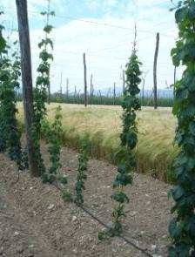
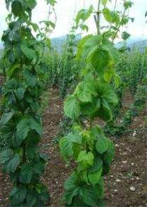
Infected hop plants with visible symptoms of stunted and poor growth, yellowing and leaf curling down.

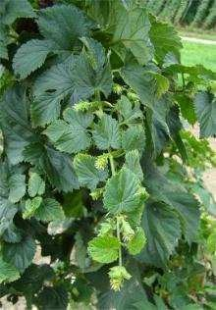
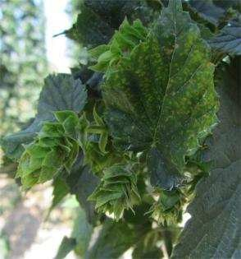
Lateral shoots have shorter internodes and abnormal growth of cones.

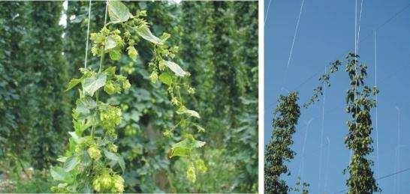
Infected plants decline from the support and their climbing upwards thereupon is aggravated

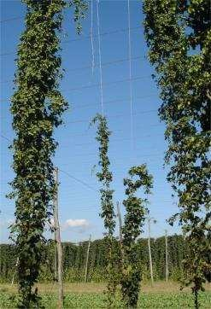
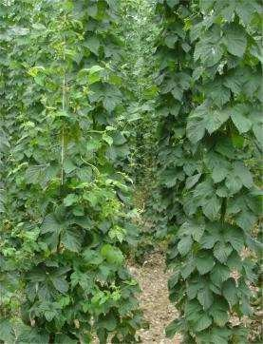
Infected plants fail to reach the level of the trellis, and certain varieties begin to blossom even up to 10 days prior to the uninfected plants.

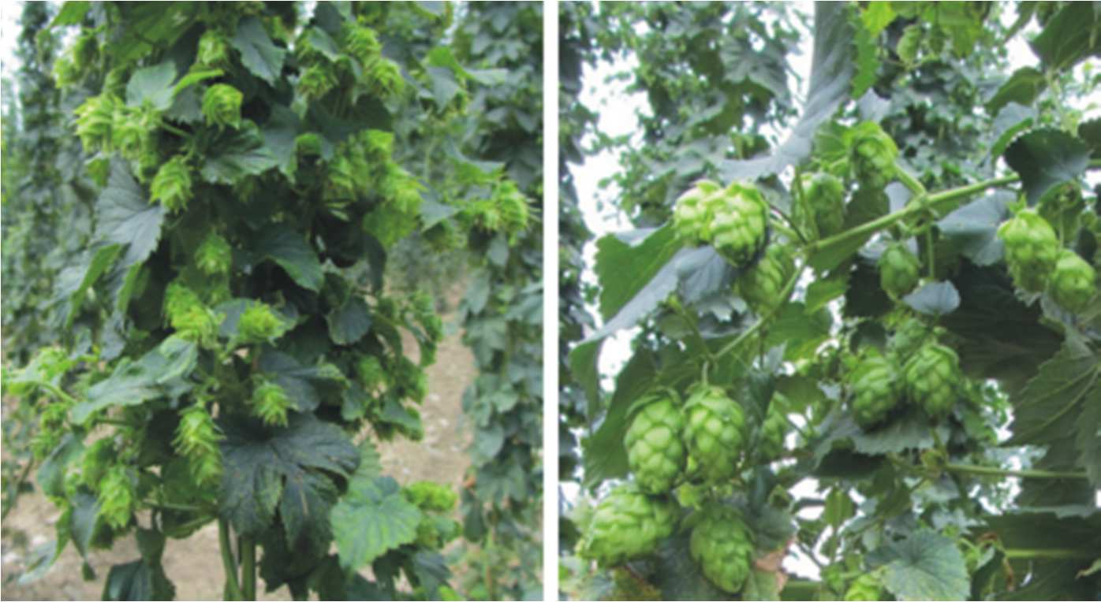
Hop cones on infected (left) and uninfected (right) plant of variety Celeia.

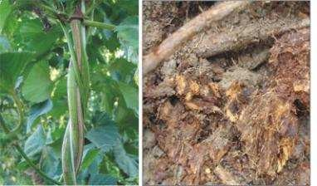
Intensified cracking of primary vine and dry rot developing on infected plants.

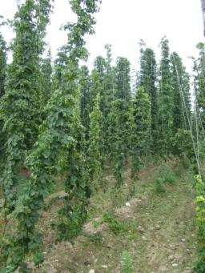
Foci of infected plants with spreading pattern along the rows.

Annex 2: Distribution map of wild Humulus lupulus
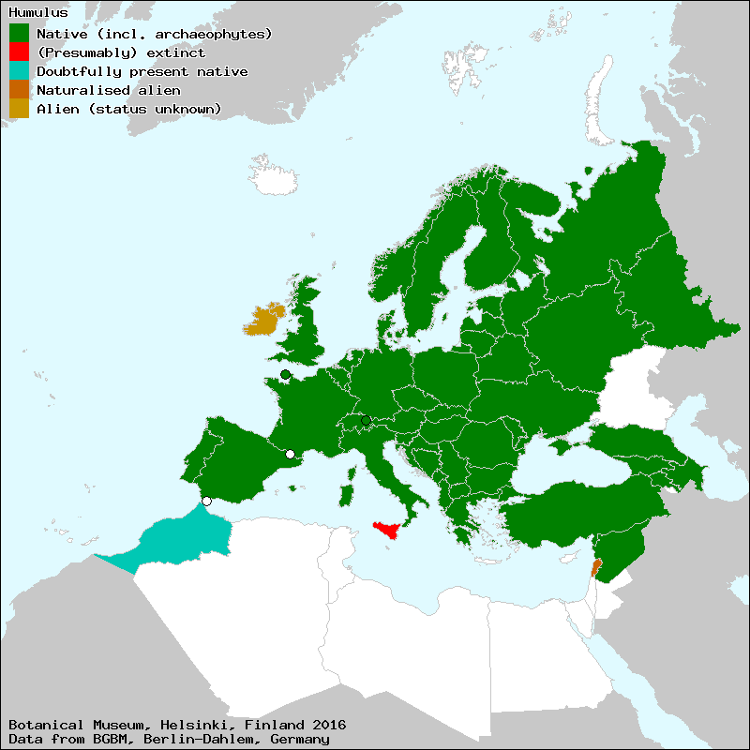
http://euromed.luomus.fi/euromed_map.php?taxon=450209&size=medium

