
INŠTITUT ZA HMELJARSTVO IN PIVOVARSTVO SLOVENIJE
Slovenian Institute of Hop Research and Brewing Slowenisches Institut für Hopfenanbau und Brauereiwesen

______________________________________________________________________________________________________________________________

PEST RISK ANALYSIS REPORT
for Citrus bark cracking viroid (CBCVd) on hop (Humulus lupulus)

EPPO PM 5/5(1)

Summary¹ of the Express Pest Risk Analysis for “Citrus bark cracking viroid (CBCVd) on hop (Humulus lupulus)”
PRA area: Slovenia
Describe the endangered area: Hop growing areas in Slovenia
Main conclusions:
The occurrence of CBCVd on hop presents an exemplary case of transmission of a hitherto less significant viroid on citruses to a new host, causing aggressive disease and high economic loss. Introduction of CBCVd into Slovenia mostly takes place through the import and sale of citrus fruits. The extent of imports of citrus fruits has been extremely high, though most household waste ends up in regulated dumping grounds. However, at improper citrus fruit waste handling, the carry over to hop or any other plant is possible. Imports of citrus plants for planting into Slovenia are relatively low and intended exclusively for the non-commercial use, as ornamentals. In case of transmission to hop, CBCVd may spread rapidly, due to intensive and specific hop cultivation that, at the time of vegetation, provides the ideal conditions for mechanic transmission, produce a high extent of plant residues, and trough vegetative hop propagation. As regards the spread it is necessary to emphasize, the high density of hop gardens in all hop growing areas of Slovenia, which are proprietarily intertwined, increasing the risk of disease spread between farms. Impact of CBCVd on hop production is very high as the plants in case of infection show stunted growth already in the first year after infection and die within 3 to 5 years. Slovenia belongs to the 6 most important hop growing countries in the world, exporting 95 % of hop production per annum, constituting a turnover of around EUR 10 million. As hop is grown as permanent crop, requiring a high level of investment, the level of economic loss at infection would be high. If phytosanitary measures are not implemented high economic losses may be expected which, on account of international interconnectedness of hop production, may extend to other hop growing countries of the European Union and worldwide.
The occurrence of CBCVd that had until recently been considered a mild citrus plant pathogen of a limited geographic distribution, causing aggressive disease on a new host, and in particular, in a fully unexpected Central European region, constitutes an entirely new momentum in the biology of this viroid, requiring a
detailed examination and immediate action.
Phytosanitary risk for the endangered area | High X | Moderate ☐ | Low ☐
Level of uncertainty of assessment | High ☐ | Moderate ☐ |  | Low X
Other recommendations:
- Notification of EPPO, IPPC and competent services of the EU
- Potential proposal of CBCVd as a new quarantine organism
- Notification of all hop growing countries and interested public
- Conducting additional research and instituting official controls
Adoption of measures to prevent the introduction and spread of CBCVd through relevant legislation

¹ The summary should be elaborated once the analysis is completed

Cesta Žalskega tabora 2, SI-3310 Žalec, Slovenia
Phone: 03 71 21 600; Fax: 03 71 21 620; www.ihps.si; E-mail: tajnistvo@ihps.si
VAT ID No: (SI) 93987161, Registry no: 5051762000, Transaction Account No: 01100-6000006134

Express Pest Risk Analysis:

Citrus Bark Cracking Viroid (CBCVd) on hop (Humulus lupulus)

Prepared by:
Dr. Sebastjan RADIŠEK Slovenian Institute of Hop Research and Brewing Inštitut za hmeljarstvo in pivovarstvo of Slovenia Plant Health Department/Oddelek za varstvo rastlin, Diagnostic Laboratory/Diagnostični laboratorij, Cesta Žalskega tabora 2,
SI-3310 Žalec Slovenia
Date: 24 April 2015

Stage 1. Initiation

Reason for performing the PRA:
In 2007, in the region of Šempeter in the Savinja Valley, an outbreak of an unknown and aggressive disease was detected, which caused the stunted growth of hop plants with a rapid spreading dynamics. In 2011, following an extensive diagnostic analysis, the presence of Hop stunt viroid (HSVd) (Radisek et al., 2012) was confirmed in the affected plants, which is described as the causative agent of hop stunt disease (Sasaki and Shikata, 1977). Based on the confirmed presence of HSVd, the risk of its spreading and causing major economic loss, the official measures for the prevention of hop stunt disease were adopted in 2011 in Slovenia by relevant Decision issued by the Phytosanitary Administration.
Due to the specific characteristics of hop stunt disease in Slovenia, expressed in a much shorter incubation period (4 months) (Jakše et al., 2014) than had been described up to that time (3 to 5 years) (Eastwell and Sano, 2009; Sano, 2003), to a higher level of aggressiveness, and to an unreliable detection of HSVd limited to the hop cones, additional diagnostic analyses were conducted using the NGS (Next Generation Sequencing) analysis. Citrus bark cracking viroid (CBCVd) was confirmed with NGS in the symptomatic plants.
At the same time, in 2014, within the same research project, it was confirmed that the main agent of the new disease in Slovenia was CBCVd, whilst HSVd most probably due to the antagonist relationship to CBCVd was inactive in the infected plants or could no longer be present (Jakše et al., 2014). The new disease on hop, caused by CBCVd has been named "severe hop stunt disease”, since resemble symptoms described for HSVd (Jakše et al., 2014).
To date, the CBCVd has been described as an economically less significant citrus viroid, and has been present only in certain citrus production countries or regions (Table 1; Chapter 6). Hop presents a new host for CBCVd on which causes severe disease symptoms and dieback.
At the same time, CBCVd is occurring in a completely new environment outside from the citrus growing geographic areas.
CBCVd had been detected in 12 Slovenian hop farms in 2014. Eradication has been implemented on the basis of a regulation laying down the prevention of the spread of HSVd, though the scientific research results have shown that the disease agent in Slovenia is in fact CBCVd. Since 2011, hop stunt diseases have been restricted to already affected hop farms, in which the viroid may still sporadically spread between hop gardens.

PRA area: Slovenia

Stage 2. Pest risk assessment

- Taxonomy:

Citrus bark cracking viroid (CBCVd):
Kingdom: Viruses and viroids; Class: Viroids; Family: Pospiviroidae; Genus: Cocadviroid

Other scientific names:
  - Citrus viroid IV
  - Citrus bark cracking cocadviroid
English identification: CBCVd; EPPO code: CBCBD0 Sources of taxonomic classification:
  - International Committee on Taxonomy of viruses; http://www.ictvonline.org/
  - The National Center for Biotechnology Information (NCBI) http://www.ncbi.nlm.nih.gov/
  - EPPO PQR http://www.eppo.int/DATABASES/pqr/pqr.htm

Pest overview
CBCVd belongs to the less studied viroids. It was mentioned for the first time in 1988 in conjunction with the citrus exocortis disease investigation in samples from California and it was then called the Citrus viroid IV (CVd IV) (Duran-Vila et al., 1988). The first complete nucleotide sequence of CBCVd was published three years later, within the research of dwarfed grapefruit trees from Israel (Puchta et al., 1991). CBCVd consists of a circular RNA molecule, sized between 283 and 286 bp (NCBI GenBank). Following the initial detection, CBCVd was confirmed as pathogen to most plant species of the genus Citrus and to certain related plants, and artificial infection of test plants showed that CBCVd infected also cucumbers, tomatoes, eggplants and certain ornamental plants (Semanchik and Vidalakis, 2005). As the CBCVd, as the only viroid, is directly linked to bark cracking on trifoliate orange tree (Poncirus trifoliata) (Vernière et al., 2004), it was in 2005 renamed into the Citrus bark cracking viroid (CBCVd). Taxonomically, CBCVd belongs to the genus Cocadviroid, which means the same genus as that of the Hop latent viroid (HLVd), though, in certain characteristics, it is similar also to the viroids of the genus Pospiviroid (Semanchik and Vidalakis, 2005). CBCVd is present in certain citrus growing countries, occurring in particular as mixed infections along with other citrus group viroids (Vernière et al., 2004; 2006). In relevant literature it may be found as one of the viroids commercially used in reducing the size of citrus fruits (Bar Joseph, 1993). Detection of CBCVd on hop means identifying it on a completely new host plant that shows a high level of susceptibility and, at the same time, this means the occurrence of CBCVd in a completely new environment.

Signs of the Severe Viroid Hop Stunt Disease
In vegetation, the first signs of disease on hop may be noticed in the beginning of June. Infected plants normally begin to sprout in spring, and in the beginning of June, their stunted growth may already be noticed. Later, during the continued vegetation, the occurrence of disease symtoms intensifies, with a distinctive shortening and compression of intermediate segments of the main bines and of the lateral branches. As the hook-hairs on the bines do not develop to a sufficient extent, the infected plants decline from the support and their climbing upwards thereupon is

aggravated. In most cases, the infected plants fail to reach the level of the trellis, and certain varieties begin to blossom even up to 10 days prior to the uninfected plants.
The leaves remain smaller and blistery in appearance, and in certain varieties they turn yellowish, with down curling edges. The cones are distinctly smaller and lighter, with fewer lupulin glands developed, and of abnormal growth in the extremely affected plants. The disease severely affects also the root of the plant, with dry rot developing and ending up in a complete dieback of the entire root system. The signs of disease caused by CBCVd are similar to the HSVd-infection as regards the affectedness of individual tissues. A considerable difference is in the incubation period as, at HSVd hop infection, the first signs of disease may be expected 3 to 5 years after infection (Eastwell and Sano, 2009; Sano, 2003), whilst at CBCVd infection, the first signs of disease show between 4 months and 1 year after infection (Jakse et al., 2014). Likewise, the development of disease in the case of CBCVd is much faster, as the plants die off completely between 3 and 5 years after infection, whilst the HSVd-infected plants survive for 10 and more years (Eastwell and Sano, 2009; Radisek et al., 2012; Sano, 2003). For its high aggressiveness, the new disease caused by CBCVd on hops has been called the severe hop stunt disease (Jakse et al., 2014). Characteristic symptoms of severe hop stunt disease are presented visually in Annex 1.

Diagnostic analyses of CBCVd
In viroid detection, different methods are used, including the biological testing, molecular hybridisation, polyacrylamide gel electrophoresis (PAGE), reverse transcription polymerase chain reaction (RT-PCR), RT-PCR for the simultaneous detection of viroids (mRT-PCR), RT- PCR linked with hybridisation, reverse transcription loop-mediated isothermal amplification (RT-LAMP), and naturally, the quantitative real time RT-PCR (RT-qPCR). Within the recent decade, the routine viroid diagnostics most frequently applies the RT-PCR using the viroid- specific oligonucleotide primers. For the RT-PCR detection of CBCVd on hop and other plants, most appropriate are the PCR primers developed by Bernad and Duran-Vila, 2006. A most significant part of diagnostic analysis that may impact the detection is also the RNA isolation from the infected plant tissue. The use of commercially available plant RNA isolation kits is advisable.

3. Is the pest a vector? Yes ☐ No ☑

CBCVd and other viroids are not the vectors of other organisms.

4. Is a vector needed for pest entry or spread? Yes ☐ No ☑

CBCVd has no known vectors. It is transmitted mechanically, by infected plants and infected plant residues.

Regulatory status of the pest

CBCVd is neither listed as harmful organism (pest) in Council Directive 2000/29/EC, nor is it on the EPPO list.

CBCVd is regulated within the Slovenian legislation:
- Decision on emergency measures against the introduction and spread of viroid hop stunt diseases (UL RS, 21/2015, 17.03.2015).
- Rules on the marketing of hop propagating material and of hop plants (UL RS, 45/13, 24/15).

Distribution

CBCVd belongs to a group of viroids occurring only on citruses in the nature and in growing areas. It is a poorly studied and less prevalent viroid of the group, estimated to have been present only in certain citrus growing countries (Duran-Villa and Semanchik, 2003; Semanchik and Vidalakis, 2005). Results of identification of viroid prevalence on citruses, implemented in certain countries, showed that CBCVd mostly occurred in combination with other viroids, and extremely infrequently as an autonomous infection.

CBCVd in citrus orchards in certain countries according to scientific publications:
  - South Africa 1.1 % (Cook et al., 2012)
  - Greece 14 % (Wang et al., 2013)
  - Italy 12.5 % (Malfitano M., et al., 2005)
  - Tunisia 2.3 % (Najar A., Duran-Vila N., 2004)
  - China 7.1 % (Cao et al., 2010)

Presence of CBCVd on hop has been confirmed only in Slovenia (Jakše et al., 2014). In 2014, the presence of CBCVd was confirmed in 12 hop farms of a total of 139 Slovenian hop growing agricultural holdings (units of production). In total, the presence of CBCVd was confirmed in
64.5 hectares, taking into account that a hop garden is declared as infected on detection of at least one (1) infected plant. In 2014, a total of 1918 infected plants (plants showing visual disease symptoms) were identified in the infected hop gardens and, taking into account the average number of plants per hectare of hop growing areas (3000), this means a 1 % level of infection. CBCVd infections are mostly limited to individual parts of the hop gardens, where, the level of infection may excess of 50 % of plants, with 20 % annual level of progression (Source: Reports of the systematic monitoring of hop stunt viroid in Slovenia in the period 2011 − 2014). Geographic distribution of CBCVd on hop in Slovenia is shown in Annex 2, Figure 2.

Table 1: Data on global spread of CBCVd

Continent | Distribution | Provide comments on the pest status in the different countries where it occurs | Reference
Africa | South Africa | Present – Citrus spp | Cook et al., 2012
Africa | Tunisia | Present – Citrus spp | Najar A., Duran-Vila N., 2004
Africa | Sudan | Present – Citrus spp | Mohamed M.E., 2009
Americas | USA, California | Present – Citrus spp | Duran-Vila et al., 1988
Americas | USA, Texas | Present – Citrus spp | Kunta et al., 2007
Asia and Middle East | Israel | Present – Citrus spp | Puchta et al., 1991
Asia and Middle East | China | Present – Citrus spp | Cao et al., 2010
Asia and Middle East | Japan | Present – Citrus spp | Ito et al., 2002
Asia and Middle East | Turkey | Present – Citrus spp | Önelge et al., 2000
Asia and Middle East | Iran | Present – Citrus spp | Hashemian et al., 2013
Europe | Italy | Present – Citrus spp | Malfitano M., et al., 2005
Europe | Greece | Present – Citrus spp | Wang et al., 2013
Europe | Slovenia | Severe outbreaks on hop (Humulus  lupulus) | Jakše et al., 2014

Host plants/habitats* and their distribution in the PRA area

In nature and in growing areas, CBCVd may be found on plants of the genus Citrus only, and on trifoliate orange (Poncirus trifoliata), which is used as rootstock for citrus grafting. Artificial inoculation research has shown that CBCVd may infect certain other plants, including cumquats, limes, tomatoes, eggplants, chrysanthemums and cucumbers, however, without developing any symptoms (Duran-Villa and Semanchik, 2003; Semanchik and Vidalakis, 2005). CBCVd on hop has been confirmed in Slovenia only, causing severe disease symptoms on infected plants (Jakše et al., 2014). It is assumed that CBCVd may have even more hosts, although additional systematic research should be performed in future (Duran-Villa and Semanchik, 2003).

CBCVd host plants
Main host (presence in nature and in growing areas):

- Citruses (Citrus spp.; Poncirus trifoliata)
- Hop (Humulus lupulus), supposedly in Slovenia (first sings of disease) as from 2007, and confirmed presence in 2014.

Artificial inoculations:

Citrus related plants of the citrus/rue (Rutaceae) family:
- Cumquats (Fortunella margarita; F. crassifolia; F. obovata)
- Limes (Microcitrus warburgiana; M. australis x M. australasica)
- Pleiosperum sp.
- Severinia buxifolia

Other plants
- Cucumbers (Cucumis sativus)
- Winter melons (Benincasa hispida)
- Tomatoes (Solanum lycopersicum)
- Eggplants (Solanum melongena)
- Chrysanthemums (Chrysanthemum morifolium)

In Slovenia, the presence of CBCVd has been confirmed on hop only. A pest risk analysis of the spread to other hosts (permanent crops etc.) has to date not been feasible on account of the lack of data. In 2014, RT-PCR analyses were conducted on samples of 15 weed plant species from the infected hop gardens, which did not show the presence of this viroid in none on the plants (Source: The 1st Partial Report, CRP V4-1405).

Table 2: List of tested weeds in CBCVd-infected hop gardens

English name (latin name) | English name (latin name)
Common pigweed (Chenopodium album) | Adam’s plaster (Polygonum persicaria)
Potato weed (Galinsoga parviflora) | Common shepherd’s purse (Capsella bursa-pastoris)
Creeping bluegrass (Poa annua) | Common sow thistle (Sonchus oleraceus)
Barnyard grass (Echinochloa crus-galli) | Corn/Creeping thistle (Cirsium arvense)
Common amaranth (Amaranthus retroflexus) | Common starwort (Stellaria media)
Green purslane (Portulaca oleracea) | Bluntleaf dock (Rumex obtusifolius)
Hairy crabgrass (Digitaria sanguinalis) | Creeping sow thistle (Sonchus arvensis)
Oilseed rape (Brassica napus)

Distribution of main hosts in Slovenia:

Hop: In 2014, 1783 ha (1349 ha of active hop gardens and 434 ha in crop rotation
(Source: Hop Yield Certification Body of SIHRB). In nature, hop is present in the lowlands of the entire Slovenia. Growing areas: the Savinja Valley with the Celje Basin; the Carinthia Region (Radlje on Drava, and Slovenj Gradec); the surroundings of Ptuj and Ormož (Annex 2, Figure 1).
Citruses: According to the Statistical Office of the Republic of Slovenia (SORS)’s data on plant production in Slovenia, and to the Eurostat data of 2014, citrus commercial growth does not exist in Slovenia.

Pathways for entry

CBCVd may at greater distances be transmitted with infected planting material, infected plant remnants, non-disinfected machinery or tools. CBCVd belongs to viroids, which are restricted to certain citrus growing areas only. Introduction into Slovenia is thus possible by way of citrus fruits or ornamental plants for planting. According to the Ministry of Agriculture and the Environment (MAE)’s data (AIS, 2014), the highest share constitutes the import of fresh citrus fruits, amounting to approximately 40,000 tons/annum.
A research study covering the main foodstuffs-selling shopping centres in Slovenia identified the presence of CBCVd in citrus fruits imported from Israel, Greece and Cyprus, in a 10 % extent of samples taken. Ornamental citrus testing was conducted to a lesser extent, and the presence of CBCVd was not identified (Source: The 1st Partial Report, CRP V4-1405).
Considering these facts, the risk of transmission of CBCVd from other areas and host plants to hops is low, provided that all the good agronomic practice measures are implemented and appropriate handling of organic waste is implemented. In case of non-compliance with these measures, or citrus waste dumping in the vicinity of growing areas or on other agricultural land, the risk may substantially increase. It is supposed that CBCVd transmission to hops in Slovenia is most probably a result of mechanic transmission from citrus fruit waste or citrus plants parts. Such transmission is corroborated by the fact that in the vicinity of primary outbreak there used to be an extensive (illegal) refuse dump of household waste and other waste that may have enabled the transmission of CBCVd to hop. However a possibility of transmission from citrus fruit to hop should be proven experimentally.

Possible pathways  (in order of importance) | Short description explaining why it is considered as a pathway | Pathway prohibited in the PRA area?  Yes/No | Pest already intercepted on the pathway? Yes/No
Hop plants for planting | Systemic infection of plants or plant parts | No | No
Plants for planting of other host plants | Systemic infection of plants or plant parts | No | No
Citrus fruits | Systemic infection of plants or plant parts | No | Yes
Parts of plants (plant remnants) | Systemic infection of plant parts | No | No
Machinery and tools | Infected plant remnants | No | No

Rating of the likelihood of entry Low ☐ Moderate ☑ High ☐
Rating of uncertainty Low ☐ Moderate ☑ High ☐

Likelihood of establishment outdoors in the PRA area

Similarly as other viroids, CBCVd may survive in infected host plants or on remains of infected plants for a limited period of time. In the absence of data on the possible transmission of CBCVd through seeds, it is supposed that it may establish itself in particular through infection of permanent crops, in which it subsequently spreads by vegetative propagation and mechanic transmission. In case of latent infections and absence of monitoring of plants, such establishment is all the more probable. Such an example is a high level of prevalence of HSVd on vines, or of Hop latent viroid (HLVd) in hop gardens. In the case of CBCVd that causes aggressive symptoms on hop, preventing its spread is rendered easier by the prompt visual detection and a short incubation period. However, the infectivity level needs to be taken into account which, in the case of CBCVd on hop, is extremely high, in addition to the proximity of hop gardens, all of which extremely aggravates the effectiveness of the spread prevention measures. If measures are not implemented, the risk of epiphytocia in hop gardens is extremely high.

Rating of the likelihood of establishment outdoors Low ☐ Moderate ☐ High ☑
Rating of uncertainty Low ☑ Moderate ☐ High ☐

Likelihood of establishment in protected conditions in the PRA area

The risk of establishment or spread of CBCVd in closed areas is low, considering the available set of host plants. An exception is the growing of planting material of host plants in greenhouses where, at non-verification of health status of parent plants, the propagation and spread of infected material are possible. In Slovenia, such a case is the growing of certified hop plants (certification level A) that takes place in greenhouses and enclosed areas only. Propagation of hop plants for planting in greenhouses takes place most intensively, and therefore, a system of control needs to be guaranteed, which prevents the introduction of CBCVd infected plants into the greenhouse and ensures the verification of the state of health prior to propagation.

Rating of the likelihood of establishment in protected Conditions Low ☐ Moderate ☐ High ☑
Rating of uncertainty Low ☑ Moderate ☐ High ☐

Spread in the PRA area

On longer distances, CBCVd may spread in particular by the infected plants for planting and infected plant remnants. Plants propagated from already infected plants begin to express the symptoms already in the first year upon planting, or already in June or in August. Incubation period in case of CBCVd takes up to one year (4 months - up to 1 year). During the incubation period, plants do not develop visual symptoms, though being infective, and may spread infection within the hop garden. In hop gardens, the disease may be transmitted mainly mechanically, by infected plant sap that remains deposited on machinery and tools during the different agro- technical activities. The spread is most intensive at the time of cutting and at other spring operations, including the training of offshoots, and at harvesting, which are most damaging to the plants. The disease progression at the annual level ranges up to 20 % of plants (Jakše et al., 2014).

Significant sources of spread are the infected plant remnants, in which CBCVd may survive all until the tissues are fully decomposed. Thus returning fresh hop waste from an infected hop garden to non-infected hop gardens can cause spread of CBCVd.

CBCVd causes also the dry rot of the root system, which means that the lignified parts of the bines during the autumnal/winter plantation treatment (e.g. during harrowing) become detached more easily and may be transferred to another, uninfected part of the plantation. In case of eradication of hop gardens, the plant remnants shall fully be ploughed through/grubbed-up and at least a two-year crop rotation with non-host plants should be done, to ensure that all the hop remnants have fully been decomposed, and thereby also the CBCVd.

Pollen, seeds and weeds have according to analyses conducted to date no relevant role in maintaining and spreading CBCVd. Likewise, CBCVd has no known vectors. Notwithstanding the extensive imports of citrus fruits, which may be CBCVd infected, this factor does not impact its spread within hop gardens, as most household waste does not end up in plantations. Presence of CBCVd on hop poses also the question of risk of transmission to other agricultural plants, including fruit plants, vines, and potatoes, which are grown in the vicinity of the infected areas. An assessment of this part cannot be presented at the time being, as long as the testing of the host specificity of CBCVd has been concluded. The RT-PCR testing of different weed plant species in infected plantations has, however, confirmed the presence of CBCVd on hops only.

Rating of the magnitude of spread Low ☐ Moderate ☐ High ☑
Rating of uncertainty Low ☐ Moderate ☑ High ☐

Impact in the current area of distribution

In citrus growing countries, CBCVd is not regarded a significant agent of disease. It mostly occurs in the combination with other citrus viroids, where the frequency of CBCVd infections is low (Chapter 6). CBCVd in form of single infection does not affect the yield or plant growth, but it does cause bark cracking of trifoliate orange (Vernière et al., 2004; 2006).
Hop is a completely new host plant of CBCVd and, as opposed to citrus trees it causes aggressive disease symptoms on hop and substantial economic losses. The eradication measures due to the presence of viroid hop stunt diseases have to date grubbed-up 25.5 ha of hop gardens, and in the remaining plantations, local uprooting of infected plants is carried out, more as a restrictive measure against the spread within the infected hop gardens. As from 2011, when the Decision on emergency measures against the introduction and spread of hop stunt viroid (UL RS 64/2011, 12.08.2011) was published, the disease has mostly been restricted to the previously infected hop farms where, despite all the measures implemented, the viroid still spreads sporadically to the new hop gardens, or the re-infection of hop garden planted on eradicated area appeared. Financial means granted to hop garden owners to compensate for the plants destroyed amounted in the period between 2011 and 2015 to 213,300.00 Euros. In addition, there are the expenses of plant destruction, machinery and tool disinfection, and of the specific means of transport for the removal of hop remnants.

Rating of the magnitude of impact in the current area of distribution Low ☐ Moderate ☑ High ☐
Rating of uncertainty Low ☑ Moderate ☐ High ☐

Potential impact in the PRA area

In Slovenia, in the period 2011−2014, the viroid hop stunt diseases were detected in 13 hop farms. Most infected farms (10) and hop gardens are situated in the Žalec Municipality, or in the vicinity of the primary outbreak location in Šempeter within the Savinjska Valley. Infections in Carinthia are limited to 2 farms, where the disease after eradication did not reappear in one (1) holding in 2014. In the case of Polskava which is a hop farm near Slovenska Bistrica four infected hop gardens were detected. The size of individual outbreaks, with individual exceptions, is relatively small, but in the case of infection of a new hop garden, the disease may successfully be eradicated through destruction of infected plants only, and at strict observation of the hygiene measures, or the eradication of an entire hop garden or a major part which includes all plant rows where the infected plants have been detected.
As the disease is still spreading, and as within the infected areas, the individual hop farms are sharing the same trellises, there still exists a high risk of spread of infection to the neighbouring farms, which are uninfected. CBCVd-infected plants express disease symptoms already during the first year post infection, and they die within a period of 3 to 5 years, which constitutes a considerable economic loss as regards permanent crops. A disease of such rapid dynamics of spreading and of such aggressiveness may seriously jeopardise hop production in Slovenia (1783 ha; 139 holdings), and in the case of transmission to the other EU Member States, also for the European hop production (approximately 30,000 hectares). Effective prevention shall be based on eradication of infected plants, the correctly implemented sanitary measures, early disease detection, and planting of healthy planting material. The risk of spread and impacts of CBCVd on other cultural plants is still unclear, on account of relatively unclear host specificity. Hop production value in Slovenia at annual level reaches on average approximately 10 million Euros. Table 4 shows the collected data on hop production in Slovenia in the period 2000 − 2014.

Table 3: Data on occurrence of viroid hop stunt diseases in Slovenia in the period 2011 − 2014.

Year | Confirmed infections in current  year (ha)* | Total number of infected plants in  current year | Eradicated areas (ha) | Number of infected farms | Number of all hop farms in Slovenia
2011 | 50,1 | 3210 | 10,80 | 10 | 129
2012 | 28,89 | 868 | 8,30 | 12 | 115
2013 | 44,82 | 1201 | 4,43 | 13 | 115
2014 | 64,5 | 1918 | 1,5 | 12 | 136
*Graphic presentation of infected hop gardens is shown in Annex 2.

Will impacts be largely the same as in the current area of distribution? Yes /No

Economic losses in hop production areas are comparable to an outbreak of HSVd on hop in Japan. Due to a higher level of aggressiveness of CBCVd, and a more extensive hop production in Slovenia and in the other EU Member States, even higher economic losses may result from a prolonged spread of infection and/or from non-implementation of the required measures.

If No

Rating of the magnitude of impact in the area of potential establishment
Low ☐ Moderate ☐ High ☑
Rating of uncertainty
Low ☑ Moderate ☐ High ☐

Identification of the endangered area

In hop production areas of Slovenia, CBCVd has already been occurring, and may jeopardise the entire hop production in Slovenia. The scope of production of the recent years has been divided between more than 100 farms that cultivate approximately 1700 hectares of hop gardens. Within the past decade, the number of farms has decreased, and at the same time, the production increased in the existing farms. In nature, hop could be found along the entire lowland areas of Slovenia, and in particular, along waterways. The risk of spread of CBCVd into natural vegetation is relatively low. Transmission may occur in case of dumping infected plants in the vicinity of natural hop habitats. The further spread within the natural hop population would be possible along the waterways only, where regular floods occur, washing away the plants. Transmission of CBCVd through seeds has not been proven, and therefore, this factor does not impact the spread in natural hop habitats. It is suspected that CBCVd has more hosts, in particular those, which can be infected by HSVd (grapevine, stone fruit trees and certain pip fruit trees).

Thus, the eradication of infected hop plants and remnants of infected plants is important to avoid the possible transmission of infection to other plants.
In the vicinity of primary outbreak of severe hop stunt disease is situated a nursery of stone fruit tree planting material (“Mirosan d.o.o.” company and several private entrepreneurs). Research of host specificity of CBCVd on the HSVd hosts has been under way within the CRP project, code: V4-1405; period 2014-2016).
Along with Slovenia, the possible transmission of infection jeopardises also the European and other hop growing countries. In Europe, hop is cultivated by 13 countries, and in 2014, hop production covered somewhat more than 25,000 hectares of hop growing areas.

Table 4: Slovenian hop growing industry: Data on surfaces, number of growers, and produce in the period 2000 − 2014 (Source: SIHRB, 2015).

Year | Crop rotation (ha) | Hop gardens (first yearlings and fertile  plantations) (ha) | Certified production in tons | Kg/ha of fertile plantation | Number of hop growers
2014 | 488,98 | 1296,16 | 2319 | 2034 | 136
2013 | 626,55 | 1165,84 | 1297 | 1222 | 136
2012 | 636,31 | 1159,49 | 1559 | 1457 | 115
2011 | 453,26 | 1376,14 | 2470 | 1878 | 129
2010 | 374 | 1488 | 2461 | 1825 | 134
2009 | 207 | 1517 | 2500 | 1795 | 139
2008 | 254 | 1618 | 2359 | 1539 | 140
2007 | 302 | 1573 | 1987 | 1355 | 157
2006 | 316 | 1468 | 1899 | 1341 | 158
2005 | 416 | 1462 | 2544 | 1801 | 159
2004 | 419 | 1520 | 2608 | 1772 | 169
2003 | 434 | 1625 | 1313 | 835 | 186
2002 | 273 | 1817 | 2194 | 1274 | 192
2001 | 251 | 1807 | 2158 | 1317 | 201
2000 | 323 | 1774 | 1805 | 1095 | 231

Overall assessment of risk

Summary of ratings and uncertainty
 | Rating level | Uncertainty
Entry | moderate | moderate
Establishment (Slovenia, EU hop countries) | high | low
Establishment (glasshouses/protected conditions in the rest of the EPPO  region) | moderate | low
Spread (PRA region) | moderate | low
Impact (in current region) | high | low
Impact in PRA region | high | low

Occurrence of CBCVd on hop constitutes an exemplary case of transmission of a previously less important viroid on citruses to a new host, causing the aggressive disease symptoms and high economic losses. Introduction of CBCVd into Slovenia principally takes place through the imports and sales of citrus fruits. The scope of imports is very high, but most household waste ends up on regulated city dumps. Nevertheless, in case of inappropriate handling of waste citrus fruits, a possibility of transmission of infection to hop does exist. Imports of citrus plants for planting into Slovenia are relatively low and intended for non-commercial use and ornamental purposes only.
In case of transmission to hop, CBCVd may spread rapidly, though intensive and specific hop cultivation that, at the time of vegetation, provides the ideal conditions for mechanic transmission, produce a high extent of plant residues, and through vegetative hop propagation. As regards the spread it is necessary to emphasize, the high density of hop gardens in all hop growing areas of Slovenia, which are proprietarily intertwined, what increase the risk of disease spread among farms.
In hop growing areas of Slovenia, CBCVd is already occurring, and may jeopardise the entire hop production of Slovenia.
Impact of CBCVd on hop is extremely high, as plants in the case of infection begin to show stunted growth already in the first year post infection, and die off within 3 to 5 years. Slovenia belongs to the 6 most important hop producers in the world, with a 95 % export per annum, and with a turnover of around 10 million Euros. As hop is cultivated as a permanent crop that requires a high level of investment, the level of economic loss on account of infections may be very high. In the case of non-implementation of phytosanitary measures, high economic losses may be expected and, given the interconnectedness of the hop growing industry, they may affect also other hop growing countries of the European Union.

Stage 3. Pest risk management

- Phytosanitary measures

Measures to prevent viroid infections are mostly based on the systematic controls, eradication of infected plants, hygiene measures, production of certified planting material, breeding of more resistant or tolerant varieties and, in certain cases, on cross-resistance.

Measures:
  - Hop planting material in Slovenia shall be based on certified planting material that guarantees the appropriate health status of plants for planting that are free from CBCVd.
  - In infected areas, and in other endangered areas, an important measure is the systematic survey that facilitates the overview of the state-of-play and the early detection of disease, and the monitoring of the dynamics of its spread.
  - Prevention of spreading and eradication within infected areas are based on the uprooting of infected plants and hop plants growing in the same row in a two metre distance and with infection rate above 20% the eradication of the infected hop garden or its part.
  - In infected areas, at least a three-annual crop rotation period shall follow after uprooting of infected plants, with non-host plants (cereals, corn..) only, so as to let the remnants of old hop plants to degrade, and to prepare the land for new hop planting. Any new or reappearing hop offshoots shall be removed.
  - Important factors of spread of infection is hop waste, and hop plant remnants from infected hop plantations. For this reason, any removal of hop waste or other hop plant remnants from the infected area back to uninfected hop gardens shall be prohibited. Hop waste from the infected area shall be removed to the grassland, agricultural land or authorised disposal site only.
  - CBCVd mostly spreads to new hop gardens within the already infected farms. It is therefore very important to disinfect the machinery and equipment, and to observe the sequence of tillage of plantations, where the infected ones shall be tilled last.
  - To prevent spreading of CBCVd from infected farms there is a need to prohibit the movement of plants for planting from the infected place of production. An exception may only be major agricultural farms that comprise several farms with the separate agricultural machinery and tools.
  - To prevent the spreading within infected farms, the production of planting material in infected hop gardens shall be prohibited.
  - Implementation of measures shall be based on the appropriate legislative provisions.
  - Professional support in hop growing and other professional services shall be at hand.
  - Hop growers shall be notified of the disease and familiarised with the measures of prevention of its spread.

Uncertainty

Given the unknowns as to transmission of CBCVd-infection to hop plants in Slovenia, the path of entry is assessed with the medium uncertainty. It would be possible that the disease has been transmitted from an illegal dump of organic waste that had been situated in the vicinity of the first focus of infection. Uncertainties arise at the spectrum of host plants, and consequently, at the possibility of spread within the endangered area. Presence of CBCVd on hop poses a question of the risk of transmission to other permanent agricultural plants, including fruit plants, vines and potatoes grown in the vicinity of infected areas. An assessment of this part cannot be presented until the testing of host specificity of CBCVd has been concluded. The RT-PCR testing of the different weed plant species within the infected areas have, for the time being, confirmed the presence of CBCVd on hops only.

Remarks

In case of non-implementation of the required measures, rapid spread of CBCVd within the Slovenian hop growing areas, and high economic losses, may be expected. Currently, CBCVd on hop is present only in Slovenia, to a limited extent, and therefore, the strict implementation of relevant measures is imperative. On account of high aggressiveness, low level of spread, and the potential economic loss that may ensue, CBCVd is appropriate for the recognition of the status of a quarantine harmful organism - quarantine pest.

Annex 1: Symptoms of CBCVd on hop

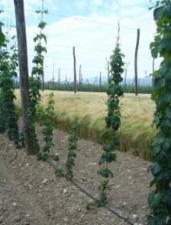
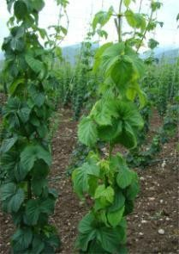
Infected hop plants with visible symptoms of stunted and poor growth, yellowing and leaf curling down.

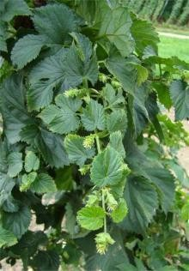
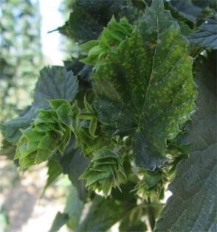
Lateral shoots have shorter internodes and abnormal growth of cones.

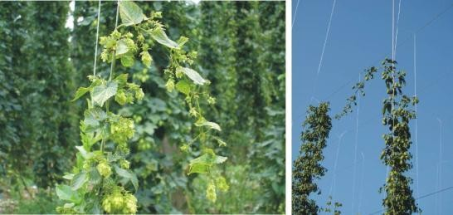
Infected plants decline from the support and their climbing upwards thereupon is aggravated

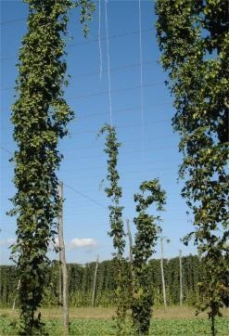
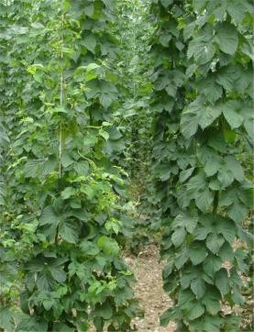
Infected plants fail to reach the level of the trellis, and certain varieties begin to blossom even up to 10 days prior to the uninfected plants.

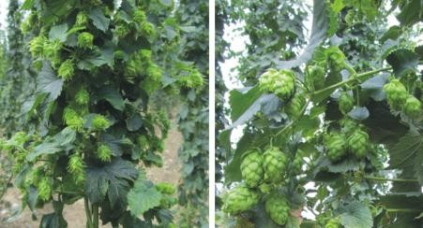
Hop cones on infected (left) and uninfected (right) plant of variety Celeia.

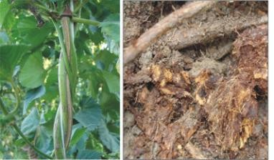
Intensified cracking of primary vine and dry rot developing on infected plants.

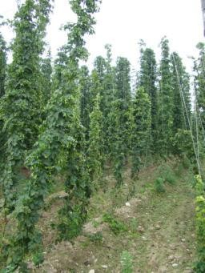
Foci of infected plants with spreading pattern along the rows.

Annex 2: Hop growing areas and geographic distribution of CBCVd on hop in Slovenia.

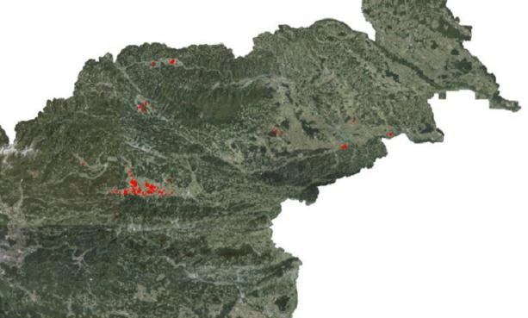

Figure 1: Hop growing areas in Slovenia in 2014 (Source: Javni pregledovalnik MKGP, 2014).

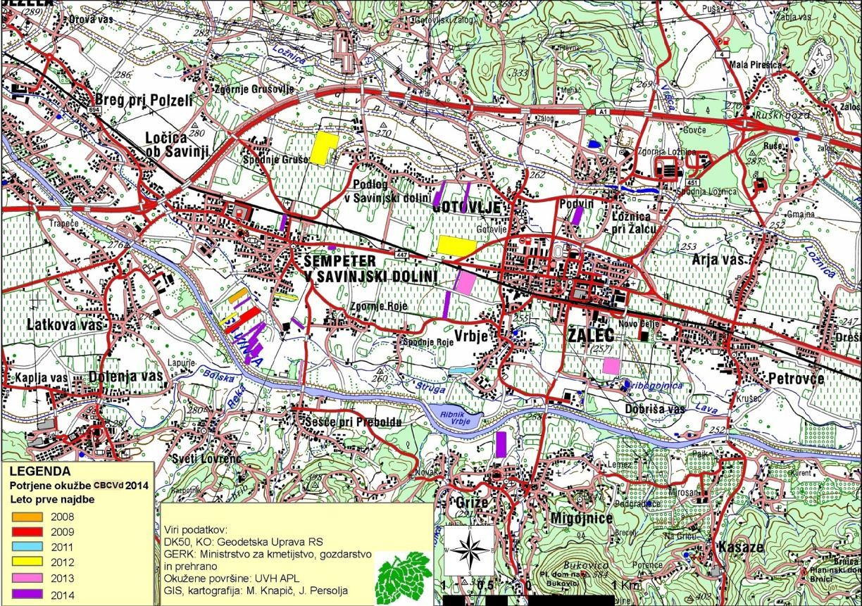

Figure 2: Geographic distribution of viroid hop stunt diseases on hop in Savinjska dolina in a period 2011-2014 (Source: FURS APL, by mag. M. Knapič, J. Persolja, 2014).

