# BRIEF SUMMARY

In the period from April to October 2019, the Krško NPP (NEK) and the research reactor in Podgorica near Ljubljana have been operating without any events significant to nuclear safety, and currently the planned refuelling outage is taking place at the Krško NPP.

In the area of legislation, in April 2019 the last decree, the “Amendments of the Decree on the Content and Preparation of Protection and Rescue Plans”, was adopted, fully aligning the Slovenian legal system with the EU Acquis. The Krško NPP was the first nuclear power plant in the world to prepare the new plant-specific Severe Accident Management Guidelines (SAMG). In the beginning of October Slovenia hosted the annual bilateral Meeting with Austria to discuss issues under the bilateral agreement. The emergency preparedness focus is on the implementation of the EPREV action plan as well as the continuation of the extensive programme of exercises and trainings.

# LEGAL SYSTEM

The process of transposition of the EU BSS directive was successfully finished by adopting the last missing regulation, the “Amendments of the Decree on the Content and Preparation of Protection and Rescue Plans”. It was adopted by the Government of the Republic of Slovenia in April 2019 and published in the Official Gazette of RS, No. 26/19.

In April 2019 the Parliament of the Republic of Slovenia also adopted the Amendments to the Ionising Radiation Protection and Nuclear Safety Act. These amendments are not related to the transposition of EU directives and include changes of security vetting procedures for foreign workers in nuclear facilities. These amendments were published in the Official Gazette of RS, No. 26/19.

Since the process of harmonization of domestic legislation with the established international standards and best international practice is a continuous process, the SNSA is already preparing amendments to some other by-laws.

# THE KRŠKO NPP

## Outage 2019

The planned outage after the 30th fuel cycle has started on 1 October 2019 in the Krško NPP. Besides the regular activities such as the refuelling and reactor physics tests with inspections of the equipment, several modifications in different phases of completion that are a part of the Safety Upgrade Program (SUP) are going to be implemented during the outage. Apart from the ongoing construction of the Bunkered Building 2 (BB2), these comprise the alternative residual heat removing system (ARHR) as well as partial implementation of the emergency control room (ECR), alternate safety injection (ASI) and alternate auxiliary feedwater (AAF) systems. An important activity during this outage, to be applied for the first time in the Krško NPP’s history, is the chemical cleaning of the steam generators’ bottom plate; its purpose is to suppress the U-tube denting due to the settled particles on the secondary side of steam generators.

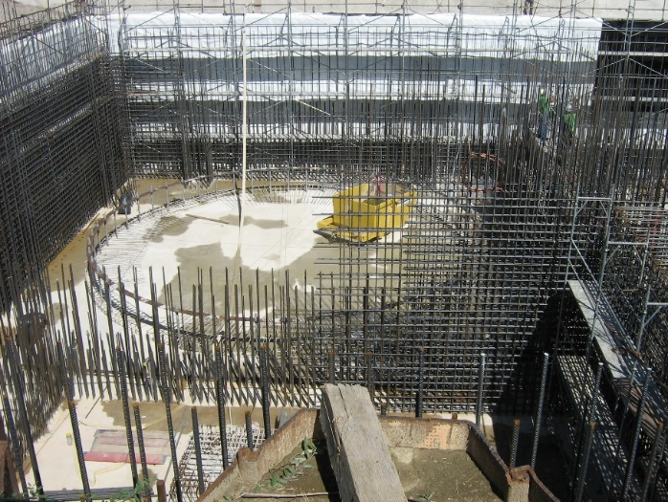

Figure 1: Construction of the bunkered building BB2 (SUP, Phase 3)

## Upgrade of Krško NPP Severe Accident Management Guidelines (SAMG) and Validation of SAMG

In 2016 the Pressurized Water Reactor Owners Group (PWROG) prepared the new guidance for SAMG of the European PWROG members, namely the PWROG-16059-P »PWROG Severe Accident Management Guidance for International Plants«, which includes new approach based on lessons-learned from the Fukushima Daiichi accident and subsequent plant improvements to cope with severe accidents. The Krško NPP volunteered to perform the validation of these new SAMGs in the scope of PWROG organization. The Krško NPP staff used this guidance and prepared the Krško NPP-specific SAMG in the new format, as the first plant in the world.

The validation of these new SAMG was performed in March 2018 using the Krško NPP full-scope simulator capable to simulate severe accident conditions. The validation scenarios were performed by the Krško NPP operators and the Technical Support Centre staff with the Westinghouse specialists in the roles of controllers and observers. Some PWROG members were also acting as observers. Four scenarios were selected for the validation: 1) Loss of AC and DC; 2) Hot leg SB LOCA with hydrogen concern; 3) Seismic event in shutdown conditions; and 4) LB LOCA with containment venting. All exercises were performed successfully. The validation findings were documented in PWROG-18030-P “PWROG SAMG for International Plants Validation Report” and will be used for further enhancing the PWROG SAMG guidance.

## Construction of the New Spent Fuel Dry Storage

Due to the operation and management restriction applied at the Krško NPP after the Fukushima Daiichi accident and the extended lifetime to the year 2043, additional storage capabilities to store spent fuel assemblies are needed. The Krško NPP decided to use the new spent fuel dry storage (SFDS) for the spent fuel storage.

In accordance with the design extension conditions (DEC) approach, the new SFDS design is based on regulatory requirements while some of design basis conditions are defined even stricter by the operator. The design and construction of the new SFDS are challenging to both the manufacturer and the operator. The nuclear industry has not yet developed well-established practice for such demanding projects. The SFDS licensing is also a challenge for the Slovenian regulator. The regulatory experience showed that in this novel work the regulator and operator could not rely on international practice only, thus we needed to define and approve original solutions.

The licensing process for the SFDS is on-going. In 2017 the SNSA issued the design conditions for the SFDS. Based on the proposed SFDS redesign the SNSA reviewed and assessed the design changes and issued the positive opinion for the construction license in January 2019. Additionally, a strategic environmental impact assessment, including transboundary impacts, is required for the siting of the SFDS and the procedures have started in October 2019. The environmental impact assessment report has been prepared to obtain the construction license.

The SNSA approval for operation is expected in 2020 and then the construction can begin. The first spent fuel transfer from the spent fuel pool into the SFDS is planned for 2021.

# RADIOACTIVE WASTE MANAGEMENT

## The LILW repository in Slovenia

In 2009 Slovenia has selected the site for the low and intermediate level waste (LILW) repository. The facility was sited in the Krško Municipality in the close vicinity of the Krško NPP. It will be a near surface silo type facility. In the last years the planning of the construction activities intensified. The project documentation, the project basis, the Safety Case with Safety Analysis Report and the Environmental Impact Assessment Report were prepared, revised several times and will be finally completed by the end of 2019. The procedure for obtaining the Environmental Consent is underway. The SNSA issued the draft preliminary consent on nuclear and radiation safety and the public hearing and the consultations on transboundary impacts have started in October 2019. The procedure for the construction license also started and currently the application for the consent to construction is under review by the SNSA. The application for the consent to construction was also divided into thematic sections based on the decision issued by the SNSA in 2017 and renewed in 2019.

The repository will accept the Slovenian half of the waste from Krško NPP, which is co-owned by Croatia, and Slovenian institutional waste. It is envisaged that the construction license will be issued in 2020 and the trial operation will start in 2023.

# INTERNATIONAL COOPERATION

## Bilateral Meeting with Austria

This year's meeting between Slovenia and Austria under the respective bilateral agreement was hosted by the SNSA in early October.

Both delegations reported and discussed the most important events and developments since their last meeting in 2018, in the fields of nuclear legislation, radiation monitoring, emergency preparedness and radioactive waste management. Furthermore, the Slovenian delegation presented the recent developments regarding the national nuclear program, in particular the operation of the Krško NPP and its safety upgrading. Within the meeting program the Austrian delegation visited the Central Storage for Radioactive Waste in Brinje near Ljubljana, where the characteristics and the operation of the storage were introduced as well as the scope of work of the Slovenian Agency for Radwaste Management (ARAO).

# EMERGENCY PREPAREDNESS

## Exercises and Trainings

On 23 May this year's first NPP Krško annual exercise was conducted. Because the exercise was not announced in advance it was once again an excellent opportunity for SNSA to test the activation time of the emergency team. In September the SNSA was an observer at the second radiological exercise conducted as part of the ENRAS (ENsuring RAdiation Safety) two-year project, ongoing since 2018 within the framework of the cross-border cooperation between the Slovenian and Croatian first responding organizations.

On the 3 and 4 June representatives from Slovenia, Austria and Croatia participated in a table-top exercise, conducted at the IAEA premises in Vienna. The objective of this table-top exercise was to test the cross-border notification and co-operation and to identify possible discrepancies in the implementation of protective measures in case of a nuclear accident at the Krško NPP with transboundary impact. The exercise was an investment in the mutual knowledge and understanding of the role of regulators and civil protection forces during the response in all participating countries.

## EPREV Action Plan

The EPREV (Emergency Preparedness Review) action plan, prepared after the EPREV mission undertaken in Slovenia in 2017 is still ongoing. The SNSA implements actions, assigned to SNSA, while the SNSA also monitors the progress of the other stakeholders’ actions. In light of the current progress, the majority of the SNSA actions will be completed by the end of this year, but some actions (mainly those that require participation of several stakeholders or involve complex implementation procedures) will not be completed within the foreseen deadlines.

Map of Slovenia showing the positions of nuclear installations