October 2017

I. BRIEF SUMMARY

In the period from April to October 2017, there were no safety significant events to be reported about the Slovenian nuclear installations.

The main activity for the SNSA in this period was the preparation of the new law and rules to achieve alignment with the EU directives. The implementation of the Krško NPP Safety Upgrade Program is advancing in line with the schedule. The topical peer review report, which is required by the Nuclear Safety Directive, is almost finished. The SNSA started process of licensing of spent fuel dry-storage, which should be operational in 2020. In May, the Krško NPP hosted the OSART mission, which gave 4 recommendations.

II. LEGAL SYSTEM

As already reported in a previous (April 2017) issue of the News from Nuclear Slovenia, the draft of the new Ionising Radiation Protection and Nuclear Safety Act (ZVISJV-1) is being under preparation. The main reason is the transposition of the new BSS Directive, the amended Nuclear Safety Directive and the Radioactive Waste Directive.

After the draft of the new Act had passed the public consultation and interdepartmental coordination, it was approved by the Government in the beginning of July 2017 and then submitted for consideration and adoption by the Parliament (National Assembly). The procedure started right after (on July 12, 2017) publishing the bill in the computer network of the National Assembly, which represents the so-called first reading of the bill. The second reading of the bill is placed on the agenda of the Committee of the National Assembly for Infrastructure,
Environment and Spatial Planning in November, while the adoption of the Act at the plenary session of the National Assembly (third reading) is foreseen by the end of the year.
By adoption the ZVISJV-1 the majority of BSS Directive transposition will be done.

Simultaneously with the new ZVISJV-1 some implementing Government Decrees and Ministerial Rules are under preparation. Based on the transitional provisions of the new Ionising Radiation Protection and Nuclear Safety Act
many implementing Decrees and/or Rules have to be adopted, for example:
- Decree on dose limits, radioactive contamination and intervention levels (UV2),
- Decree on the compulsory public utility service for the management of radioactive waste,
- Rules on the use of radiation sources and on activities involving radiation (JV/SV2),
- Rules on monitoring of radioactivity (JV10),

while some implementing Decrees/Rules, which have been adopted based on the previous 2015 Act (ZVISJV-D), will remain in force.

III. THE KRŠKO NPP

III.1. Implementation of the Krško NPP Safety Upgrade Program and other important modifications

In the first half of 2017, two important contracts were signed by the Krško NPP, i.e. the contract for construction of the Bunkered Building 2 project (it includes systems for independent injection of coolant in the primary and secondary cooling systems with dedicated sources of borated and un-borated water) and the contract for construction of the Spent Fuel Dry Storage. These two projects, which will significantly increase the safety of the plant, are to be

implemented by 2021 and 2020, respectively. In the meantime, the implementation of the second phase of the Krško NPP's Safety Upgrade Program continues. Second stage of preparatory works for the installation of the Emergency Control Room is ongoing together with several supporting modifications like design of HVAC and habitability systems. The construction of a new building for the Operations Support Centre is underway.

The implementation of flood protection of the nuclear island and the Bunkered Building 1 against a Design
Extension Condition (DEC) flood was completed and these include both passive and active flood protection measures. The modification Alternate Cooling Design of the Spent Fuel Pool (SFP), which includes installation of SFP fixed spray system, provisions for use of the mobile heat exchanger to remove heat from the SFP and fuel handling building depressurization capabilities is still in the licensing stage. In May 2017, a modification of the filtered containment venting system surveillance requirements, as defined in DEC Technical Specifications, was approved by SNSA. The full scope simulator at the Krško NPP was successfully upgraded, the final phase of the site acceptance tests was completed in August 2017. Apart from the software upgrade and the inclusion of the Emergency Control Room into the simulated environment, some new models were implemented in the simulator as well. Among these are the models for SFP alternate cooling design and for additional pressurizer relief valve operation, both already simulating the future plant modifications that are currently in the licensing process.

In September 2017, a new section of the Updated Safety Analysis Report on Severe Accidents Evaluation was approved by SNSA. The new USAR section includes description of the Emergency Operating Procedures (EOP) and Severe Accident Management Guidelines (SAMG) as well as background documentation and bases for development of plant specific EOPs and SAMGs for the Krško NPP.

In 2017, a new hydro power plant (HPP) Brežice construction on the Sava river downstream of the Krško NPP was completed. The Brežice HPP impacts the Krško NPP safety and operation, therefore an extensive project of NPP modifications and change of its operation was prepared including changes to the plant cooling systems and the ultimate heat sink. Most of these modifications were implemented during the 2016 outage. In July 2017, the project for reconstruction of the Krško NPP river dam was completed upgrading the plant ultimate heat sink to DEC conditions. In August 2017, the Brežice HPP filled up the HPP accumulation basin to the operational level and in September 2017, the HPP started its trial operation.

III.2. Topical Peer Review
Slovenia, has recently been intensely working on a technical report within the Topical Peer Review (TPR) on aging management in nuclear power plants under the Euratom Directive. According to the decision, issued by SNSA the Krško NPP shall prepare the report according to the TPR technical specification on ageing management in the plant. The preliminary report has been already prepared and sent to the SNSA and to the technical support organization for a review. The SNSA has reviewed the report and wrote parts related to regulatory oversight and assessment.

SNSA carried out a comprehensive five-day inspection in June covering all topics relevant to TPR. Generally, SNSA found out that the Krško NPP ageing management program is in good condition and that appropriate programs and procedures have been already developed and implemented. Identified weaknesses with actions for the future are also going to be an important part of the final Slovenian report. The Krško NPP and the SNSA are both trying to produce the best possible report appropriate for the peer review.

III.3. OSART in the Krško NPP
The OSART mission organized by the International Atomic Energy Agency (IAEA) took place from 15 May to 1 June in the Krško NPP.

The purpose of the OSART mission was to review the operational safety performance of the nuclear power plant against the IAEA safety standards, make recommendations and suggestions for further improvement and identify good practices that can be shared with NPPs around the world.

The OSART mission team consisted of 17 international experts, who reviewed thirteen areas: Leadership and management for safety; Training and qualification; Operations; Maintenance; Technical support; Operating experience feedback; Radiation protection; Chemistry; Emergency preparedness and response; Accident management; Human, technology and organization interaction; Long term operation and use of PSA for plant operational safety improvements.

The team identified several issues resulting in 4 recommendations and 16 suggestions. 3 good practices were also identified. Based on the results of the review, the Krško NPP will be able to further improve its performance. The Krško NPP management expressed their commitment in addressing the issues identified and invited a follow-up visit in about eighteen months to review the progress.

III.4. Construction of the Spent Fuel Dry Storage in the Krško NPP
The Krško NPP has assessed options to reduce risk associated with spent fuel. Dry storage option was proposed as a temporary storage of spent fuel from the Krško NPP. The construction of the dry storage is also a pre- condition for the operation of the Krško NPP till 2043. An Intergovernmental Commission approved the construction as a joint solution (Slovenia and Croatia).
An international tender was published on 16 October 2015. The company Holtec was selected as the best provider of a dry storage of spent nuclear fuel. The licensing process for dry storage construction started in August 2017. The design conditions for the dry storage facility were issued in September 2017 by the SNSA. Dry storage construction is envisaged in 2019 and operation in 2020.

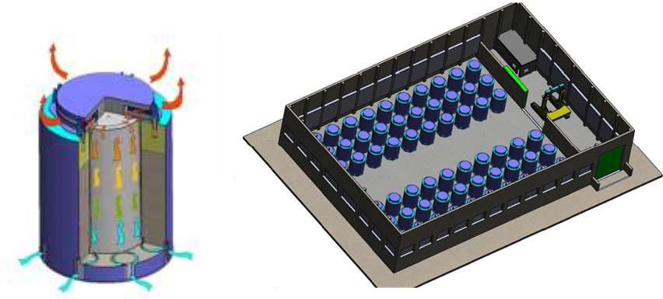
The spent fuel cask and the spent fuel dry storage building with casks.

IV. INTERNATIONAL COOPERATION

IV.1.Quadrilateral Meeting
In June the Slovak Nuclear Safety Administration in Bratislava organized a regular annual meeting in the framework of bilateral agreements between the nuclear safety regulators of the Czech Republic, Hungary, Slovakia and Slovenia, so called Quadrilateral Meeting.

In all countries we are intensively updating the legislation as it has to be harmonized with the provisions of the amended Nuclear Safety Directive and the new Radiation Protection Directive. Important operating events were reported. Most of them are failures of individual parts of the equipment on the secondary side due to control, aging, inadequate materials that cause equipment failure. Hungary and Slovakia are the only countries, where they have
new units planned or under construction.
We also reviewed international topics related to the participation of the said regulators in WENRA, ENSREG, IAEA and NEA, and highlighted the links between nuclear safety and security.

IV.2.Bilateral meetings with Austria and Croatia
This year's meetings between Slovenia on one side and Austria and Croatia on the other side under the respective bilateral agreements were all hosted by the SNSA in October.
In the meeting with Austria, Slovenia provided an overview of the nuclear programme in Slovenia, which comprised operation of the Krško NPP (NEK), description of two reactor trips, important operational events, implementation of the safety upgrade program, the increase of the Sava level due to the start of the HPP Brežice operation, the testing of passive hydrogen recombiners, the periodic safety review and the probability safety analyses. The Austrians developed a new method of sample preparation, which significantly lowered the detection limit for measuring the radioactivity of the air, and they are also engaged in updating their catalogue of countermeasures in the event of an emergency. They also reported on the operation of their LILW storage and the modifications of the TRIGA research reactor in Vienna.
In the meeting with Croatia the preparation of new legislation on both sides was presented. The Slovenian side reported on the modernization of the software for the early warning network. The main item of the meeting was the coordination of measures in the emergency in the Krško NPP. It was agreed that the work will continue on more realistic (more likely) scenarios and we will meet once again by the end of the year in Zagreb. A debate on open issues related to the transposition of the Radiation Protection Directive was held under the item AOB.

IV.3.Project of Assisting the Iranian Regulatory Authority
The consortium of Vienna based company ENCO and four nuclear regulators from the Czech Republic, Hungary, Slovakia and Slovenia was selected by the European Commission to implement the project to assist the Iranian regulator in establishing a Nuclear Safety Centre upgrading the legal framework, improve knowledge of Probabilistic and Deterministic Safety Assessments, provide training and prepare specifications for the Bushehr NPP stress tests. In July the Kick-off Meeting was organized in Tehran and the project duration is 42 months. The SNSA is mainly involved in preparing Feasibility Study for the Nuclear Safety Centre.

V. EMERGENCY PREPAREDNESS

V.1. Exercises
In the last five months SNSA participated in an international exercise ConvEx-3, which took 36 hours, starting on 21 June and ending on 22 June 2017. SNSA participated in the exercise only during working hours, but has nevertheless managed to reach all major objectives including the initial response, following the information and disseminating it. SNSA also successfully offered assistance within RANET mechanism. The exercise was once again a unique opportunity for SNSA to practice different aspects such as low number of staff working in shifts, following information on the event on social media channels, difficulties in implementing the HERCA-WENRA Approach and other.

This year’s ECUREX-2017 was conducted in conjunction with ConvEx-3. Slovenia therefore participated in both of the exercise simultaneously. One of the issues to point out as far as the ECURIE system is concerned is the audio conference that didn’t prove to be useful during the exercise.

V.2. EPREV
For the EPREV mission scheduled from 5 - 16 November 2017, SNSA is in the final stage of completing the submission of national EPR information in the EPRIMS (Emergency Preparedness and Response Information Management System). The reactor information was submitted a few months ago. On a national level the mission’s schedule was confirmed in September by all the participating organizations involved in the emergency response in Slovenia and a coordination meeting is planned in the mid October. In parallel, the details for the arrival of the mission team members are also being coordinated.

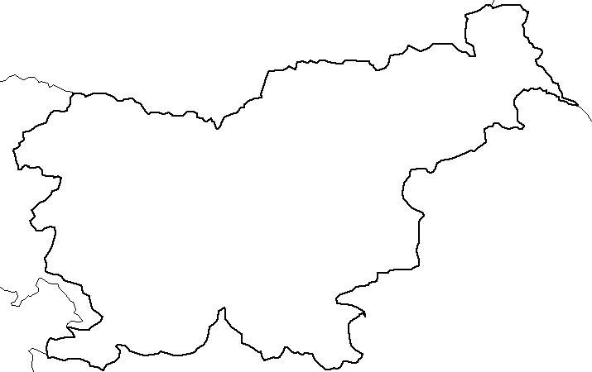
H
u
n
ga
r
y

I
t
a
l
y

A
u
s
t
r
i
a

Ž
i
r
ovsk
i

v
r
h
u
r
a
n
iu
m

m
in
e

R
ese
a
r
c
h
r
e
a
ct
o
r

H
o
t

ce
l
l

C
e
n
t
r
a
l

in
t
e
r
i
m

K
r
šk
o
nu
c
l
ea
r

p
o
w
e
r
-
p
l
an
t
L
J
U
B
L
J
A
N
A

st
o
r
a
g
e

f
o
r

r
a
d
io
ac
ti
v
e

w
as
t
e

C
r
o
ati
a

A
d
r
i
a
ti
c

S
e
a

