# BRIEF SUMMARY

In the period from May 2018 to October 2018, there were no safety significant events to be reported about the Slovenian nuclear installations.

The main activity of the Slovenian Nuclear Safety Administration (SNSA) in this period was finalization of the secondary legislation to align the domestic legislation with the provisions of the EU BSS Directive. The implementation of the Krško NPP Safety Upgrade Program Phase II is underway and it comprises “Alternative design of NEK spent fuel pool cooling”, “Operation support centre reconstruction”, “Installation of the ventilation and habitability system of the new Emergency Control Room and Technical Support Centre”. The Topical Peer Review took place in Luxembourg in May and Slovenia received one good practice, five good performances and four areas for improvement. In October 2018, the Krško NPP hosted the OSART follow-up mission. The conclusion was that 70% of the recommendations were implemented.

# LEGAL SYSTEM

In previous issues of News from Nuclear Slovenia (April 2017, October 2017 and May 2018) it was reported that in the field of legislation the alignment with the provisions of the EU BSS Directive was ongoing. One of major steps was the adoption of the new Ionising Radiation Protection and Nuclear Safety Act (ZVISJV-1). This task was completed on 12 December 2017 and reported in the previous issue of this publication.

However the adoption of the secondary legislation as required by the new Law continues. Since April 2018 two new decrees and eight new rules have been published:

* Decree on the reduction of exposure due to natural radionuclides and existing exposure situations
* Decree on radiation activities
* Rules on the use of radiation sources and on activities involving radiation (JV/SV2)
* Rules on the monitoring of radioactivity (JV10)
* Rules on the criteria of using ionising radiation sources for medical purposes (SV3)
* Rules on the requirements and methodology of dose assessment for the radiation protection of the population and exposed workers (SV5)
* Rules on approving of experts performing professional tasks in the field of ionising radiation (SV7)
* Rules on authorising radiation protection experts (SV7A)
* Rules on the obligations of the person carrying out a radiation practice and person possessing an ionising radiation source (SV8)
* Rules on radiation protection measures in controlled and monitored areas (SV8A).

# THE KRŠKO NPP

## Safety Upgrades in the Krško NPP

The implementation of the Krško NPP’s Safety Upgrade Program (SUP) is a continuous process. Several modifications of the Phase II are ongoing, such as the “Alternative design of NEK spent fuel pool cooling”, “Operation support centre reconstruction”, “Installation of the ventilation and habitability system of the new Emergency Control Room and Technical support centre”.

Regarding the Phase III modifications, the Krško NPP has commenced works on the Bunkered Building 2 (BB2) this autumn. The BB2 will contain design extension conditions (DEC) systems like the alternate safety injection (ASI) and alternate auxiliary feedwater (AAF), both with dedicated tanks of borated and unborated water with capabilities for replenishment from underground water well. The Phase III also envisages the construction of the spent fuel dry storage (SFDS) starting this winter. The prescribed DEC conditions of the new SFDS are in accordance with the new WENRA requirements of 2014. However, some of the design basis conditions defined by the operator will be even stricter. The new storage will have the capacity of up to 2.590 spent fuel assemblies in 70 casks, type HI-STORM FW systems. The SFDS shall be designed for a minimum operation of 60 years.

All the Krško NPP’s upgrades are to be completed by the end of 2021.

## Conclusion of the Topical Peer Review

Under the Euratom Directive Slovenia prepared the National Report within the Topical Peer Review (TPR) on aging management. After the Technical Support Organization had reviewed and issued an independent expert opinion on NEK preliminary report, the SNSA also reviewed this report and included its findings into the National report. The Krško NPP ageing management program fully complies with the Slovenian regulation and is constantly being improved based on internal and external operating experiences and results of R&D activities in the world.

The Krško NPP and the SNSA presented Slovenia at the TPR workshop in Luxembourg, organized in May to discuss the results of the self-assessments, the questions and comments on the National Assessment Reports as well as the replies to the questions, with a goal to identify and discuss both generic and country-specific findings on Ageing Management Programmes. As a result, Slovenia received one good practice, five good performances and four areas for improvement. The good practice was related to external peer review services, good performances were related to data collection, record keeping and international cooperation, opportunistic inspections, scope of concealed pipework included in AMPs, volumetric inspection for nickel base alloy penetration and environmental effect of the coolant. The areas for improvement to be considered are the following: methodology for scoping the SSCs subject to ageing management, delayed NPP projects and extended shutdown, inspection of safety-related pipework penetrations and non-destructive examination in the base material of beltline region.

The SNSA started to prepare the national action plan for addressing relevant findings from Luxembourg TPR workshop and findings from our own national assessment. The actions will cover the implementation of the Ageing Management Programme in the Krško NPP and improvements of regulation. Special attention will be given to findings recognized by experts in the Luxembourg TPR workshop as relevant to Slovenia.

## The IAEA OSART Follow-Up Mission to the Krško NPP

From 15 and 19 October 2018 the Krško NPP hosted an IAEA OSART (Operational Safety Review Team) follow-up mission, which reviewed the adoption progress of the recommendations and suggestions received by the original OSART mission, which took place at the end of May 2017.

The OSART mission leadership complimented the implemented measures, which fully completed 70% of the given recommendations and suggestions, with the rest 30% of measures still under implementation.

The final report of the OSART follow-up mission will be completed and published in the beginning of 2019.

# RADIATION MONITORING

## Radiation Monitoring in Fukushima Area

In August 2018, two employees from the SNSA´s Monitoring Section attended the Response and Assistance Network (RANET) Workshop in the Fukushima Prefecture in Japan. The workshop was organized by the IAEA in cooperation with the Fukushima Prefectural Centre for Environmental Creation. The purpose of the workshop was to strengthen the harmonization of response and assistance capabilities for a nuclear or radiological emergency by working sessions and field exercises, covering the aspects of radiological monitoring in response to a nuclear or radiological emergency.

The SNSA team had an opportunity to test their new instruments in a real situation. At the same time the team was able to perform a pilot test of the new Radioactivity in the Environment web portal (RVO) mobile application which displays a real-time field measurement from mobile units. Experience gained during the pilot test lead to key findings relevant for further development of the RVO mobile application.

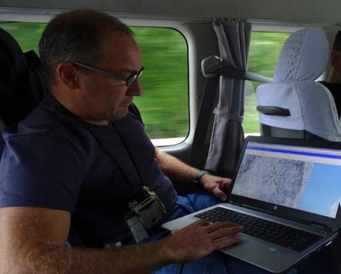

Fig. 1: Field monitoring activities

Overall the SNSA team gained valuable experience in the field of monitoring in a real situation. It is essential that the employees of the SNSA´s Monitoring section, who are also members of the Dose Assessment Expert Group, gain experience with field monitoring to really understand the capabilities of mobile units and to be able to critically evaluate the data received from the field.

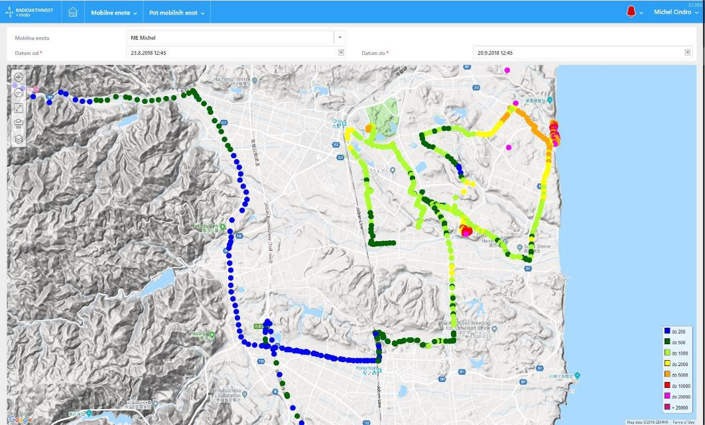

Fig. 2: Display of field measurements (Fukushima Area)

# INTERNATIONAL COOPERATION

## Projects of Assisting the Third Countries

In May 2018, the Final Meeting in Brussels concluded the project of providing assistance to the nuclear and radiation safety authorities of West Balkan countries. There was only one remaining activity on finalization of reports.

The project of Training and Tutoring in which the SNSA cooperates with the Italian company ITER, will be finished in March next year. In November 2018, the SNSA will organize a two-week on-the-job training for two tutees in the area of licensing of research reactors.

The SNSA in consortium with ENCO, TŰV-Nord and the Czech, Hungarian and Slovak nuclear regulatory bodies won the second EC contract to strengthen the Iranian Nuclear Regulatory Authority. The SNSA will be involved in the areas of the management system and emergency preparedness. The project kick-off meeting is scheduled to be in November in Tehran.

# EMERGENCY PREPAREDNESS

## Exercises and Trainings

This year the SNSA conducted a complete overview of its organizational emergency response procedures for notifying EU Members States through the ECURIE communication system. Consequently during the last few months, the SNSA emergency team staff members were fully trained on ECURIE communication tools, especially on the use of WebECURIE. Additionally, due to updates in USIE 7.0 version the SNSA emergency team members participated in trainings on the use of all new features on the USIE Training web platform.

In June 2018 the first of the two annual exercises of the Krško NPP “NEK2018-1” was conducted. As one of the vital results of this exercise communication between the SNSA’s and the NPP’s emergency teams was analysed in detail and communication procedures were revised and updated accordingly. The last exercise that the SNSA participated in, the ConvEx-2b**,** was also participated by the ACPDR (Administration for Civil Protection and Disaster Relief). The Slovenian offer of assistance (OFA) procedures were tested and proved to be in great need for a detailed revision which is planned to be executed through cooperation by the key responsible organizations in Slovenia.

Map of Slovenia showing the positions of nuclear installations