November 2016
I. | BRIEF SUMMARY
In the period from June to November 2016, there were no important events or significant issues to be reported about the Slovenian nuclear installations.

The main activity in this period was the Krško NPP outage and its start-up. Extensive work has been devoted to the preparation of the draft of the new Ionising Radiation Protection and Nuclear Safety Act as well as secondary legislation. The research reactor TRIGA celebrated its 50th anniversary and the Krško NPP Safety Upgrade Programme continues with a slower pace. Thus the deadline for finishing all activities is 2021.

In general, the nuclear and radiation safety was monitored throughout this period and no deviations from normal practices and operation were detected.

II. | LEGAL SYSTEM
Although the amendments of the Ionising Radiation Protection and Nuclear Safety Act have been adopted only a year ago, the draft of the new Ionising Radiation Protection and Nuclear Safety Act is being under preparation again. The main reason is the transposition of the new BSS directive, Nuclear Safety directive, amended Nuclear Safety directive and Radwaste directive. The draft of the new act has just been posted on the SNSA web page for one-month public consultation.

As already reported in previous (May) issue of the News from Nuclear Slovenia, two regulations have been prepared in the area of nuclear safety, i.e. Rules on radiation and nuclear safety factors (JV5) and Rules on operational safety of radiation or nuclear facilities (JV9). Both are ready for adoption by the minister of environment. Above mentioned Euratom directives are partially transposed by prepared regulations.

The third piece of legislation, which is under preparation and will transpose mostly the new BSS directive, is the new Decree on activities involving radiation; the procedure for its adoption by the Government is in the final stage.

III. | THE KRŠKO NPP

III.1. Refuelling Outage
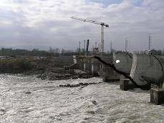
Sava river dam at the Krško NPP under reconstruction

A refuelling outage in the Krško NPP took place from 1 October until 5 November 2016. In comparison with the previous outages, when there were some reportable events, this year's outage was conducted relatively smoothly and in accordance with the plan until plant start-up, when the operators found that two isolation valves in the system for reactor coolant pumps sealing water could not close tightly. The power plant personnel decided to replace both valves to ensure isolation of sealing water. Due to the fact that at time of identification the plant was almost on noload parameters the implementation of corrective measures extended outage for 4 days.
In the evening of 5 November 2016, after 36 days of outage, the Krško NPP began to supply energy to the electrical power grid again.

Some of the main activities during this year’s outage were improvements within Safety Upgrade Plan such as, preparatory work for construction of the Emergency Control Room and making connection point on primary loop which allows connection of two new mobile high pressure pumps. Improvements were performed to prevent or mitigate the impact to the Krško NPP from a new hydro power plant Brežice that is constructed on the Sava river. These measures included modifications of circulating water system and river dam equipment and upgrading of essential service water system.

The next outage will be after the 18 months’ fuel cycle is completed, in the spring of 2018.

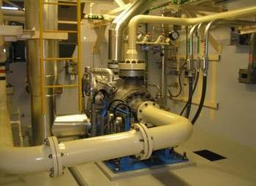
New AF turbine pump

III.2. Construction of the dry spent fuel storage is being delayed
In autumn 2015 the Krško NPP initiated public tendering for selection of the supplier of dry storage facility, which would accept spent fuel from the spent fuel pool in the near future. After selection of the supplier the tenderer, which was not selected, has filed a complaint to the National Revision Commission for Reviewing Public Procurement Award Procedures, the body that is responsible to resolve such disputes. The complaint was not over the procedural issues, but over the technical specifications of the selected offer. The National Revision Commission has therefore engaged technical experts to reanalyse technical details of the offer. This process takes time, thus delay is accumulating and the transfer of spent fuel from the pool into the dry storage is shifted into the future. The construction of dry storage facility is a condition for the operation of Krško NPP till 2043. The Slovenian Nuclear Safety Administration is not yet formally involved into that process, although during the future formal application the safety assessment should address similar analyses, which are a subject of complaint now.

IV. | INTERNATIONAL COOPERATION

IV.1. Bilateral meetings with Italy, Austria and Croatia

On 18 October 2016, the representatives of the Italian National Institute for Environmental Protection and Research (ISPRA) and SNSA met in Trieste. That was the first meeting after signing an Arrangement for the early exchange of information in the event of a radiological emergency and co-operation in nuclear safety matters in 2010. The Italian side presented the development of Italian nuclear legislation and restructuring of the Institute of ISPRA into the new organisation ISIN. They also reported on extensive program of decommissioning of its five nuclear power plants, while the Slovenian side described the operation of nuclear installations and the latest SNSA activities and challenges of the effective operation of the SNSA including management systems and safety culture. Delegations also exchanged their experiences in the area of emergency response.
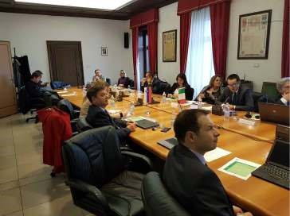
Bilateral meeting in Trieste

On 11 and 12 October 2016, the representatives of Austria and Slovenia convened in Klagenfurt at their annual meeting about nuclear safety matters. Both sides informed each other about the latest developments as regards research reactors, radioactive waste management, emergency preparedness and radiation monitoring. As usual Slovenia presented operation and safety improvements in the Krško NPP. Besides that, both sided exchanged information about harmonization of legislation with EU Directives.
On 8 November 2016 the delegations of the SNSA and the Croatian Office for Radiation and Nuclear Safety met in Zagreb. Both sides exchanged information on cooperation in the area of emergency preparedness and response as well as in the environmental radiation monitoring. Other items on the agenda were the latest developments in the regulatory framework (adoption of new regulations). An important part of the meeting was related to the realization of the approach HERCA-WENRA on cross-border cooperation in the event of a nuclear or radiological emergency.

V. | RADIATION SAFETY ISSUES

V.1. Additional Measuring Capability of the Early Warning System

The SNSA, which is responsible for radiation monitoring in the environment in Slovenia, has enhanced its measuring network by adding a new spectroscopic detection system Envinet SARA in Brinje. The SARA detector enables permanent spectroscopic online monitoring of gamma radiation, including automatic nuclide analysis. SARA is able to detect very low concentrations of artificial nuclides, thereby allowing nuclear events to be identified more quickly and effectively. The station is placed at the research reactor site, and another one is planned near the Krško NPP. In this way, main nuclear installations in Slovenia will be additionally covered by this sophisticated instruments.

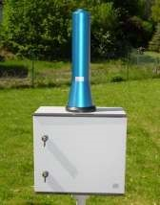
Envinet SARA spectroscopic detection system

The purchase and installation was financed by the IAEA through its national project SLO 9-018 »Technical assistance and cooperation programme«.
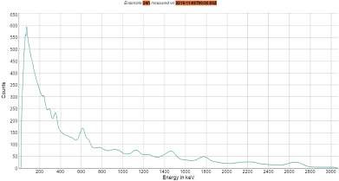

Measurement of the natural background radiation. Dose rates and activities are calculated from each peak for all detected radionuclides.

V.2. Patient Erroneously Exposed
In the Oncological Institute in Ljubljana an 84-year old female patient was irradiated due to an error. She was sent to the hospital instead of a patient with the same name, surname and the year of birth.
In June this year a wrong patient was sent the invitation for the palliative radiotherapy at the hospital in Ljubljana, although she has never been treated for cancer. The direct cause for this event was that both persons had the same name, surname and the birth year. The lady was then unnecessarily exposed to the palliative treatment and she received locally the dose of 8 Gy. The sad fact is that the lady who had to be treated died on 13 June, which was before the wrong patient was exposed.
All the data and facts about this incident are still being collected and analysed. We will provide more comprehensive report in due time.

VI. | EMERGENCY PREPAREDNESS

VI.1. Simulated EPREV
Slovenia invited the EPREV mission, which will be conducted in 2017. As part of preparing for the mission a simulated EPREV was carried by Slovenian team in line with the EPREV methodology. An action plan was issued by the inter-ministerial commission on EPR to facilitate implementation of findings in order to be better prepared for the real EPREV mission in 2017.

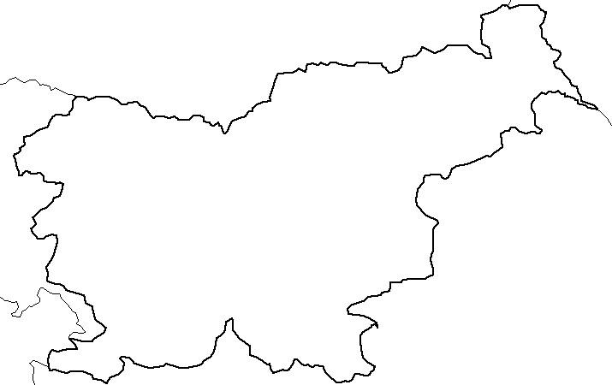

Austria
Italy
Croatia
Hungary
Krško
nuclear
power-plant
Žirovski vrh
uranium mine
Research
reactor
Central interim
storage for
radioactive waste
LJUBLJANA
Hot cell
Adriatic
Sea

