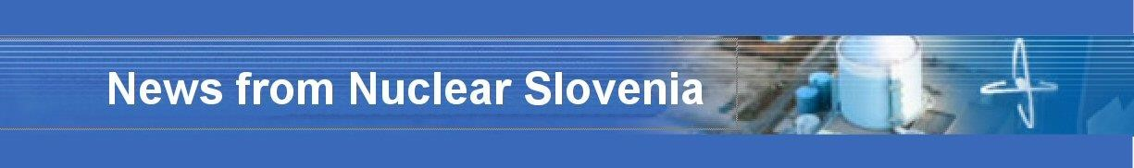

November 2015

I. | BRIEF SUMMARY
In the period from May to November 2015 there were no important events or significant issues to be reported about the Slovenian nuclear installations. However, an earthquake on 1st November 2015 with the epicentre, which was about 5 km from the Krško NPP, is to be mentioned. The earthquake magnitude was 4.2 and it was felt by the inhabitants of Slovenia and western Croatia. The earthquake was detected by the Krško NPP seismic instrumentation and it did not have any impact on its operation. The Krško NPP staff made a walk-down of the systems immediately after the earthquake and no damage was observed.
The main other activities in this period were the adoption of the Amendments to the Ionizing Radiation Protection and Nuclear Safety Act, finalization of the draft National Program for the Management of Radioactive Waste and Spent Fuel Management for the Period 2016-2025 and a visit of the IAEA Director General Yukiya Amano to Slovenia.
II. | LEGAL SYSTEM

II.1. PARLIAMENT HAS ADOPTED AMENDMENTS TO THE IONIZING RADIATION PROTECTION AND NUCLEAR SAFETY ACT
After the approval by the Government in May this year (see more in the May edition of the News from Nuclear Slovenia) the Amendments to the Ionizing Radiation Protection and Nuclear Safety Act have been sent to the Parliament for adoption. Parliament enacted the Amendments in September 2015.
Several amendments have been introduced as a consequence of the lessons learned following the Fukushima Daiichi nuclear power plant accident and the European stress tests while other amendments include:
− | a new provision related to the construction of a new nuclear facility;
− | simplification of certain administrative procedures;
− | clear definitions regarding the obligations of the Agency for Radwaste Management related to the provisions governing the implementation of various public utility services;
− | provisions concerning the vetting of persons working in nuclear facilities;
− | more detailed determination of different types of operational monitoring.
The amendments also include minor, editorial corrections as well as the elimination of minor inconsistencies and deficiencies that have been identified during the application of the Act. These amendments to the Act, together with amendments to several implementing governmental decrees and ministerial rules, transposed the 2014 updated Western European Nuclear Regulators Association reference levels. The new EU basic safety standards for protection against ionizing radiation will be transposed by the end of 2017. The amendments to the Act entered into force on 17 October 2015.The adopted amendments together with the introductory explanations and clarifications, as well as a clean copy of the Act are available in the Slovenian language on the Slovenian Nuclear Safety Administration website.

II.2. DRAFT RESOLUTION ON THE NATIONAL PROGRAMME FOR THE MANAGEMENT OF RADIOACTIVE WASTE AND SPENT FUEL FOR THE PERIOD 2016 - 2025 (ReNPROG)
In 2006, the national programme for the management of radioactive waste and spent fuel management for the period 2006-2015 was adopted based on the Ionising Radiation Protection and Nuclear Safety Act in a form of a Resolution. This was the first strategic document, which covers the full area of radioactive waste and spent fuel management in Slovenia. In 2011, the Council Directive 2011/70 / Euratom of 19 July 2011 establishing a Community framework for the responsible and safe management of spent fuel and radioactive waste was adopted, which requires EU Member States to prepare their national programs for the management of radioactive waste and spent fuel and to ensure their implementation. The Directive also requires Member States to notify the European Commission (EC) by 23 August 2015 about their programmes. Thus, the Republic of Slovenia notified the EC on the existing national programme.
The new Resolution on the National Programme for the Management of Radioactive Waste and Spent Fuel Management for the period 2016 - 2025 has been drafted following the provisions of the above stated Council Directive.
The procedure of adoption of the Resolution follows the procedure of adoption of the acts. Before the Resolution is adopted by the Parliament the public hearing of the draft Resolution was organized with all interested stakeholders. Adoption of the Resolution on the National Programme for the Management of Radioactive Waste and Spent Fuel (for the period 2016-2025) by the Parliament is foreseen in early 2016.
III. | INTERNATIONAL COOPERATION

III.1. IAEA DIRECTOR GENERAL YUKIYA AMANO VISITED SLOVENIA
Mr. Yukiya Amano, the Director General of the International Atomic Energy Agency (IAEA), visited Slovenia from 20 to 21 October 2015. During the visit he met with the representatives of the Ministry of Foreign Affairs, the Slovenian Nuclear Safety Administration, the Slovenian Administration for Radiation Protection and the Ministry of Infrastructure, as well as representatives of medical and research institutions. In the Oncology Institute and the University Medical Centre the hosts presented details of their programs in the field of nuclear therapy and diagnostics. At the Reactor Infrastructure Centre of the Institute "Jozef Stefan" in Brinje near Ljubljana, the IAEA Director General met with the Director of the Institute and visited the TRIGA research reactor, the accelerator and the Training Centre for Nuclear Technology.
Mr Amano met Ms Darja Bavdaž Kuret, Foreign Affairs State Secretary, and briefed her on the relevance of the IAEA’s work related to the recently adopted United Nations Sustainable Development Goals. He also received detailed information about the Slovenian nuclear programme and about the Slovenian involvement in the activities of the IAEA.

At the end of the visit Mr Amano concluded that Slovenia is well developed in all the areas he had seen. He recognized the Slovenian integration into the international community as well as contributions by the Slovenian experts to the activities of the International Atomic Energy Agency. He would like to see at least maintaining of such situation, if not even improving it, in order to ensure long-term sustainability.

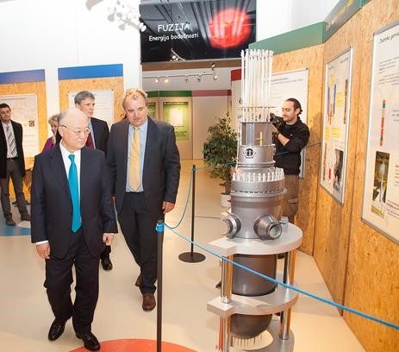

Figure 1: Yukiya Amano in the Information Centre at the Training Centre for Nuclear Technology

News from
Nuclear Slovenia,
November

201
5

Slovenian Nuclear Safety Administration

Litostrojska cesta 54
, Ljubljana, Slovenia,
www.ursjv.gov.si

2

