November 2013
I. | KRŠKO NPP

I.1. KRŠKO NPP REFUELLING OUTAGE
The scope of this year’s outage, besides refuelling, included around 30 modifications and a number of inspections and testing.
Major modifications implemented during the outage were: installation of Passive Autocatalytic Recombiners, installation of Passive Containment Filtered Pressure Relief Ventilation System, Resistance Temperature Detectors Bypass elimination, improvement of the fire protection system, etc.
The event which marked this outage and caused a substantial extension was the damaged fuel.
Extensive Fuel Cladding Damage
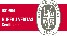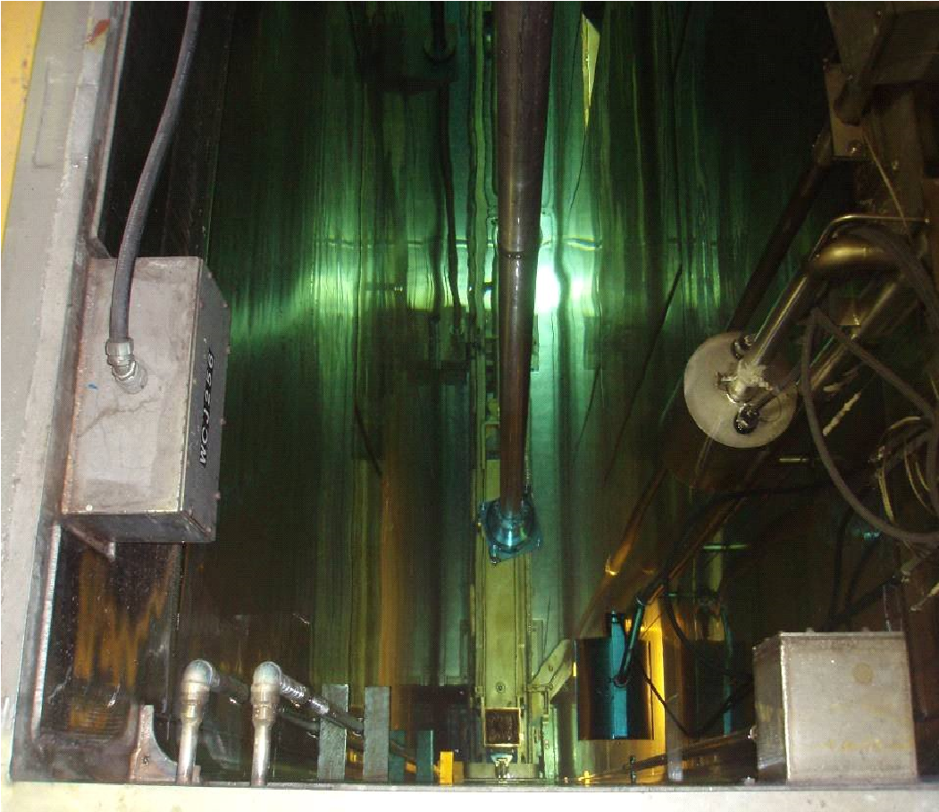
6
MINISTRSTVO ZA KMETIJSTVO IN OKOLJE
UPRAVA REPUBLIKE SLOVENIJE ZA JEDRSKO VARNOST
www.ursjv.gov.si
NEK –poškodovane gorivne palice
Picture 1: Part of a broken fuel rod at the bottom of the fuel
transfer canal
In October 2013, the refuelling outage started in the Krško NPP. All unloaded fuel assemblies were checked for integrity of fuel rods by the in-mast sipping method. Six fuel assemblies were found to be leaking. During transfer of fuel assemblies from the reactor to the spent fuel pool a 50 cm long segment of a fuel rod was found at the bottom of the fuel transfer channel. Visual inspection of all fuel assemblies unloaded from the reactor core showed open defects in 8 fuel rods cladding of three fuel assemblies. All these fuel rods were broken with some parts of cladding missing. The primary cause of the fuel rods leakage is attributed to debris fretting and to baffle jetting that can occur at these fuel assemblies’ locations at the core baffle plate. The other three leaking fuel assemblies had only tight fuel cladding defects of a single fuel rod that were caused by grid-to-rod fretting.
Open fuel cladding defects were diagnosed from measurements of I-134 activity of the reactor coolant since July 2012, two months after the previous refuelling outage. The release of fission products from the damaged fuel occurred during the NPP operation.

Extensive inspection of fuel assemblies and the core baffle plate was carried out to determine the cause of fuel defects and to assure the integrity of the fuel assemblies to be reloaded into the new reactor core. Fuel reconstitution campaign was carried out to replace several fuel rods at exposed locations on the core baffle with stainless steel dummy rods that can resist to the baffle jetting. The root cause analysis of the fuel damage including the proposed corrective actions will be prepared by the fuel supplier and by the operator after the outage.
By extensive fuel inspection during the refuelling outage the Krško NPP assured that all fuel assemblies for the next fuel cycle fulfil the acceptance criteria for reload and that their integrity is ensured. Prior to the start of operation the Krško NPP has prepared an extended Failed Fuel Action Plan that describes appropriate actions in case of a fuel leakage in the next fuel cycle.

Implementation of Post-Fukushima Safety Upgrades
In response to the nuclear accident in Fukushima, the SNSA issued a decision requiring from the Krško NPP to implement necessary safety improvement for the prevention of severe accidents and mitigation of its consequences. The resulting plan, »The Krško NPP Safety Upgrade Program (SUP)« incorporates several large modifications which will be gradually implemented in the next years. The SUP also served as the core of the Slovenian Post-Fukushima National Action Plan (NAcP). More details about the SUP and the NAcP can be found in previous editions of the News from Nuclear Slovenia (see May 2012 and May 2013).
The first upgrades from the SUP, namely installation of Passive Autocatalytic Recombiner (PAR) System and
Passive Containment Filtered Vent (PCFV) System were implemented during the 2013 outage. Both systems are designed to cope with severe accident conditions. The goal of these systems is to protect containment from overpressurisation in case of an accident.
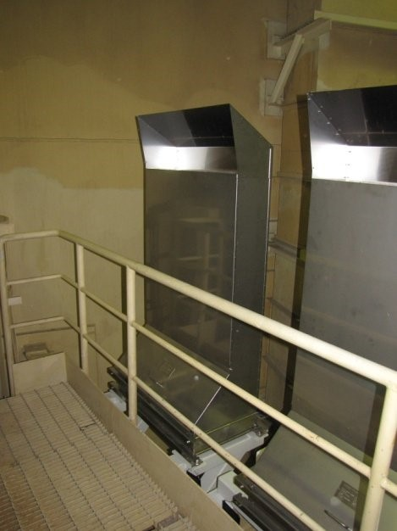
Picture 2: Installed PAR units
The PAR system at the Krško NPP will keep hydrogen concentration below the flammability limit during an accident. Twenty-two PAR units were installed in the containment. PAR is a passive device that contains no active moving parts. Its housing consists of a stainless sheet metal box, open at the bottom and near the top. Forty-four catalytic cartridges are inserted into the housing. Cartridges are fabricated from perforated stainless steel plates which hold the catalyst pellets. Recombination is accomplished by the attraction of oxygen and hydrogen molecules to the surface of catalyst.
An overpressurisation of the containment can occur also due to the production of non-condensable gases. To avoid dangerous pressure increases, PCFV is being installed at the Krško NPP. The purpose of PCFV is to provide protection of containment during potential slow overpressurization in case of a severe accident. The system is fully passive. Venting will start when the containment pressure reaches the preset value (6 bars). The aerosol and iodine filter removes solid particulates as well as gaseous elemental and organic iodine from the venting gas flow. In that way, less than 0.1% of fission products of the reactor core will be released into the environment.
Installation of the PAR System and the PCFV System is an important step in the upgrade of the Krško NPP to enable a successful response to severe accidents.

I.2. Periodic Safety Review OF NPP KRŠKO
The 2nd PSR of the Krško NPP is in its final stage, assessment of the findings and setting up the action plan. Besides the review of all the IAEA safety factors, the review includes the evaluations and measures related to the Post - Fukushima accident response. The status of findings identified during the 1st PSR was also reviewed.
During detailed topical reviews more than 300 findings were identified, none of them representing a major safety issue which may jeopardize nuclear safety of the NPP.
Recent efforts are focused on ranking of identified findings and prioritization of corrective measures. The process of PSR is underway and it will be finished approximately in the first half of 2014.

II. | RADIATION SAFETY ISSUES

II.1. EXPOSURE OF WORKERS PERFORMING INDUSTRIAL RADIOGRAPHY
In October 2013, four workers were exposed performing industrial radiography at a building construction site of a thermo power plant in Slovenia. The dosimetry service reported the received doses of 27.5 mSv, 19.18 mSv, 2.62 mSv and 1.86 mSv in one month period. The received doses of all four workers exceeded a monthly dose constraint of 1.6 mSv. The total received annual doses of two workers were 32.25 mSv and 20.52 mSv exceeding the statutory annual dose limit for occupationally exposed workers of 20 mSv.
Two workers were exposed due to technical problems with one of the devices. It also seemed that personal electronic dosimeters were not working properly. Furthermore, they did not report about the incident to a radiation protection officer.
The exceeded monthly dose constraint of the other two workers was due to workload.
A few days after the event a technical support organization examined all the devices at the site and found out that additional device of the same type was not working properly.
The event is still under investigation. An authorised technical support organisation will perform the reconstruction of the event as well as the equivalent dose for extremities, lens of the eyes, other body organs exposed and the total effective dose will be assessed.
The overexposure of the workers indicates a low level of safety culture in the company.
III. | LEGAL SYSTEM

III.1.RESOLUTION ON NUCLEAR AND RADIATION SAFETY
In 2012, the SNSA prepared a draft of the Resolution on Nuclear and Radiation Safety in the Republic of Slovenia for the period 2013 – 2023.
The proposal was adopted by the Parliament in June 2013. As a high level national policy paper it covers the following chapters:
- The fundamental safety principles;
- Description of nuclear and radiological activities in Slovenia;
- Description of international cooperation in the field of nuclear and radiation safety;
- Description of existing legislation (including binding international legal instruments, such as conventions and other relevant international instruments);
- Description of the institutional framework;
- Competence of professional support (research, education, training);  Objectives and measures to be achieved by 2023.

III.2.AMENDMENTS OF THE ACT ON IONIZING RADIATION PROTECTION AND NUCLEAR SAFETY
In mid-2012, the Slovenian Nuclear Safety Administration started the preparation of the amendments of the Ionising Radiation Protection and Nuclear Safety Act.
The main goals of this new revision of the Act are to simplify the process of obtaining a license, especially in the radiation protection area, to comply with the provisions of other relevant Slovenian legislation (e.g. in the area of construction works, spatial planning, mining, energy...) and to comply with the provisions of EU legislation, WENRA requirements and/or internationally recognised safety standards. A number of amendments were of editorial nature.
While the informal coordination with key stakeholders has already been made, the formal public consultation as well as inter-ministerial coordination are in progress.
Adoption of amendments by the Government is envisaged by the end of this year.
Due to a lack of technical and political support the concept of establishment a Public Agency for nuclear and radiation safety has been abandoned.
In parallel with and as a consequence of the preparation of amendments to the Act, amendments to secondary regulations (several Governmental decrees and even more Ministerial rules) are also underway. The majority of them will be ready for adoption after amendments of the Act have come into force.

III.3.NEW LEGISLATION ADOPTED IN THE AREA OF PHYSICAL PROTECTION
In the physical protection area two legal documents which replaced the existing legal frame in this area were adopted in 2013:
- Rules on physical protection of nuclear facilities, nuclear and radioactive materials, and transport of nuclear substances,
and
- Order on establishing a program of basic training program and periodic retraining of security personnel performing physical protection of nuclear facilities, nuclear or radioactive materials and transport of nuclear substances.
IV. | EMERGENCY PREPAREDNESS
Slovenia has improved preparedness for iodine prophylaxis protective action. Pre-distributing of KI pills in a 10 km zone around the Krško NPP started on 10 June 2013. There are regionally-based stockpiles for the rest of population. Residents around the NPP received a leaflet with a voucher inviting them to go to local pharmacies to get KI pills. There was a press conference held and a dedicated website was set up (www.kalijevjodid.si).
Slovenia is gradually improving post-accidental preparedness as well. The National Plan supplement has been developed by the SNSA for large scale accidents. The French CODIRPA was taken into account and Fukushima lessons as well. In addition, the SNSA procedure for extraordinary measures adopted after a smaller scale emergency ordered by the minister was issued.
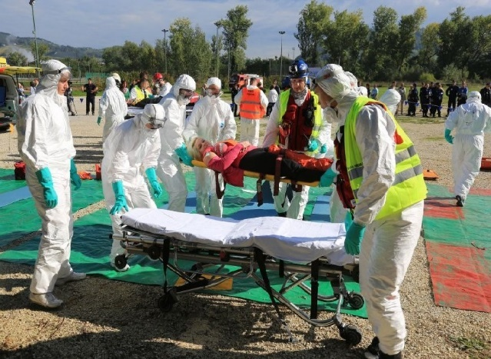
Picture 3: Exercise »Evacuation 2013«
The new IAEA EPR-NPP document is taken seriously in Slovenia. Therefore, a national seminar with over 90 participants was organized about it, paving the way for future improvement.
This year's NPP Krško annual exercise was unannounced. It was conducted in the early morning hours on 20 June 2013. The simulated emergency was fallen fuel assembly during outage. The main objective was to test the activation process of emergency teams at the plant and at the SNSA.
Another bigger exercise was a regional exercise »Evacuation 2013«, which was conducted as part of the EU project of the local municipality of Krško. The first part was a table-top exercise simulating a major release from the Krško NPP. The second part was a field exercise with actual response to a traffic accident within a contaminated zone and actual evacuation of 100 volunteers.

V. | INTERNATIONAL COOPERATION

V.1. VISITS TO THE SNSA
In July the SNSA conducted one month training for two participants from Vietnam and Jordan, who were gaining knowledge in the regulatory use of the probabilistic safety assessment. Also in July two inspectors from Montenegro visited the SNSA for one week scientific visit organized by the IAEA. In October three trainees from Indonesia, the Philippines and Iraq received a three week tutoring on safety and licensing of research reactors. In November two Indonesians had one week scientific visit on siting and seismic issues for nuclear power plants. In mid-November three participants from the Democratic Republic of Congo started one month IAEA fellowship on research reactors. On 18 in 19 November 2013, the Kosovo Agency for Radiation Protection and Nuclear Safety visited the Slovenian Nuclear Safety Administration. Their programme covered drafting of regulations, radiation monitoring, preparation of reports and international cooperation.

V.2. BILATERAL MEETING WITH AUSTRIA IN LJUBLJANA
On 7 and 8 October 2013 a regular annual bilateral meeting with Austria took place in Ljubljana. The meeting was organized in line with the bilateral agreement, which foresees early notification in case of nuclear or radiological emergency and exchange of information. The meeting addressed the following areas: legal framework, radiation protection, emergency preparedness, Slovenian nuclear power program, research reactors and radioactive waste management. This meeting’s focus was on research reactors and the delegation visited the TRIGA research reactor in Podgorica near Ljubljana on 8 October. These meetings serve as an information exchange platform as well as for prompt resolving of open issues, which may arise during the year.

Nuclear Slovenia in Brief
Slovenia is the smallest country with a nuclear power plant operating in its territory. Nuclear facilities include: 1 Nuclear Power Plant in operation (PWR, 2-loops, Westinghouse, 696 MWnet), 1 Research reactor in operation (TRIGA Mark II, 250 kW), 1 Central interim storage of radwaste (not for NPP waste - radioactive waste and spent nuclear fuel from NPP is stored within the NPP site) as well as radiation facilities and practices: 1 repository of hydro-metallurgical tailings, 1 repository of mine tailings, and around 300 organizations, engaged in radiation practices with altogether about 2000 radiation sources in use.
The Slovenian Nuclear Safety Administration was established in 1987. It is responsible for nuclear and radiation safety, transport, and management of nuclear and radioactive materials in the Republic of Slovenia.
For the radiation safety in medicine the competent authority is the Slovenian Radiation Protection Administration within Ministry of Health.
Physical protection of nuclear materials and nuclear facilities is a responsibility of the Ministry of the Interior.
Agency for Radioactive Waste Management deals with site selection and planning of the repository for low and intermediate level radwaste and is a public service of radwaste management from small producers.
Administration of the Republic of Slovenia for Civil Protection and Disaster Relief performs administrative and professional protection, rescue and relief tasks as well as other tasks regarding protection against natural and other disasters.

