November 2012
I. | KRŠKO NPP

I.1. LONGTERM OPERATION OF THE NPP KRŠKO
In June 2012 SNSA approved Aging Management Program and changes of the Safety Analyses Report which give option for long term operation. This was the last step of a long process which began with the first Periodic Safety Review. In the process of the plant life extension the NPP Krško is bound to meet Slovenian regulatory requirements. The required Aging Management Program was prepared in line with the US NRC practices. The SNSA reviewed reports regarding aging management review, and reviewed and assessed all programs related to aging management. SNSA review also included inspections in the plant with on-site walk-downs. The Krško NPP application was thoroughly reviewed by the technical support organization, which hired the international team for this specific task.
The legal requirements limit operational lifetime of the NPP to 10 years and foresee the periodic safety review as a tool to determine if safety criteria for further NPP operation have been met.

I.2. SHUTDOWN OF THE NPP KRŠKO DUE TO POLLUTION OF THE SAVA RIVER CAUSED BY FLOOD
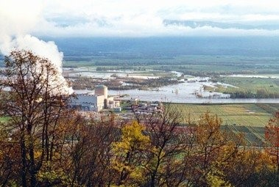
Picture 1: Floods around the NPP Krško
On 28th October 2012 the flow of the Sava River suddenly rose due to heavy rain. The river flooded the riverbanks and washed out biological (branches, logs, leaves) and other alluvial material into the river stream. Downstream of the flooded area the Sava caused clogging of the cleaning devices at the inlet of the condenser cooling system in the Krško NPP. Difference level through traveling screens of circulating water system increased over 1 meter, resulting in automatic opening of safety hatches. Because of that condenser filters and consequently pipes of the heat exchanger in the condenser have partly clogged. Condenser cooling water flow was reduced, consequently temperature and pressure increased and vacuum in the condenser was deteriorated. Efficiency of the secondary cooling system was decreased, despite the Sava water treatment facility operated at full capacity. Due to significantly reduced condenser capability for heat transfer the operators decided to manually carry out preventive shutdown of the reactor. Before that operators at the NPP started with the preparation of putting the cooling towers in operation according to the procedures in order to obtain cleaner water at the inlet of the condenser cooling system. Similar actions have already been successfully taken by the NPP in the past.
During shutdown all equipment performed as expected. The event had no on-site or off-site effects. On 30th October 2012, the Krško NPP was synchronized to the grid. Before the plant restart, the SNSA reviewed the results of a preliminary analysis of the event and after equipment inspection was carried out, it was concluded that all problems due the Sava River pollution were successfully solved and the power plant was ready for safe and stable operation.

II. | RADIATION SAFETY ISSUES

II.1. FUEL TRANSPORTATION
The shipment of slightly irradiated low enriched nuclear fuel from the United States of America for the research reactor in Vienna – Austria arrived in the port of Koper – Slovenia in October. The shipment was in less than one hour transhipped onto a truck and immediately sent to Vienna. Shipment was carefully checked for radiation by radiation safety experts from the »Jožef Stefan« Institute. The Slovenian police ensured physical protection.
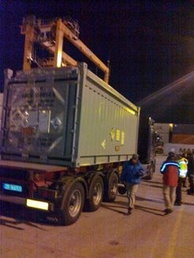
Picture 2: Shipment in the port of Koper

There was another shipment of spent fuel from Vienna which crossed Slovenian border at midnight on November 8. Early in the morning the transport arrived in the Port of Koper. Container for spent fuel and container for plutonium-beryllium source of radiation were loaded on the ship. The shipment left the port of Koper early in the morning and the ship sailed to Trieste – Italy. In Trieste the spent fuel from Italian research reactor was loaded.
With this, Slovenia has made another contribution to the international campaign for the collection and removal of nuclear fuel with highly enriched uranium from research reactors to the suppliers. The basic purpose of this campaign is to reduce the possibility of misuse of such material for nuclear weapons.

II.2. STATE INSTITUTIONS HAVE PREVENTED ECONOMIC DAMAGE IN THE JESENICE IRONWORKS
On 8th September 2012 a malfunction of the device containing radioactive source occurred in the Jesenice ironworks. The Slovenian Nuclear Safety Administration, the »Jožef Stefan« Institute and the Agency for Radioactive Waste were informed about the event. They arranged the transport of radioactive source to the hot cell of the »Jožef Stefan« Institute, where the device was repaired and then returned to the ironworks. By this, they prevented economic loss in the amount of more than 80,000 euros per each day while at the same time they showed that the state institutions are capable of swift and effective action.
In the company Acroni Jesenice there was a malfunction of the device for measuring thickness of the steel plates in line production of hot rolling mill facility. As a consequence the production was stopped. This specific device contains high-activity radiation source with radionuclide Cs-137, which is built in the original protective container. It is an integral part of the production line. After a detailed review Acroni’s engineers concluded that the container shutter was not working properly and that error was probably somewhere in the mechanical part of the device. Gauge, housing of resource and container were not damaged. Agency for Radioactive Waste arranged transportation on 11 September 2012 in accordance with the regulations, i.e. the European Agreement concerning the International Carriage of Dangerous Goods – ADR. The device was successfully repaired in the hot cell in several hours and then returned immediately to the ironworks.
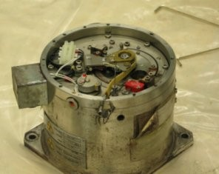
Picture 3: Radioactive source in Acroni
All the above mentioned institutions demonstrated high level of coordination and responded immediately. Despite the time pressure, all involved communicated effectively, they worked together smoothly and acted towards the same goal – efficient public service to meet the company request while the economic losses were at stake.

II.3. RADIATION EXPOSURE INCIDENTS
In August 2012 a worker working with X-ray machine in the laboratory for industrial radiography was overexposed. The dosimetric service has reported to competent authority that a worker received dose of 7,6 mSv in one month period. The particular worker performing radiography entered into the controlled area when the X-ray machine was operating. The safety system was in place, but it was turned off due to negligence.
At another occasion a worker mounting an X-ray level gauge was overexposed in one of Slovenian breweries. The level gauge was beforehand wrongly repaired by a foreign servicing company. The reconstruction of incident and a dose assessment are under investigation.
In both cases the SNSA and Slovenian Radiation Protection Administration inspections have investigated events, have demanded corrective actions and will impose enforcements.
III. | NUCLEAR SAFETY ISSUES

III.1.INTERNATIONAL MISSION INSARR TO THE TRIGA RESEARCH REACTOR
A group of international experts for nuclear and radiation safety completed a five-day mission (12 to 16 November 2012) during which the safety of the research reactor TRIGA Mark II of the »Jožef Stefan« Institute was reviewed. The mission concluded that the reactor operates well and in line with the international standards and accepted practices. The mission recognized two good practices and advised on possible improvements, for which 16 recommendations and 8 suggestions were proposed. The IAEA plans to finalize the INSARR mission report by the end of 2012.
The recommendations for safety improvements comprise both technical and organizational factors as well as improvements of procedures and update of the safety analysis report. The recommendation to the Slovenian government was to ensure adequate resources for assurance and improvements of safety of the research reactor what includes also provision for a full-time employment for the head of the reactor in the frame of the »Jožef Stefan« Institute. The mission also concluded that the regulatory supervision of the SNSA is adequate.

The director of the »Jožef Stefan« Institute Prof. Jadran Lenarčič and the SNSA director Andrej Stritar have positively accepted the mission conclusions and announced that they will make an effort to fulfil the mission recommendations as soon as practical.
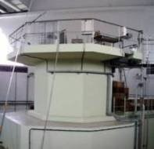
Picture 4: Research reactor TRIGA Mark II of the »Jožef Stefan« Institute intended for research, training and isotope production

IV. | LEGAL SYSTEM
As reported in the previous Nuclear Slovenia Issue (November 2011) the IRRS mission has been conducted in Slovenia at the end of 2011. Among some other issues identified by the IRRS Team, there were two related directly to the legislative part of our work:
- Slovenia should develop a national policy and strategy for nuclear safety which would be supported by a national coordinated plan to ensure the appropriate national infrastructure is in place;
- Consideration should be given to possible alternative methods of financing SNSA to provide it with the flexibility to meet its regulatory responsibilities while also ensuring it operates effectively. This should include provision for research and development.

IV.1.RESOLUTION ON NUCLEAR AND RADIATION SAFETY
As a concrete and immediate respond to the first above mentioned IRRS recommendation, the SNSA has already prepared the draft Resolution on Nuclear and Radiation Safety - as a high level national policy paper, adopted by the Parliament. The Resolution is now in the phase of informal coordination with all stakeholders in this area and it is expected to be sent to the governmental procedure by the mid-December, following the same procedure as for adoption of an Act.

IV.2.TRANSFORMATION OF THE SLOVENIAN NUCLEAR SAFETY ADMINISTRATION INTO THE PUBLIC AGENCY
As a reaction to the second item above, the SNSA started with the preparation for changing its status into a Public Agency. This could be done basically through amendment of the Ionising Radiation Protection and Nuclear Safety Act and some more legal documents (founding act of the Agency, adopted by the Government as well as a work program and financial plan for each year, etc.) The main goals which with this proposal are:
- Lesser dependence on the state budget, i.e. a relief to the state budget, and financial stability of the authority by introducing a system of licensing fees,
- Streamlining operations and elimination of administrative barriers by merging the SNSA and the Slovenian Radiation Protection Administration (SRPA) into one Agency,
- Independence of the impact on regulatory decision making (although the current administrative arrangements under the Slovene legislation even nowadays provides two bodies both, the SNSA and the SRPA, full and effective independence, the future position of the Agency would be even strengthen),
- More efficient staffing and financial flexibility. Through the licensing and annual fee system faster and more efficient response is possible to any changes in circumstances, such as life time extension of the existing nuclear power plant and / or plans to build a new one).
V. | EMERGENCY PREPAREDNESS

V.1. MAINTAINING NATIONAL EMERGENCY PREPAREDNESS
In October 2012 the SNSA moved to different rooms within the existing building, into which it has moved at the beginning of this year. This move also affected the rooms of the Emergency Preparedness Centre. It had to be squeezed into two rooms instead of three. This action resulted in shared room for the Nuclear Accident Analysis Group and for the Dose Assessment Group, as well as communication lines had to be re-installed and for the positions a new layout had to be prepared. This new setup was successfully tested in the annual nuclear emergency exercise with the Krško NPP on 14th November 2012. The scenario started with an earthquake and loss of all electrical power supply.
In 2012 the batch of Iodine pills was purchased. The pills should be distributed to all population living in the Krško urgent protective actions planning zone (i.e. within the radius of 10 km around the NPP). The initial information campaign about distribution of KI pills was organized for local authorities in September, but actual distribution has not started yet. It was planned that individuals would get their pills in pharmacies and receipt of pills should be recorded on their respective health insurance cards. The public information commissioner is reviewing this activity in light of protection of personal data and the distribution is delayed.

VI. | INTERNATIONAL COOPERATION

VI.1. SIGNATURE OF MEMORANDUM OF UNDERSTANDING WITH ALBANIAN NUCLEAR AGENCY
On 18 September 2012, on the margins of the General Conference of the International Atomic Energy Agency, the
SNSA director, Andrej Stritar, and the director of the National Nuclear Energy Agency of the Republic of Albania, Milo Kuneshka, signed the Memorandum of Understanding on the exchange of information between the two organizations.
Based on the Memorandum, the exchange of information in areas of nuclear safety installations will be facilitated, e.g. such as inspection, safeguards and waste management, as well as construction, operation, commissioning and decommissioning of nuclear installations. The Memorandum covers also issues related to transport, transit and shipment of radioactive materials including radioactive waste.

VI.2. BILATERAL MEETING WITH AUSTRIA IN GRAZ
On 11th and 12th October 2010 a regular annual bilateral meeting with Austria took place in Graz. The meeting is organized in line with the bilateral agreement, which foresees early notification in case of nuclear or radiological emergency and exchange of information. The meeting addressed the following areas: legal framework, radiation protection, emergency preparedness, Slovenian nuclear power program, research reactors and radioactive waste management. This meeting was held after the stress test campaign for NPPS was concluded early this year and the 2nd extraordinary meeting of the Nuclear Safety Convention parties took place in Vienna in August, thus the stress tests and the associated action plan for the Krško NPP were presented. These meetings contribute to regular contacts and exchange of views of both delegations, as well as to prompt resolving open issues, which may arise during the year.
The Austrian delegation has announced a thorough desk-top review of all nuclear power plants in the neighbouring countries.
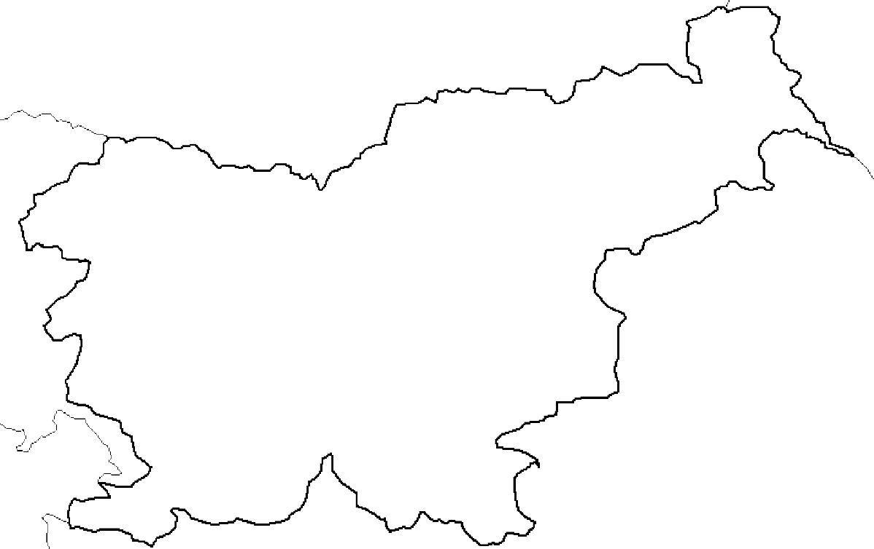
Austria
I
t
a
l
y
Croatia
H
u
n
g
a
r
y
Krško
nuclear
power-plant
Žirovski vrh
uranium mine
Research
reactor
Central interim
storage for
radioactive waste
LJUBLJANA
Hot cell
Adriatic
Sea
Nuclear Slovenia in Brief
Slovenia is the smallest country with the nuclear power plant operating at its territory. Nuclear facilities include: 1 Nuclear Power Plant in operation (PWR, 2-loops, Westinghouse, 696 MWnet), 1 Research reactor in operation (TRIGA Mark II, 250 kW), 1 Central interim storage of radwaste (not for NPP waste - radioactive waste and spent nuclear fuel from NPP is stored within the NPP site) as well as radiation facilities and practices: 1 repository of hydro-metallurgical tailings, 1 repository of mine tailings, and around 300 organizations, engaged in radiation practices with altogether about 2000 radiation sources in use.
The Slovenian Nuclear Safety Administration was established in 1988 as a body within the Ministry of the Environment and Spatial Planning. It is responsible for nuclear and radiation safety, transport, and management of nuclear and radioactive materials in the Republic of Slovenia.
For the radiation safety in medicine the competent authority is the Slovenian Radiation Protection Administration within Ministry of Health.
Physical protection of nuclear materials and nuclear facilities is responsibility of Ministry of Interior. Agency for Radioactive Waste Management deals with site selection and planning of the repository for low and intermediate level radwaste and is the public service of radwaste management from small producers.

