May 2016

I. | BRIEF SUMMARY
In the period from November 2015 to May 2016 there were no important events or significant issues to be reported about the Slovenian nuclear installations.
However, there was an earthquake on 9th of April 2016 (similar to the earthquake on 1st November 2015) with the epicentre close to the Krško NPP site. The magnitude of the earthquake was estimated to be 3.3 and the tremor was felt by the inhabitants of Slovenia and western Croatia. The earthquake was detected by the Krško NPP seismic instrumentation and it did not have any impact on its operation. The Krško NPP staff strictly followed the prescribed procedures and made a walk-down checking the operability of the systems immediately after the earthquake. No damage was observed.

II. | LEGAL SYSTEM

II.1. Parliament has adopted a Resolution on the National Programme on Radioactive Waste and Spent Fuel Management
On April 22th, 2016, the National Assembly of the Republic of Slovenia adopted the Resolution on the National Programme on Radioactive Waste and Spent Fuel Management for the period 2016 - 2025 (ReNPROG).
This Resolution, which builds on and replaces the Resolution on the National Programme on Radioactive Waste and Spent Nuclear Fuel Management for the period 2006 – 2015, contains the radioactive waste and spent fuel management policy, as well as programmes (concrete measures) for achieving the policies/objectives.
The main objective of the resolution is to protect people and the environment from unnecessary harmful effects of ionizing radiation from radioactive waste management. The ultimate objective is the disposal of such waste in disposal facilities, which will be safe for all future generations. The resolution sets the framework for the management of low and intermediate level radioactive waste, spent nuclear fuel and highly radioactive waste, directs the activities of the major nuclear and radiation facilities in the field of radioactive waste management, touches the necessary scientific and research activities, funding and communication with the public.
The resolution is appropriately placed in the overall Slovenian legal framework in this field. Based on the provisions of the Act on Ionising Radiation Protection and Nuclear Safety it is in line with the provisions of the Intergovernmental Agreement between Slovenia and Croatia on co-ownership of the Krško NPP and its content fully complies with the requirements of Council Directive 2011/70/Euratom establishing a community framework for the responsible and safe management of spent fuel and radioactive waste.

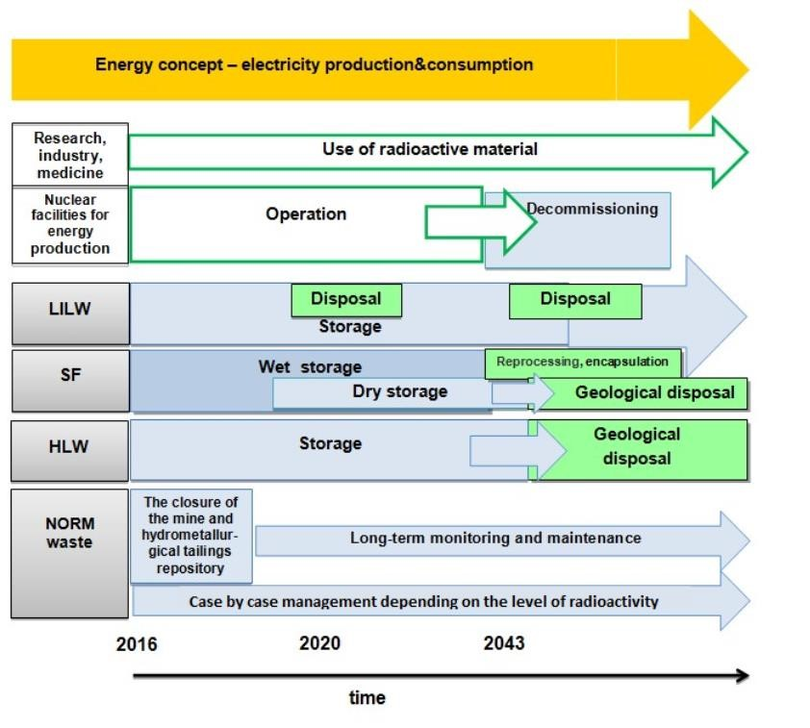
Figure 1: Basic elements of the National Programme on Radioactive Waste and Spent Nuclear Fuel Management for the period 2006 - 2015 and the timeline

II.2. Regulation Updates
The SNSA prepared drafts of two regulations, Rules on radiation and nuclear safety factors (JV5) and Rules on operational safety of radiation or nuclear facilities (JV9) due to changes of the Ionising Radiation Protection and Nuclear Safety Act. The main novelty or changes with respect to the existing requirements in the regulations JV5 and JV9 are:
- Introduction of new or renewed "WENRA Reference Levels" from September 2014,
- Introduction of changes in response to the accident in Fukushima,
- Changes in the “Safety and quality management” chapter because of changed standards of the International Atomic Energy Agency (IAEA) in this area,
- More detailed requirements regarding reporting and analysis of operating experiences.
Public hearing for both draft regulations was completed in February 2016. The two draft regulations were also approved by the Expert Council for Radiation and Nuclear Safety. It is expected for both regulations to be adopted before the end of 2016.

III. | THE KRŠKO NPP

III.1. The status of the Krško NPP's Safety Upgrade Programme
The Krško NPP, in December 2015, applied for another deadline extension, i.e. the third SUP phase to be finished by end of 2021 instead of 2018. The Krško NPP's application also includes a revision of the SUP programme. The major change is the revision of alternative ultimate heat sink, which would be assured through the use of steam generators fed by additional dedicated sources of water capable of replenishing from underground wells. This way the cooling of the reactor would be assured for at least 30 days even with the loss of existing UHS. The application is still pending final decision.
At the moment the SUP is divided into three phases.
Phase 1 was already implemented in 2013:
- Replacement of active hydrogen recombiners with passive ones (PARs); also capable of managing hydrogen from severe accidents
- Installation of passive containment filtered venting system
Phase 2 is underway and is to be implemented by the end of 2018:
- Flood protection of the nuclear island
- Operation support centre reconstruction
- Installation of pressurizer PORV bypass
- Spent fuel pool alternative cooling
- Alternate cooling of reactor coolant system and containment
- Installation of emergency control room
- Upgrade of bunkered building 1 electrical power supply
- Emergency Control Room / Technical support centre ventilation and habitability system
- Replacement and upgrade of critical instrumentation
- Construction of dry spent fuel storage facility
Phase 3, for which the plant applied for deadline extension until 2021 (pending SNSA's decision):
- BB2 – bunkered building with additional sources of borated and unborated water with injection systems for reactor cooling system, containment and steam generators capable of assuring reactor cooling for at least 30 days.

III.2. Nuclear fuel integrity and modifications to increase the fuel robustness
Damaged fuel assemblies were found during the core unload of the 2013 and 2015 Krško refuelling outages. The findings were already reported in Nuclear News of November 2013 and May 2015. A root cause analysis identified causes for fuel degradation as baffle jetting, grid-to-rod fretting and debris fretting. Several corrective actions and improvements of fuel design were taken to prevent recurrence of fuel damage or improve durability of the fuel. During the 2015 outage the upflow conversion was implemented to prevent the baffle jetting. New fuel that was loaded into the core in 2015 was improved against debris fretting by an oxide layer on the lower part of fuel rods. In 2016, the mechanical modifications of fuel assemblies' grids and bottom nozzles will be performed to enhance fuel robustness to grid-to-rod fretting and debris fretting. So far there are no leaking fuel assemblies in the core after 11 months of operation of current fuel cycle that will end in October 2016 with a refuelling outage.

III.3. Constructions on the Sava river and impacts on the Krško NPP safety and operation
In 2015 and 2016, the construction of the Brežice hydro power plant (HPP) is going on. The new HPP will change the level and flow of the Sava river and will therefore have an important impact on the Krško NPP safety and operation. To prepare the Krško NPP for new conditions on the Sava river several modifications of the Krško NPP were identified that will improve the design of the cooling systems, NPP river dam, the drainage systems, the control of groundwater level and monitoring of the Sava river water. The Brežice HPP should begin its operation at the end of the year 2016 and prior to that all modifications of the Krško NPP shall be completed.

IV. | EMERGENCY PREPAREDNESS

IV.1. The INEX 5 exercise
The SNSA organized the OECD/NEA exercise INEX 5 as a regional exercise with the IAEA and all neighbouring countries participating (Austria, Croatia, Hungary, Italy) in it. It was conducted on 16th March from 8:00 to 20:00 CET. The basic story was ice storm with nuclear emergency, run by the injects and the Krško full scope simulator. Real communication channels and procedures were used. There was no real media involved, only a short press release about the exercise was issued. The weather was simulated. The exercise was an excellent opportunity to test national and regional preparedness identifying gaps and areas to improve.

IV.2. Simulated EPREV
Slovenia invited the EPREV mission to be conducted in 2017. As part of preparations for the mission a simulated EPREV was carried by a Slovenian team in line with the EPREV methodology. It was a two-week mission held in May 2016 with 35 interviews and 77 interviewees out of which 29 were on location. There were 14 site visits. The simulated EPREV mission found out a lot of gaps to close and ways to improve and a couple of good practices. An action plan is to be developed to facilitate the implementation of findings in order to be better prepared for the real EPREV mission in 2017.

