May 2015
I. | BRIEF SUMMARY
In the period from December 2014 to May 2015 there were no important events or significant issues to be reported about the Slovenian nuclear installations. However, there was an event, which needs to be explained.
At the end of February there was an increased fuel leakage in the Krško NPP. The Krško NPP informed the media and the SNSA about this event, which indicated that the fuel could be again a problem. After initial increase the leak remained stable and the NPP did not exceed the limits which would require a shutdown. The refuelling outage started in April as scheduled. More details about the outage and the causes of the leak is provided below in II.1 “Refuelling Outage 2015” under the heading “The Krško NPP”.
In general, the nuclear and radiation safety was monitored throughout this period and no deviations from normal practices and operation were detected.
II. | THE KRŠKO NPP

II.1. REFUELING OUTAGE 2015

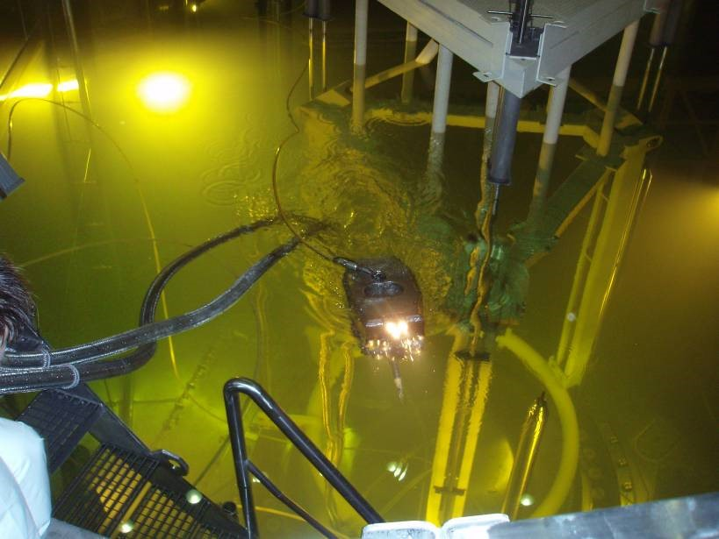
Figure 1: Foreign object search and retrieval (FOSAR)

The Krško NPP operates with 18-month fuel cycles. In 2015 the refuelling outage took place from 11 April until 16 May 2015, i.e. 36 days. In comparison to the last outage in 2013, when the main issue was damaged fuel, this year's outage was conducted smoothly and closely following the schedule. In the end of the outage the accumulated delay was only 10 hours.
A month before the outage the increased concentrations of radioactive iodine were detected in the primary coolant. This increase was attributed to a leakage of at least one fuel rod in the reactor core. The measured leakage was significantly lower than that before the outage 2013. During the refuelling operations two damaged fuel rods were found, which is significantly less than a year and a half ago. Obviously, measures to ensure the fuel integrity, implemented during the outage 2013, were quite successful in reducing fuel damage problems. During this outage carefully prepared modification of coolant upflow conversion through the core bypass was performed, which will eliminate baffle jetting, the cause for the extensive damage of the fuel in the long term.

During the outage extensive maintenance work and some technological improvements or upgrades were carried out. Some of the main activities during this year’s outage comprise replacement of the instrumentation in the reactor core, installation of the ultrasonic level measurement system of the primary coolant system, replacement of hydraulic regulators on diesel generators and the conclusion of the multiannual project of comprehensive renovation of the 400kV switchyard. Besides series of surveillance tests of the equipment and verification of equipment status, which can be carried out only when the power plant is shut down, were performed, some of the welds of the primary loop were inspected, fuel and control rods were examined using ultrasonic inspection, U-tubes of steam generators were examined, sludge lancing of steam generators was performed and electrical inverters were replaced. After replacing the low pressure turbines in 2006 a comprehensive outage of one of the turbines was carried out for the first time.
The SNSA has continuously overseen implementation of outage activities, in particular those which are important for ensuring high level of nuclear safety. The implementation of certain activities has been reviewed and approved by the SNSA before the outage. Due to extensive scope of activities the support in oversight of important outage activities was provided by technical support organizations. The plant restarted to produce electricity only after the authorized organizations and the SNSA agreed and confirmed that all the work has been properly carried out, all the tests were successful and that nuclear safety was ensured. The next outage will be in autumn of 2016.
III. | LEGAL SYSTEM

III.1. AMENDMENTS OF THE ACT ON IONIZING RADIATION AND NUCLEAR SAFETY
Drafting of the latest amendments was finalised by the end of 2013 (see November 2013 edition of the News from Nuclear Slovenia). Due the resignation of the Government in the beginning of May 2014 the second round of inter-ministerial coordination was resumed in September 2014.
The amendments have been recently adopted on the Governmental session and send to the Parliament for final adoption.

III.2. AMENDMENTS TO THE DECREES AND RULES
Decree on areas of restricted use of land due to nuclear facilities and on the conditions for construction in these areas: The latest amendments to the Decree were adopted to comply with the provisions of the Construction Act in so far as it relates to the demolition, replacement works, removal of structures and to comply with the new requirements for classifying and sorting objects according to the complexity of the construction.
The aim of the latest amendments remains the same, i.e. to ensure the implementation of radiation and nuclear safety measures, which restrict the use of land in the vicinity of nuclear facilities, thereby reducing the possibility of industrial or other accidents outside the nuclear facility, which could have an impact on nuclear safety and at the same time to impose restrictions in relation to population density and the requirements relating to local infrastructure facilities in order to minimize the possibility of damage to human health and to the environment if a nuclear facility incident occurs. The amendments to the Decree entered into force on December 20, 2014.
Decree on the criteria for determining the compensation rate due to the restricted use of land and intervention measures in nuclear facility areas: This Decree lays down the criteria for determining the amount of compensation the nuclear operator has to pay to the municipalities for restricted use of land due to the area of a nuclear facility (“the compensation”) and for planning and implementation of intervention measures (“the charge”).
The Decree was adopted as a corrective measure on the basis of the conclusions of the Court of Audit, which were set out in the Audit Report on the site selection of the repository for low and intermediate level radioactive waste. This Decree is now consistent with the Act on Protection Against Ionizing Radiation and Nuclear Safety and with the latest amendments of the Decree on areas of restricted use of land due to nuclear facilities and on the conditions for construction in these areas in order to eliminate the deviation of the current determination of compensation, as they were identified in the report of the Court of Audit. This Decree entered into force on 1 January 2015.
Amendments of the Rules of Transboundary Shipment of Nuclear and Radioactive Substances: The amendments were introduced to improve the content of the application for authorization. The amendments to the Rules entered into force on the day following its publication in the Official Gazette of the Republic of Slovenia, i.e. on July 5, 2014.

IV. | INTERNATIONAL COOPERATION

IV.1. ASSISTANCE TO THAILAND
In December 2014 the consortium of ENCO (Austria), BEL-V (Belgium), IRE-Elit (Belgium) and SNSA (Slovenia) won the project for assistance to Thailand, namely to Office of Atoms for Peace and to Thailand Institute of Nuclear Technology. The project is financed by the European Commission in the framework of the Instrument for Nuclear Safety Cooperation and comprises eight tasks, which cover strategy of the regulatory body, its action plan, regulatory framework, safety assessment and inspection, human resources development, radioactive waste management strategy and its implementation, naturally occurring radioactive materials, radiation metrology and dose assessment due to environmental radiation.

IV.2. QUADRILATERAL MEETING
In April in Begunje na Gorenjskem the SNSA organized the regular annual meeting within the framework of bilateral agreements between the Czech Republic, Hungary, Slovakia and Slovenia in the field of nuclear safety – so called quadrilateral meeting. The main objective of the meeting is a mutual exchange of information on important developments in the field of nuclear safety. A common issue for all regulators is the staff aging, thus all of the regulators are trying to recruit new young professionals. Slovenia reported on temporary and long-term solutions to eliminate nuclear fuel damage identified in the outage in 2013.
V. | NUCLEAR SAFETY ISSUES

V.1. PEER REVIEW OF POST-FUKUSHIMA NATIONAL ACTION PLAN
As it was agreed within ENSREG, the SNSA prepared the update of the National Action Plan (NAcP) improvements, which is based on the lessons learned from Fukushima accident. The document was published at the SNSA web page. The updated NAcP describes the progress of the implementation of enhancements identified in the original action plan published by SNSA in December 2012.
At the peer review workshop organized by ENSREG and held in Brussels between 20th and 24th of April 2015 Slovenia presented its own updated action plan of improvements and actively cooperated in the review of other countries' action plans.
The final report concluded that the updated Slovenian NAcP was prepared in accordance with the ENSREG guidance. It commended the total progress of the post-Fukushima measures, and as main advantages stressed good preparedness for severe accidents, which is regularly trained with the use of a full scope simulator, relatively fast incorporation of the 2014 updated WENRA Safety Reference Levels into its draft legislation, which should be adopted by the end of 2015, as well as improvement of cooperation with Croatia in the area of emergency response preparedness.
At the end of the workshop the Summary report was prepared, which will be published by ENSREG on its June 2015 conference. The final conclusion of the workshop was that the participating countries implemented several improvements in the aftermath of the Fukushima accident with the aim to reduce the risk from the external and other hazards. With the evident progress of implementing the action plans' measures the nuclear and radiation safety of European nuclear power plants will be further enhanced.

VI. | EMERGENCY PREPAREDNESS
The national Interministerial Committee on Emergency Preparedness (EPR) established two working groups in December 2013. One on reassessing basis for the Krško NPP hazard assessment, taking into account lessons from the Fukushima accident and the new IAEA guidelines; and another on solving the emergency monitoring issues. Both working groups had a number of sessions in 2014. The WG on monitoring delivered its final report in December 2014. The Committee adopted the report at its January session, moving forward with the action plan compiled in the report. The working group has finished its work in May 2015 . It is expected that some major changes in emergency planning will be proposed by its report.
The 2014 NPP Krško annual exercise was conducted as national two day exercise on 26 and 27 Nov. All major organizations were involved. The exercise was full scope. Actions in the field were limited to distribution of iodine pills though. The exercise was international with neighbouring Croatia and Italy participating. In addition the IAEA participated to test and train its new capabilities of assessment and prognosis. The exercise report is being prepared taking into account partial reports prepared by all participating organizations.
The SNSA has published a poster on orphan radioactive sources in cooperation with Administration of the Republic of Slovenia for Civil Protection and Disaster Relief.
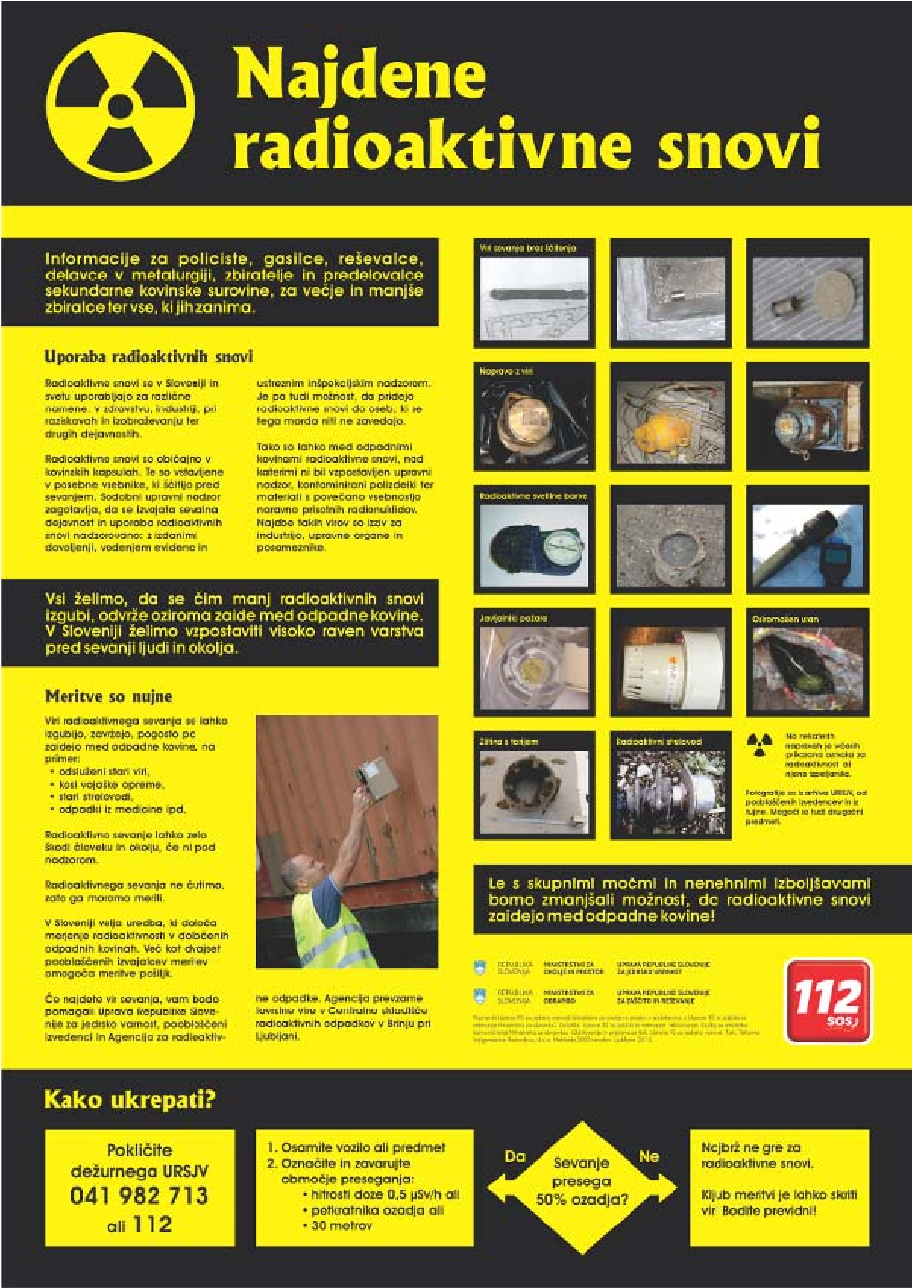

Figure 3: Poster on orphan radioactive sources

