May 2014
I. | KRŠKO NPP

I.1. CONCLUSION OF THE NPP KRŠKO SECOND PERIODIC SAFETY REVIEW
The SNSA is going to approve the 2nd Periodic Safety Review (PSR) of the Krško NPP. The PSR started in 2010, when the SNSA approved the programme which specifies the PSR detailed scope and objectives. Based on the Slovenian regulation and international practice, 15 safety factors were included in the review. During the regular 2nd PSR also an extraordinary safety review was performed due to the Fukushima accident resulting in a Safety Upgrade Programme in 2011.
During the review a few hundreds of potential safety improvements were identified. Finally, more than two hundred items were included in the action plan and will be further addressed during the next five years.
Examples of improvements which will be addressed during the Action plan implementation is related to: plant procedures periodic review, root cause analysis and corrective action programme, temporary modifications management, generation and storage of solid radioactive waste, potential wear of steam generators U tubes from secondary side loose parts, personal dosimetry and offsite radioactivity monitoring in case of emergency, heavy load drops, equipment qualification (seismic, EM interference, equipment survivability in severe accidents etc.), review of PIEs (Postulated Initiating Event) including external events and combination of internal and external events, HELB (High Energy Line Break), uncertainties analysis, hazard analysis (internal flooding, fire hazard analysis, aircraft crash), shutdown safety, DBA (Design Basis Accident) and SAMG (Severe Accident Management Guidelines), EDMG (Extended Damage Mitigation Guidelines: aircraft crash, security events), etc.
The Krško NPP PSR2 did not reveal any findings which would prevent further safe operation until the next Periodic Safety Review. Implementation of selected issues in Action plan would additionally improve the overall safety status of the plant.

I.2. REACTOR TRIP DUE TO SPURIOUS ACTUATION REACTOR PROTECTION SIGNAL OVER POWER DELTA TEMPERATURE (OPΔT)
On 23 November 2013, just a few days after the end of the refuelling outage, an automatic shutdown of the Krško nuclear power plant occurred. A reactor trip occurred due to spurious actuation of OPΔT (Over Power Delta Temperature) reactor protection signal. During the event all safety systems performed their functions as designed.
An analysis of the event identified the electromagnetic (EM) interference as the trigger for the actuation of the OPΔT signal. The EM interference was caused by switching the auxiliary relays of the reactor makeup water system, which dilutes the primary system during plant startup. This EM interference reflected as a drop of voltage measurement on some reactor coolant system (RCS) temperature measuring cards (performing the conversion of resistance from resistance temperature detectors (RTDs) to voltage) resulting in a spurious actuation of the OPΔT reactor protection signal and consequently in a reactor trip.
A detailed analysis of the event showed that a modification performed on the RCS temperature measuring cards during the regular outage introduced a small difference in the processing of the hot and cold leg temperatures of the RCS, which caused the EM interference to be reflected at the output of the cards. The analysis concluded that spurious actuation of the OPΔT reactor protection signal was a direct cause of the event. The root causes of the event were an inadequate preparation and implementation of the »RTD Bypass Elimination« modification (i.e. possible electromagnetic interference was not considered).
The problem with the EM interference was temporary solved with an Installation of AC suppressors on auxiliary relays. The Krško power plant is planning to implement additional long-term improvement assuring a more robust RTD measuring system.

I.3. PROBLEMS WITH LEAKING FUEL RESOLVED
During the outage in 2013 in the Krško NPP discovered an extensive fuel damage. Some fuel rods were broken with some parts of cladding missing. Open fuel cladding defects were diagnosed from measurements of I-134 activity of the reactor coolant even before the outage. Fuel reconstitution campaign was carried out to replace several fuel rods at exposed locations. By extensive fuel inspection the Krško NPP assured that all fuel assemblies for the next fuel cycle met the acceptance criteria for reload and that their integrity was ensured.

mCi/ml Reactor Coolant Activity - Cycle 27
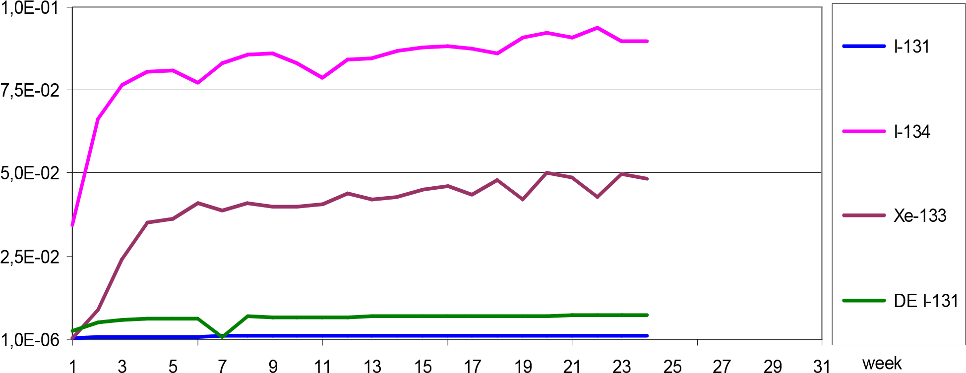
Figure 1: Reactor coolant activity in fuel cycle 27 indicates stable conditions and no defects in fuel cladding
After the outage the SNSA closely follows the conditions of the fuel through SNSA Safety performance indicators. The data from reactor coolant activity of Iodine and noble gases isotopes show that there have not been any damage to the fuel cladding from the start of the fuel cycle 27. The relatively high activity of iodine isotopes is caused by tramp Uranium from primary circuit contamination in previous fuel cycle with open defects of fuel cladding.
II. | RADIATION SAFETY ISSUES

II.1. REMEDIATION OF THE JAZBEC MINE WASTE PILE AT ŽIROVSKI VRH COMPLETED, APLLICATION FOR CLOSURE IN THE PROCESS OF RE-EVALUATION

Jazbec mine waste pile is one of the two disposal sites remaining as a result after the operation of the uranium mine at Žirovski vrh.
The mine ceased to operate in 1990. In 2006, the remediation of underground facilities was finished. Remediation works on the disposal site Jazbec started in 2005. The disposed material was covered with the layer of inert material that prevents penetration of water into in the disposal facility and at the same time limits the emanation of radon from the disposed material into the environment. Surface water was led along the disposal site, the cover of the disposal site was planted with grass and the site was fenced. The remediation of the Jazbec disposal site was completed as early as 2008. Since then the procedures of checking suitability of remediation measures, the preparation of final safety documentation and administrative procedure for closure have taken place.
The Slovenian Nuclear Safety Administration approved the final safety analysis report of the mine waste pile Jazbec and approved its closure on 8 March 2013. Doing so the Jazbec site lost its status of radiation facility and became an object of national infrastructure meaning that it will remain the state property. The ARAO – the Agency for Radwaste Management will be responsible for the long-term surveillance and maintenance of the facility. The maintenance also includes repair of damage that may arise over time while long-term surveillance includes radiological monitoring, too. Approval for closure of the Jazbec disposal site set the period in which the transfer of responsibility from the current operator to the ARAO should be made.
However, the current operator appealed on the decision for closure. The main reasons for appeal are administrative procedures that have to be undertaken according to the regulations governing the mining activities. The administrative procedure for closure of the disposal site was renewed and re-evaluation of the application is currently ongoing.
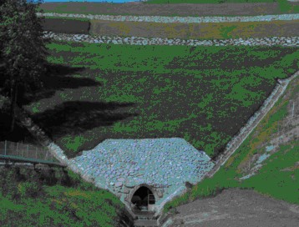
Figure 2: The former Žirovski vrh uranium mine
In the vicinity of the Jazbec site is the Boršt site, where the hydrometallurgical wastes from the processing of uranium ore were disposed. Remediation of this site was completed in 2010. After remediation the whole site started to move downhill with a rate of a few centimetres per year, which is more than it was approved by the initial safety report. However, this event does not pose any immediate threat to the environment. In the next years, appropriate technical solutions supported by risk assessment are to be made. The SNSA decision on closure of this site is pending on acceptable geotechnical stability of the site.
III. | LEGAL SYSTEM

III.1.AMENDMENTS TO THE ACT ON IONIZING RADIATION PROTECTION AND NUCLEAR SAFETY
As reported in the previous issue of the News from Nuclear Slovenia (November 2013) the informal coordination with key stakeholders and the formal public consultation were successfully concluded at the end of 2013. On the other hand the formal inter-ministerial coordination took more time than expected. The goal remains the adoption of the proposed amendments on the Governmental level in the first half of 2014 and by the Parliament in autumn 2014.

III.2.SECONDARY LEGISLATION
Two pieces of secondary legislation were drafted in the period after the November issue of the News from Nuclear Slovenia:

Amendments to the Rules on the Trans-boundary Shipment of Nuclear and Radioactive Substances
The proposed amendments to the rules seek to address deficiencies and ambiguities that have been identified during its use, especially with regard to the contents of an application for authorization. It is proposed that the application for the transit of radioactive sources with significant activity also includes a safety plan, which must be prepared in accordance with regulations governing the transport of dangerous goods. In practice, the transit of radioactive substances is mainly carried out by foreign carriers that have security plans designed in a very general form and in the manufacture where data on the risk derived from the Slovenian authorities were not taken into account.
The Rules are to be published in the Official Gazette in the next few weeks.

Amendments to the Decree on the Areas of Limited Use of Space Due to a Nuclear Facility and the Conditions of Facility Construction in these Areas
The proposed amendments to this Decree harmonise its provisions with the provisions of the Construction Act insofar as it relates to the demolition, replacement works, removing of structures and with provisions of the amended Regulation on classification of types of construction. The proposed amendments to this Decree seek to address some deficiencies and ambiguities that have been identified during its use.
The Decree has to be sent to the informal coordination with key stakeholders, which will be followed by the formal public consultation and the formal inter-ministerial coordination.
IV. | EMERGENCY PREPAREDNESS
The national Interministerial Committee on Emergency Preparedness and Response established two working groups in December 2013. One on reassessing the basis for the Krško NPP hazard assessment, taking into account lessons learned from the Fukushima accident and the new IAEA guidelines. The other on solving the emergency monitoring issues. Both working groups are expected to deliver final reports by the end of June 2014. The WG on the NPP hazard assessment will try to provide the basis for EPR neighbouring harmonization as well. Therefore, representatives from Croatia are also participating.
The SNSA has started to broaden the MKSID network. MKSID is a national communication platform for radiation emergencies connecting relevant organizations. From 16 MKSID users the number increased to 27. They include the NPP operator, all local communities, all regional civil protection headquarters that are involved in response to nuclear accident at the Krško NPP and national organizations.
The 2014 NPP Krško annual exercise is going to be conducted as a national two-day exercise. It will include actions in the field. Participation from the IAEA and the neighbouring Croatia is planned.
V. | INTERNATIONAL COOPERATION

V.1. 6th REVIEW MEETING OF THE CONVENTION ON NUCLEAR SAFETY CONTACTING PARTIES
In the period from 24 March to 4 April 2014, the IAEA convened the 6th review meeting of the CNS contracting parties. Dr Andrej Stritar, the SNSA Director, presented the Slovenian CNS report on the first day. In his presentation he described the main improvement since the last review meeting and emphasized the Krško NPP Safety Upgrade Programme, which is a corner stone of the national post-Fukushima action plan. In the preparatory stage Slovenia posted 82 questions, while we received and answered 63 questions from other parties. Among planned measures to improve safety, Slovenia will continue with its action plan, cooperate more closely in the area of emergency preparedness with Croatia and shall invite the IAEA missions (IRRS, OSART, EPREV). The continuous challenges are financial and human resources as well as radioactive waste and spent fuel disposal.

V.2. QUADRILATERAL MEETING
On 9 and 10 April 2014 the representatives of the Czech, Hungarian, Slovakian and Slovenian nuclear regulatory authorities met at their annual meeting in Balatonfüred in Hungary. They informed each other on the latest developments in their countries including events in the nuclear power plants and exchanged views on the current topics, which refer to ageing of regulatory staff, enforcement actions, human factors and approach to safety issues. The interest for new nuclear power plants diminished in all countries except in Hungary.

V.3. BILATERAL MEETING WITH CROATIA
On 18 April 2014 the delegations of the SNSA and the Croatian Office for Radiation and Nuclear Safety met in Zagreb. The aim of the meeting was to exchange information and enhance cooperation in the area of emergency preparedness and response as well as in the environmental radiation monitoring. Other items on the agenda were the latest developments in the regulatory framework (adoption of new regulations) and the Slovenian side presented the status of LILW repository, the construction of which has not yet begun.

Nuclear Slovenia in Brief
Slovenia is the smallest country with a nuclear power plant operating in its territory. Nuclear facilities include: 1 Nuclear Power Plant in operation (PWR, 2-loops, Westinghouse, 696 MWnet), 1 Research reactor in operation (TRIGA Mark II, 250 kW), 1 Central interim storage for radwaste (not for NPP waste - radioactive waste and spent nuclear fuel from NPP is stored within the NPP site) as well as radiation facilities and practices: 1 repository of hydro-metallurgical tailings, 1 repository of mine tailings, and around 300 organizations, engaged in radiation practices with altogether about 2000 radiation sources in use.
The Slovenian Nuclear Safety Administration was established in 1987. It is responsible for nuclear and radiation safety, transport, and management of nuclear and radioactive materials in the Republic of Slovenia.
For the radiation safety in medicine the competent authority is the Slovenian Radiation Protection Administration within Ministry of Health.
Physical protection of nuclear materials and nuclear facilities is a responsibility of the Ministry of the Interior.
Agency for Radioactive Waste Management deals with site selection and planning of the repository for low and intermediate level radwaste and provide a public service of radwaste management from small producers.
Administration of the Republic of Slovenia for Civil Protection and Disaster Relief performs administrative and professional protection, rescue and relief tasks as well as other tasks regarding protection against natural and other disasters.

