May 2013
I. | KRŠKO NPP

I.1. REACTOR TRIP DUE TO SUDDEN MAIN STEAM LINE VALVE CLOSURE
In February 2013 an automatic shutdown of the Krško Nuclear Power Plant occurred. The sequence of events started with sudden closure of main steam isolation valve (MSIV) on the steam line No. 2. Due to MSIV closure the steam flow increased in the steam line No. 1, which resulted in pressure drop actuating the safety injection system simultaneously with the reactor trip. During the event all safety systems remained available for their intended function.
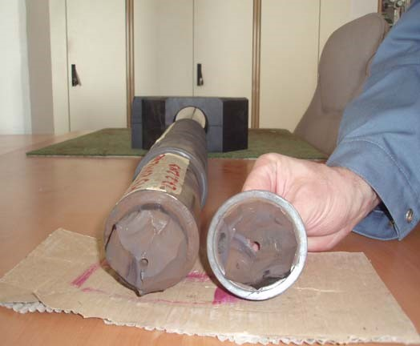
Fig. 1: The broken stem of the main steam line valve

The event has been analysed and it was concluded that the MSIV stem break (Figure 1) was direct cause for event. The root causes, which contributed to the event, were: deficiencies in design of MSIV (construction, material …), vibrations due to swirling in main steam line and MSIV, unimplemented valve modification, deficient surveillance and testing procedures (manufacturer instructions). There was also inadequate attention to operating experience, because similar event occurred 1997.
The broken stem was replaced with a new one, but there are further corrective actions to follow. In the outage 2013 the new modification on MSIV is planned to be implemented. The modification should resolve design problems in the main steam line and MSIV.

I.2. POST-FUKUSHIMA ACTION PLAN
Following the ENSREG decision the SNSA prepared National Action Plan (NAcP) of improvements, which is based on the lessons learned from Fukushima accident. The document was published at the SNSA web page in English. The NAcP comprises all actions which are aimed at minimizing risk due to natural and other hazards that could affect the Krško NPP.
The National Action Plan is structured around the planned Krško NPP’s Safety Upgrade Program (SUP), which was described in more details in previous editions of the News from Nuclear Slovenia (see May 2012). Besides the implementation of SUP the SNSA identified 11 additional actions that could further enhance nuclear, either indirectly by changing the legislation, hosting additional peer reviews, performing additional studies, or directly by improving the NPP and regulatory body processes, enhancing of emergency preparedness and nuclear safety infrastructure or improving the safety culture of both the operator and the regulatory body.
The Slovenian NAcP was prepared based on the review of recommendations issued or prepared by ENSREG, IAEA, Convention on Nuclear Safety and the U.S. Nuclear Regulatory Commission amongst others.
The review of national action plans of the EU nuclear countries, as well as Switzerland and Ukraine, took place in the workshop organized by the ENSREG in April 2013. The final conclusion of the workshop was that the countries implemented several improvements in the aftermath of the Fukushima accident.
For the Slovenian NAcP the final review report concluded that the NAcP was prepared in accordance with the ENSREG guidance. It commended the Slovenian post-Fukushima measures which were proactively implemented in the last two years, and as main advantages stressed the planned implementation within the SUP, well developed severe accident management guidelines, which are regularly trained and validated with the use of a full scope simulator, as well as the incorporation of a wide range of recommendations from several organizations, like IAEA, US-NRC, ASME and others during the preparation of the Slovenian NAcP.
II. | RADIATION SAFETY ISSUES

II.1. IONISATION CHAMBER SMOKE DETECTORS INSPECTION CAMPAIGN
Ionization chamber smoke detectors (ICSDs) containing radioisotopes have been widely installed in Slovenia in the past. Estimated number of such detectors is around 55 000 and around half of them are still in a use. While a risk to unnecessary exposure of people or contamination of the environment is relatively small during a process of installing a new detector or during servicing, handling, repairing, dismantling and transport a risk for exposure or contamination is not negligible. Moreover, according to the Slovenian legislation detectors containing Ra-226, Pu239 or Am-241 are considered as radioactive waste. A user of an ICSD must register a detector in the State Register of Ionising Sources, and pay for its removal and transport in the Central Storage for Radioactive Waste.
Since 2002 the Slovenian legislation requires much stringent control over ICSDs. Due to lack of a control of import, production and installation of such detectors in the past the Slovenian Nuclear Safety Administration (SNSA) started with collecting of all information regarding ICSDs. The extensive campaign involved Agency for Radioactive Waste as well as qualified experts who are inspecting installed ICSDs every five years. A comprehensive system of control was established.
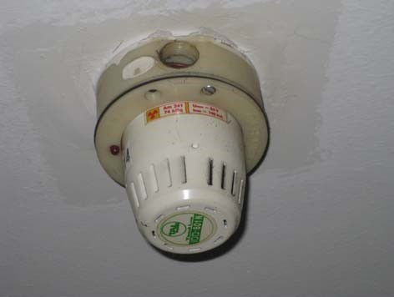
Fig. 2: Typical ICSD using 74 kBq of Am-241 installed in a shopping centre in Ljubljana.

From 2010 till May 2013 around 50 inspections were conducted in order to identify:
- companies involved in handling ICSDs,
- non- registered ICSDs,
- companies handling ICSDs as radioactive waste,
- contaminated sites.
The last contamination of storage of used ICSDs was identified in April 2013 and decontamination procedure related to Am-241 took place.
News from Nuclear Slovenia, May 2013
Slovenian Nuclear Safety Administration
Litostrojska cesta 54, Ljubljana, Slovenia,
www.ursjv.gov.si

2
Taking into account that ICSDs are widely replaced by detectors without ionising sources and a list of owners who might possess ICSDs is becoming shorter, the SNSA inspection unit expects to finish the campaign in next two years.

III. | NUCLEAR SAFETY ISSUES

III.1. GEOLOGICAL ISSUES AT KRŠKO SITE
On 25th January 25 2013 the electrical utility GEN Energija informed the Slovenian Nuclear Safety Administration (SNSA) about the Institute de radioprotection et de surete nucleaire’s (IRSN, France) letter related to the geological issues at the potential Krško II site. SNSA have also received several additional documents describing the situation.
In 2007 GEN Energija contracted a Consortium consisting of four institutions: IRSN, Bureau of Geological and Mining Research (BRGM, France), Slovenian National Building and Civil Engineering Institute (ZAG, Slovenia) and Geological Survey of Slovenia (GeoZS, Slovenia) to perform geotechnical, geological, and seismological investigations and evaluations of the Krško site. The investigations that encompass a range of activities have not yet been completed.
GEN Energija received an individual opinion in the form of a letter from one Consortium partner – IRSN. In this letter, IRSN outlined their positions on the Libna fault and its potential negative consequences on the licensing of the proposed sites. IRSN takes the opinion that the findings of these investigations led to the conclusion that the Libna fault, located in the vicinity of the plant, is capable.
After receiving the letter and additional documents the SNSA has immediately started to investigate the influence of new findings to the existing operating nuclear power plant Krško. At the moment, there is no sitting process for the second unit going on at the site. If it ever starts, the SNSA will definitely take into account the IRSN's opinion.
Therefore the SNSA requested GEN Energija to organize a clarification meeting with all members of the Consortium in order to get detailed explanation about the investigations performed, results obtained and relevant conclusions. In particular the SNSA wanted to understand the reasons for differences in opinions of Consortium members.
The meeting with all members of the Consortium as well as Krško NPP, GEN, SNSA and others took place at the end of April in Ljubljana. Members of the Consortium agreed that the Libna fault shows the signs of capability. IRSN maintained that the Libna fault is capable, but the rest of the Consortium maintained that “the Libna fault is not an important structural element of the Krško basin”. Furthermore GeoZS thinks that “the Libna fault does not meet the criteria to univocally define it as a capable fault”. By their opinion “the Libna fault should be considered capable if capability is defined in line with Safety Guide SSG-9”. The members of the Consortium agreed that even if we assume the capability of Libna fault, its impact is small and the input data for seismic design of the existing NPP Krško need not be changed.
SNSA will follow the continuing geological, geotechnical and seismological research of the Krško basin. So far on the basis of currently known preliminary results there is no reason for any immediate action.
News from Nuclear Slovenia, May 2013
Slovenian Nuclear Safety Administration
Litostrojska cesta 54, Ljubljana, Slovenia,
www.ursjv.gov.si

3
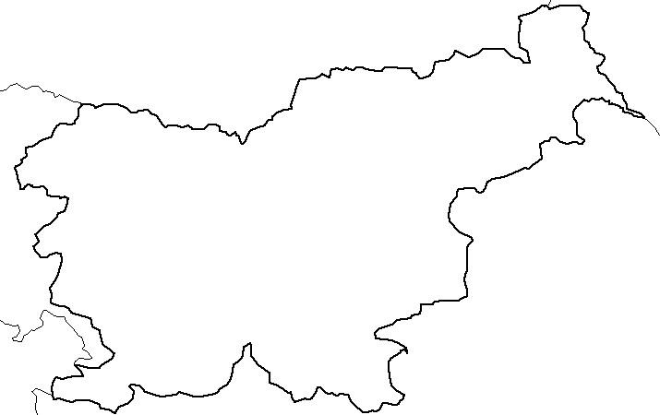

Austria
Italy
Croatia
Hungary
Krško
nuclear
power-plant
Žirovski vrh
uranium mine
Research
reactor
Central interim
storage for
radioactive waste
LJUBLJANA
Hot cell
Adriatic
Sea

Nuclear Slovenia in Brief
Slovenia is the smallest country with a nuclear power plant operating in its territory. Nuclear facilities include: 1 Nuclear Power Plant in operation (PWR, 2-loops, Westinghouse, 696 MWnet), 1 Research reactor in operation (TRIGA Mark II, 250 kW), 1 Central interim storage of radwaste (not for NPP waste - radioactive waste and spent nuclear fuel from NPP is stored within the NPP site) as well as radiation facilities and practices: 1 repository of hydro-metallurgical tailings, 1 repository of mine tailings, and around 300 organizations, engaged in radiation practices with altogether about 2000 radiation sources in use.
The Slovenian Nuclear Safety Administration was established in 1987. It is responsible for nuclear and radiation safety, transport, and management of nuclear and radioactive materials in the Republic of Slovenia.
For the radiation safety in medicine the competent authority is the Slovenian Radiation Protection Administration within Ministry of Health.
Physical protection of nuclear materials and nuclear facilities is a responsibility of the Ministry of the Interior.
Agency for Radioactive Waste Management deals with site selection and planning of the repository for low and intermediate level radwaste and is a public service of radwaste management from small producers.
Administration of the Republic of Slovenia for Civil Protection and Disaster Relief performs administrative and professional protection, rescue and relief tasks as well as other tasks regarding protection against natural and other disasters.

