May 2012
I. | KRŠKO NPP

I.1. REFUELING OUTAGE AND IMPORTANT SAFETY RELATED IMPROVEMENTS
This year in NPP Krško, more extensive type of refuelling outage took place in April and May. During the outage, the actual condition of the equipment was checked and some of equipment was modernized. The Krško NPP also carried out regular preventive maintenance of the equipment, nuclear fuel was replaced and technological upgrade was made.
In the last fuel cycle plant operation was reliable. There were no major problems with the equipment, which is the result of well planned and carried out outage activities in the previous refuelling outage and activities during plant operation. Outage was monitored also by Slovenian nuclear safety administration and authorized experts.
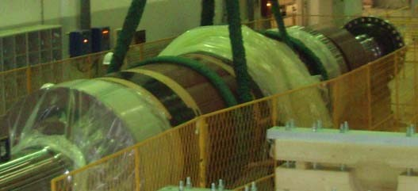
Picture 1: Rotor of the main electrical generator

The length of the outage was determined by major activities, such as reactor vessel head replacement, new generator rotor replacement, drawing up the irradiation capsules from the reactor vessel and inspection of the of the reactor coolant pump.
The other main activities during this year’s outage were refuelling with 56 new fuel assemblies, preventive inspections, maintenance activities, modifications and modernization of systems and equipment.
One of the biggest modifications in this outage was the reactor vessel head replacement including associated equipment, which includes replacement of the vessel head, new cooling shroud support ring, replacement of control rod drive mechanisms, thermal insulation for the dome and flange, core exit thermocouple nozzle assemblies, neutron shielding and simplified head assembly to streamline the refuelling process and reduce the time required to remove the reactor vessel closure. In addition, thermal sleeves and the four partial length control rods have been eliminated.
Enhancement of emergency power supply was also major modification, which provided new diesel generator and its supporting components housed in a new seismic category I safety related emergency diesel building. Diesel generator will serve as either an alternate AC source to the plant in case of a total loss of on site and off site power or as a substitute to either of the existing plant emergency diesel generators.
Supply and replacement of new main electrical generator rotor was non-nuclear safety related modification, but also quality related activity performed on major equipment, because possible failures on generator and its auxiliary and supporting systems and components can cause negative consequences leading to plant transients and trips, which could challenge reactor protection systems, functions or equipment.
There were 29 improvements in total, including second level under-voltage protection for class 1E buses, modernization and extension of the fire detection system, installation of vent valves on service water system, establishment of additional controls and indications in the control room for monitoring and better oversight on turbine support systems operation, installation of vent lines on safety injection system, replacement of service water travelling water screen, replacement of regulator valves on residual heat removal system etc.

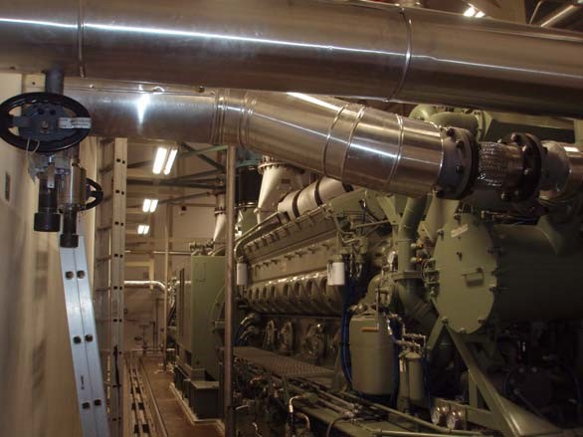
Picture 2: Diesel generator
Besides regular outage activities, the equipment was replaced and modernized due to degradation and demands of modern standards and operating experiences. Those interventions are usually made once in a power plant lifetime. Most of activities were well planned and carried out professionally.

I.2. CABLE BRIDGE INCIDENT
The cable bridge is a structure which serves as a cable tray for cables going from the reactor vessel head to the edge of the reactor cavity. In the scope of reactor head replacement a new cable bridge was installed. While lowering the cable bridge with the winch, the dynamic load due to disengagement of a free loop, which was on a winch coil because the cable was improperly reeled, the attachment was pulled out of the bridge and the cable bridge fell. Two workers were injured and hospitalized, none of them with life threatening injuries. The cable bridge fall caused damage to the cable bridge structure, cables and some nearby equipment. The root cause analysis was performed along with the damage assessment and corrective actions were proposed. Examination showed that the cable bridge fell because threads in the four tapped holes of the cable bridge winch post were stripped off and all four mounting bolts by which the cable bridge is connected via wire to the winch mounted to the upper part of reactor vessel head disengaged. Thread engagement of the mounting bolts was insufficient to carry the actual loads during lowering the cable bridge. The polar crane was then used in lieu of winches for installation of the tie rods and for cable bridge manipulation and one mechanically damaged cable was replaced. There will be also new winch provided and possible redesign of the support structure including welded connections to ensure greater margin of safety. None of the workers, including the injured ones, were contaminated and the event itself had no effect on nuclear and radiation safety.
II. | STRESS TESTS AND POST–FUKUSHIMA ACTIONS IN SLOVENIA
After the adoption of the stress tests specifications in May 2011 by ENSREG and European Commission the SNSA issued the decision for the Krško NPP to perform the special safety review of which program was completely in line with the adopted stress tests specifications. Like envisaged in the specifications, the plant gave progress report to the SNSA until August 15, while final report was prepared until the end of October 2011. Several additional analyses (e.g. evaluations of seismic and flooding margins, additional station blackout analyses to support the newest severe accident strategies, drain cycle of the batteries supplying power to the instrumentation of safety systems, water heat-up and evaporation rate in the spent fuel pool, evaluation of spent fuel pool criticality) were performed by the operator and were reviewed and supported by technical support organizations with additional calculations where necessary. All the above was reviewed by the SNSA, open issues were cleared and the national report was adopted, which was very much based on the operator’s report.
After the national report was prepared, it was subdued to peer reviews by teams of member states’ nuclear safety experts, which started in 2012. The reviews were separated into so called horizontal and vertical reviews. In the framework of the horizontal review the individual chapters of the reports were reviewed (external events, loss of all power sources, loss of the ultimate heat sink and severe accident management provisions) and questions were put up for the individual countries. This was followed by the preparation of answers and country presentations in the common Luxembourg meeting. The second part of the review, the vertical one was performed in each collaborating country. In March Slovenia was visited by a team of 8 experts, who performed detailed review of still open issues at that time. The review contained also a walk-down of the Krško NPP. The team prepared a country report, which concluded that the Krško NPP is well designed against all credible and even some very unlikely external threats at the site.
In addition to obligate the plant to perform the stress tests, the SNSA also issued a 2nd decision in September 2011 requiring from the plant to reassess the severe accident management strategy, existing design measures and procedures and to implement necessary safety improvements for prevention of severe accidents and mitigation of its consequences. This evaluation was finished in January 2012. Its action plan was reviewed and approved by the SNSA in February 2012. The proposed improvements that have tendency to increase reliability of AC power, core cooling, SFP cooling and containment integrity, as well as to reduce possible fission products and to provide emergency control provisions in case of beyond design basis accidents are: − Installation of additional high pressure pump for reactor coolant system injection,
− Installation of additional high pressure pump for feeding steam generators,
− Installation of alternative air cooled ultimate heat sink,
− Installation of additional low pressure pump for spraying and flooding the containment (this and abovementioned improvements also include several dedicated sources of borated water),
− Installation of filtered venting system,
− Installation of passive auto-catalytic recombiners in the containment,
− Installation of the emergency control room,
− Installation of separate dedicated beyond design basis accident instrumentation and control,
− Provisions for long term habitability of emergency control room and for support staff facility,
− Procurement of mobile heat exchanger (cooled by mobile equipment or air),
− Installation of permanent sprays around the spent fuel pool,
− Acquiring the technology and material for quick filling of possible ruptures in spent fuel pool,
− Additional flood protection of nuclear island and newly installed equipment,
− Extending protection against extreme air temperatures.
The time period to implement the envisioned improvements is from 2012 to 2016.
In addition to above planned modifications the Krško NPP has already implemented the majority of the requirements related to air-crashes from the INPO document B.5.b.
In January 2012 the SNSA issued the 3rd decision regarding the Fukushima event, with which it requires from the Krško NPP to review the basis and assumptions for the Radiological Emergency Response Plan. This work is still going on.
With additional planned and ongoing modifications the plant will further increase its robustness and with that the nuclear and radiation safety of its employees and public in general.
III. | THE SNSA – NEW MINISTRY AND NEW LOCATION
The new Government which started their term of office in February 2012 decided to make reorganization of Ministries to achieve more efficient administration by reducing the number of Ministries. The previous Ministry of the Environment and Spatial Planning ceased to exist and the SNSA was installed within the newly established Ministry of Agriculture and the Environment.
On 23rd January 2012 Slovenian Nuclear Safety Administration moved from the city centre to the north-west part of Ljubljana closer to the highway ring. Its street address is Litostrojska road 54, the telephone numbers remained unchanged. The new building is more spacious and thereby improves the quality of the work, while providing easier access for our visitors.
IV. | INTERNATIONAL COOPERATION

From 19-22 March the SNSA together with the IAEA and the US NNSA (National Nuclear Security Agency) organized international RAPTER course with participants from all over the world. The course was aimed to provide participants with classroom training, hands-on experience with radiation measuring equipment (i.e. detectors), as well as realistic practical exercise was organized. Participants had opportunity to practice their roles and responsibilities responding to a variety of radiological incidents.

In April the SNSA visited a four-member Malaysian delegation, which consisted of representatives from the Regulatory Body for Nuclear and Radiation Safety, the Ministry of Health and Safety, energy sector and Malaysian Nuclear Energy Corporation. The purpose of the visit was to familiarize themselves with the work of the Slovenian regulatory body for nuclear safety, because Malaysia plans to build a nuclear plant. The Slovenian representatives have explained organization and functioning of the SNSA, including presentation of the Slovenian nuclear program. The SNSA presented licensing and inspection oversight the Krško NPP, as well as performance indicators, periodic safety review, aging program of the nuclear power plant, the process of lifetime extension and foreign operational experience feedback.

In April the new Arrangement between the Slovenian Nuclear Safety Administration and the United States Nuclear Regulatory Commission for the Exchange of Technical Information and Cooperation in Nuclear Safety Matters came in force for the next five year period. This is the fourth such arrangement concluded after the expiry of the previous.

In May the Slovenian Government decided to invite the INSARR (Integrated Safety Assessment of Research Reactors) mission for reviewing safety of the TRIGA research reactor located in Podgorica near Ljubljana. The mission is going to take place in autumn this year.

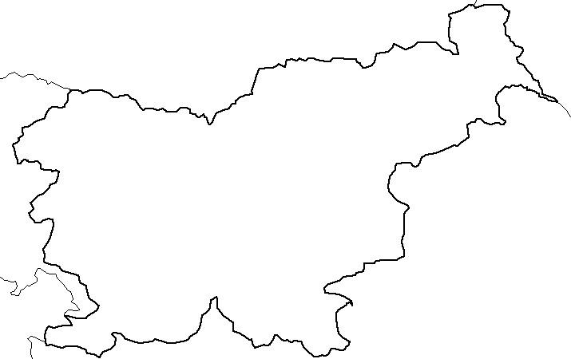

Austria
Italy
Croatia
Hungary
Krško
nuclear
power-plant
Žirovski vrh
uranium mine
Research
reactor
Central interim
storage for
radioactive waste
LJUBLJANA
Hot cell
Adriatic
Sea

Nuclear Slovenia in Brief
Slovenia is the smallest country with the nuclear power plant operating at its territory. Nuclear facilities include: 1 Nuclear Power Plant in operation (PWR, 2-loops, Westinghouse, 696 MWnet), 1 Research reactor in operation (TRIGA Mark II, 250 kW), 1 Central interim storage of radwaste (not for NPP waste - radioactive waste and spent nuclear fuel from NPP is stored within the NPP site) as well as radiation facilities and practices: 1 repository of hydro-metallurgical tailings, 1 repository of mine tailings, and around 300 organizations, engaged in radiation practices with altogether about 2000 radiation sources in use.
The Slovenian Nuclear Safety Administration was established in 1988 as a body within the Ministry of the Environment and Spatial Planning. It is responsible for nuclear and radiation safety, transport, and management of nuclear and radioactive materials in the Republic of Slovenia.
For the radiation safety in medicine the competent authority is the Slovenian Radiation Protection Administration within Ministry of Health.
Physical protection of nuclear materials and nuclear facilities is responsibility of Ministry of Interior. Agency for Radioactive Waste Management deals with site selection and planning of the repository for low and intermediate level radwaste and is the public service of radwaste management from small producers.

