May 2010
I. | OPERATION OF NPP KRŠKO

I.1. EVENTS
Since November 2009, there were no events that would present a radiological threat to the population. There were no particularities in relation to the services of radiation practices and the operators of radiation facilities.

I.2. LICENSING ISSUES
From December 2009 to April 2010, there were 9 modifications altogether. From the total number, the SNSA approved 2 modification and agreed to 6 of them. During the preliminary safety evaluation of the Krško NPP, an additional modification was found that did not present a safety issue. Therefore, the NPP only informed the SNSA about the change.
Overall, 4 modifications were connected with the documentation, while physical changes of the systems had to be made for the other 5 modifications. At the end of the year 2009, the Krško NPP had issued the 16th revision of the Updated Safety Analysis Report, considering all modifications confirmed until 15 November 2009.

I.3. 2nd PERIODIC SAFETY REVIEW
In May 2009, the Slovenian Nuclear Safety Administration issued the decision confirming the Second Periodic Safety Review (PSR) Program for the Krško NPP. The program defines the scope, content and timing of PSR, which will be completed by 2013. In accordance with the Act on Protection against Ionizing Radiation and Nuclear Safety, the NPP is required to provide regular, comprehensive and systematic evaluation and verification of radiation and nuclear safety of the facility. The evaluation and verification will be carried out as the Periodic Safety Review. The second PSR should address all changes and activities in the period 2003 to 2013, in particular: a) requirements of new regulations or standards,
b) cumulative effects of project changes in NPP and the effects of aging equipment and materials,
c) personnel changes in NPP,
- changes in the organization and management and
- the impacts of environmental changes that will occur as consequences of the construction of hydro power plants and other facilities in the vicinity of Krško NPP.

I.4. SAFETY PERFORMANCE
The most important and newest performance indicators are shown in the Table below. The performance indicators confirm the stable and safe operation of the power plant in 2009.
 | Safety and performance indicators |  | Year 2009 | Average (1983–2009)
 | Availability [%] |  | 91.2 | 85.85
 | Capacity factor [%] |  | 93.6 | 83.4
 | Forced outage factor [%] |  | 0 | 1.1
 | Gross realized production [GWh] |  | 5 738.81 | 4 966.14
 | Fast shutdowns – automatic [Number of shutdowns] |  | 0 | 2.67
 | Fast shutdowns – manual [Number of shutdowns] |  | 0 | 0.14
 | Unplanned normal shutdowns [Number of shutdowns] |  | 0 | 0.89
 | Planned normal shutdowns [Number of shutdowns] |  | 1 | 0.82
 | Event reports [Number of reports] |  | 10 | 4.56
 | Refuelling outage duration [Days] |  | 32 | 46.9
 | Fuel reliability indicator (FRI) [GBq/m³] |  | -4  8.88 10 | -2  7.55 10
II. |  | RADWASTE MANAGEMENT
The revision of the Krško NPP Decommissioning Programme and Disposal of LILW and SNF is expected to be finished in summer of 2010.
A decree approving the site for a low and intermediate level radioactive waste repository was passed by the government of the Republic of Slovenia in December 2009. The site, named Vrbina, is situated in the municipality of Krško, in the vicinity of the NPP. The Agency for RW Management (ARAO) plans to start the construction of the repository in approximately two and a half years.
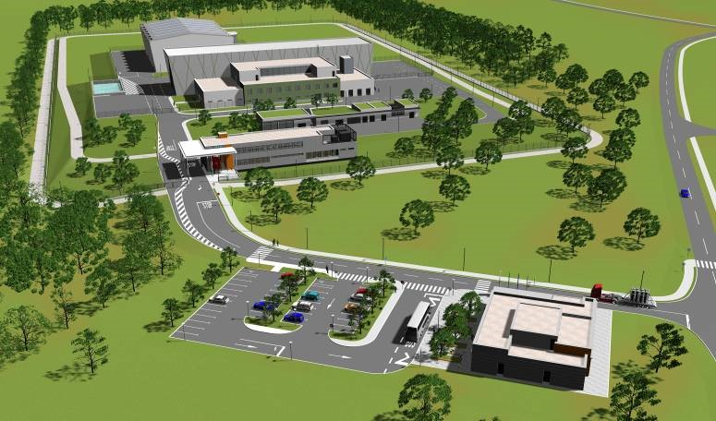
The preliminary design of the repository has already been elaborated. The construction will be carried out in phases. Two silos will have the disposal capacity of 9400 m³ each, which is about one half of the radioactive waste generated in the Krško nuclear power plant during its operation and decommissioning. The site will also be used for storage of all institutional waste generated in Slovenia. In case of an expansion of the Slovene nuclear program or an agreement between Slovenia and Croatia (which has a 50-percent share in the Krško nuclear power plant) about disposing of the entire amount of the waste, the capacity of the site can be increased.
III. | RADIATION PROTECTION
In the beginning of 2010, the SNSA started a broad range of activities to assess the number of commonly used ionization smoke detectors. In spite of the fact that at the end of 2009, the SNSA registered almost 27,000 of these radioactive sources in different organizations, it can be safely assumed that many are still unregistered. For this reason, almost 400 potential organizations were sent the request to report to the SNSA about their use of smoke detectors by the end of April 2010. As a result of the inquiry, more than 2000 unregistered ionization smoke detectors were notified to the SNSA. A few new organizations performing the radiation practice maintenance of ionization smoke detectors were also discovered. The activities are still in process.
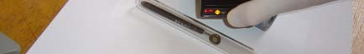
In the period 2004 -2010, the systematic inspection of ionizing radiation sources in the state took place, with emphasis on sources which were not under control in the past. The systematic inspection campaign by the SNSA included around 100 inspections of research and educational institutions, such as universities, state institutions, for example e.g. military institutions, and museums. The numerous sources were identified and control regimes established. The picture shows the first radioactive source in Slovenia, namely Ra-226 of 148 kBq (4 micro Ci), which was bought in 1902. The source was used in ophthalmology at the time and was later stored at different institutions. It was unknown to the SNSA until the 2007, when it was found during the inspection at the Institute for the history of medicine in Ljubljana.
In order to educate users of sources which were not under control in the past, the SNSA published several articles related to such sources. In addition, the SNSA prepared a lecture entitled “Radioactive materials in the museum collections” in the collaboration of The Museum Society of Slovenia in 2010. Typical radioactive items in collections that originate from the first part of the twenty century were presented as well as the safety measures which are required when handling such items.

IV. | EMERGENCY PREPAREDNESS
In 2009, a major revision of the Slovenian National Nuclear or Radiological Emergency Plan began. The revision was finished earlier this year. The plan is now in the final stage of reconciliation and it will be soon ready for adoption.
In November 2009, the SNSA started a campaign to solve the problem of distribution and administration of Potassium Iodide. The kick-off meeting resulted in the establishment of a working group, led by the State Secretary of the Ministry of Health. The working group drafted the regulation on the use of iodine tablets, which is now in the inter-ministerial reconciliation and will be adopted soon. The SNSA played a major role in the group.
In February 2010, an updated version of the MKSID in February 2010 was released. The new version includes a number of improvements and new features, but the user interface remains the same, that is intuitive and easy to use. The MKSID is now ready to replace fax machines, which remain as a backup. The number of users is rising.
V. | LEGAL SYSTEM
As reported in our 2009 November issue, the new Act on Protection against Ionizing Radiation and Nuclear Safety and the new Act on Third Party Liability and Insurance reached the final stage of preparation and the texts have been agreed upon among all relevant stakeholders. Both acts are expected to be adopted within this year or by the beginning of next year at the latest.
Notwithstanding the fact that the Slovenian nuclear legislation is in line with the European acquis and commitments Slovenia made through international treaties, more than eight years of experience in applying current nuclear and radiation safety legislation dictated the adoption of amendments necessary for smooth and workable system in this area.
The reason for the preparation of the new third party liability act lies in the fact that the existing one is based on Vienna Convention on Civil Liability for Nuclear Damage while at beginning of this millennium Slovenia became the contracting party to the Paris Convention on Third Party Liability in the Field of Nuclear Energy and Brussels Supplementary Convention. In 2004, Slovenia also signed Protocols to amend both conventions, which were ratified in Slovenian Parliament in March 2010.
The adoption of a new framework law on nuclear and radiation safety will warrant changes in the implementing regulations, therefore the amendments of some implementing rules and degrees in the draft version already have been prepared.

VI. | NEWS FROM THE REGULATORY BODY

VI.1. REORGANISATION
The Slovenian Nuclear Safety Administration (SNSA) reorganised its structure to increase its efficiency and optimize the resources. The biggest change was the establishment of the Emergency Preparedness Division and thus the importance of this activity was emphasised. At the same time, the QA manager as well as the librarian were positioned directly under the director. Currently, there are 45 employees at the SNSA.

Director
QA Manager
r Safety
Nuclea
sion
Divi
Librarian
Radi
ation
Safet
y and
erials
Mat
Divi
sion
Inspectio
n
Division
Emergency
Preparedness
Division
General Affairs
Office
International
Affairs Office
Analysis
and
Operatio
nal
ck
Feedba
Licensin
g
and
Modificati
ons
Licensing
and Records
Monitoring

VI.2. MANAGEMENT SYSTEM
In December 2009, the external organisation performed the second control audit of the SNSA management system, which meant the transition to the new version of the ISO standard, namely ISO 9001:2008. During the control audit, no non-conformances were identified, and therefore the external auditor concluded that the SNSA management system is in compliance with the standard ISO 9001:2008.

VI.3. INTEGRATED REGULATORY REVIEW SERVICE MISSION
As a preparation for an IRRS mission in 2011 or 2012, the SNSA carried out a self-assessment using the IAEA questionnaires, which was completed in April 2010. For correcting the non-conformances, an action plan was drawn up, where about 30 actions were listed Most of them are to be implemented by the end of 2010. The main findings are related to human resources planning, strengthening cooperation with other institutions, plan for issuing regulatory guides, systematic approach to training, review and assessment of nuclear and radiation facilities except NPPs, improvements in emergency preparedness and some changes that need to be made to bring legislation and the SNSA internal documents in line with the latest IAEA standards (requirements).
Slovenia sent a formal request for the IRRS mission to the IAEA in April 2010.
VII. | INTERNATIONAL PHYSICAL PROTECTION APPRAISAL SERVICE (IPPAS)
Slovenian Government invited the IAEA follow-up IPPAS mission to evaluate the status of physical protection of nuclear facilities and nuclear and radioactive materials in Slovenia. Mission was performed from 12 to 23 April 2010. The official host was the Ministry of Interior. The members of the mission reviewed the legislation, conducted interviews and visited nuclear facilities and several holders of nuclear and radioactive materials. Their observations are presented in the report, that includes several recommendations, suggestions and good practices. In general, they found the physical protection in this area to be satisfactory. An action plan will be prepared to address the mission findings.

VIII. | INTERNATIONAL COOPERATION
In the beginning of 2010, the SNSA, together with the consortium partner Enconet GmbH from Vienna, concluded the project "Assessment of the regulatory infrastructure in the field of nuclear safety and radiation protection in Albania, Bosnia and Herzegovina, Croatia, the former Yugoslav Republic of Macedonia, Kosovo (as defined by UNSCR 1244), Montenegro and Serbia", which was financed by the European Commission in the framework of EuropeAid. The main objective was to make an action plan where improvements that needs to be done in the forthcoming years for the status of radiation and regulatory infrastructure in the aforementioned countries are listed. The findings and the action plan were meant as guidelines for the assistance in the future. These countries are all very different, thus it is difficult to draw up common conclusions, but the main identified issues dealt with the improvement of legislation and regulatory framework, strengthening of inspection and enforcement, improvement of radioactive waste management, finalization of emergency plans and procedures and improvements of the radiation protection of population, workers and within medicine.
The SNSA is also active within the IAEA technical cooperation programme. Recently, the following activities were realized: scientific visits from Lithuania; two fellowships from Serbia and one from Ghana; a group fellowship on research reactors organized in Czech Republic, Hungary and Slovenia.
The bilateral arrangement on the early exchange of information in the event of a radiological emergency and cooperation in nuclear safety matters between the SNSA and Italian nuclear regulatory authority ISPRA, the Institute for Environmental Protection and Research, was signed on 24th May in Trieste. In April, the SNSA organized two regional IAEA workshops in Ljubljana
- 6.-9. 4. 2010 Waste Management Operators on Treatment/Processing of Problematic Waste from NPPs and Nuclear Facilities Decommissioning,
- 12.-16. 4. 2010 Application of Best Estimate Plus Uncertainty Analyses Methods in Nuclear Safety.
In May, there was one regional workshop in Portorož, entitled Current issues and challenges in designing, implementing, testing, licensing, and operating modern I&C systems in NPPs.

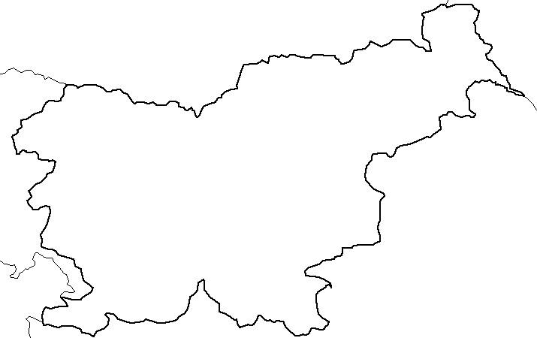
Austria
Italy
Croatia
Hungary
Krško
nuclear
power-plant
Žirovski vrh
uranium mine
Research
reactor
Central interim
storage for
radioactive waste
LJUBLJANA
Hot cell
Adriatic
Sea

Nuclear Slovenia in Brief
Slovenia is the smallest country with the nuclear power plant operating at its territory. Nuclear facilities include: 1 Nuclear Power Plant in operation (PWR, 2-loops, Westinghouse, 696 MWnet), 1 Research reactor in operation (TRIGA Mark II, 250 kW), 1 Central interim storage of radwaste (not for NPP waste), Radioactive waste and spent nuclear fuel from NPP is stored within the NPP site as well as radiation facilities and practices: 1 repository of hydro-metallurgical tailings, 1 repository of mine tailings, and around 300 organizations engaged in radiation practices with altogether about 1200 radiation sources in use.
The Slovenian Nuclear Safety Administration (SNSA) was established in 1988 as a body within the Ministry of the Environment and Spatial Planning. It is responsible for nuclear and radiation safety, transport, and management of nuclear and radioactive materials in the Republic of Slovenia.
For the radiation safety in medicine, the competent authority is the Slovenian Radiation Protection Administration within Ministry of Health.
Physical protection of nuclear materials and nuclear facilities is responsibility of Ministry of Interior.
Agency for Radioactive Waste Management deals with site selection and planning of the repository for low and intermediate level radwaste and provides public service of radwaste management from small producers.

Communication System during an Emergency for the SNSA internal as well as national communication . MKSID is a tool for communication during an emergency, created to replace conventional internal communication methods (for example, the exchange of paper documents) between expert groups at the SNSA. It is a web application that runs on an ordinary browser and thus requires no special software and almost no training. Basically, it is a platform for exchanging messages and attachments in a form of a single table, in which each message is published in one row and the newest are on the top. MKSID connects all major national stakeholders in a case of a nuclear emergency, the SNSA, the Krško NPP, Civil Protection and their external communications centers, National Environmental Agency and the Government Communication Office.

