# BRIEF SUMMARY

In the period from November 2018 to April 2019, the Krško NPP (NEK) has been operating without any events significant to nuclear safety, as well as the research reactor, located at Podgorica near Ljubljana.

In the area of legislation, the decree about potential orphan sources, which could be detected in consignments (parcels and containers transported by road, rail, sea or air), was adopted. Still one more decree needs to be passed before the Slovenian legal system is aligned with the EU Acquis. The Krško NPP operates safely and its Safety Upgrade Program proceeds in line with the schedule. We report about the broken-off part and vibrations of the NEK charging pump, as well as the reasons for the redesign of the Spent Fuel Dry Storage. In the beginning of April Slovenia hosted the annual Quadrilateral Meeting of four regulatory authorities of the Czech Republic, Hungary, Slovakia and Slovenia in Ptuj in the north-eastern Slovenia. The emergency preparedness focus is on the implementation of the EPREV action plan, as well as the continuation of the extensive programme of exercises.

# LEGAL SYSTEM

In the previous issues of the »*News from Nuclear Slovenia*« it was already reported that the process of transposition of the EU BSS directive was a major legislative project engaging many administration staff and experts in the last few years.

The process is successfully approaching its conclusion. Since the adoption of two new Governmental Decrees and eight Ministerial Rules, as reported in the previous issue of this newsletter, only two more new Decrees have been in preparation.

While the “Decree on the checking of the radioactivity of consignments that could contain orphan sources” has been adopted, the adoption of the decree entitled “Amendments of the Decree on the content and preparation of protection and rescue plans” is in the final stages and is expected to be adopted by the Government in the next two months.

It is also worth noting that some amendments are foreseen for the Ionising Radiation Protection and Nuclear Safety Act (ZVISJV-1), which was adopted at the end of 2017 and entered into force in January 2018. The main area to which amendments will apply is the security screening of foreign nationals, who intend to carry out work in the protected areas of nuclear installations. After the proposal of these amendments successfully passed the governmental approval it was sent to the Parliament where the hearings will begin in the April session under an abridged procedure.

# THE KRŠKO NPP

## Safety Upgrades in the Krško NPP

The implementation of the Krško NPP’s Safety Upgrade Program (SUP) in underway. Several modifications of the Phase II are ongoing, such as the Alternative design of NEK spent fuel pool cooling, Operation support centre reconstruction, Installation of the ventilation and habitability system of the new Emergency Control Room and Technical support centre, Installation of an additional heat removal pump. All Phase II modifications are to be completed by the end of 2019.

Regarding the Phase III modifications, the Krško NPP has commenced works on the Bunkered Building 2 (BB2) last autumn. The BB2 will contain design extension conditions (DEC) systems like the alternate safety injection (ASI) and alternate auxiliary feedwater (AAF), both with dedicated tanks of borated and unborated water with capabilities for replenishment from an underground water well. The Phase III also envisages the construction of the spent fuel dry storage (SFDS) described in more detail below.

All the Krško NPP’s SUP upgrades are to be completed by the end of 2021.

## Redesign of the New Spent Fuel Dry Storage (SFDS) at Krško NPP

The dose rate limits on the Krško NPP site perimeter shall remain unchanged despite the new SFDS being located within the site. An independent evaluation of the dose rate analyses completeness and correctness was performed by an authorized technical support organisation (TSO). The additional independent calculations included spent fuel inventory calculations and dose rates calculations. The main findings were related to described methodology and obtained results and the way variance reduction and uncertainties were used. The conclusion was that the provided margin for the site perimeter dose rate was too small and that some values/dependencies are not as expected. Consequently a revision of the project was prepared (redesign) with an improved shielding design (storage cask and SFDS building) and a new loading plan.

The licensing process for the SFDS is ongoing. In 2017 the SNSA issued the design conditions for the dry storage facility which were prepared in accordance with new Design Extension Conditions (DEC) requirements and international standards for spent fuel storage facilities. After the regulatory review of the SFDS design concept, the SNSA issued the positive opinion for the SFDS construction licence in June 2018. Based on the proposed redesign the SNSA reviewed and assessed the proposed changes of the SFDS project and in January 2019 issued the positive opinion for the construction license.

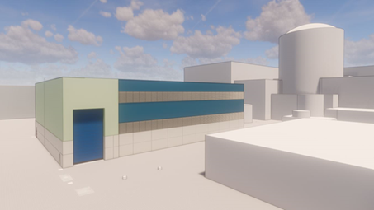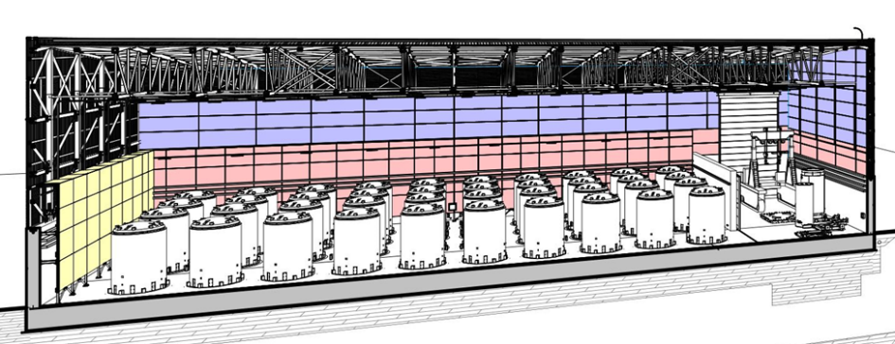

Fig. 1: New Spent Fuel Dry Storage design

## Balancing drum damage and high vibrations of the charging pump

In November 2018, unusual high vibrations were sensed on one of the two chemical and volume system charging pumps at the Krško NPP. Although no degradation of pump hydraulic characteristics (pressure, flow rate) was detected, the vibrating charging pump was stopped and isolated. High pump vibrations were caused by the eccentricity which occurred as a consequence of a ruptured balancing drum of the charging pump. The broken off piece of the drum (about 170 g of steel) was further ground by the pump rotor. A certain amount of this material, presumably in the form of dust and particles sized up to a few millimetres, left the affected charging pump and entered the primary system coolant flow, where some particles were caught in the reactor coolant pump (RCP) seal filters. The internals of the affected charging pump were replaced with the refurbished internals from the warehouse. According to the lessons learned from a similar operating experience in Tihange-1 NPP, the Krško NPP stayed at power during the incident and was charged by the remaining charging pump. The refurbished charging pump was tested and became operational within the allowed time specified in Technical Specifications. An analysis is being carried out in order to examine the event, to determine the root cause and to take further actions.

Close-up of the balancing drum of the charging pump that was damaged.  Particles of the damaged charging pump that were caught in the reactor coolant pump seal filters

Fig. 2: Damages to the balancing drum

# RADIOACTIVE WASTE MANAGEMENT

## A step forward to the LILW repository in Slovenia

In the beginning of April 2019, the SNSA issued a draft preliminary consent on nuclear and radiation safety for the low and intermediate level waste (LILW) repository in Vrbina in the Krško municipality.

The procedure for obtaining an environmental consent is a relatively time-consuming process which already began in 2017, when the Agency for Radwaste Management (ARAO) delivered an application to the Slovenian Environment Agency (ARSO). In the framework of this process the ARSO delivered an application to the SNSA in May 2018 for the issuance of a draft preliminary consent on the nuclear and radiation safety. The SNSA reviewed the extensive documentation covering the Environmental Impact Report, the Draft Safety Analysis Report, the Concept Design, the Project Basics, the expert opinion of the authorised expert on nuclear and radiation safety and the reference documentation. In July 2018, comments and a request for additional information were given by the SNSA. After several revisions of licensing documentation and explanations provided by the ARAO all open issues were resolved at the end of March 2019 and the SNSA was able to issue a draft preliminary consent. With this action the conditions for the beginning of public hearing and consultations on the transboundary impacts were fulfilled.

# INTERNATIONAL COOPERATION

## Quadrilateral Meeting

In early April the SNSA organized the regular annual meeting within the framework of bilateral agreements between the nuclear safety regulators of the Czech Republic, Hungary, Slovakia and Slovenia, the so called Quadrilateral Meeting.

The delegations reported and discussed the most important events and developments in the field of nuclear safety since their last meeting in 2018. The delegates also reported on important operating events in their nuclear facilities. Hungary, Slovakia and the Czech Republic reported about the new NPP units. Two out of four units of the NPP Bohunice, Slovakia, are under decommissioning. Slovenia also reported on the progress in the implementation of NPP Krško Safety Upgrade Programme, the revision of plans for the new spent fuel dry storage facility and the implementation of the EPREV action plan.

The participants also discussed various topics related to their participation in international organizations, the preparation of national reports according to the Convention on Nuclear Safety and the status of the two ongoing INSC (Instrument for Nuclear Safety Cooperation) projects for the support to the Iranian nuclear regulatory authority where all four countries are participating.

# EMERGENCY PREPAREDNESS

## Exercises and Trainings

The SNSA participated in the ECUREX 2018 exercise in November 2018. The purpose of the exercise was to practice the use of the WebECURIE, EURDEP website and the emergency Audio Conference among the ECURIE Competent Authorities.

In November 2018, the second annual exercise of the Krško NPP, “NEK2018-2” was conducted. The main objective of the exercise was to test the emergency response procedures and the efficiency, communication and coordination between the NPP’s and SNSA’s emergency response teams. Additionally, based on the analysis of the first annual exercise the alerting mechanism of the national EPR Plan was tested. Croatia also participated in the exercise.

Based on the analysis of the ConvEx-2b exercise, which was carried out in October 2018, the procedures on requesting/providing assistance in case of nuclear emergencies and on the cooperation between the SNSA and the ACPDR (Administration for Civil Protection and Disaster Relief) in these matters were amended. The amended arrangements were trained in the ConvEx-2b exercise in March 2019.

## EPREV Action Plan

According to the governmental decision the SNSA’s role is to monitor a progress of the Emergency Preparedness Review (EPREV) Action Plan to be fulfilled in the deadlines set. The SNSA is also responsible for the implementation of a number of actions and some of them were completed in 2018 and in the early 2019: the amendment of the Hazard Assessment for Nuclear and Radiological Emergencies, the analyses of the notification and activation system of the SNSA emergency response team, the poster for emergency workers including for the purposes of providing non-designated emergency workers with just-in-time training, the poster on information for general public on the health hazards and health effects in case of radiological emergency addressing also the most vulnerable members of the public, the amended procedures for requesting and receiving international assistance, exercise for SNSA’s officer on duty to provide advice remotely during initial response to a radiological emergency etc. Most of the actions are still ongoing, including the revision of the national emergency plan, protection strategy, procedures, guidelines and analyses.

Map of Slovenia showing the positions of nuclear installations