April 2017
I. | BRIEF SUMMARY
In the period from November 2016 to April 2017, there was a reactor trip in the Krško NPP, which is described in the text. It was considered as an operational event without impact to nuclear safety. No other important events or significant issues are to be reported about the Slovenian nuclear installations. However, the Krško NPP continues with its safety upgrade programme, including the spent fuel dry-storage construction, which was stalled for almost a year because of the appeal of the defeated bidder.

Also the new Ionising Radiation Protection and Nuclear Safety Act, which will align the Slovenian legal framework with the amended Nuclear Safety Directive and the EU BSS Directive is in the final stage before sending it to the Governmental and Parliamentary procedure.
II. | LEGAL SYSTEM
As already reported in the previous (November 2016) issue of the News From Nuclear Slovenia, the draft of the new Ionising Radiation Protection and Nuclear Safety Act is being under preparation again. The main reason is the transposition of the new BSS directive, Nuclear Safety directive and amended Nuclear Safety and Radwaste directives. The draft of the new act has already been passed to the public consultation and is in the final stage of interdepartmental coordination. It is expected that the draft of the Act will be approved by the Government in May and then submitted for consideration and adoption to the Parliament.

In the area of legislation the end of 2016 and beginning of 2017 was very intense. Based on the amendments of the Ionising Radiation Protection and Nuclear Safety Act, which have been adopted at the end of 2015 (see more in November 2015 edition of the News From Nuclear Slovenia) the following implementing decrees and Rules were adopted:

in December 2016
- Rules on radiation and nuclear safety factors
- Rules on operational safety of radiation and nuclear facilities
- Rules on the method of keeping records of personal doses due to exposure to ionizing radiation
in 2017

in January 2017
- Rules on the requirements and methodology of dose assessment for the radiation protection of the population and exposed workers

in February 2017
- Rules on the obligations of the person carrying out a radiation practice and person possessing an ionizing radiation source

in March 2017
- Decree on activities involving radiation

It goes without saying that with the adoption of the above-mentioned implementing Rules and Decree, those rules and decree, which governed the same area before, cease to apply.
III. | THE KRŠKO NPP

III.1. No deviations detected on forged parts of steam generators in the Krško NPP after Creusot Forge issues
During the WENRA meeting, the SNSA was informed about the issues of the manufacturer AREVA (ex Siemens - Framatome) with forged parts of steam generators supplied by the French Creusot Forge. Some discrepancies in the chemical composition of the material such as increased carbon segregation that could lead to a brittle fracture of the component have been detected on the surface of the forgings. There has also been a suspicion for data falsification.
After that, the SNSA immediately notified the Krško NPP about this issue and requested to check whether the replaced steam generators parts could have been made in the Creusot Forge factory. The Krško NPP stated that forged parts of Siemens-Framatome steam generators had been constructed in Japan Steel Works factory (JSW). Certificates of the JSW also proved that the carbon content in the primary chambers of the steam generators forgings is within the required limits of standard ASME II material SA 508 Class 3A. The SNSA carried out a special inspection at the Krško NPP verifying the records and certificates of materials in the Krško NPP archives.
The SNSA prepared a Comprehensive report with detailed inspection conclusions, which is published on the SNSA website. The SNSA together with the Krško NPP intend to continue with active monitoring of the open issues and activities after the events in France.

III.2. Construction of the Spent Fuel Dry Storage in the Krško NPP
One of the post-Fukushima actions in the Krško NPP is construction of the spent fuel dry storage. Three companies submitted the bid for the dry storage and after the comprehensive assessment one was selected. One of the defeated companies filed the appeal to the National Review Commission for Reviewing Public Procurement Award Procedures (shortened: National Review Commission). The non-selected bidder challenged the technical solution of the winning bidder, i.e. the correctness of the calculation of technical parameters of containers for spent fuel. The process from the appeal to the Commission decision took eight months. At the end the appeal was rejected and the contract was signed with the initially chosen bidder.
The Krško NPP will try to meet initially set deadlines for the construction of the spent fuel dry storage, but the public procurement award procedure is a complicated process which could easily take unpredictably long and jeopardize success of the project(s).

III.3. Reactor trip due to sudden main feedwater regulation valve closure

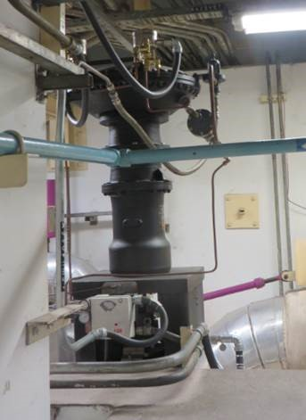
Integrated I/P converter together with positioner of the FCV-551
In February 2017, an automatic shutdown of the Krško Nuclear Power Plant occurred. The sequence of events started with a sudden closure of the main feedwater regulation valve on the feedwater line No. 1. Due to valve closure, the water flow decreased in main feedwater line No. 1, which resulted in a decreased water level in steam generator No. 1 and consequently actuated the reactor trip. During the event all safety systems remained available for their intended function.
The event has been analysed and it was concluded that the sudden valve closure (Figure 1) was the direct cause of the event. It occurred because of a failure of I/P converter, integrated in a positioner of the valve. The main cause of the event was deficiency in the design of I/P converter (construction, material…).

III.4. Upgrade and modernisation of the Krško NPP simulator
The full scope simulator has been operating in the Krško NPP since 2000 as a prime tool for adequate operators’ 'training and licencing in order to ensure safe and efficient power plant operation. Aging of the simulator equipment, however, took its toll: the I/O interface system has become obsolete and therefore difficult for servicing due to lack of spare parts, the same goes for the maintenance of active simulator components. Apart from that, the Safety Upgrade Programme of the Krško NPP anticipated the erection of an emergency control room (ECR) and its inclusion into the simulated environment that cannot be accomplished with the existing simulator equipment. These were the main motives for the decision to upgrade the existing simulator. The simulator upgrade project is carried out by the L-3 MAPPS enterprise, the descendant of the Canadian firm CAE, which supplied the original simulator configuration in 2000.
The upgrade/modernisation project is divided into two phases: the first phase includes the upgrade of a simulator platform (rehost) and is already completed. The second phase comprises the extension of I/O connections and other simulator upgrades. It is expected to be completed by the end of May 2017. Installation of systems from both phases and their final verification is going to take place between late May and August. The Slovenian Nuclear Safety Administration (SNSA) participates in the process as a supervisor and will also actively take part during the final verifications in order to ensure the required plant-referenced performance of the upgraded simulator.

III.5. Topical peer review
Slovenia is implementing the Topical Peer Review (TPR), which has been introduced under the Euratom Directive on Nuclear Safety to examine topics important to nuclear safety. TPR should be performed every six years and as decided by the European Nuclear Safety Regulators Group (ENSREG), the first TPR should be carried out on aging management in nuclear power plants in 2017. Technical specifications were prepared by the Western European Nuclear Regulators Association (WENRA) to define the scope and content of the technical report. The SNSA participated in all steps of the preparation of the document and very early informed the Krško NPP about the TPR process and submitted to them the last revision of the document.
After the start of the process, the SNSA issued a decision to the Krško NPP on implementation of the TPR and preparation of the report in accordance with technical specifications. The Krško NPP is going to prepare a draft report and final report including action plan with attached expert opinion by the technical support organization. The SNSA is going to review the report and add the part related to administrative control and evaluation of the ageing management programme. The SNSA is also planning to carry out inspections covering thematic areas from the TPR, namely electrical cables, concealed piping, reactor pressure vessels and concrete containment structures, where Slovenia decided to include also a primary self-standing steel containment. After that, Member States' reports peer review and the review report is planned to share operating experience and good practices among different countries and also to identify possible existing common issues and needed follow-up actions. The Krško NPP and the SNSA are also going to participate in the following TPR workshop.
IV. | INTERNATIONAL COOPERATION

IV.1. Renewal of Arrangement between the SNSA and NRC
On 28 March the NRC Chairman Kristine L. Svinicki and the SNSA Director Andrej Stritar signed the Arrangement between the Slovenian Nuclear Safety Administration and the United States Nuclear Regulatory Commission for the exchange of technical information and cooperation in nuclear safety matters. This Arrangement represents the fifth similar arrangement concluded with USNRC since 1995 and proves good relations between both regulatory bodies. The arrangement scope is similar to the previous ones and it foresees the exchange of information, staff and also assistance, if needed, in the area of nuclear safety, security, radioactive waste management, radiological safety, environmental impact of designated nuclear energy facilities and nuclear safety research programs. The Arrangement still needs to be ratified by the Slovenian Government.

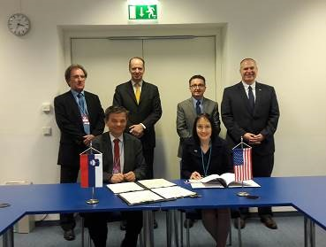
Signature of the Arrangement

V. | RADIATION MONITORING

V.1. Additional Measuring Capability of the Early Warning System
The SNSA, which is responsible for radiation monitoring in the environment in Slovenia, has enhanced its measuring network by adding a second spectroscopic detection system Envinet SARA. After installing one near the research reactor in Brinje, this one was placed in Drnovo, in the vicinity of the Krško NPP. In this way, the main nuclear installations in Slovenia are additionally covered by these sophisticated instruments.

The SARA detector enables permanent spectroscopic online monitoring of gamma radiation, including automatic nuclide analysis. SARA is able to detect very low concentrations of artificial nuclides, thereby allowing nuclear events to be identified more quickly and effectively.

The purchase and installation was financed by the IAEA through the national project SLO 9-015 »Strengthening Regulatory Capabilities of the Nuclear Safety Administration«.

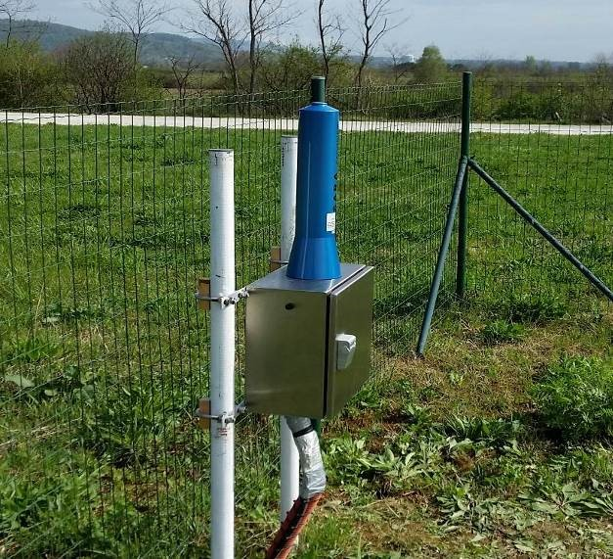
Envinet SARA spectroscopic detection system in Drnovo with the Krško NPP in the background

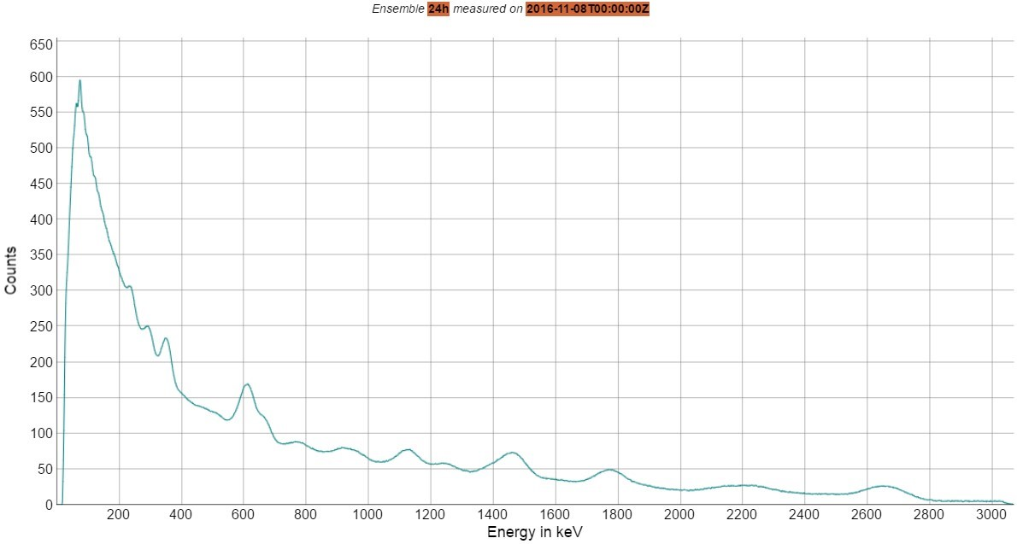
Measurement of the natural background radiation

VI. | EMERGENCY PREPAREDNESS

VI.1. Exercises
The SNSA participated in several exercises this year including the ConvEx-2a exercise in February, which covered IRMIS (International Radiation Monitoring Information System) that was introduced by the IAEA for the first time in this exercise.
This year's NPP Krško annual exercise was conducted on 22 March from 18:00 to 23:00 CET. All major organizations participated in a scenario that involved a plane crash on the NPP’s turbine building.
At last the SNSA also participated in the annual EC exercise ECUREX, organized by the HAEA that took place on 28 March 2017.

VI.2. EPREV
Preparations for the EPREV mission that will take place in Slovenia at the end of 2017 are in full swing. On 4 and 5 April the SNSA, ACDRP and IAEA met in SNSA’s headquarters in Ljubljana on a preparatory meeting, where the scope and the dates of the mission were agreed on. The mission will therefore be conducted during 5 - 16 November 2017. On the meeting the mission’s schedule was drafted, Terms of Reference harmonized and Advanced Reference Material determined.

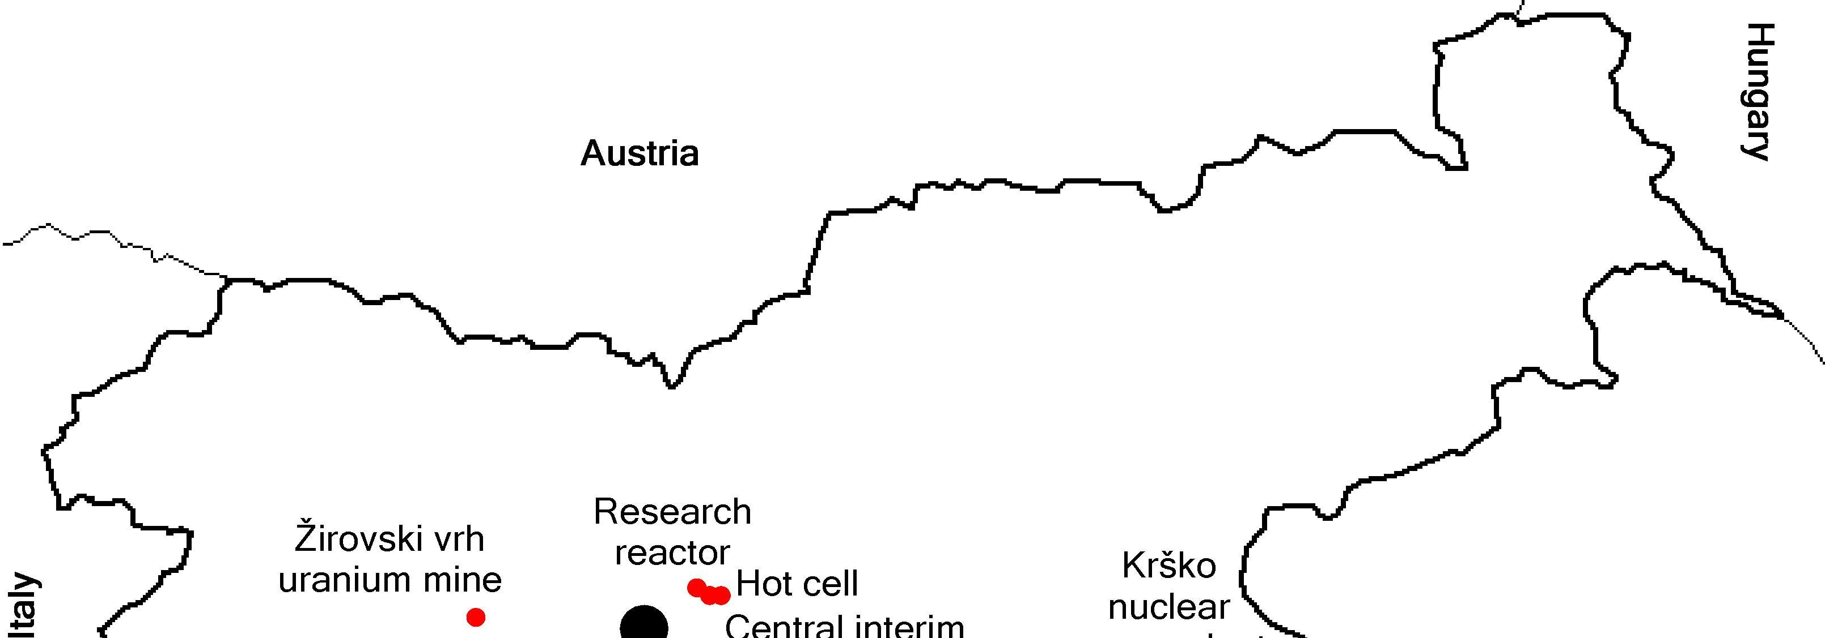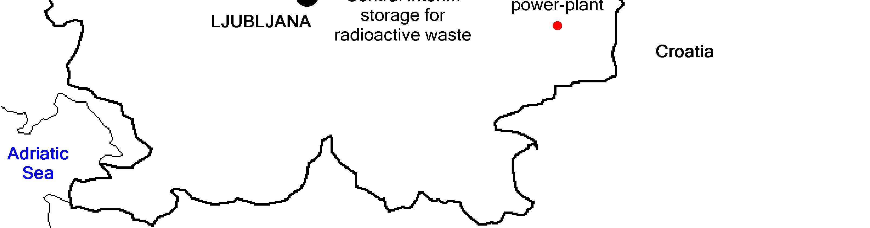
Austria
Italy
Croatia
Hungary
Krško
nuclear
power-plant
Žirovski vrh
uranium mine
Research
reactor
Central interim
storage for
radioactive waste
LJUBLJANA
Hot cell
Adriatic
Sea

