November 2014
I. | BRIEF SUMMARY
In the period from June to November 2014, there were no important events or significant issues to be reported about the Slovenian nuclear installations. However, there were some operational events which deserve attention.
One of such events was a malfunction of control rod driving mechanism due to a failed electronic card in the Krško NPP. This was detected during the monthly test of the main turbine valves and after the identification of a direct cause the electronic card was replaced.
The heavy rain period in the end of October in Slovenia affected also the site of the former uranium mine Žirovski vrh at Gorenja vas near Škofja Loka. There was some erosion damage of the upper layer covering the tailing site Jazbec, as well as damaged fence and flooded meteorological station. The SNSA team visited the site immediately after the rain and the report about this event was published on the SNSA web page, which concluded that the damage did not affect nuclear safety.
In general, the nuclear and radiation safety was monitored throughout this period and no deviations from normal practices and operation were detected.
II. | THE KRŠKO NPP

II.1. MODIFICATIONS AFTER THE FUEL DEGRADATION IN 2013
During the previous 26th fuel cycle ending in October 2013 open defects of fuel rods in three fuel assemblies were identified in the Krško NPP. The cause of open fuel defects was baffle jetting that produces strong vibrations on core locations close to the baffle. Another three fuel assemblies with leaking fuel rods were found and the causes of these defects were attributed to debris or grid-to-rod fretting.
The causes of the fuel damage were in the meantime evaluated by a Root Cause Analysis (RCA) by fuel designer. The corrective action against baffle jetting is to perform an up-flow conversion. The up-flow conversion changes the coolant flow path between the core barrel and the baffle plate from down-flow direction to up-flow. This modification will decrease pressure difference across the baffle plates and will therefore practically eliminate vibrations due to baffle jetting. The modification is planned to be implemented during the 2015 outage and is currently reviewed by the Slovenian Nuclear Safety Administration.
Against the debris induced fuel leakage a modification of fuel cladding will be performed in the next fuel cycle in 2015. The mechanical robustness of fuel cladding will be enhanced by coating the bottom part of fuel rods with an additional layer of zirconium oxide.
In the current cycle, there have not been any indications of significant fuel degradation by now.
III. | LEGAL SYSTEM

III.1. CHANGE OF GOVERNMENT – ORGANIZATION OF MINISTRIES
After July elections the National Assembly in mid-September approved the new Government of the Republic of Slovenia. Since February 2012 to the latest changes in the government organization the Slovenian Nuclear Safety Administration (SNSA) was part of the Ministry of Agriculture, which also included the "environmental" part of the former Ministry of the Environment and Spatial Planning, while the "spatial" part at that time joined the Ministry of Infrastructure. With the reorganisation of the Government - since this October - the Ministry of the Environment and Spatial Planning was re-established and the SNSA is again part of it.

IV. | INTERNATIONAL COOPERATION

IV.1. REPORT ON THE IMPLEMENTATION OF DIRECTIVE ON NUCLEAR SAFETY
The SNSA prepared a report on nuclear safety in Slovenia in line with guidelines, which were issued for writing such reports required by the Council Directive 2009/71/Euratom of 25 June 2009 establishing a Community Framework for the nuclear safety of nuclear installations. The report describes in detail implementation of the provisions of the Directive, which refer to regulatory and legislative framework, responsibilities of the regulatory authority, licence holder, as well as to expertise and skills and informing the public.

The report was handed to the European Commission in due time, i.e. before 22 July 2014.
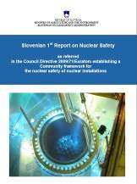

IV.2. BILATERAL MEETING WITH AUSTRIA
On 6 and 7 October 2014, the representatives of Austria and Slovenia convened at their annual meeting about nuclear safety matters in Reichenau an der Rax in Austria. Slovenia reported about the delay in amending the Act on Radiation Protection and Nuclear Safety. Both sides informed each other about the latest developments as regards research reactors, radioactive waste management, emergency preparedness and radiation monitoring. As usual Slovenia presented operation and safety improvements in the Krško NPP.

IV.3. IRRS FOLLOW-UP MISSION
Between 9 and 16 September 2014, the IRRS Follow-up Mission (Integrated Regulatory Review Service) came to Slovenia to review the implementation of recommendations and suggestions given by the IRRS mission in 2011. At the same time the IRRS Follow-up Mission also assessed whether any further recommendation needs to be given on the basis of new findings.
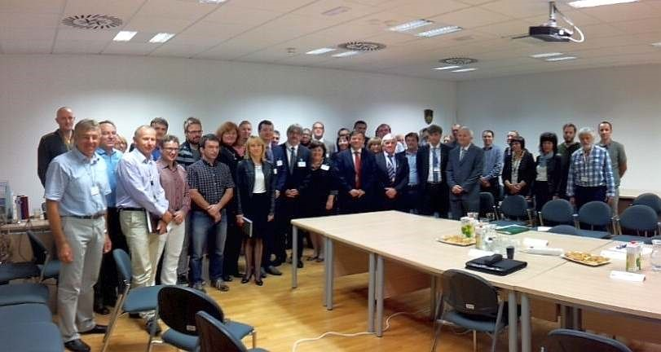
IRRS Follow-Up Team and the counterparts

At the end of the mission only one recommendation and one suggestion remained open out of the 9 recommendations (major deviations from international standards) and 29 suggestions (minor deviations from international standards). The mission also issued 2 new recommendations and 5 new suggestions. The recommendation, which remained open, was referring to the construction of a repository for low and intermediate level radioactive waste, which has not been progressing as planned. Since there has not been a visible progress since 2011, the mission again required that in the context of lack of space of the existing storage facility at the Krško NPP this issue should receive appropriate attention. The other open suggestion was aimed at coordinating the nuclear emergency preparedness with the Republic of Croatia, which is a bilateral issue and needs to be accelerated.
The mission found that the adoption of the Resolution on Nuclear and Radiation Safety in Slovenia for the period 2013-2023 was an example of good practice. The new recommendation points out that the Government should ensure adequate financial resources and a sufficient number of competent staff to work for the SNSA, as well as strengthening research and development for the purpose of administrative authority and technical support organizations is needed. The mission suggests performing an analysis of adequacy and completeness of a set of the SNSA internal technical procedures, as well as improving the rules on subcontracting of technical support organizations’ activities. Another suggestion was aimed at up-dating the Annexes of the National Nuclear and Radiological Emergency Response Plan. There was also a suggestion and a recommendation dealing with tightening the administrative control over the storage of radioactive waste in the Krško NPP, particularly in terms of accessibility and integrity of the containers.

V. | RADIATION SAFETY ISSUES

V.1. COMPARATIVE MEASUREMENTS OF DOSE RATE AND GAMMA SPECTROMETRY
On 22 October 2014, the Jožef Stefan Institute (JSI) organized a one-day measurement campaign at the Reactor Centre at Brinje near Ljubljana in order to assemble in one place as many Slovenian organizations as possible dealing with measurements of radioactivity. Among the participating organisations there were representatives of research institutions (several groups from JSI), the Slovenian Armed Forces, Institute of Oncology and the Slovenian Nuclear Safety Administration.

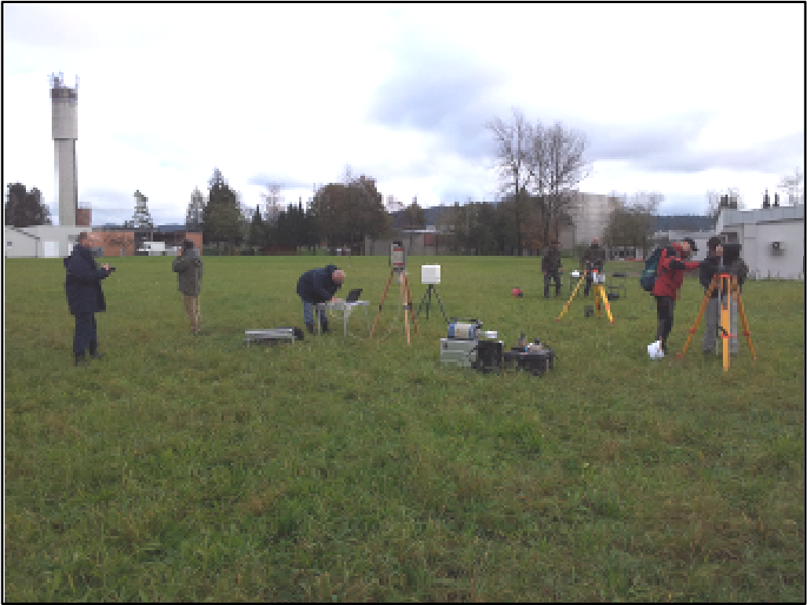

The first set of measurements consisted of dose-rate measurements, which are the first measurements conducted in the event of a radiological or nuclear accident. For this purpose, each team tested several instruments with a calibration source that was placed in the field. Measurements were performed at three distances providing results at different dose rates.
Additionally, teams capable of more sophisticated measurements were performing in-situ gamma spectrometry. This is a method that allows rapid identification of the activity and the type of radionuclides at the measuring site. The advantage of this method, compared to conventional sampling and analysis in the laboratory, is that the information is obtained much faster, which is particularly important in case of an accident.
VI. | EMERGENCY PREPAREDNESS

The SNSA has broadened the national communication platform for radiation emergencies (MKSID) now connecting already 29 relevant organizations within the country. They include the NPP operator, all local communities, all regional civil protection headquarters that are involved in response to a nuclear accident at the Krško NPP and national organizations.
This year's national seminar on emergency preparedness was dedicated to strategy on post-accident situation. The guidance document, prepared by the SNSA, was presented and lessons learned from the Fukushima recovery process were discussed along the Japanese documentary.
The 2014 NPP Krško annual exercise is going to be conducted as a national two-day exercise on 26 and 27 November. All major organizations will be involved. The exercise will include actions in the field (distribution of iodine pills in a limited scope). In addition, the IAEA is also participating to test and train its new capabilities of assessment and prognosis. The neighbouring Croatia and Italy are going to participate as well on operational level between the regulatory bodies.

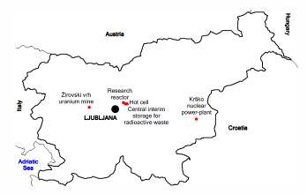

NUCLEAR SLOVENIA IN BRIEF
Slovenia is the smallest country with a nuclear power plant operating in its territory. Nuclear facilities include: 1 Nuclear Power Plant in operation (PWR, 2-loops, Westinghouse, 696 MWnet), 1 Research reactor in operation (TRIGA Mark II, 250 kW), 1 Central interim storage for radwaste (not for NPP waste - radioactive waste and spent nuclear fuel from NPP is stored within the NPP site) as well as radiation facilities and practices: 1 repository of hydro-metallurgical tailings, 1 repository of mine tailings, and around 300 organizations, engaged in radiation practices with altogether about 2000 radiation sources in use.
The Slovenian Nuclear Safety Administration was established in 1987. It is responsible for nuclear and radiation safety, transport, and management of nuclear and radioactive materials in the Republic of Slovenia.
For the radiation safety in medicine the competent authority is the Slovenian Radiation Protection Administration within Ministry of Health.
Physical protection of nuclear materials and nuclear facilities is a responsibility of the Ministry of the Interior.
Agency for Radioactive Waste Management deals with site selection and planning of the repository for low and intermediate level radwaste and provide a public service of radwaste management from small producers.
Administration of the Republic of Slovenia for Civil Protection and Disaster Relief performs administrative and professional protection, rescue and relief tasks as well as other tasks regarding protection against natural and other disasters.

