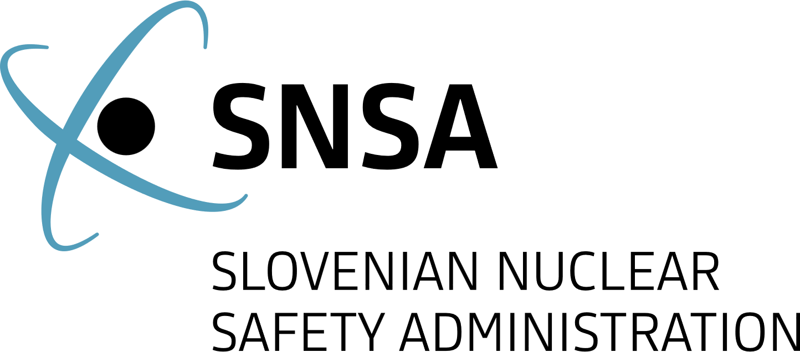

News from Nuclear Slovenia
  - October 2025
Brief Summary
In the reporting period from April to October 2025, all nuclear installations in Slovenia have been operating safely and without any significant safety events. The Krško Nuclear Power Plant (NPP) hosted an IAEA SALTO (Safety Aspects of Long Term Operation) Mission and underwent a regular outage. The construction of the low- and intermediate level radioactive waste (LILW) repository keeps progressing according to the time plan. The activities on the project for the construction of a new Slovenian power plant are still ongoing.
The Slovenian Nuclear Safety Administration (SNSA) continues to maintain good bilateral relations with foreign regulatory bodies and had a privilege to host two high level international events. In the area of emergency preparedness, the SNSA ensures the regular staff training and participation in national and international exercises.

The Krško NPP

Regular Outage
After seventeen months of safe, uninterrupted operation, the Krško NPP underwent its scheduled outage from 28 September to 28 October 2025. In addition to refuelling - during which 56 of the 121 fuel assemblies were replaced - the outage also involved extensive maintenance and technological upgrades designed to further enhance nuclear and radiation safety.
Key activities included replacing seals on both reactor coolant pumps, overhauling the low-pressure turbine, and inspecting all governor valves. A thorough visual inspection was conducted on the reactor vessel head penetrations and the bottom of the reactor vessel instrumentation penetrations. Additionally, sludge lancing, inner bundle lancing, and visual inspections of the internal structures of both steam generators were carried out. Notable upgrades included modifications to the primary system's supports and restraints, the replacement of the DRPI (digital rod position indication) display, and the modernization of the turbine's electro-hydraulic system.
The Slovenian Nuclear Safety Administration (SNSA) closely monitored all outage activities, with a strong emphasis on maintaining nuclear and radiation safety throughout the shutdown period. SNSA inspectors were present on-site during the entire outage, and expert support was provided by both domestic and international technical support organizations (TSOs). In accordance with Slovenian regulations, the Krško NPP resumed electricity production only after the TSOs and SNSA confirmed that all work had been properly completed and all tests had been successfully conducted.
The next scheduled outage at the Krško NPP is set for the spring of 2027.
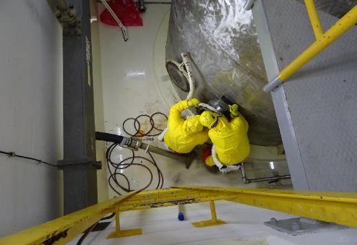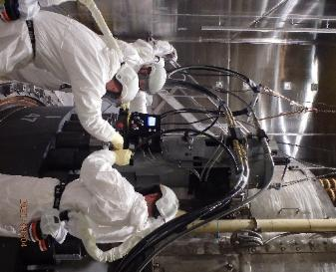
Figure 3: Work near the floor drain tank. Author: Krško NPP. Figure 4: Unscrewing of reactor bolts. Author: Krško NPP.

IAEA SALTO Mission
The SALTO mission was conducted at the Krško NPP in May 2025 to assess the plant’s preparedness for long-term operation (LTO) from a nuclear safety perspective. The SALTO team concluded that the plant is in good condition and issued no formal recommendations. However, they identified eight suggestions for improvement. These included the recommendation to implement a more systematic approach to LTO programme oversight, to comprehensively document the methodology and results for scope definition of ageing management, and to complete and fully document ageing management activities for electrical and instrumentation & control (I&C) systems, structures, and components (SSCs).
The team also highlighted a notable good practice in the use of a 360-degree Virtual Walkdown application, which integrates photographic documentation of equipment with corresponding design and maintenance data, enhancing accessibility and traceability. Additionally, six good performances were recognized. Among these were the equipment qualification programme, which was found to be comprehensively established, well-documented, and regularly revalidated for LTO, as well as the ageing management programme for the reactor pressure vessel, which was noted for its robust structure and thorough implementation.
The Krško NPP is currently developing an action plan to address and resolve all suggestions provided by the SALTO mission team. The SNSA will conduct periodic reviews to monitor the progress and effectiveness of the action plan implementation.

The JEK2 project - New Nuclear Power Plant in Slovenia
The Government of the Republic of Slovenia continues to be active in the JEK2 project through a dedicated State Secretary to the Prime Minister’s cabinet that is responsible for coordination of different ministries and administrations, including the SNSA, in preparation for the JEK2 project and the processes of licensing.
The preparation of the National Spatial Plan is currently underway. On 1 June, the Ministry of Natural Resources and Spatial Planning published the initiative for the National Spatial Plan for public consultation. This initiative includes all relevant data concerning the permanent occupation area of the NPP, the accompanying spatial zones required for its construction, and plans for relocating existing infrastructure due to the installation of the new NPP on the site. The public was invited to submit suggestions and comments, with the deadline for responses extended from 30 September to 30 October 2025.
Meanwhile, the ministries responsible for spatial planning, tasked with ensuring the consistent representation of all departmental public interests, are preparing guidelines for the development of the spatial plan. To ensure nuclear and radiation safety at the new NPP site, the SNSA developed specific guidelines to be incorporated into the National Spatial Plan. These guidelines emphasize key issues such as the planned micro-locations of facilities critical to nuclear and radiation safety, seismic hazard, flooding hazard, radioactive waste, preoperational radiation monitoring to establish baseline environmental radiation levels, and activities related to physical security, including control of the construction site fencing and entry/exit points. The SNSA places special emphasis on the proximity of the existing Krško NPP, ensuring that the construction and future operation of JEK2 will have no adverse impact on the existing NPP.
As part of the National Spatial Plan process, an environmental impact report will be prepared in accordance with environmental protection regulations. For this purpose, the SNSA will provide the Ministry of the Environment, Climate, and Energy with detailed requirements regarding the scope and accuracy of the information to be included in the environmental report. Since the National Spatial Plan itself does not specifically address radiation safety issues, the SNSA will highlight radiation exposure to the public and the environment as a primary concern.
Currently, the investor GEN energija is preparing a Technical Feasibility Study for two potential NPP vendors: EDF and Westinghouse. The final vendor selection will be announced prior to the Government of the Republic of Slovenia issuing the National Spatial Plan Decree. Consequently, all activities related to the National Spatial Plan are being conducted based on the maximum operational envelope (power, associated systems, etc.) of the proposed NPP. Before the National Spatial Plan is issued, it may therefore be necessary to adapt certain provisions of the regulation to the actual design selected.

Radioactive Waste Management

Construction of the repository for low and intermediate level waste
The construction of the LILW repository in Vrbina, in the municipality of Krško, is progressing according to plan. Excavation of the silo began in spring 2024 and is now nearly complete. A dedicated testing field has been established to evaluate concrete properties and validate the selected construction methods.
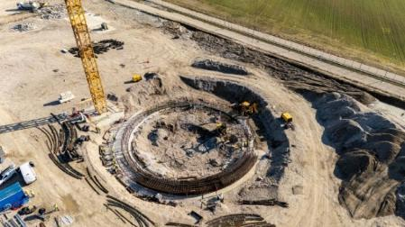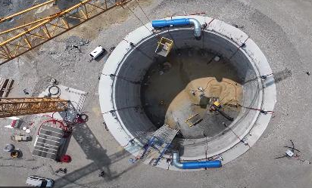
Figure 1 and 2: Construction of reinforcement connections of the reinforced concrete ring of the silo. Author: ARAO.

International Cooperation

SNSA Hosts Two International Events
On 8 and 9 April, a spring plenary meeting of the Western European Nuclear Regulatory Association (WENRA) was held in Bled, Slovenia. The participants discussed the recent situation in Ukraine and the work of the individual WENRA Working Groups, in particular on the implementation and possible renewal of Safety Reference Levels (SRL) in different areas, and cooperation and possible solutions in mutual acceptance or consideration of regulatory decisions in the review of technical solutions for the new power plant projects. The need for as uniform an approach as possible among the competent European regulatory authorities in the light of the increased interest in the peaceful uses of nuclear energy and the emerging new technologies was also emphasized.
A regular meeting of the HERCA (Heads of European Radiological Protection Competent Authorities) Working Group on Research and Industrial Sources and Practices was held in Ljubljana, Slovenia, on 30 September and 1 October. The meeting focused on discussing and exchanging experiences and best practices in various areas of the use of radiation sources in industry and research. The group members discussed the results of questionnaires used to compare national approaches to the use of radiation sources in HERCA member countries. This time, the main focus was on the analysis of regulatory requirements for the design and supply of industrial X-ray devices.

Ongoing Bilateral Contacts
The traditional quadrilateral meeting of the nuclear regulatory bodies of the Czech Republic, Hungary, Slovakia, and Slovenia, which all have bilateral agreements with each other, joined by the regulators from Finland and Poland, was hosted by SNSA in Portorož, Slovenia, on 13 and 14 May. As always, the main objective of the meeting was to share experience and information on important developments in the field of nuclear safety and to enable discussion on the important topics such as the expansion of the nuclear programs in participating countries and new regulatory challenges concerning the emergence of new nuclear technologies.
The annual meeting under the bilateral agreement with Austria took place in Ljubljana, Slovenia, on 25 and 26 September. The delegations discussed the most important events and developments since their last meeting in 2024. The topics of discussion included the new developments in the regulatory infrastructure, radiation monitoring, emergency preparedness, radioactive waste treatment and management, operation of research reactors, the operation of the Krško NPP (regular outage, aging management program including the reactor pressure vessel monitoring, probabilistic seismic hazard analysis) and activities on the JEK2 project.

NEA Director General Visits SNSA
During his three-day visit to Slovenia, the Director-General of the Nuclear Energy Agency (NEA) at the OECD, William D. Magwood IV, met with the Director of the SNSA and the State Secretary of the Ministry of Natural Resources and Spatial Planning. The discussions focused primarily on presenting Slovenia’s nuclear program, the management of radioactive waste and the construction of the low- and intermediate-level radioactive waste repository, as well as the long-term operation of the Krško Nuclear Power Plant. The JEK2 project was also discussed. Magwood also visited the Emergency Response Center at the SNSA, which is activated in the event of a nuclear or radiological emergency. At the end of his visit, he emphasized that Slovenia can be proud of the consistency it demonstrates in ensuring nuclear safety.
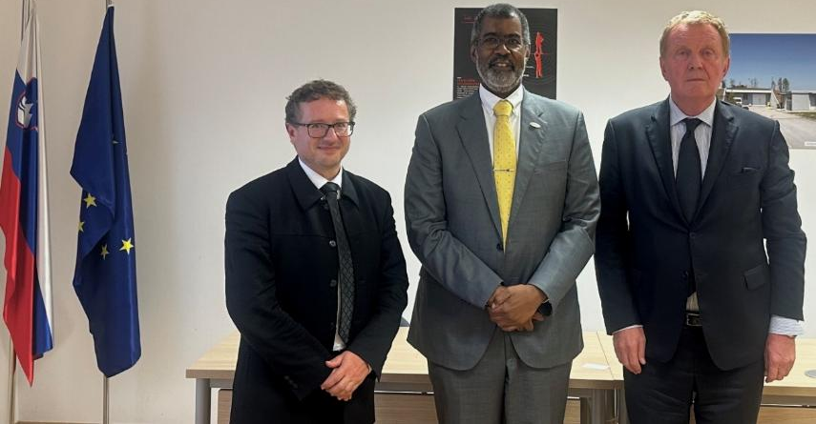Figure 2: NEA Director General Magwood with SNSA Director Sirc and State Secretary Gajšek. Author: SNSA.

Emergency Preparedness

Exercises and Trainings
In April, a Krško NPP exercise was carried out, named “NEK 2025-1 and ConvEx-2e”, reflecting to the involvement of the IAEA. The exercise was pre-announced and aimed at testing the performance of the SNSA and the Emergency Response Team during an emergency event at the Krško NPP and identifying any procedural, systemic, or technical shortcomings. The exercise also tested the use of the Assessment and Prognosis tool within the IAEA’s USIE (Unified System for Information Exchange in Incidents and Emergencies) system, internal coordination within the Emergency Response Team, and coordination between the SNSA and other external organisations.
In September, the SNSA participated in the pre-announced international ConvEx-2b exercise, intended to evaluate national procedures for offer of international assistance through the RANET (Response and Assistance Network) system. The exercise tested the procedures developed by the SNSA for this purpose and additionally coordinated with the Administration for Civil Protection and Disaster Relief.
Members of the SNSA Emergency Response Team also attended several training sessions, the most important of which was the Regional Training Course on Radiation Monitoring in Emergency Situations.

Emergency situation in Ukraine
Over three years into the conflict in Ukraine, the SNSA continues to monitor the situation at Ukraine's nuclear facilities. On 23 September, the Zaporizhzhia Nuclear Power Plant lost all offsite power. During the loss of offsite power, the plant was operating on emergency diesel generators. Temporary repairs on the Chernobyl sarcophagus damaged during the February attack were completed.

Prepared by:
Slovenian Nuclear Safety Administration
Litostrojska cesta 54
1000 Ljubljana, Slovenia

Telephone: +3861/472 11 00
Fax: +3861/472 11 99
E-mail: gp.ursjv@gov.si
URL: www.ursjv.gov.si/en

Ljubljana, October 2025

