# BRIEF SUMMARY

Apart from major floods afflicting Slovenia, the reporting period from April to October 2023, was marked by an unplanned preventive shutdown of the Krško Nuclear Power Plant (NPP) due to primary coolant leakage, whilst these situations did not deteriorate the overall nuclear safety.

The third Periodic Safety Review of the Krško NPP will be completed by the end of the year, before entering long-term operation next year. The activities with regard to the second Topical Peer Review are underway. The first spent fuel transfer campaign from the existing spent fuel pool to the new Spent Fuel Dry Storage building was successfully completed. The activities on the project for the construction of a new Slovenian power plant have accelerated in the second half of 2023.

The Slovenian Nuclear Safety Administration (SNSA) continues to monitor the status of nuclear installations in Ukraine. The National Emergency Response Plan for Nuclear and Radiological Accidents was updated. Slovenia continues its strong bilateral relations in the fields of nuclear and radiation safety with the neighbouring countries and actively participates in international events.

# THE KRŠKO NPP

## Third Periodic Safety Review

Since December 2020, the third Periodic Safety Review of the Krško NPP (PSR3) is in course according to the PSR program which defines the content and scope of the review. The program for the Krško NPP included three new safety factors: Radwaste and spent fuel; Physical protection; and Radiation protection. The safety factor Physical protection was reviewed separately because of the confidentiality of information. The review of the safety factor Probabilistic safety assessment (PSA) included results from the IAEA expert mission on fire PSA in 2020. The review of the plant compliance with the regulatory requirements was also performed. The PSR3 is completed at the time when the NPP reached 40 years of operation and therefore there was special emphasis on the plant’s long-term operation, taking into account the results of the IAEA pre-SALTO (Safety Aspects of Long Term Operation) mission. The approval of the PSR3 report is required for Krško NPP’s operating license extension of 10 years.

In 2023, the following activities were performed: the Krško NPP delivered reports that summarized the review through the 18 safety factors. All PSR3 findings were ranked according to safety criteria and a prioritization of corrective actions was determined for the findings. The implementation action plan was prepared by the operator, and it was discussed with the regulator. SNSA proposed additional actions to be performed for the resolution of those findings that SNSA considered as important for the plant’s safety improvement.

The summary report also includes a global assessment of plant safety with justification for further 10 years of plant operation. Currently, the summary report is being reviewed by SNSA. An authorized institution performed an independent review of the PSR3 report and confirmed that the PSR3 was performed appropriately. The PSR3 will be completed before the end of 2023 with SNSA approval of the report and the implementation action plan with execution period of 5 years.

## Second Topical Peer Review

The European Union’s Nuclear Safety Directive 2014/87/Euratom requires the member states to undertake Topical Peer Reviews (TPRs) at least every six years. In November 2020, at its 41st Plenary Meeting, ENSREG (European Nuclear Safety Regulators Group) decided that the topic of the second TPR (TPR II) would deal with the fire protection of nuclear power plants. WENRA (Western European Nuclear Regulators Association) then developed a technical specification for the national assessment reports (NARs). According to the criteria in the above-mentioned specification, the selected installations in Slovenia that are also covered by the Nuclear Safety Directive (NSD) are:

* Nuclear power plant: the Krško NPP, currently the only NPP in Slovenia;
* Spent fuel storage facility: Spent Fuel Dry Storage Building (on the Krško NPP’s site);
* Storage facilities for radioactive waste that are on the same site and are directly related to the types of nuclear installations listed above: Radwaste Storage Facility, Decontamination Building, Waste Manipulation Building 1 (all parts of the Krško NPP).

The Krško NPP prepared the preliminary version of the NAR, which was independently verified by an authorized organization before being sent to SNSA. Furthermore, the Krško NPP conducted a self-assessment in line with the chapters of the WENRA Technical Specifications that resulted in several new fire hazard analyses and revisions of some existing programmes and procedures.

After receiving the draft proposal of the NAR in May 2023, the SNSA prepared the regulatory chapters and sent the draft version of the NAR back to the Krško NPP with its own comments. The independent expert review of the corrected draft version of the NAR was done by a relevant Technical Support Organization (TSO) in summer 2023. Afterward, meetings between SNSA and the Krško NPP were held to finalize the NAR by the end of October 2023.

## Spent Fuel Dry Storage

The Krško NPP Spent Fuel Dry Storage (SFDS) is being constructed for the long-term dry storage of the spent fuel which will consequently improve nuclear safety due to its passive spent fuel assemblies cooling nature, reducing the overall number of spent fuel assemblies in the spent fuel pool. The SFDS together with its supporting systems and components was performed in the scope of the Krško NPP’s Safety Upgrade Program and ensures the fulfilment of the DEC A conditions in accordance with the DEC requirements given in the Slovenian legislation.

The construction of SFDS Building was finished in January 2023. The first spent fuel transfer campaign from the spent fuel pool to the SFDS Building started in April 2023. 16 Multi-Purpose Canisters (MPCs), each holding 37 spent fuel elements, amounting to 592 spent fuel elements altogether, were transported from spent fuel pool to the SFDS Building. The loading of MPCs with spent fuel elements and subsequent activities were monitored and evaluated by the SNSA inspectors and authorized TSOs. IAEA and Euratom inspectors also monitored the process, verifying that the spent fuel elements were loaded in accordance with the approved loading plan.

The Krško NPP and Holtec International successfully completed the first spent fuel transfer campaign in August 2023. The spent fuel elements were held in an analysed condition at all times during transfer. Nuclear safety was maintained during all of the activities of the first fuel loading campaign. The next spent fuel transfer campaign is planned for 2029, when the next 16 MPCs will be transported into the SFDS Building. The third and the fourth campaign are planned for 2038 and 2048.

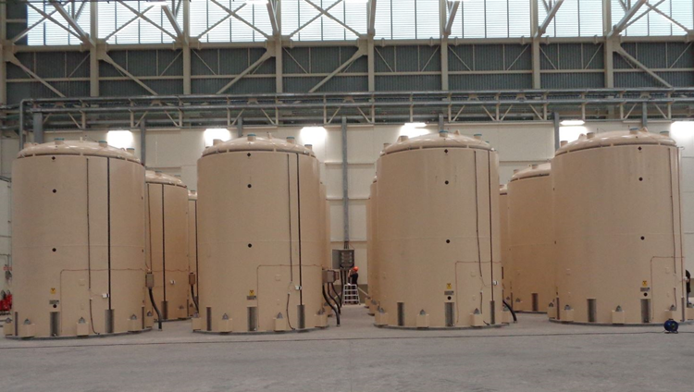

Figure 1: Final location of HI-STORM overpacks containing MPCs in the SFDS Building; author: SNSA.

## Major floods in Slovenia and Increased flow of the Sava River

On 4 August, heavy rains throughout Slovenia caused high water conditions and flooding of many rivers, including the Sava River in the Ljubljana basin and the entire course of the Savinja River. As a result, the flow of the Sava River at the location of the Krško NPP increased and at 6:30 p.m. it reached a value that requires the declaration of an extraordinary event of level 0 – unusual event according to existing NPP procedures. The Krško NPP operated at full power before, during, and after the event. Due to the increased flow and pollution of the Sava River, the NPP staff carried out actions in accordance with internal procedures. On 5 August, the flow and water level of the Sava River near the Krško NPP dropped below the criteria for a declaration of emergency and the trends indicated further reductions in flow and water levels. This was the reason that the Krško NPP declared the end of the emergency. The nuclear safety of the plant was not compromised during this event.

## Unplanned shutdown due to primary coolant leakage

On 4 October at 23:30, the Krško NPP staff detected an unidentified leakage from the reactor coolant system (RCS). The initial leakage of 28 l/h was determined through the control of the Chemical and Volume Control System inflow in RCS. The RCS leakage indication was later confirmed through a reduced level of primary coolant in the Volume Control Tank, increased level in the Containment Sump, increased containment atmospheric radioactivity, etc. On the following day, during the normal operation on power, two entries to the containment were performed, the leak location was not found. Even though that a leak of 45 l/h was about five times smaller than the value set by the limiting conditions for operation, the NPP staff decided to preventively shut down the plant.

After the unplanned shutdown, cooling down and depressurization of the primary system to 50 oC and 25 kp/cm2 began. On 7 October, a leak location was found on the weld of the reducing part (4'' x 6'') of the safety injection (SI) pipe which is connected to the reactor vessel. It is approximately 1 m away from the reactor vessel. Since the repair of the leak would be complicated due to the proximity of the reactor vessel and consequently in a high radioactivity zone and due to the limited access to the weld itself (preparation of the weld site, welding, non-destructive examination of the weld with ultrasound examination after the repair is completed), the operator decided to remove a part of the pipeline and replace it with a new part. Also, the pipeline on the second branch of the SI will be preventively replaced, although no trace of leak was found there. The problematic weld was manufactured at the factory and the pipeline was installed during the construction of the NPP. The conservative replacement of both parts of the SI pipeline was justified by a lack of information currently available regarding the causes of the crack. Both parts of the pipelines will be sent to a hot laboratory for detailed material research. Therefore, it will take from 6 to 12 months to find out the conclusions and to finish root cause analysis of the event.

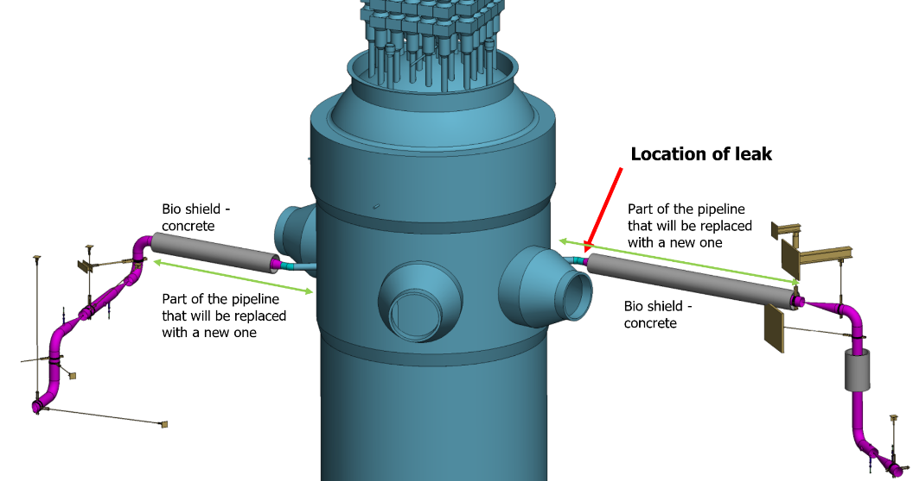

Figure 2: Leak location and part of the pipeline being replaced; author Krško NPP.

Before the restart, the Krško NPP will submit a report to SNSA including the description and timing of the event, a preliminary analysis of the event and corrective actions that were carried out to prevent recurring the event. The report will also include the results of analyses, prepared by TSOs.

SNSA was informed on the event on 5 October and immediately gathered a team to oversee the situation in the NPP. Since the unplanned shutdown, continuous inspection, and regular meetings between the Krško NPP staff, SNSA, and TSOs are held several times a week. SNSA is being duly informed of all the measures prepared and initiated by the Krško NPP. The restart of the NPP is currently foreseen in mid-November 2023.

# The JEK2 project - New Nuclear Power Plant in Slovenia

## Recent Developments

The project for the possible construction of a new Slovenian power plant (hereinafter referred as: JEK2 project) is led by the investor GEN energija, d.o.o. The JEK2 project began in 2021 when the first license, i.e., the Energy permit was issued. It defined the envelope of the future reactor that shall be a GEN III or III+ PWR plant with a 1100 MWe power and foreseen for 60+ years of operational lifetime. The project continued in 2022 with the siting process, where the investor presented an application for the project with an initiative required as a basis for the National spatial plan preparation. However, after performing the review of the initiative, the Ministry responsible for spatial planning required an upgrade. In the meantime, the energy situation in Europe has drastically changed, the investor responded promptly by expanding the project to either 1 or 2 units within the envelope of maximum power of 2400 MWe. The project is still tentative and the final decision on construction is planned to be taken in a national referendum.

## Involvement of the Government

In June 2023, the Government of the Republic of Slovenia designated a State Secretary to the Prime minister’s cabinet with the aim to coordinate the activities of different stakeholders involved in the JEK2 project. In early September, the Government appointed a working group responsible for the coordination of activities with the aim of establishing a suitable regulatory framework and speeding up the implementation of the project. The working group performs the following tasks:

* ensures the coordinated and continuous cooperation of the members and active participants of the working group in the implementation of the JEK2 project;
* monitors and coordinates the processes of siting, licensing, selection of a business model, closing of the financial structure and strategic selection of the equipment supplier;
* prepares starting points and professional bases for the national capacity-building policy in support of the JEK2 project;
* monitors the preparation of national strategic documents that deal with or have an impact on the JEK2 project or the long-term use of nuclear energy in the Republic of Slovenia and, if necessary, gives opinions in this regard;
* monitors and learns about the international practice of new nuclear constructions;
* designs content and coordinates the preparation of foundations and feasibility studies for the JEK2 project.

The working group is presided over by the previously mentioned designated State Secretary. Its members include high representatives from various ministries, as well as chairpersons of SNSA, GEN energija, d.o.o., Krško NPP and ELES (the operator of Slovenia's electric power transmission network). The working group reports on its work to the Government at least once every six months and shall prepare a final report on the performance of its tasks when it ceases to operate. The first meeting of the working group was held on 25 September.

## Future steps

The process of the National spatial plan preparation is planned to start in mid-2024. The role of SNSA in the siting process is the issuance of guidelines for the National spatial plan preparation, the review and approval of the study of variants and the positive opinion on the final stage of this licensing process. In parallel, another important process will be performed, i.e., the Strategic Environmental Assessment. This shall also include an assessment of transboundary impacts to the neighbouring countries. In parallel, the investor is proceeding with negotiations with possible vendors; three vendors were identified as appropriate candidates for the JEK2 project. The lengthy process of vendor selection will be completed before 2028 when the Final investment decision should be prepared as the basis for selecting a vendor for the new NPP. Prior to this decision, the national referendum will have to confirm the continuation of the process or possibly the rejection of the JEK2 project.

The JEK2 project is a demanding task for the SNSA with current capabilities suitable to regulate the existing national nuclear program only. At present, SNSA is preparing for the JEK2 project and expects that its staff number will be increased before the start of the siting licensing process. SNSA duly cooperates with other state authorities involved in the project.

# INTERNATIONAL COOPERATION

## IAEA General Conference

The Slovenian delegation consisting of representatives from SNSA, Ministry of Foreign and European Affairs, Jožef Stefan Institute and GEN energija, d.o.o. attended the IAEA General conference in Vienna from 25 to 29 September. The SNSA participated in several side events and presentations on various technical topics, e. g. on nuclear safety and security in Ukraine, new solutions for radwaste management, new reactor types and small modular reactors, cancer treatment in developing countries, and regulatory challenges. A traditional multilateral lunch with the regulatory bodies from European countries with similar interests and bilateral agreements with each other (Slovenia, Slovakia, Hungary and Czech Republic, additionally joined by Finland and Poland) was also organized during the conference.

## Bilateral Meeting with Austria

The annual meeting under the bilateral agreement with Austria took place in Ljubljana, on 4 and 5 October. The delegations discussed the most important events and developments since their last meeting in Klagenfurt in 2022. The topics of discussion included the new developments in the regulatory infrastructure, radiation monitoring, emergency preparedness, radioactive waste treatment and management, operation of research reactors, as well as the operation of the Krško NPP: safety upgrade programme, long-term operation, second topical peer review, status of the new SFDS project and the JEK2 project.

# EMERGENCY PREPAREDNESS

## Exercises and Trainings

In April, the national exercise on the use of the KID, the emergency communication system, was conducted. In June, SNSA participated in the IAEA ConvEx-2a exercise, which was based on the scenario of elevated radiation in the containers of a ship docked at the port of Koper. In September 2023, SNSA participated in the ConvEx-2b exercise and successfully provided assistance through the IAEA’s Response and Assistance Network (RANET). This exercise marked the first time when all Slovenian assistance providers in RANET participated simultaneously. During the exercise, the national procedures for international assistance were also tested. Other training and exercises are proceeding as scheduled. The annual exercise at Krško NPP has been postponed due to the detected reactor coolant leak (see Chapter I.5.).

## Emergency Preparedness and Response During the War in Ukraine

SNSA continues to closely monitor the situation in all Ukrainian nuclear facilities and actively participates in relevant meetings with international organizations, as well as bilateral and quadrilateral meetings on this topic.

## Emergency Response Planning

In May 2023, the Government adopted the revision of the *National Emergency Response Plan for Nuclear and Radiological Accidents,* version 4.0. The new revision is a fundamental plan that regulates a nuclear accident at the Krško NPP with a major release of radioactive substances, a nuclear accident abroad with impacts on Slovenian territory, and a radiological accident in Slovenia resulting from the uncontrolled re-entry of a satellite with radioactive materials.

Alongside this major update, several new EPR documents were prepared, including Hazard Assessment, Risk Assessment, and Risk Management Capability Assessment for Individual Accidents. These documents and plans collectively ensure that the country is well-prepared to manage and respond to nuclear and radiological accidents effectively.

Map of Slovenia showing the positions of nuclear installations