# BRIEF SUMMARY

In the reporting period from April to October 2022, all nuclear installations in Slovenia have been operating without any significant safety events. A refuelling outage at the Krško NPP was completed. Various projects related to the plant’s safe long-term operation are running smoothly and the construction of the spent fuel dry storage is progressing according to plan. Slovenian Nuclear Safety Administration (SNSA) continues to monitor the status of nuclear installations in Ukraine.

Slovenia continues and enhances its strong bilateral relations in the fields of nuclear and radiation safety with countries from various regions. The IAEA EPREV Follow-up mission reviewed the implementation of the EPREV Action Plan, adopted after the initial mission in 2017.

# THE KRŠKO NPP

## Outage 2022

The Krško nuclear power plant outage after the 32nd fuel cycle started on 1 October and finished on 7 November. Besides the regular activities, such as refuelling and reactor physics tests with inspections of the equipment, 14 modifications were implemented during the outage, namely the replacement of the high-pressure turbine, update of the seismic instrumentation system, mechanical stress improvement process (MSIP) and the replacement of the component cooling system (CC) heat exchangers.

**Replacement of the high-pressure turbine** (modification 1098-TU-L) is the final step in the Krško power upgrade program, which began with a replacement of steam generators and nuclear steam supply system (NSSS) thermal output uprate to 2000 MWt. With the replacement of low-pressure turbines, feed water heaters and moisture separator reheaters (MSRs), the maximum heat balance was rated up to 726.8 MWe. Additionally, the main generator and exciter were rated up to 850 MVA. Now, the original high-pressure turbine remains the last component in utilization of all previously built-in upgrades. With the new Siemens turbine type BB0296FA, the plant will reach presumably 736.6 Mwe according to new rating plate and heat balances. The design, material used, and mechanical strength are adequate for intended long term operation of the Krško NPP. The new high pressure turbine design includes a complete redesign of blading, replacement of the partial arc steam admission and associated control stage with full arc steam admission and all reaction stages, modification of four control valves and modification of control concept. The replacement of the high-pressure turbine required the change from turbine impulse pressure measurement to turbine inlet pressure as an indirect measurement of turbine power.

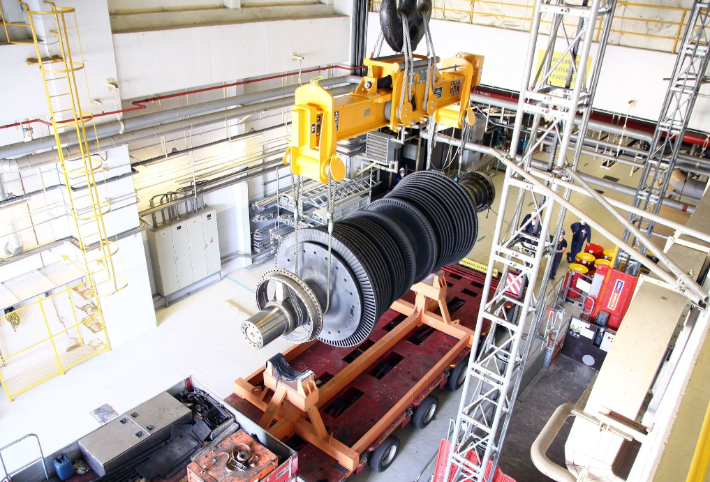

Figure 1: Replacement of the high-pressure turbine (lifting of the high-pressure turbine casing), photo: Krško NPP

**The update of the seismic instrumentation system** completely renewed the system as to support the power plant life extension and allow future functional expansion of the system to cover more stringent seismic surveillance requirements. The existing seismic instrumentation system was of obsolete technology and not capable to service the intended long-term operation of the plant, as well as also uncapable of extending its configuration for additional functions. The new system meets the requirements for operability and structural integrity during and after operating basis (OBE) and safe shutdown (SSE) earthquakes.

**The mechanical stress improvement process** (MSIP) was applied to the reactor vessel (hot leg and cold leg) and the safety injection nozzles to prevent and mitigate primary water stress corrosion cracking (PWSCC) at the nozzle to safe end welds. During the process of radially squeezing the piping to redistribute the residual stresses along the inner region of the pipe, the process also resulted in the axial elongation of the piping to the steam generators and reactor coolant pumps. Similar to the radial squeezing process, the axial elongation is a one-time, permanent deformation. The implementation of the MSIP process affects the Krško NPP in-service inspection program, where the categorization of locations of the applicable bimetal welds inspections on the reactor vessel and safety injection nozzles is changed.

**The replacement of** safety related, class 3, two **CC heat exchangers** included disassembly of existing heat exchangers and installation of new ones. Existing shell and tube CC heat exchangers have been in operation since the construction of the Krško NPP and are approaching the expiration of their design life span of 40 years of operation. Degradation mechanisms, in particular erosion and corrosion, have damaged the main constructional elements during the entire service life of CC heat exchangers. Due to the Krško NPP long term operation, the only sustainable solution was the replacement of CC heat exchangers for safe and reliable operation in the long run.

## Pre-SALTO Action Plan

In early 2022, International Atomic Energy Agency (IAEA) issued a report on the pre-SALTO mission carried out at the Krško NPP in October 2021. The plant promptly prepared an action plan to deal with the issues and/or findings included in the mission report. SNSA carried out a thematic inspection on ageing management in September 2022 in order to check the details and progress of the NPP’s pre-SALTO action plan.

During the inspection, it was confirmed that the action plan addressed every single issue (i.e., recommendations and suggestions) from the report. Some issues have already been resolved, others are in progress. The most comprehensive action, namely the ageing management review of active components, is expected to be finished by the end of 2025. The execution and implementation of the pre-SALTO action plan are monitored by SNSA, while the NPP has to report on the action plan implementation progress in regular intervals. The SALTO mission as a follow-up to the pre-SALTO is expected at the Krško NPP after the completion of its pre-SALTO action plan.

## Spent Fuel Dry Storage (SFDS)

The construction license for SFDS was obtained in December 2020. The final approval of the project/modification in accordance with the Act on Ionizing Radiation Protection and Nuclear Safety was issued in October 2022.

The dry storage building is in the final stage of construction. The finalization of the project, including arrangement of external areas around the dry storage building, is expected by the end of 2022. The preparations for the first campaign (dry tests) will start in December 2022. The first transfer campaign of 592 fuel elements in 16 containers is expected to start in February 2023 and should last until mid-July 2023. In order to ensure a high level of nuclear safety, it is envisaged that preparations for the campaign and certain critical activities will be monitored and evaluated by authorised experts.

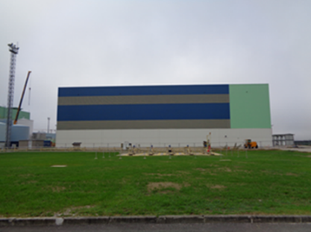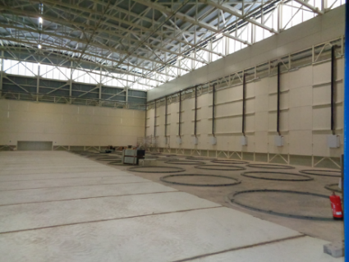

Figure 2: The Krško NPP spent fuel dry storage building, photo: SNSA.

## Status of the Krško NPP Safety Upgrade Project

The original Safety Upgrade Project (SUP) was comprised of 10 actions. These were separated into three phases. All the original SUP improvements have been completed by the end of 2021. In addition to the originally planned SUP improvements, the Krško NPP implemented a few more improvements (i.e., installing the high temperature reactor coolant pump seals, constructing the spent fuel dry storage). The latter is still ongoing, though the main designing and licensing, as well as construction of the main safety related structures are complete.

As it can be seen from the PSA results, the SUP improvements have drastically decreased risk and improved the robustness of the Krško NPP. Most of the „soft“ improvements are also completed, there are only a few of them still ongoing (e.g., development of external hazard PSA for SFP).

## Third Periodic Safety Review (PSR3)

Since December 2020, the third PSR of the Krško NPP is in course according to the PSR program which defines the content and scope of the PSR. The PSR program for the Krško NPP was prepared in line with the SNSA safety guide PS 1.01 and included three new safety factors from the Rules JV9: Radwaste and spent fuel; Physical protection; and Radiation protection. The Safety factor Physical protection is reviewed separately because of confidentiality of information. The review of safety factor PSA includes results from the IAEA expert mission on fire PSA in 2020. The review of plant compliance with the regulatory requirements was performed, including the conformance with WENRA Safety Reference Levels. The PSR3 will be completed by the 40-year operation of the NPP, therefore there is special emphasis on the plant’s long-term operation, by taking into account the results of the IAEA pre-SALTO mission. The PSR3 is required for Krško NPP’s operating license extension of 10 years.

In 2022, the following activities were performed in the PSR3: the Krško NPP delivered topical reports on the review of safety factors to SNSA for review and comment. Numerous meetings of the SNSA representatives, the NPP staff and reviewers took place to resolve comments. Final versions of topical reports were approved by SNSA in September 2022. Altogether, there were 180 PSR3 findings identified with many interfaces between safety factors to be considered. Most of the PSR3 findings were about the safety factors Plant design, Actual conditions of SSC, Safety performance, Deterministic safety analysis and Emergency Planning. In the next step, the PSR3 findings will be ranked based on their safety significance and accordingly, a prioritization of actions will be defined. In 2023, SNSA shall review the results of the prioritization process. PSR3 will be completed by the end of 2023.

# INTERNATIONAL COOPERATION

## New bilateral agreements with Poland and Morocco

In May, a Memorandum of Understanding for cooperation and exchange of information in nuclear regulatory matters was signed between SNSA and the National Atomic Energy Agency of the Republic of Poland (PAA). For that purpose, the PAA delegation travelled to Slovenia, visited the Krško NPP and briefly exchanged experience with the SNSA staff.

During the IAEA General Conference in September, SNSA and the Moroccan Agency for Nuclear and Radiological Safety and Security signed a similar Memorandum of understanding for exchange of information on various matters related to nuclear and radiation safety. Both delegations agreed to hold the first meeting under the respective arrangement as soon as possible.

## Bilateral Meeting with Austria

The annual meeting under the bilateral agreement with Austria took place in Klagenfurt, Austria, on 13 and 14 October. The delegations discussed the most important events and developments since their last meeting in Ljubljana in 2021. The topics of discussion included the regulatory infrastructure, outcomes of IAEA missions, radiation monitoring, emergency preparedness, radioactive waste treatment and management, operation of research reactors, as well as the operation of the Krško NPP, outage plans, safety upgrade programme, long-term operation, second topical peer review and the status of the new spent fuel dry storage project.

# EMERGENCY PREPAREDNESS

## Exercises and Trainings

Due to the Covid-19 pandemic, most of the SNSA staff was working from home until June 2022. After the restrictions have been lifted, the implementation of the training and exercise plan is progressing normally. From 17 to 19 May, SNSA organized and conducted, in cooperation with IAEA and the Austrian Institute of Technology (AIT), an international cyber security exercise in nuclear facilities – KiVA2022, which represents the interface between nuclear safety, security, cyber security and emergency preparedness. The cyber security activities of SNSA were also recognized as good practice by the IAEA IRRS mission. SNSA was planning to participate in the ConvEx-2a and ConvEx-2b exercise but both exercises were postponed due to the situation in Ukraine. A national theoretical exercise on the topic of preparedness for a nuclear accident at the Krško NPP, which was postponed in 2021, is now planned to be conducted in November 2022, as well as the second NPP Krško annual exercise “NEK2022-2”.

## SNSA Emergency Preparedness and Response During the War in Ukraine

In relation to the latest war-induced threats in Ukraine from 24 February onwards, SNSA is still closely following the situation in Ukrainian nuclear facilities, and attends the relevant meetings with international organizations, bilateral and quadrilateral meetings on this topic. We are following the situation in all Ukrainian nuclear power plants and other nuclear-related facilities on a daily basis. SNSA also prepares answers for the media and public to questions related to the current situation in Ukraine, nuclear safety, emergency preparedness, and mostly related to protective actions to be taken in case of a nuclear accident and other radiation hazards.

## EPREV Action Plan and Follow-up Mission

In early October 2022, Slovenia hosted the IAEA EPREV Follow-up mission, which reviewed the implementation of the EPREV Action Plan, adopted after the initial mission in 2017. The Follow up mission closely reviewed the Action plan and 28 out of 31 actions were proven to be closed. The team observed a commitment to emergency preparedness at all levels and noted that Slovenia has made significant progress in developing and revising emergency arrangements since 2017. The mission recognized a few more areas to improve (suggestions) and 2 good practices: the development of a National Protection Strategy as a stand-alone document and the development and conduct of the KiVA2022 Exercise.

Map of Slovenia showing the positions of nuclear installations