# BRIEF SUMMARY

In the reporting period from April to September 2021 all nuclear installations in Slovenia were operating without any significant safety events. The period was also marked by the 40th anniversary of the start of operation of the Krško NPP.

The renewed Rules on the Radioactive Waste and Spent Fuel Management entered into force. During the Krško NPP refuelling outage several upgrades from the Safety Upgrade Program were completed, with only two modifications remaining. During his visit to Slovenia the Austrian foreign minister visited the Slovenian Nuclear Safety Administration (SNSA). In the field of emergency preparedness, the SNSA participated in the ConvEx-2a and the annual Krško NPP exercise. The National Protection Strategy in case of an emergency was adopted by the Government.

# LEGAL SYSTEM

The renewed ***Rules on the Radioactive Waste and Spent Fuel Management*** were adopted and entered into force on 14th August 2021.

The following pieces of legislation:

* amendments to the ***Act on Ionizing Radiation Protection and Nuclear Safety (ZVISJV)*** and
* the new ***Rules on the Requirements for New Constructions and Interventions in Existing Facilities to Protect Human Health from the Harmful Effects of Radon***

which were prepared as a response to the formal notice from the European Commission (non-notification of all provisions transposing Council Directive 2013/59/Euratom of 5th December 2013 laying down basic safety standards for protection against the dangers arising from ionizing radiation) are both in the final stages of adoption. The amendments to the Act already passed the governmental procedure, were sent to the parliament and will presumably be adopted by the end of October 2021. The above stated Rules passed the inter-ministerial coordination, the approval from the EC (based on Article 33 of the Euratom Treaty) has been obtained. The proposed content of the Rules still needs to be checked by the EC based on the Directive (EU) 2015/1535 laying down a procedure for the provision of information in the field of technical regulations and of rules on information society services.

In response to the EC letter of formal notice for non-compliance with certain provisions of the Directive 2011/70/Euratom establishing a Community framework for the responsible and safe management of spent fuel and radioactive waste, a **new Resolution on the National Program for Radioactive Waste Management and Spent Fuel 2023 - 2032** (ReNPRRO23-32) is being prepared to replace the current one. A draft of the new Resolution (the so-called “expert bases”) was sent to the Ministry of the Environment and Spatial Planning and the Ministry of Infrastructure. The adoption process will continue at the governmental level and in the Parliament. The new Resolution is expected to be adopted by the end of 2023.

As previously reported, two regulations in the field of radioactive waste management are being prepared, namely:

* the ***Decree on Performing a Compulsory Public Utility Service of Radioactive Waste Management*** and
* the ***Decree Establishing a Public Radioactive Waste Management Company***.

After the public debate, both drafts have successfully passed the inter-ministerial coordination, but the adoption by the Government will be postponed until the adoption of the amended ZVISJV (see above) is finalized, since the Act represents the legal basis for the adoption of both above stated decrees.

# THE KRŠKO NPP

## Two Important Anniversaries of the Krško NPP

The Krško Nuclear Power Plant is the largest power plant in Slovenia. The plant is a 2-loop Westinghouse pressurized water reactor, with a rated thermal capacity of 1,994 thermal megawatts (MWt) and 696 megawatts-electric (MWe).

In 2020, it produced 6.0 TWh, which is 37.8% of electrical power produced in Slovenia.

The only nuclear power plant in Slovenia, the Krško Nuclear Power Plant, has recently marked two important anniversaries.

40 years have passed since on 11th September 1981 at 2:37 pm, the Krško NPP reactor reached its first criticality .

On 2nd October 1981 at 9:05 pm, the Krško NPP was synchronized with the 380 kV grid for the first time, thus started sending the first megawatts of electricity to the grid .

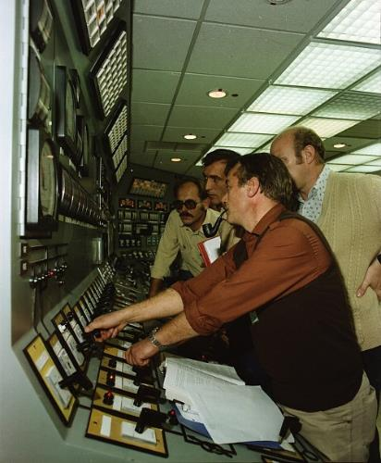

Figure 1: The Krško NPP was synchronized with the grid on 2nd October 1981 / source: www.nek.si

## Status of the Safety Upgrade Program

During the 2021 outage, the implementation of the Krško NPP's Safety Upgrade Program (SUP) continued with the installation of alternate safety injection (ASI) and alternate auxiliary feedwater (AAF) systems. Both ASI and AAF are part of the Design Extension Conditions (DEC) systems. Their reservoirs and pumps are housed in the new bunkered building BB2, which was also built within the implementation of the SUP. Other SUP modifications were also completed during the April 2021 outage, including the installation of the alternate residual heat removal system (ARHR), installation of high temperature reactor coolant pumps' seals, safety upgrade of the emergency alternate power supply, and installation of radiation monitor at the release point of the filtered venting system.

After the finished outage in May 2021, there are only two SUP modifications left to be completed. The first one is the upgrade of the operational support centre which should be completed by the end of 2021. The second one is the construction of the spent fuel dry storage (SFDS). The construction license for the SFDS was issued in December 2020. The licensing process included an environmental impact assessment with a cross-border assessment. The construction of the SFDS started in April 2021. The foundation slab construction was completed in September and the construction of the reinforced concrete walls is currently underway. The installation of the steel roof structure is planned in November. The construction of SFDS which is planned to be completed in the second half of 2022, will be followed by the first phase of fuel transfer scheduled in the first half of 2023.

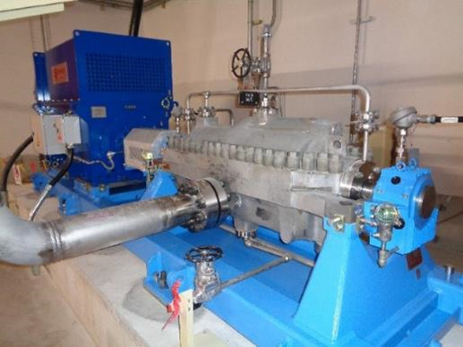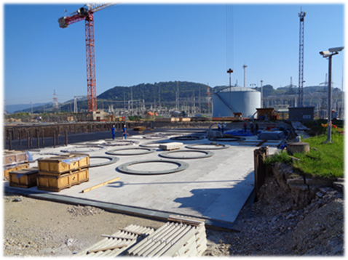

|  |  |
| --- | --- |
| Figure 2: Alternate auxiliary feedwater pump in the bunkered building 2 / source: SNSA archives | Figure 3: Construction of the foundation slab of the new spent fuel dry storage / source: SNSA archives |

# INTERNATIONAL COOPERATION

## Austrian Foreign Minister and the Governor of Styria Visited the SNSA

On 20th August 2021, Mr Alexander Schallenberg, the Austrian federal minister for European and international affairs and Mr Hermann Schützenhöfer, the governor of the land of Styria visited Slovenia. The visit to the SNSA was preceded by the meetings at the Ministry of Infrastructure and the Ministry of Foreign Affairs, which addressed, inter alia, the Slovenian energy policy including nuclear energy. The visit at the SNSA was to enable the guests to get familiar with the functioning of the SNSA emergency response centre including its main tasks during an emergency. The guests were interested in technical details of the December 2020 earthquake in Petrinja, Croatia which caused the automatic shutdown of the Krško NPP without any consequences to the plant’s systems and structures, which would require corrective actions.

## Projects of Assistance to the Third Countries

The SNSA is active in four projects, which are run under the auspices of the European Commission Instrument for Nuclear Safety Cooperation of the financial perspective 2013-2020. These projects include the two projects for assisting the nuclear regulatory authority of Iran, the projects for assisting the Ghanaian regulatory body and the State Agency for Radiation and Nuclear Safety of Bosnia and Herzegovina (BH). The implementation of all of the above-mentioned projects has been delayed due to the pandemic. In all these projects the events (workshops, courses, meetings) have been conducted utilizing virtual methods to the extent possible. The BH project was the only one with the on-the-job training implemented at the SNSA, while for the other three projects the organization of events in Europe is still not possible. The scope of the SNSA assistance comprises the tasks related to the strategy of the regulatory body, the management system, the emergency preparedness and response, the legislation review and the assistance to the licensing of the radioactive waste storage.

# EMERGENCY PREPAREDNESS

## Exercises and Trainings

In the past months, the SNSA trainings and exercises have further on been adjusted to the ongoing Covid-19 pandemic. Since certain restrictions have been lifted or new ones have been adopted, i.e. the return to office work, we are again successfully implementing the training and exercise plan. In April, the national exercise on the use of the emergency event communication system KID was conducted, and in May, SNSA participated in the ConvEx-2a exercise, where a scenario of a major radiological accident was played. In June, an annual Krško NPP exercise was also completed successfully. Due to the pandemic countermeasures the exercise was conducted twice with the same scenario to reduce a number of on-site participants during in one session, thus enabling all on-site emergency staff was able to participate. Many trainings were also conducted again, either remotely or individually or in smaller groups in the SNSA emergency response centre.

## EPREV Action Plan and Follow-up Mission

The implementation of the EPREV Action Plan is still ongoing. Currently 86 % of all the actions are completed, and 14 % (5 actions only) are remaining. The National Protection Strategy, one of the most complex actions, was adopted by the Government in July 2021. The next focus is the revision of the National Emergency Response Plan and the preparation of the Arrangements for the Termination of the Emergency. In November, a preparatory meeting for the EPREV follow-up mission is planned. In the meantime, the EPRIMS database is being updated according to the actions completed within the EPREV Action Plan.

## EPR at Krško NPP

In April, the list of recipients of the notification in case of an emergency at Krško NPP was extended to also include the National Crisis Management Centre, apart from the Civil Protection Contact Point and the SNSA. Such notification must be made in case of a site or general emergency declared by the Krško NPP. The National Crisis Management Centre is an important governmental body, responsible for the coordination and management of crises at the highest national level.

Map of Slovenia showing the positions of nuclear installations