# BRIEF SUMMARY

In the reporting period from October 2022 to March 2023, all nuclear installations in Slovenia have been operating safely and without any significant safety events. The new Resolution on the National Program on Radioactive Waste and Spent Fuel Management for the period 2023–2032 entered into force and the environmental consent for the extension of the operating period of the Krško Nuclear Power Plant (NPP) until 2043 was issued. The Spent Fuel Dry Storage building was successfully completed, and the fuel transfer process is starting.

The Slovenian Nuclear Safety Administration (SNSA) continues to monitor the status of nuclear installations in Ukraine and participates in relevant emergency exercises. The report of the EPREV follow-up mission was published. Slovenia continues and enhances its strong bilateral relations in the fields of nuclear and radiation safety with countries from various regions.

# GENERAL NEWS AND LEGAL SYSTEM

## Reorganisation of ministries

In order to ensure better operability and more successful implementation of the Government’s tasks based on the commitments from the Coalition Agreement, the Government carried out a reorganisation of ministries. By amending the Government of the Republic of Slovenia Act, certain areas of work were transposed between the ministries and three new ministries were established. As of January 2023, SNSA has become the body within the Ministry of Natural Resources and Spatial Planning.

## Revision of the Resolution on the National Program on Radioactive Waste and Spent Fuel Management for the period 2023–2032

A new *Resolution on the National Program on Radioactive Waste and Spent Fuel Management for the period 2023–2032* was adopted by the Parliament in January 2023 and replaced the previous Resolution on the National Program on Radioactive Waste and Spent Fuel Management for the period 2016–2025.

A new resolution was prepared as a response to the EU letter of formal notice for non-compliance with certain provisions of the *Directive 2011/70/Euratom establishing a Community framework for the responsible and safe management of spent fuel and radioactive waste*.

# THE KRŠKO NPP

## Environmental consent for the Krško NPP operation by 2043

The process of environmental impact assessment was accomplished at the end of 2022 and an environmental protection consent was issued in January 2023 by the Ministry of Environment and Spatial Planning for the extension of the operating period of the Krško NPP for additional 20 years (until 2043). The procedure was conducted in accordance with Aarhus and Espoo Conventions, as well as European and Slovenian regulations in this area. SNSA took part in the process, providing the conditions for nuclear safety for issuing an environmental consent. All four neighbouring countries (Austria, Croatia, Hungary, and Italy) as well as Germany participated in the cross-border environmental impact assessment. All relevant environmental topics were taken for review, including earthquake safety, resistance to climate changes and other external hazards. Improvements to ensure nuclear safety of the Krško NPP were also discussed.

## Spent Fuel Dry Storage (SFDS)

Over the past decade, the Krško NPP has introduced a series of technological improvements ensuring a higher resilience of the plant to natural and other unlikely events. Where possible, the passive solutions were chosen. The introduction of the dry storage of spent fuel is also a transition from active to passive solutions, as no additional appliance, system or energy supply is required to ensure cooling. The introduction of a spent fuel dry storage had to be carried out in accordance with spatial, environmental, construction and nuclear legislation. The process of amending of the NPP Krško spatial plan, which included a comprehensive environmental impact assessment and a cross-border consultation (with participation of Austria and Croatia), was completed in March 2020.

The integrated construction permit for the dry storage building was obtained in February 2021. An environmental impact assessment and a cross-border assessment with Croatia and Austria were also carried during this process. The process of authorization of the spent fuel dry storage system and changes of the license documents were completed by the SNSA decision issued in October 2022.

A dry storage building has dimensions of 50 x 70 x 20 meters. The thickness of the reinforced concrete base plate is 1.75 meters, while the inclusion of the perimeter walls provides flood protection and allows the anchoring of storage containers. The radiation and temperature measurements are ensured. An infrastructure for the spent fuel dry storage oversight by the International Atomic Energy Agency (IAEA) is installed. All spent fuel elements will be stored in multi-purpose canisters (MPCs) with the helium atmosphere inside. Each MPC will contain 37 spent fuel elements. The thick concrete coat of the container, into which the MPCs will be inserted, will be mechanically and radiologically protected. The cooling of the spent fuel will be passive. The robust design of the containers protects them against extreme weather and seismic hazards as well as the possible fall of a commercial aircraft. The selected technological solution also enables the transport of spent fuel elements in the future for the needs of a durable solution. In the first campaign, 16 containers with 592 spent fuel elements will be moved to a spent fuel dry storage by autumn 2023.

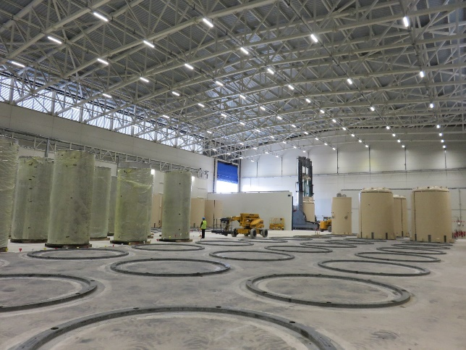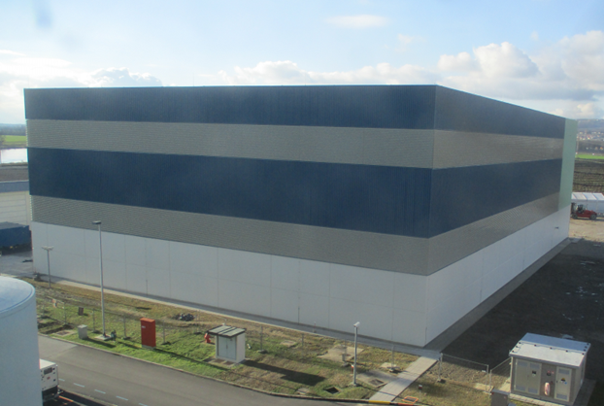

Figure 1 and 2: The spent fuel dry storage building at Krško NPP, author: Krško NPP

# RADIOACTIVE WASTE MANAGEMENT

## The LILW repository in Vrbina

Last year, an important milestone was reached in the development of the LILW repository in Vrbina in the Krško municipality. The consent for construction of the LILW repository was issued by SNSA in February 2022. At the same time, the facility was also declared to be a nuclear facility and the facility of national importance. The construction license for the LILW repository was issued by the Ministry of Environment and Spatial Planning in July 2022. The construction is expected to start in 2023.

# INTERNATIONAL COOPERATION

## Bilateral Meeting with Croatia

The annual meeting under the respective bilateral agreement with Croatia was held in Ljubljana on 13 December 2022. Participants discussed the recent developments in the fields of regulatory infrastructure, emergency preparedness and radiation monitoring, and exchanged experience in the preparation and conducting of IAEA review missions. The countries reaffirmed their close cooperation and the need for prompt exchange of data, information, and experience in all nuclear and radiation safety areas.

## New Bilateral Agreement with the US Nuclear Regulatory Commission

Bilateral relations between SNSA and US NRC have been established for 30 years and are of great importance for Slovenia since the suppliers of equipment and technology for the NPP Krško as well as for the research reactor in Brinje are from the USA. On 21 March, the heads of both regulatory bodies signed a new bilateral agreement enabling continuous technical information exchange, cooperation in nuclear safety research activities, trainings, and cooperation during nuclear and radiation emergency events.

# EMERGENCY PREPAREDNESS

## Exercises and Trainings

In January 2023, SNSA performed a review of the implementation of the 2022 Training plan. The review showed that the plan was 92% implemented, with total of 1,533-man hours of trainings. SNSA employees who are members of the SNSA Emergency Response Team had the opportunity to attend 81 individual trainings and 16 lectures dedicated to emergency preparedness and response topics. Furthermore, 12 exercises also took place.

In November 2022, SNSA participated in the evaluation and conduct of the national exercise "*Nuclear accident 2022*", organized by Administration for Civil Protection and Disaster Relief. The exercise assessed the preparedness to respond to an accident at the Krško NPP and the implementation of protective measures with emphasis on evacuation in accordance with the emergency response plans at various levels of planning. The participants, 50 in total, welcomed the performance of such exercises. They reported to have gained new experience on the course of a nuclear accident and better understanding of their individual roles and the roles of other institutions in the event of a nuclear accident at the Krško NPP. Several challenges of emergency response plans were also identified, such as the need to update the NPP’s public information brochure with information relevant to vulnerable members of the public, the need to improve plans for traffic control of cordoned areas and the need to reconsider of the current method of distribution of ITB tablets in case of an accident at Krško NPP or abroad.

## SNSA Emergency Preparedness and Response During the War in Ukraine

Related to the latest war-induced threats in Ukraine from 24 February 2022 onwards, SNSA is still closely following the situation in Ukrainian nuclear facilities and attends relevant meetings with international organizations, bilateral and quadrilateral meetings on this topic. We are daily following the situation in all Ukrainian nuclear power plants and other nuclear-related facilities. SNSA is also preparing answers for the media and public to questions related to the status in Ukraine, nuclear safety, emergency preparedness, and mostly related to protective actions to be taken in case of a nuclear accident and other radiation hazards.

## EPREV Action Plan and Follow-up Mission

In March 2023, the Government of Slovenia took note of the report on the IAEA EPREV follow-up mission activities (Emergency Preparedness REView follow-up), which was undertaken from 3 to 7 October 2022. The report encompasses the mission’s review of the implementation of the EPREV Action Plan adopted after the initial EPREV mission in 2017, and some new observations, which include 2 suggestions and 2 good practices. The report is publicly available on the [SNSA website](https://www.gov.si/assets/organi-v-sestavi/URSJV/Dokumenti/NUID/EPREV_FollowUp_Report_Slovenia.pdf).

Map of Slovenia showing the positions of nuclear installations