# BRIEF SUMMARY

Apart from the Covid-19 pandemic, the reporting period from November 2020 to March 2021 was marked by an earthquake of a 6,2 magnitude in Petrinja, Croatia, which caused the automatic shutdown and did not affect the safe operation of the Krško NPP. The earthquake did not affect any other nuclear installation in Slovenia all of them were operating without any significant safety events.

The new Rules on the Qualification of Workers in Radiation or Nuclear Facilities and the amended Decree on the National Radon Programme entered into force. The Krško NPP refuelling outage has been in progress since 1st April 2021 and it will also include a completion of several safety upgrades. The Slovenian Nuclear Safety Administration (SNSA) experts were active in the international projects for assisting the third countries to strengthen their nuclear and radiation safety regimes. In the field of emergency preparedness, the SNSA participated in the ConvEx-2b exercise and invited the IAEA EPREV follow-up mission.

# COVID-19 OUTBREAK RESPONSE

## SNSA Measures

In order to prevent the spread of Covid-19 the SNSA returned to working from home (teleworking). This measure has been in place since October 2020 with about 20 % of the staff present in the office. A rotating schedule of the office staff has been prepared until early June 2021.

All business trips, trainings, workshops, and seminars have been postponed or performed virtually. Regular services and procedures related to the licensing and registration of radiation sources are, as usual, provided by the SNSA online or via mail. Virtual inspections have been conducted at the licensees. Among other tasks, the SNSA inspectors have been monitoring the compliance of various legal entities with the measures imposed to curb the spread of Covid-19 infections.

The SNSA regularly monitors the operation of nuclear and radiation facilities and maintains daily contacts with the Krško NPP and also, if necessary, with the operators of other facilities.

In the Republic of Slovenia, a national vaccination strategy has been developed and revised four times, but neither the NPP Krško employees nor the SNSA employees have been included into any of the priority groups according to this strategy.

## Measures at the Krško NPP

The outage at the NPP began on 1st April 2021 under the Covid-19 epidemic conditions. All the measures imposed by the Government are in place. In addition, since the start of the Covid-19 epidemic in March 2020 the NPP Krško has upgraded its response and taken appropriate measures to prevent the spread of infections among its staff and other workers on the site. Typical measures include physical distance, disinfection and respiratory protection equipment.

The outage activities described in detail in Chapter III.2 below, are planned to be implemented without the vaccination. The Krško NPP has prepared some additional measures during the outage. Among these measures are frequent testing, scheduling of the entrance and exit of different groups in line with the pre-defined scheme, wearing a mask at the parking area, use of a FFP-2 mask instead of a surgical one, extending the activity time over a longer period (if not on the critical path) to reduce the number of people working simultaneously and their interactions, extending the opening hours of the canteen and increasing its facilities with tents, expanding the changing rooms area, etc. The Krško NPP has also prepared contingency scenarios in case of an outbreak of infections among the staff.

# LEGAL SYSTEM

The SNSA prepared the new ***Rules on the Qualification of Workers in Radiation or Nuclear Facilities***; the Rules entered into force on 27th November 2020.

The amended ***Decree on the National Radon Programme*** consists of one article which prolongs the application deadline of the methodology for estimating the doses from 2021 to 2023.

Following the formal notice from the European Commission (non-notification of all provisions transposing Council Directive 2013/59/Euratom of 5th December 2013 laying down basic safety standards for protection against the dangers arising from ionizing radiation) the Slovenian Radiation Protection Administration (SRPA) prepared amendments to the ***Rules on the Special Radiation Protection Requirements and the Method of Dose Assessment*** which entered into force on 5th March 2021.

As a result of the above-mentioned formal notice from the European Commission, the SNSA:

* prepared amendments to the ***Act on Ionizing Radiation Protection and Nuclear Safety*** which include, inter alia, a definition of a radiological facility: the obligation of cooperation of the authorized radiation protection experts with the authorized medical physics experts, when necessary; amended definition of the data to be communicated by an external radiation practitioner to the facility operator or to the radiation practitioner, as defined by Council Directive 2013/59/Euratom; etc. The reasons for the proposed amendments were primarily related to the envisaged new status of the Agency for Radwaste Management being a compulsory public utility service of radioactive waste management, which is to be transformed from the current public economic institution into a public company;
* prepared amendments to the ***Rules on the Radioactive Waste and Spent Fuel Management*** and
* began with the preparation of the new ***Rules on the Requirements for New Constructions and Interventions in Existing Facilities to Protect Human Health from the Harmful Effects of Radon***.

In the last quarter of 2020, the Ministry of the Interior, in cooperation with the SNSA, initiated a review of the implementing regulations in the field of physical protection of nuclear facilities and nuclear materials. The results of this review showed that amendments to two regulations in this area were needed, so the amending process began with respect to:

* the ***Rules on the Physical Protection of Nuclear Facilities and Nuclear and Radioactive Materials*** and
* the ***Order Determining the Initial Professional Training Program and Periodic Professional Training Program for Security Staff, When Performing Works Related to the Physical Protection of Nuclear Facilities, Nuclear and Radioactive Materials and Transport of Nuclear Materials***.

The public debates regarding the drafts of:

* ***the Decree on Performing a Compulsory Public Utility Service of Radioactive Waste Management*** and
* ***the Decree Establishing a Public Radioactive Waste Management Company***

were completed and the drafts of both decrees are currently undergoing an informal coordination process with the Ministry of Infrastructure and the Ministry of Finance.

# THE KRŠKO NPP

## Earthquake in December 2020

On 29th December 2020 at 12:20 local time, Croatia was hit by strong earthquake with the epicentre in the region of Petrinja. The earthquake was also sensed at the Krško NPP site while its operation at full power. The maximum peak ground acceleration (PGA) recorded at the NPP site due to this earthquake reached approximately 0.08 g, which is much less than the operating basis earthquake (OBE) for the Krško NPP (PGA = 0.15 g). Nevertheless, the reactor automatically tripped due to the negative rate of the neutron flux sensed by the excore nuclear instrumentation. The Krško NPP entered the procedure that is being used by the operational crew as an immediate response to the earthquake and announced a Level 0 event (Unusual event) in line with the four-level emergency classification system.

The Slovenian Nuclear Safety Administration (SNSA) was informed about the event and immediately gathered a team for monitoring the situation from the beginning and for informing the public. The NPP formed a team composed of system engineers from the Krško NPP, who carried out inspection of the plant’s structures, systems and components (SSCs) according to the relevant procedure. As no indications were reported on the SSCs, the emergency class “Unusual Event” was terminated at 20:10. In addition, the following day the SNSA conducted a reactive inspection at the NPP in order to clarify the circumstances that had led to the reactor trip and to check any damage due to the earthquake. Since no damage was detected on the SSCs, the NPP returned to operation. The Krško NPP also prepared an extensive analysis of the event. It concluded that the most credible cause of the reactor trip was a combination of the low frequency oscillations of the reactor vessel internals, fuel assemblies and/or excore instrumentation due to the earthquake, However, it did influence the readings of the excore neutron detectors.

## Outage 2021 and the status of the Safety Upgrade Programme

A periodic outage after the 31st fuel cycle in the Krško NPP has been scheduled for April 2021. Due to the Covid-19 pandemic the outage is being carried out under strict protective measures for the domestic and the external personnel. Apart from the regular activities, such as the refuelling and physical tests with inspections of the equipment, the work will continue on the Krško NPP's Safety Upgrade Program (SUP). This will include completing the installation of additional trains of the safety systems such as the safety injection (ASI) and the auxiliary feedwater (AAF); both have been partially housed in the recently completed bunkered building BB2 which is also a part of the SUP. In addition, the final installation of another SUP system, the residual heat removal system (ARHR), is also scheduled for this outage. Due to all these upgrades, the duration of the outage is expected to be a few days longer in comparison to the previous one. The total outage duration is planned to be 34 days (breaker-to-breaker).

After the outage has been completed, only two of the SUP upgrades will remain unfinished, i.e. the upgrade of the operational support centre and the construction of the spent fuel dry storage (SFDS). Following the completion of the cross-border environmental impact assessment procedure where Austria and Croatia had participated, the Ministry of the Environment and Spatial Planning issued a construction license for the SFDS facility in December 2020. In 2020, a nuclear licensing procedure for approving the SFDS as the safety modification has also been initiated. It is a comprehensive licensing process, which is still ongoing. The construction of the SFDS is expected to start in May 2021. The first transfer of the spent fuel elements into the SFDS is planned in early 2023.

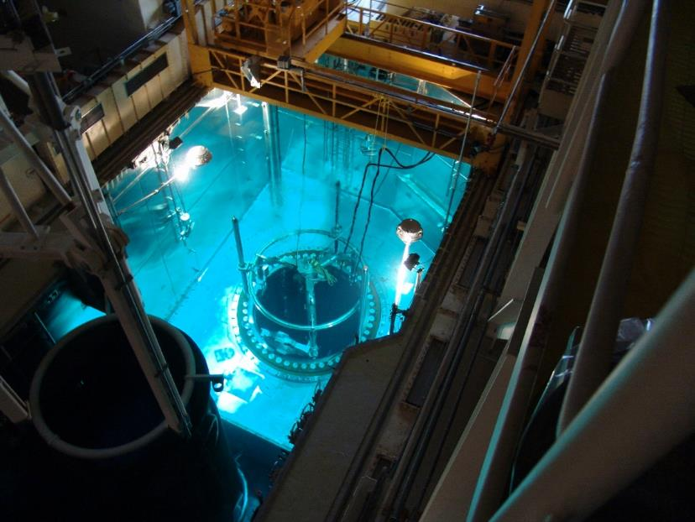 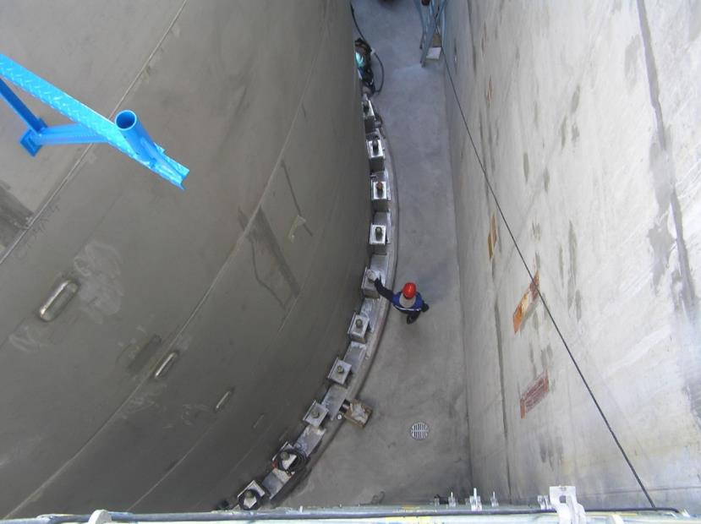

Figure 1: Preparations for the ultrasonic inspection of the reactor Figure 2: The bunkered building BB2 – vault between the AAF tank (left) pressure vessel during the outage and the BB2 wall (right)

# INTERNATIONAL COOPERATION

## Planning of IAEA Missions

In light of meeting the requirements of the Nuclear Safety and Radioactive Waste Directives, the preparations for the IAEA IRRS (Integrated Regulatory Review Service) and ARTEMIS (Integrated Expert Peer Review Service for Radioactive Waste and Spent Fuel Management, Decommissioning and Remediation Programmes) missions are underway. The self-assessment for the IRRS mission is in its final stage and the dates for both missions were set. Both missions are planned as the back-to-back missions. The IRRS mission is going to take place in the period from 4th to 14th April 2022. In order to fully utilize the outcomes of the IRRS mission, the date for the ARTEMIS mission was set from 22nd to 30th May 2022.

## Projects of Assistance to the Third Countries

The SNSA is actively involved in four projects, which are run under the auspices of the existing European Commission Instrument for Nuclear Safety Cooperation, which will be transformed into the European Instrument for Nuclear Safety within the new financial perspective 2021-2027. These four projects include the two projects for assisting the nuclear regulatory authority of Iran and the projects for assisting the Ghanaian regulatory body and the State Agency for Radiation and Nuclear Safety of Bosnia and Herzegovina (BH). All of the above-mentioned projects have been seriously hindered by the pandemic. While the Iranian projects are most affected by the current situation, the Ghanaian and the BH project have been fully utilizing virtual methods to the extent possible (workshops, courses, meetings) to keep them running. Site visits and the on-the-job trainings in the EU are currently not possible. The SNSA provides assistance in the tasks related to the strategy of the regulatory body, the management system, the emergency preparedness and response, the legislation review and the assistance to the licensing of the radioactive waste storage.

# EMERGENCY PREPAREDNESS

## Exercises and Trainings

In the last quarter of 2020 and in early 2021 the SNSA trainings and exercises were further on adjusted to the ongoing Covid-19 pandemic. Most of the SNSA staff have been working from home since October 2020, with the intention to reduce the staff present at the SNSA headquarters. Most of the trainings were adjusted to this situation and were conducted remotely using the information technology. The SNSA emergency team members also attended the IAEA webinars and workshops on the emergency preparedness and response topic remotely. Nevertheless, the SNSA participated in the ConvEx-2b exercise conducted in March 2021 and successfully offered assistance through the IAEA’s Response and Assistance Network - RANET. During the exercise the amended arrangements for the assistance between the SNSA and the ACPDR (Administration for Civil Protection and Disaster Relief) were tested. The SNSA also participated in the ARAO (Agency for Radwaste Management) exercise in December 2020.

## EPREV Action Plan and Follow-up Mission

Despite the measures taken during the Covid-19 pandemic, the activities in the field of EPREV action plan continue to be implemented. In February 2021, the Government of the Republic of Slovenia took note of the implementation of the EPREV Action Plan. A review of the current situation showed that 64 % of the actions with no deadlines were completed by January 2021. All other actions (36 %) are already being implemented. For example, the national protection strategy, one of the most complex actions, was introduced for the public hearing in February 2021. Furthermore, the action to determine the responsibilities of the organizations for the assessment and reconstruction of doses was implemented with the adoption of the amendments to the *Rules on Special Radiation Protection Requirements and the Method of Dose Assessment,* as described in Chapter II. above. According to the Governmental decision, the SNSA invited the EPREV follow-up mission. The mission is expected to take place in the second half of 2022.

## EPR upgrades at Krško NPP

Within the implementation of the SUP, the bunkered building (BB1) was constructed in the NPP Krško which includes the new Technical Support Centre (TSC) and the Emergency Control Room (ECR). The new ECR is a back-up location in case of an evacuation of the main control room (MCR) and enables the NPP to comprehensively manage the emergency response in case of an accident. The TSC enables the on-site emergency response management, also in case of a general emergency.

Map of Slovenia showing the positions of nuclear installations