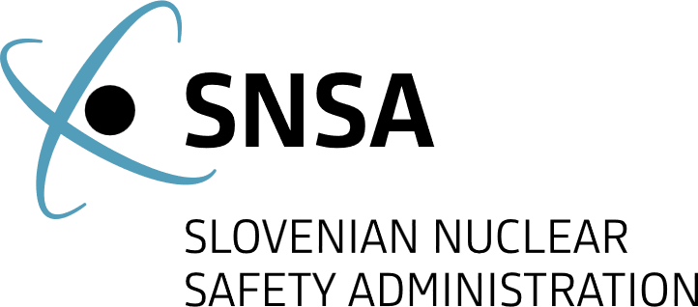

News from Nuclear Slovenia
  - April 2026
Brief Summary
In the reporting period from October 2025 to April 2026, all nuclear installations in Slovenia have been operating safely and without any significant safety events. The legislation in the field of nuclear and radiation safety is being updated regularly. The construction of the low- and intermediate level radioactive waste repository keeps progressing according to the time plan. The activities on the project for the construction of a new Slovenian power plant are still ongoing in the field of spatial placement.
The Slovenian Nuclear Safety Administration (SNSA) continues to maintain good bilateral relations with foreign regulatory bodies and hosted an international meeting. In the area of emergency preparedness, the SNSA cooperates with providers of assistance in the event of a nuclear or radiological emergency and ensures the regular staff training and participation in national and international exercises.

Legal System
On 4 February, the National Assembly of the Republic of Slovenia adopted an amendment to the Act on Liability for Nuclear Damage, extending the state guarantee for an additional four years to cover the portion of nuclear damage that cannot be insured on the market. The amendment ensures adequate financial protection for potential victims of a nuclear incident and maintains Slovenia's compliance with its international obligations.
The Government of the Republic of Slovenia adopted two important regulations in the field of nuclear safety. The Decree on the areas of limited use of space due to a nuclear facility aligns the rules with spatial planning and construction legislation, simplifies certain procedures for obtaining construction-related opinions, and at the same time maintains key restrictions to ensure nuclear and radiation safety as well as the protection of the population. In addition, the Decree implementing the Commission Regulation (EURATOM) on the application of Euratom safeguards was adopted, updating national provisions in line with the new EU regulation and introducing greater clarity, modernized procedures and more precise reporting on nuclear materials.

The JEK2 project - New Nuclear Power Plant in Slovenia
The JEK2 project continues with spatial placement activities. The Initiative for the National Spatial Plan, announced on 1 June 2025, was concluded at the end of October 2025. During the public proceedings, the Ministry of Natural Resources and Spatial Planning received suggestions and comments on the proposed initiative from the public, as well as from spatial management stakeholders, including ministries, municipal bodies, public services, and holders of public services involved in spatial planning. In addition, the public presentation of the initiative was held in the capital, Ljubljana, and in the Municipality of Krško, where JEK2 will be located. The suggestions and comments were incorporated into the guideline analysis. The guideline analysis, which includes the initiator's responses and positions regarding the comments, was published on the web-based Spatial Information System.
The spatial placement of JEK2 continues with the Implementing Decision on the preparation of the National Spatial Plan for JEK2, issued by the Ministry of Natural Resources and Spatial Planning on 17 February 2026. As the type and vendor of the nuclear power plant (NPP) have not yet been selected, the Implementing Decision addresses the spatial placement of an NPP with a capacity between 1,000 MWe and 1,650 MWe. The Implementing Decision also sets the schedule for further steps. The technical studies are to be delivered by the end of 2026. The first proposal of the National Spatial Plan is to be prepared in summer 2027, and following the public hearing at the beginning of 2028, the completion of the National Spatial Plan and the adoption of the National Spatial Plan Decree for JEK2 by the Government are scheduled for summer 2028.
Currently, the investor GEN energija d.o.o. is preparing technical studies on cumulative impacts on nature conservation, ionising radiation impact assessment on nature, the project's vulnerability in relation to expected climate change, hydromorphological changes in the Sava river, thermal impacts of JEK2 on the Sava river, hydrogeological analysis of groundwater in the JEK2 impact area including assessment of the impact of radioactive contamination, possible consequences of an accident and events at the nearby military airport and their impact on JEK2, civil aircraft accidents and the probability of an aircraft collision at JEK2, impacts of explosion and fire at the kerosene pumping station near the Krka factory (an Industrial Emissions Directive facility), probabilistic analysis of seismic hazard, cooling tower collapse scenarios, evacuation measures due to events at JEK2 and the Krško NPP, physical protection, preliminary radioactivity monitoring, and other environmental issues.
The SNSA is included in all JEK2 spatial placement activities. In October 2025, the SNSA issued guidelines for technical issues to be incorporated in the National Spatial Plan. In November 2025, the SNSA issued guidelines for the Environmental Report, which is an integral part of the National Spatial Plan. The SNSA also proposed the preparation of additional technical studies to address issues relating to the nuclear and radiation aspects of JEK2 spatial placement.

Radioactive Waste Management

Progress in Construction of the Repository for Low and Intermediate Level Waste
After completion of the diaphragm wall (primary lining) at the end of 2024, excavation of the construction pit (silo) began in March 2025. Throughout the excavation, geotechnical monitoring and geodetic surveying have been carried out continuously.
In December 2025, following the installation of the blinding concrete, PVC membrane, and reinforcement, concreting of the silo base slab commenced and was completed in February 2026. A temporary construction elevator was also installed to transport personnel and construction materials into the silo excavation pit. The elevator will be used exclusively during the construction phase, and its installation enables more efficient and safer work organization.
Currently, construction of the secondary lining walls of the silo – an important safety structure – is underway. The work is progressing according to schedule.
Prior to the start of secondary lining construction, a test field was successfully completed, where the contractor verified the suitability of the concrete mix design, as well as the adequacy of placement and curing of the secondary lining concrete. This lining will ensure key safety functions, including physical and chemical containment of radionuclides, structural stability, reduction of groundwater flow through the repository, and prevention of human intrusion into the facility.
In 2025, construction of the administrative and service building of the repository also began, while construction of the technological facility continues. Preparations are underway for the production of disposal containers.
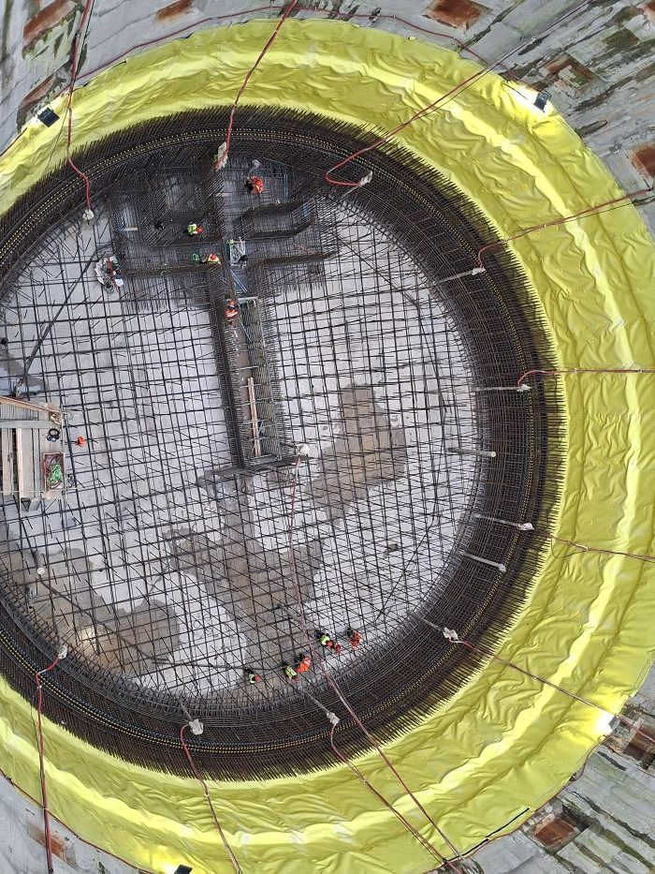
Figure 1: Construction of the silo. Author: ARAO.

International Cooperation

Ongoing Bilateral Contacts with Croatia
The annual meeting, held in accordance with the bilateral agreement between the Republic of Slovenia and the Republic of Croatia on the early exchange of information in the event of a radiological emergency, took place on 12 February in Zagreb, Croatia. Participants discussed recent developments in legislation and regulatory infrastructure and implementation of radiological monitoring. They also discussed radioactive waste management and shared progress to ongoing projects in their radioactive waste storage projects. Furthermore, information was exchanged with the Croatian side regarding key activities in 2025 in the field of emergency preparedness. Further cooperation was agreed upon for the development of coordinated response procedures in the event of an accident at the Krško NPP based on the HERCA-WENRA approach. The participants emphasized that regular meetings, open communication, and coordination of protective measures provide a solid foundation for an effective response in all situations and demonstrate a high level of trust and partnership between the two countries.

SNSA Hosts an International Meeting
A meeting of the OECD Nuclear Energy Agency’s Working Group on Human and Organizational Factors was held in Ljubljana from 3 to 5 March. Among the key topics discussed by the participants were updates and reports from the five subgroups, presentations by member states on current national practices, projects, and challenges, as well as discussions on integrating organizational aspects into future technological solutions. The final day of the meeting was dedicated to a visit to the Krško NPP and the low and intermediate level radioactive waste repository site in Vrbina. Participants were able to see presentations on the management of human and organizational factors in practice, the NPP simulator, and the construction of the repository. The exchange of experience represents an important contribution to improving administrative approaches and strengthening organizational resilience and safety culture in the nuclear sector.

Emergency Preparedness

Key Activities
In February, a meeting was held at the Slovenian Nuclear Safety Administration with providers of assistance in the event of a nuclear or radiological emergency via RANET (Response and Assistance Network). The meeting reviewed the current status of their assistance capacities. It was attended by all Slovenian providers, namely representatives of: the Slovenian Armed Forces, the Jožef Stefan Institute, the Ecological Laboratory with a Mobile Unit (ELME), the Administration of Republic of Slovenia for Civil Protection and Disaster Relief (ACPDR), the University Medical Centre Ljubljana – Division of Nuclear Medicine, the Institute of Occupational Safety (ZVD d.o.o.) and the Institute of Oncology Ljubljana.

Exercises and Trainings
In October 2025, a Correspondence exercise was held with Croatia regarding an accident at the Krško NPP. The exercise confirmed that cross-border cooperation between Slovenia and Croatia in nuclear emergency preparedness is well-established and highly coordinated in most key areas.
In November 2025, the NEK2025-2 exercise was conducted. Its aim was to verify the operations of the URSJV during an emergency and to identify potential deficiencies to improve the preparedness and response system. The drill also tested the WebECURIE (European Community Urgent Radiological Information Exchange) Training system, which had not been used previously.
In December 2025, the KiVA²⁰²⁵ exercise was held as an interactive tabletop exercise to verify procedures for nuclear facilities responding to cyber incidents. The Krško NPP participated on behalf of the nuclear power plant, while the Jožef Stefan Institute (IJS) represented the research reactor.

Emergency situation in Ukraine
Four years after the conflict began in Ukraine, the SNSA continues to monitor the status of Ukrainian nuclear facilities. At the Zaporizhzhia Nuclear Power Plant, work was undertaken at the start of the year to restore the external power supply; after a local ceasefire, repairs were made to a damaged power line.
On 14 March, the Chernobyl Nuclear Power Plant was disconnected from the 750 kV power line for nearly 24 hours due to an attack on a key electrical substation. The resulting fluctuations in the power grid activated the emergency diesel generators to supply power to the confinement (sarcophagus) and the spent fuel storage facility, which were manually shut down after 15 minutes.
Prepared by:
Slovenian Nuclear Safety Administration
Litostrojska cesta 54
1000 Ljubljana, Slovenia

Telephone: +3861/472 11 00
Fax: +3861/472 11 99
E-mail: gp.ursjv@gov.si
URL: www.ursjv.gov.si/en

Ljubljana, April 2026

