Draft proposal for a common European position regarding best practice from a European perspective in an SPLH context
Contents
1. Introduction 1
2. State of play 1
3. Draft proposal for a common European position regarding best practice from a European perspective in an SPLH context 2
3.1 Grace period 2
3.2 Conflicting applications (Art. 54(3) EPC) 3
3.3 Prior user rights 3
3.3.1 General features 3
3.3.2 Elements of "deep" harmonisation relating to prior user rights 4
4. Next steps 5

Introduction

1. At the 53rd meeting of the EPO's Committee on Patent Law, in November 2021, the European delegations agreed that it should be attempted to achieve a common European position on contentious SPLH issues relating to the grace period, conflicting applications and prior user rights, as consigned in the summary of conclusions in Document CA/PL 5/21. The first part of the exercise is to determine what constitutes best practice from a European perspective for these issues, within the context of SPLH. Once this has been achieved, a second phase will follow focusing on potential flexibilities.
2. The substance contained in this draft proposal reflects the outcomes of the deliberations in the Committee on Patent Law. On 23 October 2025, the Committee on Patent Law gave a unanimous favourable opinion on the document containing the draft proposal, the substantive content of which is reproduced here, indicating that they believed that this draft proposal could form the basis for further work within the European Patent Organisation in order to achieve such a common European position. In addition, the Committee agreed on the proposed next steps.
3. In particular, the Office was given the mandate of drawing up a public document containing the substance of the draft proposal for the purpose of consulting European users.

2. State of play

4. The present document captures points:
- on which stakeholder consensus exists, which were endorsed by the delegations,
- agreed to by the European delegations in earlier discussions within the Group B+, and/or
- agreed to by a majority of the delegations expressing a position during the European alignment process.
5. It must be emphasised that this common European position is intended as a tool to assist delegations and users in future substantive discussions on these issues. It should help European delegations to have clarity on best practice from a European perspective and to express themselves with one voice – if so wished – particularly on topics where it is difficult to do so because there are no corresponding norms in European countries, as is the case with the grace period.
6. This common European position would not be binding on the delegations, who would retain the right to take any substantive or policy position they wished both in subsequent discussions at the international level and in terms of their national legislation. The principle of "nothing is agreed until everything is agreed" would also be observed.
7. Once there is agreement on best practice, in light also of the outcomes of the European user consultations, the process will continue for delegations to reflect on possible flexibilities – again within a confidential setting.

3. Draft proposal for a common European position regarding best practice from a European perspective in an SPLH context

8. This proposal for an aligned European position captures both points on which (1) consensus has been achieved amongst stakeholders, which were subsequently endorsed by the delegations (S); and (2) a majority of the delegations expressing a position agreed in the course of the alignment process within the Committee on Patent Law, or in earlier discussions within the Group B+ (D).
9. Where the position reflects existing law in Europe, this is indicated (EPC), as well as when it reflects a largely internationally harmonised norm (H). Some parts of this proposal reproduce the proposals contained in the European study of case law on prior user rights. The proposal is outlined below:

3.1 Grace period

- A grace period would be applicable to any and all pre-filing disclosures made by or for the applicant, or with their consent, regardless of the manner and circumstances of disclosure. (S+D)

- Disclosures made by third parties in evident abuse of the applicant or their predecessor (i.e. through theft of information or breach of confidence) are graced. (EPC)

- Duration: 12 months. (D)

- Calculated from the filing date only. (D)

- Intervening disclosures of independent inventions by third parties are prior art. (S+D)

- Burden of proof on the applicant to show that a disclosure is entitled to be graced. (S+D)

- Statement requirement on the JP/KR model, listing all disclosures by or for the applicant to be graced. Sanction: if a pre-filing disclosure is not listed, it is not graced. (S+D)

- Statement filing date: (a) claiming of the grace period with the filing of the application; (b) filing of required details and supporting documents within one month of filing. These time limits should be strict. (S)

- No accelerated publication if grace period is invoked; all applications published at 18 months from the priority/filing date. (EPC)

- Prior user rights may arise when knowledge of the invention has been gained by the third party from a pre-filing disclosure made during the grace period by the applicant or their predecessor in title, or with their consent. (S)

3.2 Conflicting applications (Art. 54(3) EPC)

- Conflicting applications are relevant for novelty only.

- No anti-self-collision.

- Prohibition against double patenting

- Whole contents approach applies.

- PCT applications become secret prior art only upon entry into the national/regional phase. (EPC)

3.3 Prior user rights

3.3.1 General features

- Prior user rights can accrue where a third party has used or made effective and serious preparations to use an invention commercially. (S+D)

- Prior to the priority or filing date of the patent against which they are claimed. (H)

- Within the territory covered by the patent against which they are claimed. (H)

- Use based on independent invention by third parties gives rise to rights.¹ (S)

- The use or preparations to use the invention must not constitute an evident abuse of the inventor who created the invention used or for which preparations to use were made, or their successor in title. (D)

- No prior user rights may accrue when use is based on non-public information derived from the applicant without their consent. (S)

- Prior user rights may arise when knowledge of the invention has been gained by the third party from a pre-filing disclosure made during the grace period by the applicant or their predecessor in title, or with their consent. (S)

- Burden of proof that prior activities justify a prior user right rests on the prior user. (H)

- The prior user has the right to exploit the invention for the needs of their business. (D)

- Prior user rights are limited to the territory of the patent against which they are invoked. (H)

- Prior user rights are applicable to all patents without exceptions. (H)

- Licensing of a prior user right is not permitted. (H)

- Transfer of a prior user right permitted only if transferred together with the related business within which it accrued. (H)

- Loss of rights if use of the invention or business in which it arose is definitively abandoned. (H)
¹ The principle under this bullet point as well as the following three are all linked, and should be considered together.

3.3.2 Elements of "deep" harmonisation relating to prior user rights

10. Many users and delegations are of the opinion that for prior user rights to be harmonised, implementation by the courts across jurisdictions in a consistent and predictable manner is a prerequisite. For this, in turn, a deeper and more detailed harmonisation of norms would be necessary, in terms of both conditions of accrual and scope of the prior user rights.

11. This level of detail would be addressed only once the general features of the prior user rights listed above have been defined. Nevertheless, the principles as endorsed by the delegations as a basis for discussion are included here in simplified form for the sake of completeness.
- [Accrual] For effective and serious preparations to use the invention to give rise to a prior user right: (a) possession of the invention by the prior user must be complete; (b) concrete technical or commercial measures objectively of a nature to work towards making use of the invention possible must have been taken; (c) preparations must show that a definitive decision/intent exists to begin commercial use of the invention; (d) in the immediate future. (D)

- [Accrual] Possession of the invention is complete where the inventive idea is subjectively recognized; and the invention is objectively complete; so that the actual execution or implementation of the invention is possible. (D)

- [Scope: volume] There shall be no limitations on the volume of use of the invention. (D)

- [Scope: Embodiments] The scope of the prior user right shall be defined as a function of the possession of the invention by the prior user at the critical date. (D)

- Modifications may be made encompassing all variations and equivalents falling within the general inventive concept possessed by the prior user at the filing or priority date (D)

- Further developments beyond the embodiment used or prepared for are not permitted if they encroach further into the subject-matter of the protected invention. (D)

- The prior user cannot incorporate into their embodiment anything which has been learned from the patent specification. In particular: no modification may be adopted which is more practical or better perfected than the embodiment used prior to the critical date, if it is disclosed as such in the patent specification; Where a feature of the patented invention is missing from the embodiment used prior to the critical date, it cannot be added thereafter. (D)

- Modifications may be made even where disclosed by the patent specification if they are self-evident from the perspective of the person skilled in the art, given the prior user’s possession of the invention at the critical date. (D)

- The prior user may make any modifications to the embodiment of the invention which are not disclosed in the patent specification, or which do not fall within the scope of protection of the claims. (D)

- [Scope: types of acts] Prior users having manufactured or made effective and serious preparations to manufacture the invention prior to the critical date shall be free to engage in any acts reserved to the patent holder for the needs of their business; Where the prior use consisted of acts of use or effective and serious preparations for acts of use other than manufacturing, they shall have the right to continue do that act or to do the act for the needs of their business. (D)

4. Next steps

12. The purpose of this document is to form the basis for a consultation of European users and subsequent deliberations in the Committee on Patent Law. The EPO will consult both BusinessEurope and the epi.

13. At its meeting of 26 February 2026, the Committee on Patent Law will again be invited to give its opinion on the draft common European position but in a different context, namely: (1) after consulting European users at both national and European levels; and (2) potentially with a view to forwarding it to the Administrative Council for it to be approved as a basis for further work within the Organisation.
14. In light of the feedback of users, delegations will then complete this phase of the work focusing on the definition of best practice. As a result, a final draft of a common European position on best practice will be submitted to the Administrative Council, and the second stage of identifying flexibilities and red lines will commence.
15. Again, it is emphasised that this common European position is intended as a base line reference which the delegations can use for coordination purposes should substantive discussions take place. The document is not binding on the delegations regarding any position they may wish to take regarding either international discussions, or their national legislation. Its approval for purposes of further work within the Organisation will be followed by discussions regarding flexibilities and red lines.

Annex 1 Table comparing the draft proposal with national laws of other Group B+ delegations
GP: Grace Period
PFD: Pre-Filing Disclosure
PUR: Prior User Right
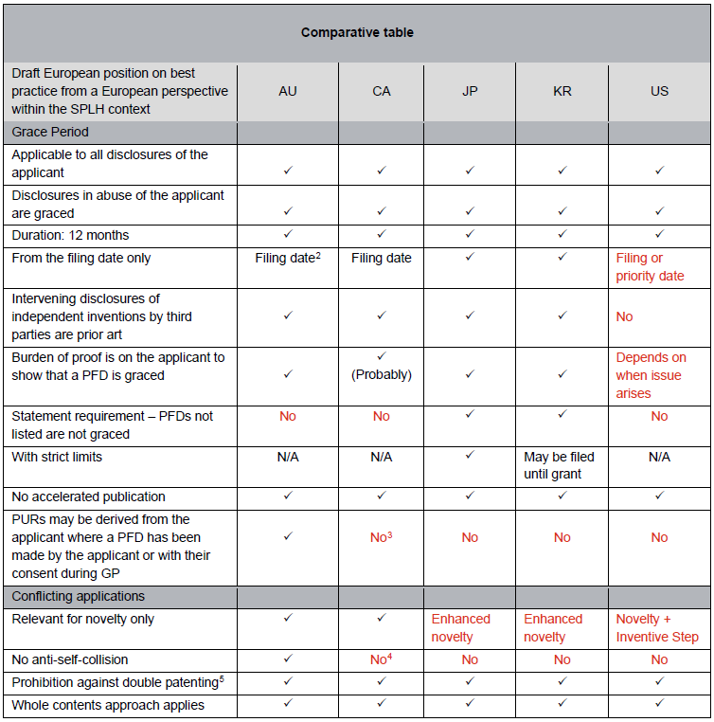
² Whilst the filing date represents the prevalent option in national laws around the world, outside Europe, it would appear that a majority of users would prefer that the filing or priority date be the reference date, with the exception of AU users, who prefer the filing date only.
³ In CA, PURs may accrue from knowledge derived from an applicant’s PFD only if the third party did not know that the applicant was the source of the knowledge. It is unclear how this may be proven, and there appears to be no case law on this provision.
⁴ In CA, conflicting applications are relevant for novelty only. Anti-self-collision applies to the first applicant, but only allows them to choose which application shall proceed to grant, and does not, as in JP, KR or the US, allow more than one patent to issue to the first applicant.
⁵ Approaches may not be harmonised.

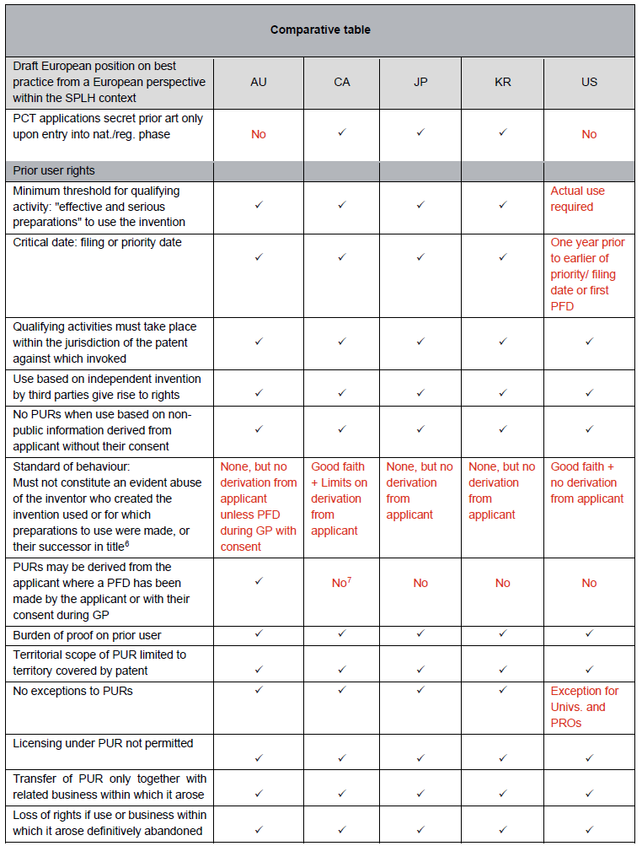
⁶ Condition applying, like that of good faith, erga omnes.
⁷ See footnote 3 above.

