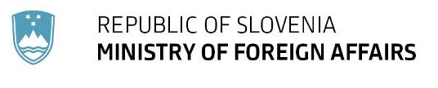
DIRECTORATE FOR MULTILATERAL AFFAIRS
AND DEVELOPMENT COOPERATION
Department for Development Cooperation and Humanitarian Assistance

November 2022

Development cooperation of the Republic of Slovenia

Slovenia has been an official development assistance (ODA) provider since 2004, when it joined the EU and graduated from the World Bank. Since 2013, Slovenia has been a member of the Development Assistance Committee of the Organisation for Economic Co-operation and Development (OECD DAC). The legal bases for Slovenia’s development cooperation are the Act on development cooperation and humanitarian aid of the Republic of Slovenia of 2018 with the implementing Decree of November 2018 and the Resolution on development cooperation and humanitarian assistance of the Republic of Slovenia of September 2017 and the Development Cooperation and Humanitarian Aid Strategy of the Republic of Slovenia until 2030 of December 2018. The Strategy specifies in more detail the objectives and strategic orientations of development cooperation and humanitarian aid, and defines concrete measures for coordinated and effective implementation. A draft action plan on a gradual increase of the GNI share has been drawn up.

I. Slovenia’s international commitments

In May 2015, during the preparations for the adoption of the 2030 Agenda for Sustainable Development, EU Member States adopted the Council conclusions on a New Global Partnership for Poverty Eradication and Sustainable Development after 2015 reaffirming the EU's collective commitment to achieving the 0.7% ODA/GNI target within the time frame of the post-2015 agenda. Member States, which joined the EU before 2002, reaffirmed their commitment to achieving the 0.7% ODA/GNI target, and those, which have achieved it, committed themselves to remaining at or exceeding the target; Member States, which joined the EU after 2002, committed to striving to increase their ODA/GNI to 0.33% within the same time frame. These commitments are also laid down in the New European Consensus on Development. In its Resolution on development cooperation and humanitarian assistance, Slovenia foresaw the drawing up of an action plan to achieve a gradual increase in the ODA/GNI ratio.

Chart 1: ODA of the Republic of Slovenia in million EUR and as a GNI percentage
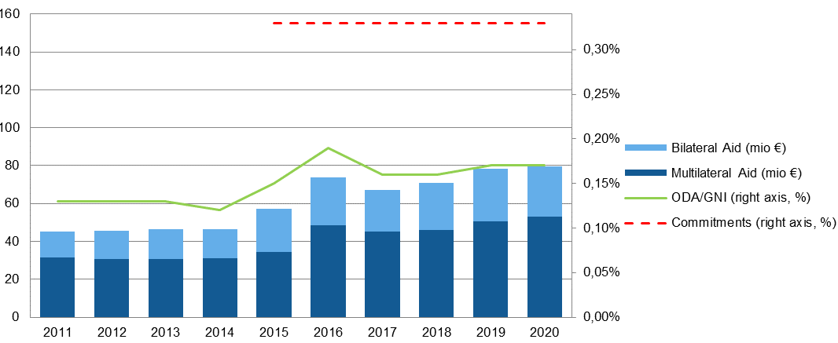
II. Official development assistance (ODA) – general

The objectives of Slovenia’s development cooperation are to contribute to the eradication of poverty and reduction of inequality and to foster sustainable development in partner countries. ODA is a key ingredient of development cooperation. Multilateral ODA accounts for the largest share of Slovenia’s ODA, approximately two thirds of the total ODA in the period between 2011 and 2020. Bilateral ODA accounts for approximately one third of Slovenia’s total ODA. The largest recipients of Slovenia’s bilateral ODA between 2011 and 2020 were the Western Balkans countries.

Chart 2: Largest recipients of Slovenia’s bilateral ODA between 2011 and 2020
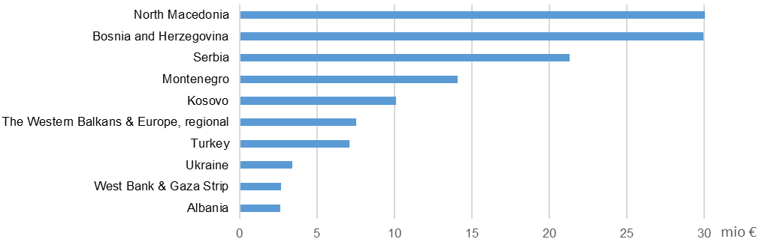
An important share of bilateral technical assistance in particular is implemented directly by ministries and their affiliated bodies, and also by other direct and indirect budget users. The largest share of bilateral development aid comes in the form of imputed student costs, and it is implemented by universities and higher education institutions in Slovenia. Slovenia’s key partners in the implementation of development cooperation are the Centre for International Cooperation and Development, ITF Enhancing Human Security, Centre for European Perspective, Center of Excellence in Finance, Slovenian NGOs, which have an important role particularly in places where Slovenia lacks a diplomatic and consular network, and international organisations with their special development and humanitarian programmes to which Slovenia makes earmarked contributions.

III. Slovenia’s ODA in 2020

In 2020, Slovenia allocated EUR 79.61 million or 0.17% of its GNI to ODA.

Chart 3: Breakdown of Slovenia's ODA in 2020 by main categories
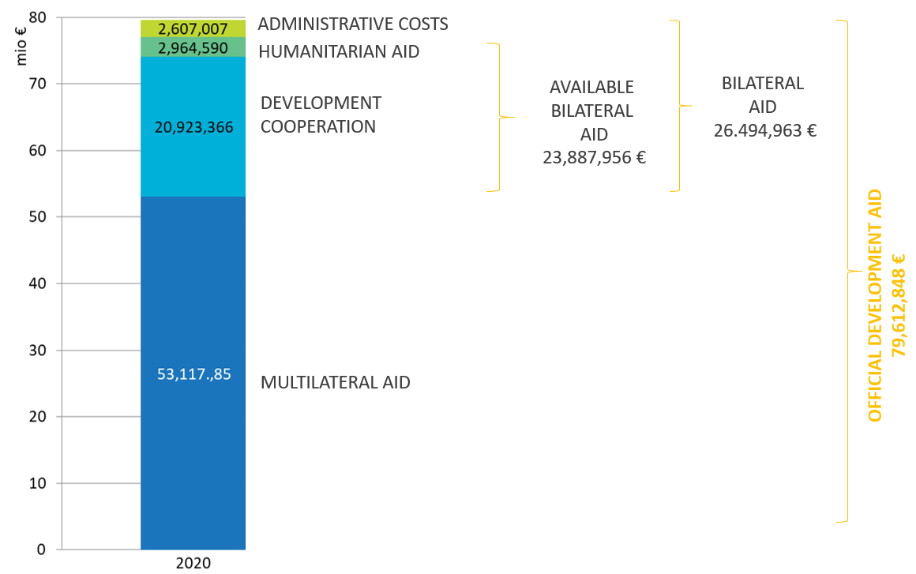

Multilateral development aid mostly consists of contributions to the EU budget to be spent for development cooperation of the EU, contributions to the extra-budgetary European Development Fund (EDF), contributions and capital increases to World Bank Group institutions and to the UN, including its agencies and funds. Other contributions include payments into the Center of Excellence in Finance’s budget, a part of the Council of Europe and OSCE membership fees, contribution to the Montreal Protocol, etc.

Chart 4: Breakdown of Slovenia's multilateral aid in 2020 by recipients

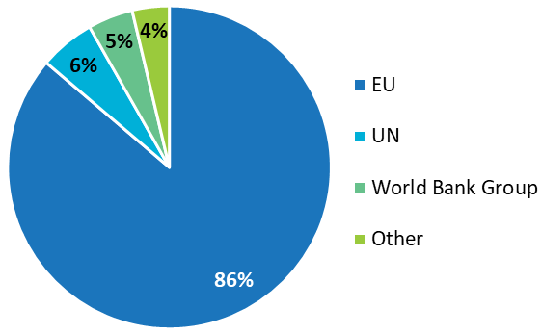

Bilateral development aid is the most consistent with the geographical and thematic priorities set out in the Resolution. The Resolution defines the following thematic priorities for development aid in a narrow sense:
- promotion of peaceful and inclusive societies, with particular emphasis on good governance, equal opportunities, gender equality and quality education; and
- the fight against climate change focused on sustainable management of natural and energy resources.

To ensure greater efficiency, the Strategy further narrows these thematic priorities and links them to four sustainable development goals: 8 – decent work and economic growth, 12 – circular economy, 13 – climate change and 16 – peaceful and inclusive society and good governance. Gender equality, women's empowerment and environmental protection are mainstreamed into Slovenia’s development cooperation.

Chart 5: Breakdown of bilateral development aid in a narrow sense in 2020 by thematic priorities

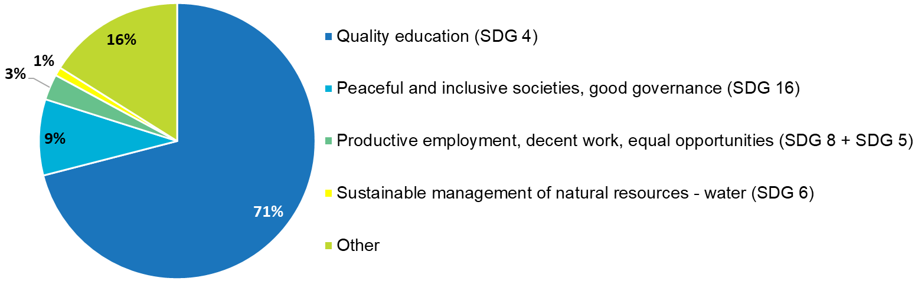

The Resolution determines the thematic priorities of humanitarian aid by area of activity:
- emergency aid is allocated independently of thematic and geographical priorities;
- aid in the aftermath of humanitarian crises (reconstruction and rehabilitation), with the following two thematic priorities:
  - human security and protection, including mine action programmes and mine victims assistance;
  - assistance in the aftermath of armed conflicts, particularly to children;
- activities to reduce vulnerability to and risk of crises, preventive action and building resilience; the thematic priority of these activities is guaranteeing a stable supply of drinking water and safe, adequate and good-quality food, especially to children.

Chart 6: Breakdown of Slovenia’s humanitarian aid in 2020 by thematic priorities

Slovenia’s geographical priorities are the Western Balkans, European neighbourhood and Sub-Saharan Africa, particularly its least developed countries (LDCs). In 2020, Slovenia channelled EUR 18.04 million or 76% of its entire available bilateral aid to the Western Balkan countries, the largest share to Bosnia and Herzegovina. To countries in the European neighbourhood it channelled EUR 0.72 million or 3% of the available bilateral aid, and to Sub-Saharan countries EUR 0.22 million or 1%.

Chart 7: Breakdown of available bilateral development aid in 2020 by regions
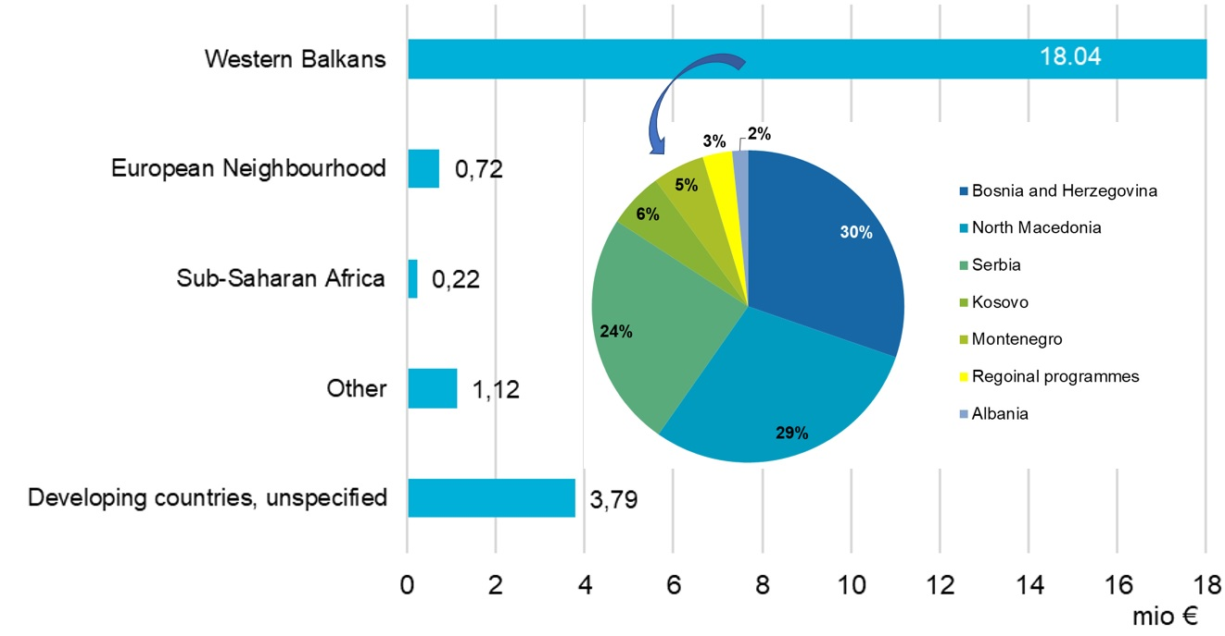

The largest share of bilateral development aid comes in the form of imputed student costs; in 2020, together with scholarships, these accounted for 55%. The second and third largest categories are earmarked contributions via international organisations and administrative costs, each accounting for 10%. All other categories accounted for less than 10% each in 2020.

Chart 8: Breakdown of bilateral development aid in 2020 by cooperation modalities
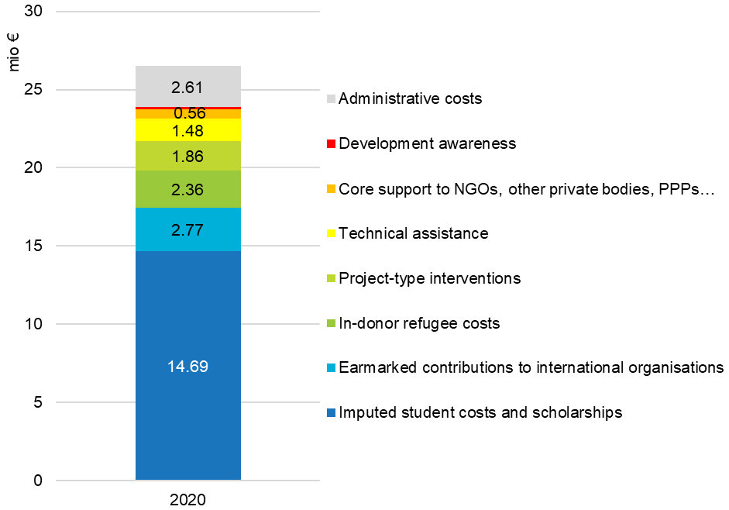

Of all line ministries, the Ministry of Finance provides the largest share of funds via its contributions to the EU budget, IDA, Centre for International Cooperation and Development and a contribution to the core budget of the Center of Excellence in Finance. The second largest contributor is the Ministry of Foreign Affairs with its development cooperation activities (ITF, Centre for European Perspective, NGOs, etc.), its contribution to the European Development Fund, humanitarian assistance, awareness raising and contributions to international organisations, which in whole or in part are ODA-eligible.

Taking into consideration only the available bilateral development aid, the largest share (60%) has been contributed by the Ministry of Education, Science and Sport in the form of imputed student costs in accordance with the protocols in force concluded with the competent institutions of Montenegro, North Macedonia, Bosnia and Herzegovina, Serbia and Kosovo. The Ministry of Foreign Affairs follows (15%) with a wide array of development and humanitarian activities carried out by its implementing partners, while the remaining providers contribute less than 10% of the available bilateral development aid each.

www.gov.si/assets/ministrstva/MZZ/Dokumenti/multilaterala/razvojno-sodelovanje/ZMRSHP_EN-final.pdf
www.gov.si/assets/ministrstva/MZZ/Dokumenti/multilaterala/razvojno-sodelovanje/Uredba_MRS_EN-final.pdf
www.gov.si/assets/ministrstva/MZZ/Dokumenti/multilaterala/razvojno-sodelovanje/Development-Cooperation-and-Humanitarian-Aid-Strategy-of-the-Republic-of-Slovenia.pdf
www.un.org/sustainabledevelopment/sustainable-development-goals/
www.consilium.europa.eu/media/24004/european-consensus-on-development-2-june-2017-clean_final.pdf
www.cmsr.si/en/centre-for-international-cooperation-and-development/
www.itf.si/about-us/itf-in-a-nutshell
www.cep.si/
www.cef-see.org/

