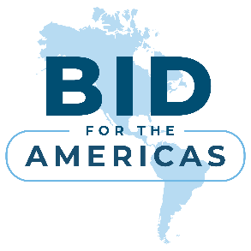
NEW date: February 2, 2026
BID for the Americas Seminar 2026: Business opportunities in Latin America and the Caribbean
We cordially invite you to the BID for the Americas Seminar 2026 to meet the Inter-American Development Bank Group (IDB Group) and explore business opportunities in Latin America and the Caribbean.
IDB Group is the leading source of financing and knowledge for improving lives in Latin America and the Caribbean. It comprises IDB, which works with the region’s public sector and enables the private sector; IDB Invest, which directly supports private companies and projects; and IDB Lab, which spurs entrepreneurial innovation.
BID for the Americas is IDB’s program designed to foster business opportunities and strengthen economic ties between 26 countries in Latin America and the Caribbean and key partners from Europe, North America, and Asia. The program consists of three pillars: procurement, trade and investment, and co-financing.
When: 2. February 2026 at 3 p.m. NEW DATE
Where: Centre of Excellence in Finance, Cankarjeva cesta 18, Ljubljana
The seminar is free of charge and will be held in English. The final programme is attached. If you would like a one-on-one meeting with the IDB team on the ground, please indicate this at the time of registration to the seminar.
Please confirm your participation to the e-mail: barbara.knapic@gov.si or by phone +386 1 369 66 81. Deadline for registration is 29. January 2026.
Programme:

14:45 Registration

15:00 Opening Remarks
Klemen Boštjančič, Minister of Finance Slovenia (tbc)
Luis Jiménez Mc Innis – IDB Group Representative in Europe

15:15 IDB’s work on Competitiveness, Technology and Innovation

Gonzalo Rivas, Head of Division Competitiveness, Technology and Innovation (online)

Q&A

15:35 BID for the Americas and IDB Procurement +: Opportunities for Slovenian companies in LAC
Samuel Moreno, Productivity, Trade and Innovation Sector (online)
Adriana Salazar, Senior Specialist, Fiduciary Management and Procurement (online)

Q&A

16:20 Sector focus: Water, rural development and circular economy
Tania Páez, Lead Specialist, Water and Sanitation (online)
Ana Ríos, Lead Specialist, Agriculture and Rural Development (online)

Q&A

17:00 Closing remarks
Dr. Melita Gabrič, State Secretary for Multilateral Affairs, Political Affairs and Development Cooperation of the Ministry of Foreign and European Affairs
Luis Jiménez Mc Innis – IDB Group Representative in Europe

17.10 Networking and One-on-one meetings

