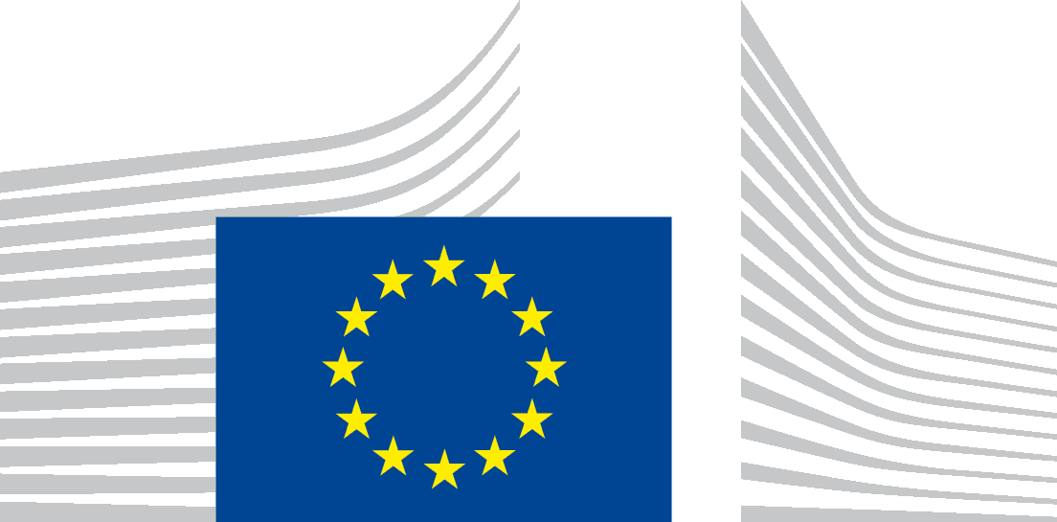 | EUROPEAN COMMISSION
VACANCY NOTICE FOR A POST OF SECONDED NATIONAL EXPERT
DG – Directorate – Unit | ENV C3
Post number in sysper: | 139121
Contact person:  Provisional starting date:  Initial duration:  Place of secondment: | François Wakenhut  1st quarter 2025  2 years  ☒ Brussels ☐ Luxemburg ☐ Other: Click or tap here to enter text.
 | ☒ With allowances ☐ Cost-free
This vacancy notice is open to:
☒ EU Member States
☐ EFTA-EEA In-Kind agreement (Iceland, Liechtenstein, Norway)
This vacancy notice is also open to:
☒ The following EFTA countries:
☒ Iceland ☒ Liechtenstein ☒ Norway ☐ Switzerland
☐ The following third countries:
☐ The following intergovernmental organisations:
Deadline for applications | ☒ 2 months ☐ 1 month

Entity Presentation (We are)
DG Environment, Directorate C – Quality of Life – Unit C3 "Clean Air & Urban Policy".
Directorate C's mission is to lead on the implementation of the zero pollution ambition for a non-toxic environment under the European Green Deal. This includes working to safeguard EU citizens from harmful environmental impacts originating from pressures on air, water and marine resources, and to contribute to the protection, improvement and sustainable use of the EU's natural capital.
Unit C.3 of DG Environment (Clean Air & Urban Policy) contributes to the European Green Deal, in particular the zero pollution ambition for a toxic-free environment with a specific focus on air quality, air pollutant emissions, urban policy, and noise. With respect to the air quality portfolio of the unit, the focus is on the development and implementation of science-based and costeffective EU policies aimed at reaching levels of ambient air quality that do not cause significant harm.

Job Presentation (We propose)
An attractive AD post for a dynamic, enthusiastic colleague, in a friendly, motivated team, to contribute to a set of tasks related to the implementation of the current and revised Ambient Air Quality Directives (including support to the preparation of a number of Implementing Acts foreseen under the revised Directive) and of the National Emission reduction Commitments Directive; to provide support to broader unit work regarding clean air mainstreaming in the context of the implementation of the Zero Pollution Action Plan

The post covers essential areas of work in support of clean air and broader zero pollution priorities:

- To contribute to the overall implementation of the current and revised Ambient Air Quality Directives, including, inter alia, monitoring Member States’ progress towards air quality standards and ensuring enforcement, as well as, in relation to the revised Ambient Air Quality Directive, support to the preparation of a number of Implementing Acts to be adopted as from 2026 onwards;

- To contribute to the implementation and further development of the National Emission reduction Commitments Directive, including monitoring Member States’ compliance progress, focus on specific provisions (e.g. air/ecosystem interface), and inputs to the ongoing evaluation of the Directive and to its follow-up;

- To contribute to clean air work strands linked to information to the public, including maintenance of and further improvements to the Air Quality Index App developed jointly with the European Environment Agency;

- To contribute to structured outreach to stakeholders, including as support on the organisation of the biennial EU Clean Air Forum set out in the National Emission reduction Commitments Directive;

- To contribute to mainstreaming clean air policy and zero pollution objectives into specific policies, with particular focus on DEFIS on the Copernicus Atmosphere Monitoring Service (CAMS).

The above responsibilities will require interaction with a number of Commission services, with Member States and stakeholders.

Jobholder Profile (We look for)

A highly motivated, well-organised colleague and team player.

Generalist, scientific, engineering and economic profiles will be considered, provided that candidates can demonstrate strong and tested analytical skills, experience in and aptitude for clean air and broader pollution-related policy development, integration and implementation work, and a high level of versatility so as to contribute to the full range of unit files and to broader Commission priorities/initiatives of relevance to the clean air portfolio and to zero pollution.

Familiarity with existing EU policies in the field of air quality, air pollutant emissions, as well as source emission legislation (e.g. transport emissions, energy efficiency, agriculture and food policy, climate mitigation, etc.). Experience related to impacts of air pollution on ecosystems would be an asset.

Experience in a public administration, working in teams and with stakeholders, and the possession of effective negotiating skills (preferably at the European level) are an important advantage.

Excellent analytical, IT and communication skills are a pre-requisite, including the ability to synthesise complex issues, identify practical solutions and to communicate effectively with non-specialists.

Ability to manage a number of files simultaneously with the capacity to produce high quality output often within short deadlines.

Team spirit, self-reliance, strong organisational skills are important pre-requisites as the ability to adapt quickly and thrive in a multi-lingual and multicultural environment.

Eligibility criteria
The secondment will be governed by the Commission Decision C(2008) 6866 of 12/11/2008 laying down rules on the secondment to the Commission of national experts and national experts in professional training (SNE Decision).
Under the terms of the SNE Decision, a national expert needs to comply with the following eligibility criteria at the starting date of the secondment:
Professional experience: at least three years of professional experience in administrative, legal, scientific, technical, advisory or supervisory functions which are equivalent to those of function group AD.
Seniority: having worked for at least one full year (12 months) with the current employer on a permanent or contract basis.
Employer: must be a national, regional or local administration or an intergovernmental public organisation (IGO); exceptionally and following a specific derogation, the Commission may accept applications where the employer is a public sector body (e.g., an agency or regulatory institute), university or independent research institute.
Linguistic skills: thorough knowledge of one of the EU languages and a satisfactory knowledge of another EU language to the extent necessary for the performance of the duties. The national expert from a third country must produce evidence of a thorough knowledge of the EU language necessary for the performance of his duties.

Conditions of secondment
During the full duration of the secondment, the national expert remains employed and remunerated by his / her employer and covered by his / her (national) social security system.
He / she shall exercise his / her duties within the Commission under the conditions as set out by aforementioned SNE Decision and be subject to the rules on confidentiality, loyalty and absence of conflict of interest as defined therein.
Allowances can only be granted when the national expert fulfils the conditions provided for in Article 17 of the SNE decision.
Staff posted in a European Union Delegation are required to have a security clearance (up to SECRET UE/EU SECRET level according to Commission Decision (EU, Euratom) 2015/444 of 13 March 2015. The selected candidate has the obligation to launch the vetting procedure before getting the secondment confirmation.

Submission of applications and selection procedure
Candidates should send their application according to the Europass CV format (Create your Europass CV | Europass) in English, French or German only to the Permanent Representation / Diplomatic Mission to the EU of their country, which will forward it to the competent services of the Commission within the deadline fixed by the latter. The CV must mention the date of birth and the nationality of the candidate.
Candidates are asked not to add any other documents (such as copy of passport, copy of degrees or certificate of professional experience, etc.). If necessary, these will be requested at a later stage.

Processing of personal data
The Commission will ensure that candidates’ personal data are processed as required by Regulation (EU) 2018/1725 of the European Parliament and of the Council (). This applies in particular to the confidentiality and security of such data. Before applying, please read the attached privacy statement.

() Regulation (EU) 2018/1725 of the European Parliament and of the Council of 23 October 2018 on the protection of natural persons with regard to the processing of personal data by the Union institutions, bodies, offices and agencies and on the free movement of such data, and repealing Regulation (EC) No 45/2001 and Decision No 1247/2002/EC (OJ L 295, 21.11.2018, p. 39

