Environmental Report
Strategic Environmental Assessment of the Euro-MED Interreg Programme 2021-2027
Final - March 2021

Table of contents
Table of contents 2
List of tables 4
List of figures 5
Acronyms 8
Chapter I – Framework and Programme background 9
General presentation of the cooperation area 9
The SEA procedure 10
Structure of the environmental report 11
Presentation of the Programme strategy 12
Chapter 2 - Context analysis, environmental indicators, and characteristics of the area to be significantly affected. 20
Climate change adaptation and associated risks 20
GHG emissions 24
Inland water quality and supply 25
Inland biodiversity and ecosystem 32
Marine ecosystem and natural resources 39
Soil quality and land use 48
Technological risks 51
Air quality and Health 51
Landscape and cultural heritage 54
Energy 58
Waste management 61
Chapter 3 –Integration with other environment and sustainable development policies in the cooperation area 66
Coherence with the community-level policies 68
Coherence with strategic policies for the cooperation area 83
Chapter 4 - Environmental protection objectives 101
Chapter 5 – Likely significant effects on the environment 103
Methodology for assessment 103
Interactions between the programme and environmental objectives 104
Environmental effect of priority axes 105
Environmental cumulative and transnational effects 110
Chapter 6 - Elements for an Appropriate assessment of Natura 2000 sites 117
Chapter 7 - Recommendation for a better environmental integration 125
Measures to prevent, reduce and offset adverse effects 125
Measures to promote, diffuse environmental best practices 127
Chapter 8 – Follow-up for the implementation phase 128
Environmental indicators 128
Provisions for an environmental monitoring system 132
Chapter 9 – Conclusion 134
Information of potential alternatives and justification of the Programme choices 134
Quality of information and rationale for analysis 134
Appendix 1 – Non-technical summary 135
Appendix 2 – Consultation results 136

List of tables

Table 1: Steps of the SEA procedure 11
Table 2: SMARTER MED - Programme's Specific objectives, objectives, expected results and type of actions. 13
Table 3: Greener MED - Programme's Specific objectives, objectives, expected results and type of actions 14
Table 4: MED Governance - Programme's Specific objectives, Objectives, expected results and type of actions 17
Table 5: Marine protected areas (Source: Eurostat - 2015) 40
Table 6: EU and transnational policies and strategies for the programme area. 66
Table 7: Programme coherence with the sustainable development goals under Agenda 2030 80
Table 8: Coherence with WestMed and EUSAIR 95
Table 9: Coherence with Alpin Space, Danube region and Black Sea strategies 96
Table 10: Environmental objectives 101
Table 11: Scale for measuring positive and negative effects 103
Table 12: Typology of potential effects 104
Table 13: Expected environmental effects from Euro-MED CP 107
Table 14: Element of influence for Mediterranean, Black-Sea, Continental and Alpine Regions 118
Table 15: Vulnerability of priority habitats in the cooperation area 119
Table 16: Threats for animal and plant species relevant for the cooperation area 121
Table 17: Possible incidences on Natura 2000 sites 123
Table 18: Proposed mitigation measures 125
Table 19: Proposed orientation measures 127
Table 20: Output and performance indicators 130
Table 21: Monitoring tasks’ responsibilities 132
Table 22: Template for environmental impact evaluation at project level 133

List of figures
Figure 1: INTERREG Euro-MED Programme area (Source: Consortium) 10
Figure 2: Mean annual temperature of Mediterranean (Source: MEDECC - 2020) 21
Figure 3: Annual precipitation in the Mediterranean (Source: MEDECC-2020) 21
Figure 4: Map of vulnerability to land degradation based on the SDI index in selected European countries (Source: DISMED project-2008) 22
Figure 5: Pattern of coastal erosion (Source: EEA-2008) 23
Figure 6: GHG emissions in kt CO2 equivalent, total of Croatia, Cyprus, France, Greece, Italy, Malta, Monaco, Slovenia, and Spain, 2007-2017. (Source: UNFCC-2018) 24
Figure 7: Total freshwater abstraction for public water supply (m3 per inhabitant) (Source: Eurostat - 2018) 26
Figure 8: Urban wastewater collection and treatment in Europe in 2017 (Data Source: Eurostat 2017.) 27
Figure 9: Ecological status of Spanish and Portuguese surface water bodies (Source: EC - 2017). 28
Figure 10: Ecological status of French surface water districts (Source: European Commission - 2017) 28
Figure 11: Ecological status of river basins in Slovenia, Croatia, Greece, Italy and Bulgaria (Source: European Commission - 2017) 29
Figure 12: Ecological status of river basin in Cyprus and Malta (Source: European Commission - 2017) 30
Figure 13: Biogeographic and marine regions in the European Union (source: EEA - 2015). 33
Figure 14: Conservation status of habitats per biogeographic regions in the cooperation area (source: EEA-2018) 34
Figure 15: Share of country designated as terrestrial protected area and the overlap between Natura 2000 or Emerald sites and national designations (Source: EEA-2020) 35
Figure 16: National protected area per IUCN category classification (Source : IUCN - 2012) 36
Figure 17: Conservation status of species in the cooperation area (Source: EEA - 2018) 38
Figure 18: Species richness for mammals (Source: IUCN’s Red List - 2009) 38
Figure 19: Location of national MPAs, Natura 2000 sites and Specially Protected Areas of Mediterranean Importance (SPAMIs) in the Mediterranean region (Source: MAPAMed, 2017) 41
Figure 20: Protected area between 2012 and 2016 (% of sea area) (Source: Eurostat-2017) 42
Figure 21: Main sources, and location of organic water pollutant in the Mediterranean Sea (Source: UNEP-2012) 43
Figure 22: Major industrial sectors emitting metals in the Mediterranean region (Source: UNEP-2012) 44
Figure 23: Sourced of nutrient emissions in the Mediterranean region (Source: UNEP-2012) 45
Figure 24: Mean surface productivity and eutrophic and hypoxic hot spots in the Mediterranean (Source: UNEP-2012) 46
Figure 25: Sources of marine litter in the Mediterranean (Source: UNEP-2012) 46
Figure 26: Quality of bathing waters per country (Source EEA - 2019) 47
Figure 27 : Percentage of soil sealing per country (Source: EEA-2020) 49
Figure 28 : Contaminated sites per Member State by contamination origin (Source: EEA-2019) 50
Figure 29: Air contaminants per sector (Source: EEA – 2019) 52
Figure 30: Concentration of PM 2.5 in 2018, in Europe (Source: EEA-2019) 53
Figure 31: Landscape distribution in Europe (Source: EEA-2020) 55
Figure 32: Area of strongly fragmented landscape (% of country area 2009, 2012, 2015) (Source: EEA-2019) 56
Figure 33: Share of landscape and other protected areas in European countries (Source: EEA-2020) 57
Figure 34: Changes in primary energy consumption, primary energy intensity and GDP between 2015-2018 (Source: Eurostat - 2020) 59
Figure 35: Progress towards renewable energy source targets by country (Source: EEA-2018) 60
Figure 36: Waste generation (excluding mineral wastes) per capita in European countries between 2010 and 2016 (Source: EEA-2019) 62
Figure 37: Municipal waste landfill rates in Europe by country, between 2006 and 2017 (Source: EEA - 2019) 63
Figure 38: Municipal waste recycled and composted in Europe between 2004 and 2017 (Source: EEA - 2019) 64
Figure 39: Natura 2000 sites in the cooperation area (Source: Consortium). 117

Acronyms
ALP: Alpine
BLS: Black Sea
CON: Continental
CP: Cooperation Programme
DPSIR: Driving force, Pressure, State, Impact, Response model
EA : Environmental Authority
EC : European Commission
EU : European Union (27 countries)
IUCN : International Union for the Conservation of Nature
JC : Joint secretariat
Ktoe : Thousand tonnes oil equivalent
LUCF: Land Use Change and Forestry
MA : Managing Authority
MED: Mediterranean
MMED: Marine Mediterranean
MS : Member State(s)
SEA : Strategic Environmental Assessment
SO : Specific Objective
TF : Task Force
Teq : Tonne Equivalent CO2
UNCCD: United Nations Convention to Combat Desertification
UNECE: United Nations Economic Commission for Europe
UNFCCC: United Nations Framework Convention on Climate Change
WFD : Water Framework Directive
WHO : World Health Organization

Chapter I – Framework and Programme background

General presentation of the cooperation area

Interreg MED is a transnational cooperation programme which covers socio-economic, environmental, territorial and governance issues. In the new programming period 2021-27, the programme area included 67 Nuts 2 regions, mainly coastal regions and islands in ten Member States, plus four pre-accession countries in the Mediterranean (IPA countries). Some of the countries are entirely included in the programme area, such as Bulgaria, Croatia, Cyprus, Greece, Malta, Slovenia, Albania, Bosnia-Herzegovina, Montenegro and North Macedonia. The programme expands geographically in this new programming period, including Bulgaria, North Macedonia and other three Spanish regions (Extremadura, Castilla La Mancha, Comunidad de Madrid); while Gibraltar, as UK territory, is withdrawing. The regions are very diverse geographically and socio-economically though they share some common environmental, coastal and maritime issues. These include marine pollution, litter management, biodiversity loss, alien species invasion, water shortages, maritime security, natural risks and extreme events. All are relevant for the Strategic Environmental Assessment (SEA).

Figure 1: INTERREG Euro-MED Programme area (Source: Consortium)
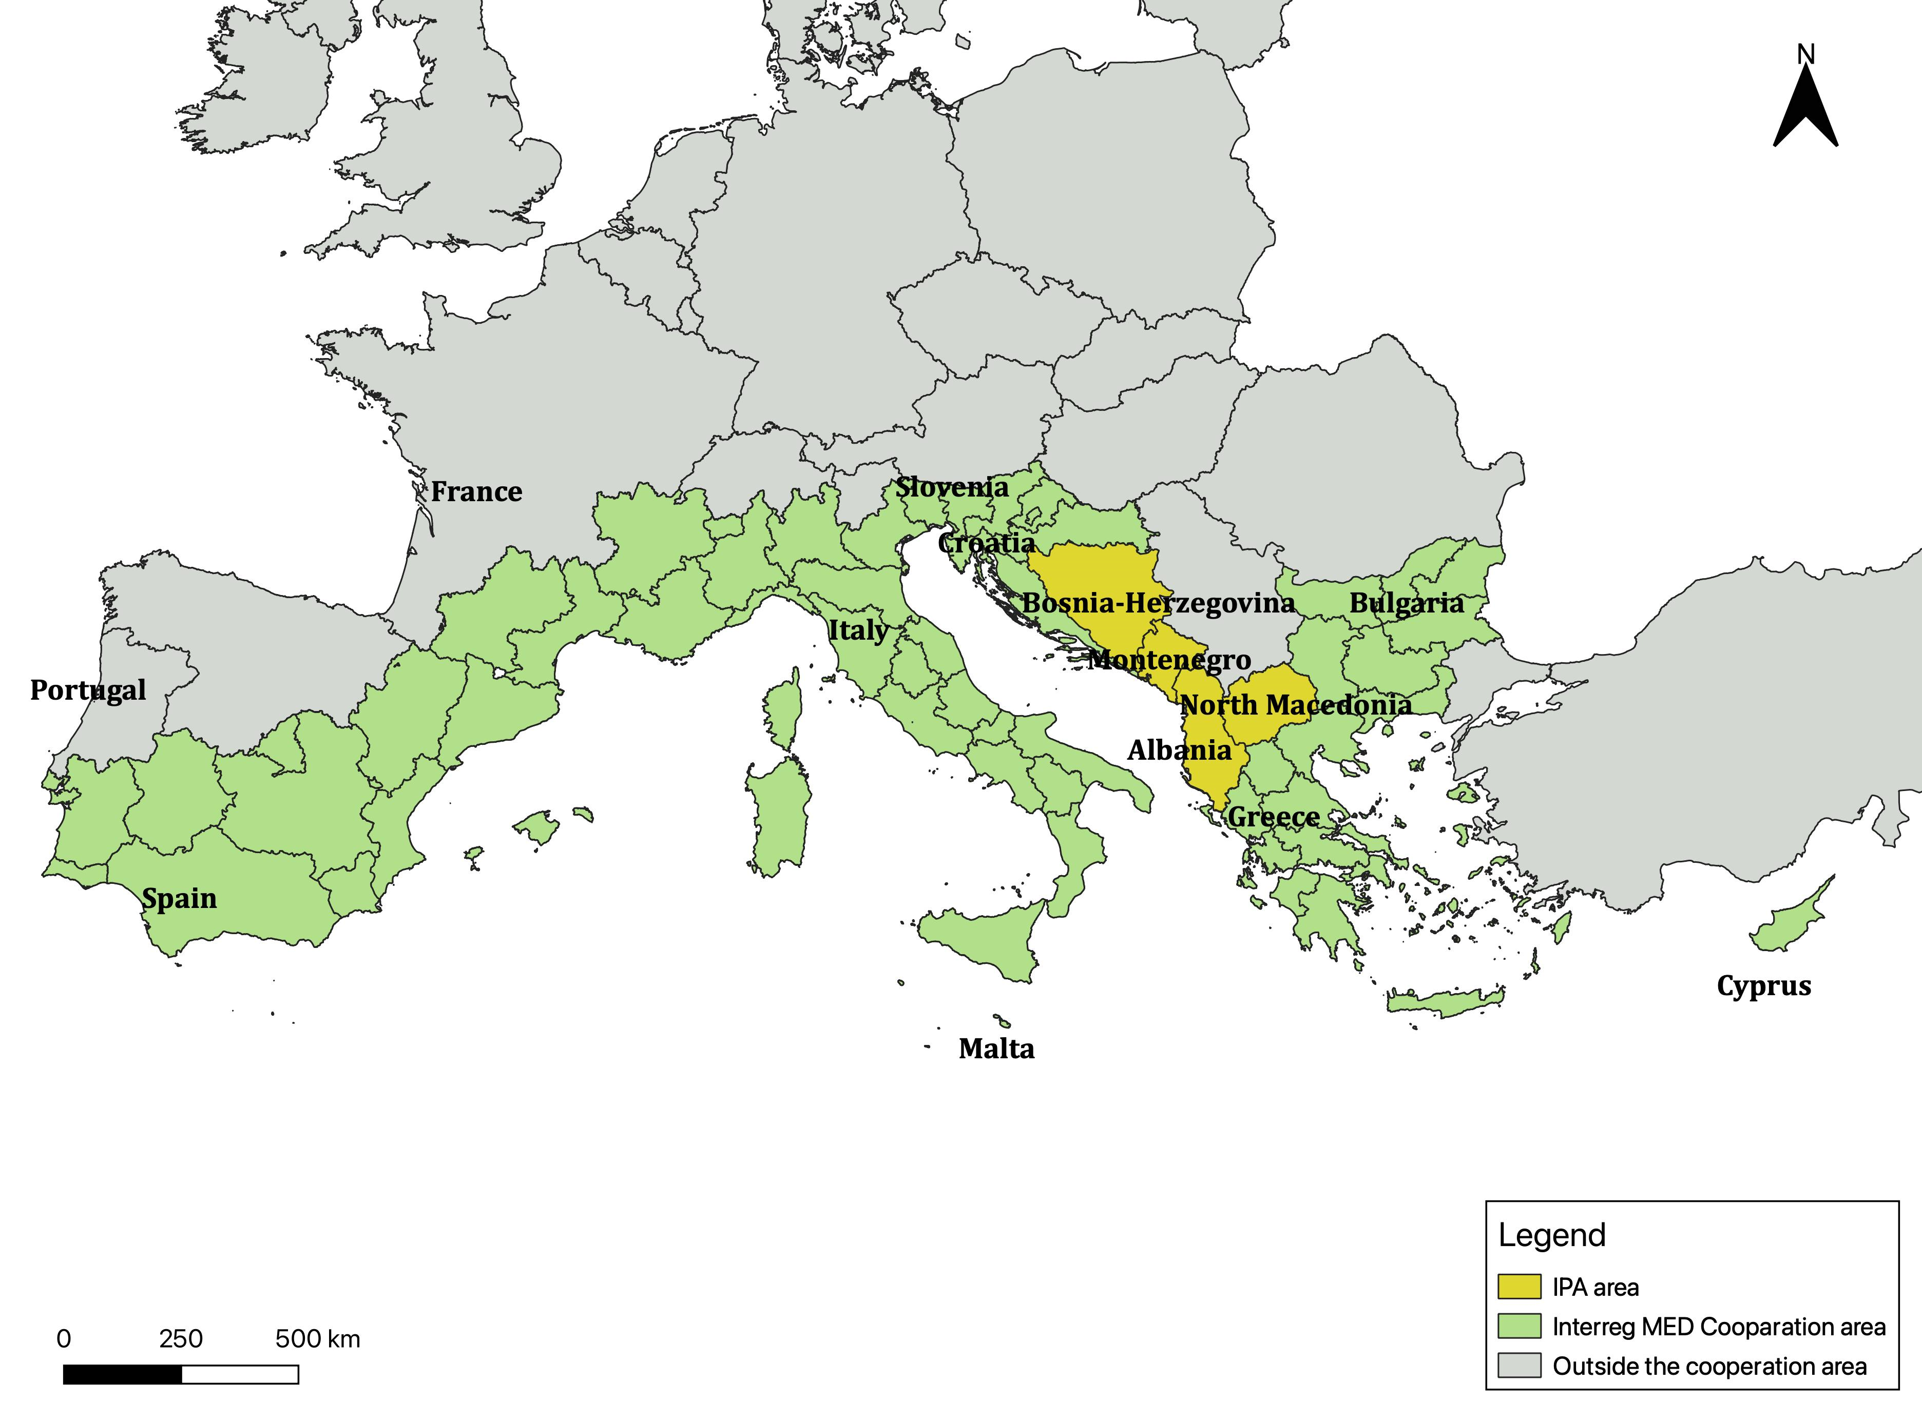

The SEA procedure
The Strategic Environmental Assessment (SEA) legislative disposition states that environmental assessment must be carried out for all plans and programmes which are likely to have significant effects on the environment.
The directive includes:
- preparation of the Environmental Report assessing environmental effects;
- consultation of environmental authorities on the content of the Environmental Report
- public consultation on the Environmental Report and Programme;
- the decision on SEA.
For Euro-MED 2021-27, the SEA steps have been carried out according to Table 1 complying with Directive 42/2001/CE. Stakeholders involved in the SEA are the Programme authority (MA), the Joint Secretariat (JS), task force (TF) members and the programme environmental authorities (EA).
Table 1: Steps of the SEA procedure

Structure of the environmental report
Based on Article 5 and Annex I of the SEA Directive, and according to Article R.122-20 from the French ‘Code de l’environnement’, the environmental report covers:
- a brief description of the programme and its objectives;
- a coherence analysis between programme and strategic documents with programme area environmental objectives;
- a description of the state of the environment and territorial trends, including environmental characteristics of areas likely to be significantly affected;
- the most likely environmental effects of the programme (including on Natura 2000 sites);
- measures envisaged to prevent and reduce adverse environmental effects;
- a proposed environmental monitoring system;
- conclusions, with discussions of alternatives and reasons for selecting the final choice;
- a non-technical summary.

Presentation of the Programme strategy
Transnational cooperation is one of five European Territorial Cooperation (ETC) goals, together with Cross-border, Outermost, Interregional cooperation and Interregional innovation investment. The priorities of transnational cooperation are listed in the ETC proposal 2018 Article 3: ‘transnational cooperation and maritime cooperation over larger transnational territories or around sea-basins, involving national, regional and local programme partners in Member States, third countries and partner countries and in Greenland, with a view to achieving a higher degree of territorial integration ('component 2'; where referring only to transnational cooperation: 'component 2A'; where referring only to maritime cooperation: 'component 2B')’.
A new approach has been introduced in the 2021-27 regulations. Programmes will be structured under five policy objectives (a smarter Europe, a greener and low-carbon Europe, a more connected Europe, a more social Europe, a Europe closer to citizens) with related specific objectives. For ETC programmes there are two other objectives (Article 14 of the ETC proposal), addressing governance: ‘a better Interreg governance’ and ‘a safer and more secure Europe’, both can be selected in ETC programmes under component 2.
The main goal of the Programme is contributing to the transition towards a climate neutral society, fighting against climate change impacts on Mediterranean resources, while ensuring sustainable growth and the well-being of its citizens.
In the programming period 2021-2027, the general goal as defined above will be achieved through:
- SMARTER MED: Priority 1 aims to reinforce societal commitment and increase innovation capacity in public authorities and private entities to implement solutions for a sustainable and greener economy in the Mediterranean by consolidating a competitive innovation ecosystem;
- GREENER MED: Priority 2 aims to provide a greener environment for the MED area, supporting a transition to a circular economy and an energy transition, promoting greener living areas, improving the management of natural resources and preventing and mitigating risks;
- MED GOVERNANCE: Better governance processes provide the backbone for the capitalisation of INTERREG MED results into policy actions, in cooperation and coordination with all other programmes and strategies intervening in the area. A Mediterranean vision and shared solutions need strong governance.
The priorities are structured in five specific objectives and several actions contributing to the expected results. In addition, the programme identified the tourism sector as a cross-cutting priority for the programming period. This considers the economic relevance of this sector for regions in the cooperation area, as well as the consequences of the socio-economic crisis due to the COVID-19 which hit the sector particularly hard in 2020 and 2021.

Table 2: SMARTER MED - Programme's Specific objectives, objectives, expected results and type of actions.
Specific objectives | Objectives | Expected results | Type of actions
(i) Enhancing research and innovation capacities and the uptake of advance technologies | - Effectively harness innovation potential to support and accelerate the transition towards a circular and sustainable economy and society.  - Boost the competitive innovation ecosystem in multiple economic sectors for sustainable consumption and production activities.  - Support knowledge sharing, creative industries and uptake of new technologies in diverse sectors related to Smart Specialisation.  - Enhance transnational cooperation between the quadruple helix stakeholders, considering the environmental dimension.  - Reinforce the role of SMEs and clusters for the coordination and implementation of Regional Smart Specialization Strategies (S3) and S3 projects. | - Sustainable economic sectors reinforced with transnationally aligned tools and practices.  - Improved transnational cooperation of stakeholders for the coherent implementation of Regional Smart Specialization strategies.  - Reinforced societal commitment and increased capacity of public authorities and private stakeholders to implement a sustainable and greener economy in the Mediterranean.  - Shared agendas towards competitive and transformative innovation ecosystems with vertical (e.g. EU/national/regional levels) and horizontal (e.g. among territories) coherence. | - Value chain development and cooperation within transnational clusters, internationalisation and extroversion of SMEs.  - apply innovative sustainable business development practices, tools and solutions for SMEs.  - accelerate innovation and technology transfer (including blue and green economy, agriculture, food production, fisheries and aquaculture, climate change, renewable resources, smart manufacturing, transport, biodiversity, health and future digital technologies).  - promote of climate friendly innovations, social entrepreneurship and entrepreneurship in new sectors and those in transition.  - change tourism practices by promoting both existing and new solutions in a new innovative way: smart tourism.

Table 3: Greener MED - Programme's Specific objectives, objectives, expected results and type of actions
Specific objectives | Objectives | Expected results | Type of actions
(iv) Promoting climate change adaptation, risk prevention and disaster prevention | - Support the development and implementation of circular practices in manufacturing, agriculture, food and fisheries and tourism, promoting innovative business models and ‘circular’ creative design processes and eco-innovation.  - Promote prevention, reduction and economic recovery of waste, increasing cooperation of stakeholders and consumer engagement. | - Innovative practices reinforcing the resilience and sustainability of production systems in key primary sectors.  - Circular and sustainable practices enabling the effective reduction and recovery of waste.  - Increased cooperation between stakeholders throughout the waste management value chain including consumer engagement. | - Support and promote circularity and sustainability of products and production systems, including eco-innovative business models for closing loops, in e.g. agriculture, food and fisheries, health, as well as manufacturing.  - support sustainable practices for waste reduction and prevention, tackling waste generation and over-packaging - with a focus on plastic.  - promote economic value recovery of waste and transformation into a resource.  - support and promote circular and sustainable practices in tourism and the cultural and creative industries.  - promote consumer engagement and awareness raising – including in the tourism sector.  - support initiatives dealing with the water-energy-food nexus.  - integrate circular economy practices into national and regional policies.
(vi) promoting the transition to a circular economy | - Prevent disasters and preserve the environmental status - protection and restoration of natural functions.  - Restore polluted / overused environment due to human activities, considering economic and social impacts.  - Support public authorities to reach 2030 and 2050 energy goals and carbon neutrality, with effective planning and financing for climate change adaptation and energy transition.  - Secure and improve environmental and living quality in a changing climate, including the extensive involvement of citizens. | - Increased capacity in the prevention and management of natural risks.  - Ensure ‘transformative change’: strengthened governance able to ensure sustainable investments and decision making.  - Facilitated development and implementation of plans for energy transition and climate change adaptation and resilience.  - Increased capacity of public authorities for planning and financing climate change adaptation, resilience and energy transition.  - Reinforced citizen engagement for more sustainable living areas in the Mediterranean. | Prevention and mitigation of environmental risks  - tackle coastal erosion and sea level rise fostering better integration of coastal zone management with other management approaches of natural resources : implementation of nature-based solutions, Maritime Spatial Planning (MSP), Integrated Coastal Zone Management (ICZM);  - forest protection to reduce the incidence and extent of forest fires and increase the absorption of CO2 and enhance the capacity of the forest to restore ecosystem services and to better manage expected climate change impacts;  - develop drought management plans, developing observatory, early warning systems on droughts / Improving knowledge: data, information sharing;  - develop management plans pertaining to other risks including rising sea levels, coastal erosion, extreme climatic events, forest fires, desertification, degradation of biotopes (land and sea), loss of agricultural resources, health effects (including heat waves, respiratory and other diseases), etc.  Prevention and mitigation of risks linked to human activities  - tackle the negative impact of major economic sectors (such as manufacturing, agriculture, fisheries, shipping and, tourism), improving monitoring systems and governance: information sharing, exchange and best available data (including Big Data), knowledge, assessments and tools on adaptation to climate change;  - encourage platforms that use emerging technologies to monitor and predict risks, implementing strategies and action plans for a sustainable recovery in the tourism sector;  - support the tourism sector to adopt more sustainable practices;  - integrate climate change adaptation and resilience into local plans for the protection and management of areas of special interest (natural and cultural heritage);  - support integrated planning and financing schemes for climate change adaptation and resilience and energy transition, including increased cooperation of local, regional and national authorities;  - support deployment of renewable energy;  - support clean energy transition with a focus on islands;  - promote energy renovation/energy efficiency of the building stock;  - promote Smart neighbourhoods / Energy communities;  - support and promote low carbon mobility to reduce congestion and air pollution, to meet energy goals and carbon neutrality.  Improve connection of urban and inland/remote areas, including islands, paying particular attention to tourism  Restoration of water polluted environment  - Restore natural functions of ground and surface water: restore freshwater ecosystems and the natural functions of rivers (lake, rivers, wetlands);  - protect and restore water polluted resources (including plastic polluted environment);  Awareness raising and promotion of environmental culture  - strengthen capacity building and awareness raising to address environmental issues in order change behaviour in the use of natural resources (including in tourism);  - foster the creation of a water-saving culture among the population (including protecting drinking water supplies).
(vii) Enhancing biodiversity, green infrastructure in the urban environment, and reducing pollution | - Improved management of natural resources by ensuring the connectivity of natural ecosystems and enhancing the sustainability and resilience of natural habitats. | - Reinforced adoption of ecosystem-based approaches for the sustainable management of natural resources.  - Improved connection and enlargement of protected areas in land and sea. | Consolidate the connection of functional ecosystems:  - reinforce transnational links to protect and more effectively restore areas covered by the Natura 2000 network and marine protected areas;  - promote the use of ‘blue and green infrastructure’ as networks of natural and semi-natural areas with different environmental features designed and managed to deliver a wide range of ecosystem services;  - enhance green infrastructure and act reduce pollution especially in urban areas;  - strengthen land-sea interaction – supporting ecological corridors in different types of landscape.  Improving the management of natural ecosystems:  - facilitate ecosystem-based and co-management approaches of natural resources (ex. small scale fisheries, wetlands…);  - build up multi-stakeholder governance to ensure sustainable use of natural resources (local governance models);  - strengthen monitoring and management of existing protected areas and support the designation of new ones (land and sea);  - explore and promote the connection / articulation between cultural and natural heritage, in particular with nature conservation areas under Natura 2000.

Table 4: MED Governance - Programme's Specific objectives, Objectives, expected results and type of actions

Specific objectives | Objectives | Expected results | Type of actions
(vi) Other actions to support better cooperation governance | - Consolidate strong MED thematic communities pooling knowledge and intelligence out of previous experiences and actively promote synergies between projects dealing with different topics but contributing together to a dedicated mission.  - Identify thematic results, relevant for capitalisation, produced by modular projects.  - Set up Networks of thematic experts and provide a platform for peer-to-peer exchanges within and between thematic community projects and their community of projects.  - Facilitate, support and promote the mainstreaming of thematic results through deployment to local, regional, national and European policies and stakeholders, as well as to international organisations, conventions and commissions in the Med area.  - Increase the visibility of the thematic projects and the Programme outside the MED community, increasing the added value of transnational cooperation.  - Support the institutional coordination of initiatives for transnational and multilevel governance among local, regional, national, European and international authorities, organisations and conventions in the MED area and beyond.  - Set up and deploy specific actions to contribute to smart transnational coordination on key policy sectors tackled within the thematic projects. | - A more coordinated approach to thematic issues with local, regional, national and European policies taking into account the results of Interreg MED projects.  - Increased institutional capacity of Mediterranean public authorities in transformative public policy, governance and transnational cooperation.  - Increased coordination and cooperation between regional, national and supranational institutions/bodies and programmes acting in the area as well as strategies and initiatives. | - create and animate thematic communities;  - create a result/output: an e-tank of Interreg Med projects;  - support modular communication and capitalisation projects and ensure the transnational transferability of joint results;  - develop synergies, produce summaries and qualitative analyses, as well as coordinate and manage (under the supervision of the JS) communication of a thematically linked group of projects and generate added value in transnational cooperation, both at thematic and territorial level, ensuring the widest possible geographic coverage;  - support modular projects in transferring activities (methodological support, putting individual results together, leveraging the transferability potential and the preparedness to effective transfer, …) and strengthen the capitalisation of jointly developed tools/measures and results that explicitly target territorial appropriation;  - work with policy makers and advocate for effective leverage and policy integration;  - contribute to the creation, between thematic community and institutional projects, of an own governance mechanism, with JS support;  - participate in the governance of the Programme vis-à-vis external structures related to the theme tackled by each community, as for example thematic European or Mediterranean networks or international structures, thematic EU programmes for capitalisation purposes;  - contribute a transition between programming periods (results, communities), capitalising on results 2014-2020, in particular through participation during the drafting of terms of reference for modular projects calls about themes, objectives and expected results;  - analyse and draw up state of the art cooperation and capitalisation processes related to the programme’s missions in the MED area beyond the Programme;  - design approaches and develop common strategies for institutional cooperation and capitalisation;  - consolidate or create networks to strengthen the presence of the MED area at transnational and European level as well as cooperation within the participating States and beyond the Programme, such as with countries of the Eastern and Southern shores;  - participate and animate a network of Managing Authorities to raise awareness of coordination and tackle common challenges in the MED area, in particular with ADRION, NEXTMED and SOUTH WEST transnational programmes but also with cross-border Interreg programmes;  - implement liaising strategies to support institutional cooperation and foster policy update;  - liaise with administrative/political structures outside the Programme and other Territorial Programmes to contribute to shared objectives (with thematic and territorial programmes in the MED area and with strategies, notably the macro-regional strategies EUSAIR and EUSALP and the WESTMED initiative, and other initiatives in the Mediterranean);  - facilitate mainstreaming between givers and takers at national and transnational level;  - support capacity building for public institutions in the region to design, implement and evaluate the transformative policies necessary to achieve the thematic mission goals;  - support capacity building in the public institutions to define and implement policies to support Programme missions;  - encourage participation and collect contributions from civil society on issues of importance for the Mediterranean (organisation of seminars, symposia, debates throughout the MED area).

The forecast breakdown per priority (%) of the indicative budget is as follows (included Technical assistance):

2021/2027
 | In | In Million € | Types of projects
TOTAL | 100% | 230 M
Technical Assistance | 8% | 18.4 M
Total available for projects | 92% | 211.6 M
Priority 1  SO 1.1 Innovation | 20% | 42.32 M | Modular projects (single module and key territorial projects)
Priority 2 | 70% | 148.12 M
S.O.2.1 Circular Economy | 20% | 42.32 M
S.O.2.2. Climate change | 30% | 63.48 M
S.O.2.3. Biodiversity | 20% | 42.32 M
Priority 3  S.O. 3.1. Governance | 10% | 21.16 M | Thematic and institutional governance projects

Chapter 2 - Context analysis, environmental indicators, and characteristics of the area to be significantly affected.

The SEA directive requires analysis of the environmental status without the programme as a basis for further evaluation of environmental effects. This chapter includes a brief presentation of environmental issues related to the Euro-MED Programme highlighting possible environmental criticality. Indicators based on the Determinant, Pressure, State, Impact, Response (DPSIR) model, are used to describe the context. Components of the context reviewed in this chapter relate to climate change and associated risks, GHG emissions, water quality and uses, biodiversity (habitat and species), maritime ecosystems, soil quality and uses, air quality and health, landscape and waste. The analysis will focus specifically on issues affecting the Mediterranean biogeographical area, where almost all the regions in the programme are located.

Climate change adaptation and associated risks
The Mediterranean climate is recognized for its hot summers and mild winters. In the cooperation area, temperatures vary across the region where highest levels are seen in the east (in the continental part of the cooperation area) . Rainfall usually varies between 600 and 1200 mm/year but can be seen as low as 100-350 mm. A major issue affecting the Mediterranean Basin is increasing temperatures. Annual mean temperatures are now 1.54°C above pre-industrial times, for both land and sea areas, which is 0.4°C more than the global average change observed. In the Mediterranean, there has been an increase of about 0.03°C, per year, which is mainly caused by anthropogenic forcing. Rising temperatures will ultimately lead to more frequent and intense heat waves. Alongside hotter days, precipitation will decrease by a predicted 4% for each degree of global warming. Less precipitation will also lead to drier conditions, especially in the most southern areas. Consequently, many lakes and reservoirs will probably dry out.

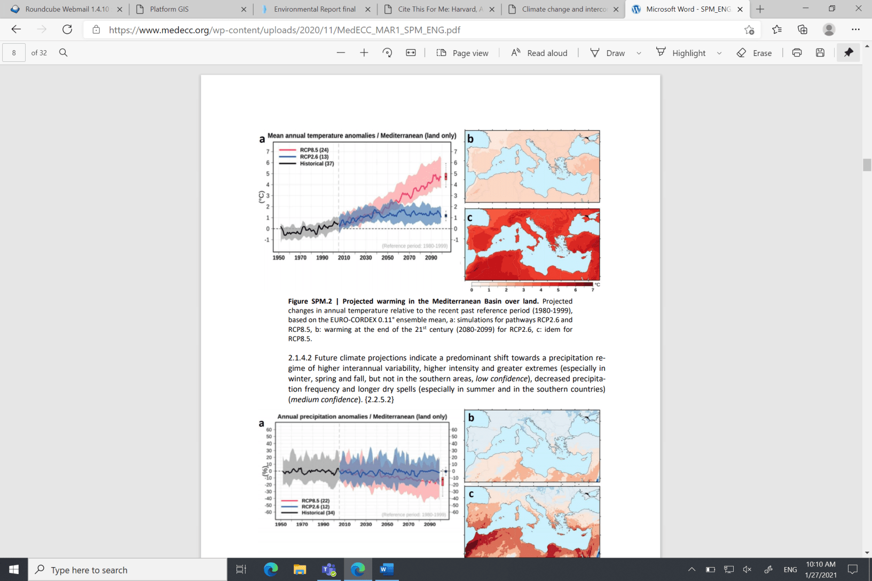
Figure 2: Mean annual temperature of Mediterranean (Source: MEDECC - 2020)

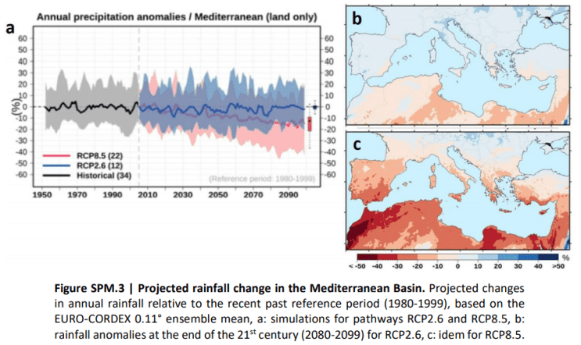
Figure 3: Annual precipitation in the Mediterranean (Source: MEDECC-2020)
Although precipitation will decrease, there will be an increase in flash floods from heavy, short and local rains in small areas. Additionally, with more sealed surfaces in urban areas, floods will be harder to control. For example, floods are expected to occur up to 14 days earlier per decade in the north of Italy, south of France, eastern Greece, and eastern Spain. Between 2000-2014, coastal and inland floods killed more than 2,000 and affected 8.7 million people. In a medium emissions scenario and without adaptation, river flooding is projected to affect approximately 300,000 people per year in the EU by the 2050s and 390,000 people by the 2080s. Additionally, with no adaptation measures, by the end of the 21st century approximately 775,000 to 5.5 million people would be affected annually by coastal flooding. The increasing risk of desertification is one of the main consequences of climate change in the Mediterranean region. Desertification has been neatly defined in the UNCCD as ‘land degradation in arid, semi-arid and dry sub-humid regions resulting from various factors, including climatic variations and human activities’. The sensitivity to desertification index (SDI) based on soil quality, climate and vegetation parameters and developed inside the Desertification Information System for the Mediterranean (DISMED) project, shows very diverse sensitivity in the Euro-MED area (see map below). The most vulnerable areas are central and southern Spain, the south of Italy (Sicilia) and regions in Greece and Cyprus.
Due to dry climates and the Mediterranean’s exposed slopes, risk of erosion is high in the region. Additionally, with the negative effects from overgrazing, deforestation and surface disturbance, this leads to an increase of erosion. As seen in the map below, Spain and Italy (as well as other regions in the East of the cooperation area) have many areas at risk. This will cause lengthier dry spells and droughts.

Figure 4: Map of vulnerability to land degradation based on the SDI index in selected European countries (Source: DISMED project-2008)
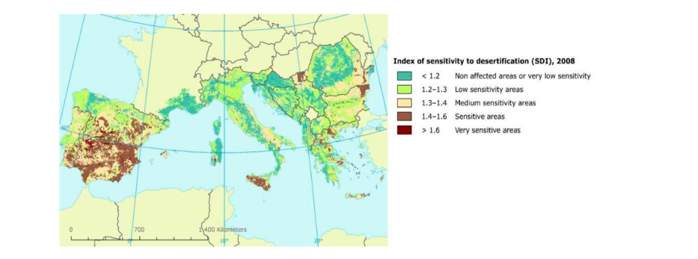
The Mediterranean Sea is becoming warmer and saltier, and its surface temperature is also increasing. During the 21st century, the basin mean sea surface temperature is expected to warm by 2.7 to 3.8°C and 1.1 to 2.1°C under the RCP8.5 and the RCP4.5 scenarios, respectively. Waters have also acidified due to absorption of CO2. Sea water surface pH has decreased by 0.08 units since the beginning of the 19th century. Rising sea levels are also a concern as it has now accelerated to 2.8 mm per year. Throughout the 21st century, sea level is predicted to be 0.43 m to 2.5 m higher than at the end of the 20th century. This also causes concern for damage along the coastline due to erosion. Coastal erosion is an increasing threat in recent years in the programme area, both due to climate change (especially sea level rise) and human pressure. For example, due to the damming of the Danube river, this has resulted in a decrease of freshwater input to the Black Sea of up to 20%, which increases salinisation and coastal erosion. In some beach areas, erosion has been seen at a rate of 12m per year.

Figure 5: Pattern of coastal erosion (Source: EEA-2008)
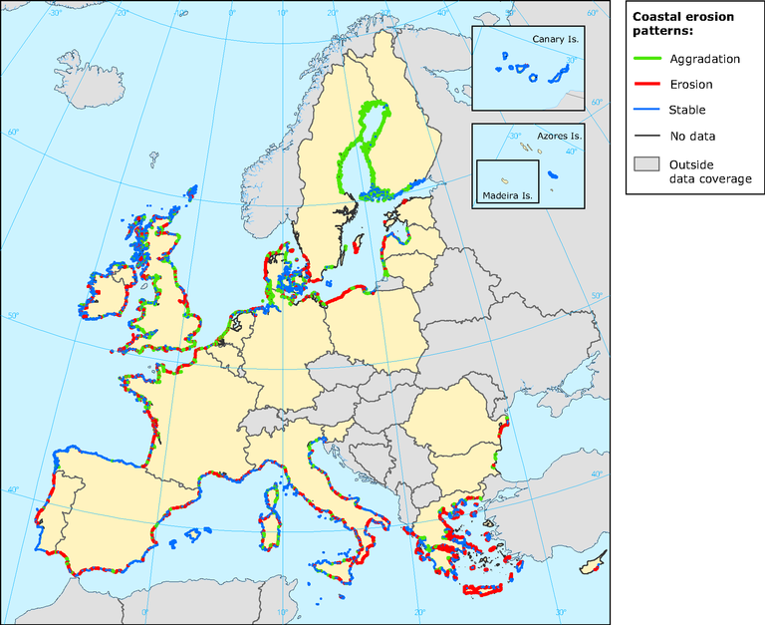

Natural ecosystems such as forests, wetlands, coastal and marine ecosystems will be greatly affected by these changes in temperature and precipitation. Hotter and drier days will threaten the diversity and survival of many Mediterranean species. There will be a higher risk of fire as well as more frequent, larger and more severe fires. Alongside land-use change, biological invasions and pollution, these will all alter the function and structure of ecosystems, making them less productive. Shifts in geographic distribution will allow warm-water species to move northwards and colonise new areas, increasing the rate of invasion.

GHG emissions
GHG emissions are the driving force of climate changes observed worldwide in recent decades. Total CO2 emissions in the cooperation area peaked in 2007, followed by falls from 2008 until 2014. Since 2014, GHG emissions have risen slightly (Figure 6), mainly due to energy and transport.

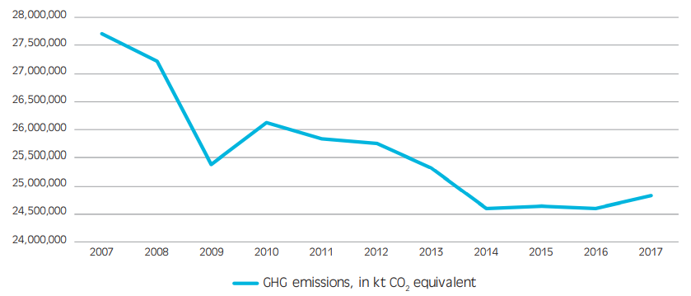
Figure 6: GHG emissions in kt CO2 equivalent, total of Croatia, Cyprus, France, Greece, Italy, Malta, Monaco, Slovenia, and Spain, 2007-2017. (Source: UNFCC-2018)

Situation, trend and threats for the cooperation area in a scenario ‘without the programme’
In the cooperation area GHG emissions have decreased since 2007 for most Member States, with some exceptions (e.g. Cyprus and Spain). Temperatures and sea levels are increasing (more than in other EU areas) with decreasing average precipitation. There are also more extreme weather events such as heat waves, storms and floods. Consequently, desertification is a threat for some territories. There are also potential increases in alien species, pests and diseases due to changes in climate conditions, e.g. tropical jellyfishes in the Mediterranean sea and the Asian tiger mosquito, as already seen across Mediterranean countries In a scenario without the programme, the general trends are reported in the following table (bearing in mind the geographic variability of threats and vulnerabilities).

Indicators | State | Trends
GHG emissions
Risk of desertification
Flood events
Coastal erosion

Inland water quality and supply
As Stated by Eurostat, Water is essential for life, it is an indispensable resource for the economy, and also plays a fundamental role in the climate regulation cycle. The management and protection of water resources, of fresh and saltwater ecosystems, and of the water we drink and bathe in is therefore one of the cornerstones of environmental protection. The EU Water Framework Directive (WFD) is the main EU directive for water related issues. The WFD requires that Member States formulate river basin management plans (RBMPs), with the objective of having European waters in good condition.

Water supply and sewage systems
Depending on the sizes of countries and resources available, water abstraction varies greatly within the different countries in the cooperation area. In terms of freshwater abstraction for public water supply in 2018, Greece had the highest water supply per inhabitant with 157 m³, whereas Malta had the lowest with 30m³ per inhabitant. For the rest of the cooperation area in 2018, Italy had 155 m³ per inhabitant, Bulgaria had 120 m³, Croatia had 110 m³, Slovenia had 82 m³, France had 81 m³, and Cyprus had 50 m³. Spain had 105 m³ in 2016. Portugal had 83 m³ in 2017. Per inhabitant values for household water use from public water supply was seen to be more or less stable over the last decade (2008-2018). Although there was an increase in Greece and Cyprus.

Figure 7: Total freshwater abstraction for public water supply (m3 per inhabitant) (Source: Eurostat - 2018)
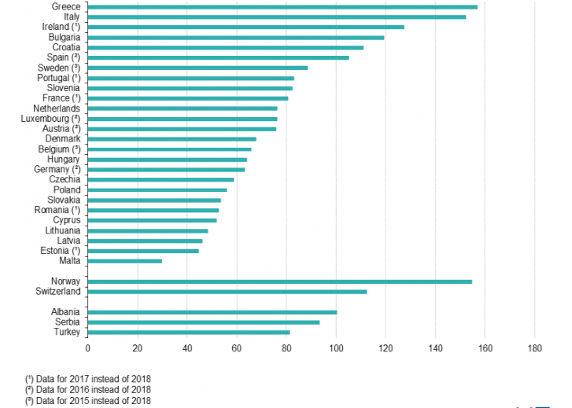

In 2017, 69% of the population in EU-27 countries were connected to tertiary level treatment and 13% to secondary level treatment. The situation is worse in the cooperation area. Those had less than 80% of their population connected to public urban wastewater treatment and are part of the Euro-MED Interreg Programme cooperation area are: Albania, Bosnia-Herzegovina, Croatia, and Slovenia. Albania and Croatia had 50-55% of their population connected but are in the process of building treatment facilities. In Bosnia-Herzegovina and Italy, 60-70% of the population were connected, while in Slovenia, 71-76% were connected. Albania, Bosnia-Herzegovina, Malta, and Portugal had more than 40% of their population with treatment below tertiary level.

Figure 8: Urban wastewater collection and treatment in Europe in 2017 (Data Source: Eurostat 2017.)
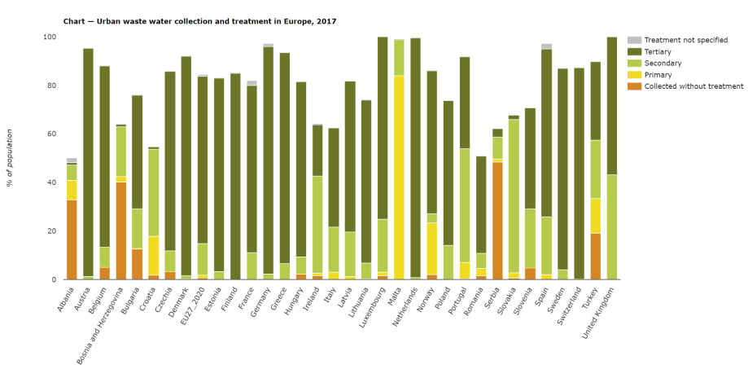

Inland water quality
Territories in the cooperation area differ in terms of water quality. In the North West of the cooperation area, Portugal has ten river basin districts (eight in mainland Portugal), four are international, sharing water courses with Spain (Minho, Douro, Tejo e Guadiana). Most of these have a good to moderate ecological status with some hot spots in bad status. Spain has 25 river basin districts, of which six are international, sharing water courses with France to the northeast and Portugal to the west. Most water bodies in Spain have high to moderate ecological status with some hot spots in bad condition.

Figure 9: Ecological status of Spanish and Portuguese surface water bodies (Source: EC - 2017).
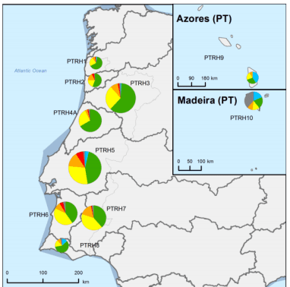 | 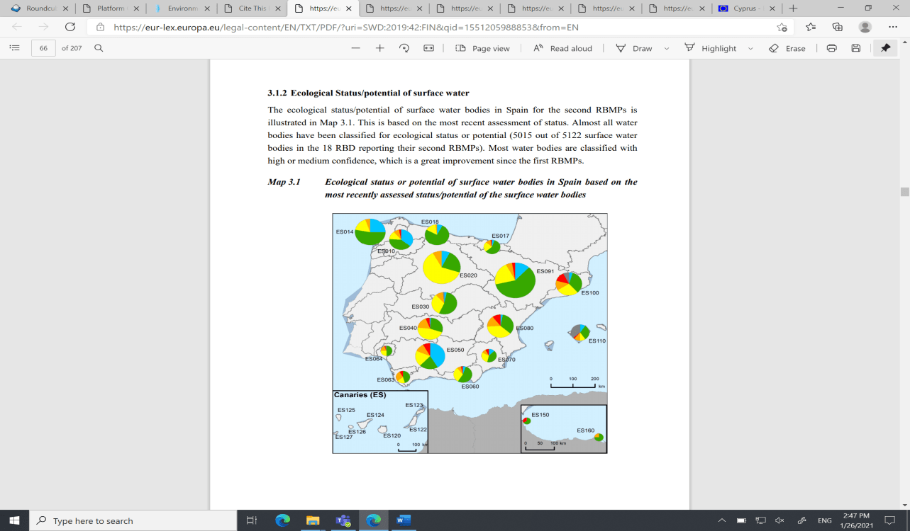
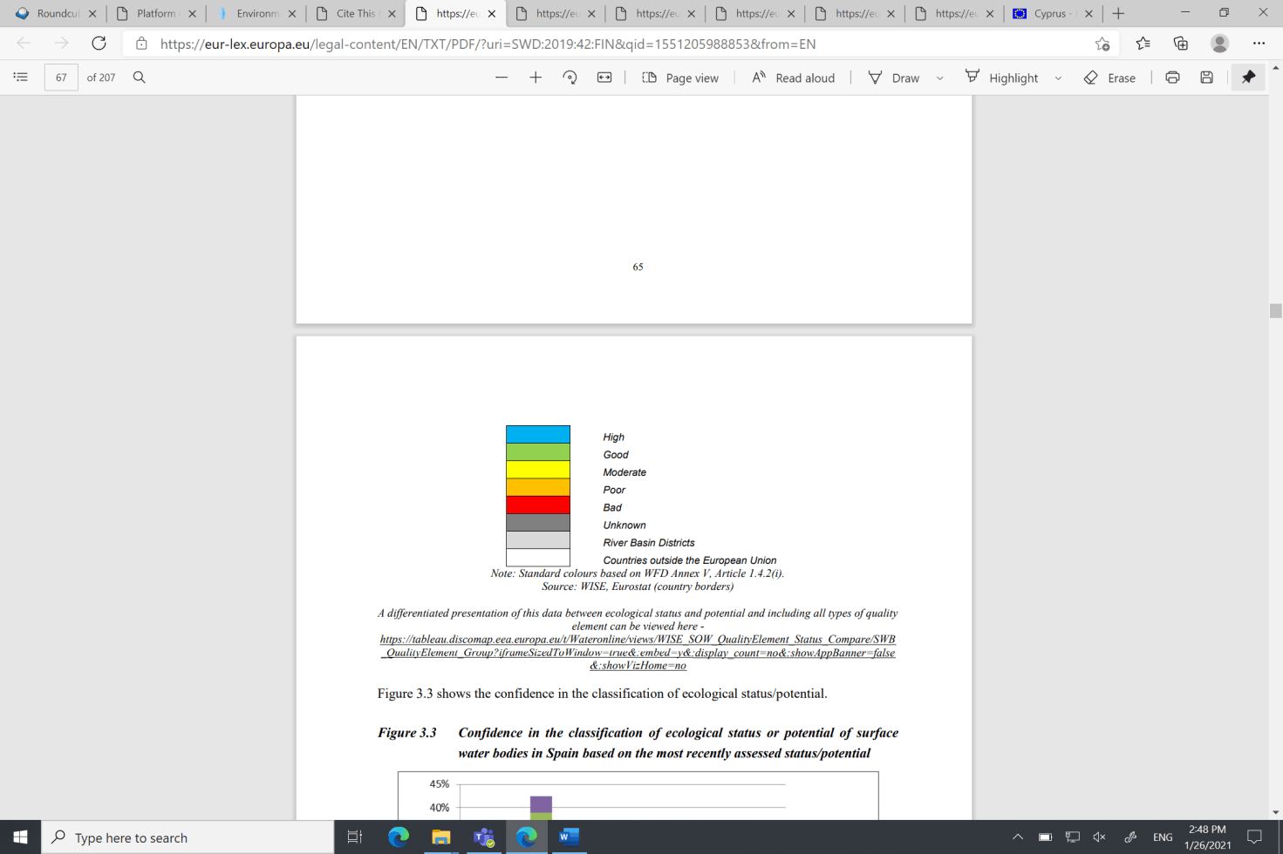

France has identified 12 river basin districts, of which 4 are overseas territories. Rhône and Garonne districts have a land border with Italy and Spain, while Corsica district is the island. Most of them have a moderate to good ecological status, some hot spots have a bad status.
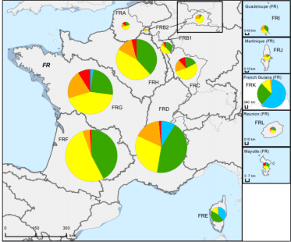
Figure 10: Ecological status of French surface water districts (Source: European Commission - 2017)

Croatia has two river basin districts, both of which are international with a similar pattern of ecological status, going from good to bad. Italy water governance is structured in river basin districts, of which two are international sharing water courses with France to the west, Switzerland and Austria to the north and Slovenia to the east. Most of them have good to moderate ecological status (except for two in southern Italy, where a significant share of the ecological status is unknown). Slovenia has two river basin districts, sharing water courses with Austria to the north and Hungary to the east. Both the river basins have good ecological status. Bulgaria has 4 river basin districts for basin management, 3 of which are international sharing water courses with Greece and Turkey to the south, Romania to the north, Serbia and Former Yugoslavia Republic of Macedonia to the west and one national river basin.
Figure 11: Ecological status of river basins in Slovenia, Croatia, Greece, Italy and Bulgaria (Source: European Commission - 2017)
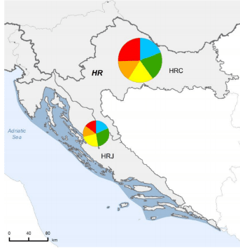 | 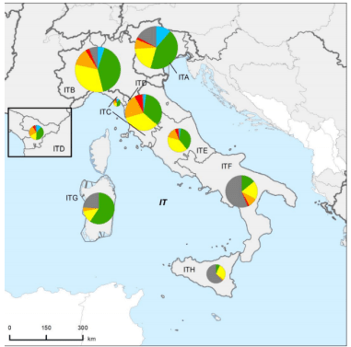
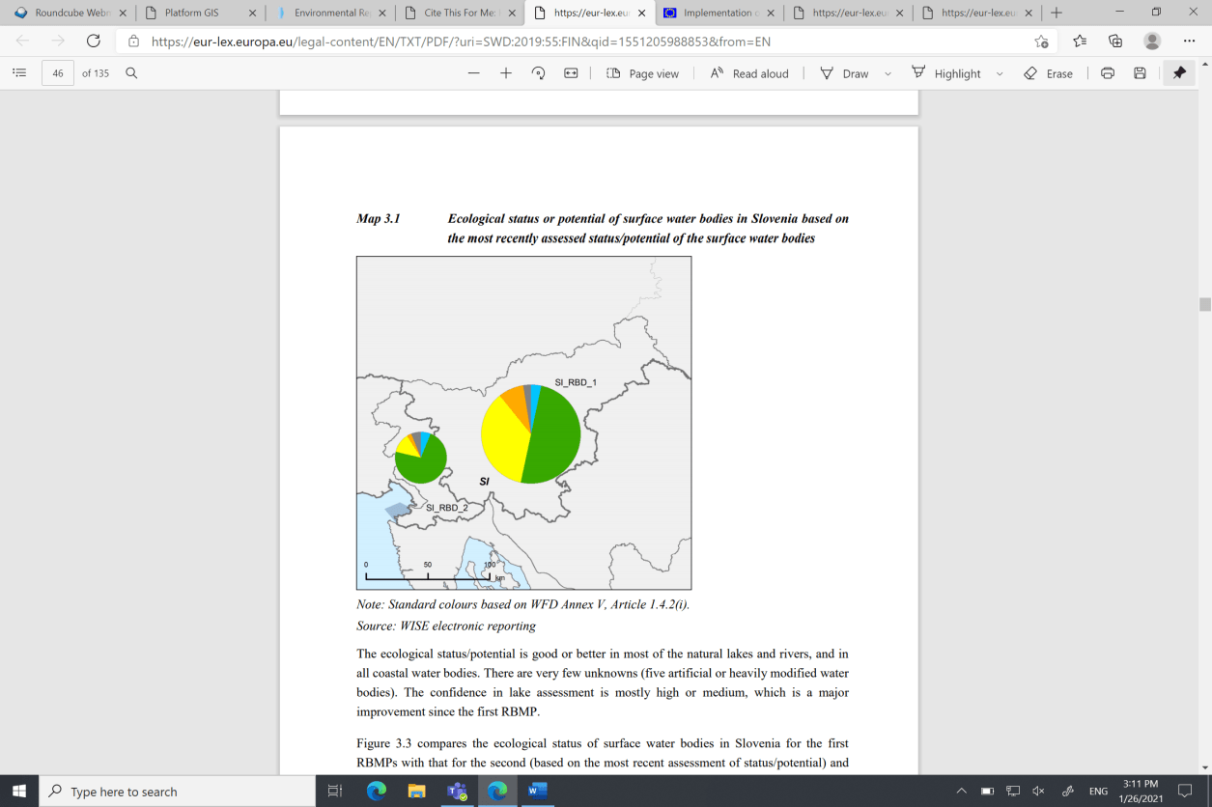 | 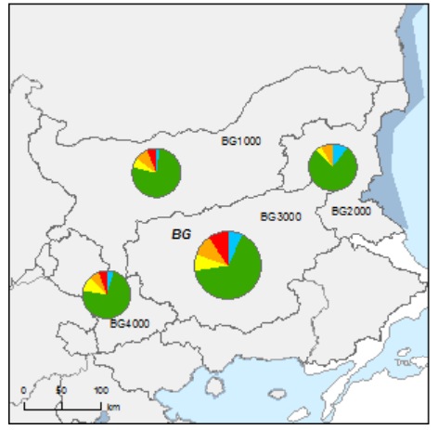
There are 14 river basic districts in Greece, five of which are international, sharing water courses with Albania (Figure 10). Cyprus has one river basin district, with an ecological status of good to moderate, while much of the status of the river basin in Malta (Malta and Gozo Islands) is unknown.
Figure 12: Ecological status of river basin in Cyprus and Malta (Source: European Commission - 2017)
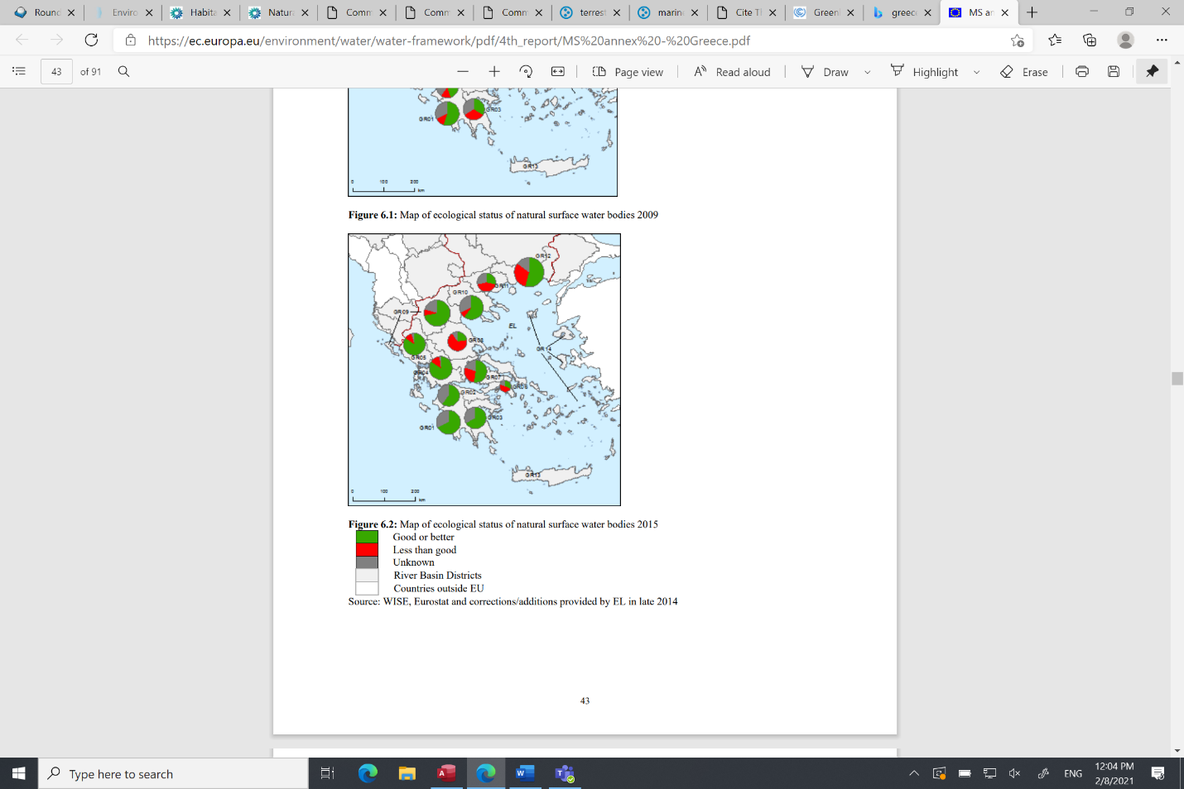
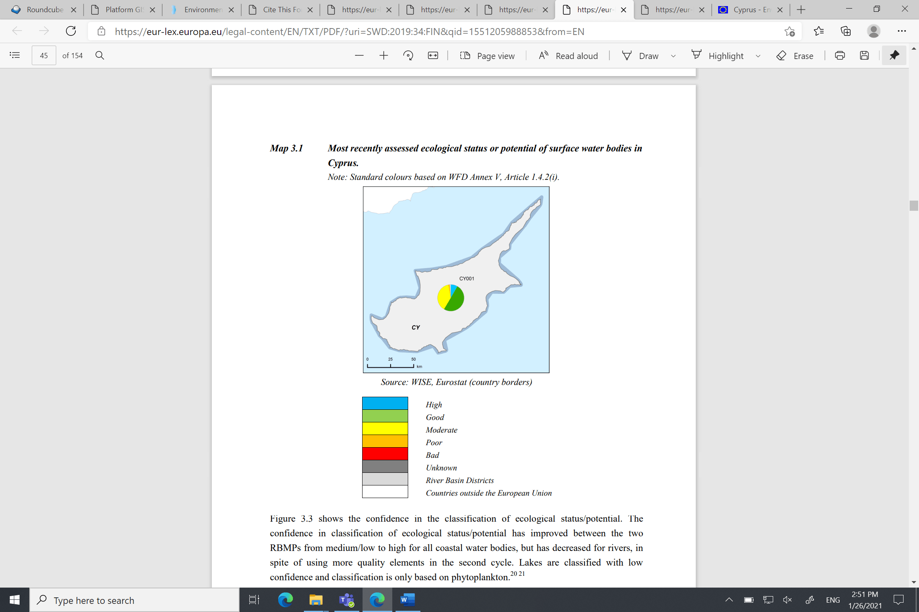 | 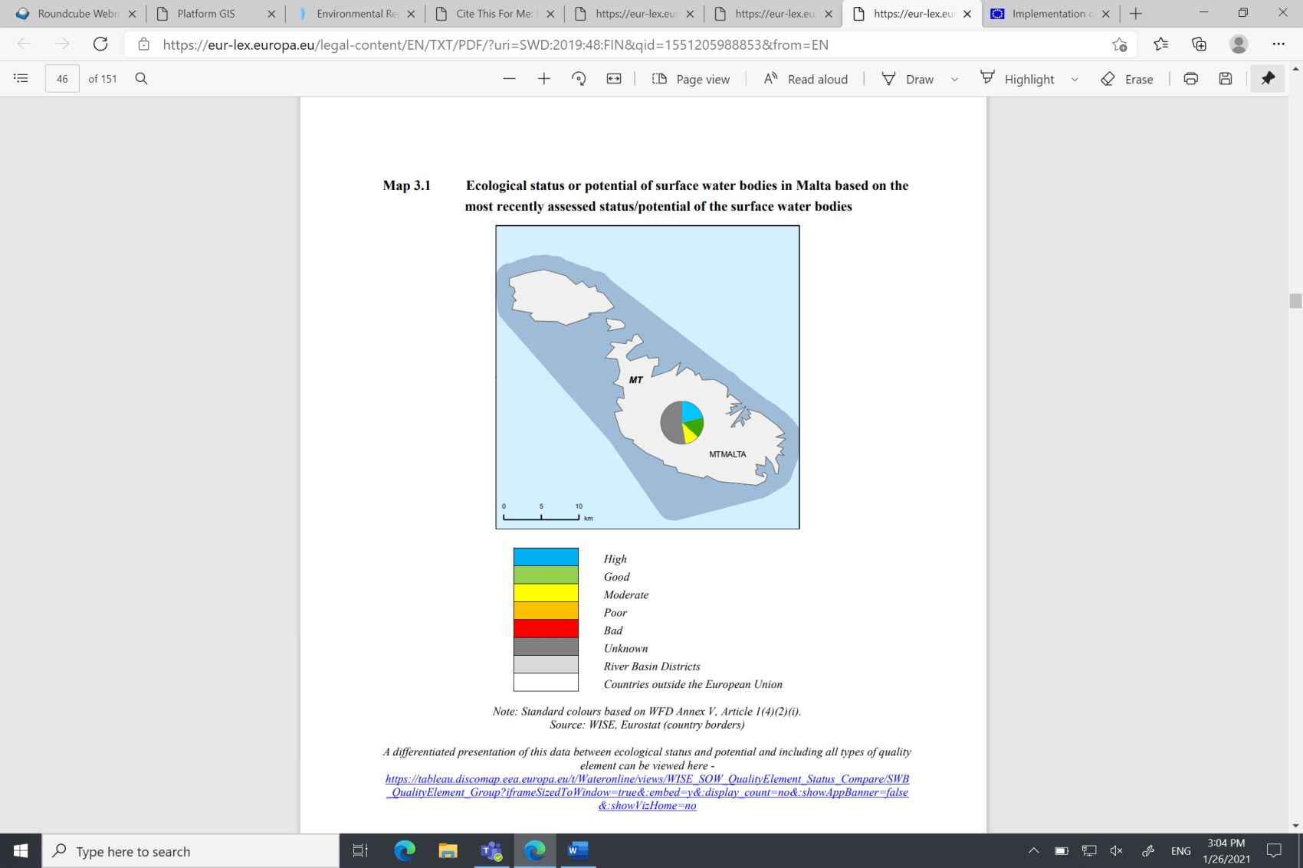

Situation, trend and threats for the cooperation area in a scenario ‘without the programme’
Population connected to a public urban wastewater treatment is variable, however in general lower than in the rest of North-West Europe. For example, Albania, Bosnia-Herzegovina, Croatia, and Slovenia have less than 80% of the population connected, which results in local pollution. The pressure on water remains high, in terms of water supply and consumption. Many river basin districts range from moderate to good ecological status, with some hot spots reporting a bad status, e.g. in Croatia. In a scenario without the programme, the general trends are reported in the following table (bearing in mind the geographic variability of threats and vulnerabilities).
Indicator | State | Trends
Population connected to public water supply sewage system
Inland water quality

Inland biodiversity and ecosystem
Biodiversity and nature sustain life on Earth, delivering numerous essential ecosystem services. They are a vital element of our cultural heritage and treasured for their recreational, spiritual and aesthetic values. As a result, biodiversity loss has fundamental consequences for our society, economy and for human health and well-being (EEA, SOER, 2020).
Natural and semi-natural ecosystem
There are nine recognised terrestrial biogeographic regions in the EU and five marine spaces. Each is characterized by vegetation, climate, and geology, which are all factors for biodiversity. Regions in the Euro-MED cooperation area belong to the Alpines, Continental, Mediterranean and Black Sea Biogeographic regions. Most of the cooperation area is included in the Mediterranean Biogeographic region and related maritime space (which represents around 20% of EU territory), and only few regions are localised in the alpine and continental biogeographic regions. Black Sea region is relevant for Bulgaria only.
More than half of the habitat types listed in the Habitats Directive can be found in the Mediterranean region, due to its varied geology and topography. Hot and dry conditions allow for forests, shrubs, bushes, and scrub to cover more than half the land. This also harbours a large range of flowers. Forests are highly diverse with more than 100 tree species (mainly broadleaved). Forests along with scrub and heathlands are widespread throughout the region, dominating more than half of the region’s landscape. Other parts are too dry for dense vegetation, instead they are covered by large grasslands. Agricultural land and grassland occupy 40% of the region and are used for crops or mixed farming systems. Most of the permanent grassland, although found across the region, only covers 6%. Tree production is woody, such as vines and olive trees. Vegetable production has been increasing over the years, especially in areas around urban centres. Cliffs, gorges, crevices, and caves are greatly seen in the mountains and along the coasts. Cliff-dwelling plants as well as a number of tree species with dwarf forms are also observed. There are also wetlands in the region, mostly along the coast. The coastline ranges from rocky coves to white sandy beaches, as well as a variety of dunes (one third of the dune flora on is endemic to the Mediterranean). Since 1990, more than 70% of dunes have declined. Largely due to urbanisation and tourism, turning these habitats into dry forests.

Figure 13: Biogeographic and marine regions in the European Union (source: EEA - 2015).
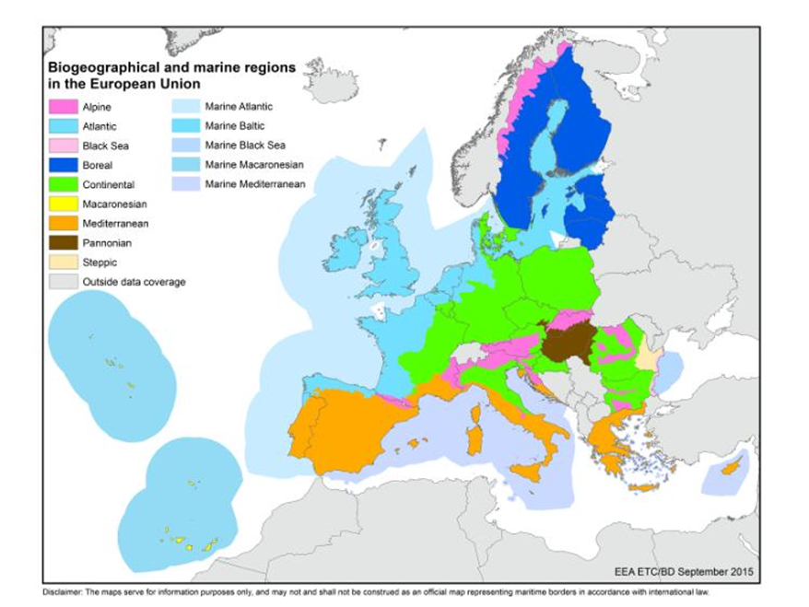

Regarding all the MS in the cooperation area and related biogeographical region, it worth noting that 23 % of habitats in the Mediterranean have a favourable (green) conservation status, whereas 41 % of habitats are in declining poor with unfavourable-inadequate (yellow) conservation status, and 30% of habitats are in declining bad: unfavourable-bad (red) conservation status. In the Alpine region, 26% of habitats are favourable, 45% are in poor status, and 19% are in bad conservation status. In the Continental region, 16% of habitats are favourable, 46% are in poor status, and 33% are in bad conservation status. In the Black Sea region, 10.64% of habitats are favourable, 80.85% are in poor status, and 6.39% are in bad status.

.

Figure 14: Conservation status of habitats per biogeographic regions in the cooperation area (source: EEA-2018)
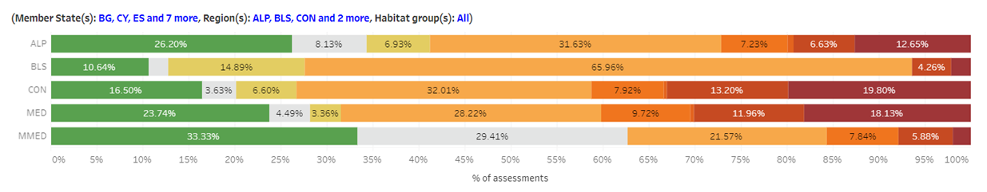
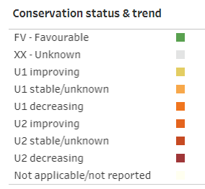
Nationally designated protected areas
Protected areas can encompass different lands and bodies of water, as well as different protection regimes. Mostly these are national parks, regional parks, natura parks, nature reserves and others, all of these can range from being highly protected sites with strict entrance restrictions, to parks where visitors are welcome. The share of protected areas in Euro-MED countries is quite high: ranging between 35%-40% of the land area in Slovenia, Bulgaria, Croatia, Cyprus and Greece and 20%-30% for Spain, Portugal, France and Italy and 9.65% in Northern Macedonia .

Figure 15: Share of country designated as terrestrial protected area and the overlap between Natura 2000 or Emerald sites and national designations (Source: EEA-2020)
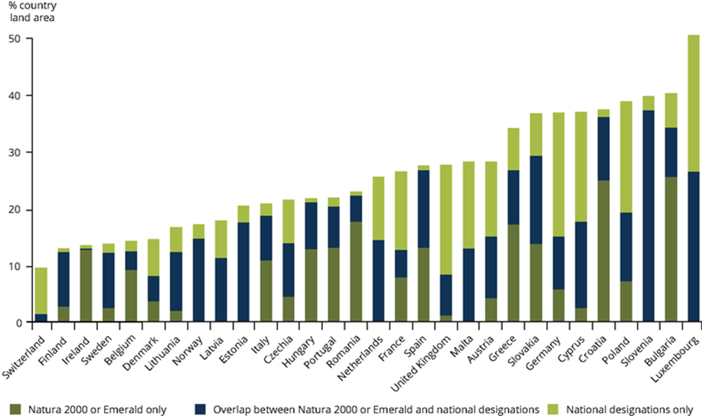
Most of the nationally designated areas (65%) are small nationally sites, between 1-100 ha. However, 94% of Greek protected areas are above 100 ha and 7% over 10,000 ha, whereas Italy has most of its designated areas between 1-100 ha and 100-1000 ha.
The International Union for Conservation of Nature (IUCN) has identified seven protected area categories, based on management objectives. Most of these categories fall under classifications V (protected landscape), IV (Habitat/ Species Management Area) and II (National park) in Member States cooperating in the Euro-MED Interreg Programme.
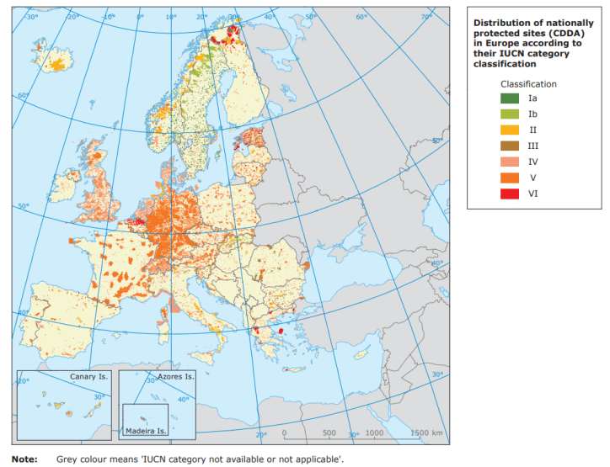
Figure 16: National protected area per IUCN category classification (Source : IUCN - 2012)

Natura 2000 network
An important tool for biodiversity protection is the Natura 2000 network, based on the Habitats Directive and the Birds Directive to protect habitat and species of peculiar importance. The aim of the network is to ensure the long-term survival of Europe's most valuable and threatened species and habitats (priority habitats and species). Natura 2000 is based on management and assessment tools rather than strict reserves. It works for the sustainable ecological and economic management of ecosystems. The Natura 2000 network includes Special Areas of Conservation (SAC) designated by Member States under the Habitats Directive and incorporates Special Protection Areas (SPAs) which are designated under the 1979 Birds Directive. With 28,000 sites, the network covers one fifth of Europe’s land area (18%/1.35 million km2). Natura 2000 sites in Member States belonging to the cooperation area account for around 20 % of the total.
Species protection
The Birds Directive protects all naturally occurring wild bird species in the EU. According to the EU-level assessment, 47% of bird species have a ‘good’ population status, whereas species with poor and bad status have increased 7% (from 32% to 39%). Annex 1 of the Bird directive identified 121 breeding species in the Mediterranean region.
In general, half the plants and animals considered in the Habitats Directive are local to the Mediterranean region. This region contains more plant species than all the other plant species in the rest of the biogeographic regions together. Approximately 25,000 flowering plant types have been identified so far (10% of all known plants on earth), and half of these only occur in the Mediterranean. In total, 80% of European plant species are endemic to the Mediterranean. For example, two thirds of European tree species and herbaceous flora are in the Mediterranean region. More plants also means there is a high diversity of insects and other invertebrates that have developed associations and dependency with specific plants. Additionally, most reptiles are found here as well as migrating birds, where an estimated two billion birds find refuge in (or go through) this area due to its mild winter. The Mediterranean region is also home to the richest number of invertebrates, with 75% of European insect fauna found there and, in some cases, endemism can be 90%. Moreover, specie richness’s for mammals is particularly high in the area (see map below).
Freshwater fish are also found in high numbers considering the favourable geography, which also causes high levels of endemism. Of 300 species, 131 (40%) are regional or local. Lastly, the Mediterranean Sea contains 8% to 9% of the world’s marine species, which contributes to high diversity.

The conservation status of species in biogeographic and marine regions in 2020 are reported below. Mediterranean species with a good (green) status of conservation are 30% of the total, whereas 38% are in poor status, and 16% are in bad conservation status. In the Alpine region, 33% of species conservation status are favourable, 34% are in poor status, and 13% are in bad conservation status. In the Continental region, 28% are in favourable status, 32% are in poor status, and 20% are in bad conservation status; while in the Black Sea region, 36.52% of species are in favourable status, 33.05% are in poor status, and 2.6% are in bad status. At least 168 (14%) of the coastal species assessed in the IUCN are threatened with extinction at a global or regional level in the Mediterranean region (data 2012), 101 of them are endemic. Birds and insects make up the greatest number of threatened animals. In declining order, Spain, France, and Italy have the highest number of threatened species in coastal habitats. Most of the threatened coastal birds, invertebrates and plants are in France and Spain, and the highest number of threatened amphibians and reptiles are in Spain and Italy.

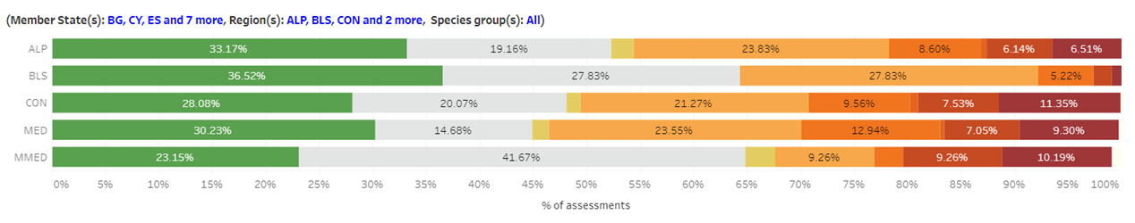
Figure 17: Conservation status of species in the cooperation area (Source: EEA - 2018)

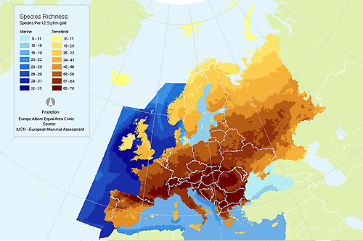
Figure 18: Species richness for mammals (Source: IUCN’s Red List - 2009)

Situation, trend and threats for the cooperation area in a scenario ‘without the programme’

The area covered by the Interreg Programme is mostly in the Mediterranean Biogeographic region. This region has high biodiversity due to its climate and geographical characteristics. National designated protected areas cover a relevant percentage of the area. As with the Alpine and Continental regions, there is a low percentage of ‘good’ conservation status of habitats and species and a high percentage of ‘poor’ (and declining). Habitats and species are also threatened due to high endemism (with populations covering a small territory). This results in high sensitivity to climate change and local human pressures, contributing to a decrease in conservation status in the medium and long term. In a scenario without the programme, the general trends are reported in the following table (bearing in mind the geographic variability of threats and vulnerabilities).

Indicator | State | Trends
Designed protected area | ☺ | n.a
Natura 2000 network
Habitat conservation
Species conservation

Marine ecosystem and natural resources
To address marine issues and improve the quality of marine and coastal ecosystems, the Commission has provided a clear framework of intervention in EU marine areas, the Marine Strategy Framework Directive (Directive 2008/56/EC) with the objective of preserving natural resources upon which human activities depend. The Directive wants to achieve a ‘Good Environmental Status’ for marine water, defined by the following parameters:
- Ecosystems, including their hydro-morphological (i.e. structure and evolution of water resources), physical and chemical conditions, are fully functioning and resilient to human-induced environmental change;
- The decline of biodiversity caused by human activities is prevented and biodiversity is protected;
- Human activities introducing substances and energy into the marine environment do not cause pollution. Noise from human activities is compatible with the marine environment and its ecosystems.
Two frameworks contribute specifically to protection of the Mediterranean marine ecosystem: The Convention for the Protection of the Marine Environmental and the Barcelona Convention for the Coastal Region of the Mediterranean. Both set a protocol for Specially Protected Areas and Biological Diversity in the Mediterranean (SPA/BD Protocol) – which aids countries to establish Marine Protected Areas (MPAs).
MPAs
MPAs, are geographically distinct zones defined to set economic and ecological conservation objectives. The Mediterranean regional sea surface area is 2 517 000 km2, of which 114 461 km2 (around 9% of EU waters) in 1 410 sites are covered by MPAs. Natura 2000 covers 109 301 km2 in 1 225 sites.

Table 5: Marine protected areas (Source: Eurostat - 2015)
Regional seas surrounding Europe | Regional sea surface area (km) | EU MS share of sea surface area of regional sea (km) | EU MS share of sea surface area of regional sea (%) | Area covered by MPAs in EU water within 200nm (km) | Total num. of sites
Mediterranean Sea | 2,517,000 | 1,210,000 | 48.1 | 9.5 | 1410
Western Mediterranean Sea | 846,000 | 660,000 | 78 | 15.6 | 724
Ionian Sea and Central Mediterranean Sea | 773,000 | 240,000 | 31 | 1.6 | 274
Adriatic Sea | 140,000 | 120,000 | 87.7 | 2 | 199
Aegean-Levantine Sea | 758,000 | 190,000 | 25.1 | 2.6 | 221
Black Sea | 474,000 | 64,000 | 13.5 | 4.5 | 62

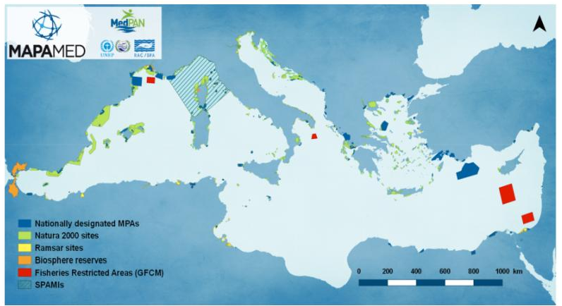
Figure 19: Location of national MPAs, Natura 2000 sites and Specially Protected Areas of Mediterranean Importance (SPAMIs) in the Mediterranean region (Source: MAPAMed, 2017)

Between 2012 and 2016 protected sea regions increased in the Euro-MED area, mostly in the Black Sea and the Western Mediterranean. At least, 251 690 km² of the Mediterranean Sea should have been covered by MPAs or Other Effective Area-Based Conservation Measures (OECMs) by 2020 to reach Aichi Target 11 and SDG 14.

Figure 20: Protected area between 2012 and 2016 (% of sea area) (Source: Eurostat-2017)
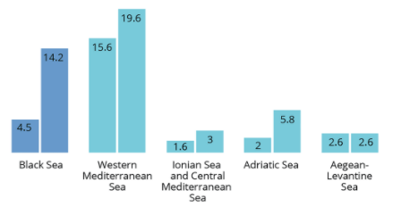

Pressure on marine system from human activities and pollution
Pressures from human activities vary across the Mediterranean Sea. Coastal development and sprawl lead to habitat fragmentation, loss and degradation, while increases in artificial structures along the coast affect stability and lead to a deficit of sediments. In addition, destruction of soil surface layers creates erosion, making it easier for ground-water pollution to enter the system. Degradation of dunes from erosion increases desertification and reduces biodiversity. Around 80% of marine pollution comes from land-based sources; mainly agriculture, industry, and municipal waste.
Pollutants are a major source of impact. They can include wastewater organic matter, heavy metals, persistent organic pollutants (POPs), hydrocarbons, microorganisms, and nutrients. Sources can be discharge points, atmospheric deposition, marine activities (fishing, shipping, mining), dumping grounds or surface fluvial run-off. The Black Sea region has dealt with the negative effects of salinisation, which influences both soil biology and crop productivity, as well as indirectly effects for soil in loss of stability and structure.

A lack of wastewater treatment facilities (or inadequate facilities) mean wastewater organic matter enters the marine system easily. An increase in particle concentration reduces light penetration in water, reducing photosynthesis. Furthermore, as the matter decomposes it uses up oxygen, creating anoxic zones which can be fatal for organisms. Normally, benthic (seabed) communities are affected first, which then affect the flux of nutrients throughout the food chain. Sources of organic pollutants are dispersed all along the coast. Oil refining makes up more than half the sources, followed by food industries (one third). It worth noting a concentration of sources along the coast of Croatia.

Figure 21: Main sources, and location of organic water pollutant in the Mediterranean Sea (Source: UNEP-2012)
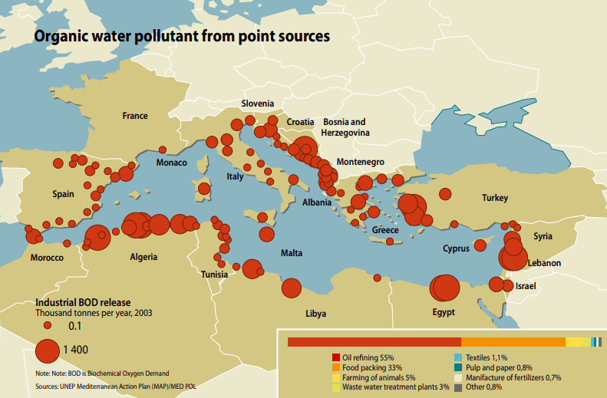

Major sources of heavy metals are industrial wastewaters, atmospheric deposition and run-off from metal contaminated sites. Atmospheric deposition allows heavy metals to enter open-water areas, which leads to accumulation in sediments on the sea floor and in the food web, affecting marine organisms. Most heavy metals are toxic and can exacerbate biochemical reactions, causing stress. The main industrial sectors emitting heavy metals into the Mediterranean region are energy production, a large contributor for Nickel (gas), Cadmium (gas) and Arsenic (gas), cement manufacturing, Copper (gas) and Mercury (gas), while Chromium (liquid) largely comes from oil refining.

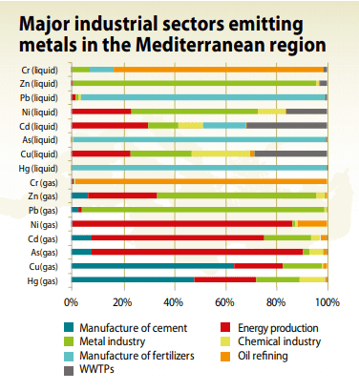
Figure 22: Major industrial sectors emitting metals in the Mediterranean region (Source: UNEP-2012)
Persistent Organic Pollutants (POP) are organic compounds resistant to environmental degradation, persisting for long periods of time and instigating bioaccumulation in animal tissue and biomagnification in food chains. This ultimately leads to impacts on human health when consumed. Marine organism health is also affected as POPs alter reproductive systems which could influence their survival. POPs such as hexachlorobenzene (HCB) and polychlorinated biphenyl (PCB) are often released as unwanted by-products by the cement and metal industries.
Marine traffic and transport are a large source of oil pollution and polycyclic aromatic hydrocarbons (PAH). Due to tank washing, some crude oil is deliberately dumped. Other operations such as loading, discharging and bunkering can release oily waste. Some 1.000 tonnes of PAH enter the Mediterranean Sea year also from aquaculture, incomplete combustion of biomass, solid waste and atmospheric particulates from the combustion of fossil fuels.
Increased nutrients - dissolved nitrogen and phosphorous - lead to eutrophication. Nutrient over-enrichment comes mainly from municipal sewage discharge and fertiliser run-off from agricultural areas, lawns and golf courses.

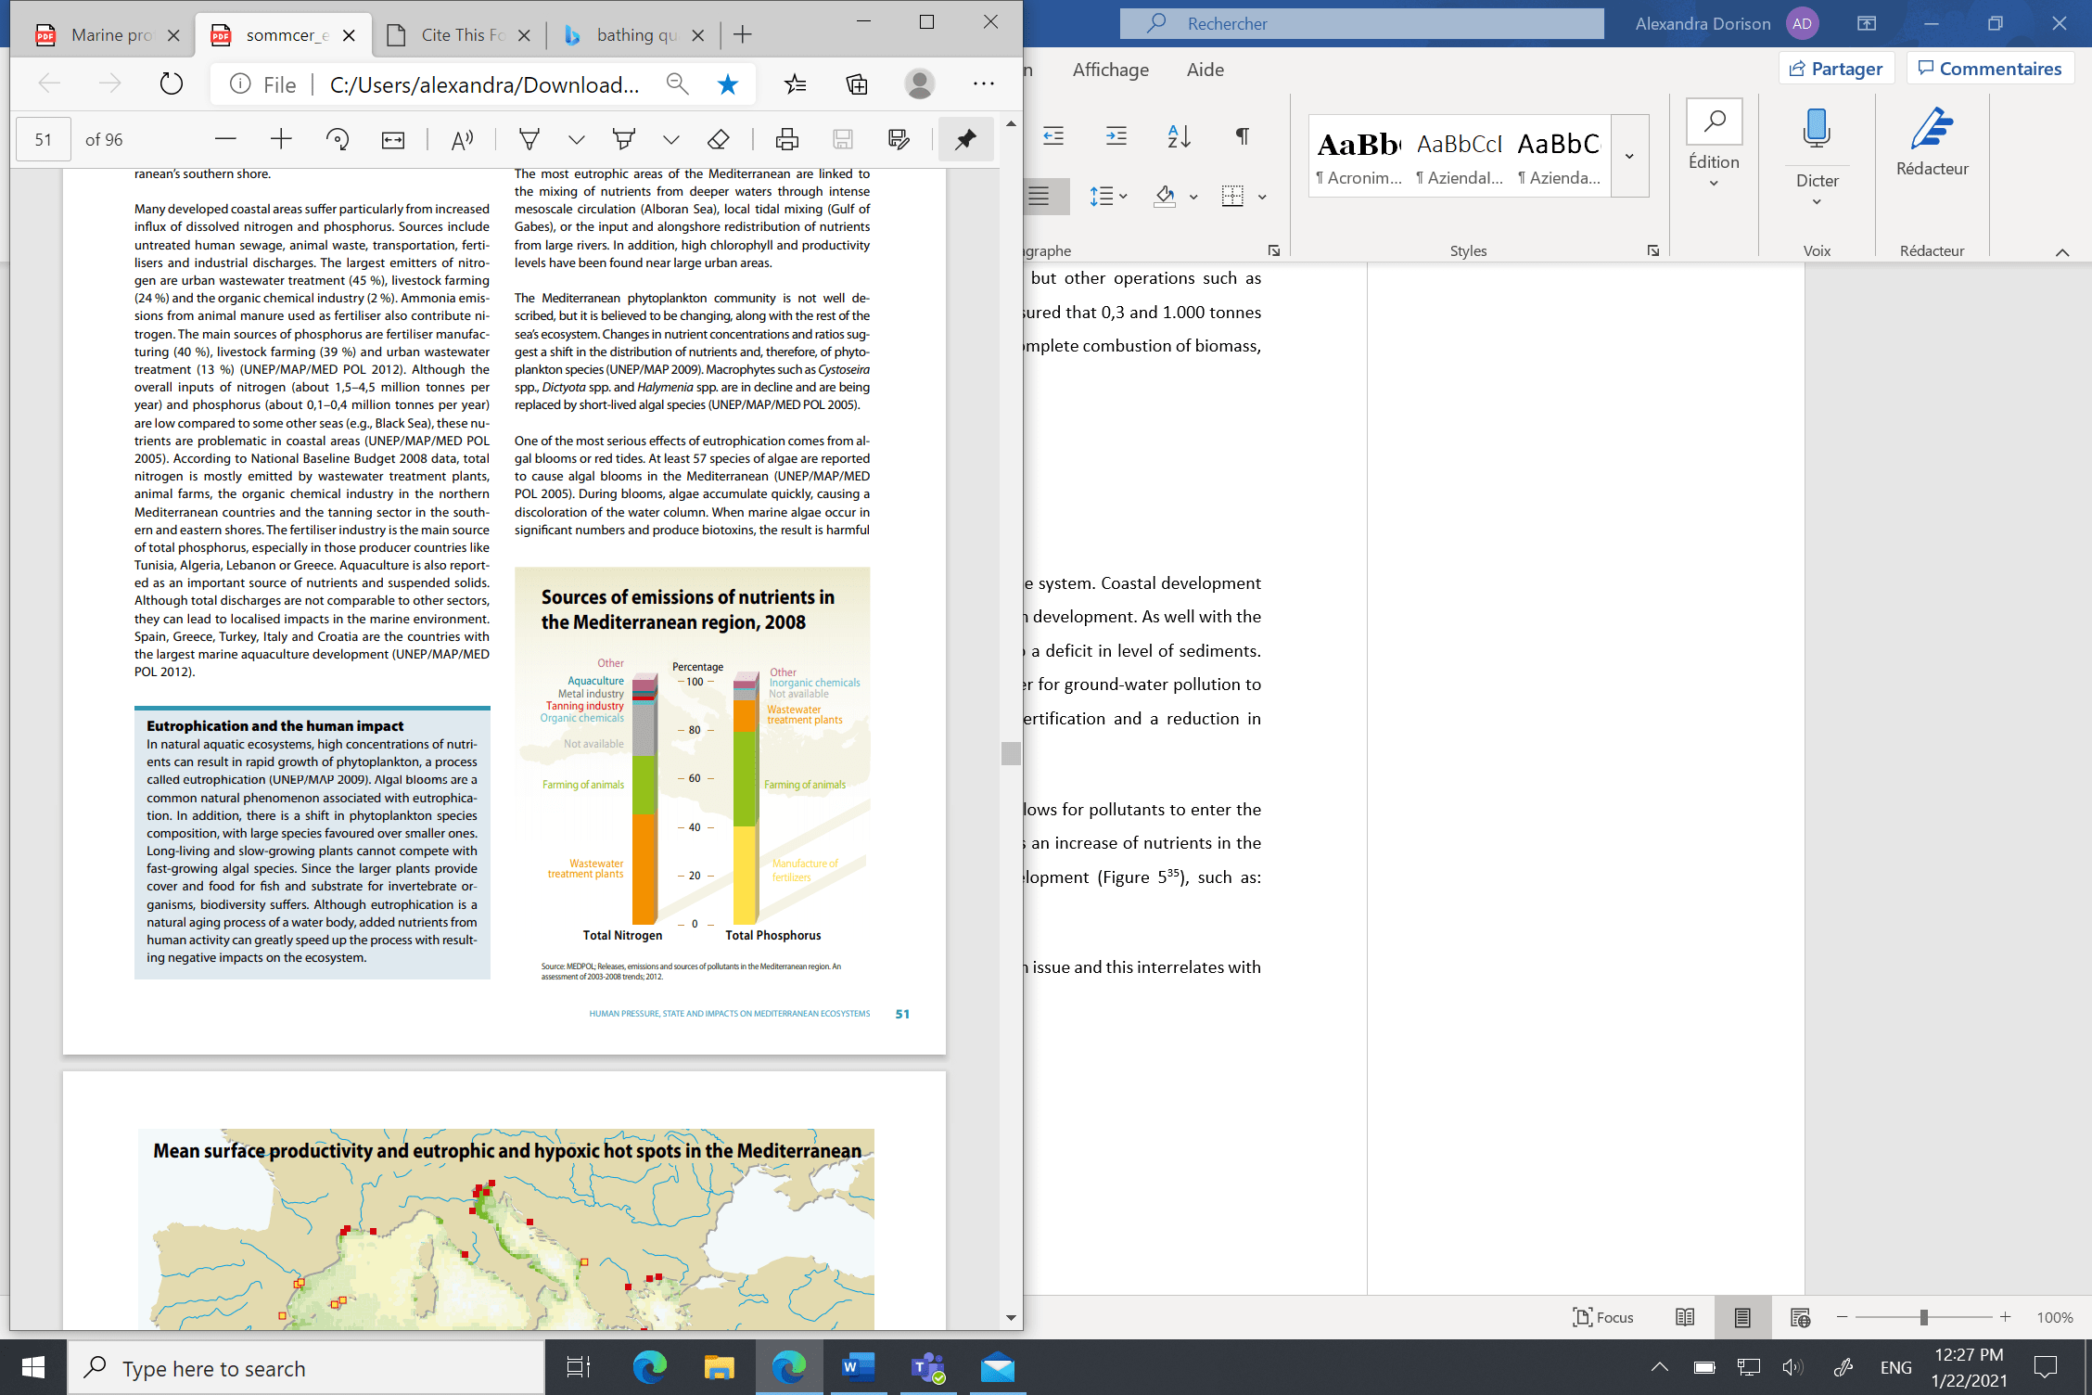
Figure 23: Sourced of nutrient emissions in the Mediterranean region (Source: UNEP-2012)

Eutrophication leads to a large increase in algal blooms which produce biotoxins, resulting in human illness as well as fish, bird and mammal deaths. It also leads to hypoxic and anoxic zones, making living conditions very tough for marine organisms.

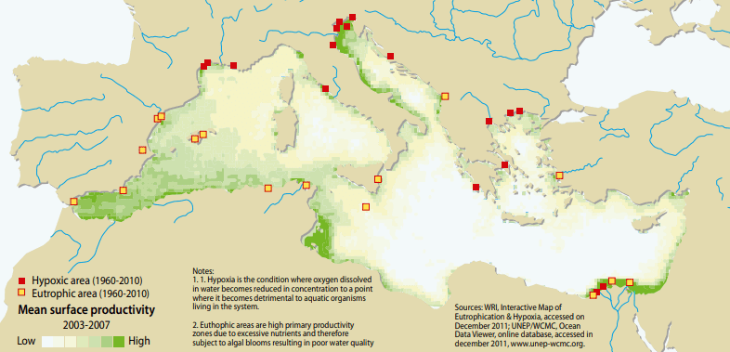
Figure 24: Mean surface productivity and eutrophic and hypoxic hot spots in the Mediterranean (Source: UNEP-2012)
Marine litter mostly from household disposal has increased along coastlines in recent decades, affecting the water column and sea floor. Litter such as plastic affects marine animals with entanglement and ingestion.

Figure 25: Sources of marine litter in the Mediterranean (Source: UNEP-2012)
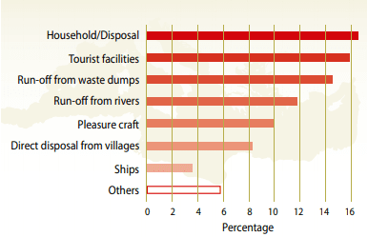

Bathing water quality
The Bathing Water Directive introduced in 2006, gives monitoring and management frameworks for improving bathing water quality. By investing in urban water treatment plants and wastewater networks, untreated pollutants have decreased. Part of the directive was for all bathing sites to be at least ‘sufficient’ quality by 2015. By 2019, 95% of EU bathing sites met that requirement. Most Member States in the cooperation area have excellent quality bathing water: Cyprus has the highest share with 99.1% of sites meeting the grade, followed by Malta (97.7%), Greece (95.7%) and Croatia (95.6%). In 2019, 38 bathing water sites in Spain, 36 in Italy, 8 in Spain, 2 in France and 1 in Portugal were poor quality.
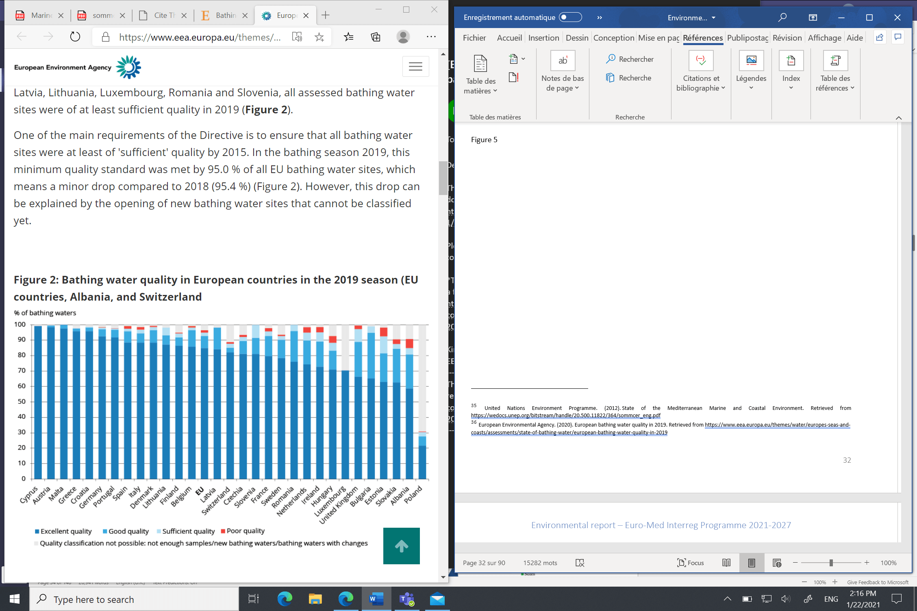
Figure 26: Quality of bathing waters per country (Source EEA - 2019)

Overfishing and fish stocks decline

Since the 1970s, 90% of Mediterranean fish populations have now been “overfished”. For example, the European hake and red mullet are exploited 10 times over suggested limits. Processes such as bottom trawling help to catch large quantities of marine organisms, wiping out populations along the seafloor. Not only does this impact in the decline of populations, but as well on damaging sensitive habitats, irreversibly. At the end of this process, there is a large number of unwanted catches (such as juveniles), which are ultimately discarded, creating huge amounts of waste, as well as not allowing these fish to reproduce – leading to even more population decline. Invasive non-indigenous species introduced by humans have been also a rising issue, which interrelates with overexploitation of commercial fish stocks. From natural invasion through waterways, transportation by ships and intentional/unintentional introduction from aquaculture, these impact biodiversity as well as public health, tourism, and the fishing industry.

Situation, trend and threats for the cooperation area in a scenario ‘without the programme’

The Mediterranean region has 190 nationally designated MPAs covering 114 461 km² and 1 225 Natura 2000 sites. The number and surface of protected areas is increasing. Although the quality of most bathing sites in the region is excellent, pollution from human activities remains a critical issue. Pollutants can be from wastewater organic matter, heavy metals, persistent organic pollutants, oil pollution and PAH. Maritime litter is also an issue. All these threaten the marine ecosystem, increasing toxic elements in the system, creating more eutrophication and anoxic zones, as well as affecting human and marine life. Fish stocks are at risk, threatened by overfishing and invasive non-indigenous species. In a scenario without the programme, the general trends are reported in the following table (bearing in mind the geographic variability of threats and vulnerabilities).

Indicator | State | Trends
Marine protected area
Pollution sources
Bathing water quality
Fish stocks

Soil quality and land use
Land is the earth’s surface not covered by water, whereas soil is the uppermost layer of the ground, composed of organic matter, water, minerals and living organisms. The Soil Thematic Strategy sets the basis for a framework Directive and an Impact Assessment on this issue at EU level. Soil is a non-renewable resource with many vital functions. Soils provide physical support to economic activities, especially for buildings and urban infrastructure. Soil also provides numerous ecological services. It regulates water, nitrogen and carbon cycles, it is a carbon sink and a life support system for many species of animals and plants. For years, soil has been under a growing human pressure in the cooperation area.
Soil degradation and artificial soils and surfaces
Soil degradation is mainly due to the increase of artificial soil, mainly through buildings and roads. Artificial soils influence water storage, climate regulation, habitats and others. Between 2006 and 2015, the percentage of soil sealing in the cooperation area increased, except for Montenegro. Malta is a specific case, with more than 15% of artificial soil.
Figure 27 : Percentage of soil sealing per country (Source: EEA-2020)

Contaminated sites
Various human activities contaminate soil with environmentally hazardous substances including heavy metals, organic material and pesticides. In the cooperation area, the main activities contaminating soil are municipal and industrial waste treatment and disposal as well as industrial and commercial activities. For example, industrial waste treatment and disposal is responsible for 100% of soil contamination in Croatia. In Montenegro there is little contamination from this activity, but some from municipal waste treatment and disposal along with industrial and commercial activities (as in France and Italy). Cyprus has a large percentage of soil contamination from municipal wate treatment and disposal, and Malta’s soil contamination has similar percentages of industrial and municipal waste treatment, disposal and storage. Macedonia has a large percentage in Municipal waste treatment and disposal.
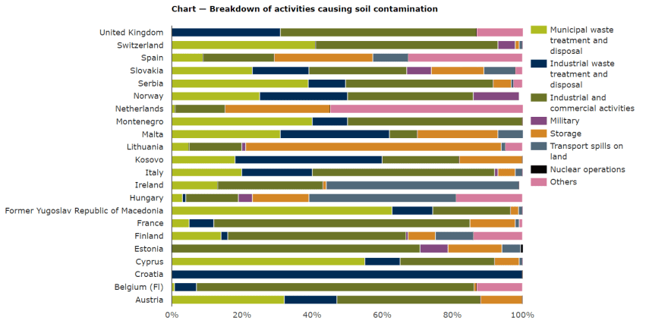
Figure 28 : Contaminated sites per Member State by contamination origin (Source: EEA-2019)

Situation, trend and threats for the cooperation area in a scenario ‘without the programme’

Over the years, the surface covered by artificial soil has increased in the cooperation area, alongside a decrease in pasture and cropland, as well as fragmentation of the landscape. The Mediterranean region is also affected by a decrease in soil moisture (desertification), salinisation (rising sea levels), soil erosion and contamination. The main sources of contamination are municipal and industrial waste treatment and disposal, although this varies between Member States, e.g. 100% of soil contamination in Croatia is from industrial waste treatment and disposal, on the other hand, little contamination comes from this activity for Montenegro. In a scenario without the programme, the general trends are reported in the following table (bearing in mind the geographic variability of threats and vulnerabilities).
Indicator | State | Trend
Artificial soils and surfaces
Contaminated sites

Technological risks
Accidental discharges are one of the main pressures, in terms of technological risk, affecting the marine and coastal environment. These discharges are mainly from transportation of fossil fuels and production of energy. It worth noting that 44% of the Mediterranean area is designated for offshore drilling and exploration activities. From 1970 to 2009, Italy had the most accidents (16), as well as Greece (5), and Spain (3). Spillage of oil and other chemical substances exacerbate the impacts of pollution, leading to the reduction of plankton and marine fauna and flora.

Air quality and Health
Air quality legislation and standards are mainly covered by the Ambient Air Quality Directive 2008/50/EC, including standards for pollutants, ambient concentrations of air pollution from mobile sources, improved fuel quality and environmental protection requirements in the transport and energy sectors. Also relevant for the Euro-MED programme is Directive 2012/33/EU addressing sulphur and particulate matter emissions from marine shipping.

Air pollution
Exposure to particulate matter can lead to more premature deaths from heart disease, strokes, lung diseases and lung cancer. Exposure to air pollution has also been seen to reduce lung function, increase respiratory infections and aggravate asthma. Primary pollutants such as particular matter, black carbon, nitrogen oxides and others are directly emitted into the atmosphere. Secondary pollutants such as ozone and volatile organic compounds form in the atmosphere from precursor pollutants.
Figure 29: Air contaminants per sector (Source: EEA – 2019)
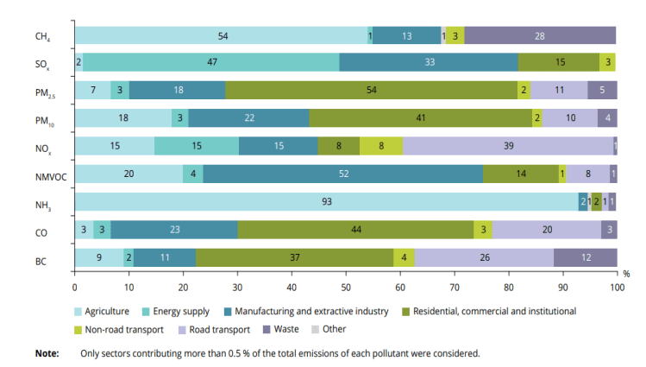
For particulate matter, the concentration of PM2.5 in the cooperation area differs across countries. Most regions have a PM2.5 annual mean of 5-10 and 10-15 (µg/m3). In the alpine region and east of Spain, PM2.5 the annual mean is less than 5, while concentrations are higher in Northern Italy at 20-25 with more than 25 µg/m3.

Figure 30: Concentration of PM 2.5 in 2018, in Europe (Source: EEA-2019)
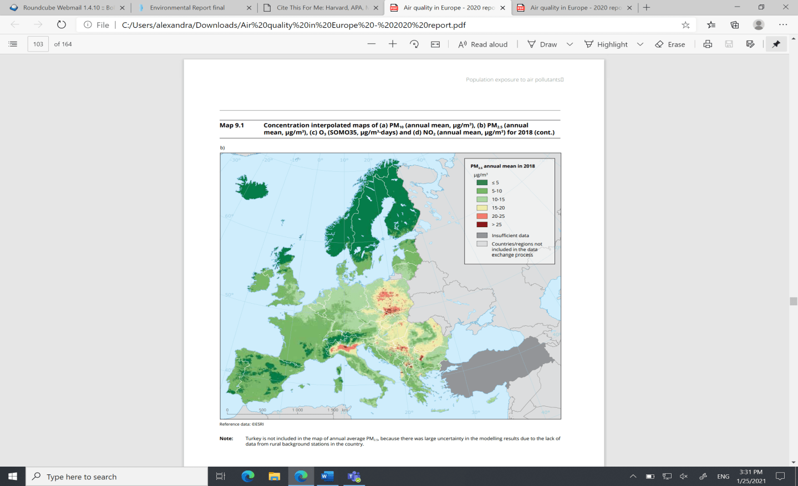

Situation, trend and threats for the cooperation area in a scenario ‘without the programme’

Air pollutants vary and come from diverse sources. Air quality is closely linked to local conditions and varies a lot across Member States and regions. Exposure is generally higher in urban areas. Overall, from 2000 to 2018 the concentration of pollutants has decreased. The Euro-MED cooperation area generally has a low concentration of PM_{2.5}, with some exceptions (e.g. North-East Italy). In a scenario without the programme, the general trends are reported in the following table (bearing in mind the geographic variability of threats and vulnerabilities).

Indicator | State | Trends
Particulate matter emissions
Other air pollutant emissions
Exposure to pollutants in urban areas

Landscape and cultural heritage
The European Landscape Convention (ELC) is the first international treaty in Europe which focuses on the protection, management and planning of landscapes. This treaty covers land, water (inland and seas), natural, rural, urban and peri-urban landscapes. Considering both cultural and man-made landscapes, the ELC makes sure that every landscape is protected with quality improving. Landscapes have unique characteristics, so there are different measures and policies for each one.
Landscape
Landscapes in the cooperation area are mostly ‘bocages or enclosed landscapes’ as well as the sub-section ‘Mediterranean semi-bocage’, as reported for Croatia and Bosnia-Herzegovina. In Italy there are extensive ‘open fields’, such as ‘Mediterranean open land’, also found in Eastern Spain, Albania, and Greece. In the Alpine region, landscapes are ‘mountains’. There are also artificial landscapes in some parts of Greece, Italy, and Eastern Spain reported as ‘huerta’.

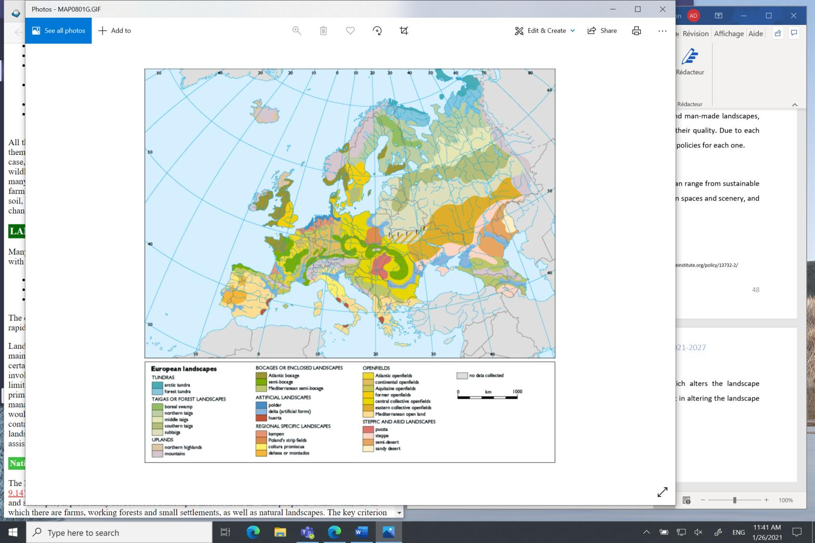
Figure 31: Landscape distribution in Europe (Source: EEA-2020)

Landscape fragmentation, as a percentage of the country area, is high in Malta and France, less in Slovenia and Italy and limited in Croatia, Spain, and Greece with strong differences between regions. In general, the situation was almost unchanged in all the countries between 2009 and 2015.

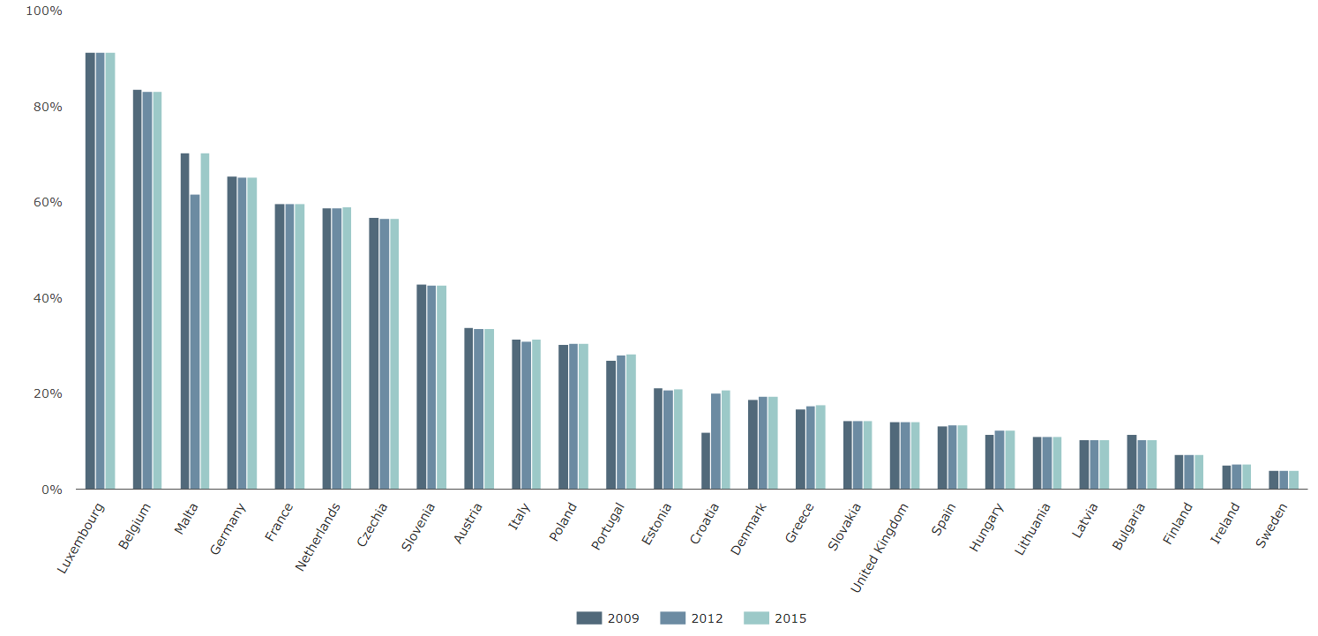
Figure 32: Area of strongly fragmented landscape (% of country area 2009, 2012, 2015) (Source: EEA-2019)

Protected sites
Category V in the IUCN system of protected areas focuses on protected landscapes and seascapes. Protected landscapes also include areas where people live, work and farm, as well as working forests, small settlements and natural landscapes. Compared to other Member States, Mediterranean countries in the cooperation area have a smaller share of land area under landscape protection.

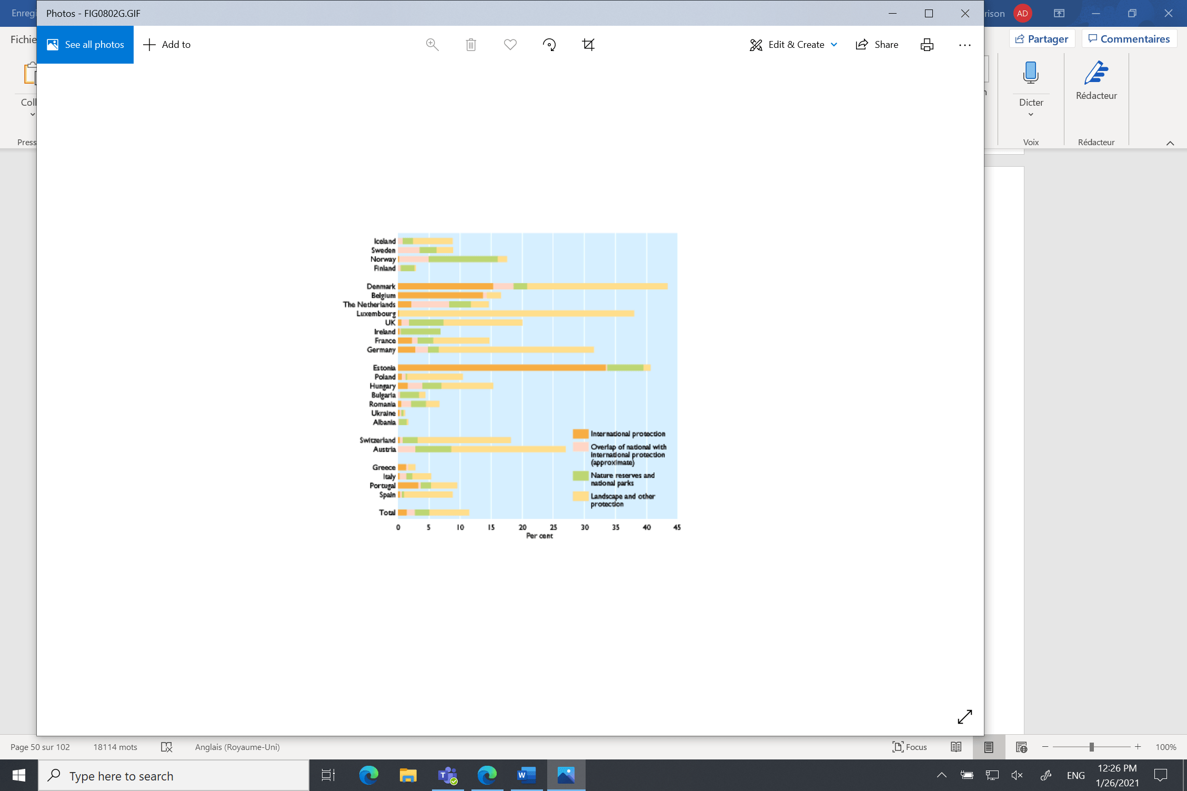
Figure 33: Share of landscape and other protected areas in European countries (Source: EEA-2020)
Situation, trend and threats for the cooperation area in a scenario ‘without the programme’
Most of the landscapes in the cooperating area are ‘bocages or enclosed landscape’, ‘open fields’, and to a lesser extent ‘artificial landscapes’ and ‘mountains’. In general, Mediterranean regions have a low share of protected landscape sites compared to Nordic and western countries. Malta reports the most fragmented landscapes, as well as France with some 70% fragmentation; while other countries have a slow rate of fragmentation compared to the EU average. The trend was stable between 2009 and 2015 In a scenario without the programme, the general trends are reported in the following table (bearing in mind the geographic variability of threats and vulnerabilities).

Indicator | State | Trends
Landscape variability
Protected sites |  | n.a
Fragmentation

Energy
A significant proportion of energy is imported for domestic consumption and dependency on fossil fuel remains high. Reducing fossil fuel consumption is at the heart of the strategy to prevent climate change and increase resource consumption efficiency. In addition, the development of renewable energy technologies is a key factor for increasing European company competitiveness in emerging markets. To reduce dependency on fossil energy in Europe and to promote the development of alternative energy sources by 2020, European institutions elaborated the ‘energy package’. These legislative commitments address climate and energy issues in the EU, with ambitious objectives to increase renewable energy production by 32.5% and increase energy efficiency by 32%. Targets have been broken down by Member State to account for national characteristics, costs and different potential for improvements in energy efficiency.

Energy consumption and efficiency

By 2018, 75% of greenhouse gases emitted in the EU were traced back to the supply and use of energy84. The highest energy consumption was reported in transportation (34% of final energy consumption), followed by industry and residential (both 25%) and services (13%). Between 2005 and 2018, final energy consumption in the EU-28 fell by 5.8%. The situations in the cooperation area are not homogeneous. During the period, final energy consumption rose in Cyprus, Malta, and Slovenia while a large reduction was observed in Greece, with -4.8% in final energy consumption and -25.7% in primary energy consumption86. The situation is similar in France, Spain, Italy, Croatia and Portugal where both trends were downward.
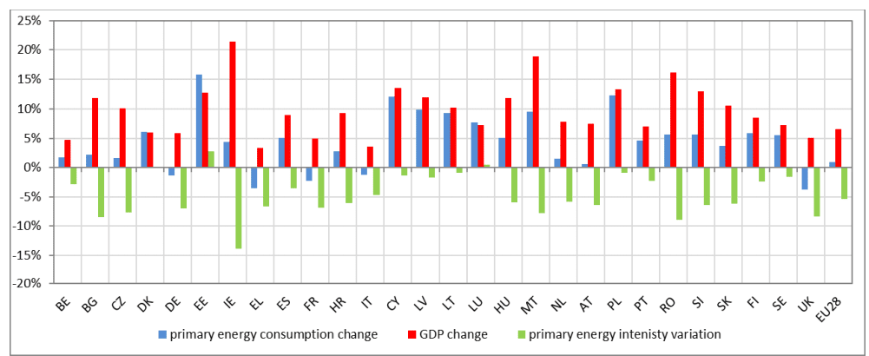
Figure 34: Changes in primary energy consumption, primary energy intensity and GDP between 2015-2018 (Source: Eurostat - 2020)

Renewable energy
In terms of progress towards national targets on the use of renewable energy, all Member States (except France) have met or exceeded their intermediate target 2018, while Croatia and Italy managed to achieve their renewable energy targets for 2020 set under the Renewable Energy Directive. Between 2005 and 2017, the largest increase in the share of renewable energy in gross final energy consumption was in Italy (+10.7 %). Renewable energy accounted for 30.7 % of gross final electricity consumption, 19.5 % of energy consumption for heating and cooling, and 7.6 % of transport fuel consumption in the EU.
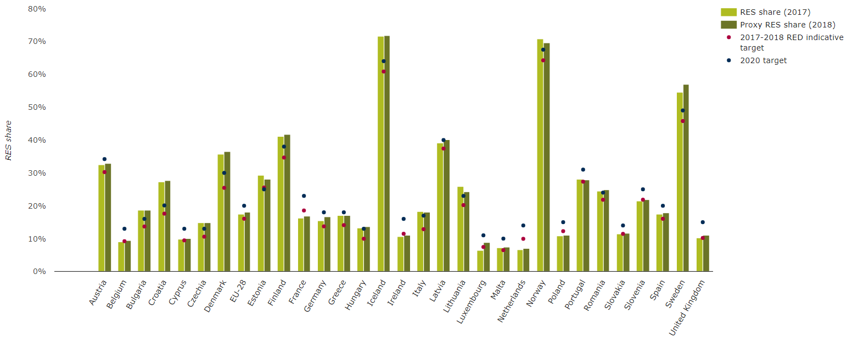
Figure 35: Progress towards renewable energy source targets by country (Source: EEA-2018)

Situation, trend and threats for the cooperation area in a scenario ‘without the programme’

In general, energy consumption decreased between 2005 and 2018 in the cooperation area, with some differences according to the sector (e.g. transport energy consumption increased) and country (Malta energy consumption increased). Renewable energy production and consumption have increased over the years, particularly thermal solar energy. In a scenario without the programme, the general trends are reported in the following table (bearing in mind the geographic variability of threats and vulnerabilities).

Indicator | State | Trends
Energy consumption
Renewable energy

Waste management
Waste production is a major source of pressure on the environment. It contributes to the overconsumption of natural resources and is a source of pollution for soil and water. Better waste management, such as recycling, lowers the cost of waste disposal and helps reduce the impact of economic activity on ecosystems.
Three main documents guiding waste management have been adopted at EU level. The Waste Framework Directive sets basic concepts and definitions related to waste management and lays down basic waste management principles. Commission Decision 94/3/EC establishes a list of waste, while Council Directive 1999/31/EC covers waste landfills.
Waste production and landfill
Countries in the cooperation area generally report low waste generation compared to other EU countries. Croatia and Montenegro are lowest in terms of waste generation, while Slovenia, Spain, Italy, and France are in the mid-range. Increases were seen in some territories between 2010 and 2016, e.g., Malta or Bulgaria, but the situation is not homogeneous as Greece and France reported a decrease in the same period.
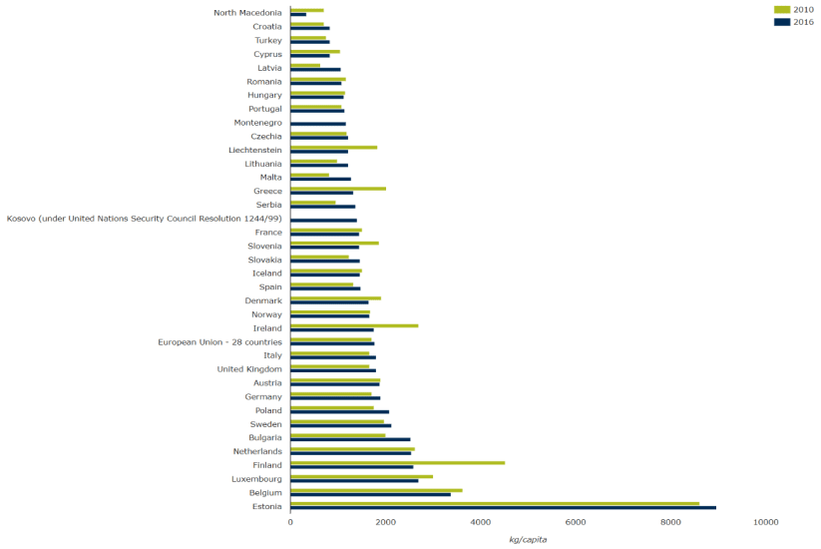
Figure 36: Waste generation (excluding mineral wastes) per capita in European countries between 2010 and 2016 (Source: EEA-2019)

Landfill is one of the most harmful options for waste disposal. Between 2010 and 2016, the share of landfill waste decreased from 29% to 25% (212 million tonnes to 188 million tonnes) in the EU. Landfill varies greatly in the cooperation area; in some countries it is low (e.g. France and Italy) while there are still many countries which a high share of their municipal waste in landfill. In the cooperation area landfill is still an issue for many countries. Bosnia-Herzegovina had 99% of its municipal waste in landfills, Malta reports 93%, while Cyprus and Greece landfill more than 80% of their waste. Croatia landfills 60%, and Spain and Portugal more than half.
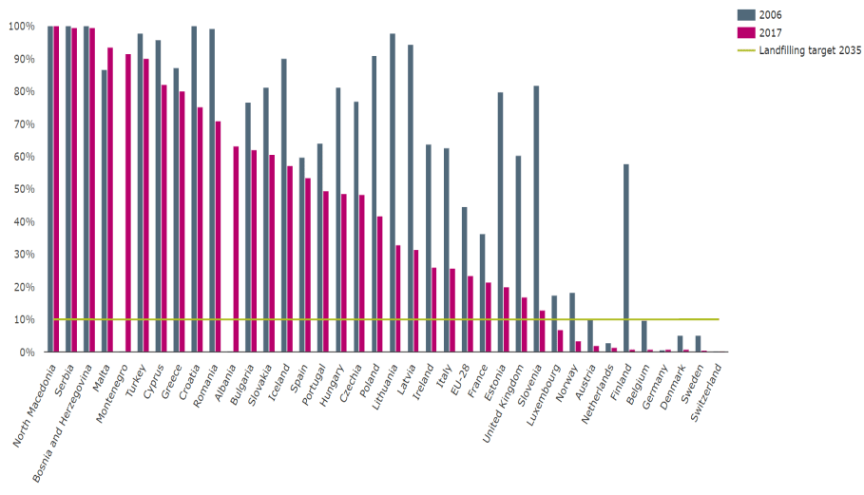
Figure 37: Municipal waste landfill rates in Europe by country, between 2006 and 2017 (Source: EEA - 2019)

Recycling

46% of all municipal waste in the EU was recycled or composted in 2017 (with a target to reuse and recycle at least 55% by 2025). In general, recycling of municipal and packaging waste has increased substantially. Between 2004 and 2017, recycling of municipal waste increased by 16% and packaging waste recycling increased 13% between 2005 and 2016. Although a large amount of municipal waste is being recycled, there is still a large difference between Member States that recycle and those that do not. Malta reports one of the lowest shares of municipal waste recycled and composted, with almost no change between 2004 and 2017. Cyprus, Greece, Portugal, Croatia, and Spain are also at the lower end of recycling. Slovenia and Italy made progress with 30% increases.

Figure 38: Municipal waste recycled and composted in Europe between 2004 and 2017 (Source: EEA - 2019)
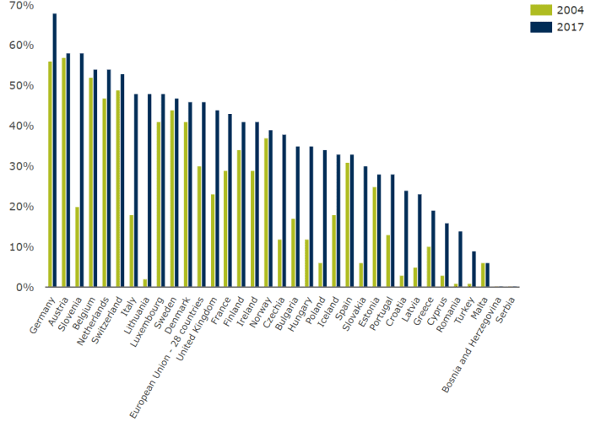

Packaging waste recycling saw similar trends, increasing from 54% (2005) to 67% (2016). There is also a difference between Member States in recycling rates, but that has reduced since 2005. Cyprus had the highest increase since 2005 with over 49% of its packaging waste being recycled. By 2016, most countries had reached the recycling target of 55%, except for Malta. Croatia, Portugal, Greece, Italy, France, and Spain are all recycling more than 55% of their packaging waste.

Situation, trend and threats for the cooperation area in a scenario ‘without the programme’

Waste production is still increasing in the EU (by 3% between 2010 and 2016), where households and manufacturing sectors generated the most. Malta reports a large increase in waste generation, whereas Greece had the largest decrease. The share of waste sent to landfills decreased in the EU (from 29% to 25%, between 2010 and 2016). However, countries in the cooperation area such as Malta, Bosnia-Herzegovina, Cyprus and Greece, still landfill more than 80% of their municipal waste. Recycling has increased in the EU, but differences between Member States are still large. Malta has one of the lowest percentages of municipal waste being recycled with Cyprus, Greece, and Croatia. In a scenario without the programme, the general trends are reported in the following table (bearing in mind the geographic variability of threats and vulnerabilities).

Indicator | State | Trends
Waste production
Landfill deposit
Recycling

Chapter 3 –Integration with other environment and sustainable development policies in the cooperation area

According to Annex I(e) of the SEA Directive the ER should analyse the synergies and complementarities between Euro-MED Programme with other key plans or strategies for the cooperation area that deal with environmental issues covered by the Programme strategy. Coherence with Euro-MED ‘Specific Objectives’ was analysed using a specific assessment matrix. External coherence analysis built on the list of documents drawn up by SEA experts and considered their transnational coverage (see list in the table below).

Table 6: EU and transnational policies and strategies for the programme area.
European policies and strategies
Title/name | Relevance with the cooperation area | Relevance with programme objectives
Green deal (climate objectives) | All Member States | Mitigation and adaptation to climate change
EU Biodiversity strategy for 2030 | All Member States | Tackle biodiversity issues at EU level
Circular economy actions plan | All Member States | More efficient use of natural resources and less pollution
Clean energy package | All countries | Energy security, renewable energy, energy efficiency
Clean air package | All Member States | Air quality and public health
Soil conservation and desertification strategies | All Member States | Soil fertility, contaminated soils, nutrients flows
European Union maritime security strategy (EUMSS) | All Member States | Environmental and maritime risks management
Agenda 2030 and Mediterranean Strategy for Sustainable Development (MSSD) 2016-2025 | All countries | 12 Sustainable development goals and targets identified for the Mediterranean region
Transnational policies and strategies relevant for the areas
Title/name | Relevance with the cooperation area | Relevance with programme actions
Strategic Programme for Mediterranean forests | All MS | Forest management, natural risks and biodiversity
Macro-Strategy for Adriatic and Ionian Region (EUSAIR) | Involving: Italy, Croatia, Greece, Albania (IPA), Montenegro (IPA) and Bosnia (IPA) | Blue economy, transport, environment and sustainable tourism
Macro-strategy for the Alpine Region | Involving: Italy, France and Slovenia | Sustainable management of energy, natural and cultural resources
Macro-strategy for the Danube Region (EUSDR) | Involving: Croatia, Slovenia, Bosnia (IPA), Bulgaria. | Environmental threats, transport, and energy issues
West-Med Initiative | Involving: France, Spain, Italy and Portugal | Blue economy, maritime security and risk management
Maritime agenda for the Black Sea (on-going) | Involving Bulgaria | Biodiversity management, waste and pollution management; transports
ENI CBC MED, ENI Italy-Tunisia, and ENI CBC Black sea | Involving: Portugal, Spain, France, Italy, Greece, Malta, Cyprus | Rural development, climate action and disaster resilience, energy and transport issues.

The coherence levels were established using a methodology developed specifically, based on the following criteria:
- CONTRAST (C): where the Programme strategy could potentially clash with local stakeholder interests or the Programme differs from strategic goals;
- NEUTRAL (N): where the Programme strategy and key plans have no common fields of interaction for target groups or objectives;
- COHERENT (S/O): where the Programme strategy and the key plans and strategies share similar strategic goals, actions and target groups.
In this section, the framework of policy and strategy at European level is presented for all environmental issues, along with coherence with the Programme. A final table synthesises the coherence analysis.

Coherence with the community-level policies

Biodiversity, Landscape and Cultural Heritage Policy Framework
The European framework on nature protection is stated by the EU Biodiversity strategy for 2030 (COM(2020) 380), whose main objective is ‘to put Europe's biodiversity on a path to recovery by 2030 and reverse the degradation of ecosystems for the benefit of people, climate and the planet by building our societies’ resilience to future threats such as climate change, forest fires, food security and disease outbreaks’. The Strategy set targets for different ecosystems:
- Agricultural land (‘Increasing organic farming and biodiversity-rich landscape features on agricultural land and reducing the use and risk of pesticides by 50% by 2030’);
- Forestry (‘Increasing the quantity of forests, by planting 3 billion trees by 2030, and improving their health and resilience, with stricter protection of remaining EU primary and old-growth forests’);
- Freshwater ecosystems (‘Restoring at least 25 000 km of EU rivers to a free-flowing state’);
- Sea (‘Protecting a minimum of 30% of the EU’s sea and maintain or reduce fishing mortality of marine resources at or under Maximum Sustainable Yield levels’).

Priority Axis | Specific Objectives | Interaction with the policy | Coherence results
Priority Axis 1:  Smarter MED | SO (i): Enhancing research and innovation capacities and the uptake of advanced technologies | No interaction found | N
Priority Axis 2:  Greener MED | SO (vi): Promoting the transition to a circular economy | No interaction found | N
Priority Axis 2:  Greener MED | SO (iv): Promoting climate change adaptation, risk prevention and disaster resilience | The enhancement of Europe's biodiversity may help to build resilience to future threats such as climate change (EU Biodiversity strategy for 2030) | S/O
Priority Axis 2:  Greener MED | SO (vii): Enhancing biodiversity, green infrastructure in the urban environment, and reducing pollution | Compatible with the EU Biodiversity strategy for 2030 | S/O
Priority Axis 3:  MED Governance | ISO (vi): Other actions to support better cooperation governance | No interaction found | N
Legend: S/O = Coherent, N = Neutral

Air quality and Climate change

On 11 December 2019, the Commission adopted the European Green Deal (COM(2019) 640) with the aim to transform the EU into a fair and prosperous society, with a modern, resource-efficient and competitive economy where there are no net emissions of greenhouse gases in 2050 and where economic growth is decoupled from resource use. The main targets concern:
- Reduction of greenhouse gas emissions (cut at least 40% from 1990 levels), by implementing the EU Emissions Trading System, the Effort Sharing Regulation with Member States' emissions reduction targets and the Land use, land use change and forestry Regulation;
- Increase adaptation to climate change, by strengthening efforts on climate-proofing, resilience building, prevention and preparedness;
- Invest in renewable energy (at least 32% share for renewable energy);
- Improve energy efficiency (at least 32.5% improvement).
On 4 March 2020, the Commission adopted the European Climate Law (COM(2020) 80), with the aim to reach the 2050 climate neutrality objective. The main targets are:
- Set the long-term direction of travel for meeting the 2050 climate-neutrality objective through all policies, in a socially fair and cost efficient manner, ensuring that the transition to climate neutrality is irreversible;
- Provide predictability for investors and other economic actors, by creating a business environment for industry and investors, with the pace of emission reductions mapped out from 2030 to 2050;
- Set up adaptation strategies and plans that include comprehensive risk management frameworks, based on robust climate and vulnerability baselines and progress assessments.
On 18 December 2013, the European Commission adopted the Clean Air Policy Package (COM(2013) 918), which proposes legislation to reduce harmful emissions in the longer term and at the same time promote measures which mitigate atmospheric warming and climate change. In particular, the package includes:
- The new Clean Air Programme for Europe with measures to ensure that existing targets are met in the short term, as are new air quality objectives up to 2030. The package also includes support to reduce air pollution, improve air quality in cities, as well as research, innovation and international cooperation;
- A revised National Emission Ceilings Directive with stricter national emission limits for six main pollutants;
- A proposal for a new Directive to reduce pollution from medium-sized combustion installations, such as energy plants for street blocks or large buildings, and small industry installations.
Furthermore, the Commission on 9 December 2020 adopted The Sustainable and Smart Mobility Strategy (COM(2020) 789), which aims to reach the following targets:
- Reach a sustainable and greening mobility, by developing efficient and interconnected multimodal transport for passengers and freight with infrastructure for zero-emission vehicles;
- Improve digitalisation and automation to further increase safety, security, reliability and comfort, thereby maintaining the EU’s leadership in transport equipment manufacturing and services;
- Ensure that the mobility will be accessible for everyone and that the sector offers good social conditions, reskilling opportunities, and provides attractive jobs.
Priority Axis | Specific Objectives | Interaction with the policy | Coherence results
Priority Axis 1:  Smarter MED | SO (i): Enhancing research and innovation capacities and the uptake of advanced technologies | Compatible with the Sustainable and smart mobility strategy | S/O
Priority Axis 2:  Greener MED | SO (vi): Promoting the transition to a circular economy | No interaction found | N
Priority Axis 2:  Greener MED | SO (iv): Promoting climate change adaptation, risk prevention and disaster resilience | Compatible with the European Climate Law and clean air policy strategy | S/O
Priority Axis 2:  Greener MED | SO (vii): Enhancing biodiversity, green infrastructure in the urban environment, and reducing pollution | Compatible with the Sustainable and smart mobility strategy and clean air policy package | S/O
Priority Axis 3:  MED Governance | ISO (vi): Other actions to support better cooperation governance | No interaction found | N
Legend: S/O = Coherent, N = Neutral

Clean energy package
On 25 February 2015, the Commission adopted the Energy Union Strategy (COM(2015) 80) which aims at secure, sustainable, competitive and affordable energy for EU consumers. The strategy focuses on energy security and efficiency, decarbonisation and creation of a European energy market as well as research, innovation and competitiveness. Since its launch in 2015, the European Commission has published several packages of measures and regular progress reports on implementation of the key priority.
On 11 December 2018, the Commission adopted Regulation (EU) 2018/1999 on the governance of the energy union and climate action, as part of the Clean energy for all Europeans package. The Regulation set targets involving:
- Energy efficiency, a revised target of energy use for 2030 of 32.5%, and a roadmap for renovation of the national stock of residential and non-residential buildings, both public and private;
- Renewable energy, an ambitious new target of at least 32% in renewable energy by 2030, with specific provisions to foster public and private investment;
- National Energy and Climate Plans (NECPs), a new energy rulebook and country-specific recommendations to achieve the 2030 targets on energy efficiency and renewable energy. The national plans should also include objectives and funding targets for public and, where available, private research and innovation relating to the Energy Union;
- Consumers, strengthened consumer rights and new rules for individuals to produce, store or sell their own energy easily;
- Internal Energy Market, new laws that will increase electricity interconnectivity. On energy security, the regulation aims to guarantee the security of supply by helping integrate renewables into the grid.
Priority Axis | Specific Objectives | Interaction with the policy | Coherence results
Priority Axis 1:  Smarter MED | SO (i): Enhancing research and innovation capacities and the uptake of advanced technologies | Compatible with the Energy union strategy | S/O
Priority Axis 2:  Greener MED | SO (vi): Promoting the transition to a circular economy | No interaction found | N
Priority Axis 2:  Greener MED | SO (iv): Promoting climate change adaptation, risk prevention and disaster resilience | Compatible with Regulation (EU) 2018/1999 on the governance of the energy union and climate action | S/O
Priority Axis 2:  Greener MED | SO (vii): Enhancing biodiversity, green infrastructure in the urban environment, and reducing pollution | Compatible with Regulation (EU) 2018/1999 on the governance of the energy union and climate action | S/O
Priority Axis 3:  MED Governance | ISO (vi): Other actions to support better cooperation governance | No interaction found | N
Legend: S/O = Coherent, N = Neutral

Circular economy
The new Circular Economy Action Plan (COM (2020) 98) contributes to restore biodiversity and natural capital in Europe, by promoting the circular economy. The Action Plan aims to ensure the sustainability of renewable bio-based materials and develop an Integrated Nutrient Management Plan, with a view to stimulating the markets for recovered nutrients. The main priorities of the Plan concern:
- Designing sustainable products, addressing the presence of hazardous chemicals in products, and increasing their energy and resource efficiency, and reducing (over)packaging and packaging waste, including by setting targets and other waste prevention measures;
- Combatting environmental crime notably in the areas of illegal exports and illicit trafficking, strengthen controls of shipments of waste, and improve the sustainable management of waste in third countries;
- Reducing carbon and environmental footprints, by developing modelling tools to capture the benefits of the circular economy on greenhouse gas emission reduction at EU and national levels;
- Empowering consumers and public buyers, incentivising product-as-a-service or other models where producers keep ownership of the product or responsibility for its performance throughout its lifecycle;
- Mobilising the potential of digitalisation of product information, including solutions such as digital passports, tagging and watermarks.
Priority Axis | Specific Objectives | Interaction with the policy | Coherence results
Priority Axis 1:  Smarter MED | SO (i): Enhancing research and innovation capacities and the uptake of advanced technologies | Compatible with the Circular Economy Action Plan | S/O
Priority Axis 2:  Greener MED | SO (vi): Promoting the transition to a circular economy | Compatible with the Circular Economy Action Plan | S/O
Priority Axis 2:  Greener MED | SO (iv): Promoting climate change adaptation, risk prevention and disaster resilience | Compatible with the Circular Economy Action Plan | S/O
Priority Axis 2:  Greener MED | SO (vii): Enhancing biodiversity, green infrastructure in the urban environment, and reducing pollution | The promotion of circular economy biodiversity may help to restore biodiversity and natural capital (Circular Economy Action Plan) | S/O
Priority Axis 3:  MED Governance | ISO (vi): Other actions to support better cooperation governance | No interaction found | N
Legend: S/O = Coherent, N = Neutral

Soil and desertification
The UN Convention to Combat Desertification (UNCCD) was adopted on 17 June 1994 by the Intergovernmental Negotiating Committee. It aims to combat desertification through international cooperation and partnership with a view to achieving sustainable development; to implement long-term integrated strategies that focus simultaneously on improved productivity of land, and the rehabilitation, conservation and sustainable management of land and water resources, leading to improved living conditions; and to encourage the use of existing financial mechanisms. In October 2015, the United Nations Convention to Combat Desertification (UNCCD) endorsed SDG target 15.3, which includes Land Degradation Neutrality, this can be achieved when the amount and quality of land resources necessary to support ecosystem functions and services and enhance food security remains stable or increases within specified temporal and spatial scales and ecosystems. The new UNCCD 2018-2030 Strategic Framework is the most comprehensive global commitment to Land Degradation Neutrality to restore the productivity of vast expanses of degraded land. The Framework sets strategic objectives which aim to restore land degradation, improve the living conditions of affected populations, enhance the resilience of vulnerable populations and ecosystems against the effects of drought, generate global environmental benefits through effective implementation of the UNCCD and build effective partnerships at global and national level.
The Soil Thematic Strategy was adopted by the European Commission in 2006 (COM(2006) 231), to protect soil while using it sustainably, through the prevention of further degradation, the preservation of soil function and the restoration of degraded soils. The strategy is based awareness raising, research, integration, and legislation. The Commission will update the EU Soil Thematic Strategy in 2021 to help to fulfil EU and international commitments on Land Degradation Neutrality.
Moreover, in May 2020 the Commission adopted the new EU Biodiversity Strategy for 2030 (COM(2020) 380, which also addresses land and soil degradation aiming to:
- Increase efforts to protect soil fertility and health, by reducing soil erosion and the overuse of nutrients, while increasing soil organic matter levels, through the adoption of sustainable soil management practices, such as organic farming;
- identify contaminated soil sites, restoring degraded soils, defining the conditions for their good ecological status, introducing restoration objectives, and improving the monitoring of soil quality. Moreover, the strategy will also promote the goal of zero pollution from nitrogen and phosphorus flows from fertilisers through reducing nutrient losses by at least 50%, while ensuring there is no deterioration in soil fertility.
Priority Axis | Specific Objectives | Interaction with the policy | Coherence results
Priority Axis 1:  Smarter MED | SO (i): Enhancing research and innovation capacities and the uptake of advanced technologies | No interaction found | N
Priority Axis 2:  Greener MED | SO (vi): Promoting the transition to a circular economy | No interaction found | N
Priority Axis 2:  Greener MED | SO (iv): Promoting climate change adaptation, risk prevention and disaster resilience | Compatible with the Soil Thematic Strategy and the EU Biodiversity Strategy for 2030 | S/O
Priority Axis 2:  Greener MED | SO (vii): Enhancing biodiversity, green infrastructure in the urban environment, and reducing pollution | Compatible with the Soil Thematic Strategy and the EU Biodiversity Strategy for 2030 | S/O
Priority Axis 3:  MED Governance | ISO (vi): Other actions to support better cooperation governance | Compatible with the Soil Thematic Strategy and the UN Convention to Combat desertification | S/O
Legend: S/O = Coherent, N = Neutral

Water and Marine ecosystems

The EU Water Framework Directive (2000/60/EC) is the cornerstone of EU water legislation. This Directive establishes a framework for the protection of surface waters and groundwater. It sets objectives to meet 'good status' for all waters by 2015. The Directive also requires Member States to establish river basin management. Developed in response to the requirements of Article 17 of the Water Framework Directive, the Groundwater Directive (2006/118/EC) is designed to specifically prevent and combat groundwater pollution. Other European regulations have an indirect impact on water bodies such as the Nitrates Directive (91/676/EEC), which aims at reducing nitrate and organic matter pollution from agricultural land, but also the Urban Waste Water Treatment Directive (91/271/EEC) aimed at reducing pollution from sewage treatment works and certain industries, the Integrated Pollution Prevention and Control Directive IPPC (96/61/EEC) aimed at controlling and preventing the pollution of water by industry and the Drinking Water Directive (98/83/EC).
The Marine Strategy Framework Directive (2008/56/EC) applies to marine waters. It provides a common framework for joined up governance of the marine environment and sets the overarching goal of achieving ‘Good Environmental Status’ (GES) by 2020 across Europe’s marine environment. Member States must establish monitoring programmes to regularly evaluate the status of their marine waters. Linked to this Directive, the 'New Bathing Water Directive' (2006/7/EC) concerning bathing water quality provides a more proactive approach to informing the public about water quality using quality categories for bathing waters from 'poor', to 'excellent'.
The European Union maritime security strategy (EUMSS) addresses maritime security challenges and aims to foster mutual support between Member States and enable joint security contingency planning, risk management, conflict prevention and crisis response and management. The Framework set strategic objectives to enhance capacity for conflict prevention and crisis response, prevent conflicts and incidents, mitigate risk and protect the EU´s marine environmental status, security at the Union's external borders, as well as critical maritime infrastructure.
The EU Maritime Security Strategy Action Plan puts the European Union Maritime Security Strategy (EUMSS 24 June 2014) into practice. The plan focuses on strengthening and supporting EU responses in the global maritime domain, developing a coordinated approach on maritime security issues in international context and with third countries, implementing the Common Information Sharing Environment (CISE) and enhancing maritime security research and innovation, education and training, capability development, risk management and protection of critical maritime infrastructure.
Priority Axis | Specific Objectives | Interaction with the policy | Coherence results
Priority Axis 1:  Smarter MED | SO (i): Enhancing research and innovation capacities and the uptake of advanced technologies | Compatible with the EU Maritime Security Strategy Action Plan | S/O
Priority Axis 2:  Greener MED | SO (vi): Promoting the transition to a circular economy | No interaction found | N
Priority Axis 2:  Greener MED | SO (iv): Promoting climate change adaptation, risk prevention and disaster resilience | The enhancement of maritime transport infrastructure may help to take appropriate adaptive actions and share best practices in order to mitigate natural and man-made disasters, including climate change (The European Union maritime security strategy) | S/O
Priority Axis 2:  Greener MED | SO (vii): Enhancing biodiversity, green infrastructure in the urban environment, and reducing pollution | Compatible with the EU Water Framework Directive and marine strategy framework directive | S/O
Priority Axis 3:  MED Governance | ISO (vi): Other actions to support better cooperation governance | Compatible with the European Union maritime security strategy | S/O
Legend: S/O = Coherent, N = Neutral

Agenda 2030 (MSSD) and UN Sustainable Development Goals
The Mediterranean Strategy for Sustainable Development (MSSD) 2016-2025, adopted by all Mediterranean countries at the 19th Meeting of the Contracting Parties to the Barcelona Convention (COP 19) in Athens, from 9-12 February 2016 (Decision IG.22/2), provides a policy framework to translate the 2030 Agenda for Sustainable Development and the SDGs at regional, sub-regional, national and local levels in the Mediterranean region. The strategic objectives are:
1. Ensure sustainable development in marine and coastal areas by protecting them from the unsustainable open ocean resource exploitation;
2. Promote resource management, food production and food security through sustainable rural development and the sustainable use, management and conservation of natural resources and ecosystem;
3. Plan and manage sustainable Mediterranean cities by enhancing urban resilience to reduce vulnerability to risks from natural and human-induced hazards including climate change;
4. Face climate change as a priority by Increasing scientific knowledge, raising awareness, and developing technical capacities;
5. Foster the transition towards a green and blue economy by encouraging environmentally friendly and social innovation;
6. Improve governance in support of sustainable development, by enhancing regional, sub-regional and cross-border dialogue and cooperation and promoting the engagement of stakeholders (civil society, scientists, local communities) in the governance process at all levels.

A specific analysis of coherence with each the SDGs is done in the table below.

Priority Axis | Specific Objectives | Interaction with the policy | Coherence results
Priority Axis 1:  Smarter MED | SO (i): Enhancing research and innovation capacities and the uptake of advanced technologies | Compatible with the MSSD | S/O
Priority Axis 2:  Greener MED | SO (vi): Promoting the transition to a circular economy | No direct interaction found | N
Priority Axis 2:  Greener MED | SO (iv): Promoting climate change adaptation, risk prevention and disaster resilience | The enhancement of ecosystem’s resilience may help to reduce vulnerability to risks from natural and human-induced hazards including climate change (MSSD) | S/O
Priority Axis 2:  Greener MED | SO (vii): Enhancing biodiversity, green infrastructure in the urban environment, and reducing pollution | Compatible with the MSSD | S/O
Priority Axis 3:  MED Governance | ISO (vi): Other actions to support better cooperation governance | Compatible with the MSSD | S/O
Legend: S/O = Coherent, N = Neutral

Table 7: Programme coherence with the sustainable development goals under Agenda 2030
Legend: S/O = Coherent, N = Neutral
UN Sustainable Development Goals | SO(i) Research/innovation | SO (iv) Circular economy | SO(vi)  Climate change | SO(vii)  Biodiversity/GI | ISO(vi)  Governance | Comment on intersection
GOAL 1: No Poverty | N | N | N | N | N | Even if no interaction was found, better governance could help address priorities such as poverty.
GOAL 2: Zero Hunger | N | N | N | N | N | Even if no interaction was found, a better waste management system plays a crucial role in the circular economy model, as it is strictly interconnected with production and consumption patterns.
GOAL 3: Good Health and Well-being | S/O | N | S/O | S/O | N | Accelerating innovation and technology transfer may help to increase good health and promoting prevention means better risk management and ensuring good health and quality of life for people.
GOAL 4: Quality Education | N | N | N | N | N | Even if no interaction was found, better governance could help address priorities such as quality education.
GOAL 5: Gender Equality | N | N | N | N | N | Even if no interaction was found, better governance could help to address priorities such as gender equality
GOAL 6: Clean Water and Sanitation | N | N | S/O | S/O | N | Promoting the restoration of water polluted environments may help to conserve natural functions of ground and surface water and protect drinking water supplies
GOAL 7: Affordable and Clean Energy | S/O | N | S/O | N | N | Promoting innovation and development potential may help to increase key intervention fields related to blue and green economies, such as clean energy. Moreover, the importance of energy transition may help to face climate change.
GOAL 8: Decent Work and Economic Growth | N | N | N | N | N | Even if no interaction was found, research and innovation may help to promote economic growth.
GOAL 9: Industry, Innovation and Infrastructure | S/O | S/O | N | S/O | N | Promote social Innovation and creative industries and at the same time finance energy transition, particularly climate-resilient and energy efficient infrastructures and buildings.
GOAL 10: Reduced Inequality | N | N | N | N | N | Even if no interaction was found, better governance could help address priorities such as the reduction of inequality.
GOAL 11: Sustainable Cities and Communities | S/O | S/O | S/O | S/O | N | Promoting the transition to a circular, greener and resilient economy may help to create sustainable societies and communities.
GOAL 12: Responsible Consumption and Production | S/O | S/O | N | N | N | Boost the competitive innovation ecosystem in multiple economy sectors for sustainable consumption and production activities.
GOAL 13: Climate Action | S/O | N | S/O | S/O | N | Promoting climate friendly innovations, social entrepreneurship and entrepreneurship in new sectors and those in transition and answering the central issue of climate change for the future of Mediterranean regions (accelerated warming)
GOAL 14: Life Below Water | N | N | N | S/O | N | Promoting the preservation of marine biodiversity and restoration of degraded marine environments
GOAL 15: Life on Land | N | N | S/O | S/O | N | Promoting the restoration of freshwater and degraded land, sustainable land use and soil protection and actions that support ecological connectivity of blue and green infrastructures, together with the support to connections between protected areas, including Natura 2000 sites
GOAL 16: Peace and Justice Strong Institutions | N | N | N | N | N | Even if no interaction was found, better governance could help to address priorities such as peace and justice and strong institutions
GOAL 17: Partnerships to achieve the Goal | N | N | N | N | S/O | Implementing mainstreaming strategies in local, regional, national and European policies in partnership with institutional coordination projects to improve coordination of specific policies at transnational level
Legend: S/O = Coherent, N = Neutral

Synthesis of the coherence of the Programme with policies at European level
The analysis revealed that Priority Axes, Strategic Objectives and associated actions address many environmental issues, as well as SDGs. These include climate change monitoring and adaptation, safeguards from natural and man-made disasters, biodiversity protection, marine water quality, and eco-innovation. In recent years, the Commission has adopted regulations, updated strategies and published reports to highlight the urgency of addressing climate change. The programme matches European and international policies and strategies on environmental and sustainability issues.

Coherence with strategic policies for the cooperation area

EU Strategy for the Adriatic and Ionian Region (EUSAIR)
EUSAIR focuses on the Adriatic and Ionian Seas and covers eight countries: four EU Member States (Croatia, Greece, Italy, Slovenia) and four non-EU countries (Albania, Bosnia and Herzegovina, Montenegro, Serbia). The Communication and Action Plan was adopted by the European Council in 2014. The Strategy incorporates the Maritime Strategy for the Adriatic and Ionian Seas adopted by the Commission on 30 November 2012. The general objective of the Strategy is to promote economic and social prosperity and growth in the region by improving its attractiveness, competitiveness and connectivity. It should also play an important role in promoting EU integration for the Western Balkans. The Action Plan indicates four pillars, each with its own specific objectives:
- Blue Growth:
- Promotion of research, innovation and business opportunities in blue economy sectors;
- Adaptation to sustainable seafood production and consumption;
- Improved sea basin governance.
- Connecting the Region:
- Strengthening maritime safety and developing a competitive regional intermodal port system;
- Developing reliable transport networks and intermodal connections, for freight and passengers;
- Achieving a well-interconnected and well-functioning internal energy market.
- Environmental Quality:
- Ensuring good environmental and ecological status of the marine and coastal environment by 2020;
- Contribution to the EU Biodiversity Strategy to halt the loss of biodiversity;
- Improved waste management.
- Sustainable Tourism
- Diversification of tourism products and services;
- Sustainable and responsible tourism management (innovation and quality).

Priority Axis | Specific Objectives | Interaction with the policy | Coherence results
Priority Axis 1:  Smarter MED | SO (i): Enhancing research and innovation capacities and the uptake of advanced technologies | Compatible with EUSAIR | S/O
Priority Axis 2:  Greener MED | SO (vi): Promoting the transition to a circular economy | Compatible with EUSAIR | S/O
Priority Axis 2:  Greener MED | SO (iv): Promoting climate change adaptation, risk prevention and disaster resilience | Compatible with EUSAIR | S/O
Priority Axis 2:  Greener MED | SO (vii): Enhancing biodiversity, green infrastructure in the urban environment, and reducing pollution | Compatible with EUSAIR | S/O
Priority Axis 3:  MED Governance | ISO (vi): Other actions to support better cooperation governance | Compatible with EUSAIR | S/O
Legend: S/O = Coherent, N = Neutral

West-Med initiative
The West-Med initiative is a strategy that covers ten countries: five EU Member States (France, Italy, Portugal, Spain, Malta) and five non-EU countries (Algeria, Libya, Mauritania, Morocco and Tunisia) and aims to help public institutions, academia, local communities, small and medium-sized enterprises and entrepreneurs to develop local and regional maritime projects together. The Framework for Action (SWD(2017) 130) main goals are:
- A safer and more secure maritime space
- Increased cooperation between coastguards, through training and staff exchange;
- Maritime safety and response to marine pollution, which includes improved data sharing on maritime traffic in the southern countries.
- A smart and resilient blue economy
- Promotion of strategic research and innovation;
- Development of a network of marine clusters;
- Skills development, through ad hoc training on sustainable blue growth;
- Sustainable consumption and production, for maritime transport, ports, maritime and costal tourism, marine aquaculture, promoting energy efficiency and adaptation to climate change.
- Improved maritime governance
- Improve the management of maritime, marine and coastal areas, through eco-friendly engineering solutions;
- Promote data collection, maintenance and storage of marine and maritime knowledge;
- Reduce marine biodiversity loss, by identifying and monitoring the main stressors, such as invasive species, acoustic pollution, and marine litter;
- Enhance marine habitat conservation through concrete actions, such as the establishment of marine protected areas;
- Promote the sustainable development of small-scale fisheries and coastal communities.

Priority Axis | Specific Objectives | Interaction with the policy | Coherence results
Priority Axis 1:  Smarter MED | SO (i): Enhancing research and innovation capacities and the uptake of advanced technologies | Compatible with the West-Med initiative | S/O
Priority Axis 2:  Greener MED | SO (vi): Promoting the transition to a circular economy | No direct interaction found | N
Priority Axis 2:  Greener MED | SO (iv): Promoting climate change adaptation, risk prevention and disaster resilience | The enhancement of maritime transport, ports and costal tourism may promote climate change adaptation in coastal cities (the West-Med initiative) | S/O
Priority Axis 2:  Greener MED | SO (vii): Enhancing biodiversity, green infrastructure in the urban environment, and reducing pollution | Compatible with the West-Med initiative regarding habitat conservation | S/O
Priority Axis 3:  MED Governance | ISO (vi): Other actions to support better cooperation governance | Compatible with the West-Med initiative | S/O
Legend: S/O = Coherent, N = Neutral

ENI CBC MED
ENI CBC MED is a Cross-Border Cooperation (CBC) initiative implemented by the EU under the European Neighbourhood Instrument (ENI). The Programme brings together the coastal territories of 14 EU and partner countries to foster fair, equitable and sustainable development on both sides of the EU’s external borders. The strategic framework of the Programme is based on 4 Thematic Objectives and 11 Priorities as a contribution to socio-economic and environmental challenges in the Mediterranean region, which are:
- SMEs and business development
- Support innovative start-ups, with a particular focus on young and women entrepreneurs;
- Strengthen and support Euro-Mediterranean networks, clusters, consortia and value-chains;
- Encourage sustainable tourism initiatives and actions.
- Technology transfer and innovation
- Support technological transfer and commercialisation of research results, strengthening links between research, industry and other private sector actors;
- Support SMEs in accessing research and innovation.
- Social inclusion and fight against climate change
- Provide young people and women with marketable skills;
- Support social and solidarity economic actors, also improving capacity and cooperation with public administrations for service provision.
- Environment and climate change
- Support sustainable initiatives targeting innovative and technological solutions to increase water efficiency and encourage the use of non-conventional water supply;
- Reduce municipal waste generation;
- Support cost-effective and innovative energy renovations for building types and climatic zones, with a focus on public buildings;
- Incorporate the Ecosystem-Based management approach to Integrated Coastal Zone Management into local development planning.
The cooperation area of the Italy-Tunisia ENI CBC Programme 2014-2020 spans the regions on both sides of the maritime route between Sicily and Tunisia. The Programme aims to improve business, education and research, technology and the environment in the regions concerned. The Programme focuses on business and SME development, support for education, research, technological development and innovation, and environment protection, climate change mitigation and adaptation. The ENI CBC Black sea programme aims to improve the welfare of the people in Black Sea basin regions through sustainable growth and joint environmental protection. In particular, it promotes economic and social development in regions on both sides of common borders in the Black Sea Basin area, addressing common challenges for the environment, public health, safety and security. The Programme focuses on business and SME development and environmental protection, as well as climate change mitigation and adaptation. The approach concerns ‘people to people’ cooperation, promotion of local and regional good governance, development of communication technologies and promotion of gender equality and opportunities for youth.
Priority Axis | Specific Objectives | Interaction with the policy | Coherence results
Priority Axis 1:  Smarter MED | SO (i): Enhancing research and innovation capacities and the uptake of advanced technologies | Compatible with ENI CBC MED, ENI CBC Italy-Tunisia and ENI CBC Black sea programmes | S/O
Priority Axis 2:  Greener MED | SO (vi): Promoting the transition to a circular economy | Compatible with ENI CBC MED | S/O
Priority Axis 2:  Greener MED | SO (iv): Promoting climate change adaptation, risk prevention and disaster resilience | The reduction of greenhouse gas emissions, and the promotion of renewable energy and energy efficiency may help to anticipate and mitigate the adverse effects of climate change (the ENI CBC MED). It is also compatible with ENI CBC Italy-Tunisia and ENI CBC Black sea programmes | S/O
Priority Axis 2:  Greener MED | SO (vii): Enhancing biodiversity, green infrastructure in the urban environment, and reducing pollution | Compatible with ENI CBC MED, ENI CBC Italy-Tunisia and ENI CBC Black sea programmes | S/O
Priority Axis 3:  MED Governance | ISO (vi): Other actions to support better cooperation governance | Compatible with ENI CBC MED and ENI CBC Black sea programmes | S/O
Legend: S/O = Coherent, N = Neutral

Strategic Programme for Mediterranean forests
This programme was approved in 2013 and includes nine strategic lines:
- Improve sustainable production of goods and services by Mediterranean forests;
- Enhance the role of Mediterranean forests in rural development;
- Promote forest governance and land tenure reforms at landscape level;
- Promote wildfire prevention in the context of global changes;
- Manage forest genetic resources and biodiversity to enhance adaptation of Mediterranean forest to climate change;
- Restore degraded Mediterranean forest landscapes;
- Develop knowledge, training and communication on Mediterranean forests;
- Reinforce international cooperation;
- Adapt existing financial schemes and develop innovative mechanisms to support implementation of forest policies and programmes.

Priority Axis | Specific Objectives | Interaction with the policy | Coherence results
Priority Axis 1:  Smarter MED | SO (i): Enhancing research and innovation capacities and the uptake of advanced technologies | Compatible with the Strategic Framework on Mediterranean forests | S/O
Priority Axis 2:  Greener MED | SO (vi): Promoting the transition to a circular economy | No interaction found | N
Priority Axis 2:  Greener MED | SO (iv): Promoting climate change adaptation, risk prevention and disaster resilience | Promoting resilience of forest ecosystems and other wooded lands in the Mediterranean may help facing climate change (the Strategic Framework on Mediterranean forests) | S/O
Priority Axis 2:  Greener MED | SO (vii): Enhancing biodiversity, green infrastructure in the urban environment, and reducing pollution | Compatible with the Strategic Framework on Mediterranean forests | S/O
Priority Axis 3:  MED Governance | ISO (vi): Other actions to support better cooperation governance | Compatible with the Strategic Framework on Mediterranean forests | S/O
Legend: S/O = Coherent, N = Neutral

Macro-Strategy for the Alpine Region
The EU Strategy for the Alpine Region involves 7 countries of which five are Member States (Austria, France, Germany, Italy, Slovenia), and two are non-EU (Liechtenstein and Switzerland). The Commission adopted a Communication (COM(2015) 366) and an Action Plan (SWD(2015) 147) on the EU Strategy for the Alpine Region on 28 July 2015. The Strategy has three specific objectives, followed by specific actions, as reported in the action plan:
- Ensure fair access to job opportunities:
- Development of a research and innovation system;
- Support to SMEs and e-services;
- Promotion of joint macro-regional activities to increase employment.
- Improve mobility and connectivity:
- Improve transport system, particularly for passenger and freight transport;
- Improve new connectivity technologies and promote accessibility for populations.
- Deal with environmental issues and promote renewable and reliable energy solutions:
- Promote the sustainable use of resources and at the same time protect water resources and cultural heritage;
- Develop ecological connectivity, through ecological corridors or green infrastructure;
- Increase the resilience to climate change, particularly natural risk prevention
- promoting energy efficiency and the production and use of renewable energy.
As a cross-cutting objective, the strategy aims to improve governance, particularly coordination across all decision-making levels.

Priority Axis | Specific Objectives | Interaction with the policy | Coherence results
Priority Axis 1:  Smarter MED | SO (i): Enhancing research and innovation capacities and the uptake of advanced technologies | Compatible with the EU Strategy for the Alpine Region | S/O
Priority Axis 2:  Greener MED | SO (vi): Promoting the transition to a circular economy | No interaction found | N
Priority Axis 2:  Greener MED | SO (iv): Promoting climate change adaptation, risk prevention and disaster resilience | Compatible with the EU Strategy for the Alpine Region | S/O
Priority Axis 2:  Greener MED | SO (vii): Enhancing biodiversity, green infrastructure in the urban environment, and reducing pollution | Compatible with the EU Strategy for the Alpine Region | S/O
Priority Axis 3:  MED Governance | ISO (vi): Other actions to support better cooperation governance | Compatible with the EU Strategy for the Alpine Region | S/O
Legend: S/O = Coherent, N = Neutral

Macro-Strategy for the Danube Region (EUSDR)

This is the largest and most diverse macro-regional strategy, involving 14 countries: nine EU Member States (Austria, Bulgaria, Croatia, Czech Republic, parts of Germany, Hungary, Romania, Slovakia, Slovenia), three Accession Countries (Bosnia and Herzegovina, Montenegro, Serbia) and two Neighbouring Countries (Moldova, parts of Ukraine). The Danube Strategy was adopted on 8 December 2010 (COM(2010) 715), followed by an Action Plan (COM(2010) 715). The Action Plan was completely revised and published on 6 April 2020 (SWD(2020) 59). The strategy intends to develop coordinated policies and actions, reinforcing the commitments of Europe 2020 towards smart, sustainable and inclusive growth, based on four pillars:

- Connecting the region
- Sustainable energy (promote energy efficiency and renewable energy);
- Improve mobility (Raid-Road-Air and waterway);
- Promote sustainable tourism and protect Danube cultural heritage.
- Protecting the environment
- Increase water quality;
- Reduce environmental risk;
- Protect biodiversity and landscapes, increase air and soil quality.
- Building prosperity
- Support exchange of information and promote cooperation to stimulate excellence in research and innovation;
- Increase the competitiveness of enterprises;
- Promote knowledge, skills and competences.
- Strengthening the region
- Improve institutional capacities;
- Promote law enforcement and security.
Priority Axis | Specific Objectives | Interaction with the policy | Coherence results
Priority Axis 1:  Smarter MED | SO (i): Enhancing research and innovation capacities and the uptake of advanced technologies | Compatible with EUSDR | S/O
Priority Axis 2:  Greener MED | SO (vi): Promoting the transition to a circular economy | No interaction found | N
Priority Axis 2:  Greener MED | SO (iv): Promoting climate change adaptation, risk prevention and disaster resilience | Compatible with EUSDR | S/O
Priority Axis 2:  Greener MED | SO (vii): Enhancing biodiversity, green infrastructure in the urban environment, and reducing pollution | Compatible with EUSDR | S/O
Priority Axis 3:  MED Governance | ISO (vi): Other actions to support better cooperation governance | Compatible with EUSDR | S/O
Legend: S/O = Coherent, N = Neutral

Maritime agenda for the Black Sea
The Common Maritime Agenda for the Black Sea is a sea basin initiative, involving seven countries: two EU Member States (Bulgaria and Romania) and five non-EU countries (Georgia, Republic of Moldova, Russian Federation, Republic of Turkey and Ukraine). The initiative aims at supporting regional cooperation for a more sustainable blue economy in the Black Sea and is developed in the broader framework of the Black Sea Strategy. The main goals concern protection of the marine ecosystem, promotion of the blue economy and investments in the Black Sea blue economy. Each goal is structured in priorities, which are:
- Goal I – Ensure healthy marine and coastal ecosystems:
- Ensure protection of marine ecosystems, by restoring the Black Sea ecosystem and promoting joint monitoring;
- Address marine pollution and plastic litter;
- Support sustainable fisheries and aquaculture in the Black Sea;
- Promote marine research infrastructure in the Black Sea.
- Goal II – Promote the blue economy:
- Foster business models, stimulate marine and maritime research and innovation;
- Promote transport and digital connectivity of the Black Sea;
- Promote blue skills and blue careers.
- Goal III - Fostering Investment in the Black Sea blue economy:
- Improve access to financial resources and promote sustainable investment in the blue economy;
- Promote maritime entrepreneurship and clusters.

Priority Axis | Specific Objectives | Interaction with the policy | Coherence results
Priority Axis 1:  Smarter MED | SO (i): Enhancing research and innovation capacities and the uptake of advanced technologies | Compatible with the Common Maritime Agenda for the Black Sea | S/O
Priority Axis 2:  Greener MED | SO (vi): Promoting the transition to a circular economy | No interaction found | N
Priority Axis 2:  Greener MED | SO (iv): Promoting climate change adaptation, risk prevention and disaster resilience | Compatible with the Common Maritime Agenda for the Black Sea | S/O
Priority Axis 2:  Greener MED | SO (vii): Enhancing biodiversity, green infrastructure in the urban environment, and reducing pollution | Compatible with the Common Maritime Agenda for the Black Sea | S/O
Priority Axis 3:  MED Governance | ISO (vi): Other actions to support better cooperation governance | Compatible with the Common Maritime Agenda for the Black Sea | S/O
Legend: S/O = Coherent, N = Neutral

Result of the coherence analysis at cooperation level

The following table presents a synthesis of the previous individual analysis. It describes the relation between specific strategies or plans addressing the main environmental issues at different levels and the Priority Axes of the Programme. Therefore, these Strategies/Plans might be in synergy with the priority axes or there might be a neutral relation since they do not explicitly address any objectives of the Priority Axes of the Programme.
The external coherence analysis demonstrated that the Programme is very coherent with other strategies at EU and international level in the cooperation area.

Table 8: Coherence with WestMed and EUSAIR
Environmental topic | LEVEL | DOCUMENT | P1 – Smarter MED | P2 – Greener MED | P3 – MED Governance | Strategic environmental priorities for the Programme area
Climate change | Mediterranean | WestMed | N | S/O | S/O | - Mitigation and adaptation to expected climate changes;  - Promote nature-based solutions for climate change challenges;  - Promote adaptation in key vulnerable sectors.
Climate change | Region of Adriatic and Ionian SEAs | EUSAIR | N | S/O | S/O
Inland Ecosystems | Mediterranean | WestMed | N | S/O | N | - Contribution to the EU Biodiversity Strategy goal to halt the loss of biodiversity;  - Restore degraded ecosystems and their associated services;  - Protect and preserve the diversity of species.
Inland Ecosystems | Region of Adriatic and Ionian SEAs | EUSAIR | N | S/O | N
Marine Ecosystem | Mediterranean | WestMed | S/O | S/O | S/O | - Ensuring a good environmental and ecological status of the marine and coastal environment;  - Foster business models, stimulate marine and maritime research and innovation;  - Prevent further deterioration, protect and improve the state of coasts and terrestrial and wetland ecosystems that depend directly on aquatic ecosystems.
Marine Ecosystem | Region of Adriatic and Ionian SEAs | EUSAIR | S/O | S/O | S/O
Water quality and supply | Mediterranean | WestMed | N | S/O | N | - Monitoring of water resources;  - Minimise pollution and hazards in the water;
Water quality and supply | Region of Adriatic and Ionian SEAs | EUSAIR | N | S/O | N
Air quality | Mediterranean | WestMed | N | S/O | N | - Reduce emissions into the atmosphere;  - Ensure ongoing improvements in air quality to avoid damage to heritage, natural ecosystems;  - Obtain air quality that does not give rise to significant negative impacts and reduce risks to human health and the environment.
Air quality | Region of Adriatic and Ionian SEAs | EUSAIR | S/O | S/O | N

Table 9: Coherence with Alpin Space, Danube region and Black Sea strategies
Environmental topic | LEVEL | DOCUMENT | P1 – Smarter MED | P2 – Greener MED | P3 – MED Governance | Strategic environmental priorities for the Programme area
Climate change | Alpine region | The EU Strategy for the Alpine Region | N | S/O | S/O | - Accelerating the shift towards a low-carbon economy;  - Promoting climate change adaptation, risk prevention and disaster resilience;  - Supporting integrated planning and financing schemes for climate change adaptation and resilience, including increased cooperation of local, regional and national authorities.
Climate change | Danube region | Macro-Strategy for the Danube Region | N | S/O | S/O
Climate change | Black Sea | Common Maritime Agenda for the Black Sea | S/O | S/O | N
Climate change | Black Sea | ENI Black sea | S/O | S/O | N
Inland Ecosystems | Alpine region | EU Biodiversity Strategy for 2030 | N | S/O | N | - Develop ecological connectivity, through ecological corridors or green infrastructure;  - Preservation and restoration of ecosystems and biodiversity;  - Promote services provided by forests for the protection of biodiversity and encourage research and valorisation of biodiversity;  - Implementation of management plans to preserve ecosystem services.
Inland Ecosystems | Danube region | Macro-Strategy for the Danube Region | N | S/O | S/O
Inland Ecosystems | Black Sea | Common Maritime Agenda for the Black Sea | S/O | S/O | N
Marine Ecosystem | Alpine region | The EU Strategy for the Alpine Region | N | N | N | - Ensure the protection of marine ecosystems, by restoring marine ecosystems and promoting joint monitoring programme;  - Address marine pollution and plastic litter;  - Promote adequate maintenance of coastal and marine biodiversity in the Mediterranean region;  - Foster business models, stimulate marine and maritime research and innovation.
Marine Ecosystem | Danube region | Macro-Strategy for the Danube Region | N | N | N
Marine Ecosystem | Black Sea | Common Maritime Agenda for the Black Sea | S/O | S/O | N
Marine Ecosystem | Black Sea | The European Union maritime security strategy | N | N | S/O
Soil quality and land use | Alpine region | The EU Strategy for the Alpine Region | N | S/O | N | - Improve and/or maintain the soil quality and enhance and/or maintain soil-related ecosystem services;  - Strengthen soil protection and sustainable land use.
Soil quality and land use | Danube region | Macro-Strategy for the Danube Region | N | S/O | N
Soil quality and land use | Danube region | UNCCD Strategic Framework | N | S/O | S/O
Soil quality and land use | Black Sea | Common Maritime Agenda for the Black Sea | N | N | N
Air quality | Alpine region | The EU Strategy for the Alpine Region | N | S/O | N | - Reduce emissions into the atmosphere;  - Promote decarbonisation and reduction of air pollutants in the transport sector;  - Take measures to gradually reduce air pollution, as a minimum step to respect limits for pollutants.
Air quality | Danube region | Macro-Strategy for the Danube Region | S/O | S/O | N
Air quality | Black Sea | Common Maritime Agenda for the Black Sea | N | N | N
Water quality | Alpine region | Mediterranean Strategy for Sustainable Development | N | S/O | N | - Promote water use efficiency and ensure smart water use;  - Promote monitoring, prevention and reduction of water pollution deriving from hazardous and emerging substances;  - Enhance cooperation, increase and exchange knowledge and secure financing to water quality measures;  - enhancing waste water treatment and promoting best management practices.
Water quality | Danube region | Macro-Strategy for the Danube Region | S/O | S/O | S/O
Water quality | Black Sea | Common Maritime Agenda for the Black Sea | N | S/O | N
Landscape and cultural heritage | Alpine region | The EU Strategy for the Alpine Region | N | S/O | N | - Support and promote cultural tourism;  - Promote and encourage the development of the cultural activities and creative sectors;  - Support the implementation of a harmonised monitoring system dedicated to sustainable tourism and cultural/natural heritage;  - Investments in valorisation of cultural and natural heritage.
Landscape and cultural heritage | Danube region | Macro-Strategy for the Danube Region | S/O | S/O | N
Landscape and cultural heritage | Black Sea | Common Maritime Agenda for the Black Sea | N | S/O | N
Energy | Alpine region | EU Strategy for the Adriatic and Ionian Region | N | S/O | N | - Apply potential clean renewable energy production (i.e. with low or no emissions);  - Increase energy independence;  Ppromote energy efficiency and use of renewable energy;  - Improve energy efficient, cost efficient and innovative low-carbon technologies, including smart solutions;  - Research in marine renewable and alternative energy.
Energy | Alpine region | The EU Strategy for the Alpine Region | S/O | S/O | N
Energy | Danube region | Macro-Strategy for the Danube Region | S/O | S/O | N
Energy | Black Sea | Common Maritime Agenda for the Black Sea | S/O | S/O | N
Waste management | Alpine region | The EU Strategy for the Alpine Region | S/O | S/O | N | - Improve financing, operation and technology of wastewater infrastructure and services;  - Promote waste reduction practices in production and food supply;  - Raise awareness of waste reduction.
Waste management | Danube region | Macro-Strategy for the Danube Region | S/O | S/O | N
Waste management | Black Sea | Common Maritime Agenda for the Black Sea | S/O | S/O | N
Legend: S/O = Coherent, N = Neutral

Chapter 4 - Environmental protection objectives
According to the SEA directive, the Environment Report takes account of ‘the environmental protection objectives, established at international, Community or Member State level, which are relevant to the plan or programme and the way those objectives and any environmental considerations have been taken into account during its preparation’.
The selection of environmental objectives relevant for the Cooperation Programme has been based on the characteristics of the cooperation area, the legislative framework at EU level and the Coherence Analysis performed in Chapter 3. The objectives have been aggregated by environmental theme.
The Environmental objectives will constitute the basis for assessment of possible effects. According to the Context Analysis (Chapter 2) and the Coherence Analysis (Chapter 3), some of the Environmental Objectives are a priority for the cooperation area (i.e. being common threats for all countries in the Mediterranean area, with large territorial and time scales and with a high priority in the political agenda at EU level). This will be considered in attributing significance to the possible environmental effects during further assessment.

Table 10: Environmental objectives
Environmental issues | Priority | Topic | General environmental objectives
Climate change and associate risks | X | GHG emission | Reduce GHG emissions
Climate change and associate risks | X | Adaptation | Reduce flood risks
Climate change and associate risks | X | Adaptation | Reduce risks linked to coastal erosion
Climate change and associate risks | X | Adaptation | Reduce risks of desertification
Air quality |  | Air pollution | Improve air quality
Water quality and supply |  | Water quality | Improve or maintain underground, surface and bathing water quality
Water quality and supply |  | Water use | Reduce pressures on fresh water
Inland ecosystem | X | Inland Biodiversity | Protect and preserve the diversity of species
Inland ecosystem | X | Inland Natural resources | Restore degraded ecosystems and their associated services
Marine ecosystem | X | Marine Biodiversity | Protect and preserve the diversity of species
Marine ecosystem | X | Marine Natural resources | Improve or maintain costal water quality
Marine ecosystem | X | Marine Natural resources | Reduce the pressures on natural resources
Soil quality and use |  | Soil quality | Remediate contaminated soils and lands
Soil quality and use |  | Soil management | Improve efficiency in soil and land management
Technological risks |  | Risks prevention | Prevent technological risks
Health and Sanitary risks and nuisances |  | Human health protection | Reduce chemical pollution and its effect on health
Health and Sanitary risks and nuisances |  | Human health protection | Decrease noise pollution
Health and Sanitary risks and nuisances |  | Human health protection | Reduce electromagnetic pollution
Natural and cultural heritage and Landscape |  | Landscape and cultural heritage | Preserve landscape and cultural heritage
Energy |  | Renewable | Promote renewable energies
Energy |  | Efficiency | Improve energy efficiency
Waste management |  | Production | Reduce the production of waste
Waste management |  | Recycling | Promote recycling and reuse

Chapter 5 – Likely significant effects on the environment

Methodology for assessment
The Directive requires the evaluation of significant effects on the environment that are likely from actions implemented by the CP. The evaluation must consider direct and indirect impacts, their probability, scale, frequency, duration, reversibility, the cumulative nature of their effects and their transnational dimension.
Analysis of these effects involves three steps.
- Firstly, environmental objectives identified are matched with the proposed actions and eligible activities of the CP;
- In a second step, the SEA experts combined this table with an estimation of effect intensity weighted by the characteristic of each effect. This gives a scale of intensity for positive and negative effect as illustrated in the table below.

Table 11: Scale for measuring positive and negative effects
Positive | Effect intensity | Negative
++ | Very significant | --
+ | Significant | -
? | Unknown | ?
n.s. | No significant effects | n.s.
Legend:
++ = very significant positive effects; -- = very significant negative effects
+ = significant positive effects; - = significant negative effects
ne = no effects; n.s. = no significant effects; ? = unknown effect
- Thirdly, the information is organised to assess the cumulative and cooperation effects (cross-border, maritime and transnational) of each action planned by the CP. The cumulative impacts will be ordered by environmental theme and evaluated considering all causal relationships impacting that theme.

Interactions between the programme and environmental objectives

General assessment
According to the Interreg goals, actions planned for the territorial cooperation objective are much more related to networking, planning and information sharing than infrastructural investments with significant direct and well documented effects on environment. In the current programme strategy, few interventions concern infrastructure and equipment and many are “immaterial” and should have indirect effects (see table below). These are often based on policy decisions made in or outside the cooperation area which are at this stage unknown (especially strategies or action plans where implementation depends on many external factors).

Table 12: Typology of potential effects
Interventions under ERDF | Potential environmental effects and time horizon | Euro-med planned interventions
Investment in infrastructure and equipment | Direct, local, certain, non-reversible.  Short to long term | Large infrastructure is excluded; small scale investments and infrastructures not excluded in SO (i) and SO (vi)
Support for innovation projects, pilots | Indirect, local, non-reversible  Medium, long term | Few pilots (equipment) or infrastructure (at small scale) not excluded in SO (i) and SO (vi)
Research, training, dissemination and communication | Indirect, intangible, non-local, reversible  Short, medium | Many interventions planned in all SOs
Strategy and action plan | Indirect, intangible, non-local, reversible  Medium, long term | Many interventions planned in all SOs
Networking, cooperation and exchange of experience and best practices | Indirect, intangible, non-local, reversible  Short, medium | Many interventions planned in all SOs

Environmental effect of priority axes
Results shown in the table below highlights that some environmental issues are not affected by the Programme, such as air quality, soil or noise. There is, however, a major focus on climate change, biodiversity, natural maritime resources, waste and energy. No negative effect has been identified at this stage.
PRIORITY 1 – Smarter MED
The SO (i) is devoted to enhancing research and innovation capacities and the uptake of advanced technologies in the cooperation area. The planned interventions range from strategic design to development of innovative solutions and networking between public and private institutions. Sectoral coverage is extensive and includes the blue and green economy, manufacturing, transport, tourism, the cultural and creative industry and others. Target groups are SMEs, private organisations, universities, NGOs and LRAs. Most of the interventions should have ‘intangible’ outputs, with ‘indirect’ and ‘reversible’ effects on the environment. Small investments are not excluded. Actions planned under priority 1 should impact GHG emissions, air quality, waste production, as well as water and energy consumption.
However, even if the general objective is to promote an ‘innovative sustainable economy’, an environmental assessment of this SO is not straightforward. In general, innovation could imply less pressure on resources with increased resource efficiency in production and consumption, but it is clearly true only with the green economy and explicit sustainable solutions. In that sense, actions promoting ‘climate friendly innovation’ should contribute directly to reducing GHG emissions and fossil fuel consumption (this explains the ‘+’ in the table). Interventions dealing with ‘value chain development’, or ‘technology transfer’ have unknown effects as do actions on ‘changing tourism practices’ and promoting ‘smart tourism’. If the actions improve tourism quality (in terms more sustainability) this could reduce the existing impact, otherwise this is not guaranteed (i.e. an intervention increasing tourism could have negative effects on resource use and ecosystems).
PRIORITY 2 – Greener MED
The three specific objectives under priority 2 contribute directly to the environmental objectives of the cooperation area. The objectives are clearly consistent with the EU ‘Green deal’, with a specific focus on the circular economy (SO vi), climate change (SO iv) and biodiversity management (SO vii). The provisional financial allocation to priority 2 accounts for 70% of the budget.
Specific objective (vi) promotes the circular economy in the cooperation area. Actions are devoted to improving waste management and resource efficiency, including waste reduction (e.g. plastic), eco-innovation and efficient water consumption. The sectors concern mainly agriculture, food and fisheries, manufacturing and tourism. Potential positive direct impacts are expected in terms of less waste, increased recycling, less chemical pollution (through reuse and recovery), decreased pressure on fresh water and natural resources in general, as well as less GHG emissions (but this is ‘indirect’ and not directly mentioned in the actions taken). Some positive impacts are also expected on energy efficiency and air quality, but these are ‘not certain’ as they depend on the technology.
Specific objective (iv) promotes climate change adaptation, risk prevention and disaster resilience. The interventions are broad, including coastal erosion, forest protection, sea level rising, desertification, energy transition and renewable energy, freshwater ecosystems and carbon transport. Actions cover planning, monitoring, capacity building, ITC solutions, networking and other supporting activities involve environmental and energy authorities and organisations as well as NGOs, SMES and research centres. Potential direct impacts are expected on risk management capacity development, as well as an improved water quality, energy efficiency and promotion of renewable energy. Some lesser effects are also expected in terms of soil and land management (forest protection and soil restoration in agriculture).
Interventions under specific objective (vii) are dedicated to the conservation and preservation of biodiversity, consolidating ecosystem connections and improving the management of natural resources. Targets groups include environmental authorities, managers of protected areas, public and private authorities, research centres and universities, as well as NGOs, citizens and SMEs. Expected direct positive effects are mostly on inland and maritime ecosystems, as well as the preservation and valorisation of landscape and cultural heritage. Other lesser effects are also expected in terms of better soil management efficiency and air quality through green infrastructure in urban areas.
PRIORITY 3 - MED Governance
Interventions planned under specific objective ISO1 should support the decision-making process, promote networking and enhance capacity building for public and private organisations in the cooperation area. Even though supporting capacity building of public institutions is a precondition for implementing sustainable development policies in the long term, actions under priority 3 have no clear expected environmental effects.

Table 13: Expected environmental effects from Euro-MED CP
Environmental issues | Environmental objectives | SO (i) | SO (vi) | SO (iv) | SO (vii) | ISO (vi)
Climate change and associate risks | Reduce GHG emissions | + | n.s | ++ | n.e | n.e
Climate change and associate risks | Reduce flooding risks | n.e | n.e | + | n.s | n.e
Climate change and associate risks | Reduce risks linked to coastal erosion | n.e | n.e | + | n.s | n.e
Climate change and associate risks | Reduce risks of desertification | n.e | n.e | + | n.s | n.e
Air quality | Improve air quality | ? | ? | n.e | n.s | n.e
Water quality and supply | Improve or maintain underground, surface and bathing water quality | n.e | n.e | + | n.s | n.e
Water quality and supply | Reduce pressure on fresh water | ? | + | n.e | n.e | n.e
Inland ecosystem | Restore degraded ecosystems and their associated services | n.e | n.e | n.e | + | n.e
Inland ecosystem | Protect and preserve the diversity of species | n.e | n.e | n.e | + | n.e
Marine ecosystems | Improve or maintain costal water quality | ? | n.e | n.e | n.e | n.e
Marine ecosystems | Protect and preserve the diversity of species | n.e | n.e | n.e | + | n.e
Marine ecosystems | Reduce pressure on natural resources | ? | n.s | + | + | n.e
Soil quality and use | Remediate contaminated soils and lands | n.e | n.e | n.s. | n.e | n.e
Soil quality and use | Improve efficiency in soil and land management | n.e | n.e | n.e | n.s. | n.e
Technological risks | Prevent technological risks | n.e | n.e | n.e | n.e | n.e
Health and Sanitary risks and nuisances | Reduce chemical pollution and its effect on health | n.e | + | n.e | n.e | n.e
Health and Sanitary risks and nuisances | Decrease noise pollution | n.e | n.e | n.e | n.e | n.e
Health and Sanitary risks and nuisances | Reduce electromagnetic pollution | n.e | n.e | n.e | n.e | n.e
Natural and cultural heritage - Landscape | Preserve landscape and cultural heritage | n.e | n.e | n.e | + | n.e
Energy | Promote renewable energy | n.e | n.e | + | n.e | n.e
Energy | Reduce energy consumption and improve energy efficiency | ? | ? | + | n.e | n.e
Waste management | Reduce waste | ? | + | n.e | n.e | n.e
Waste management | Promote recycling and reuse | ? | + | n.e | n.e | n.e

Environmental cumulative and transnational effects
According to the methodological approach, cumulative effects have been assessed.
Climate change and related risks | Cumulative effect
Climate change and related risks | ++
Relevance to the cooperation area
Climate change is of primary importance for the cooperation area, especially adaptation to floods, desertification and sea level rise. All territories involved in the Programme are affected by climate change and are adapting their policies to minimise the consequences.
Cumulative effects
The main effects of the OP on climate change are first order effects on environmental objectives for climate adaptation and GHG reduction. Effects on energy efficiency and renewable energy (first order) are also considered as energy consumption is a major cause of GHG emissions. Biodiversity and natural resources (both inland and marine) through ecological services are important tools for climate change adaptation (second order). Similarly, air quality can contribute to global warming, through atmospheric pollutants (second order). Since water quality and management, soil use and waste management can contribute to biodiversity and ecosystem conservation they are included in the cumulative effect (third order).
The resulting cumulative effect is very positive. In addition to the effects directly related to the climate change objectives, mainly from SO (iv), a relevant contribution comes from positive effects (second and third order) on inland and marine ecosystems from SO (vii).
Transnational and sea-basin effects
Climate change is a classic example of a transnational issue. Wherever the issue originates its consequences are widely distributed across the cooperation area and beyond. GHG reduction efforts will have global effects. Risks linked to climate change impact common environmental components and areas with no consideration for man-made boundaries. So, it is crucial to contemplate adaptation objectives using cooperation instruments, such as the instruments planned by the Interreg Programme Euro-MED.
Synergies, complementarities with other programmes and policies
To strengthen its positive impact, the Programme strategy should build on synergies with other strategies and policy instruments: WESTMED, EUSAIR, Strategic Programme for Mediterranean forests (SPMF), EUSAR, MSDR, CMABS. It worth noting that the search for synergies is one of the gaols of objective ISO (vi).

Inland and Marine ecosystems | Cumulative effect
Inland and Marine ecosystems | ++
Relevance to the cooperation area
The cooperation area is almost entirely included in the Mediterranean biogeographical area with very diverse landscapes and ecosystems, both inland and maritime. A few regions are included also in the biogeographical regions Continental, Alpine and covering a portion of the Black-sea. It hosts much of Europe’s biodiversity in terms of habitat and species. The natural environment in the area is threatened by various factors, mostly human pressure (such as tourism and costal settlements) and climate change. These increase the risk of costal erosion, floods and droughts. Cooperation tools for managing natural resources need to be enforced.
Cumulative effects
The very significant positive effect on natural resources results mainly from effects on marine ecosystems and inland biodiversity (SO (vii)) on which the progamme acts decisively (first order). Second order effects are on climate change adaptation (SO (iv)) and, to a lesser extent, on soil and landscape that contribute to the maintenance and recovery of natural inland and marine ecosystems. It worth noting that the cumulative effects on ecosystems from tourism are not well known at this stage. Negative effects are not completely excluded which could balance expected positive effects in specific territories.
Transnational effects
The marine ecosystem is shared by almost all countries and regions in the Programme and is characteristic of this cooperation area (excepted for North Macedonia). On the other hand, the transnational nature of inland ecosystems relates to the ecological services it provides (e.g. cardon sequestration). In addition, several sectors such as tourism, which could affect biodiversity and natural resources, are transnational by nature. The Programme promotes coordination in activities and sectors such as innovation and tourism, which strongly influence biodiversity.
Synergies, complementarities with other programmes and policies
To strengthen its positive impact, the Programme strategy should build on synergies with other strategies and policy instruments: WESTMED, EUSAIR, ENI-MED CBC, Strategic Programme for Mediterranean forests (SPMF), EUSAR (on inland ecosystems), MSDR (only inland ecosystems), CMABS. It worth noting that the search for synergies is one of the gaols of objective ISO (vi).

Water | Cumulative effect
Water | +
Relevance for the cooperation area
Water is a strategic resource in the cooperation area. Quality and availability of water have a different status in the different regions and countries.
Cumulative effects
The cumulative effects on water are expected to be positive, mainly from SO (vi) (circular economy) and (iv) (climate change), and from second and third order effects on related environmental issues (climate change risk management and waste management). It worth noting that a possible negative effect from tourism is not excluded but is not known at this stage. Minor positive effects on soil quality (second order effects) have also been considered.
Transnational effects
Considering the geographical distribution of Regions and Countries involved in the Programme, the physical sharing of inland water resources (such as joint management of a river basin) is limited (e.g., between France and Spain, or Spain and Portugal). Nevertheless, effects on water resources could also have large-scale consequences, confirming the transboundary nature of this issue, when considering for example the Danube basin.
Synergies, complementarities with other programmes and policies
To strengthen its positive impact, the Programme strategy should build on synergies with other strategies and policy instruments with similar objectives: WESTMED, EUSAIR, ENI-MED CBC, EUSAR (on inland ecosystems), MSDR (only inland ecosystems), CMABS. It worth noting that the search for synergies is one of the gaols of objective ISO (vi).

Air | Cumulative effect
Air | n.s.
Relevance for the cooperation area
Air quality in the area is not homogeneous and the main area has high emissions, especially particulates. Critical situations are where the cooperation area is densely populated (urban areas) and linked to major international communication axes.
Cumulative effects
The cumulative effect on air quality is mainly from SO(i) and SO(vi) which could contribute to a direct reduction of atmospheric pollutants (first order effect) and through SO(iv) which promotes GHG reduction, energy efficiency and renewable energy (second order effects). Also, the reduction of waste production has been taken into account (second order), while inland and marine ecosystem have been considered for their mitigation of pollution (second order).
Transnational effects
Actions on a limited administrative scale could have local effects, whereas cooperation and networking on, for example, the environmental sustainability of marine and coastal transport, will have real transnational effects. All in all, the effects are positive but not significant in the cooperation area and the contribution from the Programme to air quality is second order
Synergies, complementarities with other programmes and policies
To strengthen its positive impact, the Programme strategy should build on synergies with other strategies and policy instruments with similar objectives: EUSAR, MSDR; to which the SO ISO (iv) could contribute.

Landscape and Cultural Heritage | Cumulative effect
Landscape and Cultural Heritage | +
Relevance for the cooperation area
The cooperation area hosts natural and cultural hotspots whose value has been recognised by UNESCO. The area also has landscape fragmentation, due to many built-up areas along the coast, and the problem has increased in recent years. Nevertheless, landscape and cultural heritage are key for development of the area.
Cumulative effects
To preserve landscape and cultural heritage an important role is played by adaptation measures and actions to tackle natural risks (second order effects, mainly from SO(iv)). These tend to minimise any adverse impact on heritage assets and settings. Direct effects of the Programme on preserving landscape and cultural heritage are also considered. Landscapes are the exterior form of natural and human systems, so actions to conserve natural ecosystems (SO(vii)) will contribute to the quality of the landscape. At this stage of programming, the potential effects from tourism are not well known. An increase could negatively affect fragmentation of coasts in some areas through the development of new settlements. This need to be prevented.
The cumulative effect is positive and significant (excluding potential but unlikely negative impacts from tourism)
Transnational effects
Landscape and cultural heritage are by definition in particular areas or locations. Nevertheless they can be affected, also positively, by transnational activities, primarily tourism.
Synergies, complementarities with other programmes and policies
To strengthen its positive impact, the Programme strategy should build on synergies with other strategies and policy instruments with similar objectives: EUSAR, MSDR, CMABS. It worth noting that the search for synergies is one of the gaols of objective ISO (vi).

Soil | Cumulative effect
Soil | +
Relevance for the cooperation area
The cooperation area presents criticality concerning soil, especially soil sealing from urban development and contamination from industry and agriculture.
Cumulative effects
The Programme does not focus on soil protection, and the effects are limited to specific actions. Major contributions to the significant positive effect on soil come from SO(vii), with a direct contribution (first order); and SO(vii) on climate change risks (second order). Positive contributions also come from action on landscape protection (second order effect).
Transnational effects
Some aspects of soil quality, such as the release of nutrients and erosion, are transborder. In addition, soil is strongly influenced by human activity such as agriculture. The Programme does not emphasise soil in the objectives.
Synergies, complementarities with other programmes and policies
To strengthen its positive impact, the Programme strategy should build on synergies with other strategies and policy instruments with similar objectives: EUSAR, MSDR. It worth noting that the search for synergies is one of the gaols of objective ISO (vi).

Waste and energy | Cumulative effect
Waste and energy | ++
Relevance for the cooperation area
Controlling and reducing waste and fossil energy consumption are at the heart of EU strategies for a circular economy, energy and air quality packages and the Green Deal. There is widely varying cooperation, with hot spots in terms of waste production and landfilling. However, the general trend is for more recycling. Energy consumption has decreased, and the development of renewable energy is reported in the whole cooperation area, but the dependence on fossil energy sources remains high.
Cumulative effects
The contribution of the Programme to the circular and low carbon economy is high. The main contribution comes from SO(vi) through reduced chemical pollution and waste production, and from SO(vii) with positive effects on energy consumption and renewable energy. A positive contribution (second order) is also expected from SO(i), through specific innovation and research projects, but this needs to be confirmed during implementation.
Transnational effects
Waste management and the development of renewable energy is transnational by nature and supported by EU and international policies. Plastic litter is a common issue for all countries in the Mediterranean area.
Synergies, complementarities with other programmes and policies
To strengthen its positive impact, the Programme strategy should build on synergies with other strategies and policy instruments with similar objectives in the area: WESTMED, EUSAIR, EUSAR, MSDR and CMABS. It worth noting that the search for synergies is one of the gaols of objective ISO (vi).

Health | Cumulative effect
Health | +
Relevance for the cooperation area
Health and sanitary risks are a threat in the Programme area, especially in hot spots of atmospheric pollution. Health can be considered extensively, including the safety of the population (e.g. exposure to natural hazards).
Cumulative effects
The overall contribution of the Programme to health issues is positive but not very significant. SOs play a role in the cumulative effect with positive contributions to a general improvement of environmental condition, mostly second and third order. The main contribution comes from SO(vi) through reduced chemical pollution, and from SO(iv) with positive effects on climate change adaptation improving life conditions (second order) and all SOs contributing to marine ecosystem quality (third order) . A positive contribution on air quality (second order) is expected from SO(vi).
Transnational effects
Health could be considered a transnational issue because it is strongly influenced by environmental quality.
Synergies, complementarities with other programmes and policies
To strengthen its positive impact, the Programme strategy should build on synergies with other strategies and policy instruments with similar objectives in the area. It worth noting that the search for synergies is one of the gaols of objective ISO (vi).

Chapter 6 - Elements for an Appropriate assessment of Natura 2000 sites

According to Annex I(d) of the SEA Directive, the assessment should consider ‘any existing environmental problems which are relevant to the plan or programme including those relating to any areas of a particular environmental importance, such as areas designated pursuant to Directives 147/2009/CE and 92/43/EEC’.
An overview of the Natura 2000 Network is presented in Figure 38 (a list of Natura 2000 sites in the cooperation area is provided in a separate file).

Figure 39: Natura 2000 sites in the cooperation area (Source: Consortium).
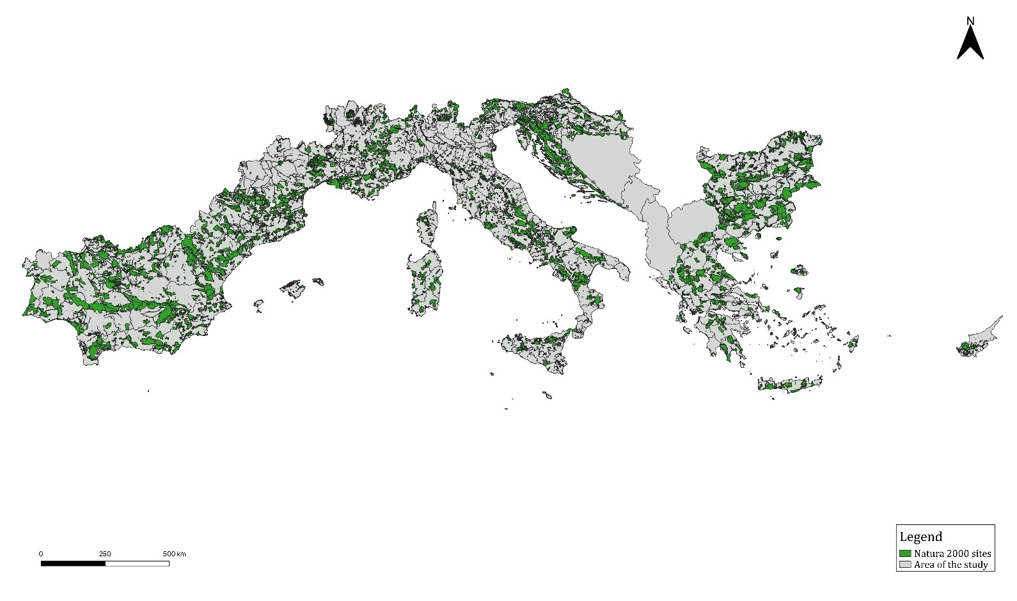

This section underlines the absence of significant effects the Programme could have on Natura 2000 sites and on habitats and species protected under the Birds Directive and the Habitats Directive. At this stage of programming, an in-depth assessment is not possible as the Programme covers a broad area and does not define local actions. However, the Programme still has interactions with Natura 2000 areas, in particular protected habitats.
As a consequence, the analysis has been carried out through:
- relevance check of the ‘elements of influence’ for the Continental and Mediterranean Regions;
- analysis of the interaction between habitat aggregations and Programme SOs;
- analysis of the possible incidence of habitat deterioration and disturbance of species.
As a first step, the main influences on biodiversity for Continental, Alpine, Black Sea and Mediterranean Regions have been extracted from the literature. Results are presented in Table 18, where the existence and relevance in the cooperation area is also signalled, according to the following scale:
- Priority for the whole area: the context or coherence analysis have signalled the issues as relevant or critical for the whole cooperation area;
- Priority for hot spots: even if previous analysis have not identified a broad criticality for the issue, there are hot spots in the cooperation area where the influence is relevant;
- Not critical: the influence is not a priority for the cooperation area.

Table 14: Element of influence for Mediterranean, Black-Sea, Continental and Alpine Regions
Element of influence | Continental Region | Mediterranean Region | Alpine Region | Black Sea  Region | Priority for the cooperation area
 | Main influences
Climate change | X | X | X | X | Priority for the whole area
Urbanization and tourism |  | X | X | X | Priority for all coastal areas
Economic use of species | X | X |  |  | Not critical
Agriculture, including vineyards | X |  |  |  | Priority for hot spots
Agriculture, with irrigation, grazing and abandonment |  | X | X |  | Priority for hot spots
Forestry | X |  | X |  | Priority for hot spots
Freshwater fishing | X |  |  |  | Not critical
Hunting | X | X | X | X | Priority for hot spots
 | Other important influences
Infrastructure | X | X |  |  | Priority for hot spots
Intensive use of rivers | X |  |  | X | Priority for hot spots
Contaminants | X | X | X | X | Priority for hot spots
Alien Species and vegetation succession | X | X | X | X | Priority for hot spots
Deforestation, afforestation, forest fire |  | X | X |  | Priority for hot spots
Exploitation of wetlands |  | X |  |  | Priority for hot spots
Mining and quarrying | X | X | X | X | Priority for hot spots
Climate change, as previously underlined, is a key element for the cooperation area, especially in terms natural risks. The Programme invests resources to address climate change effects and promote adaptation. Land use (urbanisation, infrastructure, agriculture, forestry) is distributed differently in different regions, so it is relevant only for hot spots. Tourism is relevant for the entire area, especially coastlines, while the intensive use of rivers (for example the Po basin) for contaminants and other environmental elements is not the same for all regions in the cooperation area (the economic use of species and freshwater fishing don’t appear relevant for the Programme).
As a second step, considering each element, there is an analysis of the interaction between habitat aggregations, species and Programme SOs. The two following tables illustrates the type of vulnerability for habitats and species in the cooperation area.

Table 15: Vulnerability of priority habitats in the cooperation area
Habitat | Priority habitat | Biogeographical region | Vulnerability
Coastal and halophytic habitats | 1120 Posidonia beds  1150 Coastal lagoons  1340 Inland salt meadows  1510 Mediterranean salt steppes (Limonietalia)  1520 Iberian gypsum vegetation (Gypsophiletalia)  1530 Pannonic salt steppes and salt marshes  1630 Boreal Baltic coastal meadows | Marine Mediterranean, Black Sea, Mediterranean, Alpine, and Continental | Changes in water body conditions. Grazing by livestock. Vegetation succession. Roads, railroads, and paths. Afforestation. Invasive alien species. Mining and quarrying.
Coastal sand dunes and inland dunes | 2130 Fixed coastal dunes with herbaceous vegetation ("grey dunes"  2140 Decalcified fixed dunes with Empetrum nigrum  2150 Atlantic decalcified fixed dunes (Calluno-Ulicetea)  2250 Coastal dunes with Juniperus spp.  2270 Wooded dunes with Pinus pinea and/or Pinus pinaster  2340 Pannonic island dunes | Mediterranean, and Continental | Invasive alien species. Vegetation succession. Air pollution. Grazing by livestock. Urbanisation and human settlement.
Freshwater habitats | 3170 Mediterranean temporary ponds  3180 Turloughs | Mediterranean, Alpine, and Continental | Mining and quarrying. Pollution of groundwater. Changes in water body conditions.
Temperate heath and scrub | 4020 Temperate Atlantic wet heaths with Erica ciliaris and Erica tetralix  4070 Bushes with Pinus mugo and Rhododendron hirsutum (Mugo-Rhododendretum hirsuti)  40A0 Subcontinental peri-Pannonic scrub  40C0 Ponto-Sarmatic deciduous thickets | Black Sea, Mediterranean, Alpine, and Continental | Sport and leisure infrastructures. Vegetation succession. Changes in water body conditions. Modification of cultivation practices.
Sclerophyllous scrub (Matrorral) | 5140 Cistus palhinhae formations on maritime wet heaths  5220 Arborescent matorral with Zyziphus  5230 Arborescent matorral with Laurus nobilis | Mediterranean, and Continental | Roads, railroads, and paths. Outdoor sports, leisure, and recreational activities. Agricultural cultivation. Fertilisation in agriculture. Invasive alien species. Urbanisation and human settlement
Natural and semi-natural grassland formations | 6110 Rupicolous calcareous or basophilic grasslands of the Alysso-Sedion albi  6120 Xeric sand calcerous grasslands  6220 Pseudo-steppe with grasses and annuals of the Thero-Brachypodietea  6230 Species-rich Nardus grasslands, on siliceous substrates in mountain areas (and submountain areas, in Continental Europe)  62B0 Serpentinophilous grasslands of Cyprus  6240 Sub-Pannonic steppic grasslands  6250 Pannonic loess steppic grasslands  6260 Pannonic sand steppes  6270 Fennoscandian lowland species-rich dry to mesic grasslands  6280 Nordic alvar and Precambrian calcareous flatrocks  62C0 Ponto-Sarmatic steppes  6530 Fennoscandian wooded meadows | Black Sea, Mediterranean, Alpine, and Continental | Vegetation succession. Grazing by livestock. Mining and quarrying. Fertilisation in agriculture.
Raised bogs and mires and fens | 7110 Active raised bogs  7210 Calcareous fens with Cladium mariscus and species of the Caricion davallianae  7220 Petrifying springs with tufa formation (Cratoneurion)  7240 Alpine pioneer formations of Caricion bicoloris-atrofuscae  7310 Aapa mires  7320 Palsa mires | Black Sea, Mediterranean, Alpine, and Continental | Air pollution. Vegetation succession. Pollution to surface waters. Fertilisation in agriculture. Grazing by livestock
Rocky habitats and caves | 8160 Medio-European calcareous scree of hill and montane levels  8240 Limestone pavements | Mediterranean, Alpine, and Continental | Mining and quarrying. Roads, railroads, and paths. Invasive alien species. Grazing by livestock.
Forests | 9010 Western Taiga  9020 Fennoscandian hemiboreal natural old broad-leaved deciduous forests (Quercus, Tilia, Acer, Fraxinus, or Ulmus) rich in epiphytes  9040 Nordic subalpine/subarctic forests with Betula pubescens ssp. Czerepavonii  9050 Fennoscandian herb-rich forests with Picea abies  9080 Fennoscandian deciduous swamp woods  9180 Tilio-Acerion forests of slopes, screes and ravines  91AA Eastern white oak woods  91D0 Bog woodland  91E0 Alluvial forests with Alnus glutinosa and Fraxinus excelsior (Alno-Padion, Alnion incanae, Salcion albae)  91G0 Pannonic woods with Quercus petraea and Carpinus betulus  91H0 Pannonian woods with Quercus pubescens  91I0 Euro-Siberian steppic woods with Quercus spp.  91S0 Western Pontic beech forests  9210 Apennine beech forests with Taxus and Ilex  9220 Apennine beech forests with Abies alba and beech forests with Abies nebrodensis  9370 Palm groves of Phoenix  9390 Scrub and low forest vegetation with Quercus alnifolia  9510 Southern Apennine Abies alba forests  9530 (Sub-) Mediterranean pine forests with endemic black pines  9560 Endemic forests with Juniperus spp.  9570 Tetraclinis articulata forests  9580 Mediterranean Taxus baccata woods  9590 Cedrus brevifolia forests (Cedrosetum brevifoliae) | Black Sea, Mediterranean, Alpine, and Continental | Sport and leisure infrastructure. Grazing by livestock, Fire and fire suppression. Forest exploitation, forest and plantation management and use. Roads, railroads, and paths.

Table 16: Threats for animal and plant species relevant for the cooperation area
Groups | Biogeographical region
MAMMALS. 1352 Canis lupus, 1354 Ursus arctos, 1356 Mustela lutreola, 1362 Lynx pardinus, 1367 Cervus elaphus corsicanus, 1374 Rupicapra pyrenaica ornata  Threats: Habitat loss and degradation have the largest impact on both threatened and non-threatened terrestrial mammal species. Human disturbance, accidental mortality (vehicle collisions). Hunting and collection of terrestrial wild animals. Roads, railroads, and paths. Other changes to ecosystems. Invasive alien species. Changes in water body ecosystems. Interspecific faunal relations. | Black Sea, Mediterranean, Alpine, and Continental
REPTILES. 1296 Macrovipera schweizeri, 4007 Natrix natrix cypriaca, 7007 Dolichophis cypriensis  Threats: Habitat loss, fragmentation, and degradation have the largest impact on both threatened and non-threatened reptiles. As well as harvesting, deliberate persecution, and pollution. Modification of cultivation practices. | Mediterranean
AMPHIBIANS. 1169 Salamandra aurorae, 1186 Proteus anguinus, 1187 Alytes muletensis, 1199 Pelobates fuscus insubricus  Threats: Habitat loss is the most significant threat, pollution and invasive alien species also threaten this group. Invasive alien species include fishes, fungal diseases, and pathogens. Roads, railroads, and paths. Interspecific faunal relations. Changes in water body conditions. Modification to farming practices. | Mediterranean, Alpine, and Continental
FISH. 1100 Acipenser naccarii, 1101 Acipenser sturio, 1117 Ladigesocypris ghigii, 1153 Valencia hispanica, 1992 Valencia letouneuxi | Mediterranean and Continental
INVERTEBRATES. 1080 Carabus olympiae, 1084 Osmoderma eremita, 1087 Rosalia alpine, 1093 Austropotamobius torrentium, 4010 Armadillidium ghardalamensis, 4024 Pseudogaurotina excellens, 4039 Nyphalis vaualbum, 4061 Lampedusa melitensis, 5378 Osmoderma barnabita, 6199 Eupalgia quadripunctaria  Threats: Habitat loss and fragmentation. Many are sensitive to modifications of their environment, such as in overgrazing and changes in forestry practice, agricultural intensification. Hunting and collection of terrestrial wild animals. Forest and plantation management and use. Fire and fire suppression. Changes in water body conditions. Invasive alien species. Pollution to surface waters. Interspecific faunal relations. Problematic native species. | Black Sea, Mediterranean, Alpine, and Continental
PLANTS. 1142 Salicornia veneta, 1388 Bryoerythrophyllum campylocarpum, 1390 Marsupella profunda, 1431 Abies nebrodensis, 1432 Globularia stygia, 1433 Hypericum aciferum, 1452 Silene rothmaleri, 1459 Silene holzmannii, 1461 Silene hicesiae, 1463 Silene orphanidis, 1465 Silene velutina, 1467 Gysophila paillosa, 1470 Arenaria nevadensis, 1472 Aquilegia pyrenaica subsp. Cazorlensis, 1475 Aconitum corcisum, 1476 Ranculus wyleri, 1478 Consolida samia, 1485 Diplotaxis siettiana, 1487 Jonopsidium acaule, 1488 Coronopus navasii, 1490 Coincya rupestris, 1494 Brassica macrocarpa, 1531 Ribes sardoum, 1546 Cysisus aeolicus, 1548 Astragalus maritimus, 1552 Vicia bifoliolate, 1555 Astragalus verrucosus, 1558 Astragalus aquilanus, 1568 Erodium rupicola, 1570 Erodium astragaloides, 1572 Linum mulleri, 1575 Euphorbia margalidiana, 1584 Daphne rodriguezii, 1595 Tuberaria major, 1598 Lythrum flexuosum, 1599 Laserpitium longiradium, 1600 Naufraga balearica, 1603 Eryngium viviparum, 1605 Bupleurum capillare, 1606 Bupelurum kakiskalae, 1611 Seseli intricatum, 1619 Apium bermejoi, 1627 Primula apennina, 1634 Limonium insulare, 1642 Limonium pseudolaetum, 1643 Limonium strictissimum, 1644 Armeria rouyana, 1646 Armeria helodes, 1655 Centaurium rigualii, 1661 Galium littorale, 1662 Galium viridiflorum, 1663 Convolvulus argyrothamnus, Convolvulus fernadesii, 1668 Lithodora nitida, 1672 Syphytum cycladense, 1674 Anchusa cripsa, 1682 Thymus lotocephalus, 1684 Nepeta sphaciotica, 1695 Thymus camphoratus, 1707 Atropa baetica, 1713 Linaria ricardoi, 1717 Linaria tursica, 1718 Linaria hellenica, 1719 Linaria ficalhoana, 1732 Veronica oetaea, 1751 Campanula sabatia, 1760 Carduus myriacanthus, 1765 Artemisia granatensis, 1766 Anthemis glaberrima, 1768 Lamyropsis microcephala, 1772 Centaurea citricolor, 1776 Centaurea kalambakensis, 1778 Centaurea lactiflora, 1780 Centaurea niederi, 1782 Centaurea pinnata, 1786 Crepis crocifolia, 1790 Leontodon siculus, 1791 Centaurea horrida, 1794 Centaurea balearica, 1799 Centaurea peucedanifolia, 1800 Jurinea fontiqueri, 1802 Aster pyrenaeus, 1804 Senecio elodes, 1806 Centaurea attica subsp. Megarensis, 1840 Asphodelus bento-rainhae, 1842 Androcymnium rechingeri, 1858 Narcissus nevadensis, 1872 Borderea chouardii, 1880 Stipa veneta, 1883 Stipa austroitalica, 1897 Carex panormitana, 1901 Cephalanthera cucullate, 1905 Ophrys lunulate, 2092 Delphinium caseyi, 2103 Arabis kennedyae, 2131 Astragalus marocarpus subsp. Lefkarensis, 2227 Pinguicula crystallina, 2250 Centaurea akamantis, 2283 Chionodoxa lochiae, 2296 Scilla morrisii, 4079 Cremnophyton lanfrancoi, 4083 Helichrysum melitense, 4085 Palaeocyanus crassifolius, 6194 Iberis runemarkii, 6197 Centaurea heldreichii, 6198 Centaurea princeps, 6217 Heriinaria litardierei, 6231 Onois maweana, 6281 Leopoldia gussonei, 6282 Klasea lycipifolia, 6351 Degenia velebitica, 6947 Euphrasia nana, 6955 Eokochia Saxicola, 6994 Tripolium sorrentinoi, 6999 Clinopodium taygeteum, 7009 Ophrys kotschyi subsp. kotschyi  Threats: intensified livestock farming, and especially overgrazing has the worst impact. Plant species are affected through livestock eating them or due to trampling. Habitat loss and fragmentation due to conversion of grasslands into agricultural land for livestock, arable farming, or forestry. Recreational activities such as hiking, mountaineering, or walking are the second biggest factor. Invasive alien species. Many plant species are very attractive and therefore collected for their beauty. Urban and tourism development creates transport infrastructure expansion of urban environments. Mining and quarrying. Fires. Droughts. Climate change. Pollution. | Mediterranean, Alpine, and Continental

The key aspects are the following:
- SO (iv) promotes the circular economy, reducing the possible impact on water pollution and in terms of wastes production should contribute to reducing pressure on coastal and halophytic habitats. In addition, through the circular economy, the reduction in water consumption could reduce water harvesting reducing pressure on freshwater habitats, raised bogs, mires and fens and, possibly, on some types of forest.
- The SO (vi) focuses on adaptation to climate change through improved resilience. Even if the actions are not directly addressed in biodiversity management, they could contribute to less climate change impact on natural resources, including habitat and species of interest.
- SO (vii) is devoted to biodiversity protection, with a particular focus on Natura 2000 sites. The objective is to promote an ecosystem-based approach for the management of natural resources and improved the connection and enlargement of protected areas in land and sea. It does include mainly intervention on planning, monitoring, knowledge, and networking with positive consequences on habitat and species conservation. In particular, a contribution to habitat conservation is expected for coastal and halophytic habitats, coastal sand dunes and inland dunes and freshwater habitats from the actions related to ‘strengthening land-sea interaction – supporting ecological corridors in different landscape’.
As a third step and according to the general Commission guidance document on the management of Natura 2000 sites, Programme incidences are analysed in terms of deterioration of habitat and disturbance of species. The appropriate factors have been taken into account for each of these.

Table 17: Possible incidences on Natura 2000 sites
Topics | Factors | Assessment result
Deterioration of habitats | Natural range and area covered by the habitat | No reduction of habitat is expected. Programme does not include actions on land use change or infrastructure realisation
Deterioration of habitats | Specific structure and functions of the area necessary for its long-term maintenance | No interference with habitat structure or function is expected
Deterioration of habitats | Conservation status of typical species | No direct interference with the conservation status of species is expected.
Disturbance of species | Population dynamics | No event which could contribute to the long-term decline of species populations is expected
Disturbance of species | Natural range of the species | No direct interference with the natural range of species is expected. Indirect interference from tourism cannot be excluded.
Disturbance of species | Availability of habitat for the species | No reduction of habitats is expected
The Programme has mainly immaterial actions that do not interact directly with habitat or species. Actions on networking, sharing of best practices, monitoring and knowledge of natural resources could contribute to habitat and species conservation. The only potential interference could be from tourism, as a transversal priority for the Programme. Increased tourism in natural areas protected under Natura 2000 network could disturb species. Nevertheless, the actions listed in the SOs are towards sustainable tourism, so impacts are unlikely. Adequate measures during implementation could prevent any risk.
Conclusion
An accurate estimate of the Programme impact on the Natura 2000 network is not straightforward without precise information on actions and project locations, however significant negative impacts are not expected. The nature and scope of SOs and relative actions should exclude, at this stage, negative impacts on Natura 2000 habitats and species. To ensure biodiversity preservation in 2000 Natura sites, introducing eco-conditionality criteria in project selection is recommended. To go through the selection process, projects should demonstrate they have no significant effects on any Natura 2000 site. In addition, introducing specific criteria could help to avoid disturbance to protected species. This will require to not promote tourism in protected habitats for example, with peculiar attention to coastal habitat or habitat with a high endemism rate (such as in caves).
Under these conditions, the Programme will not bring additional damage to habitats and species of Community interest for which conservation objectives have been set and Natura 2000 sites created.
.

Chapter 7 - Recommendation for a better environmental integration

The Programme is devoted to cooperation in pursuing sustainable objectives and has mainly positive effects on the environment. Some potential negative effects could be verified under priority 1 devoted to innovation and from the transversal priority on tourism, even if at this stage of the analysis they are unlikely and their extent is not known. The few potential negative effects, mostly due to resource consumption (in terms of energy, waste production and materials), can be easily avoided if adequate preventive and accompanying measures are taken during implementation.
The measures submitted to the Programme drafters can be divided into:
- Mitigation of potential negative effects, including additional specific activities or actions to avoid, remove, or off-set the adverse effects;
- Orientation of specific objectives or actions; through alternative instruments or tools to be promoted by the Programme during all implementation phases;
- Green selection criteria, to improve the sustainability of projects;
- Provisions for implementation, including guidelines for applicants during the preparation and management of projects (e.g. guidance on compensation to reduce the carbon footprint of projects) and specific environmental monitoring measures (see section).
In this section we propose measures to reduce possible negative effects as well as recommendations and suggestions to improve integration of environmental topics in the Programme.

Measures to prevent, reduce and offset adverse effects
Increased tourist flow could have negative effects on the use of natural resources in the cooperation area, specifically impacting Natura 2000 sites. Even if such effects are unlikely, this makes the definition of mitigation measures useful to avoid negative effects of tourism, for example impacts on protected habitat or reducing the use of resources such as water or soil.
SO (i) aims to enhance research and innovation and the uptake of advanced technologies. Even though direct negative effects in term of increased atmospheric emission, waste production and energy consumption are not expected, a specific approach is required to clarify sustainable innovative solutions that can be promoted and what are ‘advanced technologies’ in terms of sustainability that are eligible for support.

Table 18: Proposed mitigation measures
Axis | SO | Assessed effect | Mitigation Measure
SMARTER MED | SO (i) | Possible negative effect on use of resources (energy and water) and increase of emissions (GHG, waste) from innovations | Explicit guidance on the type of ‘advanced technologies’ addressed by the Programme, i.e.: technologies contributing to a reduction, reuse and recovery of waste and materials, energy efficiency, and promotion of renewable energy
SMARTER MED | SO (i) |  | Select more eco-efficient projects.
Transversal priority: Tourism | SO(i), (iv), (vi), (vii) | Possible increased use of resources (GHG emission, water and waste production) from tourist flows | Make tourism sustainability explicit in the CP (list of actions allowed, guidance and best practices in the field).
Transversal priority: Tourism | SO(i), (iv), (vi), (vii) |  | In project selection, specify criteria for sustainable tourism, especially in natural areas, i.e. including the requirement for a sustainability management and monitoring plan, waste management, energy efficiency, renewable energy.
Transversal priority: Tourism | SO(i), (iv), (vi), (vii) | Possible interference with protected habitat from tourism flows | Do not promote tourism in protected habitat, with particular attention to coastal habitats

Measures to promote, diffuse environmental best practices
In addition to the mitigation measures, the following table shows proposed indicators to improve the environmental performance of the Programme.

Table 19: Proposed orientation measures
Axis | SO | Orientation Measure | Expected contribution to environmental sustainability
SMARTER MED | SO (i) | Promote more eco-efficient projects. | Strengthens the positive effects of actions on the use of natural resources
SMARTER MED | SO (i) | Give priority to interventions with a low carbon impact | CO2 emission reductions
GREENER MED | SO (iv) | Promote more eco-efficient projects. | Strengthens the positive effects of actions on the use of natural resources
GREENER MED | SO (iv) | Give priority to interventions with a low carbon impact | CO2 emission reductions
GREENER MED | SO (vi) | In selection of projects favourite critical site or areas where: the climate risks are high and/or targeting area densely populated or/and with a large geographical extension. | Actions addressing sustainability in the cooperation area as a whole.
GREENER MED | SO (vii) | Give priority to projects/sites/areas addressing more than one environmental objective, e.g. habitat conservation, climate change and cultural heritage. | Actions addressing sustainability, involving more than one environmental component (contributing to more than one SDG)

Chapter 8 – Follow-up for the implementation phase

A monitoring system is integral to the SEA procedure (Annex 1 of the SEA directive). A description of monitoring measures must be included in the environmental report (Art. 10) and monitoring measures must be available when the decision is publicised (Art.9). Monitoring will track significant environmental effects of implementation and identify adverse effects at an early stage. This represents an opportunity. The implementation phase can be analysed and success measured, giving the opportunity to deal with uncertainties, take corrective measures and also update the Programme. Monitoring permits a comparison between assessed and actual environmental effects and allows a readjustment of the Programme instruments. Art. 10 of the SEA Directive says that monitoring can be split into:
- An adequate set of indicators;
- Procedures and responsibilities (governance).
Proposed indicators for Programme effects and governance (‘who’, ‘how’ and ‘when’) could be used to construct the monitoring system. To avoid overlaps or duplicated monitoring, indicators and monitoring arrangements will be integrated as far as possible into the Programme governance.

Environmental indicators
A useful and diffused model for the indicators is the Drivers, Pressures, State, Impact and Response model of intervention (DPSIR). State indicators identify Driving forces and Pressures and measure the Impact (as a change in the State). Feedback mechanisms are then activated to reduce or remove the impact (Response). The Driving forces are usually considered in the SWOT analysis to define the strategy. The Response corresponds to mitigation measures delineated in the previous section. In Cooperation Programme monitoring systems, the following three categories of indicator are usually used:
- Descriptive;
- Output;
- Performance.
It is possible to associate these categories with the PSI (Pressure, State, Impact) defined in the DPSIR model.
Descriptive indicators are collected in the context analysis section. They describe the initial state and, with monitoring, could show variations in the environment over 2021-27. Information to quantify descriptive indicators can be obtained directly from national environmental agencies, or public and private organisations engaged in producing and communicating environmental information to the public, as well as from projects supported by the Programme (e.g. MED Renewable energy 2014-2020).
Output environmental indicators highlight implementation of the Programme in its environmental dimension. They can contribute to understanding the environmental performance.
Performance indicators measure the Programme contribution to environmental objectives. They show how much the change in environment, in terms of impact, can be attributed to the Programme. Performance indicators could be incorporated in the monitoring systems as environmental result indicators.
The indicators proposed for the environmental monitoring system are listed in Table 21. The context indicators are mainly used in context analysis, but could be expanded or replaced by other indicators depending on the availability of data in the cooperation area. Environmental performance, result and output indicators should mainly be derived from Programme common and specific output and can be directly or indirectly addressed by the monitoring system or ongoing evaluation of the Programme.

Table 20: Output and performance indicators
S.O. | Expected environmental effect | Context indicator | Environmental output indicator | Environmental performance indicator
S.O. (i) and (iv) | Eco-efficiency (reduction in use of primary resource) | Use of primary resources (water, energy, waste) | Number of enterprises and institutions participating in transnational research/innovation projects aimed at eco-efficiency | Change in the use of primary resources
S.O. (i) and (iv) | Eco-efficiency (reduction in use of primary resource) | Use of primary resources (water, energy, waste) | Number of innovative eco-efficiency services, products and tools transferred to enterprises | Change in the use of primary resources
SO (vi) | Improvement of knowledge on climate change | Cooperation area using regular monitoring of climate change or adaptation planning | Public institutions participating in monitoring projects on climate change | Cooperation area using regular monitoring of climate change or adaptation measure planning
SO (vi) | Improvement of knowledge on climate change |  | Inhabitants benefiting from adaptation capacity management coordinated measures
SO (vi) | Reduction of risks associated to climate changes | Inhabitants exposed to high level of risks | Inhabitants benefiting from risk management coordinated measures  Public institutions participating in risk monitoring project | Increase in disaster response capability
SO (vii) | Conservation and restoration of inland and marine ecosystem | Conservation status of habitat types and species of Natura 2000 sites in Programme area | Surface area of habitats supported to attain better conservation status (in hectares) | Improved conservation status of biodiversity in the Adriatic Basin
Transversal tourism | Pressure of tourism on natural resources | Use of primary resources (water, energy, waste) by tourism sector | Number of sustainable tourism projects | Increase in number of tourists related to sustainable projects
Transversal tourism | Pressure of tourism on natural resources | Natura 2000 network | Projects targeting sites in Natura 2000 network | Number of tourists visiting protected area or Natura 2000 sites
Transversal CC | Reduction in GHG emission, carbon footprint, carbon offsetting | CO2 emissions | Number of projects with a low carbon strategy (carbon offsetting) | Decreased CO2 emissions and improved carbon footprint

Provisions for an environmental monitoring system
Collecting and processing data is at Programme and project levels, as are its evaluation, interpretation and consideration of the consequences. Defining the monitoring system at Programme level involves, firstly, attributing responsibility to the different phases and then designing the framework to collect and report the indicators. The following table proposes responsibility for each task. A person within the MA/JS monitoring team should be responsible for environmental monitoring. National and Regional Environmental Authorities, the JS and the MA will support them. Environmental monitoring should also be carried out by the evaluation team (for some tasks), in coordination with the environmental monitoring manager.

Table 21: Monitoring tasks’ responsibilities
Task | Responsible
Data collection | Monitoring team; JS/MA/EA; Evaluators
Data processing | Monitoring team; JS/MA/EA; Evaluators
Interpretation and Evaluation | Monitoring team; JS/MA/EA; Evaluators
Conclusion (decision making) | Decision maker (MA, Monitoring Committee)
Even though Directive 2001/42/EC does not contain any specific stipulation on how to report the monitoring process and its results, reporting is important when evaluating first results and at the closure of the Programme. The first allows readjustment of the Programme while the second gives information about the overall performance and environmental impact of the Programme.
Environmental impact information lacking at the Programme level, including some performance indicators, will be collected at project level during the ongoing evaluation of the Programme. This should only occur at a defined implementation stage, with particular regard to early preparation and conclusion of the project. Monitoring environmental effects at project level should consider:
- Embedding information collection in routine Programme monitoring activities to only address crucial information not available at any other level;
- Using predefined forms (see below) and guidelines provided to project partners for homogenous information collection and to enable indicator aggregation at Programme level;
- The project must obviously comply with environmental legislation and obligations under European and national regulations. So, project team leaders should be required to draft their final report to illustrate how they took legal aspects and other sustainable goals into consideration.

Table 22: Template for environmental impact evaluation at project level
Environmental issues | Description of environmental effects | Environmental indicator used | Intensity of potential environmental effects |  |  | Action taken
Environmental issues | Description of environmental effects | Environmental indicator used | Strong | Medium | Low or not significant | Action taken
CO2 emissions
Water
Soil
Biodiversity
Air-quality
....
All information collected at different levels will be included and analysed in an environmental report, periodically drafted by the monitoring team in collaboration with evaluators and made available for decision making to the JS and MAs. The report should be discussed in monitoring committees, especially during Programme reviews and decisions regarding reprogramming or adjustment of the strategy to ensure more satisfactory sustainable development of the area.
The environmental monitoring and evaluation system will be fine-tuned in specific guidance drafted in the early phase of Programme implementation. Details will be provided on environmental and monitoring rules, evaluation questions, data collection tools, as well as a calendar for monitoring and reporting activities, publicising and communication.

Chapter 9 – Conclusion

Information of potential alternatives and justification of the Programme choices

Directive 42/2001/CE in article 5(1) and article 9(1b) requires an analysis of alternatives and a justification of choices made. However, the Programme not reporting risk of significant negative effects, such definition of alternatives must be considered as unnecessary at this stage.
Alternative compares only the Programme strategy with the ‘zero-option’, i.e. no Programme in the 2021-2027 period. As reported in chapter 5 and 6, compared to the zero-option scenario, the effects of the Programme are all positive. The proposed Strategy clearly contributes to improving environmental conditions in the cooperation area.

Quality of information and rationale for analysis
The information used in this report comes from official statistics and documents identified during early phases of the study. Information in a transnational format was favoured as much as possible. Data from European statistics institutions and available at the level of the cooperation area were often lacking. This is due to the large area covered by the Programme as well as different data collection and reporting approaches adopted by IPA countries. Data from different statistical sources were aggregated, so indicators describing the transnational environmental context must be considered as an estimation.

Appendix 1 – Non-technical summary
Provided in a separate document

Appendix 2 – Consultation results
Provided in the final version of the report.

Directive 2001/42/EC of the European Parliament and of the Council of 27 June 2001 on the assessment of the effects of certain plans and programmes on the environment. OJ L 197, 21.7.2001, p. 30
Proposal for a REGULATION OF THE EUROPEAN PARLIAMENT AND OF THE COUNCIL on specific provisions for the European territorial cooperation goal (Interreg) supported by the European Regional Development Fund and external financing instruments COM/2018/374 final - 2018/0199.
The national budgetary envelopes will be transmitted on 19.03.2021 to the European Commission by the Programme's participating States.
European Environment Agency, The Mediterranean biogeographical region, 2016.
Mediterranean Experts on Climate and Environmental Change (MedEC), Climate and Environmental Change in the Mediterranean Basin – Current Situation and Risks for the Future, 2020.
Plan Bleu and UNEP, SOED - State of the Environment and Development in the Mediterranean, 2020.
See above Mediterranean Experts on Climate and Environmental Change, 2020.
European Environmental Agency, Indicators - Flood and Health, 2016.
European Environmental Agency, Indicators - Soil Moisture, 2017.
EEA, SOED - State of the Environment and Development in the Mediterranean, 2020
European Commission, The EU Water Framework Directive.
Eurostat, Water statistics - Statistics Explained, 2020.
Countries that were part of the European union from 1 Jan 2007 to 1 July 2013.
European Environmental Agency, Urban Wastewater Treatment in Europe, 2017.
Data collected from European Commission, Second River Basin Management Plans - Member State, 2017.
European Commission, The State of Nature In The EU, publication on-line, 2020.
European Environmental Agency, Nationally designated terrestrial protected areas in Europe, 2020
Information on nationally designated areas is in the Common Database on Designated Areas (CDDA)https://www.eea.europa.eu/data-and-maps/data/nationally-designated-areas-national-cdda-15
https://www.iucn.org/theme/protected-areas/about/protected-area-categories
European Commission, The State Of Nature In The EU, publication on-line, 2020.
European Environmental Agency, SOED - State of the Environment and Development in the Mediterranean, 2020.
Directive 2008/56/EC of the European Parliament and of the Council of 17 June 2008 establishing a framework for community action in the field of marine environmental policy (Marine Strategy Framework Directive) (OJ L 164, 25.6.2008, p. 19).
http://ec.europa.eu/environment/marine/good-environmental-status/index_en.htm
These protocols are included in the region-wide network of Specially Protected Areas of Mediterranean Importance (SPAMIs), which promote the conservation of natural areas, threatened species and their habitats.
European Environmental Agency, Marine protected areas in Europe's seas. An overview and perspectives for the future, 2015.
SOED, State of the Environment and Development in the Mediterranean, 2020
SOED, State of the Environment and Development in the Mediterranean, 2020.
United Nations Environment Programme, State of the Mediterranean Marine and Coastal Environment, 2012
United Nations Environment Programme, State of the Mediterranean Marine and Coastal Environment, 2012.
European Environmental Agency, European bathing water quality in 2019, 2020.
Ocean organisation, Overfishing and pollution have trashed the Mediterranean, 2016.
EC COM (2006) 231, see also the Proposal for a Soil Framework Directive – COM (2006) 232
Plan bleu and UNEP, SOED - State of the Environment and Development in the Mediterranean, 2020.
Definition of IUCN category V: ‘Areas of land, with coast and sea as appropriate, where the interaction of people and nature over time has produced an area of distinct character with significant aesthetic, cultural and/or ecological value. Safeguarding the integrity of this traditional interaction is vital to the protection, maintenance and evolution of such an area.’
The ‘Energy Package’ is made of the following regulatory documents: Directive 2003/87/CE establishing a scheme for greenhouse gas emission allowance trading within the Community and amending Council Directive 96/61/EC, the ‘Effort Sharing Decision’, the ‘Renewable energy’ Directive (2009/31/EC) and Directive 2009/31/EC of 23 April 2009 on the geological storage of carbon dioxide.
Share of renewable energy in gross final energy consumption in Europe (2019).
Directive 2008/98/EC of the European Parliament and of the Council of 19 November 2008 on waste and repealing certain Directives(OJ L 312, 22.11.2008, p. 3).
Commission Decision 94/3/EC of 20 December 1993 establishing a list of waste pursuant to Article 1a of Council Directive 75/442/EEC on waste (OJ L 5, 7.1.1994, p. 15).
Council Directive 1999/31/EC of 26 April 1999 on the landfill of waste (OJ L 182, 16.7.1999, p. 1).
European Parliament, Waste management in the EU: infographic with facts and figures, 2020
‘The environmental protection objectives, established at international, Community or Member State level, which are relevant to the plan or programme and the way those objectives and any environmental considerations have been taken into account during its preparation.’
Directive 2001/42/EC Annex II (2)
The methodology in this report is based on the QUASAR approach, for more details see “G.Galassi and F.Levarlet (2017), ‘Improving Sustainability of Programmes in Strategic Environmental Assessment Procedures: the QUAlitative Structural Approach for Ranking (QUASAR) the environmental effects’, European Journal of Sustainable Development (2017), 6,1, p.233-246.
The QUASAR approach identified 5 criteria with different weights: Time horizon (weight = 0.5), Spatial horizon (weigh=0.5), Certainty (weight=1), Reversibility (Weight=1) and Environmental criticity (Weight = 0,5).
"?": some actions planned by the programme could have indirect impacts that are difficult to estimate under the current assessment methodologies. E.g. projects for innovation or R&D could have environmental effects depending on many different factors, such as technology, market conditions or implementation, unknown at the beginning of the programme.
Three levels contributing to the cumulative effect are considered: 1. Effects from actions directly influencing the environmental issue (and related objective); 2.The contribution of other environmental components to the objective; 3.Third order effects acting on second order ones. Example: actions for reducing the level of water pollution has a first order effect for this objective, a second order effect for aquatic biodiversity and a third order effects for marine resources in general.
Article 3 proposed ERDF Regulation and Article 6 of the ETC Regulation.
Condé, Sophie, et al. (2002). The Continental, Alpine and Mediterranean biogeographical regions. European Environment Agency, Copenhagen
European Commission (2000) “Managing Natura 2000 sites: The provisions of Article 6 of the 'Habitats' Directive 92/43/EEC”, 69 pp;
For a presentation of the DPSIR approach see for example EEA, Environmental indicator: typology and overview, Technical report n°25, 1999.

