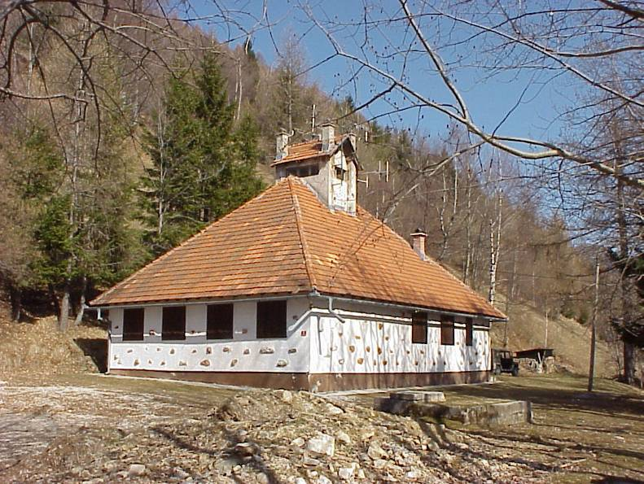

TK objekt Srednji Vrh

|  |  |
| --- | --- |
| DSC_0695  antene | DSC_0708  TK prostor |