Number:
Date:

Pursuant to Article 51 of the Physical Assets of the State and Local Government Act (Official Gazette of the RS, No. 11/18 and No. 79/18 – ZSPDSLS-1) and Article 16 of the Decree on Physical Assets of the State and Local Government (Official Gazette of the RS, No. 31/18), the Republic of Slovenia, Ministry of Defence, Vojkova cesta 55, 1000 Ljubljana issues

A public invitation to tender for the sale of the Bailey assembly bridge parts

1 Name and seat of the organizer of the public invitation to tender

Republic of Slovenia, Ministry of Defence, Vojkova cesta 55, 1000 Ljubljana.

2 Object of sale

Metal parts of the Bailey assembly bridge as listed in appendix 2 to this tender. The tenderers must offer to purchase all items of the sale together.

Minimum required offered price for entire quantity is 8,000.00 EUR.

3 Inspection of the object of sale

Object of the sale is at the National Logistic centre of the Administration of the Republic of Slovenia for civil protection and disaster relief Roje, Ljubljana – Šentvid, Slovenia. Individuals wanting to inspect object of the sale must submit the request via an e-mail: dlcroje@urszr.si at least 3 working days prior to the date of wanted inspection and agree on the inspection time. Inspection depends on and will adjust to countries’ and the public invitation to tender organizers’ COVID-19 virus infection containment measures (got over the disease, vaccinated or tested is a necessary condition for inspection).

4 The amount of security

The tenderers must enclose a receipt of the payment of security in the amount of EUR 1,000.00 to the tender. The security shall be paid on current account of the Ministry of Defence no. 01100-6370191114, reference 00 201000-29112021, SWIFT/BIC: BSLJSI2X with the heading “Security for the Bailey purchase”. The security will be included in the purchase price of the selected tenderer. The security will be returned, without interest, to those tenderers who will not be selected within 30 days of the written notification of the results of the selection procedure.

5 Terms of sale:

- The objects of sale will be sold on an “as is” basis; hence any complaints filed after the conclusion of the contract shall not be taken into account.
- It is only possible to purchase all the objects of this sale together.
- The criterion for the selection of the most favorable tender is the highest offered price.
- After receiving bids seller can perform additional negotiations to achieve bids that are more favorable.
- A procedure in accordance to article 17 of Decree on physical assets of the state and local government (Official Gazette of the RS, No.31/18) shall be conducted, if more most favourable tenders will be received.
- The selected tenderer must conclude a sales contract with the seller within 15 days following the confirmation of the receipt of electronic notification on the selection results.
- Should the selected tenderer not conclude the contract within 15 days after necessary conditions have been met and should he be the one to be held responsible for that, or should he withdraw from the contract or not pay the purchase price within the agreed timeframe, the seller has the right to withdraw from the contract or to rescind the contract of use forthwith and to retain the paid security.
- Objects of the sale, which are the object of the contract, shall be transferred into the ownership of the buyer after the full payment of the purchase price and into the buyer’s possession following the handover.
- The buyer must accept objects of the sale by signing the handover protocol in due time which shall not exceed 30 days after the payment or as greed with the seller. The handover cannot be done before the purchase price is paid in total.
- The buyer shall cover expenses for transfer of ownership and any other expenses arising from the sale. The buyer shall also cover the transportation of objects of the sale and logistic costs (Incoterms 2010, EXW shall apply).
- Tenderers, which are not allowed to participate in this tender, are the appraiser and members of the sellers’ committee and to them related persons.
- Only those tenders that meet the requisite conditions shall be taken into consideration.

All elements of the tender offer are binding.

Written tenders must include:
  - Information on the tenderer including the price offered for the object of the sale/purchase and the statement that the tenderer accepts all tender specifications (filled, signed and stamped form Annex 1 or separate document with requested data).
  - Indicative term plan of removal of the goods (starting after contract is signed and full payment done).
  - Certificate of paid deposit, inclusive of the reference number of this Notice.
  - Authorisation of participation at the public tender-opening session, if the person present is a representative.
  - Statement that the tenderer is not an affiliated person as per paragraph 7, Article 51, of the ZSPDSLS-1 (Annex 3).

Interested tenderers must submit the tender in the Slovenian or the English language.

6 Method and term of purchase price payment

The buyer shall pay the purchase price against the invoice issued by the seller within 15 days at the latest after the invoice is issued by the seller. Pursuant to subparagraph 5 of Article 5 of the Value Added Tax Act (Official gazette of the Republic of Slovenia, nos. 13/11 – UPB, 18/11, 78/11, 38/12, 83/12, 86/14, 90/15, 77/18, 59/19 and 72/19), VAT shall not be charged, therefore, it will not be paid by the buyer. The payment of the full purchase price within the period laid down for payment is an essential element of the sales contract.

7 Deadline for the submission of the tender

Tenders delivered to the address Ministrstvo za obrambo (Ministry of Defence), Vojkova cesta 55, 1000 Ljubljana, Slovenia, MoD Main Office, by mail or in person by 12.00 hrs on 29 November 2021 will be taken into consideration. The Ministry's main administration office, where the bids can be submitted in person, is open Monday through Friday from 09:00 to 13:00. Bids not submitted by the deadline will be returned to the bidder unopened.

The front side of the envelope must display the following:
PONUDBA ZA ODKUP DELOV MOSTU BAILEY,
ŠT. ZADEVE: 478-117/2021
»NE ODPIRAJ – PONUDBA«

The back side of the envelope must display the tenderer’s name and address.

8 Tender validity period

Tenderers are bound by the submitted tender at least 120 days from the tender submission deadline.

9 Time and location of the opening of tenders

Public opening of tenders will take place at 13.00 hrs on 30 November 2021 in the premises of the Ministry of Defence, Vojkova cesta 59, Ljubljana, Slovenia.

10 Termination of the procedure

The seller may stop, with no liability, the sales procedure before the conclusion of the legal transaction upon which tenderers will be returned any paid securities.

11 Information relevant to the public invitation to tender procedure

For any information related to this public invitation to tender procedure, please refer to Mr. Aleksander Kuntarič (e-mail: aleksander.kuntaric@mors.si, tel.: +386 1 471 25 48).

Uroš Korošec
Secretary
Director General

Sent to:
- To be published on the MoD website (Portal GOV.SI).

Annex:
- Form with information on the tenderer (Annex 1),
- List of parts, object of this sale (annex 2),
- Tenderer Statement on non-affiliation (annex 3),
- Unofficial translation in English of the invitation to tender.

Annex 1 INFORMATION ON THE TENDERER and the TENDER

Personal information will be used solely for the needs of this tender procedure and will be archived after use as per relevant legislation pertaining documentary material business.

- TENDERER (title of the legal person,
name and surname of the natural person)

- ADDRESS OF TENDERER

- POINT OF CONTACT (for legal persons)

- TELEPHONE

- E-MAIL ADDRESS

- REGISTRATION NUMBER OR PERSONAL
IDENTIFICATION NUMBER

- TAX ID NUMBER OR VAT ID NUMBER

- CURRENT ACCOUNT NUMBER,
BANK NAME AND ADDRESS

- PERSON RESPONSIBLE FOR
THE SIGNING OF THE CONTRACT (for legal persons)

offers the seller, the Republic of Slovenia, Ministry of Defence, in accordance with the tender specifications, to purchase _____________________________________, for a tender price of ___ ____ EUR, without the VAT (in words:………………………………………………).

I declare to comply with all tender specifications of the seller.

Tenderer:

Place and date:

Stamp and signature:

Annex 2

DATA ON OBJECT OF THE SALE

Name of the element | No. of pcs | Weight per piece (kg) | Weight together (kg)
BB1 panel | 40 | 263,10 | 10.524,00
BB 5 Standard Transom | 22 | 204,10 | 4.490,20
BB3 Raker | 30 | 8,20 | 246,00
BB15 Swaybrace | 26 | 29,50 | 767,00
BB2 Bracing Frame | 20 | 18,10 | 362,00
BB4 Panel Pin | 40 | 0,06 | 2,40
BB7 Plain Stringer | 77 | 83,90 | 6.460,30
BB8 Buttin Stringer | 16 | 86,18 | 1.378,88
BB13 Riband | 30 | 28,12 | 843,60
BB6 Transom Clamp | 30 | 2,70 | 81,00
BB 19 Bearing | 4 | 31,75 | 127,00
BB 31 baseplate | 4 | 181,50 | 726,00
BB62 Female end post | 4 | 59,00 | 236,00
BB63 Male end post | 4 | 66,20 | 264,80
BB24 Plain ramp | 23 | 163,30 | 3.755,90
BB25 button ramp | 12 | 167,80 | 2.013,60
BB65 Launching Link MK | 2 | 12,70 | 25,40
BB 18 Jack shoe | 6 | 16,33 | 97,98
BB 38 Junction Chess | 10 | 28,00 | 280,00
 |  | Together | 32.682

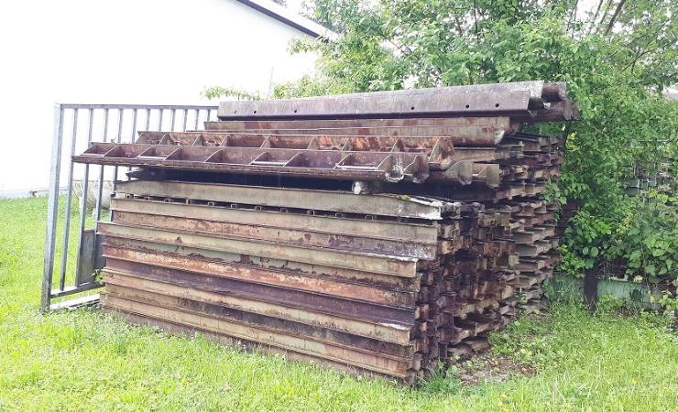
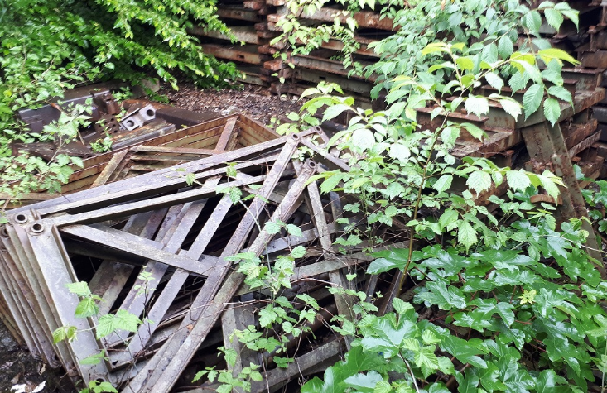
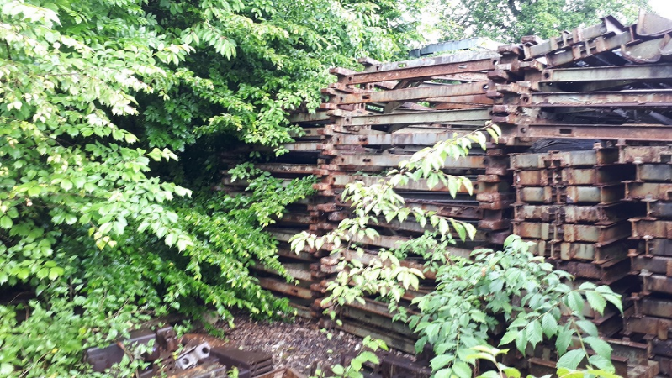

Annex 3

Tenderer statement

Tenderer ___________________________________________ hereby declares, that I am not an affiliated person to the member of the commission or the appraiser as per paragraph 7. Article 51. of the Physical Assets of the State and Local Government Act (Official Gazette of the RS, No. 11/18 and No. 79/18 – ZSPDSLS-1).

Date: ___________________

_________________________
(Signature)

Stamp

As per paragraph 7. Article 51. of the Physical Assets of the State and Local Government Act (Official Gazette of the RS, No. 11/18 and No. 79/18 – ZSPDSLS-1), an affiliated person is considered to be: - A natural person who is with a member of the commission or an appraiser in blood relationship up to any knee and in an ancillary line up to the third knee, or who is with a member of the commission or appraiser in law, cohabitation, partnership or not, or in kinship up to the second generation, regardless of whether the marriage or partnership has ended or not, - A natural person who is in a relationship of guardianship or adoptee or adoptive parent with a member of the commission or appraiser, - A legal person in the capital of which a member of the commission or appraiser has a share of more than 50 percent, and - other persons with whom, according to known circumstances or on any legal basis, a member of the commission or appraiser is connected, so that due to this connection there is a doubt about his impartiality in performing the function of a member of the commission or appraiser.

