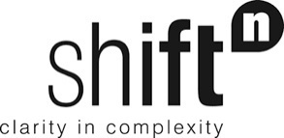

A foresight process to design the 2024-2028 Slovenian strategies for developing Non-Governmental Organisations and Volunteering
Final Report
MARCH-MAY 2023

Status: | Final report
Structure: | 41 pages
Authors: | Philippe Vandenbroeck (shiftN)
Document Reference: | SLO_NGO_03_23
 | shiftN bv

Contents
1 Scenarios as a foresight method
2 First stakeholder workshop: scenario development
3 Future scenarios for the Slovenian NGO and Volunteering sector
4 Second stakeholder workshop: policy measures

1 Scenarios as a foresight method
Foresight refers to the ability to predict or anticipate future developments. In other words, it involves looking ahead and identifying what might happen in the future, based on current trends, data, and other factors.
Future scenarios are one amongst a range of foresight methods. The foresight field encompasses many different methods: expert consultation methods, predictive models, trend scanning and analysis, horizon scanning, back casting and others.
Characteristic for the scenario approach is that it goes beyond an extrapolation of past trends into a single future. The method projects alternative futures based on an understanding of how driving forces, that can be perceived today, interact (Figure 1). Each scenario is internally consistent and plausible.

Figure 1. Overall rationale of the futures scenario approach.
The end product of a scenario process is a set of scenarios, usually presented in the form of a collection of stories that each describe a future state and, if so desired, the transition path that links present to future.

Example of a set of future scenarios
An example helps to familiarise oneself with the look and feel of a set of future scenarios. The material referenced here is extracted from a report published in 2017. It is a fairly complex study that is thematically related to the policy challenge that is approached in the present assignment. The study is based on an analysis of the global context faced by international Aid NGOs. This results in 23 clusters of driving forces (trends and uncertainties) associated to three key areas: the global context, humanitarian crises in that global context, and the humanitarian ecosystem. Figure 2 shows just 6 of these clusters, pertaining to the 'humanitarian crises' area.
Figure 2. Six clusters of driving forces
This analysis is the basis for the development of four different future scenarios, defined by two key uncertainties: the nature of the crises facing the humanitarian ecosystem (localised vs systemic) and the effectiveness of global governance to deal with these crises (withdrawal vs new coordination mechanisms). They are visualised in Figure 3 and very short summaries of each are shown in Figure 4.

Figure 3. A scenario framework that defines four different futures.

Figure 4. Summaries of the four scenarios.

Types of scenarios
Not all scenarios are alike. There exist different types of scenarios. Here we make a distinction between contextual scenarios and typological scenarios.
- Contextual (or exploratory) scenarios describe possible futures of the context around the planning organisation. Scenarios will offer different sets of opportunities and threats to the planning organisation. The example above fits in this category.
- Typological scenarios describe how a future system works to achieve a desired level of performance. For instance, one might envision different futures for a city that all comply with the requirement that they contribute in a positive way to quality of life and increased ecological sustainability. Each scenario then encompasses contextual drivers and a particular way in which the city works with these drivers to achieve the desired performance.

Applications of scenarios
The scenario methodology can be flexibly deployed to pursue different objectives. Here we distinguish between four typical ways to using scenarios (Figure 5):
- Windtunnel function: scenarios are used to 'test' strategy/policy options for their future robustness. If policy options fail to create the desired effects in the context of one or more scenarios they are not robust and backup (contingency) strategies may need to be developed.
- Antenna function: scenarios are used as a conceptual lens to scan for emerging and long range developments (horizon scanning).
- Awareness function: scenarios are used as a way to engage members of an organisation in strategic conversation and to align them in face of organisational challenges.
- Dialogue function: scenarios are used as a way to structure the debate between stakeholders who may not be familiar with or suspicious vis-à-vis each other's view on the future.
One might say that in the first two ways of applying the method the product (or outcome) is most important, while in the latter two the focus is more on the quality of the process.
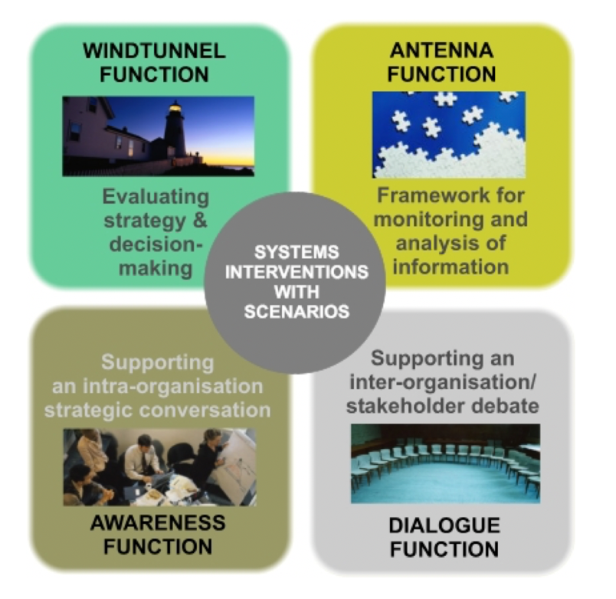
Figure 5. Ways of applying the scenario methodology.

The scenario development process
From unstructured to structured complexity
The scenario development process can be represented as an hourglass. As the process unfolds it moves from unstructured complexity (top of the hourglass) to structured complexity (bottom) via a phase of structured simplicity (neck).
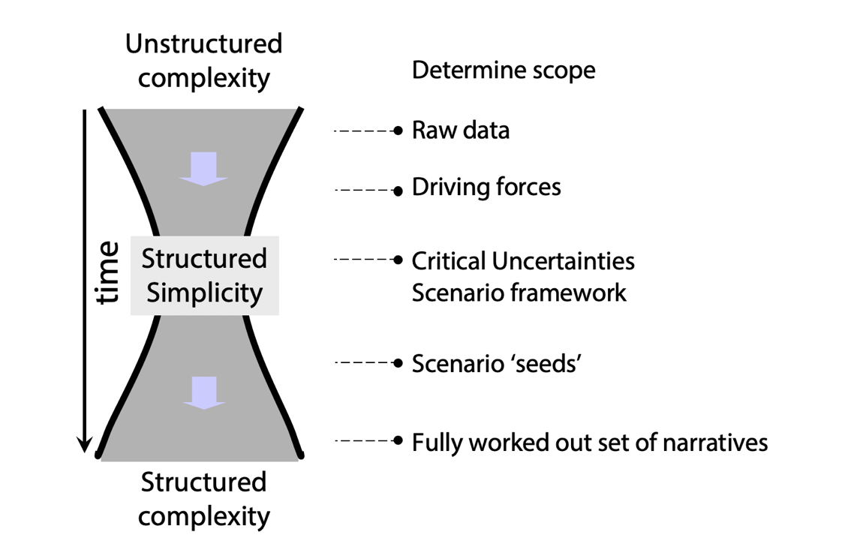
Figure 6 - The hourglass model: from unstructured to structured complexity
Determining the scope
The reflection needs to start from a focal question 1) that has a bearing on the future and 2) connects to the organisation's strategic agenda. For instance, "How will the world look like in 10 years' time?" is a potential starting point for a scenario process. Arguably this generic question will lead to very generic scenarios and it will not be easy to establish a meaningful connection with an organisation-specific strategic agenda. The more precise the question can be formulated and the more direct the link with the strategic challenge, the better it is.
It is also important to agree how far one wants to look into the future. An appropriate time horizon is informed by the dynamics of the systems one wants to study. For instance, the built environment changes relatively slowly, so it is not very helpful to develop scenarios on the future of a city with a very short time horizon. Most strategy and policy processes tend to settle on time horizons that are 5 to 15 years away.
Moving down the hourglass
Once the focal question has been formulated one can start with the process proper.
- In an initial step one draws up an inventory of driving forces (trends and uncertainties) that are relevant with the scope defined by the focal question. This can happen via desktop research, expert/stakeholder consultation or simple brainstorming. Data will be poorly structured which is why this represents a state of unstructured complexity.
- Those driving forces are then documented and prioritised based on their assumed impact and the associated level of uncertainty.
- This then leads to the identification of so-called critical uncertainties. These are a limited number of driving forces that are assumed to exert a very decisive influence on the dynamics of the environment.
- Those key uncertainties then form the building blocks of a scenario framework. Very often, the so-called '2-by-2' matrix is used, which is composed of two key uncertainties. Placing those two key uncertainties orthogonal to each other creates a scenario framework ('system of axes') in which four scenarios can be placed. At this stage of the development process, complexity is reduced to a limited number of underlying dimensions. The neck of the hourglass is thus referred to as the moment of 'structural simplicity' in the scenario process. The scenario framework defines a number of scenario 'seeds'.
- From then on, complexity begins to increase again. The scenarios defined by the framework are further developed, often into rich narratives that describe the dynamics within each of the scenarios as well as the end state at the chosen time horizon. The scenario narratives will reintegrate many of the driving forces identified earlier in the process.
- The end result is a set of scenario narratives, each of which by itself paints a picture of a complex, future reality. In contrast to the weakly structured complexity the process began from, the scenarios offer a coherent window into the uncertain future. They are thus collectively referred to as the phase where 'structured complexity' has been generated.

Scenarios to support Slovenian NGO/Volunteering policy
The aim of the present assignment is to support the development of an update of Slovenia's NGO and Volunteering strategy for the period 2024-2028. The Ministry of Public Administration is responsible for developing the strategy.
The scenario process aims at developing contextual scenarios. The focal question is:
"What world will Slovenian NGOs and Volunteers face in 2032?"
'World' encompasses all drivers beyond the NGO and Volunteering sector proper.
The scenario development process engages a range of stakeholders, from within and beyond the sector.
A first (face-to-face) workshop (6 April) was focused on the inventory and prioritisation of driving forces and the drafting of a scenario framework.
Once the scenario framework has been consolidated, members of the stakeholder groups developed the scenario narratives.
A second (online) workshop was devoted to the brainstorming of policy options. |
2 First stakeholder workshop: scenario development

Agenda
The stakeholder workshop was a full day session. The aim was to move halfway down the methodology hourglass. The main expected output was a rich inventory of driving forces (trends and uncertainties) that are expected to shape the context around the Slovenian NGO and Volunteering sector in the coming 10 years. In a second step these driving forces were thematically clustered and prioritised to yield a limited set of critical uncertainties.. The agenda for the workshop was structured as follows.
Introduction and warm-up
- 00:00 - 00:15 Welcome and introduction to the workshop.
- 00:15 - 00:30 Personal introductions
- 00:30 - 01:00 Intro to the scenario approach + Q&A
- 01:00 - 01:20 Warm-up exercise
Inventorising driving forces
- 01:20 - 01:30 Assignment driving forces
- 01:30 - 01:45 Coffee break
- 01:45 - 02:30 Brainstorm driving forces
- 02:30 - 03:00 Harvesting driving forces
- 03:00 - 03:45 Lunch (meanwhile clustering of drivers by team)
- 03:45 - 04:00 Assessing driving forces
- 04:00 - 04:20 Second iteration driving forces
- 04:20 - 04:30 Second harvest driving forces
Developing a scenario framework
- 04:30 - 05:15 Impact uncertainty matrix
- 05:15 - 05:30 Feedback
- 05:30 - 06:00 Exploration of possible scenario frameworks
However, the actual process flow was modified during the day itself. As a result, the group was able to move beyond the exploration and selection of a scenario framework and to make a first sketch of four future scenarios.

Output from the warm-up exercise
As a warm-up exercise the attendees were invited to consider the past and reflect on what they thought was the most influential event or driver that shaped their organisation's environment. The result of this individual brainstorm session is the following collection of events, thematically grouped under five headings:

Environment-related events
- Covid-19 pandemic (mentioned 10 times)
- Global warming (mentioned 2 times)
Social events
- Migration crisis (mentioned 8 times)
- Shrinking civic space
- US states passing measures against ESG and LGBT+
- Declining number of volunteers
- Rise of consumerism
Political events
- Rise of populism (mentioned 2 times)
- 9/11
- The rise of nationalism
- The Janša government
- Decrease in global solidarity due to geopolitical tensions
Economic events
- Changes to the welfare system
Technology-related events
- Impact of social media
- Impact of AI
Altogether these events suggest an increasingly challenging environment for NGOs to work in, due to a succession of crises and deep structural changes due to demographic, technological, environmental, and political drivers.

Output from the brainstorm on driving forces
The collection of driving forces was brainstormed in two iterations. In a first step the group was divided in subgroups and each group was asked to propose a minimum number of 20 trends or uncertainties. After these were harvested, another brainstorm round was held to fill in gaps. The output can be found in Appendix 1.

The choice for a scenario framework
During the lunch break the process facilitator proceeded with an approximate clustering of the drivers in thematic clusters. This suggested a pattern that might offer a basis for an interesting scenario framework. The collection of drivers seemed to fall into two main groups:
- A set of drivers that represented all kinds of stresses on Slovenian society.
- A set of drivers that reflected a capacity of Slovenian society to handle stresses.
This suggests that the environment in which Slovenian NGOs will have to work in 10 years' time will be shaped by these two meta-drivers: pressure on society and the capacity to handle these pressures. Considering these two meta-drivers as critical uncertainties allows to construct a classic 2x2 scenario framework.
- Critical uncertainty 1: the level of pressure on Slovenian society (e.g. from climate change, political/armed conflict, migration, and economic downturn). At one end of the spectrum this level of pressure is considerably higher than today, at the other end the pressure remains status quo.
- Critical uncertainty 2: the degree to which Slovenian society is able to handle these pressures (e.g., because of the presence of trust and social capital, of high problem-solving capacity, diversity, and reliable public services and infrastructures). At one end of the spectrum this ability is high, at the other end it is low (perhaps even lower than it is today).
The framework then defines four starting points for developing scenarios:
- Creative society: a scenario where the high pressure on society is matched by a high capacity to handle complexity.
- Conflict society: a scenario where the high pressure on society is not matched by a requisite capacity to handle complexity. In other words, in this world there is a deficit in societal resilience.
- Complacent society: a scenario where the low pressure on society is matched by a relatively low capacity to handle complexity.
- Celebration society: a scenario where the low pressure on society is exceeded by a high capacity to handle complexity. In other words, in this world there is a surplus in societal resilience.
The scenario framework is visualised in Figure 7.
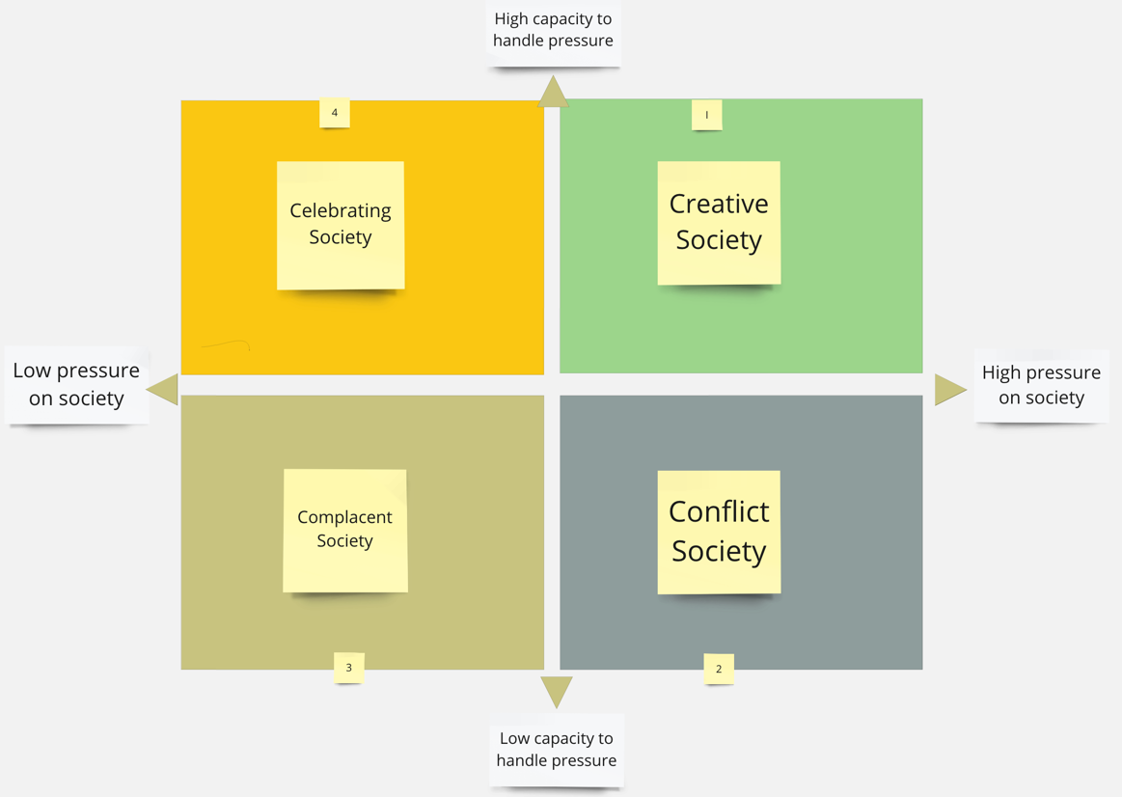
Figure 7. Scenario framework (2x2 matrix based on two critical uncertainties)

This framework was sketched out by the process facilitator during the lunch break and subsequently presented to the group as a possibility to move forward. The group accepted this framework, and the rest of the session was devoted to make a first sketch of each of the first scenarios.
3 Future scenarios for the Slovenian NGO and volunteering sector
Four subgroups set to work, each working separately to develop a draft outline of one scenario. The assignment given by the facilitator was as follows:
- Describe this scenario at time horizon (2032) through the eyes of two personas. Personas are fictitious people that live in that world.
- Draw up a timeline that shows how Slovenian society moves from the present state to the future state in your scenario.
- Identify 15 drivers from the collection of brainstormed drivers and indicate how they show up in your scenario.
Due to time constraints the groups were not able to finish all these tasks. However, each group was able to draw up two mini-portraits of personas.

Scenario 1 - Creative Society
Persona 1: Ms. Šija
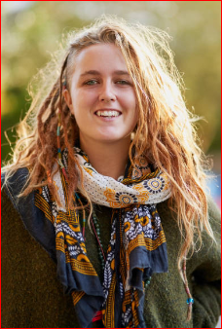
Ms. Šija is 28 years old and has graduated from Faculty of Public Administration. AI made her redundant, hence she reskilled herself to mobility maintenance/electro engineer. She lives in an off-grid community housing (cooperative model). Inhabitants are of diverse background/origins/age. Šija is the coordinator of community garden with rainwater collection system. This morning she prepared work plan of weekly duties. She is happy that she can have hot shower (due to water shortages households are having water for shower on odd/even days).
She can use food from the community garden, additionally she is relying on universal basic services (UBS) voucher for food, mobility, water, etc. Currently she is collecting coupons for the discounted insects flour steak. Within UBS scheme she has free access to good quality public transport. She works at the only car repair shop in the city and works only with rich clients. That gives her a bit of extra income for her to afford some goods that UBS does not allow for. Today she is having car maintenance work shift from 8.00 - 12.00. Then she goes to the home for the elderly where she is volunteering in providing companionship for 10 residents, sharing her skills and knowledge of gardening. This is organised by a social engagement agency that runs on the NGO model – the volunteering work is helping her to be socially connected and engaged.
Persona 2: Mr. Krasniqi
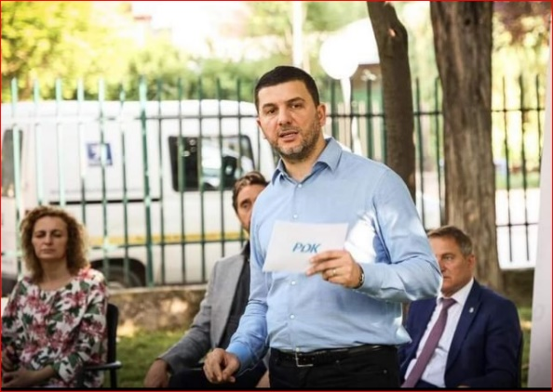
Mr. Krasniqi is a mayor of middle size municipality which is very successful economically and socially. In past years the demography changed significantly, young people prevail, mainly migrants.
First thing in the morning robot prepares him coffee and his AI secretary lists him all the key meetings and tasks of the day. He uses self-driving car, owned by the state. His most important task is to meet the delegation of foreign investors from Kazakhstan that want to build the recycling facility. To assess its viability, municipality`s prompt engineer used AI to foresee environmental, economic and social consequences. And the result is positive. Opposition party (lead by major’s wife) and CSOs are organising protests against this initiative. The base for their arguments (health concerns and economic viability) is generated by an open-source AI. After meeting with the investors, he meets representatives of opposition and CSOs to attempt to reach consensus. Since the results are not aligned, they agree to put the final decision in the hands of the National commission for application of AI results.
For the forthcoming weekend trip his family of six goes by train to eco village at SE of Slovenia, where they combine hiking and relaxing, but also assist with regular duties to maintain the village (gardening, logging, milking the goats, etc.).
End state Creative Society 2032
People, especially young, are organising themselves in informal communities – social movements. Societal values are socialist and green, solidarity is institutionalised. Cost of living is high; people are conscious and frugal consumers. All financial transactions are traceable, barter system is the only way to »stay below the radar«. Digitalisation is an important tool that is enabling this connectivity.
Due to the past government(s) legacy, the new government is facing with the major difficulties to implement their programme. Opposition is getting stronger and there are some radical “pockets” of NGO/CSO opponents in the country. Political parties are weak, independent lists based on movements are getting more attention.
The NGO sector is strong and has social power as the society is aware that they are the only ones that can address migrations and other challenges. Start-up ecosystem is thriving (focus on green transition issues). Investment in public transport has helped to reduce pressure on the urban centres. Wide car-ownership is costly and not socially accepted.
The government is implementing their plan on reduce the precarious work, UBS (universal basic services) have “settled in”. Migrants can claim citizenship, in this way they are forming a new voters pool for the left.
AI in public sector takes over parts of the tasks of civil servants, that must use this “freed” time for community service. Media is fully digitalised and based on AI summaries of individuals' posts – resulting in people to be only interested in their microenvironment. NGOs are the channel for trustworthy information.
Timeline
2023-2025 | High migration influx
2023-2026 | Extreme heat wave – three years in a row
2026 | QAnon Parliamentarian elections
2027 | Digital currency
2028 | NGO sector weakened, operating in guerrilla mode
2029 | Early elections, Left-Green party wins
 | Digital currency regulated
2030 | Automatisation in the public sector
2031 | Universal basic services introduced; high influx of people working in the NGO sector
Drivers
Level of professionalization within NGO sector = high
Trust level in NGO = high
Value on social cohesion = high
Viability of society to enforce solidarity tax policy = low
Ability to work together across cultures = low
State's response to ageing population = low
Climate transition risk = high
Water availability (SLO/EU) = low
Life costs increase due to climate crisis = high
Rise of Artificial intelligence = high
Credibility of information & higher manipulation possibility (AI) = low
Government services outsourcing - NGO becoming service providers = high
Changes in welfare system = high
Working week shortening and impact on civic activation = high
Migrations (immigration & emigration) = high

Scenario 2: Conflict Society
Persona 1: Alina
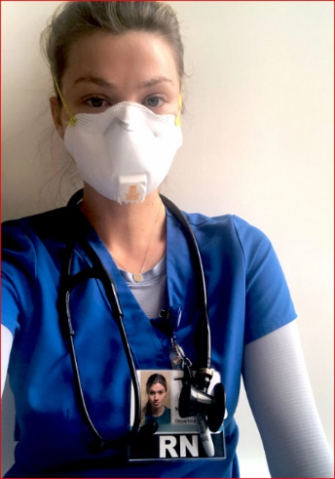
Alina, aged 50, a single parent, war immigrant from Ukraine, came to Slovenia in 2022 with an underaged son Dimitry (11 years old). She woke up at 4.00 after going to bed at 24:00 after another 16-hour shift in a private nursing home for the elderly and a 4-hour schoolwork with Dimitry. Dimitry was alone again all afternoon yesterday, after being bullied in school. He has no extracurricular activities and no help with schoolwork; she cannot afford them, and no free activities are available. She will again struggle to find transport to work; she does not own a car and there is no public transport available and will take her at least two hours only to get to work. She is fatigued going to work, knowing that her head nurse and relatives of the elderly will constantly complain about her work. She cannot afford day-care for Dimitry, who has lately showed some serious behavioural problems, and has no right to any child benefits, due to her immigrant status. She lives a very isolated life, has no relatives in Slovenia and no social network. At work she steals painkillers, she needs them for her back pain, since she cannot afford to see the doctor and to resell them, to make ends meet. She hopes, she does not get arrested, because if so, she will get deported (no legal aid is available) and Dimitry will be left alone and homeless (no child protection services available).
Persona 2: Kenan

Kenan, 20 years old, social media influencer, living in a 200 m² penthouse, on the top floor of the highest skyscraper in Ljubljana. His family, the 5th wealthiest family in Slovenia, bought the apartment for him. Today he woke up at 1:00 PM, feeling dizzy from yesterday’s wild virtual party. He orders his virtual assistant Maxi to prepare breakfast, he wants mangos from a Columbian eco farm, that are produced exclusive for his family. They need to be very fresh; flown in this morning on his private jet. He gets annoyed since his private maid was late this morning; there was the electricity shortage in the suburbs and there is no fuel at the petrol stations.
Then he calls Alina, because he needs some painkillers. He could get them from his personal, private doctor, but he remembers Alina is an immigrant, and by soliciting drugs from her, he could report her to the police, and he will get more media exposure and clicks on his social media accounts. Only so will he win the contest for becoming the editor-in-chief of the nationally most view TV show “Glitz and glamour” and ban the news about social rights, environmental injustice, and those always critical non-governmental organisations.
End state Conflict Society 2032
Slovenia is a highly fragmented and polarised country, affected by severe natural disasters (drought, floods) and pollution. The social system shows features of feudalism. The land and natural resources were privatised and are now owned by the wealthy few and global corporations. There are very few public services and of low quality. Only the wealthy can afford quality healthcare, education etc. Basic commodities (food, energy, housing) are scarce, and the availability is hampered due to increased protectionism of the national states. EU is weak, only addressing the needs of the big corporations.
Slovenia is no longer a full parliamentary democracy. The parliament and the government are highly controlled by big corporations and the capital.
Individualism prevails in the society; no social networks exist, and volunteering ceased to exist. The social divide and social inequalities are high; expressed in the Gini coefficient over 80 %. Civic space is severely hindered, rights to organise and participate in public life are non-existent and highly controlled by the state. Only pro-governmental NGOs are allowed to operate. People do not engage in public life. Conflicts between different social strata, demographic groups and ethnics groups are very frequent. There are more and more marginalised groups subject to hate and attacks.
Media are only privately owned, serving solely the interest of the economy. Critical thinking and criticizing the government is discouraged and penalised by withdrawal of funds or prohibition to operate. Intellectuals had to leave the country. Critical universities had to close.
Technology is present in all aspects of everyday life and society and used for control. The digital divide is widening, and many people are left behind. Technology is controlled by the global corporations. Data is used to steer socially acceptable behaviour.

Timeline

2025 | Financial crisis, war in Ukraine continues, high increase in living-costs
2026 - 2028 | Natural disasters (floods, drought)
 | New laws passed on privatisation of education, healthcare, natural resources
 | Reactivation of TEŠ 6, decision taken not to invest in nuclear power plant, energy cuts
2029 | Laws passed to hinder civic space (right to organise, right to protest etc.), high decrease of self-organisation and thus NGOs
2030 | Elections, low turnout, extremist political party takes over
 | Limited and worsened conditions for self-food production
2031 | Imposing total technological control in society to steer socially acceptable behaviour

Drivers
Rise of tools that weaken/destroy NGO sector
Structure of public funding and level of change of national/EU public finance (in NGO funding)
Populism
Increase of individualism
Social cohesion decreasing as a value
Level of social detachment, polarization of society on different topics
Amount/severity of natural disasters, life costs increase due to climate crisis
Rise of artificial intelligence and impact of ai on critical thinking,
Impact of social media/influencers on social values
Access to basic public services
Changes in welfare system
Increasing social divide
Consumerism
Development of conflicts in EU (security, migrations, food security)
Falling of trust in science and expert institutions.

Scenario 3 - Complacent Society
Persona 1:
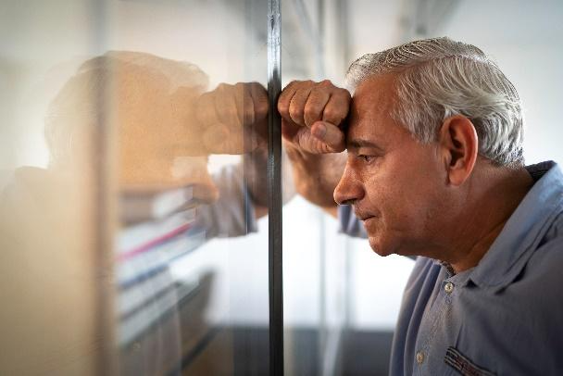
Janez is 60 and has five years until he retires. He works as an elementary school teacher for physical education and is not very passionate about his job. He is under-cover nationalist, although he is not an active political party member.
He has his own house which he inherited, closed off with a high fence & cottage in the countryside (small vineyard & garden), which he also inherited. He owns 2 cars with his wife. His kids and grandkids live in one of the floors of the house and do not pay living costs. He is digitally illiterate, hence most of his online engagement is done by his grandson.
He is not interested in any humanitarian or NGO work, but occasionally donates blood. His hobby is cycling. Generally, he is indifferent, but does worry about future, especially about his pension, which will be relatively low – therefore he keeps his cottage house & vineyard as an asset. When he has free time he works in the vineyard, considers it more of a duty than pleasure, but washes the pain down with a glass or two of homemade wine. He worries what would happen if he would fall seriously ill, as public services are quite basic. His wife does grocery shopping and usually buys what is discounted. Every year they take a one-week vacation by the sea.
Person 2: Fatime

Fatime is 17 and first-generation immigrant. She lives with her family: parents are blue collar workers and two brothers. Children were raised in a patriarchal manner.
She is about to choose which university she wants go to. She is working part-time in McDonalds, so she can cover her expenses. She has big expectations for the future, likes luxury items. As many other girls she aims to become an influencer and a has profile on social media where she tries to get as many followers as possible. She feels responsibility towards them and is stressed if the number falls or if she gets nasty comments.
However, she does not expect to earn a living with what she learnt though formal education and is keener on making money the “fast way”, therefore also susceptible to be recruited for shady business (escort, Onlyfans) and very vulnerable. Her biggest fear is that the family would find out and stop her from doing what she is up to. She has no possibility to get own apartment, but she aims to become independent and famous.
She is gullible and has already been a victim of a scam, which she is ashamed of. She does not see anybody to confide to, no one to offer psychological support. Her home room teacher was Janez, he did not recognize her pressure/needs. There was also no individual or collective in her life path which would detect what is happening to her and support her.
End state Complacent Society 2032
In Slovenia, there is no consensus on what is important, and realities are fragmented. There is a high level of corruption, nepotism, and low trust in government. Public services are provided for all, but to get a better/faster service, people must pay from their own pocket. Young people do not engage in politics and voters are dying out. Slovenia has not experienced any major disasters or climate induced changes that would undermine the resilience of the ecosystem.
Quality of life is lowering due to aforementioned factors, but not drastically. Technology is slowly entering into all pores of society, causing new stratification impetus, and widening the digital divide.
Production has become robotic; the excess workforce has transferred to craftsmanship. People have difficulty accessing well-paying jobs - they are for those, who have in depth IT knowledge. The most desirable jobs are in the public sector, although the remuneration is not high, and work is not creative. There is a major divide between those who just work to survive and those who control technology and live in luxury.
High-end technology is regulated, control over collection of personal data is left to nation states, corporations gain free access to it. Media worldwide is dominated by fake and manufactured news. The percentage of ethnically Slovenian population is falling due to the ageing of the population and low birth rate. Additionally, the security situation has slowly deteriorated to a level where the presence of security structures is gradually increasing, and the likelihood of terrorist activity has increased. Internal security resources are strengthened. Additionally, there is no real opposition, corruption reigns, and even if a scandal is exposed, the public is already oblivious to it.
Timeline
 | 2024 | EU elections, low turnout, especially among the youth (10 %)
 | 2025 | Financial crisis, weakening of social network
 | 2026 | Ceasefire in Ukraine achieved – peacebuilding process starts
 | 2027 | Regular parliament elections, left-wing parties win
 | 2027 | Protraction of environmental degradation (affects food & life quality, morbidity rises)
 | 2028 | Strong economic recession. General tiredness/fatigue in society, absence of any NGO policy + personal data protection regulations are lifted (GDPR)
 | 2029 | EU elections, low turnout, especially among the youth (3 %)
 | 2030 | Economic turnover
 | 2032 | Corporations become more important than nation states – EU existence becomes questionable
(in this society everything happens slowly and citizens do not notice it as big milestone/disruption)
Drivers
Trust level in NGO
Increase of individualism
Level of social detachment
Amount of people left behind (IKT, AI)
Possibility of war
Ageing of population and State's response
Impact of price raising and poverty
Life costs increase due to climate crisis
Impact of social media/ influencers on social values
Access to basic public services
Changes in welfare system
Increasing social divide
Consumerism
Development of conflicts in EU (security, migrations, food security)
Migrations (immigration & emigration)
Scenario 4 - Celebration Society
Persona 1
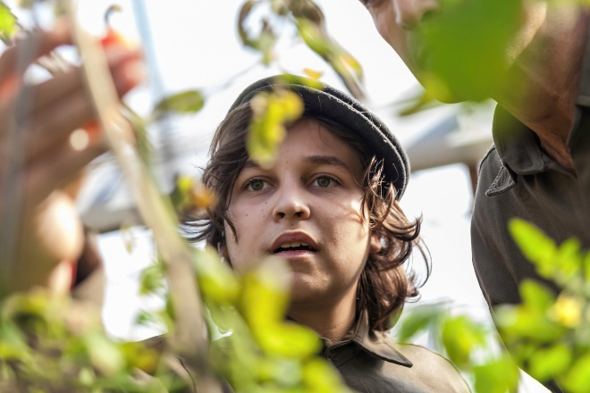
Young woman, who lives on a farm in Prekmurje, a true example of hard work and dedication. Despite being only 17 years old, she already has a strong sense of responsibility towards her community. Every morning, she commutes to Ljutomer to attend high school, and today is no exception. But it's not just another ordinary day, as today is a sports day and pupils are going to the community center to help out older citizens of Ljutomer and interact with them.
After a long day at school, this young woman returns to her family farm where there is always a lot to do. But she doesn't mind the hard work, as she's always been passionate about farming and being outdoors. In fact, she's so passionate about agriculture that she's also an active member of the local firefighters’ brigade and leads a local group called "Young Farmers against Pesticides". Through this group, she advocates for the use of organic and sustainable farming practices and hopes to inspire others to adopt a similar approach.
Despite her busy schedule, this young woman remains focused and committed to her goals. She's determined to make a positive impact on her community and is not afraid to put in the hard work required to achieve it. As she continues to grow and develop, there's no doubt that she will become a true leader in her community and beyond.
Persona 2
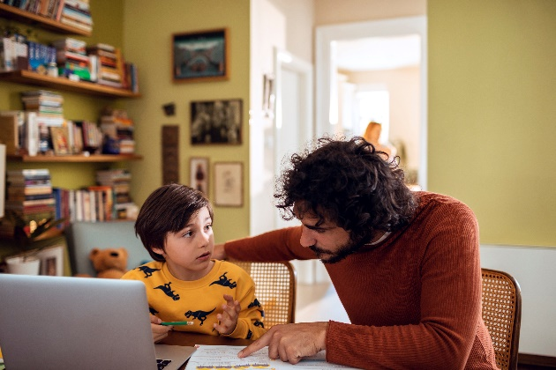
This man, at the age of 40, is a single father to a 12-year-old son. They live in an apartment complex attached to a nursing home where he works as a nurse. He puts in 36 hours a week and is paid a decent wage for his work. His job is on the department with dementia patients, which is set up like a closed village square. He takes care of the patients with compassion and dedication, which is why he is respected and loved by both his colleagues and the patients.
Every morning, after preparing breakfast for his son, he sends him off to school with a bicycle. Since he often works night shifts, he uses his before-noon time to complete household chores, tend to the community garden, help his neighbours with shopping, listen to VAL 202, and read some new Slovenian books. He also takes some time to rest and recharge for the rest of the day.
In the afternoons, his son returns from school, and they spend quality time together. They both get to play interactive games with the dementia patients, which is something they both enjoy. This experience also allows his son to develop empathy and understanding towards those who are struggling with dementia.
Despite being a single father and working as a nurse in a challenging environment, this man is always looking for ways to contribute to his community and make a positive impact. His compassion, dedication, and work ethic make him a true role model for his son and those around him.
End state Celebration Society 2032
Slovenia is a more stable, prosperous, and equitable country with a higher quality of life for its citizens.
The introduction of long-term law, real estate tax, and decentralization of state administration would help to reduce the cost of living and create a more evenly spread population across the country. The end of the war in Ukraine and stabilisation of food supply and lower fuel costs would help to create a more stable economic environment for Slovenia.
The introduction of the school reform, as well as the health system reforms that show results, would lead to a more efficient and effective education system and a more accessible healthcare system for all citizens. The implementation of the Universal basic income would help to reduce poverty and improve the standard of living for many Slovenian citizens.
Additionally, the implementation of worldwide rules for AI and the closing of tax havens would help to create a more just and equitable global economic system. The introduction of COVID generic medicine production in Slovenia would also help to ensure access to affordable medicine for all citizens.
Finally, the nuclear power plant KRŠKO, 2nd block starting production would help to meet the country's energy demands and reduce dependence on foreign energy sources. Revenues from oilfield Poček are effectively managed by State investment fund.

Timeline
2024 | Introduction of long-term law, Real estate tax and decentralisation of state administration (moving institutions across Slovenia). That caused evenly spread of population and lower cost
2025 | end of war in Ukraine, stabilisation of food supply, lower fuel costs
2026 | Signed contract for technology supplier of Nuclear powerplant Krško, TEŠ6 powerplant turned off
2026 | Health system reforms show results, no more clientelism, lower costs of life
2027 | Regular parliament elections, left-wing parties wins, announcement of Universal Basic Income (UBI)
2027 | School reform introduced
2027 | Oil/Gas field found on military proven ground Poček
2028 | Reforms are bringing results and improved standard of living to citizens
2028 | Worldwide rules for AI are implemented, COVID generic medicine production starts also in Slovenia
2028 | State investment fund established to manage Oil/Gas revenues
2029 | Worldwide global income tax is implemented and tax avoiding places (tax heaven) are mostly closed.
2030 | Universal basic income is introduced in Slovenia
2031 | Parliament elections, Enlighted liberal-Christian collaboration rules Slovenia
2031 | Denationalisation process is officially closed (1991-2031), no more costs for state
2032 | Nuclear power plant KRŠKO, 2nd block start production

Drivers
Increase in the level of cooperation between the private sector and NGO due to a sustainability transition.
Level of professionalization within NGO sector.
Ability to work together across cultures.
Availability of psychology aid for low income and children.
Access to basic public services.
Economic crisis.
Impact of price raising and poverty.
Loss of jobs due to automation.
Credibility of information in higher manipulation possibility (AI).
Level of political stability.
Climate transition risk.
Innovation in public education.
Quality of public education.
Level of support and acceptance of NGO in society/shareholders.
Trust level in NGOs.

||

4 Second stakeholder workshop: Policy Measures

Design of the workshop
In the second workshop the focus shifted to the brainstorming of policy options to update and improve the 2018-2023 Slovenian NGO and Volunteering strategy.
Participants to the workshop are listed in Appendix 3.
The overall reasoning to connect the scenarios to the policy frameworks is as follows:
- Each scenario is condensed in a limited set of societal needs. Put differently: each future is seen as a bundle of needs.
- Then an assessment is made to what extent the current NGO/Volunteering sector in Slovenia is able to respond to these needs. This step effectively amounts to a gap analysis between future needs and current capabilities.
- In a third step measures are brainstormed designed to close the gap between future needs and current capabilities. The idea is to supplement the existing government strategy in such a way that it supports NGOs and volunteering organisations in closing the gap between future needs and available capabilities.
The overall flow of the workshop is visualised in Figure 8 and the agenda is included as Figure 9:
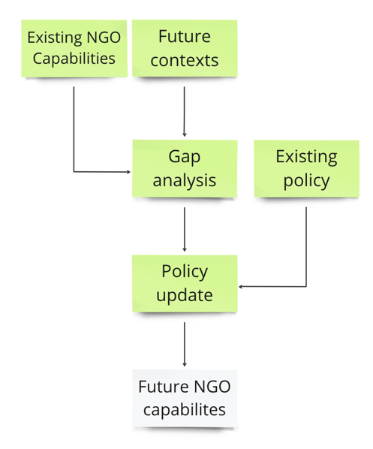
Figure 8. Overall flow of the workshop
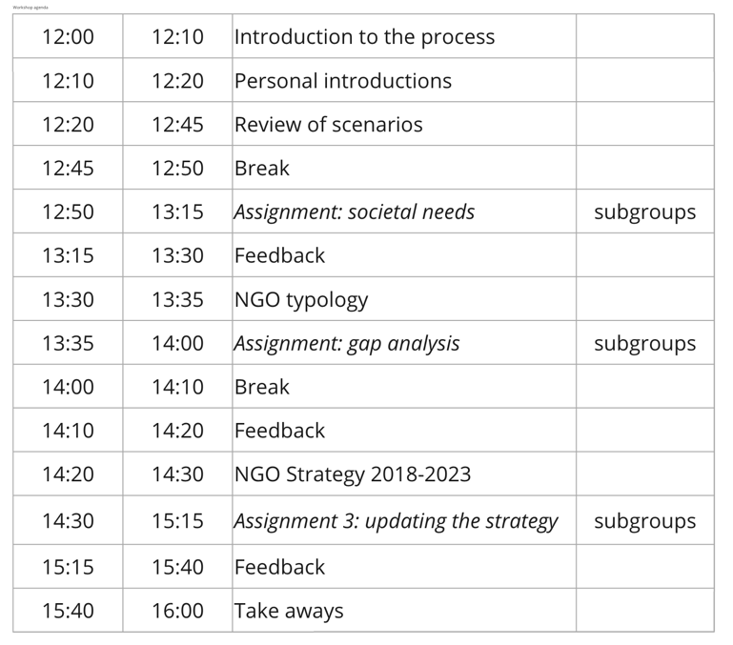
Figure 9. Online workshop agenda

First step: condensing scenarios into key societal needs
Participants were split into four subgroups, each working in one scenario. Each subgroup was asked to propose five key needs associated to their given scenario.
Creative Society
Key needs
- Reform of the political system; enabling implementation of democratic principles; higher public participation.
- Stimulating solidarity not as obligation but as way of life.
- Accessible and high-quality public services (education, public transport, healthcare, media).
- Resilience to climate change and disasters.
- Higher emphasis on social sciences, education and critical thinking.
Conflict Society
Key needs
- Independent media.
- Community building.
- Access to available public services.
- Regulations for corporations and misuse of data.
- Promotion of democratic environment and clean environment.
Complacent Society
Key needs
- Social security.
- Health and education services.
- Community building and spaces.
- Digital sovereignty.
- Information and media literacy.
Celebrating Society
Key needs
- Equal distribution of economic surplus.
- Support for inclusion, solidarity and cooperation.
- Decentralised and resilient local communities.
- Responsive and adaptive NGOs.
- Low pressure on the environment.
Reflections on the key needs: this short assignment resulted in a set of fairly generic needs that reflect an overall concern, across all scenarios, to increase the resilience of local communities. More specifically, they point to the need to provide access to critical resources and services, and to enhance the agency of citizens and communities (solidarity, critical thinking, various sorts of literacies).

Second step: assessing the gap between current capabilities and future needs
In a second the step the participants continued to work in their subgroups. In order to account for the diversity in the Slovenian NGO sector, a 3-part framework was presented that encompasses relatively distinct types of NGO and volunteering organisations (acknowledging the fact that some organisations combine different elements of the typology in their strategy and operations.) The framework is presented below as Figure 10.
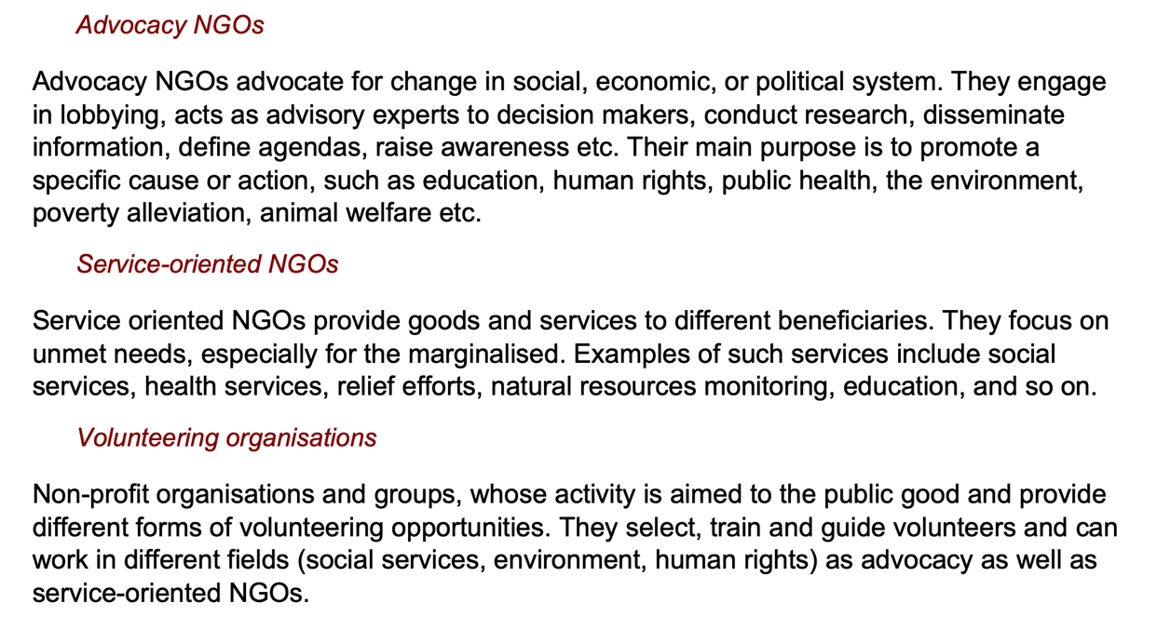
Figure 10. Typology of NGO and volunteering organisations.
The subgroups were then asked to assess the extent to which each type of organisation was currently able to meet the key societal needs identified in the previous assignment. The gap was expressed as a score on a scale from 1 to 5 (1 = not able to meet this need; 5 = very well able to meet this need). This resulted in a scoring table for each scenario. The tables are included below as Figures 11 to 14.
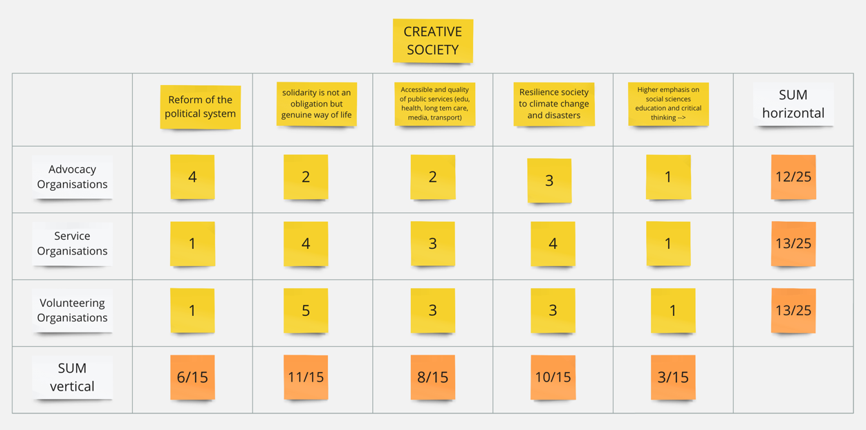
Figure 11. Creative scenario: assessment of the gap between current capabilities and scenario-specific needs.
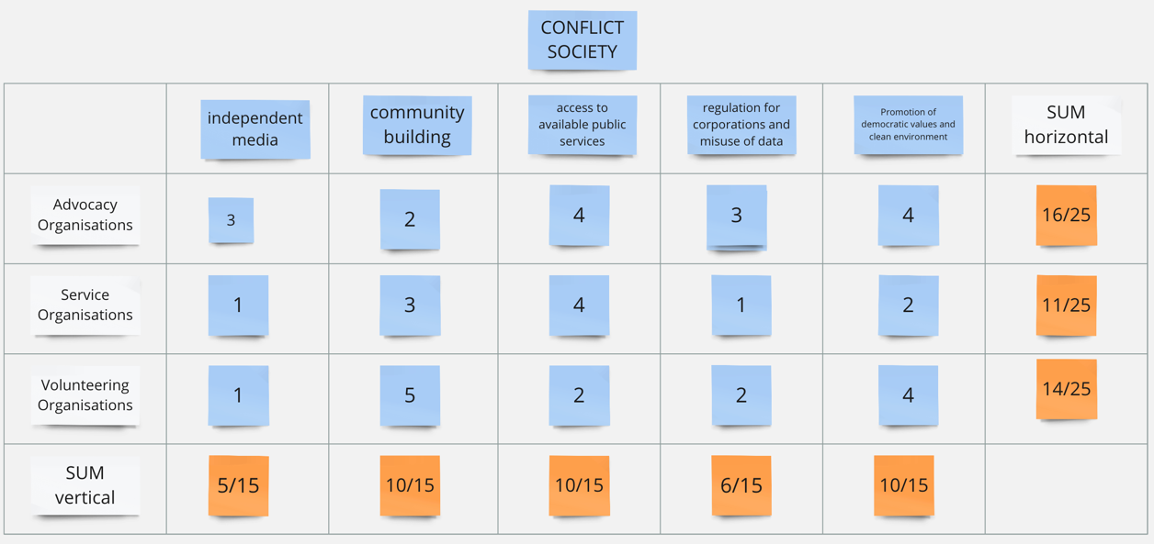
Figure 12. Conflict Society: assessment of the gap between current capabilities and scenario-specific needs.

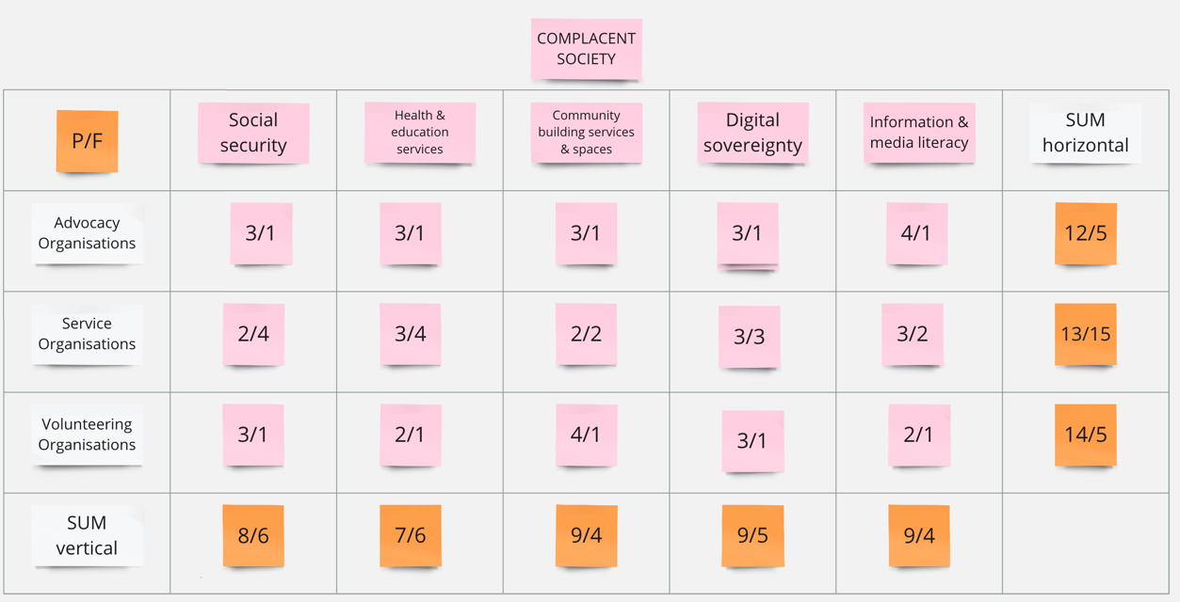
Figure 13. Complacent Society: assessment of the gap between current capabilities and scenario-specific needs (note: this group provided two scores; the first refers to the capabilities of current Slovenian NGOs to the future needs in Complacent Society; the second reflects the capabilities of NGOs functioning in that future scenario to respond to the particular needs).

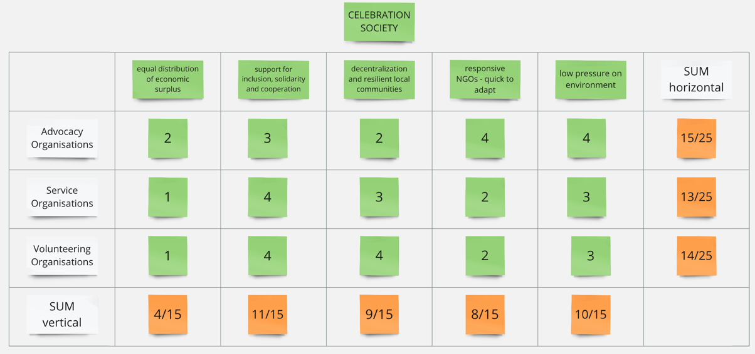
Figure 14. Celebrating Society: assessment of the gap between current capabilities and scenario-specific needs.
Reflections on the gap analysis: a summary table with the aggregate score per scenario (in columns) and per type of organisation (in rows) suggests some patterns (Figure 15):
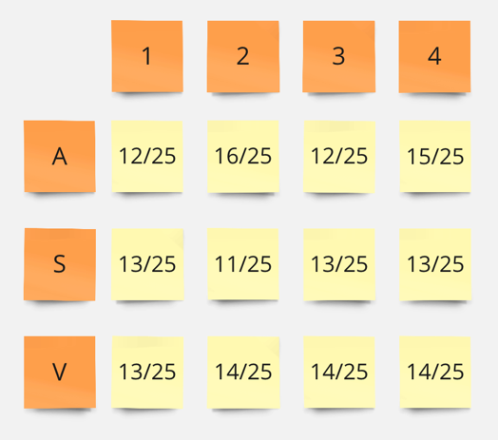
Figure 15. Summary table of scores for different scenarios (1 to 4) and three types of organisations (Advocacy, Service, and Volunteering).
- The three types of organisations seem to be able to respond to societal needs across all four scenarios 'moderately well', with aggregate scores varying around the middle of the scale (between 10 and 16 out of a maximum of 25).
- Service organisations have the lowest average score across all scenarios (not shown in the table). They function more or less similarly across scenarios. It is only in Conflict Society harder for them to respond to needs.
- Advocacy organisations, on the other hand, have the clearest mandate and most fitting capabilities in Conflict Society.
- Aggregate scores for volunteering organisations differ very little across scenarios.
- On the whole it is interesting to see that Slovenian NGOs do not seem to be particularly well equipped to contribute to the opportunities of the relatively positive scenarios (Creative and Celebrating Societies).

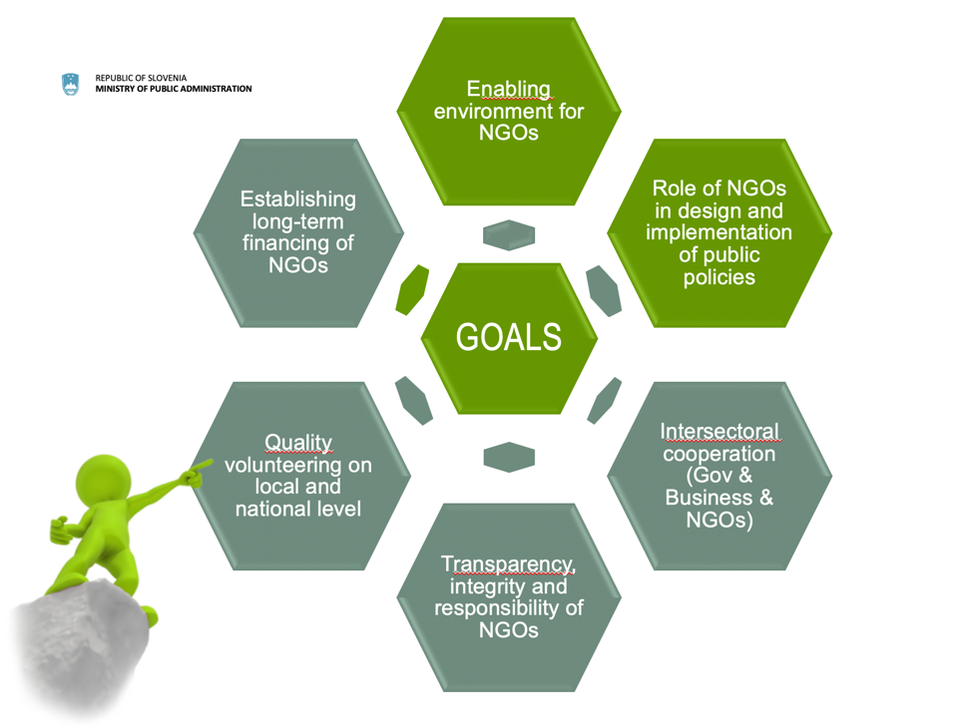
Third step: brainstorming measures to reinforce current capabilities
Figure 15. Schematic overview of the key elements of the 2018-2023 Slovenian strategy to develop NGOs and volunteering.
Below is an overview table that groups all suggestions for measures by theme and scenario.

 | Creative Society | Conflict Society | Complacent Society | Celebrating Society
Financing | - Real estate policy with public facilities to benefit NGOs  - Tax relief measures to establish & strengthen the relationship between NGOs and business increase from 0,3 to 0,5 gradually to 1 %  - Supporting environment for NGOs - long term financing for advocacy organisations are important for their stability (output and results of the advocacy organisations depend on stability of environment in which they work - different elements: employment, capacity, premises, long term financing) | - Training for higher empowerment in obtaining funds.  - Simplification of calls for proposals  - To enhance the developmental orientation of budgetary Fund for NGOs and other financial resources for NGOs. | - Stabile financing (not depending on political party in power). | - Calls for proposals not specifically for associations/institutes/foundations, but for all NGOs without discrimination  - Municipalities will not consider Non-Governmental Organisations Act (Zakon o nevladnih organizacijah) if they will have to look at each and every statute to determine if an entity is actually an NGO  - Long-term strategies at local level are needed.
Enabling Environment | - Reducing administrative burden for NGOs reporting  - Diversification and building relationships | - A stimulating, supportive environment. | - Strong enabling environment to keep the sector healthy.  - Stabile, foreseeable legal environment - no major legislative changes. | - A unified database/register of all NGOs  - The institutions should comply strictly with the Non-Governmental Organisations Act  - Joint, national IT solutions.
Role in public policies | - Special status for the NGOs acting in public interest to have beneficial status (e.g. shorter time to get access to information and to decision makers)  - Current status of the NGOs acting in public interest does not give any preference (in legal lawsuits, exempting from the payment of fees, strategic litigation) | - Special measures for civil dialogue and advocacy. | - Strengthening advocacy NGOs.  - Participation of NGOs in public policy making in general.  - Strengthening social cohesion & capital as a value (primary role of NGO and volunteering sector). | - Increasing responsibility of NGOs to participate.  - Education for participation
Intersectoral cooperation | - Strong support to build the crosscutting networks  - Line ministries should establish relationships with NGO under their scope of work | - Strengthening of cooperation between public administration and NGOs  - Tax credits for companies that promote volunteering and NGOs.  - Joint actions/projects of the business, NGOs and the public sector. | - Promoting smart and responsible use of digital technologies (regulative & supervision by the state).  - Governance thick-ness (intertwined institutions). | - Creating more opportunities for open, cross-sectoral consultations and cooperation.  - Improved access to decision-makers - involvement in decision-making process.
Transparency | - Self-reflection - where NGOs can improve --> developing of tools for the NGOs to support them in this process (e.g. platform for sharing these tools) |  | - Protecting credibility of NGOs through transparency. | - NGO transparency standards a part of the evaluation criteria.
Quality volunteering | - Support for the volunteering mentors | - Systematic promotion of volunteering in Education. |  | - Support for development of new forms of volunteering.
Reflections on the suggestions for measures to be included in the new policy framework:
- Participants confirmed that the suggestions collected in this assignment amount to an extension of the existing framework. There seems to be little appetite to reframe the agenda in a significant way. This is a confirmation that the current policy is a good basis to build on. However, more emphasis should be put on the implementation of existing measures (which is seen from suggestions such as: The institutions should comply strictly with the Non-Governmental Organisations Act, all the measures under "Quality volunteering")
- Measures are proposed at very different levels - some on very generic (e.g. protecting credibility of NGOs through transparency), others as concrete line of action (e.g. unified database/register of all NGOs). All, however, need to be further operationalized. We would recommend the ministry to structure the output on a spectrum of short-term and operational to long-term and strategic.
- Since the process was running within limited time-framework and several workshop participants expressed they would need more time to come up with different measures for NGO and volunteering development, more reflection is needed to draw up the exhaustive list of measures and agree on concrete approaches to turn these ambitions into reality. Therefore, we would advise the ministry to share the output of the workshop and invite stakeholders involved in the process to review.
- There is no clear differentiation of agendas across scenarios. This seems to suggest that this table encompasses a core set of policy measures that enables NGOs to adapt to different futures.

Reflections on the process/recommendations for further developments
- The process documented in this report had to be designed and implemented in a short 4-month time window. Ideally there is somewhat more time, particularly in between two workshops, to process interim results and allow participants to prepare for the strategy workshop.
- Since online environments offer a certain degree of convenience but generally lead to less rich outputs. We would recommend working in live gatherings whenever possible.
- The success of the present process hinges on significant resources from the coordinating team within the Ministry and a fluid collaboration with the contracted facilitator.
- The scenarios are likely a useful tool for NGOs to support the development of organisational strategies. It could be helpful to diffuse the scenarios in the sector.
- The scenarios that have been developed can be applied to policy contexts beyond the present focus on NGO and volunteering strategy. They might be diffused beyond the Ministry of Public Administration.

Appendix 1
List of brainstormed drivers (trends and uncertainties)
NGO-related issues
Non-realistic expectations for NGO services
No academic that systematically addresses NGO
Impact of overregulated society on the development of NGO programs
Level of cooperation between Private sector and NGO due to sustainability transition
Lack of partnership between business and NGO
Unstable labour status in the NGO
Level of professionalization within NGO sector
Rise of tools that can weaken/destroy NGO sector
Trust level in NGO
Structure of public funding
Level of change of national/EU public finance (in NGO funding)

Societal issues
Aging of population, level of NGO's ability to join volunteering sector
Increase of individualism
Value of individualism as individual success
Value on social cohesion
Political/media perception of NGO as society "leeches"
Rise of nationalism
Viability of society to enforce solidarity tax policy
Extent/degree/speed of individualization in society
Level of social detachment
War in Ukraine
Ability to work together across cultures
Class warfare
Polarization of society on different topics
Level of security in society
Access to public health system
Impact of overprotective parenting on volunteering and civic engagement
Impact of higher retirement age on volunteering
High sensations request to increase fundraising chances
Amount of people left behind (IKT, AI)
Impact of working force lacking on different economic sectors (care, infrastructure)
Trust level in science and expert institutions
Possibility of war
Armed conflicts threats
Climate change migrations

Cluster 3: Environmental issues
Ageing of population and State's response
Economic crisis
Impact of price raising and poverty
Loss of jobs due to automation
Climate transition risk
Rise of pandemics
Water availability (SLO/EU)
Amount/severity of natural disasters
Extinction of species
Life costs increase due to climate crisis
Volume of public funding

Technological issues
Rise of Artificial intelligence
Digitalization increases generation gap
Impact of social media/ influencers on social values
Credibility of information in higher manipulation possibility (AI)
Impact of AI on critical thinking and general knowledge
Impact of AI on the school system

Economic issues
Distribution of population
Fast internet and mobile development
Government services outsourcing - NGO becoming service providers?
Access to basic public services
Changes in welfare system
US states passing measures against ESG & LGBT
Increasing social divide
Consumerism
Addressing lack of trust
Change of economic paradigm
New social networks and social media
Working week shortening and impact on civic activation
Development of conflicts in EU (security, migrations, food security)
Falling of trust in science and expert institutions
Migrations (immigration & emigration)
Possibility of war
Climate change migrations
Appendix 2
Participants to the scenario development workshop, Ljubljana, 6 April 2023
Simona Smolej Jež | Social Protection Institute of the Republic of Slovenia
Marjan Cukrov | Ministry of Public Administration
Mojca Žerovec | Ministry of Public Administration
Marjana Dermelj | Ministry of Public Administration
Polona Šega | Ministry of Public Administration
Urška Bitenc | Ministry of Economy, Tourism and Sport
Tjaša Pureber | Ministry of Culture
Katja Simončič | Ministry of Solidarity-Based Future
Tadej Beočanin | Muncipality of Ajdovščina
Tatjana Hvala | Institute Knowledge (public institute)
Tina Divjak | CNVOS (Centre for Information Service, Co-operation and Development of NGOs)
Borut Jerman | PiNA Cultural Educational Association
Alenka Blazinšek Domenis | Institute NEFIKS - regional focal point
Tjaša Arko | Slovene Philantrophy
Peter Tomažič | Slovene Caritas
Cvetka Tomin | Slovenian Red Cross
Uroš Brezovšek | Slovenian Association of Friends of Youth
Filip Dobranić | Today is a new day - Institute for other studies
Marko Peterlin | IPoP - Institute for Spatial Policies
Tina Cigler | Association for Developing Voluntary Work Novo mesto - regional focal point
Jure Stojan | Institute for Strategic Solutions
Tina Cipot | LIDL
Appendix 3
Participants to the online policy option workshop, 31 May 2023
Name and surname | Organisation
Simona Smolej Jež | Social Protection Institute of the Republic of Slovenia
Tatjana Rakar | Faculty of Social Studies, University of Ljubljana
Marjana Dermelj | Ministry of Public Administration
Polona Šega | Ministry of Public Administration
Mojca Žerovec | Ministry of Public Administration
Marjan Cukrov | Ministry of Public Administration
Karmen Mitrović | Ministry of Labour, Family, Social Affairs and Equal Opportunities
Tatjana Orhini Valjavec | Ministry of the Environment, Climate and Energy
Samra Mušić | Ministry of Health
Tatjana Hvala | Institute Knowledge (public institute)
Rok Primožič | Municipality of Škofja Loka
Uroš Brezovšek | Slovenian Association of Friends of Youth
Tina Cigler | Association for Developing Voluntary Work Novo mesto - regional focal point
Tjaša Arko | Slovene Philanthropy
Alenka Blazinšek Domenis | Institute NEFIKS - regional focal point
Cvetka Tomin | Slovenian Red Cross
Marko Peterlin | IPoP - Institute for Spatial Policies
Borut Jerman | PiNA Cultural Educational Association
Veronika Vodlan | CNVOS (Centre for Information Service, Co-operation and Development of NGOs)
Helena Zevnik Rozman | Slovene Caritas
Katarina Bervar Sternad | PIC - Legal Center for the Protection of Human Rights and the Environment
Simon Delakorda | Institute for Electronic Participation (INePA)

IARAN, The Future of Aid INGOs (https://www.iaran.org/future-of-aid)
These two meta-drivers reflect the basic structure of an important insight from systems thinking, known as Ashby's Law of Requisite Variety. This states "that for a system to be stable, the number of states that its control mechanism is capable of attaining (its variety) must be greater than or equal to the number of states in the system being controlled." In other words: a system is only able to survive if it has the capacity to handle more (or at least as much) complexity than it is confronted with in its environment. See: https://www.edge.org/response-detail/27150
See Strategy for developing Non-Governmental Organisations and Volunteering until 2023

