RESOLUTION

on enhancing seismic safety by 2050 "LET'S OUTRUN THE EARTHQUAKE" (ReKPV50)

# INTRODUCTION

The Resolution on Enhancing Seismic Safety by 2050 "LET'S OUTRUN THE EARTHQUAKE" (hereafter: the Resolution) establishes an active policy to strengthen the earthquake resistance of the Slovenian building stock, with which the state contributes to reducing the consequences of a potential earthquake.

The Resolution is guided by the Constitution of the Republic of Slovenia (Official Gazette of the Republic of Slovenia [Uradni list RS], Nos 33/91-I, 42/97, 66/00, 24/03, 69/04, 68/06, 47/13, 75/16 and 92/21), which in Article 72 provides that everyone has the right, in accordance with the law, to a healthy living environment, and in Article 67 that the manner in which property may be acquired and used shall be laid down in legislation so as to ensure its economic, social and ecological function.

The people are not adequately prepared or aware of seismic risks in Slovenia, as relatively weak earthquakes occur somewhat frequently while devastating earthquakes are less frequent. Thus, people do not develop a sense of seismic risk through their own experience, or, rather, they usually come to such knowledge only when a major disaster occurs. They therefore tend to focus on other aspects of the suitability of their dwellings, such as appearance and energy efficiency, rather than on the basic aspects of health and life protection. Recent earthquakes occurring near Slovenia and in the past also within its territory have shown that, due to damage and the collapse of facilities, a major earthquake has a significant impact on people's health, life and well-being. Particularly vulnerable are small communities, among which Slovenia belongs. Moreover, the reconstruction of earthquake-affected areas and communities is a lengthy process.

In recent years, significant investments have been made in buildings’ energy renovations. It is recognised that the system should be complemented by a comprehensive renovation of buildings, also taking into account a healthy and safe living and working environment and good structural condition of buildings. A structurally sound building is one of the key conditions for protecting human life and health. Most of the buildings that have so far been energy renovated have not been comprehensively addressed, among other things without seismic analyses and possibly necessary strengthening of structures. In the coming years, it will be necessary to increase the share of buildings for which computational earthquake resistance is assessed and which are thus ready to undergo comprehensive renovation, provided that adequate funding is provided. Improving the building stock’s earthquake resistance will in turn increase the safety of Slovenian population.

From the technical background document: Seismic stress test of building stock in Slovenia (2020–2050), Background documents for the preparation of the Resolution on the Seismic Safety Enhancement Programme, University of Ljubljana, Faculty of Civil Engineering and Geodesy, Institute of Structural Engineering, Earthquake Engineering and Construction IT (IKPIR), 2020, (hereinafter: the background document), prepared by the Institute of Structural Engineering, Earthquake Engineering and Construction IT at the Faculty of Civil Engineering and Geodesy, University of Ljubljana, shows that the seismic resilience of Slovenian building stock and the community is deficient. In the event of a major earthquake, especially in the country’s large towns and its cities, significant damage to property and many casualties can be expected. As earthquakes have major impacts on other important functions ofsociety, a strong earthquake would also have the potential to disrupt the functioning of major facilities and systems, and thus potentially paralyse the entire country and society.

The Resolution pursues the overall objective of protection against natural and other disasters, including the prevention or mitigation of the consequences of natural disasters, with a view to making life safer and better. Slovenia has a system in place for initial emergency responses immediately after an earthquake, mainly as part of its protection and rescue system. To date, earthquake protection and rescue plans have been produced at all levels (national, regional, local), based on the Decree on the content and elaboration of protection and rescue plans (Official Gazette of the Republic of Slovenia [Uradni list RS], Nos 24/12, 78/16 and 26/19). The following documents have been prepared:

* Seismic Risk Assessment, [1]
* Seismic Risk Management Capacity Assessment, [2]
* Healthcare Response Plan in Case of Natural and Other Disasters in the Republic of Slovenia, [3]
* Assessment of Seismic Risk in the Republic of Slovenia, [4]
* Earthquake protection and rescue plans at all levels (national, regional, local and others),
* Seismic risk in Slovenia (POTROG), designed to meet the needs of planning and operation of the protection, rescue and relief forces of the Civil Protection Service. [5]

The Resolution therefore focuses on prevention, which is more effective and acceptable in the long term than other forms of disaster protection, not least in terms of providing funding for the measures. As it involves large-scale measures, a longer timeframe for its implementation is provided for. The Resolution takes into account the provisions of the Resolution on the National Programme for Protection against Natural and Other Disasters 2016–2022 (Official Gazette of the Republic of Slovenia [Uradni list RS] No 75/16), which states that in order to reduce the seismic hazard and thus the consequences of an earthquake, it is necessary to adopt and start implementing a seismic rehabilitation programme for housing and important public facilities used in education, childcare, nursing of special demographics, healthcare and other public activities, and for industrial and infrastructural facilities. As an urgent measure, the need is stressed of raising awareness and educating the population about the urgent professional renovation of facilities, as unprofessional works could even worsen seismic safety.

The Resolution is also based on a decision adopted on 25 January 2021 by the National Assembly of the Republic of Slovenia, Committee on Infrastructure, Environment and Spatial Planning, which instructs the competent ministry to address the issue in a comprehensive manner and on the basis of expert knowledge, and to prepare a resolution regulating the seismic rehabilitation programme for earthquake-prone facilities.

The Resolution is an instrument for the gradual strengthening of the building stock, as no significant financial investment has been made to improve its earthquake resistance. An exception is the region of Posočje, where the aim has been both to recover from damage and to repair and reinforce damaged facilities after the earthquake. The action programmes foreseen in the Resolution will ensure that the seismic retrofitting of buildings at risk is systematically addressed, which has several positive parallel effects. As the issue is not one of dealing with post-earthquake recovery of already damaged facilities, where immediate financial, organisational and implementation solutions must be provided, the burden of urgent retrofit is spread over a longer period of time. In order to avoid the adverse effects of an earthquake, it is essential that the evaluation of the seismic risk and the retrofitting of the building stock in Slovenia be initiated as soon as possible.

The Resolution allows for long-term preventive action starting the process of the retrofitting of earthquake-prone buildings. With these activities, the building stock will gradually be strengthened, which will contribute to improving the safety of people and the environment. Increased earthquake resistance of buildings reduces the possibility of knock-on incidents in the event of damage to buildings (fires, explosions, spills of hazardous substances, etc.).

The background document shows that a systematic approach to education and human capacity building in earthquake engineering will have to be established, as well as a link between society itself and the engineering and research sectors.

Seismic retrofitting of existing buildings also means that the country follows the principles of the circular economy: buildings are professionally maintained and renovated, thus reducing the likelihood of being lost to an earthquake. At the same time, seismic retrofitting of existing buildings reduces the use of raw materials and emissions during construction processes compared to new buildings, and reduces development pressure on natural open space.

The renovation of earthquake-prone buildings is primarily aimed at reducing the risk of loss of life and of injury to people, and at improving well-being and quality of life. In addition, it usually makes sense to design the renovation of buildings in a more holistic way, including towards the improvement of their energy performance and the provision of a healthier living environment. Earthquake retrofitted and comprehensively renovated buildings therefore gain additional value in the long term, which is not the case for only energy-renovated buildings, even though significant investments have so far been made for this purpose alone.

Seismic risk assessment and seismic retrofitting of cultural heritage buildings is one of the essential measures for the protection and integrated conservation of cultural heritage.

In the event of severe damage to buildings following an earthquake, the decommissioning of inadequately strengthened energy renovated buildings would have a greater negative impact on the environment than still usable comprehensively renovated buildings, while at the same time the decommissioning would be more expensive and the financial resources invested in energy renovation would be wasted. Comprehensive renovations of buildings will also have a positive impact on the Slovenian economy, in particular on construction and other related industries.

# 2. SEISMIC SAFETY SITUATION

## **2.1 General**

An earthquake is a natural phenomenon that can neither be predicted, controlled, nor regulated; only the seismic ground motion can be measured (e.g. ground acceleration) and the amount of energy released defined as earthquake magnitude. An earthquake is always accompanied by a high degree of shock and uncertainty, due to people's lack of understanding, preparedness and sense of the level of seismic hazard and the magnitude of ground motion that can occur in strong earthquakes.

In terms of the consequences of an earthquake event, Slovenia’s geographical location makes it one of the EU’s more earthquake-prone Member States. Earthquakes are one of the natural disasters that pose a high risk to Slovenia, as the building stock is concentrated in the most earthquake-prone areas (Figure 1 and Figure 2) and is also relatively old.

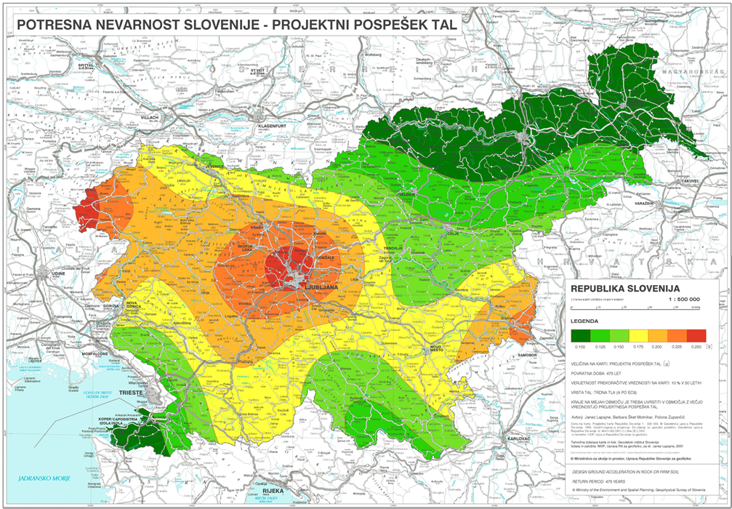

Figure 1: Design ground acceleration map of Slovenia for a return period of 475 years. [6]

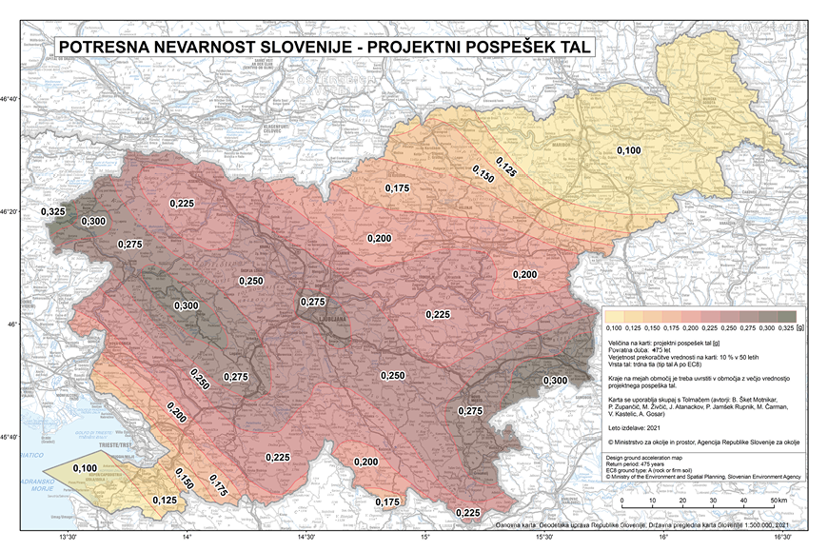

Figure 2: New seismic hazard map of Slovenia: design ground acceleration of Slovenia for a return period of 475 years. [7]

The new map is applicable from 1 May 2022 and has been published as a Corrigendum to SIST EN 1998-1:2005/A101:2009/AC:2022, Eurocode 8: Design of structures for earthquake resistance – Part 1: General rules, seismic actions and rules for buildings – National Annex – AC Corrigendum. During the transition period (from 1 May 2022 to 1 May 2024), the existing official map is also applicable in earthquake resistant designing.

A good half of the Slovenian territory lies in an area where the expected intensity of an earthquake is VIII EMS-98 (European Macroseismic Scale) with a return period of 475 years. The central part of Slovenia is also located in the area potentially affected by an earthquake of intensity VIII EMS-98, where a potential earthquake would have severe long-term consequences difficult to remedy in all areas due to the dense population, the high level of commuting, the large number of state and economic institutions, and the intersections of transport and energy infrastructure.

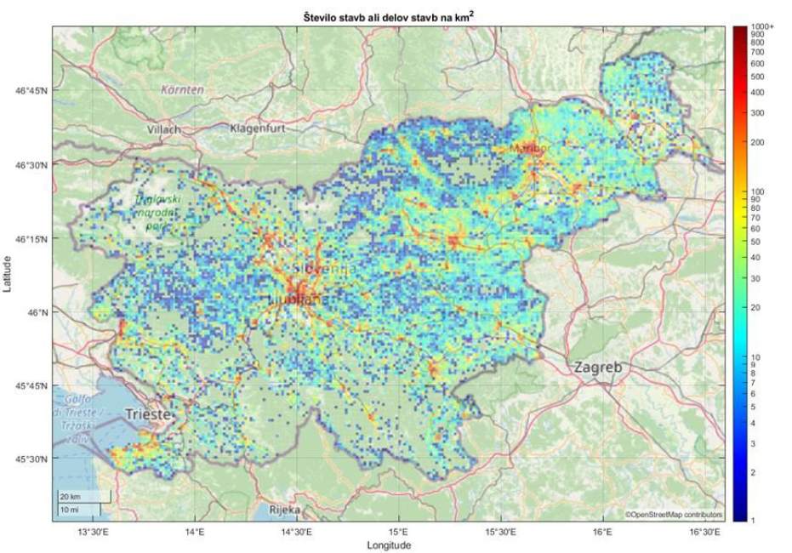

Figure 3: Density of buildings (number of buildings and/or parts of buildings) per km2 of area in Slovenia, as shown in the background document.

Strong earthquakes can simultaneously trigger several knock-on incidents, notably fires and explosions, hazardous material accidents, landslides, rock falls and floods, human and animal diseases, power and water supply disruptions, nuclear accidents, high water barriers' collapses, and so on. Modern science does not yet have the tools to predict the location, timing and magnitude of an earthquake, but there are methods of seismic risk analysis that can at least roughly take into account the knock-on effects of earthquakes and predict their consequences using probabilistic estimates, taking into account the effect of uncertain variables, which has not yet been implemented at an adequate level, neither in Slovenia nor the rest of the European Union.

The background document has shown that the seismic risk of the existing building stock in Slovenia is unacceptable due to excessively high probability of exceeding the borderline condition of total damage to buildings and of subsequent expected monetary losses.

The background document shows that between 88 thousand and 228 thousand people live in the most vulnerable buildings. In the event of an approximate repeat of the 1895 Ljubljana earthquake in 2020, the median value of direct damage to buildings would be EUR 7.2 billion, representing around 15% of the Slovenian 2019 Gross Domestic Product (hereinafter: the GDP).

## **2.2 Seismic events and recovery on Slovenian territory**

Within the Republic of Slovenia, the magnitudes of earthquakes do not usually reach very high values, but the effects can be significant due to their relatively shallow foci. Earthquakes have occurred throughout history, and their consequences and effects on people and their built environment depend mainly on facilities' levels of earthquake resistance, unless the earthquakes are exceptionally strong. In the 20th century alone, 15 earthquakes have occurred in Slovenia that have reached or exceeded the European macroseismic scale (EMS) intensity of Vll. At this seismic intensity, moderate facility damage can occur. In the seismic history of the area within present Slovenian borders, such an earthquake has occurred at least 50 times since the beginning of the 16th century.

The strongest recorded earthquake in the present-day Slovenian territory was the Idrija earthquake in 1511, with an estimated magnitude of 6.8. The Ljubljana earthquake of 1895, with a magnitude of 6.1, is better known to the public. Other notable earthquakes were the Kozjansko region earthquake of 1974, with a magnitude of 4.8, and the Friuli earthquake of 1976, with a magnitude of 6.5. The 1976 earthquake and the aftershocks that followed affected Posočje, especially Breginj.

The last strong earthquakes in the Bovec region were in 1998 and 2004, with magnitudes of 5.6 and 4.9.

So far, the largest-scale rehabilitation works in Slovenia to improve seismic resilience were carried out in Posočje, when a national technical office was also established to take care of the seismic retrofitting of facilities after two earthquakes. The first such earthquake occurred on 12 April 1998 in the Upper Posočje region, with a magnitude of 5.6. The most severe effects reached intensity VII–VIII EMS-98. The focus of the earthquake was located between the Lepena valley and the Krn mountain range at a depth of about 8 km. In addition to the extensive damage to facilities in the Bovec, Kobarid and Tolmin regions, the earthquake also caused considerable changes in the natural environment, with numerous rock falls, which in some places completely destroyed mountain paths. The second major earthquake occurred on 12 July 2004, with its epicentre in the Upper Posočje region. The maximum intensity reached was VI–VII EMS-98.

Under the auspices of the national technical office, the largest number of seismic retrofit works in the country were carried out. Planning such retrofit works has facilitated the acquisition of additional knowledge and experience in this field, while at the same time the works providers themselves have also acquired additional knowledge.

The earthquake with a focus near Petrinje, Croatia, in December 2020 also caused damage to buildings in Slovenia. Most of the damaged buildings are cultural heritage buildings (more than 300 damaged buildings have been registered). Damage occurred mainly to sacral buildings, castles and mansions. Due to a lack of financial resources, the damage caused by the earthquake, which worsened these buildings’ already deficient earthquake resistance, has not been rehabilitated, which further increases the risk of loss of cultural heritage.

## **2.3 Building stock situation**

The consequences of an earthquake event depend mainly on the earthquake resistance of the structures in which we find ourselves during an earthquake. The science of earthquake engineering developed rapidly in the second half of the last century and at the end of the 20th century, and has recently advanced to a stage where it is reflected in practice in the design and construction of earthquake resistant facilities with an emphasis on the protection of human life. It is important to bear in mind that even modern standards for earthquake resistant designing do not prevent damage to buildings and loss of property, as, from an economic point of view, the high potential of seismic load would make the construction of such facilities prohibitively expensive.

In Slovenia, the most problematic facilities from a seismic point of view are those that were built according to the standards in force until 1964, when the first regulation for seismically resilient construction works was introduced in Slovenia. Since then, the knowledge of the profession in the field of earthquake engineering and seismology has advanced considerably. In 1981, a new regulation was issued, which included some elements of modern standards for earthquake resistant design. At the end of 2005, Slovenia adopted the Rules on the mechanical resistance and stability of structures (Official Gazette of the Republic of Slovenia [Uradni list RS] Nos 101/05, 61/17 – Building Act (GZ) and 199/21 – GZ-1), hereinafter referred to as the Mechanical resistance rules, which introduces the European standard for earthquake resistant construction (SIST EN 1998 Eurocode 8 group of standards – Design of structures for earthquake resistance) into our legal order. A transitional period was established until 1 January 2008, during which the new requirements for the design of buildings were introduced and at the same time construction was still allowed under the old 1981 regulations as amended. Since 2008, properly designed and constructed buildings are considered to provide adequate earthquake resistance. The 2001 seismic hazard map of Slovenia – design ground acceleration is an annex to the National Supplement to EC8 and is used as part of the regulations for the design of buildings. From 1 May 2022 to 1 May 2024, the new Seismic Hazard Map of Slovenia is applicable in addition to the existing official map (2001), while after 1 May 2024 only the new map will be in use.

The collected building survey data showed that only 8% of the hospitals have had an earthquake resistance study done, which means that 8% of the hospitals have had their structures surveyed and the earthquake resistance assessed. Around 60% of hospitals were built before 1964, while only 10% of hospitals were built after 2008 and can therefore be assumed to be adequately resistant to earthquakes.

Homes for the elderly as well as care and works centres are also among the buildings housing the most vulnerable groups of people. The earthquake resistance of this category of buildings is only estimated for about 15% of these buildings. An analysis of the current situation of these buildings shows that around 25% of the buildings were built before 1964. Around 10% of these buildings were built after 2008, when the Mechanical resistance rules entered into force.

A large proportion of the building stock in the core public sector was built before the technical regulations requiring adequate earthquake resistant designing came into force. Around 40% of these buildings were built before 1964. After the entry into force of the Mechanical resistance rules in 2005, only about 6% of the buildings in the core public sector were built. Until now, the main investment in these buildings has been in energy renovation, while comprehensive renovation, which also includes increasing earthquake resistance, has been neglected.

**2.3.1 Seismic stress test of the characteristic Slovenian building stock**

In order to evaluate the risk posed to a society by an earthquake, it is first necessary to have a good understanding of all the factors that affect how structures respond to seismic shocks and that affect the protection of life. Therefore, it is necessary to know a site’s seismic hazard, which determines the expected ground motion intensities, the building stock and the occupancy of buildings in the event of a critical seismic event. The seismic stress test provides indicative seismic risk values for a group of buildings or an entire characteristic building stock.

The seismic stress test for the characteristic Slovenian building stock was carried out as part of the preparation of the background document and it covered just over half a million buildings or parts of buildings that are inhabited, or rather those whose value exceeds EUR 50,000 according to the real estate mass valuation model.

**2.3.2 Methodology for the seismic stress test**

The exposure of the building stock involved in the seismic stress test was defined based on the buildings’ locations, their year of construction, their intended use, their surface area, the supporting structure’s material, the building’s value and its number of storeys. Nevertheless, based on publicly available data and familiarity with the building stock as a whole, the seismic vulnerability and exposure can be modelled approximately at the level of the building classes into which buildings with similar characteristics are grouped.

The seismic hazard model shall determine the relationship between the ground motion intensity, the ground factor and the return period of the ground motion intensity. Such a model is a consequence of probabilistic seismic hazard analysis, which takes into account the influence of randomness and uncertainty in seismic hazard modelling in a systematic way.

The model of the earthquake effects on buildings and people is measured by various seismic risk indicators. The two most commonly used models are the time-dependent earthquake effects model, which evaluates the effects of all possible earthquakes in a selected period of time, and the event-dependent earthquake effects model.

The first model has the advantage of being more general, as it takes into account all possible earthquakes, the impact of which is then averaged over a selected time period (e.g. one year, 50 years). The second model is easier to understand by the general public, as it reflects a simulation of an earthquake and its consequences.

The seismic stress test of the characteristic Slovenian building stock was carried out using a model for the case of a devastating earthquake. The following seismic risk indicators were included:

* number of buildings or parts of buildings within the selected borderline condition of damage,
* expected damage,
* expected number of casualties.

Publicly available data on the building stock are incomplete and rather unreliable for the determination of an accurate exposure model, and therefore the assessment of the building stock’s earthquake resistance is also rather unreliable. Slovenia lacks such a building register that would provide adequate data for modelling seismic vulnerability and exposure at the individual building level. The publicly available data lack important information, including the type of structural system, the dimensions of the supporting structure elements, the material properties, the design process and results, as well as information on any subsequent works to the building structure.

**2.3.3 Results of the seismic stress test based on a time-dependent earthquake effects model**

The results of the seismic stress test are influenced by many factors. It is based on a probabilistic seismic risk analysis comprising a seismic hazard model, a building stock exposure model, a vulnerability model, a model of the consequences of earthquakes and earthquake events on buildings and people, and a seismic risk method. Due to the uncertainty and incompleteness of the building stock data and the randomness of the seismic ground motion, the impacts of uncertainty and randomness are weighted, which allows the results to be presented and disseminated with a certain degree of confidence. Therefore, the results below are stated as a median, or rather with an interval of values referring to the 90% confidence interval.

The key problem is posed by buildings classified in a high-risk class in terms of the probability of total damage. The total number of such buildings or parts of buildings ranges from 20,000 to 56,000 (90% confidence interval), representing between 4% and 11% of the characteristic Slovenian building stock (median 7%). According to the Central Population Register, between 88,000 and 228,000 people live in these buildings. If buildings that are also above the tolerable risk according to the target expected annual loss criterion are taken into account, it turns out that between 32,000 and 75,000 buildings or parts of buildings are earthquake-prone. For these buildings or parts of buildings, the probability of exceeding the borderline condition of total damage in 50 years is greater than 3%, or rather the expected annual loss is greater than EUR 270/100 m2 of the floor area of the building.

The number of earthquake-prone buildings or parts of buildings is therefore between 6% and 14% of the characteristic Slovenian building stock. Between 130,000 and 300,000 people live in these buildings, or rather between 6% and 15% of the total population in Slovenia. The value of the building stock classified in the unacceptable risk class ranges from EUR 6.4 billion to EUR 13.4 billion by applying 2019 values.

These buildings must be strengthened or replaced, or their expected annual loss otherwise reduced over the next 30 years. If the building stock does not undergo adequate renovation, the earthquake resistance of some buildings will further deteriorate over the years.

## **2.4 Assessment of the consequences of a strong earthquake**

If the historic Ljubljana earthquake of 1895 (M 5.9, I VIII EMS) were to have been repeated in 2020, the consequences would be massive. It is estimated that between 42,000 and 102,000 buildings would be damaged, with economic loss of between EUR 2.5 billion and EUR 16.6 billion, and median direct damage to buildings of EUR 7.2 billion. This means that such an earthquake would cause direct damages equivalent to 15% of the 2019 GDP of Slovenia, taking into account only the damage to the building stock excluding the damage to infrastructure facilities and other indirect damages. The damage thus estimated does not include other indirect costs that would occur in the event of an earthquake, such as provision of temporary housing, population recovery costs, infrastructure failure, rupture of critical infrastructure, disruption of economic production, loss of income due to loss of labour, etc. Also not covered are the losses suffered by Slovenia due to the loss of its cultural heritage as one of the basic elements of its national identity and continuance of its national and state community. The damage caused to the buildings would be catastrophic for Slovenia, especially as the renovation process would be quite lengthy, since a very large number of buildings would have to be rehabilitated or rather demolished and replaced. This fact makes it important to strengthen the building stock before a devastating earthquake strikes, which means that it is necessary to act preventively and to gradually start reinforcing the building stock.

## **2.5 The impact of earthquakes on people**

The injuries to people caused by the effects of an earthquake are influenced by many factors. First and foremost, human injury depends on the intensity of the seismic event, the quality of construction works, building occupancy at the time of the earthquake, and also on subsequent works on the building’s construction, where all works to on load-bearing elements, and in particular their removal, are problematic.

The number of injured also depends on the supporting structure’s material and the type of the structural system and the design of the facility, as these factors also determine how the building collapses in the event of a very strong earthquake. The number of casualties and injured also depends on the time of occurrence of the earthquake, as building occupancy varies during the day, during the week and between months. The estimated number of people in a building is also affected by daily commutes. The population distribution varies during the weekday and weekends, and is also affected by national holidays and main school breaks. The number of casualties is affected, among other things, by the condition of the critical infrastructure damaged in the earthquake, which is important for the provision of medical and other care to the victims after the earthquake.

The number of casualties is therefore influenced by many factors that cannot be predicted in advance. Assessing the impact of an earthquake on people is a complex process, involving many uncertainties and assumptions. In the event of total structural collapses, casualties are to be expected regardless of the material and structural system.

# OBJECTIVES

The Resolution imposes the preparation of implementing documents – action programmes for seismic risk reduction (hereinafter: the action programmes). The action programmes will be updated periodically, presumably every five years, with the first one to be readjusted within two years of the adoption of the Resolution. The implementation of the measures will be gradual, with initial activities striving to create the conditions to achieve the set objectives. However, interim reviews of efficient implementation of the action programme measures will also be carried out.

The Resolution primarily aims to establish a strategic framework for the formulation of action programmes and to raise awareness among the general public, expert community and decision-makers about the imminent earthquake hazard and the condition of the Slovenian building stock in terms of earthquake resistance.

The level of familiarity with the earthquake resistance of the majority of the building stock is low. It is therefore planned to ensure a more detailed familiarity with the condition of the entire building stock in terms of earthquake resistance in the first years of implementation, starting with the facilities for which the consequences of damage or even collapse following an earthquake would have the greatest societal impact.

The overarching objective is that the seismic risk of the building stock after implementing the measures provided for in the Resolution should be below the acceptable risk, still to be defined by social consensus by taking into account the society’s capacity for recovery after a devastating earthquake and the seismic risk of the area concerned. According to the baseline seismic stress test of the building stock,1 this means that between 32,000 and 75,000 buildings or parts of buildings will need to be seismically retrofitted and in some cases even replaced over the coming decades. The retrofitting and replacement of buildings will be gradual due to limited human and financial resources. Despite the resource constraints, it makes sense to act relatively quickly, as a longer time period increases the risk of the building stock’s ageing and deterioration, while a longer time period also increases the risk of a higher probability of a devastating earthquake.

The action programmes will pursue the main objectives of the Resolution, which are as follows:

1. AWARENESS RAISING: the public will be made aware of the risks posed by an earthquake and the measures that can be taken to reduce these risks to an acceptable level, which will contribute to raising society's (owners' and decision-makers') awareness of the importance of seismic safety and better accepting the necessary actions to be taken;
2. ESTABLISHING A SYSTEM-LEVEL LEGAL FRAMEWORK: a system-level legal framework shall be established to regulate this area, from possible adjustments to the normative framework allowing for more effective action, to the establishment of a central management and steering system for the long-term building retrofit project;
3. TRAINING AND EDUCATION: building professionals and other stakeholders in construction processes will be provided with additional skills. The aim is to provide quality training to the profession to adequately address the seismic risk that buildings are facing and to train retrofitters to use appropriate building materials and methods;
4. BUILDING STOCK SURVEY: an expert survey of relevant existing buildings will be carried out and their risk level will be identified to serve as a basis for further action;
5. PROVISION OF FINANCIAL RESOURCES FOR SEISMIC RISK REDUCTION: the possibilities of providing financial resources for the renovation of earthquake-prone buildings, or rather for the reduction of seismic risk, will be explored;
6. DESIGN AND SEISMIC RETROFIT OF EARTHQUAKE-PRONE BUILDINGS: design and renovation of earthquake-prone buildings, whereby priority areas and efficient use of public funds will be identified in order to renovate key buildings first. Demolition and building of a new facility instead of renovation may also be opted for on the basis of cost benefit analyses, where architectural, environmental and conservation policies and objectives have to be taken into account;
7. CONCERN FOR ENSURING AN ADEQUATE QUALITY OF SEISMIC RETROFIT: expert support in the preparation, implementation and quality control of the design and seismic retrofit;
8. INVENTORY OF THE CONDITION OF BUILDINGS: public access to the implemented measures data and the achieved level of earthquake resistance shall be established.

# 4. SEISMIC RISK MEASURES

In order for seismic risk to be effectively managed, the Resolution provides for potential action programmes. These will contain key activities to encourage society to take measures to increase the earthquake resistance of both building stock and the community. The action programmes will focus on providing information about seismic risk, raising public awareness regarding seismic resilience and safety, educating experts in the field, implementing measures to evaluate seismic safety, progressively improving seismic resilience, and systematically regulating the field, as well as obtaining sources of funding.

For each planning period, objectives and actions towards seismic safety will be determined and the possibilities of providing adequate sources of funding will be explored. In this context, a review of the achieved objectives and of the actions related to the building stock for the previous period will also be carried out.

In the context of the preparation of the implementation part of the action programmes, more detailed objectives of providing seismic safety will be set and will be based on the key measures of the Resolution. Based on the action programmes’ implementation, it will be determined whether additional measures need to be identified to achieve the set objectives, and the financial implications of the measures will be assessed for each of the presumably five-year planning periods.

The key measures that Slovenia will take to address seismic risk management are as follows:

* raising awareness and disseminating information on seismic hazard and safety, and on seismic risk,
* measures for the systemic regulation of the improvement of seismic resilience,
* education and training of designers, operators, supervisors, manufacturers of construction materials and reviewers of design documents, as well as decision-makers in managing authorities and other stakeholders in construction processes,
* seismic risk assessment of the existing building stock,
* improvement of seismic resilience: through adequately detailed design documents, investment preparation, organisation of logistics and completion of construction and other works,
* preparing financial products and exploring the possibility of providing adequate sources of financing to retrofit buildings to reduce seismic risk.

As there is insufficient knowledge of the building stock’s condition in terms of earthquake resistance, individual mathematical assessments of the earthquake resistance of buildings should be made already at an early stage. In the context of the action programmes, criteria will be established for a priority set of buildings to be strengthened or replaced with new buildings in cases where a retrofit was no longer viable. The priority set criteria will include in particular the societal importance of a facility or a building, its cultural value, its usable floor area, the number of people normally occupying the building, the location of the building on Slovenia’s seismic hazard map and the building’s demonstrated lower earthquake resistance. The obvious advantage of the immediate retrofitting of such buildings is avoiding the catastrophic consequences of an earthquake, the possibility of providing emergency care to people in the immediate aftermath of an earthquake, and the country’s as normal as possible functioning. However, retrofitting these buildings also makes sense in other respects. As they are usually public buildings with large floor areas (schools are such an example), they can serve as post-earthquake emergency shelters for people whose living quarters are severely damaged during the earthquake. At the same time, some of these buildings are easier to renovate because they are not fully occupied for a certain period of the year (schools are such an example). The level of familiarity with some of these buildings is relatively high, which means that additional research possibly delaying the actual retrofitting will not be necessary or can be carried out on a much smaller scale.

## **4.1 Raising awareness and disseminating information on seismic hazard and safety, and on seismic risk**

Activities for raising awareness of seismic risk and of the steps to ensure seismic safety are key elements to achieving earthquake resistance of the building stock.

One important measure is to inform the users, owners, tenants, buyers of buildings or apartments and renovation operators, who face works to the supporting structure as a matter of urgency, about the importance of earthquake-proof construction.

Building owners often carry out works to supporting structures without the prior professional judgement of a structural designer, without realising that even minor adaptations to supporting structures can be problematic in the event of an earthquake. Therefore, in the coming years, increased activity will also be undertaken to raise awareness among key actors in the construction process.

It is crucial that information on seismic risk be provided to stakeholders exposed to seismic risk in time. Better awareness of seismic risk among building owners will encourage owners to invest in seismic strengthening of their buildings.

## **4.2 Measures for the systemic regulation of the improvement of seismic resilience**

The need for systemic regulation of this area has emerged inter alia from the catastrophic earthquakes in neighbouring countries. Further lessons learned about the field’s better systemic regulation will show in practice mainly through the implementation of pilot projects for the renovation of earthquake-prone buildings and the establishment of a comprehensive model for seismic risk assessment at various levels of accuracy. These will be followed by actions through action programmes and recommended changes for removing systemic barriers to effective action.

**4.2.1 Organisational structure responsible for improving seismic resilience**

The Ministry responsible for construction affairs leads the implementation of the seismic resilience policy and the implementing body.

In order to implement the proposed measures of the Resolution, an implementing body will need to be established under an appropriate legal basis and its scope of tasks will need to be defined, including the management of activities to improve seismic resilience (e.g. training of certified engineers, operators, supervisors and surveyors, and checking the adequacy of the proposed measures for individual buildings). It is also expected to carry out all the necessary procedures for technical assistance in the preparation of design and investment documentation and for the allocation of financial resources for the implementation of projects to improve seismic resilience by renovating earthquake-prone buildings. The organisational form of the implementing body will be laid down in a legislative act.

**4.2.2 Database for the expert community**

All building survey data will be collected in one place and will serve as a basis for the further implementation of projects and possibly repeated seismic stress tests, which will increase the set of information on buildings. A systematic approach will require legal regulation, as a single database will be established on the surveyed buildings and also on the buildings that have already been seismically retrofitted, which will form the basis for more detailed seismic risk analyses. The seismic stress test will be updated per the updated earthquake resistance assessments of individual buildings or groups of buildings, and will include data from the established database. The seismic stress test model and its variants will be used for further preventive action.

**4.2.3 Establishment of an inventory of building earthquake resistance**

An inventory of buildings’ earthquake resistance will be established, showing the surveyed and seismically retrofitted buildings, which will increase the set of information on buildings.

## **4.3 Measures for education and training of designers, operators, supervisors, manufacturers of construction materials and reviewers of design documentation, and other actors involved in construction processes**

As there has been little demand for seismic retrofitting and as it has been carried out on a small scale, there are not enough experts in Slovenia with knowledge and experience in the seismic analysis of existing facilities, in particular in providing seismic safety, who are able to model buildings using non-linear methods. Therefore, additional experts will need to be trained in the coming years through appropriate (educational) institutions to perform seismic analyses of various levels of accuracy.

Construction operators in the market have a lot of experience with construction of new buildings, but less with seismic retrofitting, as these skills are specific. There has not been a strong demand for these services in the market so far, so the development of this segment has been insufficient. It has been found that there is a lack of operators in the market for such retrofitting. With a growing demand for the retrofitting of structures, the level of operators’ knowledge will also need to be increased, both in theory and in practice. In the coming years, the training of operators in seismic retrofitting of facilities will be increased.

As seismically retrofitting buildings is a very complex problem, seismic analyses and the determination of the necessary measures can only be carried out by suitably qualified experts. These are mainly civil engineers, who already acquired the relevant skills during their schooling. Based on initial experience, the seismic retrofit designing may need to be further regulated, as SIST EN 1998-3:2005 Design of structures for earthquake resistance – Part 3: Assessment and retrofitting of buildings requires that in most cases the strengthening of existing buildings is based on the results of non-linear analyses. Given the complexity of such analyses and the fact that students do not acquire such knowledge in their master's degree studies, civil engineers will need to be further trained. It is therefore reasonable that seismic analysis and the design and control of seismic retrofit projects for existing facilities should be carried out only by appropriately qualified experts.

The seismic retrofitting of a building includes, as a minimum, the survey of the existing building and the materials used, the analysis of its seismic response, the design of the strengthening (if applicable), the control (revision) of the seismic strengthening design, the completion and supervision of the seismic strengthening. The design and technical execution of all processes of seismically retrofitting a building must be flawless, as otherwise defects may occur that cannot be detected in the next process or subsequently corrected, as this may be the case with some other essential requirements for constructions and products. Therefore, a seismic retrofit process needs to be properly regulated in a systemic way. Given the complexity of the problem, it is essential to ensure that the design documentation is controlled and that the implementation is supervised by suitably qualified staff.

## **4.4 Measures for the evaluation of seismic safety**

The level of familiarity with the building stock is not yet good enough, but more detailed structural surveys will see it increase in the coming years. Based on the information received, seismic stress tests will be updated in the future. In the coming years, data will be collected on all buildings in the characteristic building stock and will be used to improve the models used in the seismic risk analysis.

Vulnerability analyses at the level of individual buildings can be very precise and complex, or they can be simpler but less reliable. Due to the large volume of buildings, the limited time available and the need for suitably trained experts, it makes sense to first apply a lower level of accuracy to buildings that are less important for society, and a higher level of accuracy to more important buildings.

Therefore, a multi-level method for vulnerability analysis will have to be developed. Most of the information needed to carry out such analyses could be gathered with the help of construction engineers who would be trained in building surveying.

## **4.5 Measures to improve seismic resilience**

Experience has shown that it is only feasible and reasonable to strengthen certain earthquake-prone facilities to the point of protecting lives, while in some cases with a view to reducing expected losses, strengthening is not economically viable. Therefore, simply prescribing measures to strengthen buildings would be insufficient so as to establish long-term strengthening of the earthquake resistance of the building stock. In order for the seismic resilience improvement measures to be as effective as possible and in order to create societal interest in implementing such measures, these should be implemented together with other measures (raising awareness, education, training, etc.).

Further implementing parts of the Resolution will also provide for priority strengthening of buildings. The criteria for the priority strengthening of buildings should include the facility’s societal importance, the possibility of temporarily accommodating a large number of people and the possibilities for providing care immediately after an earthquake. In the case of multi-dwelling buildings, it is reasonable to give priority to the most vulnerable buildings with a high number of occupants, as these are the buildings where the highest loss of life is expected in the event of major earthquakes. Priority will also be given to retrofitting cultural heritage buildings that have the status of a cultural monument or are protected under international regulations.

Seismic designing and retrofitting of buildings and the conduct of works will comply with the regulations and standards in force. The seismic retrofit project activities will presumably include a preliminary rough analysis of the structure and an identification of the parts of the structure to be seismically strengthened, the acquisition of information on geometry, details and materials, an analysis of the existing structure and a control of the borderline condition in respect of the building category, proposed retrofit methods, a preparation of the appropriate design documentation for the selected retrofit method, as well as a review of the seismic retrofit project, selected retrofit method implementation in accordance with the implementation documentation and its supervision.

**4.6 Consideration of possible funding of seismic risk reduction measures**

In order to achieve the objectives of the Resolution, adequate level of financial resources will have to be provided for the implementation of the proposed measures. A more detailed definition of the amount of funding needed for the implementation of individual measures to reduce seismic risk will be included in the action programmes. These will include not only the amount of required funds and the baseline criteria for identifying priority interventions, but also possible sources for funding the measures.

# 5. MONITORING THE RESOLUTION’S IMPLEMENTATION

A system for monitoring the effectiveness of the Resolution’s implementation shall be established to determine whether the measures’ implementation and the achievement of the objectives of the Resolution are effective. The monitoring shall be managed by the Ministry responsible for construction.

Regular monitoring of the Resolution’s implementation will provide an overview of the measures’ effectiveness and appropriateness for achieving the set objectives. It will be carried out mainly through the updating of the action programmes and the monitoring of the implementation of the measures to achieve the Resolution’s objectives. The main purpose of such monitoring is to determine the effectiveness of the implementation of the measures or projects concerned on an ongoing basis. The action programmes will specify the activities to be carried out within each measure, the body responsible for the activities (e.g. the organisation responsible for carrying out the activities) and the deadline by which the activities must be completed. The Ministry responsible for construction is responsible for updating the action programmes and monitoring the objectives set. Interim and final reports on the implementation and effectiveness of the activities carried out shall be adopted by the Government of the Republic of Slovenia.

# 6. SOURCES AND REFERENCES

[1] Seismic Risk Assessment; September 2015, available at:

<https://www.gov.si/assets/ministrstva/MNVP/Dokumenti/Graditev/ocena_tveganja_potres_september2015.doc>

[2] Seismic Risk Management Capacity Assessment, April 2018, available at:

<https://www.gov.si/assets/ministrstva/MNVP/Dokumenti/Graditev/ocena_zmoznosti_obvladovanja_tveganja_za_potres.docx>

[3] Health Care Response Plan in Case of Natural and Other Disasters in the Republic of Slovenia, January 2022, available at: <https://www.gov.si/teme/katastrofna-medicina>

[4] Assessment of Seismic Risk in the Republic of Slovenia, June 2018, available at:

<https://www.gov.si/assets/organi-v-sestavi/URSZR/Datoteke/Ocene-ogrozenosti/ocena_ogrozenosti_potres.pdf>

[5] POTROG, Seismic risk in Slovenia research project for the needs of the Civil Protection Service, available at: <http://potrog2.vokas.si/>

[6] Design ground acceleration map of Slovenia for a return period of 475 years, J. Lapajne, B. Šket Motnikar, P. Zupančič, Ministry of the Environment and Spatial Planning, 2001, available at:

[https://www.arso.gov.si/potresi/potresna %20nevarnost/projektni_pospesek_tal.html](https://www.arso.gov.si/potresi/potresna%20nevarnost/projektni_pospesek_tal.html)

[7] New seismic hazard map of Slovenia – design ground acceleration of Slovenia for a return period of 475 years,

<http://potresi.arso.gov.si/doc/dokumenti/potresna_nevarnost/Karta_potresne_nevarnosti_2021.jpg>

National Assembly  
of the Republic of Slovenia  
**Urška Klakočar Zupančič**  
President

Resolution was published in Official Journal (Uradni list RS, št. 122/23)