 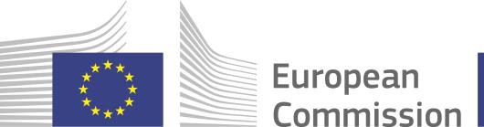

EU ECONOMIC GOVERNANCE FRAMEWORK REFORM – FINDING CONSENSUS TO ENSURE SUSTAINABILITY AND GROWTH

Congress Center, Brdo pri Kranju, 9 March 2023

***Hybrid event***

|  |  |
| --- | --- |
| 9.00-10.00 | *Arrivals and coffee* |
| 10.00-12.00 | Moderator of the event is Mitja Gaspari, former Minister of Finance and former Governor of the Bank of Slovenia  **Opening speech:**  Robert Golob, Prime Minister, Slovenia  Paolo Gentiloni, Commissioner for Economy, European Commission  **Panellists**:  Klemen Boštjančič, Minister of Finance, Slovenia  Paolo Gentiloni, Commissioner for Economy, European Commission  Paschal Donohoe, President of the Eurogroup Fernando Medina, Minister of Finance, Portugal  Johanna Lybeck Lilja, State Secretary, Minister of Finance, Sweden (on-line)  Pierre Gramegna, Managing Director, European Stability Mechanism |
|  | Questions from the audience including the media will be possible |
| followed by | *Buffet lunch* |