**Robert Golob**

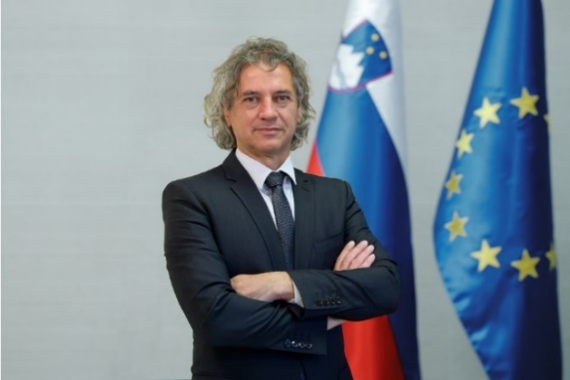

Dr Robert Golob, born 23 January 1967, graduated from the Faculty of Electrical Engineering of the University of Ljubljana, where he was also awarded a doctoral degree in 1994. He is one of the leading experts in power engineering in Slovenia.

In 1998, Dr Golob was appointed head of the negotiation team for energy in the EU accession negotiations. A year later he became State Secretary for Energy and participated in the drafting of key legislation in this area.

In 2002, he established a private company, Strela-G, which was later transformed into GEN-I. In little more than a decade, the company turned from a local into a global electricity supplier.

Dr Golob entered politics on 24 January 2022 at the congress of the Green Actions Party (*S*tranka zelenih dejanj), where he became the party’s president. At the same congress, the party was renamed Freedom Movement (Gibanje Svoboda). In the 2022 elections, he was elected as a deputy of the National Assembly and the party won a record 34.45% of the votes and 41 seats in the National Assembly.

**Paolo Gentiloni**

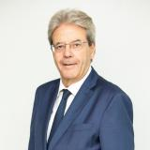

Paolo Gentiloni is the European Commissioner for Economy since December 2019.

He served as Prime Minister of Italy (2016- 2018), Minister of Foreign Affairs and International Cooperation (2014-2016), Member of the Committee on Foreign Affairs (2013-2014) and Minister of Communications (2006-2008).

Previously he was Spokesperson for the Margherita Party (2002-2007), Chairman of the Broadcasting Services Watchdog Committee (2005-2006), Spokesperson for the Mayor of Rome and Commissioner in the City of Rome (1993-2000). Previously he worked as a professional journalist.

Born in 1954, Gentiloni graduated in Political Sciences from La Sapienza, Rome.

His last book is “La sfida impopulista” (T*he (Un)populist challenge*).

**Klemen Boštjančič**

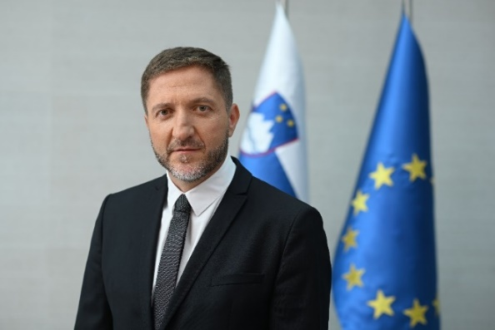

Klemen Boštjančič, born 1 September 1972, is a university graduate in economics. For the last 10 years, he has led his own consulting firm specialising in financial and business restructuring (primarily of companies in difficulties), business model analysis, acquisitions and mergers, licencing and recruitment.

He was involved in several projects carried out by banks and other financial institutions. He has managed numerous restructuring projects, and cooperated with many investors, such as banks, financial funds, natural persons and the state. He was a holder of the procuration of Trimo d. d. For two years he served as Chairman of the Board of Adria Airways d. d., and during that time the company successfully concluded financial restructuring and started implementing a restrictive but very ambitious plan of operational restructuring. He was appointed Minister of Finance of the Republic of Slovenia on 1 June 2022.

**Paschal Donohoe**

Portret Paschala Donohoeja

Paschal Donohoe T.D. is Ireland’s Minister for Public Expenditure, National Development Plan Delivery and Reform. He was appointed to this role in December 2022. Prior to this role, he served as Minister for Finance in two Governments since June 2017. Minister Donohoe was first elected President of the Eurogroup in July 2020, and then again in December 2022. His second two-and-a-half-year term formally began in January 2023. In this role, he is also the Chairperson of the Board of Governors of the European Stability Mechanism. Minister Donohoe also previously served as Minister for Public Expenditure and Reform from May 2016 - June 2020, and from July 2014 - May 2016, as the Minister for Transport, Tourism and Sport. He also held the position of Minister for European Affairs at the Department of An Taoiseach and the Department of Foreign Affairs from July 2013 - July 2014.

Minister Donohoe was first elected as a Teachta Dála (T.D. – Member of the Irish Parliament) in February 2011 for the Dublin Central constituency. Prior to this he was a member of Seanad Éireann (the Senate), from 2007 - 2011. He also served as member of Dublin City Council from 2004 - 2007. As a T.D., Minister Donohoe served as the Chair of Ireland’s Future in Europe Oireachtas Sub-Committee, as well as a member of the Public Accounts Committee. He has also served as the Vice-Chair of the European Affairs Committee and, as a Senator, he served as a member of the Joint Oireachtas Committee on Transport.

Minister Donohoe is a graduate of Trinity College Dublin, with a degree in Politics and Economics and he attended St. Declan’s Christian Brothers School.

**Fernando Medina**

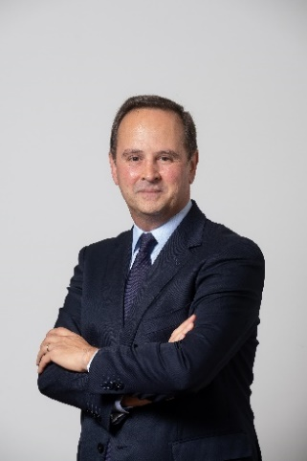

Fernando Medina was born in Porto in 1973. He is an economist, with a degree from the Porto School of Economics and a master’s degree in Economic Sociology from University of Lisbon’s ISEG - Lisbon School of Economics & Management. He was Mayor of Lisbon (2015-2021), Deputy Mayor in charge of Finance (2013-2015) and President of the Lisbon Metropolitan Area (2017-2021). He was a member of parliament and Vice-President of the Socialist Party’s Parliamentary Group (2011-2013); he was on the Budget and Finance Committee and the Committee to Monitor the Economic and Financial Assistance Programme. He was Secretary of State for Industry and Development for the Ministry of Economy (2009-2011) and Secretary of State for Employment and Vocational Training for the Ministry of Labour and Social Solidarity (2005-2009). He was Advisor for Education and Advisor for economic affairs for Prime Minister António Guterres. He held several posts in bodies and services belonging to the Ministry of Labour, the Ministry of Economy and is currently a permanent staff member of AICEP.

He is a member of the Socialist Party’s Secretariat.

**Johanna Lybeck Lilja**

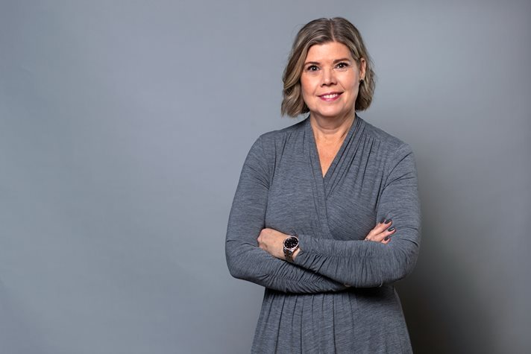

Johanna Lybeck Lilja is State Secretary to Minister for Finance of Sweden Elisabeth Svantesson. She is responsible for Economic policy and international economic cooperation.

Born in 1966, lives in Stockholm, married and has three children.

She studied Economics at Stockholm University and attended University of Massachusetts in the U.S. (1988-1989) on a scholarship. She obtained Certified European Financial Analyst Diploma (DEFA) from Stockholm School of Economics (1999-2000). From 2003 until 2004 she participated in leadership training of Sveriges Riksbank and in 2008 she studied Basic EU law at Uppsala University.

In the past she held different positions and assignments: Special Adviser, Working Group on Pensions (2010-2014), Chair, Financial Markets Committee (2010-2012), Chair, preparation group for the Financial Stability Council (2013-2014), Board Member/Member, Advisory Committee, Nasdaq Nordic (2016-2022), Board Member, SwedSec Licensiering AB (2017-2022), Project Manager, Näringslivets EU-fakta Assignments (1994-1995), Economist, Sveriges Riksbank (1996-2000), Head of Department, Sveriges Riksbank (2000-2004), Adviser, Sveriges Riksbank (2004-2008), Director and Special Adviser, Ministry of Finance (2008-2010), State Secretary, Ministry of Finance (2010-2014), Strategic Adviser, Nordea (2015-2022).

**Pierre Gramegna**

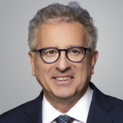

Pierre Gramegna is the Managing Director of the European Stability Mechanism (ESM) since 1 December 2022 and CEO of the European Financial Stability Facility (EFSF) since 13 December 2022.

Mr Gramegna was Minister of Finance of the Grand-Duchy of Luxembourg and member of the ESM Board of Governors from December 2013 to January 2022.

In his eight years as Minister of Finance, Mr Gramegna rebalanced the national budget and ensured that Luxembourg fully complied with the EU Stability and Growth Pact. During his term, the country was rated AAA by all rating agencies.

Mr Gramegna also served as chairperson of the Ecofin Council in 2015 where he chaired the ministerial meetings and oversaw major directives on the automatic exchange of information and transparency.

In his capacity as Finance Minister, Mr Gramegna served as Governor to the International Monetary Fund and several multilateral development banks. In 2016, he was elected Chairman of the European Bank for Reconstruction and Development for one year.

In 2017, he set up the Luxembourg House of Financial Technology to promote fintech and the enhanced digitalisation of the financial centre.

Mr Gramegna’s commitment to issues related to climate change is illustrated by his participation in many United Nations Climate Change Conference ministerial meetings and initiatives taken in the field of sustainable finance, including the setting up of a climate finance platform with the European Investment Bank.

From September 2003 to December 2013, Mr Gramegna served as Director General of the Chamber of Commerce of Luxembourg. During that term, Mr Gramegna served for several years as Vice-President of Eurochambres and as Chairperson of Cargolux Airlines from 2004 to 2008 in addition to being a member of several boards, including the Luxembourg Stock Exchange and BGL BNP Paribas Luxembourg SA.

Mr Gramegna held a diplomatic career spanning from April 1983 to August 2003, holding various posts including:

* Ambassador of Luxembourg in Japan, also accredited in South Korea, from 1996–2002;
* Consul General of Luxembourg in San Francisco from 1993–1996;
* Counsellor at the Embassy of Luxembourg in Paris from 1988–1992; and
* Secretary, First Secretary at the Ministry of Foreign Affairs of Luxembourg from 1983–1988.

Mr Gramegna studied Law and Economics at the University of Paris II (Pantheon-Assas) where he graduated with a degree (Maîtrise) in civil law in 1981 and a degree (licence) in economics in 1982. He also holds a Master of Advanced Studies (DEA) in European Community Law and was awarded the title of Doctor Honoris Causa from the ESCP Business School in Paris and the Sacred Heart University of Luxembourg.

**Mitja Gaspari**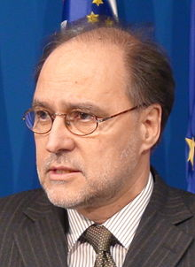

Mitja Gaspari studied economics at the University of Ljubljana and has gained a masters degree in monetary economics from the University of Belgrade Faculty of Economics.

Gaspari worked in the National Bank of Yugoslavia, where he became vice-governor in 1988. In September 1991, he became a senior advisor in the World Bank. Between 1992 and 2000, he served as Slovenian Minister of Finance. Mr Gaspari served as the governor of the Bank of Slovenia between 2001 and 2007. During his mandate, Slovenia adopted the euro as its official currency. Between 2008 and 2012 Gaspari was Minister in charge for Development and European Affairs. During his mandate Slovenia joined the OECD (2010).