|  |
| --- |
| Number: 38100-4/2022/5  Date: 25 August 2022  **GIGABIT**  **INFRASTRUCTURE**  **DEVELOPMENT PLAN 2030** |

Table of Contents

1 INTRODUCTION 4

2 EU TARGETS AND OBJECTIVES 8

2.1 Connectivity for a Competitive Digital Single Market – Towards a European Gigabit Society 9

2.2 5G for Europe: An Action Plan 9

2.3 2030 Digital Compass: the European way for the Digital Decade 9

2.4 2030 Policy Programme "Path to the Digital Decade" 10

3 THE STATE OF BROADBAND NETWORK DEVELOPMENT IN SLOVENIA 10

3.1 Analytical overview of the main indicators 10

3.2 Granting radio spectrum for the construction of 5G networks and the deployment of 5G technology 14

3.3 Comparing connectivity in Slovenia with the EU average 17

4 SLOVENIA’S STRATEGIC OBJECTIVES FOR GIGABIT INFRASTRUCTURE DEVELOPMENT 19

5 PLANNED INVESTMENT TO ACHIEVE OBJECTIVES 19

5.1 Strategic definition 20

5.2 Assessment of the investment gap 22

6 MEASURES TO ACHIEVE THE OBJECTIVES 24

6.1 Legislative measures 24

6.1.1 Transposition of Directive (EU) 2018/1972 establishing the European Electronic Communications Code 24

6.1.2 The transposition of Directive 2014/61/EU on measures to reduce the cost of deploying high-speed electronic communications networks 25

6.1.3 The allocation of radio spectrum in Slovenia and measures to ensure adequate radio spectrum coverage 26

6.1.4 Additional measures in connection with 5G networks 27

6.1.5 Compliance with EU state aid rules 28

6.2 Strategic measures 29

6.2.1 Mapping of infrastructure 29

6.2.2 Demand stimulation and the promotion of digitalisation and digital transformation 30

6.2.3 The provision of universal service 30

6.2.4 Toolbox for reducing the cost of deploying very high capacity networks 31

6.3 Financial measures 31

6.3.1 Public co-financing of the deployment of broadband networks in white spots 32

6.3.2 Other financial measures 32

6.4 Other measures for achieving the objectives 33

6.4.1 Geoportal 33

6.4.2 Infrastructure investment portal 33

6.4.3 AKOS Test Net 34

6.4.4 Technical assistance and expert advice 34

7 INDICATORS 35

8 ANNEX 36

1. INTRODUCTION

The intense and all-encompassing digitalisation of society is changing consumers' communication habits and expectations, which is reflected in the decline of fixed telephony and the increasing demand of modern users of electronic communications for enhanced internet connectivity anywhere, anytime and with any device. These changes are also reflected in the fact that high capacity mobile access to all online content is one of people’s most important needs. At the same time, businesses, households and other socio-economic stakeholders expect to have access to high capacity optical networks at fixed locations. There is no doubt that a modern and high-performance fixed and mobile electronic communications infrastructure is one of the key factors in the digital transformation of society and the competitiveness of the economy. Hence, it is in the public interest that, within its powers, the Government of the Republic of Slovenia provides appropriate guidelines and support for such infrastructure in its national development policies. This Gigabit Infrastructure Development Plan 2030 (hereinafter: the Plan) is a response to the development challenges in electronic communications in the next development period.

The Plan is Slovenia’s strategic document for the setting up – and partly also for promoting the use of – infrastructure that will enable gigabit connectivity to all Slovenian households or homes, [1]businesses and the main socio-economic drivers, [2]while providing uninterrupted 5G coverage in all urban and other populated areas and along major terrestrial transport paths. The Plan is fully harmonised with the fundamental digital objectives of the European Union (hereinafter: the EU) in the field of connectivity but it does not include digital objectives in the field of digital infrastructure which will be covered by other strategic documents and public policies.[3]The Plan includes objectives and measures aimed at developing gigabit infrastructure, hence making Slovenia one of the most digitally advanced countries by 2030, providing coverage by gigabit networks to all households and 5G coverage of all populated areas. The Plan’s key intermediate objective is to provide by 2025 all Slovenian households with internet connectivity offering at least 100 Mbps, upgradeable to gigabit speed.

The Plan also constitutes a basis for the allocation of funds from the recovery and resilience facility, cohesion policy funds for the period 2021–2027 and other public funds in this field. In this way, the *ex ante* conditionality is met for the deployment of broadband infrastructure in white spots and the promotion of connectivity with the uptake of the most suitable technologies.

The achievement of the objectives set out in the Plan will provide the gigabit infrastructure necessary for the deployment of modern digital content and services and a prerequisite for a double digital and green transformation of the economy and society. The development of an information society or knowledge-based society is based on the general use of information and communications technologies (ICT) and the internet in all fields of social life and creativity. A prerequisite for this is a ubiquitous high capacity electronic communications infrastructure, accessible electronic communications services, and appropriate digital skills and knowledge. Economic and general development in a modern digital society is directly connected with the development of high-quality broadband infrastructure that serves as the basis for the development and use of the internet. Strategic planning should therefore follow the development of ubiquitous high capacity broadband infrastructure (fixed, mobile and satellite) that will be open and accessible to all end-users, creating equal opportunities for inclusion in the information society. Accessible broadband infrastructure throughout the country enables balanced development, reduces the digital divide and increases the involvement of individuals in contemporary social trends. In terms of development guidance, the uptake of the internet is a strategic tool for increasing productivity and digital competencies, creating innovative business models, products and services, making communication more efficient, and increasing the overall efficiency of society.

Studies on the socio-economic impact of investment in broadband infrastructure have established a strong interdependence between broadband penetration and economic growth, and a positive impact on employment and productivity. According to the OECD study, there is a direct correlation between the penetration of broadband services and GDP growth – a 10% increase in broadband connectivity can be expected to raise per capita GDP growth by 0.9 to 1.5 percentage points.[4]A study by Ericsson, Arthur D. Little and Chalmers University of Technology shows a similar correlation, namely that broadband deployment leads to enhanced productivity and innovation in companies. It also pointed to wider social and environmental benefits, including positive impacts on households.[5]Similarly, a study by the International Telecommunication Union entitled Impact of Broadband on the Economy found that broadband networks in rural areas enable balanced rural development and create a favourable environment for the development of small and medium-sized enterprises.

The COVID-19 epidemic showed how much people and businesses in the EU need connectivity and how important it is to them. Electronic telecommunications networks, especially very high capacity networks, played a crucial role in the response to the crisis, enabling telework, tele healthcare, distance education, remote personal communication and entertainment. Widespread gigabit connectivity will underpin the future intensive deployment of high capacity broadband networks in health, education, transport, logistics and media, which play a key role in the EU's economic and other development. The availability of wired and complementary wireless connectivity and subsidiary satellite connectivity contributes significantly to the provision of affordable and accessible services and to bridging the digital divide. At the same time, connectivity is an important means of informing the public and played an important role in limiting the spread of the virus.

Broadband internet access brings positive socio-economic impacts for the country and citizens. It enables balanced development throughout the country, reduces the digital divide and increases the involvement of individuals in contemporary social trends. It opens up new opportunities for people in business, private and public life: learning, employment, access to public information and services, access to various content and social media, increased productivity, innovative business models, products and services, more effective communications, etc.

Consequently, broadband infrastructure that provides internet access is one of the key factors for socio-economic development, and its deployment and promotion are in the public interest.

Particular attention should be paid to 5G networks, a technological breakthrough in terms of gigabit data transfer rates, very short latencies allowing real-time data transmission and massive machine-to-machine (M2M) communications in the context of the Internet of Things (IoT). 5G technology is a major improvement in the capabilities of mobile communications networks for all types of personal, public and business mobile communications. The development is moving towards the mass production and deployment of affordable devices with embedded SIM cards and low battery consumption. 5G networks will drive industrial automation (Industry 4.0), automated transport, smart cities, smart homes, smart buildings and similar. 5G technology is expected to enable major advances in the deployment of autonomous vehicles and next-generation transport.

Figure 1: 5G technology – latency and data transfer rates

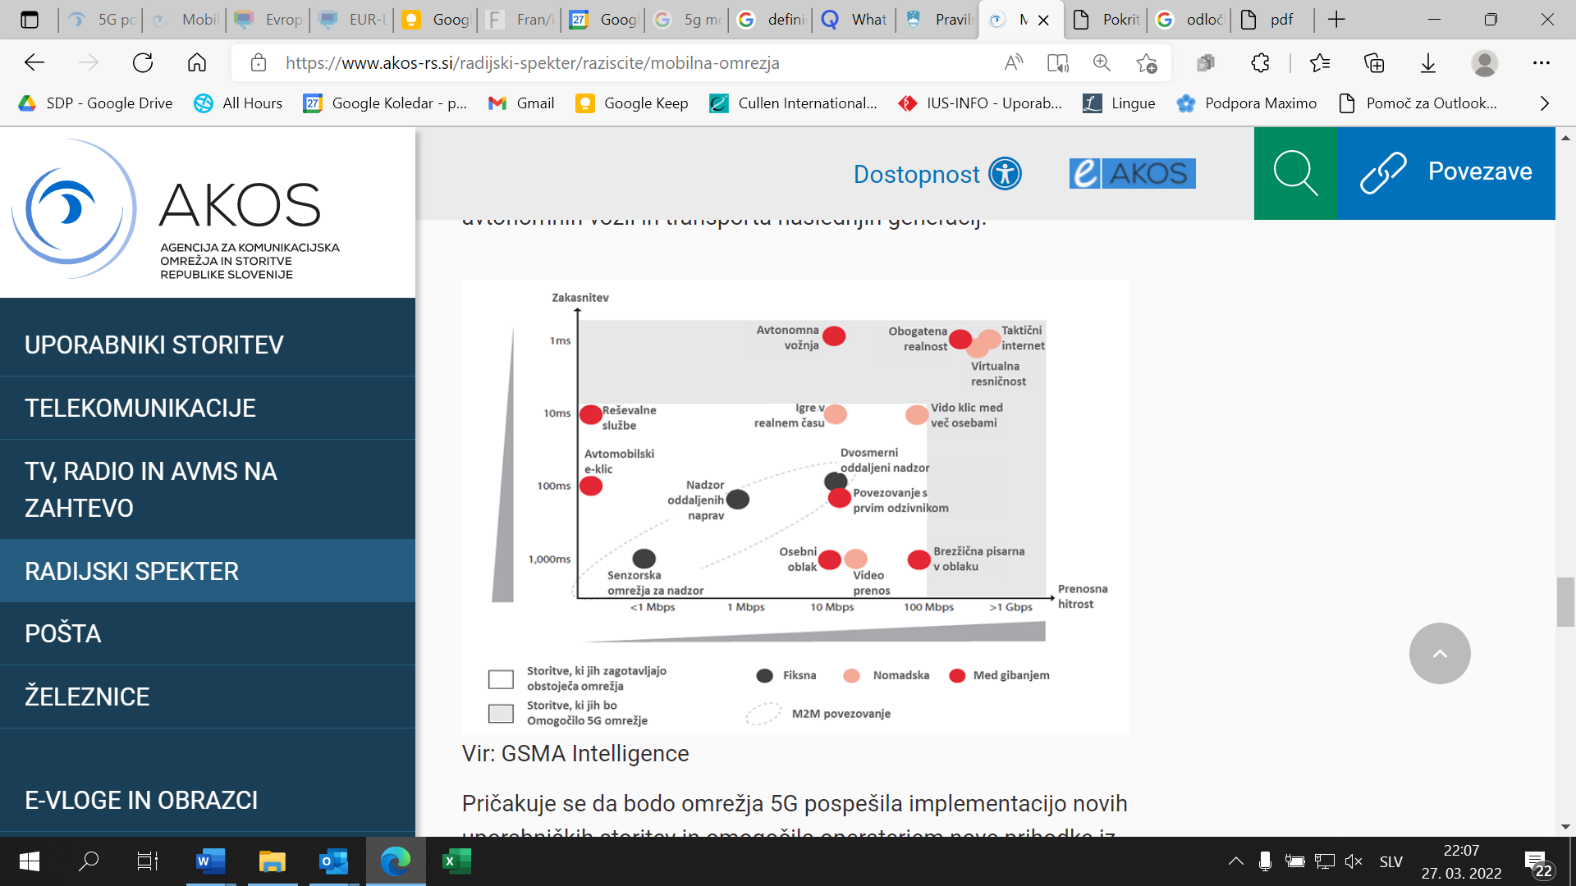

Source: GSMA Intelligence and Agency for Communication Networks and Services of the Republic of Slovenia (AKOS)

By design, 5G technology enables the use of public mobile communications network infrastructure to meet the needs of different sector verticals, such as the transport vertical for connected and automated driving, the Internet of Things for smart cities and Industry 4.0, public protection and disaster relief. 5G networks will accelerate the deployment of new user services and enable operators to generate new revenues. The development of new wireless transmission technologies, network equipment, antennas and antenna systems and new user devices will further accelerate the development of ICT and related application and content suppliers. The use of centralised radio access networks with dense small cells is foreseen. According to statistics, 80% of mobile users are static and only 20% are mobile, which means that new models will be used to provide indoor coverage of end-users with 5G network equipment, thus relaxing the requirements on outdoor coverage networks. The widespread use of the virtualisation of network functionalities and software-defined networks will enable innovative ways of using and sharing mobile networks and, on this basis, new business models.

The advantages of 5G technology development include:[6]

* highly efficient mobile networks providing better mobile network characteristics at lower investment costs;
* an ultra-fast mobile network, including the next generation of densely deployed small base stations with high data transfer rates; frequencies below 700 MHz and above 4G Hz will also be used, as well as dynamic spectrum access;
* combining fibre and wireless networks, which will provide internet data transfer rates of up to 10 Gbitps at millimetre waves (20–60 GHz) and will be dedicated to nomadic services [7](such as Wi-Fi) in addition to mobile access;
* supporting and meeting the needs of certain vertical sectors, notably automotive, transport, healthcare, energy, manufacturing, media and entertainment.

5G technology enables high capacity mobile communication for demanding video transmission, M2M communications and electronic communications services that are particularly sensitive to latency. Using software-defined networking technologies and the virtualisation of network functions, network slices can be created and managed as virtually autonomous networks. They can be used to cover the specific needs of sectoral verticals, i.e. the content of networks.

All technologies that can contribute to the connectivity objectives, including emerging and future technologies, will be treated in line with the principle of technology neutrality for the purposes of national action, taking the characteristics of each technology into consideration. This decade may see rapid further development, enabling even more powerful virtual and augmented reality technologies and accelerated development of smart cities and artificial intelligence and, with enhanced M2M communications, the development of the Internet of Things in general.

The Plan addresses the development of infrastructure for publicly available electronic communications services in accordance with the statutory powers of state authorities. In terms of the efficient use of public funds and the availability of state-of-the-art communications services, the use of public 5G mobile communications infrastructure is also envisaged to meet the specific communications needs of state authorities in the field of public protection and disaster relief. To meet the internal communications needs of its authorities, the state will be involved in dedicated development programmes at the EU level, in particular the Secure Connectivity Initiative (GOVSATCOM and EuroQCI projects), which is aimed at establishing a global satellite constellation and developing secure satellite communications services for state users in the EU Member States available anywhere on Earth. The Initiative will ensure the EU's infrastructural and services autonomy in the field of highly secure communications for police, military, diplomacy, external border control, anti-trafficking activities, and crisis management of natural, humanitarian and other disasters. It is also envisaged that the system will provide complementary public internet access services for end-users in locations where quality terrestrial access cannot be provided.

1. EU TARGETS AND OBJECTIVES

The EU connectivity objectives, summarised below, are defined in the following acts:

* (2.1) Communication from the Commission to the European Parliament, the Council, the European Economic and Social Committee and the Committee of the Regions "Connectivity for a Competitive Digital Single Market – Towards a European Gigabit Society" (COM(2016) 587 final, 14.9.2016),
* (2.2) Communication from the Commission to the European Parliament, the Council, the European Economic and Social Committee and the Committee of the Regions "5G for Europe: An Action Plan" (COM(2016) 588 final, 14.9.2016),
* (2.3) Communication from the Commission to the European Parliament, the Council, the European Economic and Social Committee and the Committee of the Regions "2030 Digital Compass: the European way for the Digital Decade" (COM(2016) 118 final, 9.3.2021),
* (2.4) Proposal for a Decision of the European Parliament and of the Council establishing the 2030 Policy Programme "Path to the Digital Decade" (COM(2021) 574 final, 15.9.2021).

## 2.1 Connectivity for a Competitive Digital Single Market – Towards a European Gigabit Society

The document sets out the following three main strategic objectives for the EU up to 2025:

* + gigabit connectivity for all main socio-economic drivers such as schools, transport hubs and main providers of public services as well as digitally intensive enterprises[8];
  + all urban areas and all major terrestrial transport paths have uninterrupted 5G coverage, and
  + all European households, rural or urban, have access to internet connectivity offering a downlink of at least 100 Mbps, upgradable to gigabit.

## 2.2 5G for Europe: An Action Plan

The Action Plan aims to build momentum for investment in 5G networks and create new innovative ecosystems, thus enhancing European competitiveness and delivering concrete benefits to society. With regard to 5G coverage, it sets the same main objective as the Communication "Connectivity for a Competitive Digital Single Market – Towards a European Gigabit Society": all urban areas and major terrestrial transport paths will have uninterrupted 5G coverage by 2025.

## 2.3 2030 Digital Compass: the European way for the Digital Decade

In this document, the European Commission proposes to set up a Digital Compass to translate the EU’s digital ambitions for 2030 into concrete targets and to ensure that these objectives will be met. Its cardinal points for mapping the EU’s trajectory up to 2030 are:

* a digitally skilled population and highly skilled digital professionals. In addition to people’s basic digital skills and knowledge, it proposes that there be 20 million employed ICT specialists in the EU, with convergence between women and men.
* secure and performant sustainable digital infrastructure: all European households will be covered by a gigabit network, with all populated areas covered by 5G; the production of cutting-edge and sustainable semiconductors in Europe including processors amounting to at least 20% of global production in value; 10,000 climate-neutral highly secure edge nodes are deployed in the EU, distributed in a way that will guarantee access to data services with low latency (a few milliseconds) wherever businesses are located; by 2025, Europe will have its first computer with quantum acceleration, paving the way for Europe to be at the cutting edge of quantum capabilities by 2030;
* owing to the digital transformation of businesses, 75% of European enterprises will have taken up cloud computing services, big data and artificial intelligence; more than 90% of European SMEs will reach at least a basic level of digital intensity; Europe will grow the pipeline of its innovative scale-ups and improve their access to finance, leading to doubling the number of unicorns in Europe;
* digitalisation of public services should guarantee 100% online provision of key public services available for European citizens and businesses; 100% of European citizens have access to medical records (e-records); and 80% of citizens will use a digital ID solution.

2.4 2030 Policy Programme "Path to the Digital Decade"

The European Commission proposed the adoption of a Decision of the European Parliament and of the Council establishing the 2030 Policy Programme "Path to the Digital Decade". The aim of this Decision is to achieve the objectives for Europe's digital transformation of society and the economy in accordance with the values of the EU. The proposal is based on the document "2030 Digital Compass: the European way for the Digital Decade” and follows the specific digital objectives to be achieved in the EU by the end of this decade. The proposed objectives for digital infrastructure are identical to those defined in the 2030 Digital Compass (See 2.3).

1. THE STATE OF BROADBAND NETWORK DEVELOPMENT IN SLOVENIA

## 3.1 Analytical overview of the main indicators

An important indicator reflecting the development of the electronic communications market is the penetration of broadband access, calculated as the number of broadband residential and business connections per 100 inhabitants or households in Slovenia.

In the first quarter of 2022, 34.07% of the population and 87.06% of households in Slovenia had fixed broadband internet access (see Figure 2), with high-speed internet access technologies dominating (see Figure 3).

Figure 2: The trend in fixed broadband access penetration

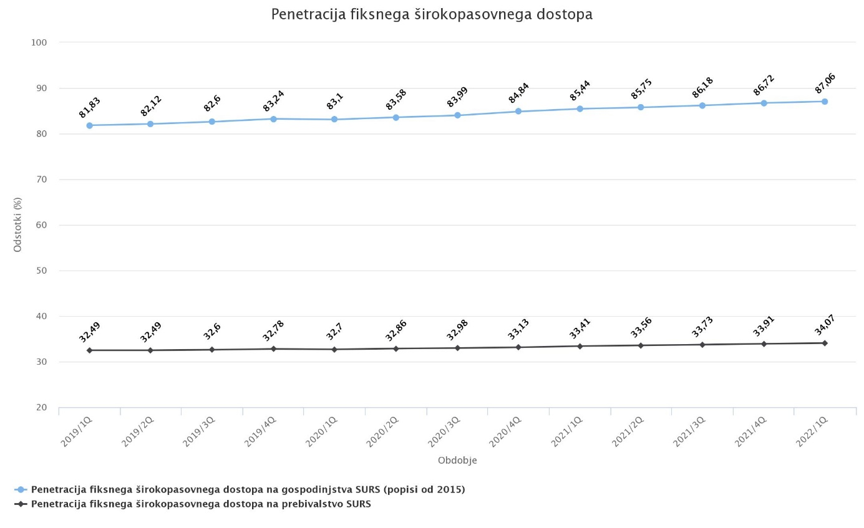

Source: AKOS, eAnalitik

Figure 3: The trend in the share of fixed broadband technologies in relation to the number of broadband internet connections

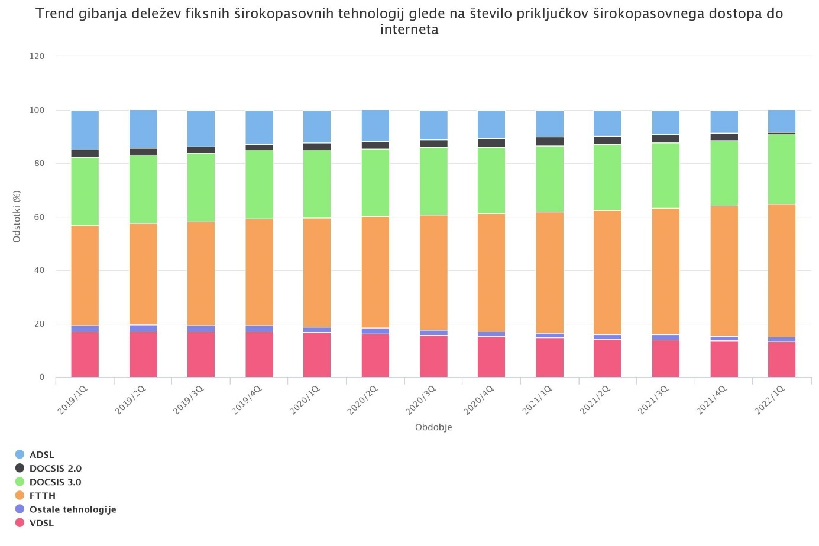

Source: AKOS, eAnalitik

The share of Fibre to the Home (FTTH) connections and the deployment of high-speed access technologies in cable networks (DOCSIS 3.0 and DOCSIS 3.1) have been increasing as these technologies are becoming dominant. The number of Next Generation Access lines (NGAs) has also been increasing (see Figure 4). Hence there are more than 600,000 active fixed broadband internet access lines, of which approximately 100,000 are low capacity lines or non-NGA lines, with a penetration rate of 70.72% of NGA fixed broadband internet access lines per household (see Figure 5).

Figure 4: The trend in the number of NGA and non-NGA fixed broadband internet access lines

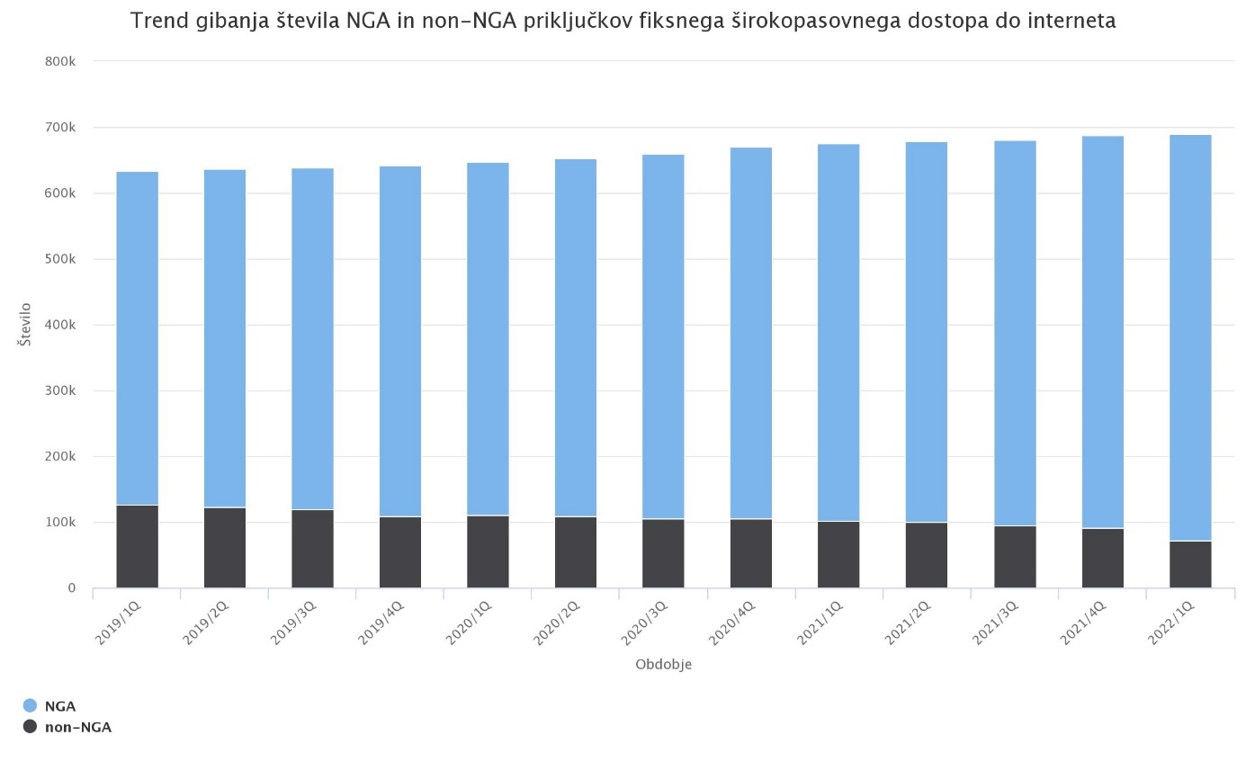

Source: AKOS, eAnalitik

Figure 5: The penetration of NGA fixed broadband internet access lines by household

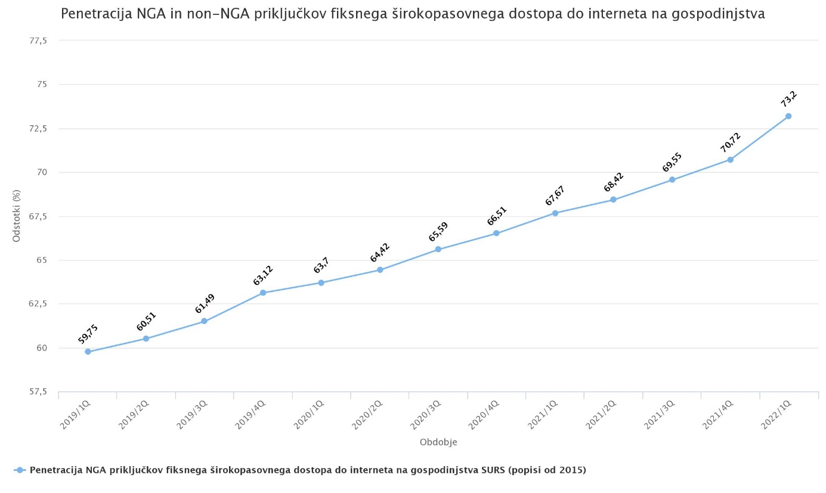

Source: AKOS, eAnalitik

The share of access connections at higher speeds has been increasing, facilitating access to demanding electronic communications services (see Figure 6).

Figure 6: The market share of fixed broadband internet access connections by access speed

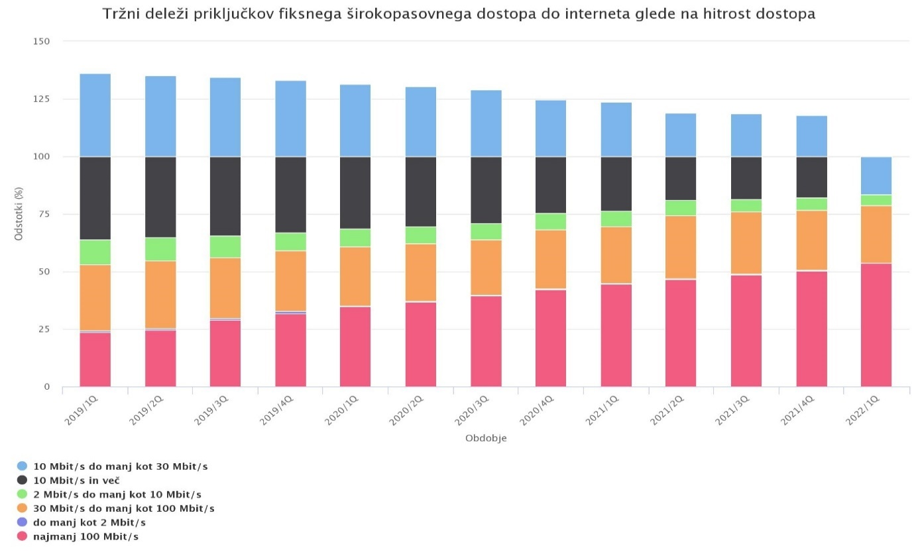

Source: AKOS, eAnalitik

In the area of broadband internet access, there has also been a marked increase in mobile broadband traffic (see Figure 7).

Figure 7: The trend in mobile broadband access

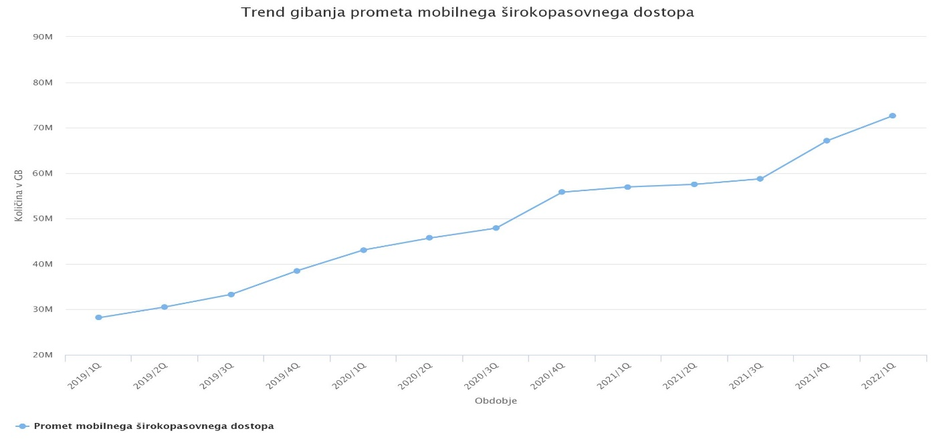

Source: AKOS, eAnalitik

In the analytical review of the main indicators of the state of network development in Slovenia, the above analytical findings should also be explained in terms of geographical characteristics. Slovenia is characterised by a dispersed and sparse population with an average population density of 104 inhabitants per square kilometre in 2020, with higher densities in urban centres and lower densities in rugged and not easily accessible areas.[9]

## 3.2 Granting radio spectrum for the construction of 5G networks and the deployment of 5G technology

In March 2019, the Government of the Republic of Slovenia adopted the Roadmap for the use of the 470-790 MHz frequency band in Slovenia, with its commercial use planned from 1 July 2020 onwards. In April 2020, the Government of the Republic of Slovenia adopted an amendment to the Roadmap, providing for a postponement of the commercial use of the 470-790 MHz frequency band due to cross-border harmful radio interference.

In its Summary of the Mobile Communications Market Analysis 2014–2019, [10] AKOS found a marked increase in the share of users of mobile broadband internet access and a significant increase in mobile broadband penetration (from 44% to 83%) in the period 2014–2019. Data traffic also grew strongly over the period (by more than 1800%, or 18 times), both in terms of broadband penetration and average data traffic per broadband user (by 1000%, or 10 times).

On the basis of the above analysis and in line with the guidelines of the competent ministry, AKOS prepared and conducted a public auction of all available harmonised bands, namely 700 MHz, 1500 MHz, 2100 MHz, 2300 MHz, 3600 MHz and 26 GHz.

Following the successful completion of the second public auction of radio frequencies in these bands, four bidders were granted the frequencies. The radio frequencies in the 700 MHz, 1500 MHz, 3600 MHz and 26 GHz bands were made available immediately after the decisions granting radio frequencies were issued (by the end of the first half of 2021), while the radio frequencies in the 2100 MHz band were made available for use from 22 September 2021 and the radio frequencies in the 2300 MHz band from 1 January 2022.

All frequency bands are intended to provide mobile communications services to end-users in line with the principle of technology neutrality. The rights of use are granted for 15 years, but will be extended accordingly after the transposition of Directive (EU) 2018/1972 of the European Parliament and of the Council establishing the European Electronic Communications Code.

The operators participating in the public call for tenders assumed the obligations under this public call for tenders to provide publicly available broadband services over mobile terrestrial networks. These obligations were imposed on them in the decisions granting radio frequencies in such a way that they will:

* within one year of the start of the availability of each radio frequency band, start using these frequencies and offer services to end-users on these frequencies in at least one major city from the list of 11 cities;
* within five years of the start of the availability of each radio frequency band, already use all frequencies in the entire acquired radio frequency band and offer services to end-users on all these frequencies in at least every major city from the list of 11 cities.

The obligations concerning time limits do not apply to frequencies in the 700 MHz SDL, 1500 MHz and 26 GHz bands that are subject to the obligation to start using and offering services to end-users on these frequencies in at least one major city from the list of 11 cities within five years of the start of availability.

Three operators that were granted at least a spectrum of 2 × 25 MHz below 1 GHz together with frequencies in the 700 MHz band will have to make commercially available public broadband services over mobile terrestrial networks using the entire radio spectrum at their disposal by 31 December 2025:

* to 99% of the population of Slovenia outside buildings,
* on 99% of motorways and expressways,
* on at least 60% of main and regional roads of category I and II,
* on at least 60% of active railways with passenger traffic, with coverage inside trains being the responsibility of railway stakeholders,

with a user experience of at least 30 Mbps from the base station to the mobile user terminal (downlink) and 3 Mbps from the user terminal to the base station (uplink).

On the frequencies 700 MHz FDD and/or 3600 MHz in priority bands and, to allow comparable services, also in the 2100 MHz band, the operators will have to:

* start offering services to end-users using 5G technology in at least one of the acquired frequency bands in at least one major city from the list of 11 cities within three months of the issuance of the decision;[11]
* by 31 December 2025, offer services to end-users using 5G technology and provide functionality and support for enhanced mobile broadband access, provided that the operator has at least 70 MHz of the contiguous spectrum, and also support for massive (IoT) networks on the acquired frequencies in at least one of the major cities from the list of 11 cities. If the availability of the required functionalities is not supported, the operator must provide evidence. AKOS will examine the evidence and, if justified, extend the deadline for compliance.

It should be noted that, according to the public call for tenders, the provision of services entails that the service is made available through base stations covering at least 75% of the population of each urban area, and the mere use of radio frequencies and the provision of services require availability through at least one base station in an urban area.

In order to ensure efficient use of the radio spectrum to improve coverage and minimise activities affecting the environment, infrastructure sharing options include:

* passive or active infrastructure sharing based on a radio spectrum or spectrum sharing,
* commercial roaming access agreements,
* joint deployment of infrastructure for the provision of networks and services based on the use of a radio spectrum.

With regard to security, operators will be required to establish, implement, maintain and continuously improve appropriate and proportionate organisational, technical and other measures to ensure that risks to the security of information systems, networks, services and information are adequately managed.

In this respect, stakeholders must take into consideration the Cybersecurity of 5G networks – EU Toolbox of risk mitigating measures.[12]

Following the expiry of the deadlines for the fulfilment of the obligations resulting from the public call for tenders by public auction of all harmonised bands, mobile operators are expected to maintain or increase the coverage achieved in line with the evolution of technology and the growth in the use of services.

## 3.3 Comparing connectivity in Slovenia with the EU average

In the 2022 edition of the Digital Economy and Society Index (DESI), Slovenia ranks 11th among the EU Member States, and in terms of connectivity 10th (see Figure 8). Slovenia has above-average coverage of very high capacity fixed networks, with broadband penetration of at least 100 Mbps gradually increasing, but still below the EU average. 5G network readiness in Slovenia is above the EU average, with 98% of the harmonised 5G spectrum awarded at the AKOS multi-frequency auction in April 2021. Furthermore, 5G services are already available to users. Broadband NGA coverage of households is close to the EU average, while coverage in rural areas is significantly lower, which needs to be taken into account when planning further development. This is due, in part, to the poor rural broadband infrastructure. Future development planning should take into consideration the typical dispersed settlement pattern of rural areas in Slovenia, which potential private investors, i.e. electronic communications operators, consider to be the main impediment to creating sustainable business models in these areas.

Figure 8: Executive summary DESI 2022 – Slovenia, connectivity

Figure 8: Executive summary DESI 2022 – Slovenia, connectivity

Figure 8: Executive summary DESI 2022 – Slovenia, connectivity

SOURCE: European Commission, Digital Economy and Society Index 2022 – Slovenia.

A comparative overview of NGA coverage and fixed very high capacity network coverage in the EU Member States, including an overview of rural areas, is presented in the following two figures:

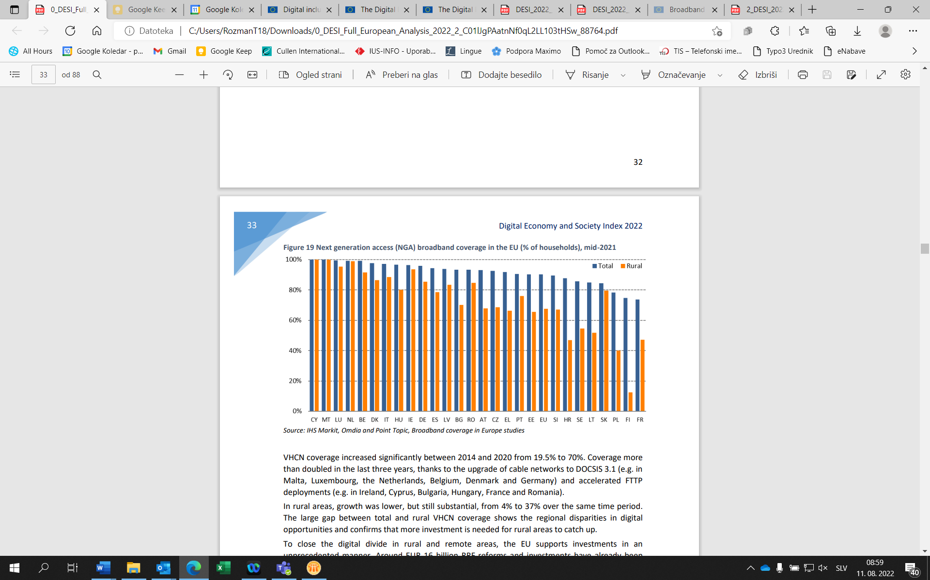Figure 9: Overview of NGA coverage as a % of households for the territory of all EU Member States and separately for rural areas, 2021

Source: European Commission, Digital Economy and Society Index 2022 – digital infrastructure; based on the IHS Markit, Omdia and Point Topic, Broadband coverage in Europe studies.

AKOS data on NGA coverage in Slovenia in May 2022:

* total or entire territory: 90.5%
* rural areas: 70.68%

Figure 10: Overview of fixed very high capacity coverage as a % of households for the territory of all EU Member States and separately for rural areas, 2021

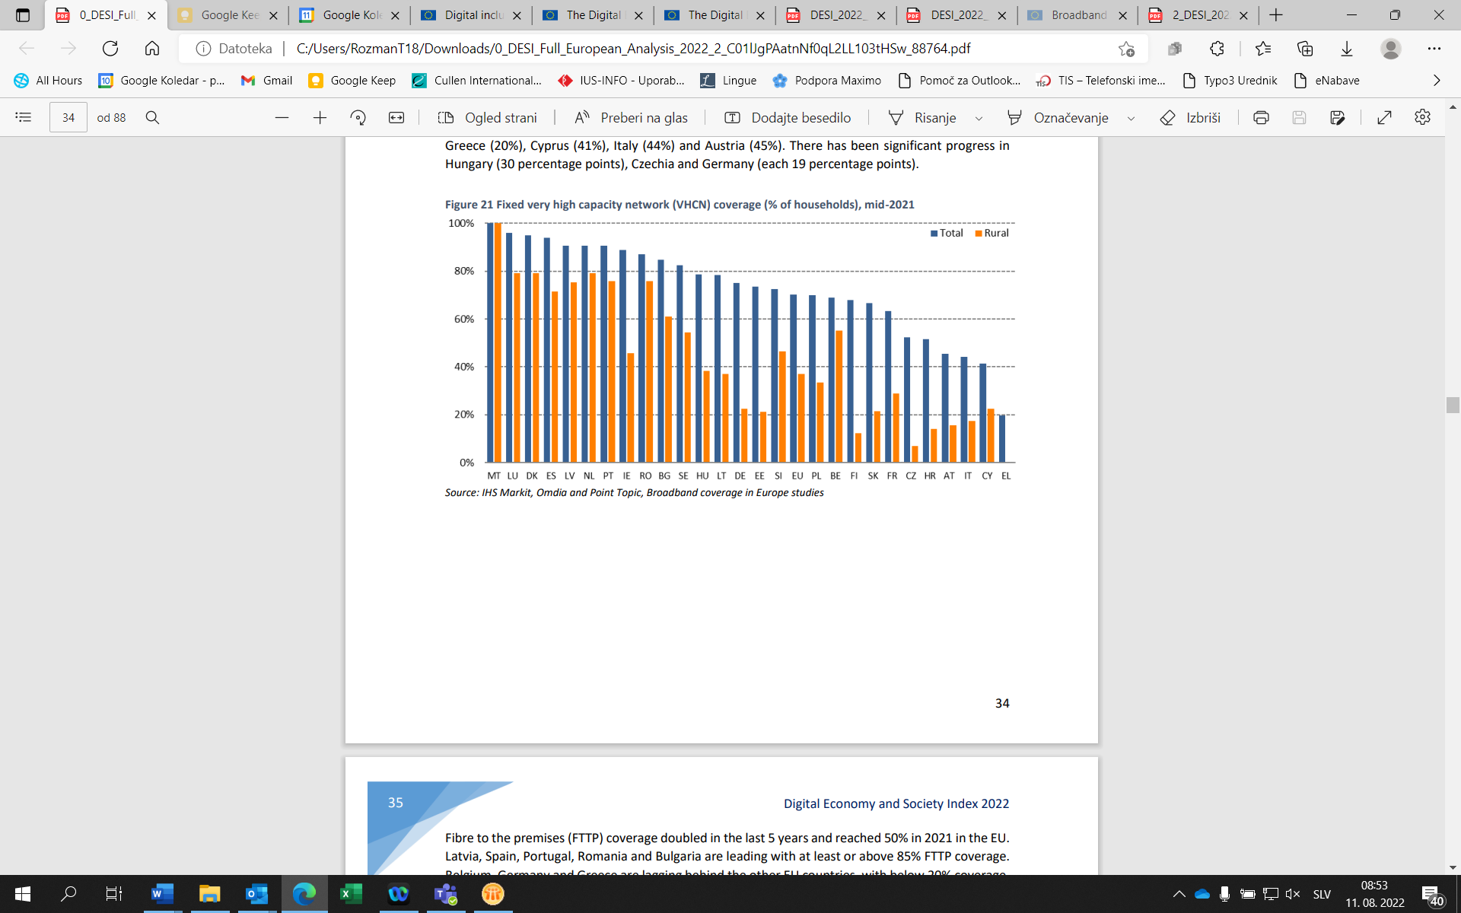Source: European Commission, Digital Economy and Society Index 2022 – digital infrastructure; based on the IHS Markit, Omdia and Point Topic, Broadband coverage in Europe studies.

AKOS data on fixed very high capacity network coverage in Slovenia in May 2022:

* total or entire territory: 75.5%,
* rural areas: 51.52%.

1. SLOVENIA’S STRATEGIC OBJECTIVES FOR GIGABIT INFRASTRUCTURE DEVELOPMENT

The strategic objectives are ambitious and exploit the opportunities provided by ICT to ensure lasting economic and social benefits, such as improved competitiveness, the creation of new and quality jobs, and the balanced development of rural and urban areas. Slovenia’s strategic objectives for gigabit infrastructure development include:

* 1. gigabit connectivity [13]for all main socio-economic drivers, such as schools, cultural institutions, transport hubs and main providers of public services as well as digitally intensive enterprises, by the end of 2025;
  2. all urban areas and all major terrestrial transport paths will have uninterrupted 5G coverage by the [14]end of 2025;
  3. all households, rural or urban, will have access to internet connectivity offering a downlink of at least 100 Mbps, upgradable to gigabit, by the end of 2025;
  4. gigabit connectivity for all households, enterprises and other socio-economic drivers in rural areas and cities by the end of 2030;
  5. all populated areas are covered by [15]5G networks by the end of 2030.

|  |  |  |  |
| --- | --- | --- | --- |
| Objective/year | Providing connectivity to households | Providing connectivity to socio-economic drivers | Providing coverage by 5G networks |
| 2025 | All households, rural or urban, have access to internet connectivity offering a downlink of at least 100 Mbps, upgradable to gigabit. | All main socio-economic drivers, such as schools, cultural institutions, transport hubs and main providers of public services as well as digitally intensive enterprises, have gigabit connectivity. | All urban areas and all major terrestrial transport paths have uninterrupted 5G coverage. |
| 2030 | All households are covered by a gigabit network. | All enterprises and other socio-economic drivers are covered by a gigabit network. | All populated areas are covered by 5G networks. |

1. PLANNED INVESTMENT TO ACHIEVE OBJECTIVES

## 5.1 Strategic definition

The European Commission estimates that reaching the EU-wide objectives for 2025 will require an overall investment of approximately EUR 500 billion, representing an additional EUR 155 billion over and above a simple continuation of the trend of the current network investment and modernisation efforts of the connectivity providers.[16]Most of the investment will come from the private sector, with appropriate active policy action by the EU Member States.

Investment in the electronic communications sector in Slovenia totalled approximately EUR 400 million in 2008, but declined significantly in 2009 to approximately EUR 180 million. In subsequent years, investment fluctuated. It peaked in 2020 when it amounted to EUR 284 million, an increase of EUR 52 million or 23% compared to 2019 (see Figure 11). In terms of infrastructure investment in the electronic communications market in Slovenia, a sharp increase in the number of announcements of intended construction has been recorded since 2019 (see Figure 12).

Figure 11: Investment in electronic communications and revenue from electronic communications services, Slovenia

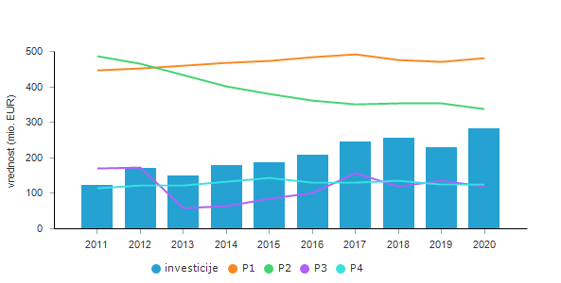

R1: revenue from the fixed public telephone network

R2: revenue from public mobile telephone services

R3: revenue from interconnection services

R4: other revenue

Sources: AKOS, SURS

Figure 12: Number of announcements of intended construction

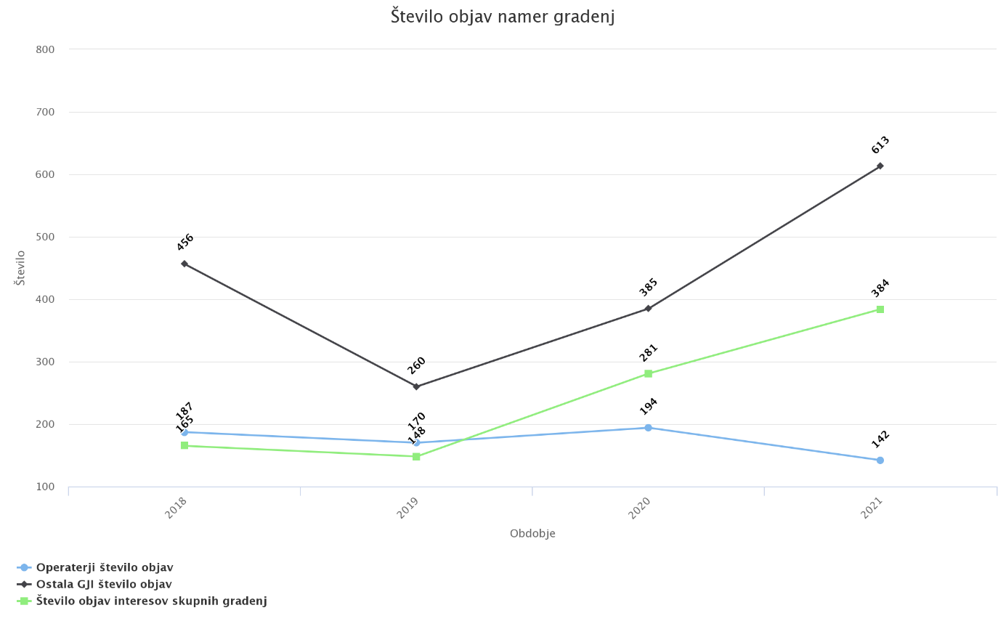

Source: AKOS, eAnalitik

It should be noted that private investment also depends on state action and policy in the field of electronic communications. In the years when the state invests public funds in white spots, i.e. areas where there is no adequate infrastructure or market interest of electronic communications operators to build in the next three years, private investment is also higher in order to protect the commercial interest. The role of the state and public policies in promoting connectivity is important both as encouragement of private investment and the provision of public funds to co-finance the deployment of broadband networks in areas for which operators did not express a market interest in building broadband connections. In the future, a significant share of high capital private investment will be directed towards the construction of fixed and mobile networks. In order to attain the development objectives regarding broadband infrastructure, the entire investment trend must be strengthened and must continue in the coming years.

Network construction and technology convergence will also enable Public Protection and Disaster Relief (PPDR) services or ESINET deployment and development solutions in line with the development of technology and regulations in the EU.

Public funds will be used to co-finance the construction of the following broadband infrastructure:

* the construction of open fixed broadband networks in white spots, i.e. areas where there is no adequate infrastructure or market interest of electronic communications operators in building in the next three years, in line with the principle of technology neutrality;
* the construction of 5G open passive mobile networks (open passive base stations) in areas where mobile networks are not built or where only mobile networks capable of supporting previous generations of mobile services are available and where no construction is planned in the next few years; co-financed infrastructure is not taken into account for the purposes of meeting the coverage obligations of mobile network operators arising from the conditions attached to the rights of use of 5G spectrums; cost containment or coverage of the large capital investments made by operators and service providers will be among the important factors influencing the development of the mobile network;
* the construction of open networks to ensure connectivity for all socio-economic drivers, in particular for those educational institutions that lack satisfactory internet connectivity, independently of white spot coverage.

The Plan also foresees the use of public funds for a connectivity voucher scheme to provide a comprehensive demonstration of state measures to enhance connectivity. In line with the principle of technology neutrality, connectivity vouchers will be made available to households or users for subscription to a new broadband internet access service or for an upgrade of their current subscription to a service that provides a minimum download speed of 100 Mbps. As the measure is intended to stimulate demand for broadband internet access service in areas where high-speed broadband coverage is already in place, the measure will focus in particular on co-financing connectivity in geographical areas where more expensive technologies are available to users. This is complementary to the provision of high-speed fixed broadband access, as explained in more detail below.

## 5.2 Assessment of the investment gap

Two projects for the construction of open broadband networks financed from public funds are being implemented (i.e. GOŠO 4 and GOŠO 5), which will, by 30 September 2023, provide access to high-speed broadband networks for 15,424 households that currently do not have access to high-speed broadband networks and for which no market interest was expressed for the construction of such networks.

Based on a careful and detailed mapping and an inquiry into market interest in building a broadband network, 107,932 households in [17]Slovenia were identified as potential white spots in 2021. From a total of 855,448 Slovenian households, the following households were deducted:

* households at addresses where at least one fibre or coaxial network connection point already exists, or
* households at addresses for which a contract was signed within the framework of projects GOŠO 1, GOŠO 2, GOŠO 4 and GOŠO 5 or the Rural Development Programme,[18] or a contract for an expressed market interest was signed in 2019 (when chronologically the last market interest inquiry was conducted).

At the time of the preparation of the Plan, there are no signed contracts for a credible expression of market interest in the construction of a broadband network, and the Plan is therefore based on the premise that the use of public funds is necessary and appropriate to provide access to a broadband network for the 107,932 households identified as potential white spots.

To provide coverage for 8,500 (out of a total of 107,932) households for which there is no expressed market interest, it is foreseen that gigabit infrastructure will be deployed through the GOŠO 6 call for tenders, which is expected to be published in the second half of 2022 and for which funding will be provided from the second tranche of the Recovery and Resilience Plan (grants). These households will be located in sparsely populated (less than 150 inhabitants per km2) or geographically challenging areas (not easily accessible) where adequate ICT infrastructure with suitable capacity is not yet available. As these are areas where the construction of infrastructure is the most expensive, EUR 3,500.00 per household or connection is envisaged to be co-financed from public funds.

In accordance with the Annex to the Council Implementing Decision on the approval of the assessment of the recovery and resilience plan for Slovenia, the investment must be completed by 30 June 2026 at the latest, and the relevant service or ministry will aim to complete construction by the end of 2025 at the latest.

In order to provide coverage for the remaining 99,432 households for which there is no expressed market interest, it is foreseen that gigabit infrastructure will be deployed by the end of 2030 at the latest on the basis of the GOŠO 7 call for tenders, which is expected to be published in the first half of 2023, and further calls for which funding will be provided within the Multiannual Financial Framework 2021–2027. As these households are expected to be located in geographically less challenging locations (compared to the 8,500 households to be covered under the GOŠO 6), the indicative amount of public co-financing is estimated at EUR 2,500.00 per household or connection, which is a 10% reduction in the average price offered in the GOŠO 5 call for tenders. If the analysis of the locations of white spots shows different geographical circumstances of the white spots, the amount of co-financing per household or connection will be adjusted accordingly. In extreme cases, where no other measure (non-financial or financial) can provide adequate connectivity to terrestrial networks, up to 10,793[19] households will be provided with connectivity using other available technologies with a minimum download speed of 100 Mbps. The envisaged amount of EUR 15,326,344.00 was calculated as being 50% co-financed by the state for a period of 24 months in accordance with the applicable EU rules on state aid and was based on the costs of satellite broadband access, which is considered a base case scenario for connectivity in not easily accessible areas without any prejudice as to the actual selection of the most suitable technology. This figure takes into account that the cost of satellite access is EUR 1,420.00 per household (calculated for 10,793 households) for a period of two years (EUR 500 for the equipment and EUR 100 for the monthly subscription, which is reduced by 5% on an annual basis due to the advancement of technology and the development of competition) and 50% co-financing by the state.

All projects will have a minimal spatial and environmental impact, as priority will be given to sharing the existing infrastructure and to joint construction and integration with other infrastructure investments.

To attain Slovenia’s strategic objectives for the development of gigabit infrastructure until 2030, public funding in the following amount will be required:

|  |  |
| --- | --- |
| **Objective** | **Assessment of the investment gap** **(required public funds) in EUR** |
| Gigabit connectivity for 8,500 households in not easily accessible areas which lack gigabit infrastructure or market interest in building in the next three years. | 30,000,000.00 |
| Gigabit connectivity for 99,432 households in areas where there is no gigabit infrastructure or market interest in building in the next three years. | 248,580,000.00 |
| Promotion of connectivity for 10,793 households until the construction of a fixed broadband network. | 15,326,344.00 |
| All populated areas and all major terrestrial transport paths will be covered by 5G networks. | An assessment will be made on the basis of a new mapping and market interest inquiry to be carried out by 21 December 2023. |
| Gigabit connectivity for all socio-economic drivers in Slovenia. | An assessment will be made on the basis of a new mapping and market interest inquiry to be carried out by 21 December 2023. |
| **Total** | **293,906,344.00** |

1. MEASURES TO ACHIEVE THE OBJECTIVES

## 6.1 Legislative measures

### 6.1.1 Transposition of Directive (EU) 2018/1972 establishing the European Electronic Communications Code

As infrastructure development and electronic communications services are largely dependent on the efficiency of the electronic communications market, Slovenia will promote competitiveness, transparent regulation and a stable legislative framework. Slovenia will transpose the provisions of the European Electronic Communications Code into the new Electronic Communications Act (hereinafter: the ZEKom-2), which will create a stable and predictable regulatory and, consequently, business environment that will encourage the private investment of electronic communications operators in the development of electronic communications infrastructure and services.

The ZEKom-2 will further stimulate private investment and competition, including through the activities of AKOS. In the case of network construction, optimal measures can significantly facilitate investment in broadband infrastructure and hence reduce the costs of developing high-speed communications infrastructure providing gigabit connectivity. The provisions on the construction of networks and associated infrastructure in the Electronic Communications Act (Official Gazette of the Republic of Slovenia [*Uradni list RS*], Nos 109/12, 110/13, 40/14 – ZIN-B, 54/14 – Dec. of the CC, 81/15, 40/17, 30/19 – Dec. of the CC, 189/21 – ZDU-1M; hereinafter: the ZEKom-1) will be largely maintained in the ZEKom-2. The following will be the main innovations in the construction of broadband networks: the service or ministry responsible for electronic communications will be the national spatial planning authority for the planning of public communications networks and associated infrastructure, which will reduce the construction costs and environmental impact; the buffer zone for electronic communications systems will be defined; the procedure for inquiries into market interest in construction will be amended so that it will be carried out as an inquiry into the intended construction or upgrade of high capacity networks, with an additional market interest inquiry to be carried out at the request of the public sector authority allocating public funds, and the competence for market interest inquiries will be transferred from the service or ministry to the regulatory authority; in the case of joint constructions, the establishment of an easement on immovable property owned by the state or a self-governing local authority will be subject to inclusion in the easement agreement of a provision allowing for joint construction by another network operator, but only on the same route and subject to the payment of appropriate compensation for the easement.

The ZEKom-2 will also provide a national legal basis for state co-financing to promote connectivity in line with the development of new technologies.

### 6.1.2 The transposition of Directive 2014/61/EU on measures to reduce the cost of deploying high-speed electronic communications networks

Directive 2014/61/EU is transposed by the ZEKom-1 and aims to encourage the deployment of high-speed electronic communications networks. It includes measures such as the sharing and reuse of existing physical infrastructure (all types of infrastructure), which creates the conditions for the more cost-effective deployment of electronic communications networks. Cooperation between sectors is particularly important in this context. It is essential for the widespread uptake of high-speed internet, whose digital infrastructure supports virtually all sectors of the modern and innovative economy, to reduce costs and improve the efficiency of the deployment of high-speed electronic communications. The Directive builds on the existing best practices in some Member States and is based on four pillars: 1) access to and the transparency of existing physical infrastructure, 2) the coordination and transparency of planned construction works, 3) the streamlining of the permit granting procedure, and 4) in-building physical infrastructure. The Directive also requires Member States to designate one or more competent authorities to perform the tasks of the national dispute settlement body and to designate one or more competent authorities at the national, regional or local levels to perform the tasks of a single information point.

In order to remove barriers to the provision of communications networks and associated facilities and to encourage their development and deployment, AKOS issued a Recommendation on the sharing of physical infrastructure.[20]The sharing of public service infrastructure makes it easier for the owner thereof to make greater use of it, while at the same time making it easier for investors in electronic communications networks to deploy such networks, particularly financially, but also in terms of time and organisation. Furthermore, network operators are encouraged to use free capacities in existing public service infrastructure as much as possible, making the deployment of elements of electronic communications networks easier, more efficient and, above all, cheaper. The sharing of existing infrastructure also contributes to sustainability for all citizens, as it reduces the scope of activities affecting the environment.

### 6.1.3 The allocation of radio spectrum in Slovenia and measures to ensure adequate radio spectrum coverage

Mobile communications networks play an important role in ensuring ubiquitous access to the internet. As users increasingly demand connectivity at higher speeds, the need to provide additional radio spectrum is also increasing. Slovenia will follow the release of radio spectrum at the international level and allocate it to mobile communications network operators according to the needs. The guiding principle for radio spectrum management is to offer all available radio frequencies to interested stakeholders in a competitive procedure in accordance with the legislation and without undue delay.

AKOS, which has the public authority to manage the radio spectrum in Slovenia, will assign radio spectrum for the provision of publicly available communications services to end-users, including frequency bands harmonised at the EU level for the deployment of 5G networks. Detailed measures or activities to ensure adequate radio spectrum coverage in Slovenia are defined in the Strategy for the Management of Radio Spectrum, which was adopted by the Government of the Republic of Slovenia on 25 November 2021.

Based on its assessment at the time of drafting the call for tenders drawing on an analysis of the state of play, AKOS will impose the following general and additional coverage obligations in calls for tenders for the assignment of radio frequencies for the provision of publicly available communications services to end-users:

* general coverage obligations – providers acquiring radio spectrum in any radio frequency band will be required to commercially provide publicly available broadband services in mobile terrestrial systems in each of the acquired radio frequency bands by starting to use those frequencies and offering services to end-users on those frequencies in a specified geographic area within a specified timeframe from the time of the availability of each radio frequency band,
* additional coverage obligations for a specific part of the radio spectrum – providers will be required to commercially provide publicly available broadband services over mobile terrestrial networks, using all the radio spectrum at their disposal at the end of the call for tenders, in such a way so as to ensure coverage in accordance with the provisions of the call for tenders, e.g. by providing certain coverage of the main transport paths and the population of Slovenia.

### 6.1.4 Additional measures in connection with 5G networks

Slovenia will ensure that sufficient radio spectrum is made available in time for the deployment of the latest technologies for a wide range of uses, thus ensuring a predictable and stable environment for market participants.

With regard to 5G, it should be highlighted that the assignment of new radio spectrum bands within the framework of the EU policy and the relevant analyses of AKOS as the radio spectrum manager is necessary to ensure commercial use. This will not preclude the operation of already deployed systems, e.g. safety applications of transport systems (ITS) using the unlicensed 5875-5935 MHz frequency band and electronic toll systems using the 5795-5815 MHz frequency band.

The main EU legal basis for the reorganisation of radio spectrum deployment and the assignment of new additional frequency bands is Decision 2017/899 of the European Parliament and of the Council on the use of the 470-790 MHz frequency band in the Union and Directive (EU) 2018/1972 of the European Parliament and of the Council establishing the European Electronic Communications Code.

Decision 2017/899 of the European Parliament and of the Council on the use of the 470-790 MHz frequency band requires Member States, with the exception of Cyprus, to allow the use of the 700 MHz band (694-790 MHz) for terrestrial systems for wireless broadband electronic communications services by 30 June 2020 or, in case of duly justified reasons, by 30 June 2022. These are the first additional frequencies dedicated to the deployment of new generation 5G mobile technology. They used to be reserved for broadcasting.

Directive (EU) 2018/1972 of the European Parliament and of the Council establishing the European Electronic Communications Code specifies in recital 135 and Article 54, as determined by the Radio Spectrum Policy Group, priority bands for meeting the objectives of the 5G Action Plan, i.e. 3.4-3.8 GHz and 24.25-27.5 GHz bands, which should be made available for terrestrial systems capable of providing wireless broadband services. This is an amendment to Decision 2017/899 of the European Parliament and of the Council on the use of the 470-790 MHz frequency band. These bands are complementary. In terms of the propagation of radio signals for greater territorial coverage and in terms of available bandwidth for higher data transfer rates.

At the World Radiocommunication Conference 2023 (WRC-23), a new spectrum for next generation mobile technologies 5G and 6G will be considered under agenda items 1.1 to 1.5. Within the EU, allocations and/or identifications are possible under agenda items 1.2 (the identification of a new spectrum in the frequency band 6425-7125 MHz) and 1.5 (co-primary mobile spectrum allocation in the frequency band 470-694 MHz), with a decision still pending.

In line with the development of 6G technology, Slovenia will provide sufficient radio spectrum, while proactively participating in working committees of the EU and the International Telecommunication Union when issues related to 6G technology will be discussed.

With a view to improving the mobile network coverage of Slovenian territory and improving the quality of public mobile communications services, AKOS issued a Recommendation on procedures for ensuring mobile network coverage of uncovered or underserved areas.[21]This Recommendation is aimed at encouraging operators – holders of decisions on the assignment of radio frequencies for the provision of publicly available communications services to end-users – and local communities to work together to improve the coverage of uncovered or underserved areas and to proactively address problems caused by poor coverage or to upgrade their networks. Against this background, the important role of local communities in ensuring mobile coverage at all stages of mobile network deployment, i.e. from the siting of base stations onwards, is recognised.

In order to meet the future communications needs of public protection and disaster relief authorities, Slovenia will procure from public mobile communications operators a 5G sector vertical or a PPDR network slice with specific functions for these users. Joint procurement of advanced broadband services to meet the communications needs of public protection and disaster relief authorities is also envisaged. The PPDR network slice will be managed by one of the state authorities or an entity authorised by Slovenia. Depending on the extent of the deployment of PPDR functionality in the national PPDR slice, a gradual functional transition from the existing dedicated radio communications systems will be carried out. For mobile communications services for PPDR users, the 2 × 5 MHz radio spectrum is reserved in the 700 MHz frequency band. Although it was not subject to a public auction of harmonised bands for 5G (referred to in Section 3.2), it will be assigned to an operator selected by the state through a public call for tenders for the provision of the 5G PPDR slice or radio communications services to PPDR users.

As regards security, stakeholders must take into consideration the 5G Cybersecurity Toolbox. Strategic security measures include:

* hardware and software manufactured by high-risk vendors (HRVs – defined by the SSNAV/SNAV) is not used for the purposes of resource allocation, authentication, access rights, communications transport functions, network security functions, integrity and availability, and when this network is used to provide connectivity to users in critical infrastructure sectors and in networks of the state administration and the armed forces;
* a multi-vendor approach to preventing mobile network operators from becoming dependent on a single supplier (which could be classified as a high-risk vendor in the future);
* the provision of national roaming at least for critical users (i.e. critical infrastructure sectors, the state administration, the armed forces).

### 6.1.5 Compliance with EU state aid rules

Commission Regulation (EU) No 651/2014 declaring certain categories of aid compatible with the internal market in application of Articles 107 and 108 of the Treaty, as last amended by Commission Regulation (EU) 2021/1237 of 23 July 2021 (hereinafter: Regulation 651/2014/EU), introduces, in addition to aid for fixed broadband networks, aid for 4G and 5G mobile networks, as well as aid for projects of common interest in the field of pan-European digital connectivity infrastructure and connectivity vouchers. All state aid measures in the field of gigabit infrastructure will fully comply with EU state aid rules.

## 6.2 Strategic measures

### 6.2.1 Mapping of infrastructure

The mapping of electronic communications infrastructure was introduced in 2004 on the basis of the ZEKom-1 primarily to protect the existing public communications networks. In the same year, the Surveying and Mapping Authority of the Republic of Slovenia (GURS) established a Consolidated Cadastre of Public Infrastructure – a database to which operators send data on their networks. As a result, all networks are listed in public records. Data on the owners and locations of lines are accessible to all interested users.

The mapping of infrastructure is an important tool for planning investment in the electronic communications infrastructure, as precise knowledge of the existing infrastructure is crucial for the designation of white spots. In cooperation with the Surveying and Mapping Authority of the Republic of Slovenia and on the basis of the amendments to the ZEKom-1, the mapping of infrastructure was upgraded to provide a more detailed overview of the existing electronic communications infrastructure, which is essential for the designation of white spots down to the household level.

A new provision on geographical surveys of network deployments in Article 22 of Directive 2018/1972/EU was in part transposed in the ZEKom-1 and will be transposed in its entirety in the ZEKom-2. The provision comprises a geographical survey of the reach of electronic communications networks capable of delivering broadband access, and a forecast for a given period of the reach of broadband networks, including very high capacity networks.

The obligation to conduct geographical surveys of the reach of electronic communications networks was transposed by Slovenia in Article 14 of the ZEKom-1, which imposes the obligation to enter data on electronic communications networks in the relevant record of the Surveying and Mapping Authority of the Republic of Slovenia. Hence, Article 14 of the ZEKom-1 provides the basis for the collection of data for geographical surveys, which can be upgraded if needed.

In order to allocate public funds for the deployment of broadband networks, Article 11a of the ZEKom-1 provides for an inquiry into market interest in building broadband networks. Article 22 of Directive 2018/1972/EU is somewhat broader in this respect, and hence the transposition of the provision on the forecast of the reach of broadband networks in the third subparagraph of paragraph one of Article 22 of Directive 2018/1972/EU will require the replacement of the existing Article 11a of the ZEKom-1 with a new Article in the ZEKom-2. At least every three years, AKOS will be obliged to publish a public call for inquiries into investors’ intentions to build very high capacity networks or to upgrade or extend existing networks to provide speeds of at least 100 Mbps within a timeframe determined by AKOS, but no later than in three years. Where a public sector body allocates public funds for building broadband networks, AKOS will conduct a market interest inquiry into the construction of high capacity networks or the upgrade or extension of existing networks to allow download speeds of at least 100 Mbps over the next three years. The technical aspect of the conduct of inquires will be the responsibility of AKOS, which will also inform operators of any potential overlapping of market interest. The details of the implementation of this Article will be laid down by AKOS in a general act.

### 6.2.2 Demand stimulation and the promotion of digitalisation and digital transformation

Demand stimulation, the promotion of digitalisation and digital transformation are mentioned in this Plan to present a complete overview of measures, but – with the exception of connectivity vouchers (see Section 5 and Subsection 6.3.2) – they are not operationalised nor are they included among the objectives and financially evaluated because they are not part of this Plan but of other strategies and documents.

Slovenia will stimulate demand for broadband services and promote digitalisation and digital transformation, which will in turn increase the density of broadband connections and reduce the digital divide among the population. An increase in the uptake of the internet and ICT services will also enhance access to information and social inclusion. As regards big investments, user demand for broadband connections or network utilisation has a positive impact on the revenues of investors and electronic communications operators.

The Promotion of Digital Inclusion Act (Official Gazette of the Republic of Slovenia [*Uradni list RS*], No 35/22) should be highlighted as a fundamental measure for stimulating demand and promoting digitalisation and digital transformation. The purpose of this Act is to increase the digital inclusion of the population of Slovenia and to facilitate the comparative progress of the digital development of the Slovenian economy and society.

### 6.2.3 The provision of universal service

Universal service is the minimum set of services of specified quality available to all end-users in Slovenia at an affordable price, regardless of their geographic location.

The aim of universal service is to prevent digital exclusion. It is intended to be a safety net for users who cannot obtain affordable services on the market. Universal service is particularly important for bridging the digital divide in the transition period when gigabit connectivity will not be available to all inhabitants.

Universal service is provided for in the ZEKom-1 and is fully compliant with EU law in this area. Universal service includes the following services:

* connection to the public telephone network and access to publicly available telephone services at a fixed location,
* access to data communications at a transfer speed suitable for functional access to the internet at a fixed location,
* ensuring and providing access to a universal directory and a universal subscriber information service,
* public pay telephones[22] and
* measures for end-users with disabilities, other persons with special needs, and people with low income.

Different technologies may be used to provide universal service. The choice of technology depends on the technical possibilities at the user's permanent residence. Individual services are provided by providers selected on the basis of the procedure laid down in the ZEKom-1. The designation procedures are managed by AKOS, which, based on market analyses and public consultations, defines specific measures and designates providers. The procedure is repeated every five years to ensure that universal service meets people’s needs and the market requirements.

Under universal service, every household is currently entitled to internet access ensuring a downlink of 10 Mbps and an uplink of 1 Mbps at the place of permanent residence. If users are unable to obtain such service from commercial service providers, they may request it from the designated universal service provider.

### 6.2.4 Toolbox for reducing the cost of deploying very high capacity networks

When constructing broadband networks, the common Union toolbox for connectivity aimed at reducing the cost of deploying very high capacity networks and ensuring timely and investment friendly access to the 5G radio spectrum must be taken into consideration.[23]These tools comprise:

* streamlining permit granting procedures,
* increasing transparency through a single information point,
* expanding the right to access existing infrastructure,
* improving the dispute resolution mechanism,
* reducing the environmental impact of networks,
* assessing environmental impact,
* providing a schedule of spectrum authorisation procedures, and
* providing investment incentives.

## 6.3 Financial measures

### 6.3.1 Public co-financing of the deployment of broadband networks in white spots

The development of broadband infrastructure in rural areas is hampered by scattered settlement patterns and low population density, hence private investors generally do not succeed in carrying out financially sustainable investment projects. Slovenia will use public funds to co-finance projects of private investors for the construction of infrastructure in white spots which lack appropriate infrastructure and commercial interest in its deployment.

Public co-financing of deployment in white spots will increase the affordability and availability of open and suitable quality infrastructure and services prepared for the future.

In order to improve the financial sustainability of investment projects, the maximum amount of public co-financing per household – white spots – will be broken down, where appropriate, by the population density of each settlement in a municipality. Settlements will be classified into groups according to the population density or other more appropriate criteria. The construction, management and operating costs of broadband networks are considered eligible costs under Regulation 651/2014/EU.

Prior to the publication of individual measures for the co-financing of the deployment of broadband networks in white spots from public funds, an inquiry will be made into the market interest of electronic communications operators in deploying appropriate gigabit infrastructure and the actual situation will be verified. The co-financed infrastructure will have to enable the achievement of Slovenia’s strategic objectives set out in the Plan.

### 6.3.2 Other financial measures

In line with the principle of technology neutrality and state aid rules, eligible investments will include, in addition to the deployment of broadband networks in white spots, also investments enabling 5G coverage of all populated areas and major terrestrial transport paths by co-financing the construction of open passive base stations, and enabling gigabit connectivity for all socio-economic drivers in Slovenia.

As regards financial measures needed to provide 5G coverage, we would like to explain that, compared to the financial measures needed to attain the other objectives of this Plan, they depend to a significantly greater extent on private investment, in particular on the amount of implemented investments (in addition to investment needed to meet the obligations under the radio frequency allocation decisions based on the auction of multi-frequencies allocation in April 2021) and their coverage.[24]Against this background, new mapping will be conducted[25] by 21 December 2023 and a market interest inquiry will be carried out for 5G network deployment. The gap between, on the one hand, 5G coverage as guaranteed by market interest and compliance with 5G coverage obligations in the radio frequency allocation decisions and, on the other hand, the targeted 5G coverage, will thus be identified. The investment gap to be closed by public funds will also be identified.

In order to boost connectivity, households or users will be offered connectivity vouchers enabling subscription to a new broadband internet access service or an upgrade of an existing subscription to a service of at least 100 Mbps. The connectivity voucher scheme will be made available to households or users in areas where there is already at least one reliable network with at a minimum speed of 100 Mbps but with more expensive technologies for users, which will be verified through mapping and public consultations. The voucher scheme will be designed so as not to distort competition and will fully comply with the principle of technology neutrality in the sense that vouchers can be used to subscribe to the services of any operator that can reliably deliver speeds of at least 100 Mbps over the existing broadband network, irrespective of the technologies used.

As part of public co-financing, it will be possible to use complementary forms of funding from EU, national or regional sources. The “double” claiming of costs and expenses that have already been or could be reimbursed from any other public source or were approved will not be allowed.

In line with the state aid requirements, a public consultation on the main features of the planned measures and on the list of target areas will be organised in the context of the public co-financing of broadband access.

## 6.4 Other measures for achieving the objectives

### 6.4.1 Geoportal

AKOS operates a Geoportal that displays electronic communications data (points, lines, polygons) and network connection points and is updated daily. This means that the latest data are always displayed according to the Consolidated Cadastre of Public Infrastructure of the Surveying and Mapping Authority of the Republic of Slovenia. The latest mobile signal measurements were added, showing the signal quality (very good, good, borderline) at measured locations, i.e. national and municipal roads. The collected data facilitate the identification of areas with a good or poor signal or no mobile signal, with fixed and mobile coverage, etc. The date of each measurement is also provided.

### 6.4.2 Infrastructure investment portal

The portal is available on the AKOS website and is designed to promote infrastructure sharing and joint deployment. Intentions to build and invitations to investors in electronic communications networks and associated infrastructure to express their interest in including electronic communications networks and associated infrastructure in the planning or joint construction are published on this portal.

### 6.4.3 AKOS Test Net

The AKOS Test Net is a measurement and analytical tool that provides end-users with a transparent overview of the state of mobile and fixed broadband access in Slovenia by measuring the speed and quality of broadband connections in fixed and wireless networks. It can be used to measure various parameters, such as the data transfer rate, latency and availability of network services. To a large extent, the measurements depend on the terminal equipment on which the measurement is performed. Therefore, the AKOS Test Net measurements at end-users mainly reflect the quality of the user experience, which, among other things, depends on the state of the mobile network. In its programme of work and financial plan, AKOS undertook to further develop and improve the AKOS Test Net and to provide as reliable and accurate measurements as possible.

### 6.4.4 Technical assistance and expert advice

Slovenia has a single contact point, i.e. the Broadband Competence Office (hereinafter: the BCO). It provides citizens, local communities, operators of electronic communications and other interested stakeholders with information on co-financing options for the deployment of broadband infrastructure in white spots, on the project for the installation of Wi-Fi hotspots (WiFi4EU) and other projects for the deployment of broadband infrastructure. The BCO is a body within the ministry responsible for electronic communications. The idea behind its establishment was to have in every Member State a single contact point or source of information on its broadband infrastructure. The tasks of the national BCO include cooperation with other BCOs at the EU level, the provision of information and advice to local communities, citizens and businesses, and support for representatives of local and regional authorities in order to increase the efficiency of investment in broadband infrastructure with funds from the European Regional Development Fund, and, if possible, in combination with other financial instruments, such as the Connecting Europe Facility.

1. INDICATORS

Indicators of the Recovery and Resilience Facility

|  |  |
| --- | --- |
| Additional dwellings with internet access provided via very high capacity networks | **2025** |
| Number | 8,500 |

Other indicators – plan

|  |  |  |  |
| --- | --- | --- | --- |
| 2025 | All households, rural or urban, have access to internet connectivity offering a downlink of at least 100 Mbps, upgradable to gigabit. | All main socio-economic drivers, such as schools, cultural institutions, transport hubs and main providers of public services as well as digitally intensive enterprises, have gigabit connectivity. | All urban areas and all major terrestrial transport paths have uninterrupted 5G coverage. |
| 2030 | All households are covered by a gigabit network. | All enterprises and other socio-economic drivers are covered by a gigabit network. | All populated areas are covered by 5G networks. |

1. ANNEX

List of abbreviations

|  |  |
| --- | --- |
| **AKOS**  **BCO**  **GDP**  **EU**  **PSI**  **GURS**  **ICT**  **Mbps**  **NGA**  **OECD** | Agency for Communication Networks and Services of the Republic of Slovenia  Broadband Competence Office  gross domestic product  European Union  public service infrastructure  Surveying and Mapping Authority of the Republic of Slovenia  information and communication technologies  megabits per second  next generation access network  Organisation for Economic Co-operation and Development |
| **SURS** | Statistical Office of the Republic of Slovenia |
| **ZEKom-1** | Electronic Communications Act |

1. Different terms are used in various fundamental European strategic and legal documents to denote communities of inhabitants to be provided connectivity. The general statistical term "household" is used in the Communication from the Commission entitled "Connectivity for a Competitive Digital Single Market – Towards a European Gigabit Society". In the Commission Delegated Regulation (EU) 2021/2106 of 28 September 2021 on supplementing Regulation (EU) 2021/241 of the European Parliament and of the Council establishing the Recovery and Resilience Facility by setting out the common indicators and the detailed elements of the recovery and resilience scoreboard, the term dwelling is defined as a room or a suite of rooms in a permanent building or a structurally separated part of a building which is designed for habitation by one private household all year around. The term "household" is used in the 2030 Digital Compass and in the Proposal for a Decision of the European Parliament and of the Council establishing the 2030 Policy Programme "Path to the Digital Decade". The term "household" is normally used in this Plan as this is a well-established neutral term that is interchangeable with the terms "home" and "dwelling". Nevertheless, the terms "home" and "dwelling” are also used in this Plan when referring to national and EU documents using these two terms to avoid confusion.
2. In accordance with the Communication from the Commission entitled "Connectivity for a Competitive Digital Single Market – Towards a European Gigabit Society", the main socio-economic drivers are schools, transport hubs, digitally intensive enterprises and main providers of public services, namely primary and secondary schools, railway stations, ports and airports, local authority buildings, universities, research centres, medical clinics, hospitals and stadiums. The Plan explicitly defines the gigabit connectivity of cultural institutions as a strategic objective of Slovenia.
3. Not all EU digital objectives in the field of digital infrastructure are included in the Plan, as measures and strategies for attaining certain objectives set in the Proposal for a Decision of the European Parliament and of the Council establishing the 2030 Policy Programme "Path to the Digital Decade" and referring to the production of cutting-edge and sustainable semiconductors, the deployment of climate-neutral highly secure edge nodes, and activities to acquire the EU’s first computer with quantum acceleration are defined and operationalised in other documents and public policies.
4. <http://www.itu.int/ITU-D/treg/broadband/ITU-BB-Reports_Impact-of-Broadband-on-the-Economy.pdf>, p. 7 (last accessed 30 March 2022)
5. <http://www.ericsson.com/res/thecompany/docs/corporate-responsibility/2013/ericsson-broadband-final-071013.pdf>, p. 7 (last accessed 30 March 2022)
6. Based on AKOS [(https://www.akos-rs.si/radijski-spekter/raziscite/mobilna-omrezja](file:///C:\Users\Lucija\AppData\Local\Temp\notesF68211\(https:\www.akos-rs.si\radijski-spekter\raziscite\mobilna-omrezja), p. 7 (last accessed 30 March 2022)
7. Nomadic users are users of electronic communications services who use different network termination points to access public communications networks.
8. They include, for example, primary and secondary schools, railway stations, ports and airports, local authority buildings, universities, research centres, medical clinics, hospitals and stadiums.
9. <https://www.stat.si/obcine/sl/Theme/Index/PrebivalstvoGostota> (last accessed 11 August 2022)
10. [Povzetek_analize_mobilnega_trga.pdf (akos-rs.si)](https://www.akos-rs.si/fileadmin/user_upload/Povzetek_analize_mobilnega_trga.pdf) (last accessed 28 March 2022)
11. https://www.akos-rs.si/fileadmin/user_upload/dokumenti/Raziskave__analize__porocila_in_statistika/RF_Spekter/Pokritost_s_storitvami_mobilnih_tehnologij_julija_2021.pdf
12. [Cybersecurity of 5G networks – EU Toolbox of risk mitigating measures | Shaping Europe’s digital future (europa.eu)](https://digital-strategy.ec.europa.eu/en/library/cybersecurity-5g-networks-eu-toolbox-risk-mitigating-measures)
13. Gigabit connectivity should be interpreted as cost effective symmetrical internet connectivity providing download and upload speeds of at least 1 Gbps (based on the Communication from the Commission "Connectivity for a Competitive Digital Single Market – Towards a European Gigabit Society").
14. According to the definition of Trans-European Transport Networks (based on the Communication from the Commission "Connectivity for a Competitive Digital Single Market – Towards a European Gigabit Society”), major terrestrial paths are motorways, national roads and railways.
15. The populated area as a unit has at least one inhabitant and is a settlement in the sense of the territory of a municipality defined by the Local Self-Government Act (Official Gazette of the Republic of Slovenia [*Uradni list RS*], No[94/07](http://www.uradni-list.si/1/objava.jsp?sop=2007-01-4692) – official consolidated version, [76/08](http://www.uradni-list.si/1/objava.jsp?sop=2008-01-3347), [79/09](http://www.uradni-list.si/1/objava.jsp?sop=2009-01-3437), [51/10](http://www.uradni-list.si/1/objava.jsp?sop=2010-01-2763), [40/12](http://www.uradni-list.si/1/objava.jsp?sop=2012-01-1700) – ZUJF, [14/15](http://www.uradni-list.si/1/objava.jsp?sop=2015-01-0505) – ZUUJFO, [11/18](http://www.uradni-list.si/1/objava.jsp?sop=2018-01-0457) – ZSPDSLS-1, [30/18](http://www.uradni-list.si/1/objava.jsp?sop=2018-01-1356), [61/20](http://www.uradni-list.si/1/objava.jsp?sop=2020-01-0901) – ZIUZEOP-A and [80/20](http://www.uradni-list.si/1/objava.jsp?sop=2020-01-1195) – ZIUOOPE).
16. Connectivity for a Competitive Digital Single Market – Towards a European Gigabit Society, p. 7.
17. Including all households for which the market interest from previous market interest inquires was not realised.
18. Public calls for tenders under the Rural Development Programme are published by the Ministry of Agriculture, Forestry and Food.
19. It corresponds to 10% of potential white spots based on the mapping and market interest inquiry carried out in 2021.
20. The Recommendation is available at: <https://www.akos-rs.si/fileadmin/user_upload/dokumenti/Zakonodaja/Priporocila_agencije/Priporocilo_v__zvezi_s_skupno_uporabo.pdf> (last accessed 6 July 2022).
21. The Recommendation is available at: https://www.akos-rs.si/fileadmin/user_upload/dokumenti/Javna_posvetovanja_in_razpisi/2022/Priporocilo_v_zvezi_s_postopki_zago_P.pdf (last accessed 6 July 2022).
22. Based on an analysis of the provision of public pay telephones carried out by AKOS, the obligation to provide public pay telephones or other access points for public voice telephony ceased to exist on 2 December 2019 when the decision designating the provider of public pay telephones expired.
23. COMMISSION RECOMMENDATION (EU) 2020/1307 of 18 September 2020 on a common Union toolbox for reducing the cost of deploying very high capacity networks and ensuring timely and investment-friendly access to 5G radio spectrum, to foster connectivity in support of economic recovery from the COVID-19 crisis in the Union.
24. In this context, it should be highlighted that for the deployment of open mobile infrastructure, the co-financed infrastructure will not be taken into account for the fulfilment of the coverage obligations of electronic communications operators stemming from the conditions concerning the rights to use the 5G spectrum.
25. Article 22 of Directive (EU) 2018/1972 establishing the European Electronic Communications Code.