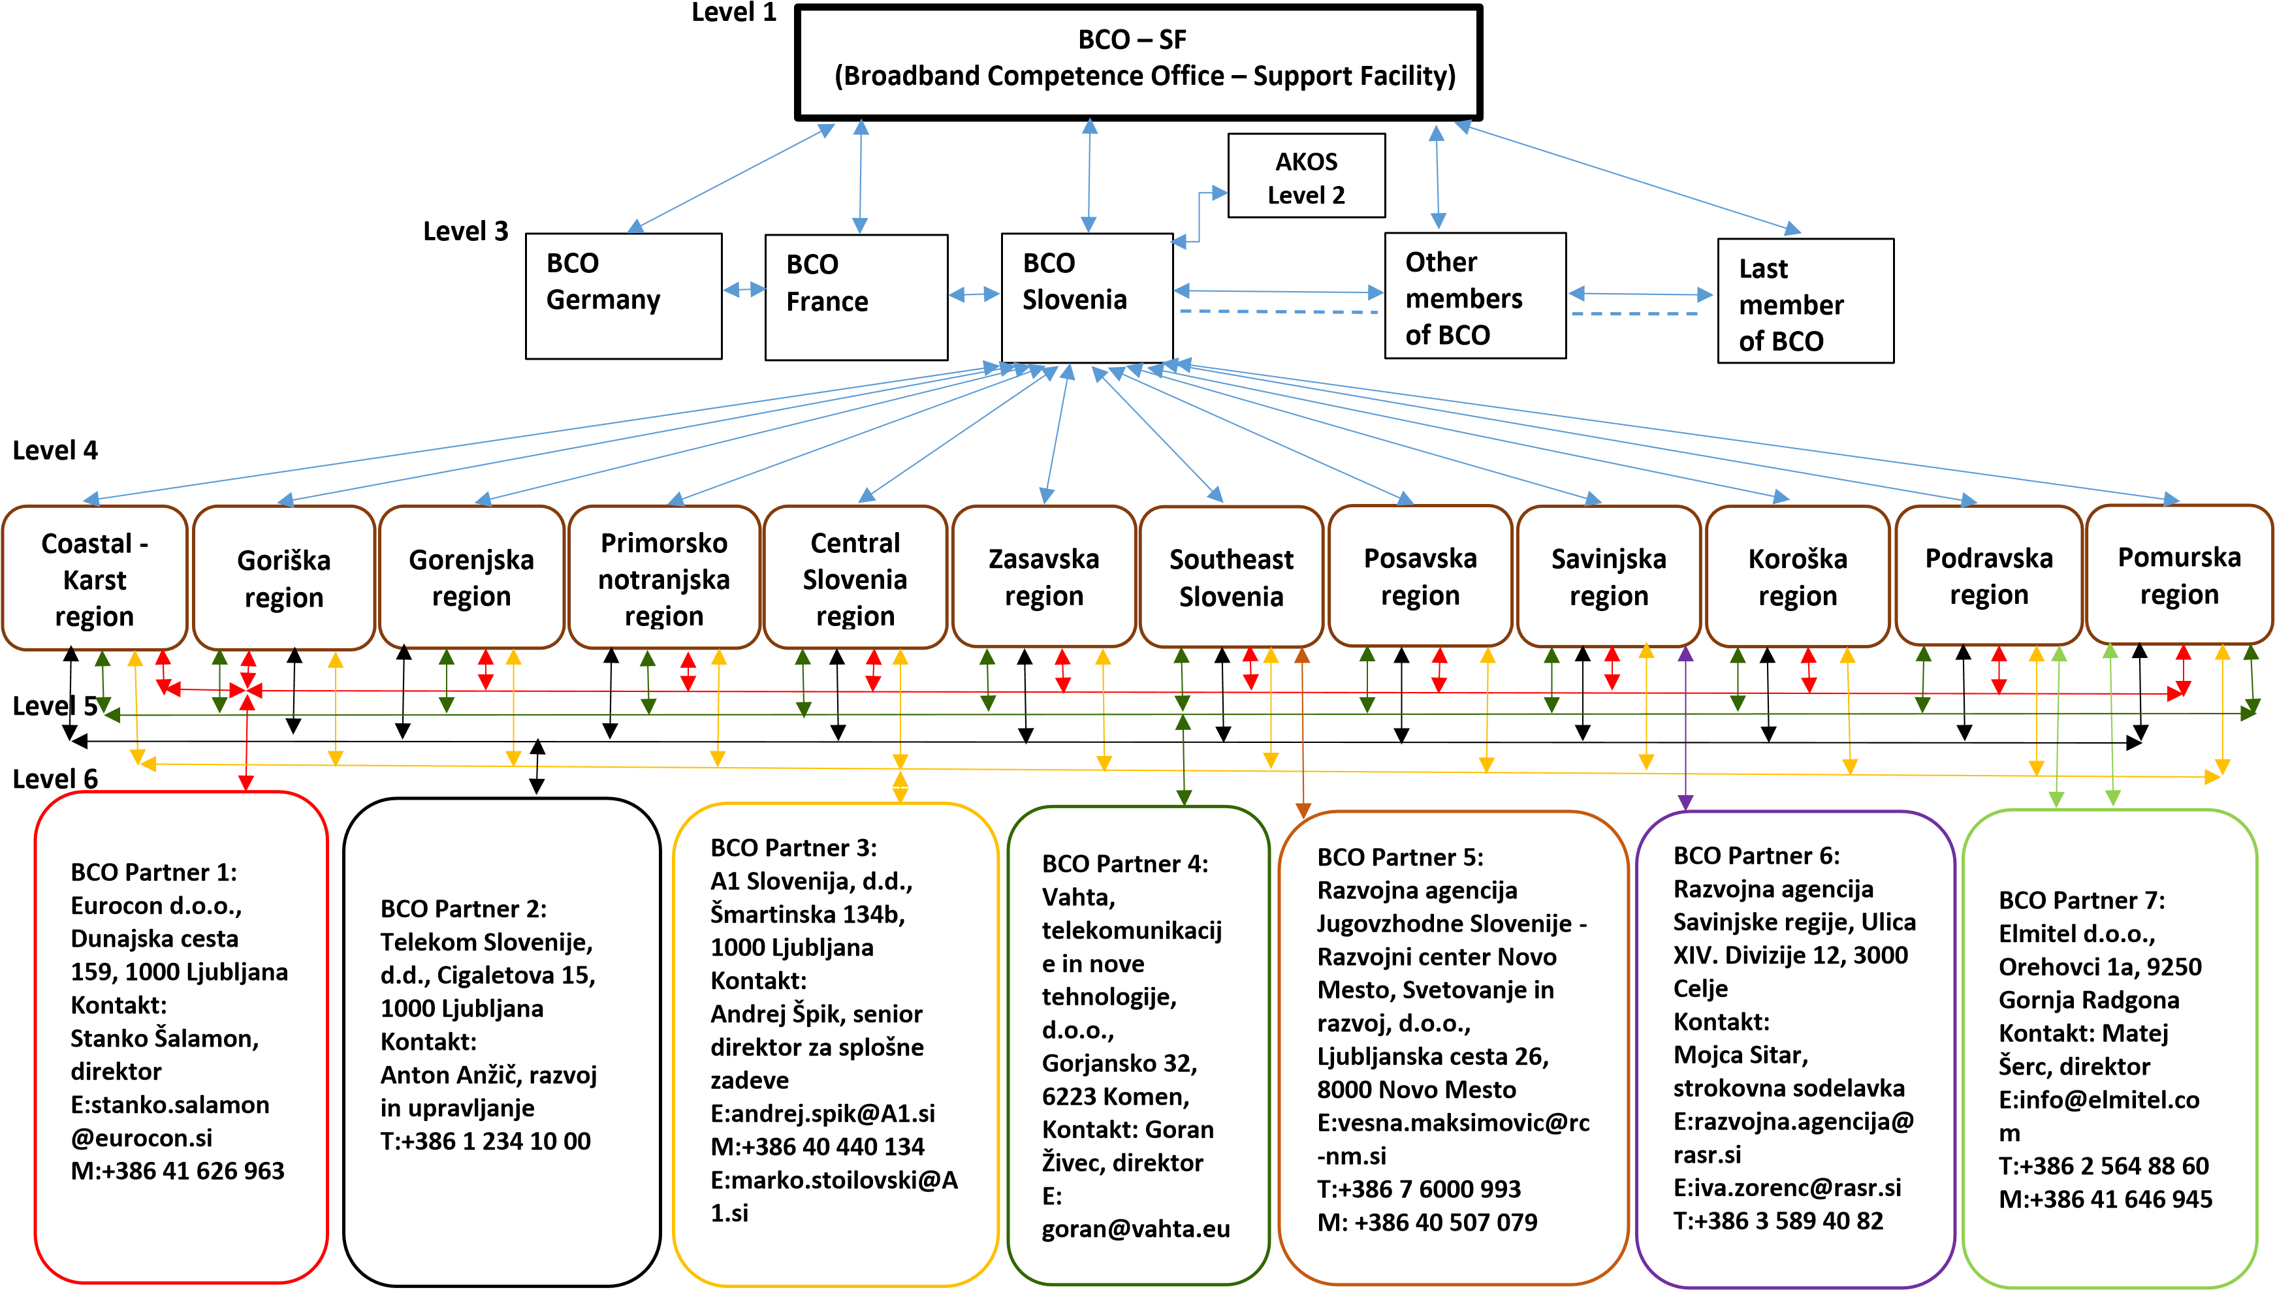**Competence centre for broadband infrastructure (BCO) organization structure**

**Level 1 - BCO-SF (Broadband Competence Office - Support Facility)** at the European level offers EU Member States the services, solutions and examples of good practices in the field of broadband infrastructure.

**Level 2 - AKOS (Agency for Communication Networks and Services of the Republic of Slovenia) cooperates with BCO Slovenia** to support the provision of services and solutions for end-users and local communities.

**Level 3 - All BCOs of Member States** cooperate with each other and at the same time as BCO-SF, in exchanging best practices in the field of broadband infrastructure and services.

**Level 4 - Indicates the regions in the Republic of Slovenia**, which will be covered by the individual BCO provider as part of their activities.

**Level 5 - MPA, as BCO Slovenia** invited the companies, institutions and stakeholders to participate in the public call. It follows from the public invitation that anyone who already offers services and solutions that are the subject of BCO Slovenia's tasks can respond to the invitation to participate. The holders who expressed interest in cooperating with BCO Slovenia undertake activities within the scope of BCO Slovenia's activities and become BCO Partners. The activities of the BCO providers cover the areas described in the response to the public call BCO Slovenia (6th level).

**Level 6 – BCO Partners**