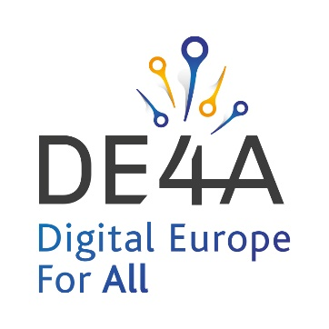

DE4A to Demonstrate How it is Streamlining Interactions Between Citizens, Businesses and Governments During European Week of Regions and Cities
Live Online Information Session: Tuesday, October 12, from 17:30 to 18:30 (CEST)

BRUSSELS, BELGIUM, SEPTEMBER 29, 2021 – Digital Europe for All (DE4A), has been selected as a partner for the European Week of Regions and Cities. The EU funded project, that is supporting the Single Digital Gateway Regulation across Europe and helping to make the digital single market a reality, will host a live online information session during the event. DE4A consortium partners will demonstrate how interactions between citizens, businesses and governments can be streamlined, through the demonstration of its Moving Abroad pilot.

In an efficient Digital Single Market, effectively enabling the cross-border exercise by citizens and businesses of their Single Market rights is just as important for cities and regions as for Member States. Speeding up the efficiency of business is essential for continued growth. Staff and citizen mobility is both a complementary requirement and an essential requirement to attract incoming business activity. The DE4A project is streamlining how EU citizens, business and governments interact.
As a selected European Week of Regions and Cities partner, DE4A will host a live free-to-attend online information session entitled ‘Streamlining how citizens and business interact with governments’. Taking place on Tuesday, October 12, from 17:30 to 18:30 (CEST), the session will present the current challenges of cross-border interoperability and how the DE4A project is helping citizens and businesses overcome them. DE4A will introduce its Moving Abroad pilot which be launches in October 2021, with the aim of creating a digitised process for requesting and delivering evidence in real-time (free from any language barriers), to streamline the process for EU citizens moving from one Member State to another.
The European Week of Regions and Cities (#EURegionsWeek) is the biggest annual Brussels-based event dedicated to cohesion policy. It has grown to become a unique communication and networking platform, bringing together regions and cities from all over Europe, including politicians, administrators, experts and academics.

Registration for DE4A’s ‘Streamlining how citizens and business interact with governments’ webinar is open now.

About DE4A
For a completely working digital single market, effectively enabling the cross-border exercise by citizens and businesses of their Single Market rights, EU Member States must address several challenges on delivering better services.

Digital Europe for All (DE4A) is a three-year pilot-led project, that is being driven by 10 Member States and a consortium of 23 partner organisations in support of the Single Digital Gateway Regulation across Europe ((EU) 2018/1724) and helping to make the digital single market a reality.

The project is aligned with strategic eGovernment Action Plan 2016-2020 and European Interoperability Framework Implementation Strategy and with full regulatory compliance, establishing a culture of co-creation, transparency, accountability and trustworthiness.

Its goal is facilitating migration towards European Digital Public Services co-delivered across borders, across sectors and with different participants, reinforcing trust in public institutions, and unleashing multiple measurable positive impacts on efficiency gains and reduction of administrative burden and costs.

The project has received funding from the European Union’s Horizon 2020 research and innovation program under G.A. No. 870 635.

For more information visit: www.de4a.eu

Editorial contact
Graham Thatcher
EEMA (DE4A Consortium Partner)
Email: graham.thatcher@eema.org

